NOTICE OF ORDER
Wildlife and Countryside Act 1981
Lancashire County Council

THE LANCASHIRE CC (RESTRICTED BYWAY ALONG MOSS LANE, OVERTON)
DMMO 2022

Notice is hereby given that the above referenced Order has been submitted to the Secretary of State for Environment, Food and Rural Affairs for determination. An Inspector will be appointed by the Secretary of State to determine the Order.
The start date for the above Order is 26 August 2025

Consideration of the Order will take the form of exchanges of statements of case and comments on statements of case.
The effect of the Order, if confirmed without modifications, will be to modify the Definitive Map and Statement of Public Rights of Way for the area, by recording a restricted byway known as Moss Lane from Downeyfield Road immediately to the east of Downeyfield Bridge in a generally south south easterly direction to Middleton Road immediately east of Middlepool Bridge.

The length of the route is 0.88km and the width varies between 5 metres and 12 metres.
Any queries relating to this Order should be referred to Paul Scrivener by email: Paul.Scrivener@planninginspectorate.gov.uk quoting reference number ROW/3347497 on all correspondence. Alternatively, queries may be sent in writing to The Planning Inspectorate, Rights of Way Section, Room 3/A Eagle Wing, Temple Quay House, 2 The Square, Temple Quay, Bristol, BS1 6PN. Telephone: 0303 444 5000.
Any person wishing to view the statements of case and other documents relating to this Order may do so by appointment at County Hall, Fishergate, Preston, PR1 0LD, for further information please contact Simon Moore at simon.moore@lancashire.gov.uk or on 01772 531280. Documents have also been made available online. To access the documents, please use the following URL address: https://www.lancashire.gov.uk/council/transparency/dmmos/moss-lane- 2022
Timetable for sending in statements of case and comments Within 2 weeks of the start date 9 September 2025
The Order Making Authority, or where the Order Making Authority is taking a neutral
stance and the applicant or other party are taking the case forward in support of the order, must ensure their statement of case is received by the Secretary of State. As soon as possible after the deadline, the Secretary of State will send a copy (excluding copies of any supporting documents - these will be available to view at the Authority’s
offices) to everyone who has made an objection or representation, the applicant and any other person who has written to us in respect of the Order.
Within 8 weeks of the start date 21 October 2025
Everyone who has made an objection or representation or any other written representation or any other person wishing to make representations in writing must ensure their statement of case is received by the Secretary of State. As soon as possible after the deadline, the Secretary of State will send full copies to the Authority. Copies (excluding copies of any supporting documents - these will be available to view at the Authority’s offices) will also be sent to the applicant, every person who has made an objection or representation and any other person who has written to us in respect of the Order.

Within the same period the applicant (if applicable) must ensure their statement of case is received by the Secretary of State. As soon as possible after the deadline, Secretary of State will send a full copy to the Authority. Copies will also be sent to everyone who has made an objection or representation and any other person who has written to us in respect of the Order (excluding copies of any supporting documents - these will be available to view at the Authority’s offices).
Within 14 weeks of the start date 2 December 2025
Everyone who has made an objection or representation, the Authority, the applicant (if applicable) and anyone who has written to us in respect of the Order must ensure that their comments on any or every other statement of case is received by the Secretary of State. As soon as possible after the deadline, the Secretary of State will send copies of these comments to everyone else.

In fairness to the other parties everyone should keep to the timetable to ensure that statements of case and comments are received on time. Late documents will be returned.
We cannot accept any inflammatory, discriminatory or abusive comments. Any documents containing such comments will be returned.

If you use Artificial Intelligence (AI) to create or alter any part of your documents, information or data, you should tell us that you have done this when you provide the material to us. See the detailed guidance for further information.

Notice of order for w/r
WILDLIFE AND COUNTRYSIDE ACT 1981

THE DEFINITIVE MAP AND STATEMENT OF PUBLIC RIGHTS OF WAY FOR THE COUNTY OF LANCASHIRE

THE LANCASHIRE COUNTY COUNCIL RESTRICTED BYWAY ALONG MOSS LANEf OVERTON
DEFINITIVE MAP MODIFICATION ORDER 2022

This Order is made by Lancashire County Council (the "Authority") under Section 53(2)(b) and 53(3)(b) of the Wildlife and Countryside Act 1981 (''the Act") because it appears to that Authority that The Definitive Map and Statement of Public Rights of Way for the County of Lancashire require modification in consequence of the occurrence of an event specified in Section 53(3)(c)(ii) namely the discovery by the Surveying Authority of evidence which (when considered with all other relevant evidence available to them) shows that a right of way which is shown in the map and statement as a highway of a particular description, namely footpath, ought to be there shown as a highway of a different description, namely a restricted byway.
The Authority have consulted with every local authority whose area includes the land to which the Order relates. Lancashire County Council hereby order that:
- For the purposes of this Order, the relevant date is 18th May 2022.

- The Definitive Map and Statement of Public Rights of Way for the County of Lancashire shall be modified as described in Part I and Part II of the Schedule and shown on the map attached to the Order.
- This Order shall take effect on the date it is confirmed and may be cited as The Lancashire County Council Restricted Byway along Moss Lane, Overton Definitive Map Modification Order 2022.

Dated this 18th day of May 2022.

THE COMMON SEAL of the )
Lancashire County Council ) was hereunto affixed in the presence of )

Authorised Signatory
�
SCHEDULE

e..;BTJ

MODIFICATION OF THE_DEFINITIVE MAP

DESCRIPTION OF PATH OR WAY TO BE UPGRADED

Restricted byway known as Moss Lane from Downeyfield Road immediately to the east of Downeyfield Bridge (at point A on the Order Map) in a generally south south easterly direction to Middleton Road immediately east of Middlepool Bridge (point 8). The entire route is shown between points A and B on the Order Map with a dashed green line.

The length of the route is 0.88km and the width varies between 5 metres and 12 metres.

PARTU

MODIFICATION OF DEFINITIVE_STATEMENT

VARIATION OF PABILCULARS OF PATH OR WAY

The Statement to be amended for Overton 1 to read as follows:

Overton 1:

No. of Path: 11111

Kind of Path: "Restricted Byway"

Position: •Restricted byway known as Moss Lane from Downeyfield Road immediately to the east of Downeyfield Bridge at SD 4316 5912 in a generally south south easterly direction to Middleton Road immediately east of Middlepool Bridge at SD 4351 5833."
Width: Varying between 5 and 12 metres as shown on the Ordnance Survey 25 inch Sheet
XXXIV.1, surveyed 1890 and published 1891. Limitations: None
Length: 0.88 km
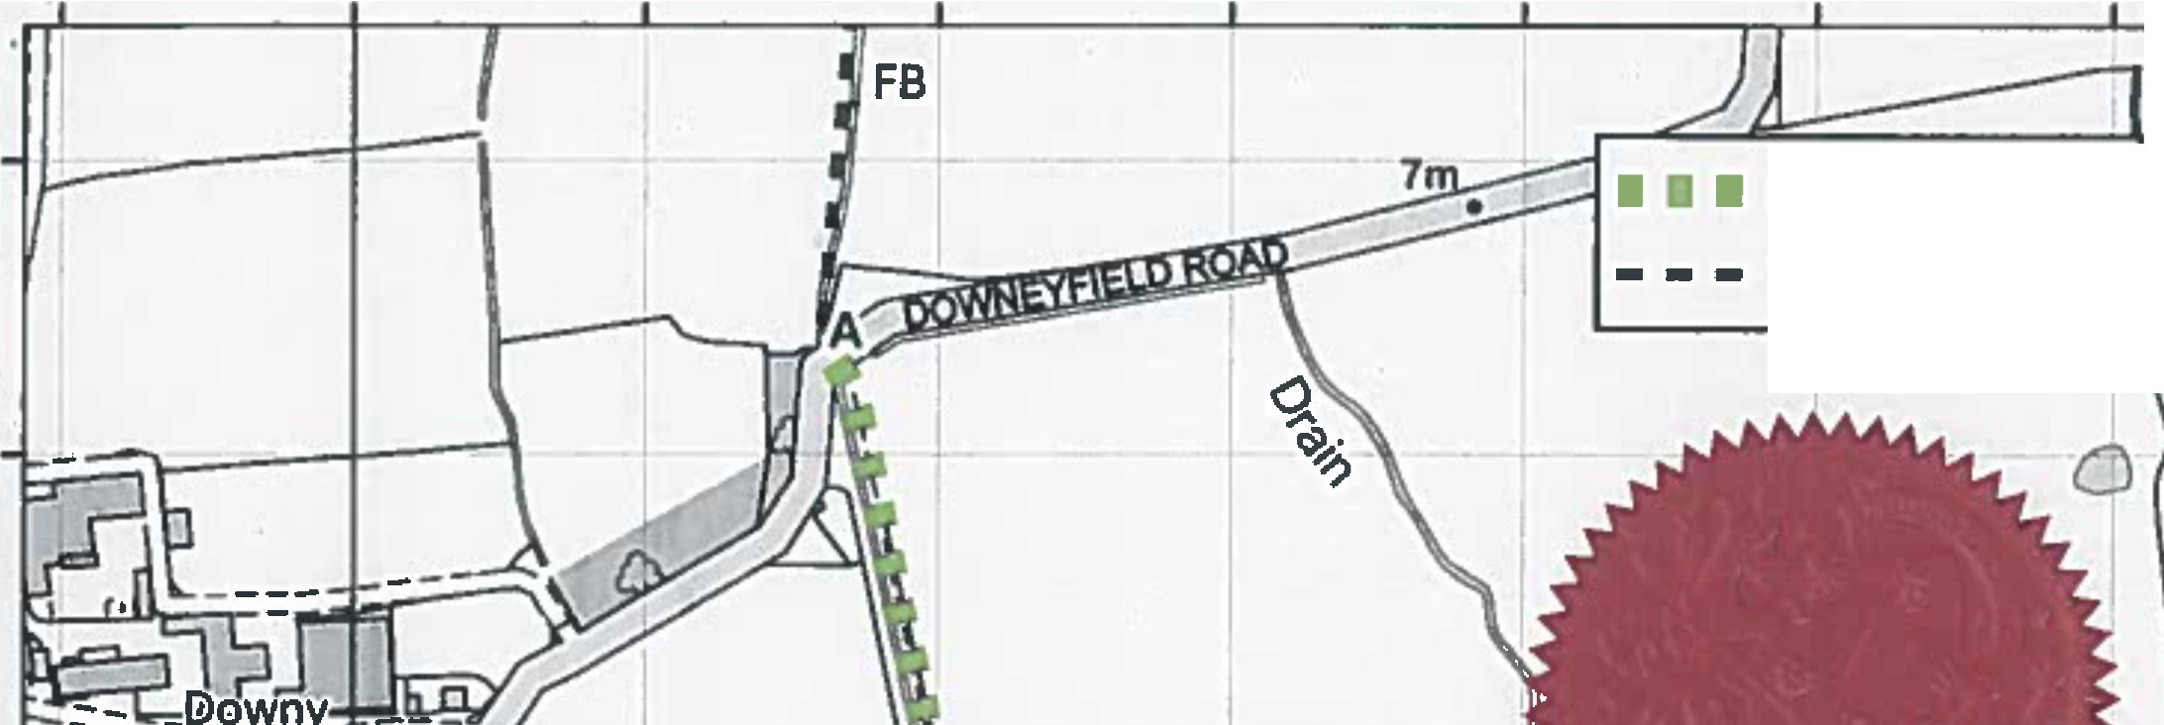
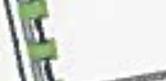

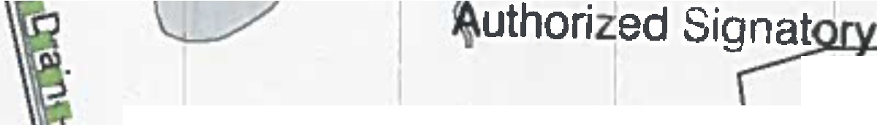
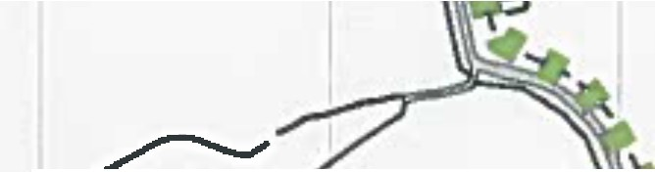
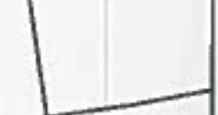
342900 343000 343100 343200 343300 343400 343500 343600
\
r"
r
�
I
r
p; 1
Ii
•
�
\
; ~\-t

g
a:
•IC)

0
Order Route A-8 ;�
Public Footpaths

0
....
0
a,
•IC)
.g...
QI
•
IC)

g�- -Fi@iiw ,
; Farm

'
I
-n1
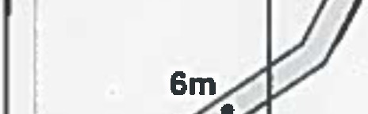

- ';,Ofo"' ' C)
ti/
_ ! _ _ _ Text \- _� � _ _ _ II
I
; '
11·�\I + I Ii
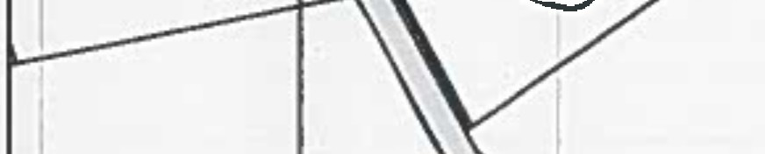
it �\�f/,,. '
\.

- g
r--
Ill
•in
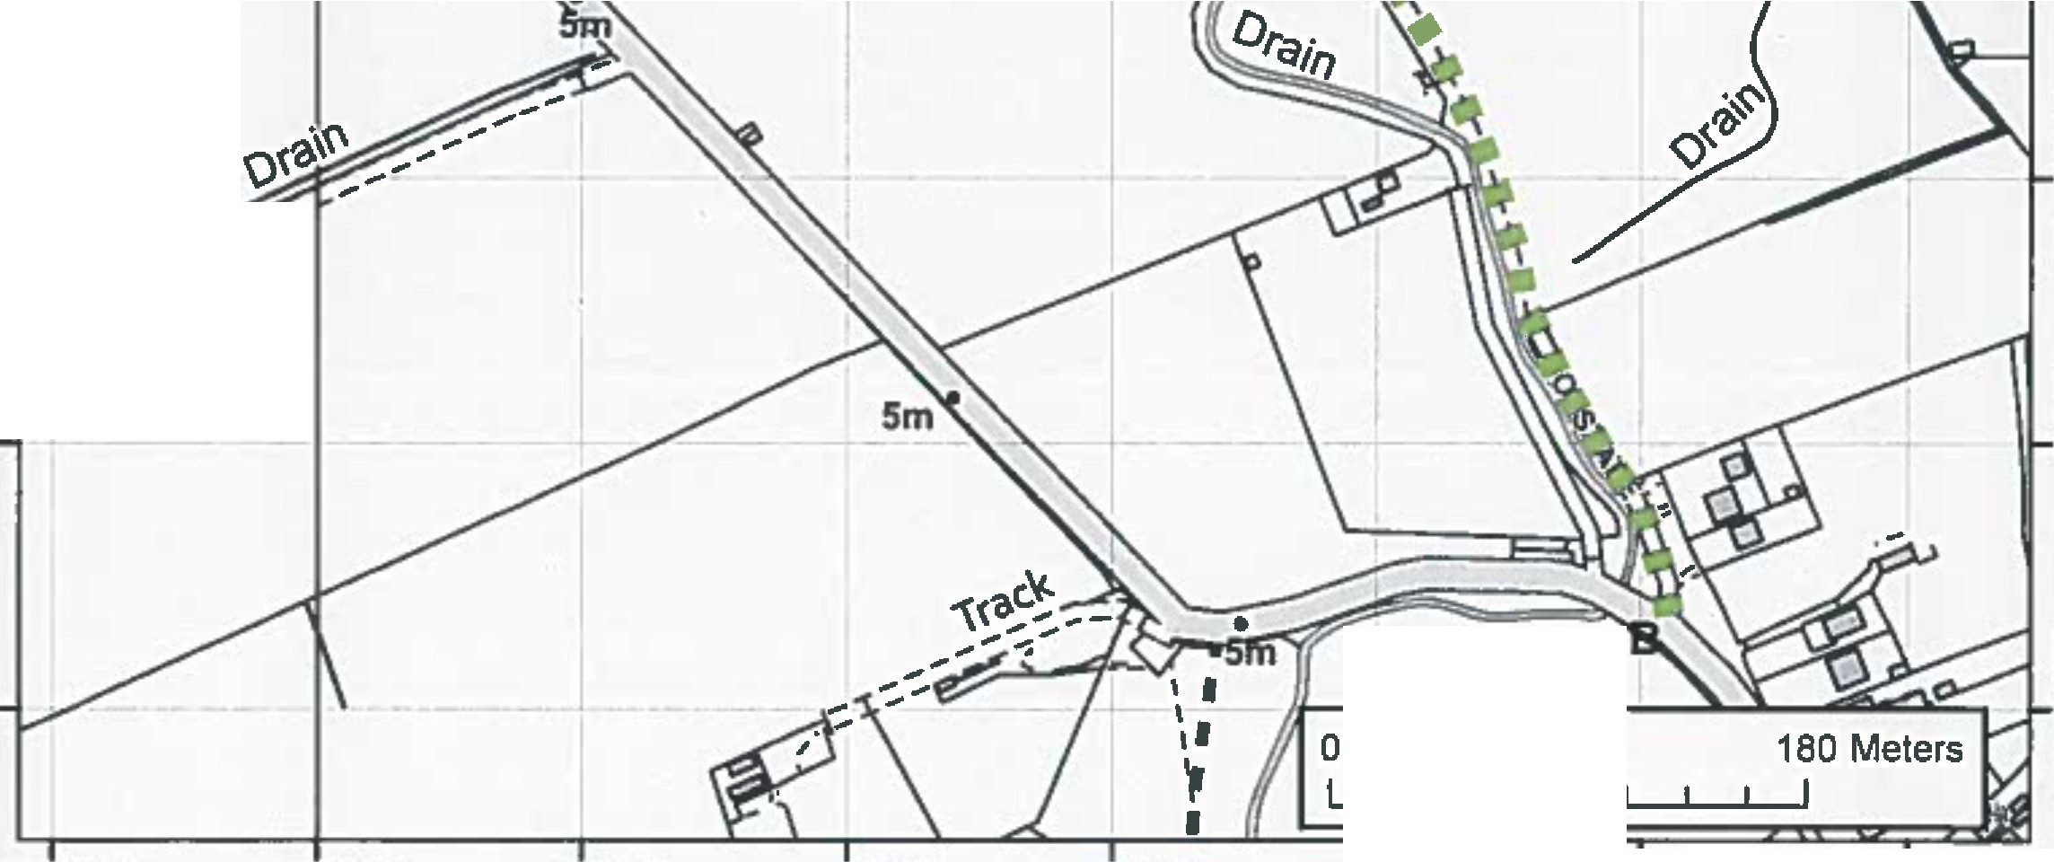
11I ,�
I
'
1 �I
t - - -� / ,0 - -- � 1

i1 �-
. ,..,
0
0
in
1•8

g 0
!;
m•
Ill
•
in

.g.,
1•8

45 90
.g.,
1•8

342900 343000 343100 343200 343300 343400 343500 343600

La�e  ec...nci, | Public Rights of Way PROW@lancashlre.gav.uk 01772 530317 | WIidiife and Countryside Act 1981  Upgrading to Restricted Byway of Footpath Overton, known as Moss Lane | 1:4,000 | -  w♦•
'
Th• dlglt/1ed Rlghll al Wllf lnlarmadan 1hauld b1u1ed lar 9uld1nc1 anly H 111accuracr c.,natbe guwantHd, Rlghll of Way lnlcnna•an mull bnlflfi1dan lhl CUITIIII Dlilnlllv1 Map belar. being 1upphd at UHd lot any purpon.
Thia Map II r.ptoduc1d from 0nln1nc1Survey m1tlfl1I with 1111 pttmll1lon of Otdn.,c1 Surwy an blhall of lht conttoll•al H• Mll11ty'1 Sbtlontty 0flc1(Cl Crawn CGpynghl UnaulhoriHd rtptoduclian lnh1n911Crown Capyright and mey lead lo Prosecution ar cMI proclldln91. Llacuhn Caunty Coundl Uc1nc1 No.100023320

