NOTICE OF ORDER
Wildlife and Countryside Act 1981
Lancashire County Council

The Lancashire CC - (Dark Lane, Earby) DMMO 2018

Notice is hereby given that the above referenced Order has been submitted to the Secretary of State for Environment, Food and Rural Affairs for determination. An Inspector will be appointed by the Secretary of State to determine the Order.
The start date for the above Order is 2 September 2025

Consideration of the Order will take the form of exchanges of statements of case and comments on statements of case.

The effect of the Order, if confirmed without modifications, will be to modify the Definitive Map and Statement of Public Rights of Way for the area, by adding a bridleway known as Dark Lane from the northern end of Birch Hall Lane (U40026) and junction of footpaths 32 and 38 Earby at SD 9186 4684 (Point A on the Order Map), along an enclosed track varying between 3 and 4 metres wide in a generally easterly direction for approximately 240 metres to the County Boundary at SD 9210 4680 (point B).

Any queries relating to this Order should be referred to Paul Scrivener by email: Paul.Scrivener@planninginspectorate.gov.uk quoting reference number ROW/3348826 on all correspondence. Alternatively, queries may be sent in writing to The Planning Inspectorate, Rights of Way Section, Room 3/A Eagle Wing, Temple Quay House, 2 The Square, Temple Quay, Bristol, BS1 6PN. Telephone: 0303 444 5000.
Any person wishing to view the statements of case and other documents relating to this Order may do so by appointment at County Hall, Fishergate, Preston, PR1 0LD, for further information please contact Ansar Sadiq at ansar.sadiq@lancashire.gov.uk or on 01772 532435.

Documents have also been made available online. To access the documents, please use the following URL address:

http://www.lancashire.gov.uk/council/transparency/dmmos/dark-lane- earby-2018/

Timetable for sending in statements of case and comments Within 2 weeks of the start date 16 September 2025
The Order Making Authority, or where the Order Making Authority is taking a neutral stance and the applicant or other party are taking the case forward in support of the order, must ensure their statement of case is received by the Secretary of State. As soon as possible after the deadline, the Secretary of State will send a copy (excluding
copies of any supporting documents - these will be available to view at the Authority’s offices) to everyone who has made an objection or representation, the applicant and any other person who has written to us in respect of the Order.
Within 8 weeks of the start date 28 October 2025
Everyone who has made an objection or representation or any other written representation or any other person wishing to make representations in writing must ensure their statement of case is received by the Secretary of State. As soon as possible after the deadline, the Secretary of State will send full copies to the Authority. Copies (excluding copies of any supporting documents - these will be available to view at the Authority’s offices) will also be sent to the applicant, every person who has made an objection or representation and any other person who has written to us in respect of the Order.

Within the same period the applicant (if applicable) must ensure their statement of case is received by the Secretary of State. As soon as possible after the deadline, Secretary of State will send a full copy to the Authority. Copies will also be sent to everyone who has made an objection or representation and any other person who has written to us in respect of the Order (excluding copies of any supporting documents - these will be available to view at the Authority’s offices).

Within 14 weeks of the start date 9 December 2025
Everyone who has made an objection or representation, the Authority, the applicant (if applicable) and anyone who has written to us in respect of the Order must ensure that their comments on any or every other statement of case is received by the Secretary of State. As soon as possible after the deadline, the Secretary of State will send copies of these comments to everyone else.

In fairness to the other parties everyone should keep to the timetable to ensure that statements of case and comments are received on time. Late documents will be returned.
We cannot accept any inflammatory, discriminatory or abusive comments. Any documents containing such comments will be returned.

If you use Artificial Intelligence (AI) to create or alter any part of your documents, information or data, you should tell us that you have done this when you provide the material to us. See the detailed guidance for further information.

Notice of order for w/r
WILDLIFE AND COUNTRYSIDE ACT 1981

THE DEFINITIVE MAP AND STATEMENT OF PUBLIC RIGHTS OF WAY FOR THE COUNTY OF LANCASHIRE

THE LANCASHIRE COUNTY COUNCIL (DARK LANE, EARBY) DEFINITIVE MAP MODIFICATION ORDER 2018
This Order is made by Lancashire County Council f1the Authority") under Section 53(2)(b) of the Wildlife and Countryside Act, 1981 ("the Act") because it appears to that Authority that the Definitive Map and Statement of Public Rights of Way for the County of Lancashire require modification in consequence of the occurrence of an event specified in Section 53(3)(c)(i) namely the discovery by the Authority of evidence which (when considered with all other relevant evidence available to them) shows that a right of way which is not shown in the map and statement subsists or is reasonably alleged to subsist over land in the area to which the map relates, namely a bridleway.

The Authority have consulted with every local authority whose area includes the land to which the Order relates. Lancashire County Council hereby order that:

- For the purposes of this Order, the "relevant date" is 28th March 2018.
- The Definitive Map and Statement of Public Rights of Way for the County of Lancashire shall be modified as described in Part I and Part II of the Schedule and shown on the map attached to the Order.
- This Order shall take effect on the date it is confirmed and may be cited as The Lancashire County Council (Dark Lane, Earby) Definitive Map Modification Order 2018.

Dated this 28th day of March 2018.

THE COMMON SEAL of the )
Lancashire County Council ) was hereunto affixed in the presence of )

/\.uthorised Signatory
SCHEDULE

PARTI

MODIFICATION OF THE DEFINITIVE MAP

DESCRIPTION OF PATH OR WAY TO BE ADDED

A bridleway known as Dark Lane from the northern end of Birch Hall Lane (U40026) and junction of Footpaths 32 and 38 Earby at point A on the Order Map, along an enclosed track varying between 3 and 4 metres wide in a generally easterly direction for approximately 240 metres to the County boundary at point 8.

PART II

MODIFICATION OF DEFINITIVE STATEMENT VARIATION OF PARTICULARS OF PATH OR WAY
11Bridleway 80 known as Dark Lane from Birch Hall Lane (U40026) and junctions of Footpaths 32 and 38, grid reference SD 9186 4684 in a generally easterly direction along an enclosed sunken track for 240 metres to the County boundary at SD 9210 4680. All lengths and compass directions given are approximate.

Width:

Varying between 3 and 4 metres Limitations: None
Length: 0.24 km11
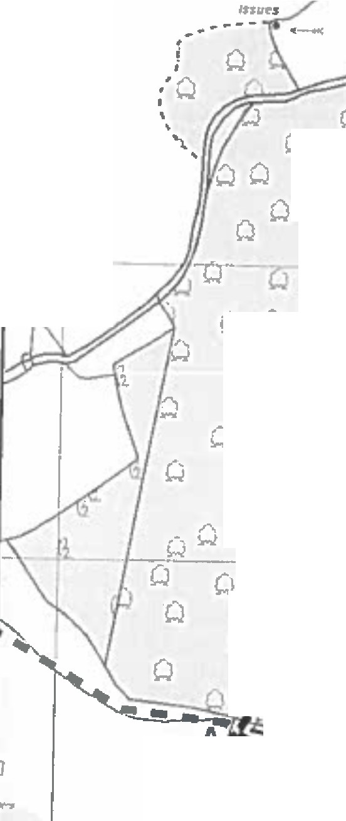
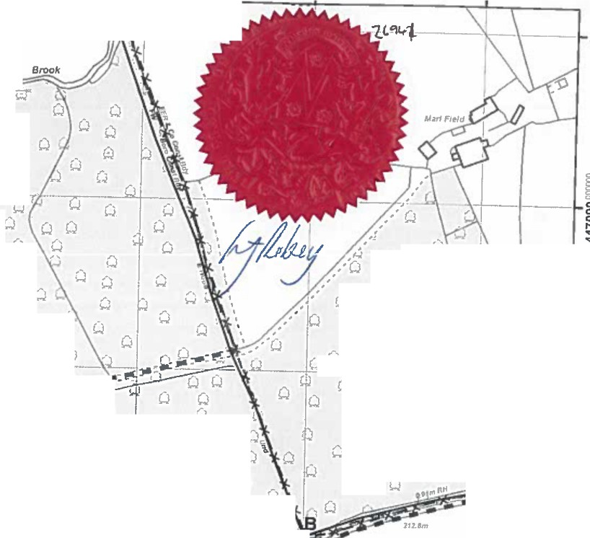
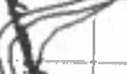

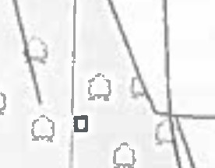
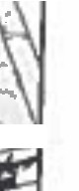
.
�I l391soooooooo
391900=0
392000 000000
392100
392200000000
i
\
\IV
I
...t
I
,I
Wentcllff
I
Q
�
fJ
I
i
'
�I
01
Q
Q
Q
§
0
0
0
0
::J
r,..
t-Q
s
g
C
C
C
0
0
0,
ID
i
Q Q
CJ
Q
CJ Q CJ
w/' Q
lo
W\ Q l\
01
Q
CJ
Q
.,.,
Q
\
I
Q
0
CJ
QQ
lo
�
,,.,
',.,/a
QW
CJ
Q
Q
QQ
on
0 Q
ri --­
�
w
Q
-� 9i-:.w-U FP lff
/re/
�,-#' w
o
w
-°"•-�·
w,,.
(.J Q0
Q Q Q Q
Q
ow
Q
o,
QCJ--�
·- c\�\ �I
Q01QtO
Jo
Q
w
w C.J
QQ
w
D
CJ
::J
Q
Q
Q
I0
�
L
�
�
o I
I
o ,,_ ow .ci
·.:i
QQQ
Q
QIO Q
,
Q
QQ
K#-�Nf
11,51
-•lh(q"'I�--
��k,-,,._JQ I.
-_:J Q
-
I
Q CJ
�
0
8
gJ
,�·
L-

i
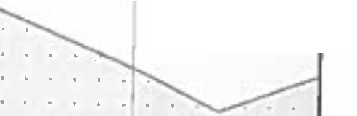
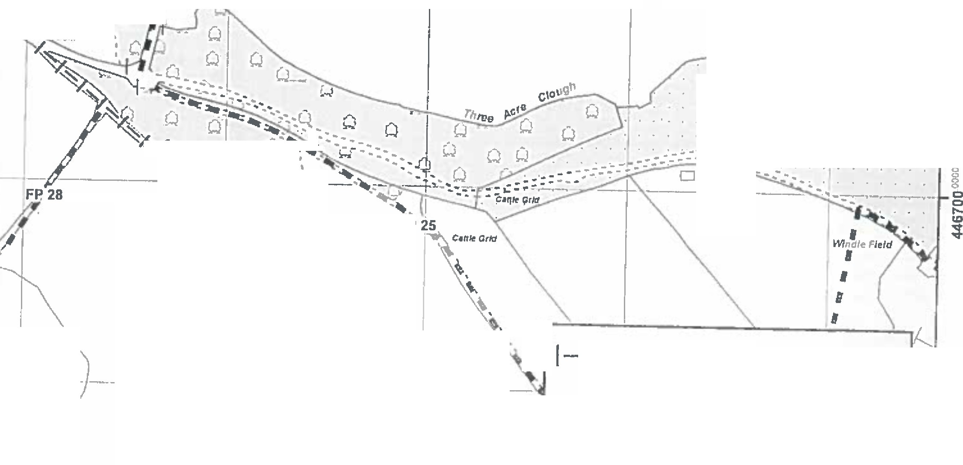
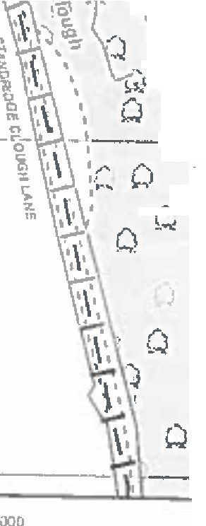

! B,!�����!�_Lane • • ,.�---- I fl
I
!

.
.o·.
- -- J!,.,/
�
i
-'1t�.
::_.._....: -- �.
.!.
8

0
0
r,..
;ID
� Q Q'. D
·/'/' ��-�
�-:
� Q,
BW�,29� ,. � ..
1,.W :
I i \ :
• •\ - ' ' ..
.
' '
.
g
0....
0
ID
�

-:J ',
'
I
¼t. !l

0 ',
0 1,":-�,
0
t\,
\..,
--- l '4

1-1-1-1 Order route A-8
�.1i
0
0
�
u, , .. Q '
\I�
u,
'<1"
'<1"

C '.
r•
•I

Public Footpath

x-x-x-
l
Q ' \
I
I
/ �-oun� bou�dary I_?
1
/' I I I I I I I I I §
§ Q •I'
..-, o 30 60 120 Meters J_s
§ -X

--# L.:::=;::=::::::::�::=;:;=:::;=�-- - 0
0
0
Ill
� ... .... .. _"'-, /j�� �. f5
tO
� 391800

000000
3919QQOOOiJOO J92QQQOG0000
tO
392100= 392200 OOO<XJO �
I
Lancashire  Oounc:I  Cou<>ty ·•· | Andrew Mullaney  Head ol Planning and Envlranmen1 | Wildlife and Countryside Act 1981  Addition of bridleway along Dark Lane, Earby I | 1:2,500 | s  •. .d?l.,  �f'C
'
The digi�a,d RigMs or Way lnlormaUan should be und lor guidance only u Us accuracy cannot be guaran1ecd. RJghb of Way lnronnaUon must be ve�ficd on 1h• curren1DeflnlUvI Map before being Iuppllod or used for any purpose.

This Map 11 reproduced from Ordnance Survey material "4th1h•pcnnlnion al Ordnance Survey on be/iaWaftht canln>ller of Hor Mtjesly'I S1a1ione,y Offlc1 (CJ Crown CopyrtghL UnIuthori1od repn,dudlon lnlringH Crown Copyright and may l11d lo ProIecullon or clvnpmeeedlng,,LancuhlrtCounty Council Ueanctllo, 10002332!1

