NOTICE OF ORDER

Wildlife and Countryside Act 1981
Lake District National Park Authority
Footpath 409052/419049, Gaterigghow Bridge to Hollins Bridge along the River Irt, Parishes of Gosforth and Wasdale DMMO 2023

Notice is hereby given that the above referenced Order has been submitted to the Secretary of State for Environment, Food and Rural Affairs for determination. An Inspector will be appointed by the Secretary of State to determine the Order.

The start date for the above Order is 4 April 2025

Consideration of the Order will take the form of a public local inquiry.

The Inquiry will be held at Gosforth Public Hall Whitecroft / Wasdale Road Gosforth CA20 1AS on 30 September 2025 at 10.00am.

The effect of the Order, if confirmed without modifications, will be to modify the Definitive Map and Statement for the area by adding a footpath alongside (and across) the River Irt from Gaterigghow Bridge at NY 107 041 to near Hollins Bridge at NY 104 029 as shown on the order plan.

Any queries relating to this Order should be referred to Zoe McPhail by email: zoe.mcphail@planninginspectorate.gov.uk quoting reference number ROW/3339653 on all correspondence. Alternatively, queries may be sent in writing to The Planning Inspectorate, Rights of Way Section, Room 3/A Eagle Wing, Temple Quay House, 2 The Square, Temple Quay, Bristol, BS1 6PN. Telephone: 0303 444 5481.

Any person wishing to view the statements of case and other documents relating to this Order may do so by appointment at LDNPA, Wayfaring House, Murley Moss, Oxenholme Road, Kendal, LA9 7RL, Please contact Nick Thorne on nick.thorne@lakedistrict.gov.uk or 01539 79262. Documents can also be viewed on https://tinyurl.com/riverirtpath

Timetable for sending in statements of case and proofs of evidence

Within 8 weeks of the start date by [by 30 May 2025]

The Order Making Authority must ensure their statement of case is received by the Secretary of State. As soon as possible after the deadline, the Secretary of State will send a copy (excluding copies of any supporting documents - these will be available to view at the Authority’s offices) to everyone who has made an objection or representation and the applicant and any other person who has written to us in respect of the Order.

Within 14 weeks of the start date [by 11 July 2025]

Everyone who has made an objection or representation and anyone who wishes to give evidence at the Inquiry must ensure their statement of case is received by the Secretary of State. As soon as possible after the deadline, the Secretary of State will send full copies to the Authority. Copies will also be sent to the applicant, every person who has made an objection or representation and any other person who has written to us in respect of the Order (excluding copies of any supporting documents - these will be available to view at the Authority’s offices).

Within the same period the applicant (if applicable) must ensure their statement of case is received by the Secretary of State. As soon as possible after the deadline, the Secretary of State will send a full copy to the Authority. Copies will also be sent to everyone who has made an objection or representation and any other person who has written to us in respect of the Order (excluding copies of any supporting documents - these will be available to view at the Authority’s offices).

4 weeks before the date of the inquiry [by 2 September 2025]

The Authority, everyone who has made an objection or representation, the applicant (if applicable) and anyone who wishes to give evidence at the Inquiry must ensure their proof of evidence (together with any summary) is received by the Secretary of State. As soon as possible after the deadline, the Secretary of State will send copies of:

- the Authority’s proof of evidence to everyone who has made an objection or representation, the applicant and anyone who has submitted a statement of case (including copies of any supporting documents – although none should be submitted with a proof of evidence);

- the applicant’s proof of evidence to the Authority, everyone who has made an objection or representation and anyone else who has submitted a statement of case (including copies of any supporting documents – although none should be submitted with a proof of evidence); and

- all other proofs of evidence to the Authority, the applicant, everyone who has made an objection or representation and anyone else who has submitted a statement of case (including copies of any supporting documents – although none should not be submitted with a proof of evidence).

All parties must keep to the timetable set out above and ensure that statements of case and proofs of evidence are received by the Secretary of State on time. Late documents will be returned.

We cannot accept any inflammatory, discriminatory or abusive comments. Any documents containing such comments will be returned.

Notice of order for inquiry

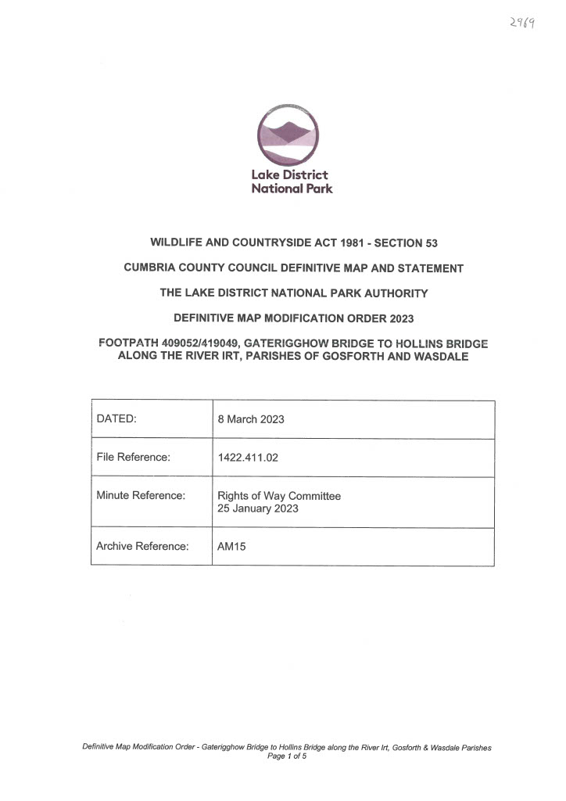
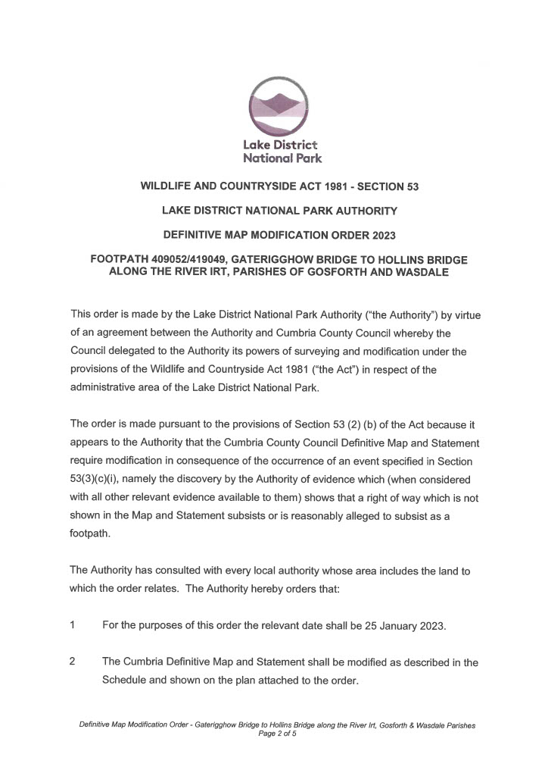
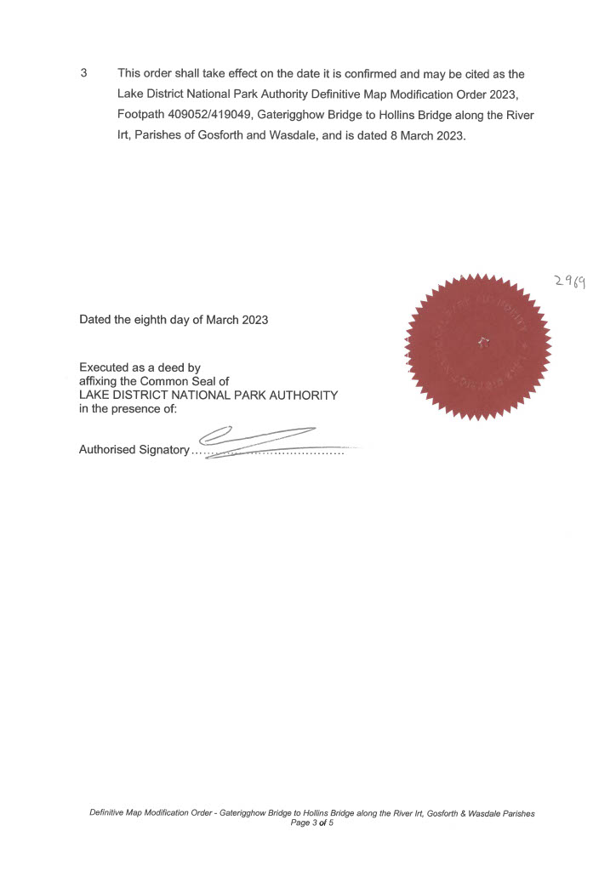
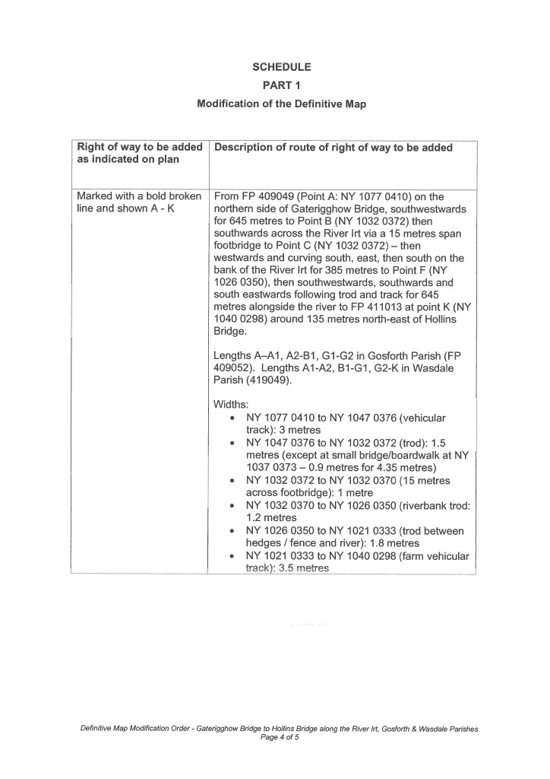
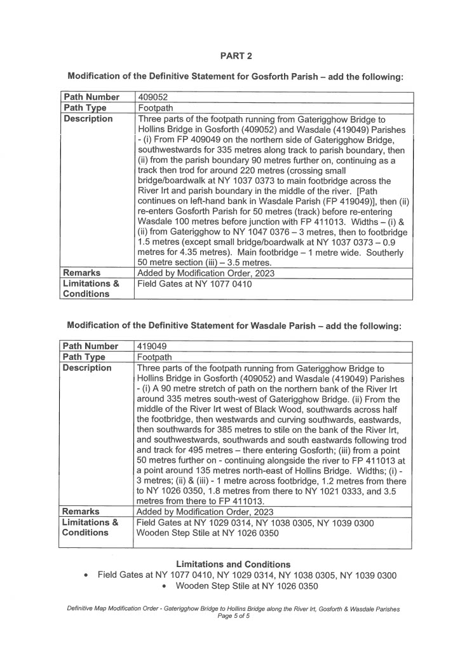
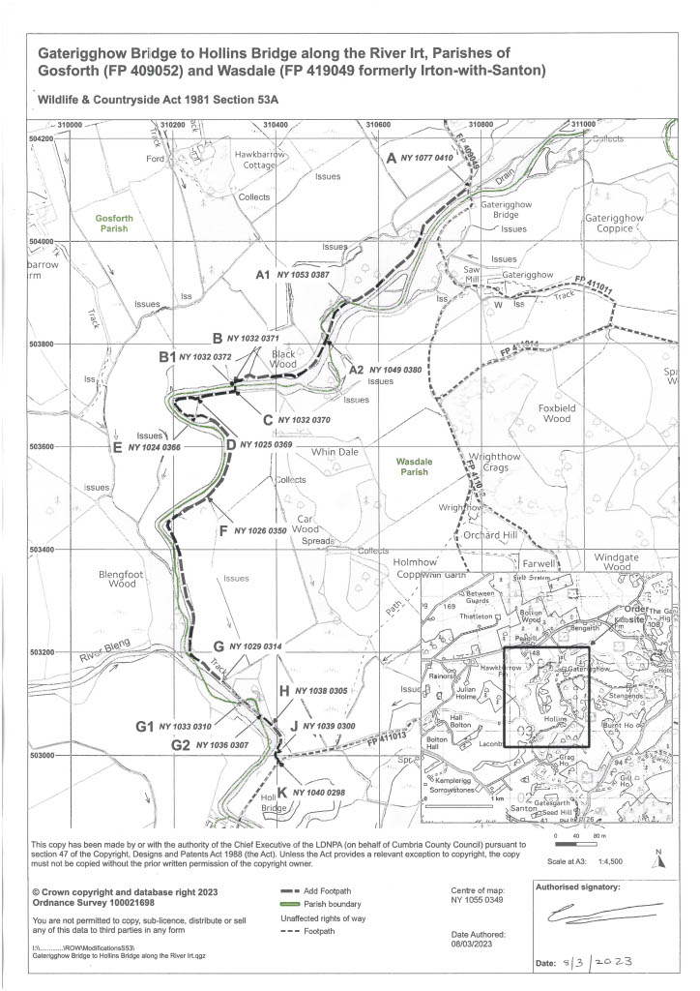

If you wish to make a legal submission, this should be submitted at the same time as your statement of case. Otherwise legal submissions will have to be submitted in writing on the day of the inquiry.

