NOTICE OF ORDER
Wildlife and Countryside Act 1981

Staffordshire County Council

(Public Footpath at Cheadle Road to Footpath 39 Woodlands Hall, Cheddleton) Modification Order 2020

Notice is hereby given that the above referenced Order(s) has/have been submitted to the Secretary of State for Environment, Food and Rural Affairs for determination. Following an earlier exchange of written representations, the Inspector appointed to determine the Order(s) issued a letter in which he/she proposed to make modifications to the Order(s) as drafted. Following advertisement of those proposals objections/representations have been received.

The start date for the above Order(s) is 16 September 2025.

Consideration of the Order(s) will take the form of a public local inquiry. It is being held so that an Inspector can hear evidence in respect of the Inspector’s proposed modifications only.
The Inquiry will be held at Staffordshire Moorlands DC, Moorlands House, Stockwell Street, Leek, ST13 6HQ on 13th January 2026 at 10.00am.

The effect of the Order, if confirmed without modifications, will be to modify the Definitive Map and Statement for the area by adding:- A length of Public Footpath in Cheddleton Parish commencing at point A on the map (NGR 397060 – 351140), the south side of Cheadle Road, Cheddleton, and running in a generally east-south easterly direction for approximately 547 metres then in a generally south easterly direction for approximately 80 metres, then running in a generally east-south direction for approximately 217 metres to its terminus at point B on the map (NGR 397777 – 350720) approximately 60 metres west of Felt House Farm.

The effect of the proposed modification(s) would be to:
- Delete all references to a ‘footpath’ and insert ‘bridleway’.
- Insert ‘May’ to the date of the Order.
- In the Schedule, Part I, in the description of path or way to be added delete ‘for approximately 217 metres’, ‘on the map (NGR
397777 – 350720) approximately 60 metres west of Felt House Farm’ and insert ‘at its junction with Cheddleton Footpath 39.’
- in the Schedule, Part II, in the description of where the path terminates delete ‘Track approximately 60 metres west of Felt House Farm’ and insert ‘Cheddleton Footpath 39’. In the description of the width of the path delete ‘1.8’ and insert ‘2.4’.
- in the Order map, delete ‘B’ and continue the path line from B in a straight line to its connection with Cheddleton Footpath 39 and label that connection as B. Insert the notation for bridleway for the entire length of the route.

Any queries relating to this Order should be referred to Paul Scrivener by email: paul.scrivener@planninginspectorate.gov.uk quoting reference number ROW/3322875 on all correspondence. Alternatively, queries may be sent in writing to The Planning Inspectorate, Rights of Way Section, Room 3/A Eagle Wing, Temple Quay House, 2 The Square, Temple Quay, Bristol, BS1 6PN. Telephone: 0303 444 5000.

Any person wishing to view the statements of case and other documents relating to this Order may do so by appointment at Reception, Staffordshire County Council, 1 Staffordshire Place, Tipping Street, Stafford ST16 2LP. Please contact David Adkins, tel: 01785 276187, or email: david.adkins@staffordshire.gov.uk.

Timetable for sending in statements of case and proofs of evidence
Within 8 weeks of the start date by 11 November 2025.

The Order Making Authority, the applicant and everyone who has made an objection or representation following the proposed modifications and anyone who wishes to give evidence at the Inquiry must ensure their statement of case1 is received by the Secretary of State. As soon as possible after receiving it the Secretary of State will send a full copy to the Authority. Copies (excluding copies of any supporting documents - these will be available to view at the Authority’s offices) will also be sent to everyone who has made an objection or representation following the modifications, the applicant and anyone else who has previously written to us in respect of the Order.

4 weeks before the date of the inquiry by 16 December 2025

1 If you wish to make a legal submission, this should be submitted at the same time as your statement of case. Otherwise legal submissions will have to be submitted in writing on the day of the inquiry.
The Authority, everyone who has made an objection or representation following the proposed modifications, the applicant (if applicable) and anyone who wishes to give evidence at the Inquiry must ensure their proof of evidence (together with any summary) is received the Secretary of State. As soon as possible after receiving them, the Secretary of State will send copies of:

- the Authority’s proof of evidence to everyone who has made an objection or representation following the proposed modifications, the applicant, anyone who has submitted a statement of case and anyone else who has previously written to us in respect of the Order;

- the applicant’s proof of evidence to the Authority, everyone who has made an objection or representation following the proposed modifications, anyone who has submitted a statement of case and anyone else who has previously written to us in respect of the Order; and
- all other proofs of evidence to the Authority, the applicant and anyone else who has either submitted a statement of case or who has previously written to us in respect of the Order .

All parties must keep to the timetable set out above and ensure that statements of case and proofs of evidence are received by the Secretary of State on time. Late documents will be returned.
We cannot accept any inflammatory, discriminatory or abusive comments. Any documents containing such comments will be returned.

Notice of order for inquiry mods
\

WILDLIFE AND C-OUN.TRYSIDE ACT 1981
.

OEFINITJ•VE MAP ANO STATEMENT FOR THE DISTRICT OF STAFFORDSHIRE
- MO-ORLANDS.
:8'J'i�\t-wtw.
Staffordshire County Council (Pubfic� · t Cheadle Road to Footpath 39 at
Woodlands Hall, Cheddleton) Modification Order 2020
This Order is made by Staffordshire County Council under section 53(2)(b) of the Wildlife and Countryside Act 1981 ("the Act") because it app�ars to the authority that the
Definitive Map and Statement for the District of Staffordshire Moortand. s. require
modification in consequence of the occurrence of an event specified in section·53(3)(c)(i), namely, the discovery by the Authority of evidence which (when considered with all other relevant evidence available to them) shows that a right of way which is not shown in the map and statement subsists or is reasonably alleged to subsist over land in the area to
!• which the map relates, bejng a right of way such that the land over which the right subsists is a public path. ·

The Authority has consulted with every local authority whose area includes the land to which the order relates. The Staffordshire County Council hereby order that:
- For the purposes of this order the relevant date is the date that it is niade.
- The definitive map and statement for the District of Staffordshire Moorlands shall
be modified as described in Part f and Part ll of the Schedule and shown on the map attached to the Order�.
l
•

- This order shall take effect on the date it is confirmed and may be cited as the Staffordshire County Council (Public.�,, •...�c,.._.at Cheadle Road to Footpath 39 at Woodlands Hall, Cheddfeton) Modification Ord�r 2020 ·

I

Given under the Common Seat of the Staffordshire County Council on the \ 0 day of
� •. 202'.t

•
•

THE COMMO·N SEAL of
STAFFORDSHIRE cou·NTY COUNCIL •
was h·ereunto affixed in the presence
•
o- f-..,-

'

•
•
•

Authorised -Signatory .

·.,

MMU I XX191X I 03.474724

Page 1 .1

· c 36








••

•

•

•
•

•

SCHEDULE
•
- PART I·
••

Modification of Definitive Map
Description of path or way to be added .
br�o.��� .. • . . . .
A length of feo�#l 1n Cheddleton Parish commencing at point A on the map (NGR
397060 - 351140), the south side of Cheadle Road, Cheddleton, and running in a generally east-south easterly direction for approximately 547 metres then in a generally south easterly direction for approximately 80 metres, then running in a generally east south easterly direction fof apJ;)f0�fflffltciy 2t7 A1etFOS·to its terminus at point B -On•tRe

- . . ::.. :f:"t=elt I louse Far1·rt.
.
G\\-; ,' �5 0'-'V\C.k-\ CV\. I.•->•� Q\.e'-�c \t,_\.e,"Y\ fcxl:,;p<� 3 C�.
PART II

Modification of Definitive Statement Varia.tion of particulars of path or way
��;¾l\fvJ<
Type of Path

Path commences at
Public Footpath�
South side of Chea.die Road, Cheddleton
Path finishes at +rao �FO*imately,60.,metres wost of f:elt House Farm
- C..Y\.et� '\-of\......,k.?0 \-{J('� '3(�
The width of the Public-Foot13o,tfw'l ill be ·1.8 metres.
•J.s,.,A..,11,,A,� 2. •Lr ,
•

•

•

•

•

•


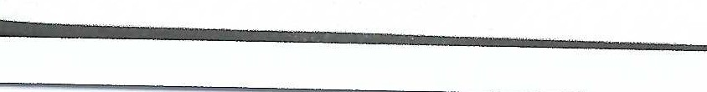
Page2
MMU / XX191X I 03474724
•
•
•
•
•

C 37



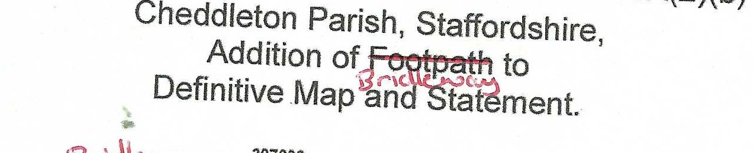
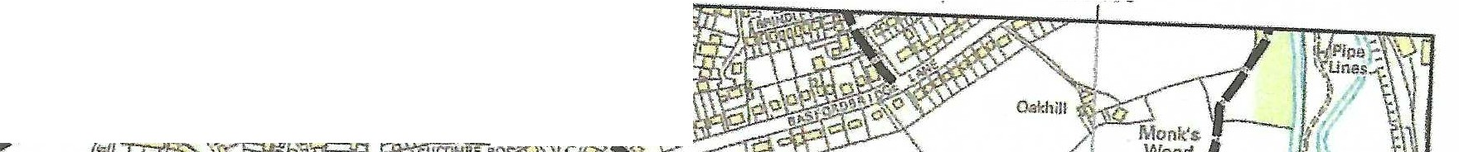
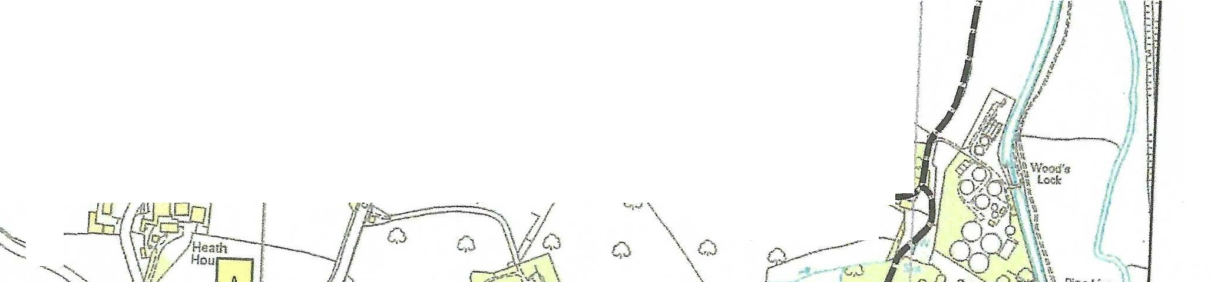
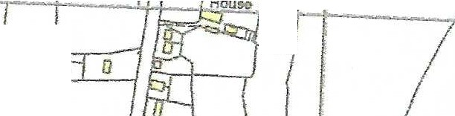
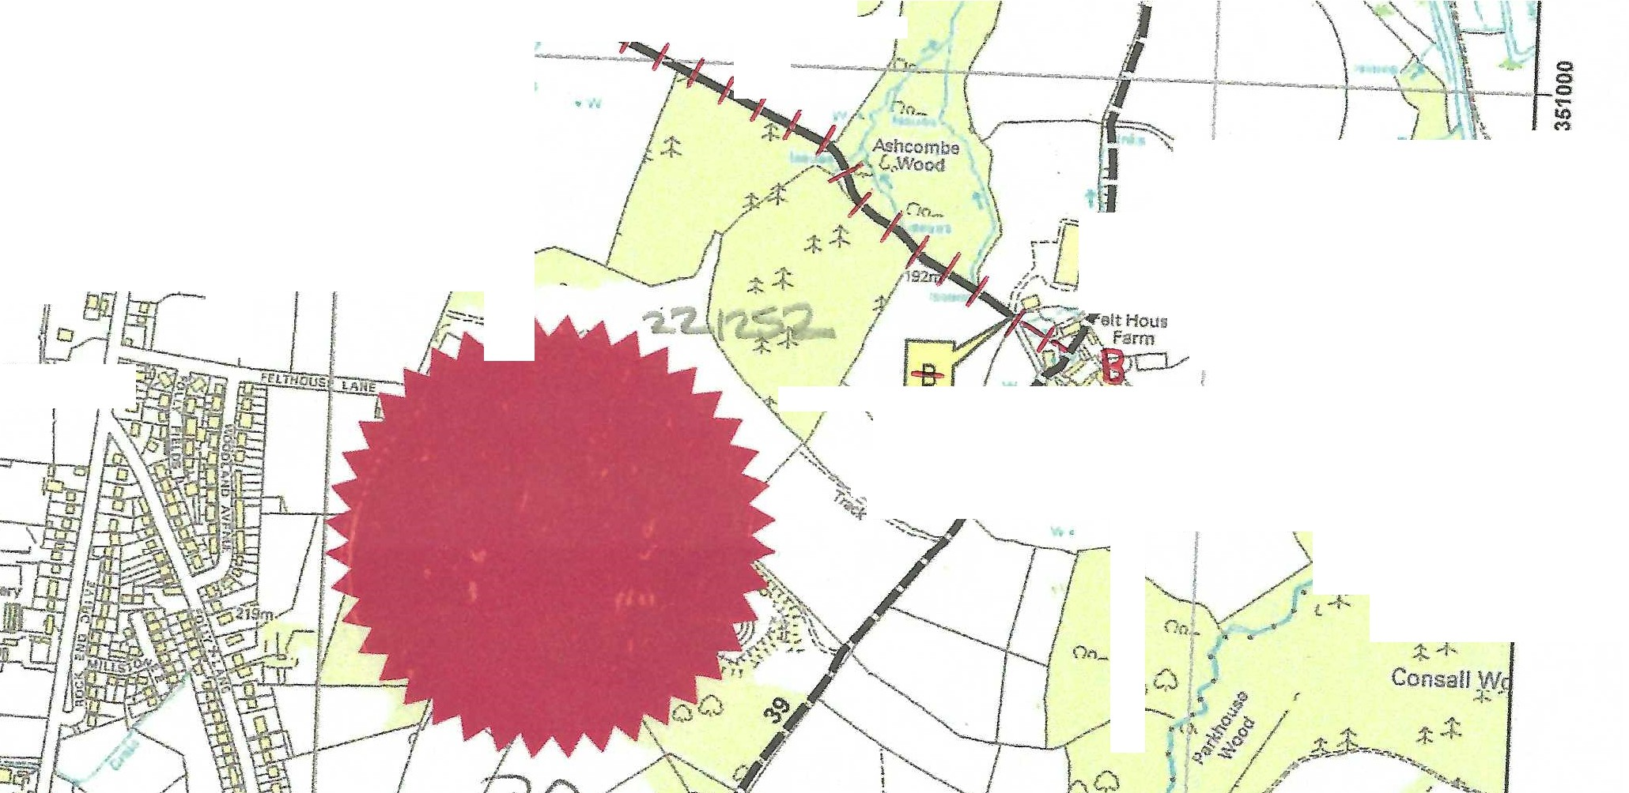
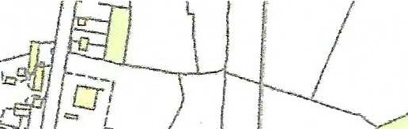
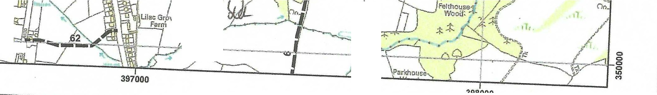

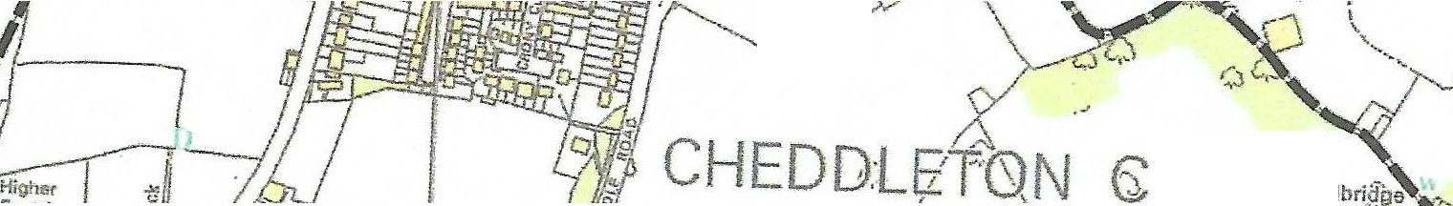
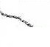


•'

----• .��c.\\e,\;-.>t'

397000
•

St • o· s ire
County Council

Public Feetfi)otR>-in the vicinity of Ashcombe Park, Cheddleton. Legal status of map - Order Map
Al
,.. �

r ;:/

r�lv!l�'

Cric�t
Ground

I l 6:Po

Basfordbrij!ge ''
Farm
i Migt1r;r Brund
0
•

Heath
Hou,--.
I A
\

0 Holly
.,,
0
0
- �
M
I}

,

Ashcombe Park/�

0 \.'.

0 . �

I
I

,;,.-.,.._ ...
- --=-;;JS_'' ·��

. "","'·,,-I·-�--' .. -- '.·'·,.,
1 ·. ;
. ..�.,.� L
- \
i.c
•
1 •. �!� , •
-..ji-- Cottage
---,
=CJI'
-I
,,.l . .
-.... r--.-...f'\ c.::_-
r � -...- ,...·
1 CJ \_ ' ..........., I
' "- J ,,,,_,,1�"� "'")-\
"-. Wcool,nd ,,· ,/ //; "
'-/ Hall'- ...-\ / )
/-;�\,,. 1 .,,. \, '\ " : -
�,/� . l ,..._J,.. •

• •
,,..
- ::j::_
-
t

Lilao Gro"ve""-.
,.
m Farni •
'
...


397000 398000

© Crown Copyright and database rights 2019.
•
•
Map created at the scale of 1:10,000 (facsimiles may vary)

Right of Way to be added ( A - B }

Rights of Way Unaffected
Ordnance Survey 100019422. You are not permitted to copy, sub-license, distribute or sell any of this data to third parties in any form.
Use of this data is subject to the terms and conditions shown at www.staffordshire.gov.uk/maps.
Produced by Staffordshire County Council, 11/12/2019.
File Reference LJ648G
----·

•

Footpath
- C38

