NOTICE OF ORDER

Highways Act 1980
Kent County Council
Wildlife & Countryside Act 1981. (Public Footpath ZR109 (part), Bobbing) Rail Crossing Diversion and DMMO 2024

Notice is hereby given that the above referenced Order has been submitted to the Secretary of State for Environment, Food and Rural Affairs for determination. An Inspector will be appointed by the Secretary of State to determine the Order.

The start date for the above Order is 7 August 2025

Consideration of the Order will take the form of a public local inquiry.

The Inquiry will be held at Bobbing Village Hall, Sheppey Way, Bobbing, Sittingbourne, Kent ME9 8PL on 14 January 2026 at 10.00am.

The effect of the Order, if confirmed without modifications, will be to divert the entire width of that length of public footpath numbered ZR109, which commences at its connection with public footpath ZR111 at NGR TQ 8864 6472 (point A) and runs south south-west across the railway for
14 metres to an unaffected length of public footpath ZR109 at NGR TQ 8863 6470 (point B), between the points A-B on the Order plan, and it will add a new length of public footpath numbered ZR109, with a width of 2.5 metres, which commences at the aforementioned point B and runs west north-west under the A249 road bridge for 71 metres to NGR TQ 8857 6473 (point D), then runs west, west north-west and west for 98 metres to NGR TQ 8847 6474 (point E), and then runs south-west for 13 metres to its connection with the Sheppey Way at NGR TQ 8846 6473 (point F), between the points B-C-D-E-F on the Order plan.

All directions general, all distances approximate.

Any queries relating to this Order should be referred to Joanne Reid by email: rightsofway2@planninginspectorate.gov.uk quoting reference number ROW/3347586 on all correspondence. Alternatively, queries may be sent in writing to The Planning Inspectorate, Rights of Way Section, Room 3/A Eagle Wing, Temple Quay House, 2 The Square, Temple Quay, Bristol, BS1 6PN. Telephone: 0303 444 5136.

Any person wishing to view the statements of case and other documents relating to this Order can do so online using the following link on the Kent County Council website: Let’s talk Kent.

Anyone wishing to view them should Register and then search for the case (e.g. Footpath ZR109 Bobbing). Alternatively, an appointment can be made to view the documents at the Kent History & Library Centre, James Whatman Way, Maidstone, Kent, ME14 1LQ by contacting Maria McLauchlan on 03000 413420, email: maria.mclauchlan:kent.gov.uk

Timetable for sending in statements of case and proofs of evidence

Within 8 weeks of the start date by [by 2 October 2025]

The Order Making Authority must ensure their statement of case is received by the Secretary of State. As soon as possible after the deadline, the Secretary of State will send a copy (excluding copies of any supporting documents - these will be available to view at the Authority’s offices) to everyone who has made an objection or representation and the applicant and any other person who has written to us in respect of the Order.

Within 14 weeks of the start date [by 13 November 2025]

Everyone who has made an objection or representation and anyone who wishes to give evidence at the Inquiry must ensure their statement of case is received by the Secretary of State. As soon as possible after the deadline, the Secretary of State will send full copies to the Authority. Copies will also be sent to the applicant, every person who has made an objection or representation and any other person who has written to us in respect of the Order (excluding copies of any supporting documents - these will be available to view at the Authority’s offices).

Within the same period the applicant (if applicable) must ensure their statement of case is received by the Secretary of State. As soon as possible after the deadline, the Secretary of State will send a full copy to the Authority. Copies will also be sent to everyone who has made an objection or representation and any other person who has written to us in respect of the Order (excluding copies of any supporting documents - these will be available to view at the Authority’s offices).

4 weeks before the date of the inquiry [by 17 December 2025]

The Authority, everyone who has made an objection or representation, the applicant (if applicable) and anyone who wishes to give evidence at the Inquiry must ensure their proof of evidence (together with any summary) is received by the Secretary of State. As soon as possible after the deadline, the Secretary of State will send copies of:

- the Authority’s proof of evidence to everyone who has made an objection or representation, the applicant and anyone who has submitted a statement of case (including copies of any supporting documents – although none should be submitted with a proof of evidence);

- the applicant’s proof of evidence to the Authority, everyone who has made an objection or representation and anyone else who has submitted a statement of case (including copies of any supporting documents – although none should be submitted with a proof of evidence); and

- all other proofs of evidence to the Authority, the applicant, everyone who has made an objection or representation and anyone else who has submitted a statement of case (including copies of any supporting documents – although none should not be submitted with a proof of evidence).

All parties must keep to the timetable set out above and ensure that statements of case and proofs of evidence are received by the Secretary of State on time. Late documents will be returned.

NOTE: If you use Artificial Intelligence (AI) to create or alter any part of your documents, information or data, you should tell us that you have done this when you provide the material to us. See the detailed guidance for further information.

We cannot accept any inflammatory, discriminatory or abusive comments. Any documents containing such comments will be returned.

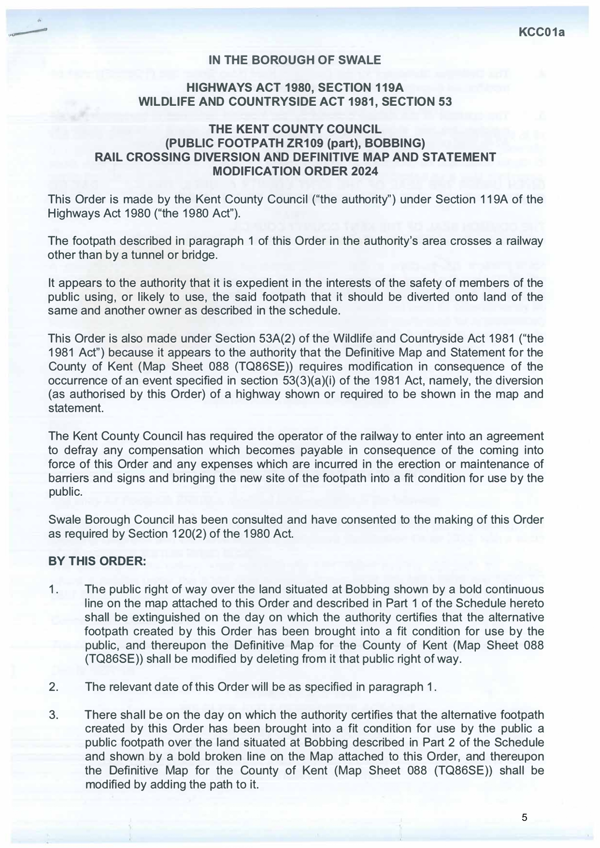

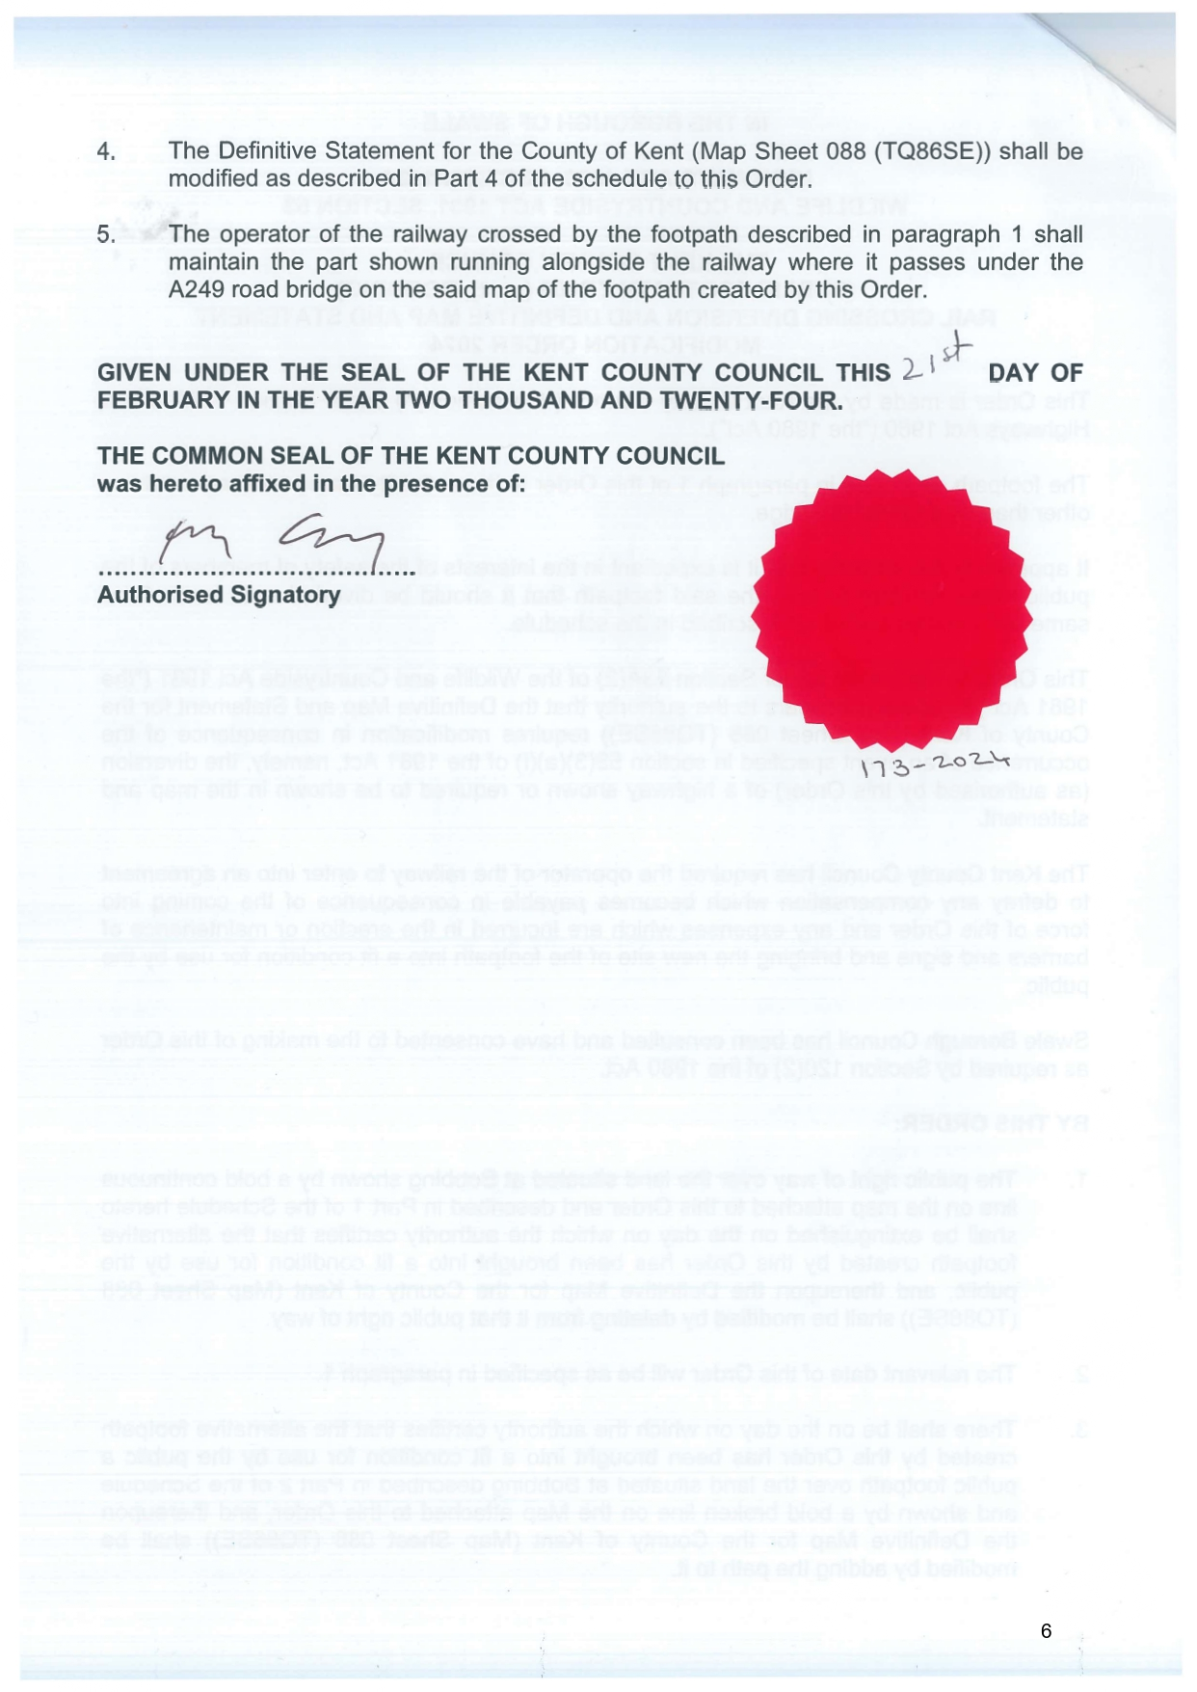

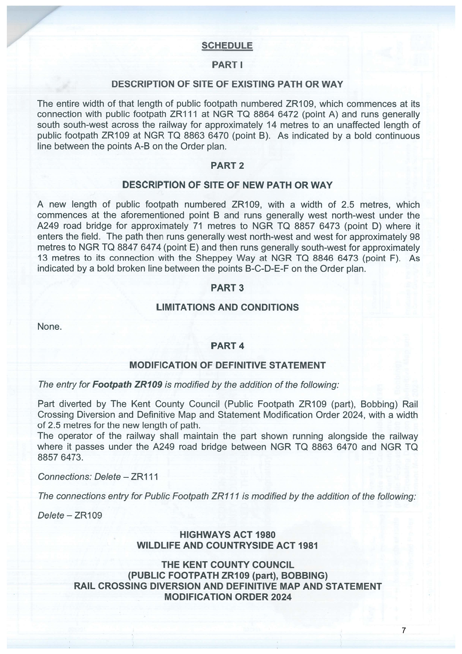

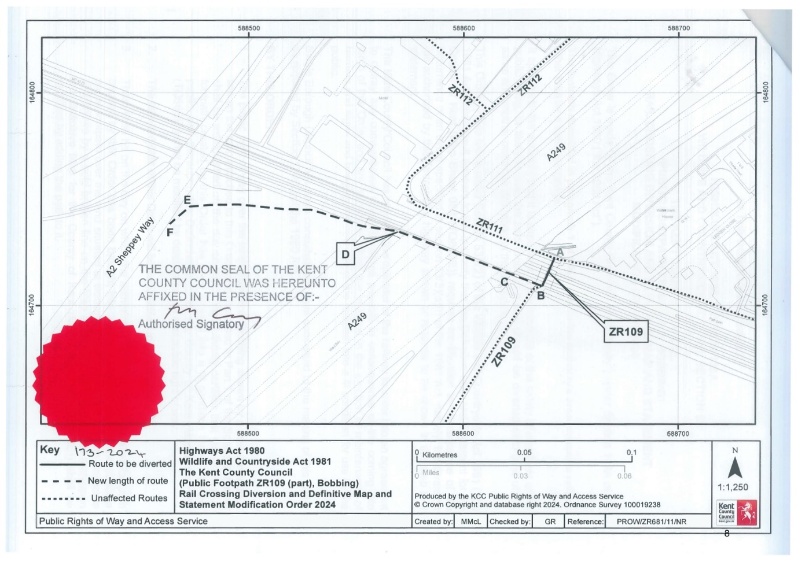

If you wish to make a legal submission, this should be submitted at the same time as your statement of case. Otherwise legal submissions will have to be submitted in writing on the day of the inquiry.

