Publication withdrawn

This guidance is out of date and was withdrawn in August 2025.

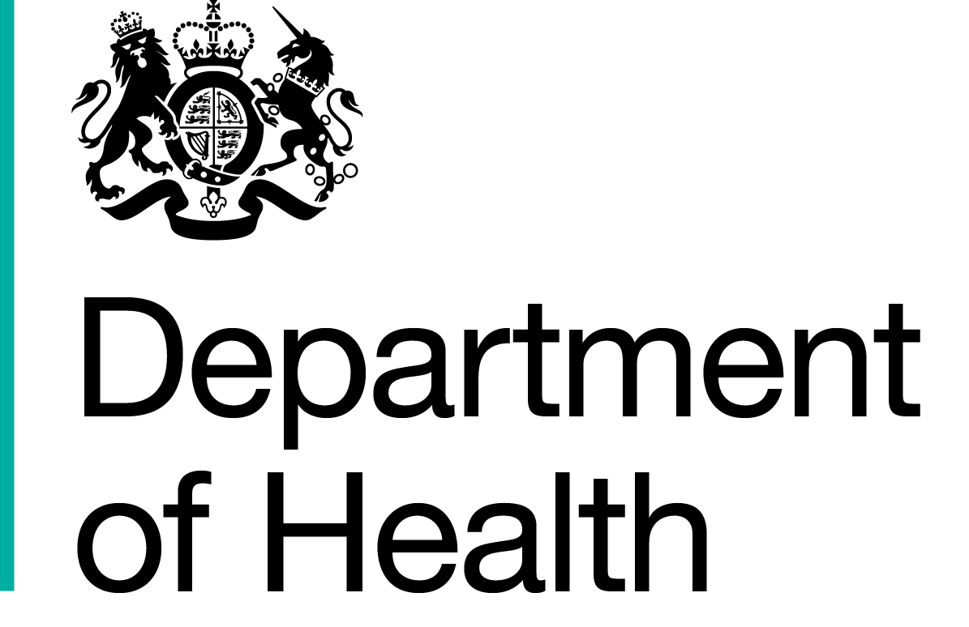

The Dementia Challenge

Making it the business of every nurse providing care and support to people with dementia and their carers

Dementia Self-Assessment Framework for all in-patient settings

July 2026

Self-Assessment for the Dementia Programme

Please return the completed form by: | 6 monthly
Please return to: | Director of Nursing/Head of Nursing/Care Setting Manager
Name of organisation
Contact details for person filling out the Dementia Assessment Framework | Name: | Title:
 | Email: | Telephone number:
Date returned to | Date:
This benchmarking tool is developed by nurses and care staff, working with people that have dementia to ensure implementation of the nursing contribution to the
6Cs and dementia pathway¹. By contributing to the dementia pathway we mean the nurses/care staff roles in increasing basic awareness, reducing stigma, assessment, diagnosis and ongoing support of people with dementia and carers through to end of life care.

The self-assessment framework can be used to baseline current position against best practice criteria, developing a shared action plan with staff group, then to re assess following implementation of action plans to demonstrate continuous improvement. It provides a self- assessment framework for health and social care staff, teams and the organisation to use in considering changes to improve practice and to develop a plan and to review progress around their involvement in dementia
care across the whole pathway. Plans may be developed by the team working in an area but will be supported by managers and the organisation.

This Dementia Self-Assessment Framework is not prescriptive and can be adapted according to the local requirements:
- Using the levels described below, please indicate on the form the level that best reflects the current position with an X in the box.
- Examples of evidence to support your decision both objective and subjective, should be provided, please embed at the end of the document.
- This self-assessment is not linear and you may move backwards and forwards through the levels over the next year along the implementation journey.
- This self-assessment is to help understand where you are and what you need to do over the coming year to further improve services.
- An additional benefit of the self-assessment is to share good practice and learning on a wider scale.

- Dementia Pathway - Making a Difference in Dementia: Nursing Vision and Strategy - Referred throughout document

Guide to ratings - Where your service is now – indications of current service provision

Level 0 – 0-25% progress  Not engaged with this area of work- very little work to date on the contribution to the 6Cs and across the dementia pathway.  - Lack of evidence of understanding and/or engagement at this stage.  - Not able to implement robust delivery, as waiting for external changes or agreements. | Level 1- 25-50% progress  More work needed on the 6Cs, the nursing contribution to the 6Cs and dementia pathway.  - Organisation/service reacts effectively to address priorities and risks.  - Evidence of improvements in processes in the system, specific dementia programmes and initiatives in place to develop the system and address issues, but these tend to be fragmented. | Level 2- 50-75% progress  Making significant progress, but more work needed on the 6Cs, the nursing contribution to the 6Cs and dementia pathway.  - Clear nursing /care strategy in place for developing the system and a dementia programme of support and assurance.  - Dementia local plans are in place but further work is being undertaken to coordinate strategically.  - Regular assurance is being sought and forward progress is being made on delivery plans. Robust processes in place demonstrating tangible results. (plus level 1) | Level 3 – 75-100% progress  Nurses/care staff involve themselves in dementia care across the whole pathway. From increasing basic awareness and reducing social stigma and lack of knowledge to ensuring best care for people with dementia and families at the end of their lives and enabling, if not providing, on-going support to families. No further action needed.  - Fully embedded assurance systems & development programmes to demonstrated improved outcomes that are regularly evidenced; strategy & plans constantly evolving; disseminates lessons learnt/best practice and checks understanding and adoption.  - Risks are not impacting on service delivery as they are being pro-actively managed through the dementia action plans. (plus level 1 & 2)

Making this happen within dementia care (all health and care settings) nurses/senior care staff need to take the lead in these 6 areas and embedded throughout is Leadership, Ownership, Partnerships
Please embed any evidence in the table at the end of this framework
Level of Delivery - Team/Practice/Ward/Care Setting/Area | Level of compliance/ baseline score |  |  |  |  | Description of progress and evidence to support implementation. | Outline the barriers that have stopped you from moving towards implementation of the nursing contribution, 6Cs and Dementia pathway. | List the elements that you need to progress to overcome these barriers and what needs to be undertaken by your Team/Practice/Ward/ Care Setting/Area
Level of Delivery - Team/Practice/Ward/Care Setting/Area | 0 | 1 |  | 2 | 3
- Maximising health and wellbeing. Helping people to stay independent

- The Team/Practice/Ward/Care Setting/Area has an identified/named lead (and deputy) for dementia:
- Lead is known to all staff.
- All staff are able to liaise with the lead.
- Lead is available to patients and carers.
- Their name is visible to staff and visitors/families (e.g. in the ward welcome pack; and displayed on visitor noticeboards or in patient leaflets).

- The Team/Practice/Ward/Care Setting/Area unit provides dementia training to all relevant staff:
- Staff aware of the dementia pathway.
- Staff aware of their contribution to the 6C’s.
- Evidence of access to and completion of e-learning modules or other training
- Evidence on the uptake of training by all relevant staff

- Systems are in place for all nurses and care staff to ask family and/or friends during an admission, if the person has had any problems with their memory in the last 12 months:
- Evidence of this question being asked e.g. at admission meetings, initial visits from family and friends, evidence of people with suspected dementia referred to a memory assessment service specialising in the diagnosis and initial management of dementia.

- There is evidence of a good quality dementia care package that includes:
- A holistic multi-disciplinary assessment.
- Personalised care plans based on knowledge of the person's life history, that seek to maintain independence and offer meaningful activities.
- Effective communication throughout.
- The process puts the person at the centre and seeks to involve them and their family/care at all stages.
- If required, supports a smooth transition to other settings.
- If required - start effective, multi-disciplinary discharge planning on admission.

- Working with people to provide a positive experience

- There is evidence that nurses/care staff know the characteristics of dementia.

- There is evidence of person centred planning and using a relationship centred approach to working with people with dementia.

- Strengthened partnership working across health and social care. Working in partnership to ensure effective communication between primary and secondary care to improve discharge planning, including GPs, voluntary and independent sectors to co-ordinate care around the person with dementia needs and their carers.

- Developed systems to obtain and measure impact of service delivery through patient and carer feedback:
- Evidence of audit changes resulting from feedback.

- Carer’s strategy in place that provides carers with a holistic assessment and information and advice.

- Uses the carer as a resource for understanding the person with dementia.

- Carers’ views are sought throughout the assessment and treatment process and acted on where necessary.

- Carers are regularly updated and involved in care plans, treatment and discharge planning.

- There is evidence of the organisation’s zero tolerance of inequality which supports Staff to not accept discrimination of any kind, e.g. age, gender, cultural background, cognitive ability etc:
- Organisational policy/guidelines in place.

Level of Delivery - Team/Practice/Ward/ Care Setting/Area | Level of compliance/ baseline score |  |  |  |  | Description of progress and evidence to support implementation. | Outline the barriers that have stopped you from moving towards implementation of the nursing contribution, 6 Cs and Dementia pathway. | List the elements that you need to progress to overcome these barriers and what needs to be undertaken by your Team/Practice/Ward/ Care Setting/Area
Level of Delivery - Team/Practice/Ward/ Care Setting/Area | 0 | 1 |  | 2 | 3
- Delivering care and measuring impact
- Developing a culture of compassionate care:
- The 6Cs for dementia nursing, values and behaviours are understood by all staff and embedded in nursing and care practice.
- There is evidence of education and training in key evidence based aspects of dementia care.
- Patient satisfaction surveys and representative group’s feedback are acted upon.

- Commissioners and their providers are:
- Working together to incorporate the long-term strategies of the dementia pathway within robust service specifications.
- Where appropriate, using professional expertise and business acumen to:
- Influence and direct dementia commissioning plans.
- Utilise population and robust public health data, local demographics, service user/carer experience to inform Joint Strategic Needs Assessment and local area agreements.
- Use an evidence base to report outcomes.
- Identify and measure harm as a way of quality improvement.
- Benchmark dementia care quarterly to measure effectiveness.
- Patient satisfaction surveys/PALS contributions and complaints reflections.

- Building and strengthening leadership
- Support the team in improving and reshaping care, using creative approaches to service provision, to improve choice, personalisation, efficiency and effectiveness.

- Empowering the team through Role
Modelling good practice and providing supervision.

- Using professional expertise and business acumen to:
- Influence and direct dementia commissioning plans.
- Utilise population and robust public health data, local demographics, service user/carer experience to inform Joint Strategic Needs Assessment and local area agreements.
- Use an evidence base to report outcomes.
- Identify and measure harm as a way of quality improvement.
- Benchmark dementia care quarterly to measure effectiveness.
- Patient satisfaction surveys/PALS contributions and complaints reflections.

5. Ensuring we have the right staff, with the right skills and attributes in the right place
- All staff have received training in dementia care as considered appropriate for their role.
or
There is a plan in place for all staff to receive training as considered appropriate for their role, which is consistent with the Dementia Nursing Vision and Strategy (see link at page 2)

- Providing access to clinical supervision for all nurses/care staff:

- Clinical dementia specialists/leads are available to offer expert advice, and support to other staff in meeting the complex needs of people with dementia.

- Ensure robust systems are in place to safeguard vulnerable adults:
- Ensure the current workforce receives appropriate, on-going, up to date training to ensure they are fully conversant with safeguarding arrangements across organisations and contributes to development and audit to ensure systems are effective.
- Works within the NMC Codes of Conduct, Discrimination Acts and Mental Capacity Act as applicable.

- Utilising workforce/service planning tools to determine the appropriate skill mix and ensure adequate staffing levels to meet the needs of people with dementia.

To refer and delegate within the team to maximise resources and utilise expertise of other skilled professionals.

- Contributing as part of a multi-agency team, to support individuals and families /carers for those with dementia and complex needs.

- The right information and advice is provided at the right time and that the right support is put in place for people with dementia, their carers, public and professionals to ensure an integrated approach and help to navigate through the system.

- Nursing and care staff have received training in end of life care and/or can access specialist advice to ensure that people with dementia receive high quality care at the end of their lives at any time of the day or night, regardless of the setting.

6. Supporting positive staff experience
- Staff that are skilled and have time to
Care:
- Media reports
- CQC reports
- Professional concerns – staff focus groups
- Staff appraisal
- Acts and legislations
- Provide clinical supervision

- Developing leaders of the future by providing excellent practice placements:
- student placement feedback

- Growing and supporting the workforce through:
- Appropriate mentorship
- Preceptorship
- Enabling access to the E-learning for healthcare models on Dementia
- Providing opportunities for feedback and acting on this

- Creating opportunities in supporting teams to be pro-active; more structured and supported to provide a dementia friendly environment.

Additional Comments:

Appendix 1

- Please list any documents that your organisation has created and that you feel may be useful to others as a point of reference.
- Please include case studies, tools, guidance and reports.
- The Dementia Team at the Department of Health wish to set up a national sharing and learning network and this information will help contribute to this.

Name: | Title:
Email: | Phone:
Document Name | Description, purpose and proposed benefits | Embedded document

Acknowledgements
This framework has been developed in partnership with a range of stakeholders across the NHS and other organisations. Thanks are extended to all contributors, specifically the following:

Task and Finish Group Members
Lesley Benham  Manager of Dementia Services,  Melcombe Community Hospital | Ben Bowers  Queen’s Nurse,  Professional Lead Community Nursing  (Honorary),  Hertfordshire Community NHS Trust | George Coxon  Director/Owner  Classic Care Homes Ltd/Pottles Court  & Summercourt and MHNA Chair | Maya Desai  Policy Advisor,  The Queen’s Nursing Institute | Aileen Fraser  Consultant Nurse Older People and Safeguarding Adults/NLC Clinical Fellow,  Bristol Community Health
Karen Harrison Dening  Head of Admiral Nursing (Interim) & Practice Development Lead,  Dementia UK | Patricia Higgins  Memory Service Nurse Specialist,  Oxleas NHS Foundation Trust,  Bromley | Marie Hudson  Queen’s Nurse,  Advanced Community Nurse | Vicki Leah  Nurse Consultant for Older People, University College London Hospitals | Sally-Ann Marciano  Carer
Obi Amadi  Professional Officer  Unite the Union (health sector) | Charlotte Nutting  Learning Disability Practitioner,  Enable Care and Home Support | Elizabeth Parker  Carer | Rebecca Sidwell  Project Manager,  National Dementia Strategy Implementation,  Department of Health | Vanessa Smith  Head of Nursing,  Quality and Assurance/Mental Health of Older Adults and Dementia CAG,  South London and Maudsley NHS Foundation Trust
Deborah Sturdy  Director of Care,  Red & Yellow Care | Ben Thomas  Professional Officer,  Mental Health Learning Disabilities  Department of Health | Rachel Thompson  Dementia Lead,  Royal College of Nursing | Robert Tunmore  Nursing Officer – Communications  Department of Health | Christine Webb  Modern Matron, Older People’s Mental Health, RDASH  & Unite/Mental Health Nurses Association Organising Professional Committee Member
Sarah Whittle  Dementia Strategy and CQUIN Manager,  Bristol Community Health | Sue Williams  Queens nurse , Community Dementia Nurse , 2gether foundation Trust for Gloucestershire NHS
Secretariat  Pauline Watts  Professional Officer for Health Visiting,  Department of Health | Sue Hatton  Workforce Directorate,  Department of Health | Judy Walker  Health Visitor Programme,  Department of Health

