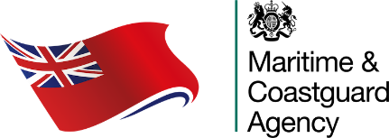 | Extended Dry Docking Company Annual Survey Declaration | MSF 6571  Version  1.0
Vessel Name

When completing this form, please refer to MGN 672(M) as amended and notes section, as required.

When completed, please return to MCA Customer Services Manager and hqsurvey@mcga.gov.uk.

A.1 SHIP IDENTIFICATION AND GENERAL DATA
IMO No. |  | Official No.
Type of vessel | Please Select | Keel laying date | Click or tap to enter a date.
UK Class | Please Select | Recognised Organisation (for SAFCON) | Please Select
Gross Tonnage |  | SAFCON Renewal Date | Click or tap to enter a date.
Date of last bottom inspection (indicate whether IWS) | Click or tap to enter a date.
Annual survey completion date | Click or tap to enter a date.

A.2 IN WATER SURVEY ITEMS
Stern Tube Oil Analysis remains within limits: (% water content to be submitted)
Bow Thrust Oil Analysis remains within limits: (% water content to be submitted)
Confirmation from Master that no groundings have occurred since last annual survey
Details of any Conditions of Class imposed, revised and deleted since last annual survey (Note 1)
Confirmation that Impressed Current Cathodic Protection where fitted continues to operate satisfactorily

A.3 RO DECLARATION
Recognised Organisation Office
Name of Surveyor |  | Date | Click or tap to enter a date.
Email |  | Signature

Notes:

- Copy of print out from Recognised Organisation’s computer system i.e. Bureau Veritas Veristar or LR Class Direct live will be acceptable.

Your Information
We collect personal information about you to carry out our official duty and to keep the UK ship register up to date and to make sure our services are planned to meet ship owner’s needs.

For more information on how we use your information please see our full privacy policy available on our website https://www.gov.uk/government/organisations/maritime-and-coastguard-agency.

