Annex 1
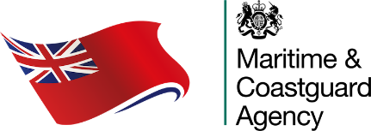 | Extended Dry Docking Planning Document | Version  1.0
Vessel Name

When completing this form, please refer to MGN 672(M) as amended and notes section, as required.

When completed, please return to MCA Customer Services Manager and hqsurvey@mcga.gov.uk as soon as possible within the survey window
A.1 SHIP IDENTIFICATION AND GENERAL DATA
IMO No. |  | Official No.
Type of vessel | Please Select | Keel laying date | Click or tap to enter a date.
UK Class | Please Select | Recognised Organisation (for SAFCON) | Please Select
Gross Tonnage |  | SAFCON Renewal Date | Click or tap to enter a date.
Date of last bottom inspection (indicate whether IWS) |  | Click or tap to enter a date.
Annual survey range dates

A.2 IN WATER SURVEY DETAILS
Planned approved location for IWS |  | Planned date of IWS |  | Click or tap to enter a date.
Confirmation that Company have identified a suitable dry dock which can accommodate the ship within a month if an unsatisfactory outcome from IWS
Location |  |  | Confirmation

A.3 COMPANY DECLARATION
Company Name & Position
Email contact |  | Date of application | Click or tap to enter a date.
Telephone |  | Signature

Notes:
- It is anticipated that the dry dock availability and location may not have been confirmed until nearer the time of the IWS so may be submitted later by email.
- The MCA reserves the right to attend with the Recognised Organisations for the 7 /12 year and 15 year docking surveys as part of it’s policy of monitoring Recognised Organisations undertaking statutory surveys on it’s behalf.

Your Information
We collect personal information about you to carry out our official duty and to keep the UK ship register up to date and to make sure our services are planned to meet ship owner’s needs.
For more information on how we use your information please see our full privacy policy available on our website https://www.gov.uk/government/organisations/maritime-and-coastguard-agency.

