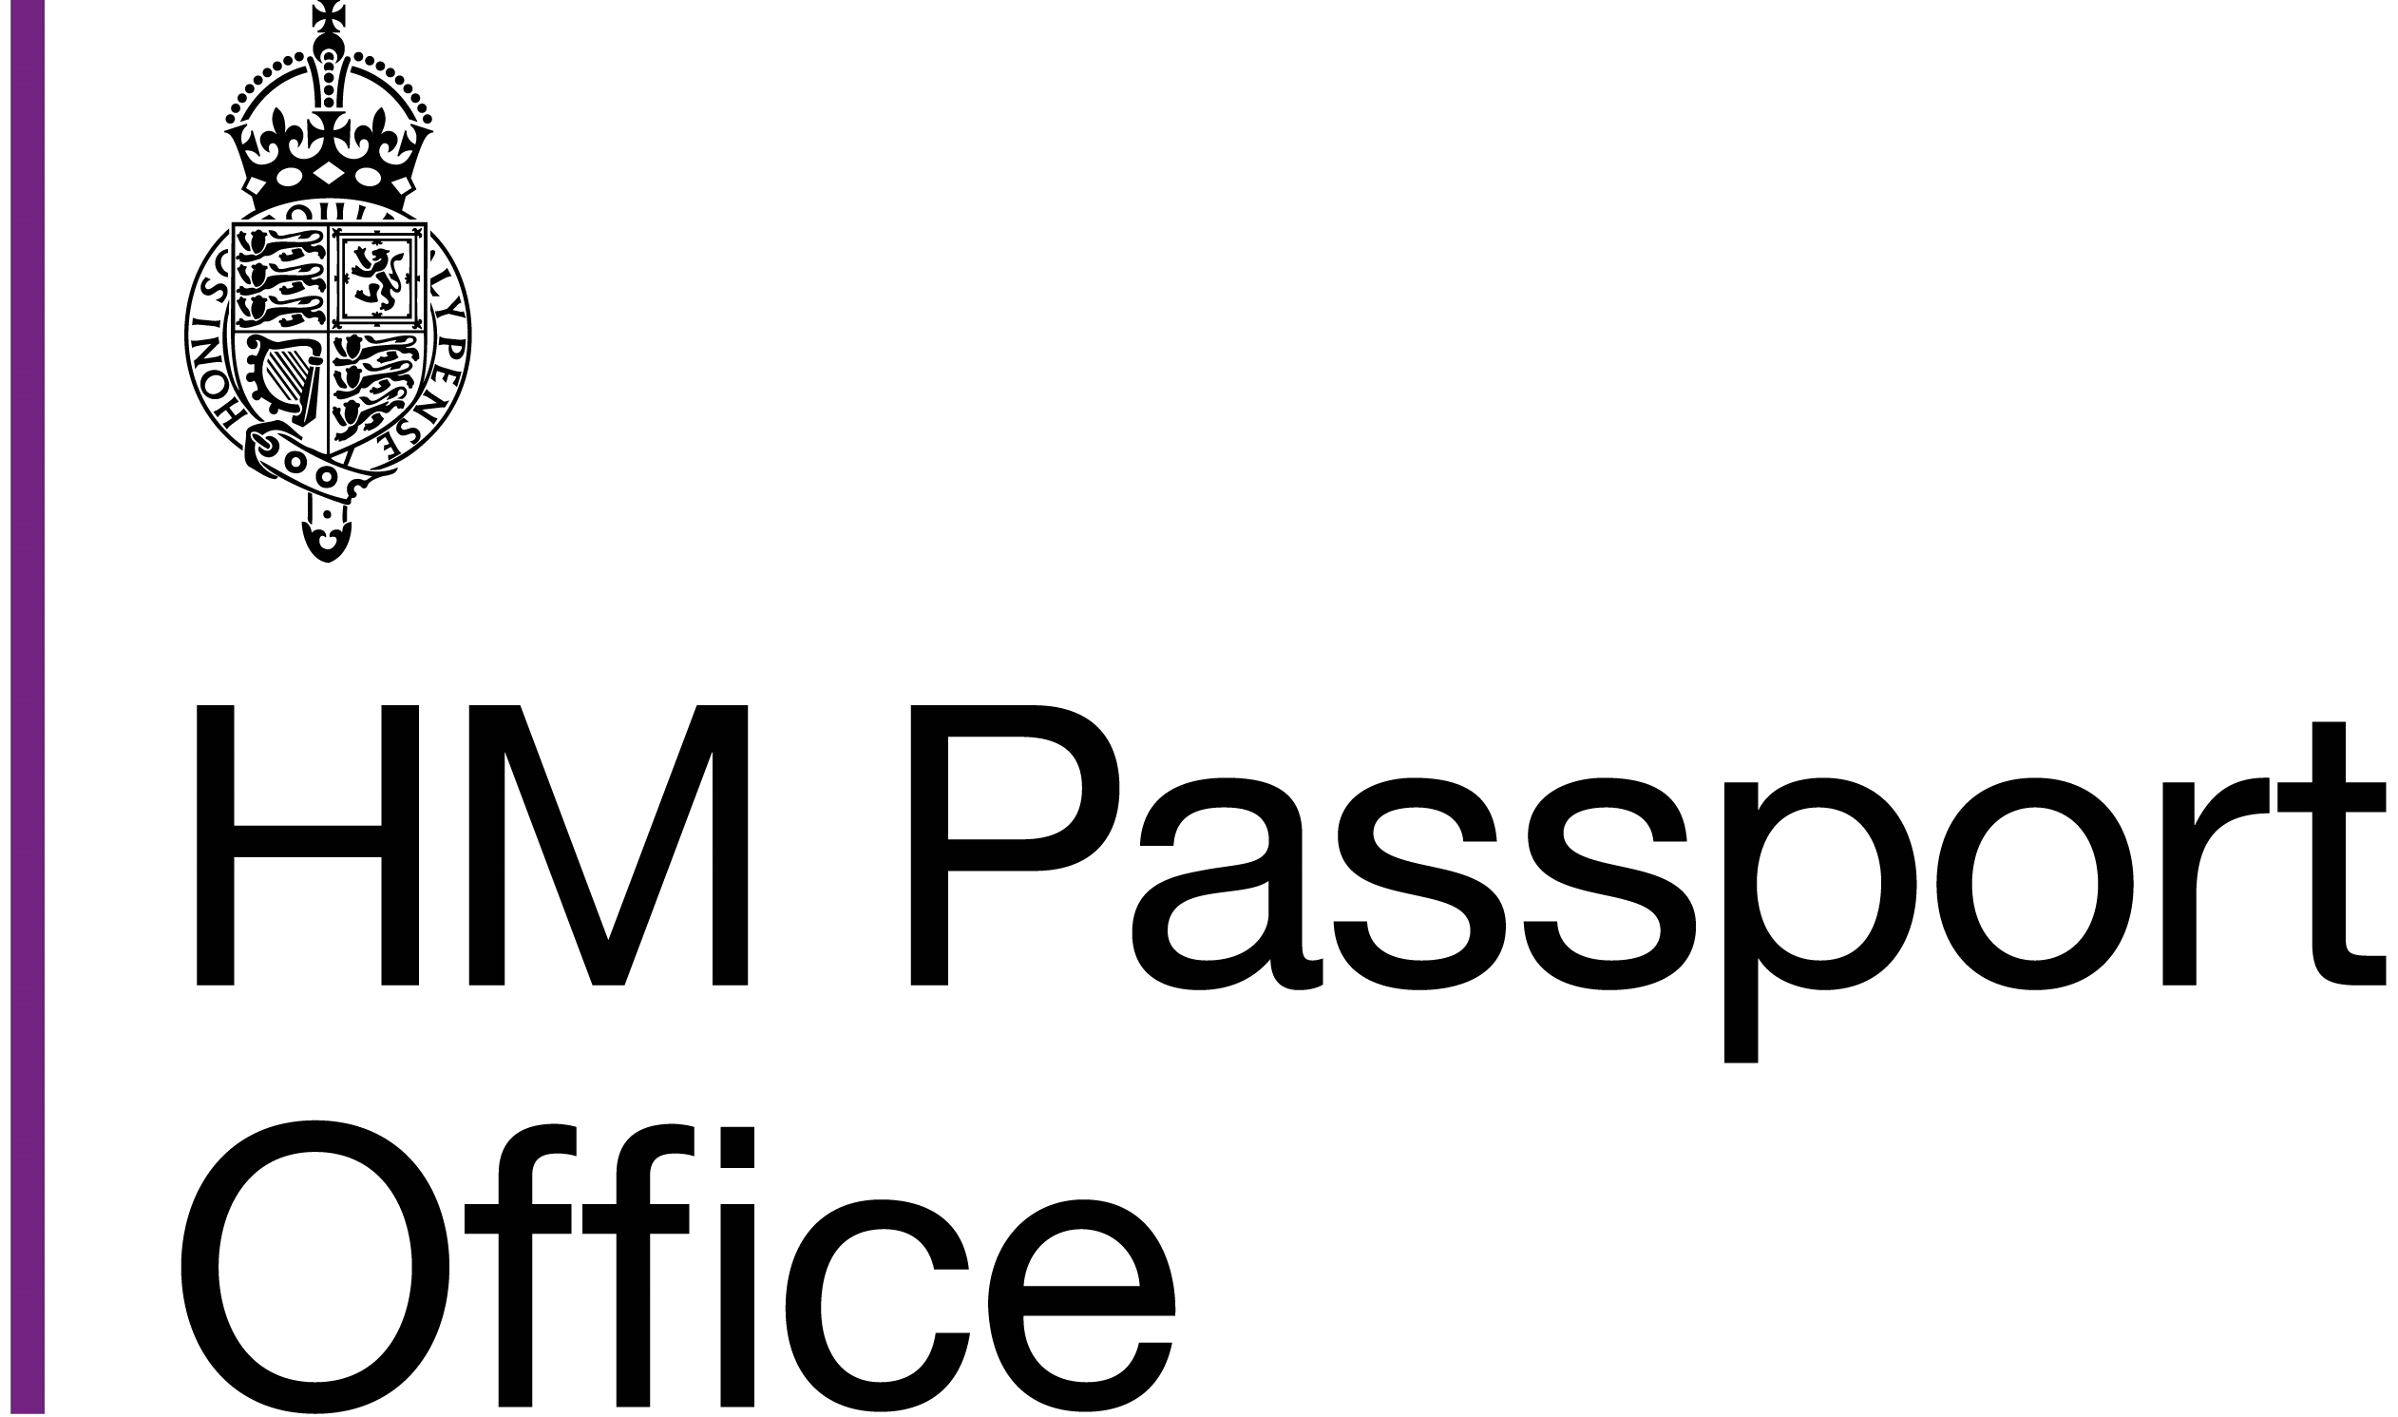 General Register Office
Application form to correct the details on a

Birth Registration
Before completing this form please read: 'How to apply for a correction to a birth registration'
This can be obtained from your local register office or at www.gov.uk
The application should be made by the mother and the father/2nd parent (if their details are included on the certificate). If you are applying for a correction to your own birth certificate we will need a letter from the person(s) who originally registered the birth agreeing to the correction.
There is a statutory fee for each application. If the application does not need to be referred to the General Register Office (GRO) the fee will be £83.00. Any application requiring referral to GRO the fee will be £99.00.
This is a consideration fee and, as such, is not refundable. The fee must be paid at the point of application.
1.1 Applicant's details:
Title
Forenames
Surname
Current address

Telephone no.

Email
We may need to contact you, how would you prefer to be contacted? Please tick one.
E-mail Telephone Post
Your relationship to the child named on the certificate
1.2 Child's details as stated on birth certificate:
Forenames
BC2 March 2025
Surname
Date of birth

2.0 Details of the error(s) and the correction(s) to be made to the birth registration. Please clearly explain in the boxes below what is wrong and what the correct details are:
2.1 Error as it is shown on the certificate 2.2 The correct details to be shown
2.3 Please give as full an explanation as possible of how the error occurred:
Yes
2.4
Please confirm that you have checked the birth certificate and that all
errors have been identified and noted above.
3.0 Before the correction can be authorised you will need to provide evidence that an error has been made.
You need to show that the information originally given at the time of the registration was wrong.
You will have to produce document(s) that clearly show what the correct information should be. These documents should be valid or dated around the time of the birth.
It is not possible to list every example of acceptable evidence, but it should be an official document which shows the correct information. Examples will include:
passport identity card  photocard driving licence letter from a government department bank/building society statement | utility bill  credit card statement letter from a hospital/doctor  certificate of 1st marriage (for correction to maiden name)
Please do not send in original documents or photographs of original documents; we will accept photocopies which have been certified by a professional or reputable person as a true copy of the original. A list giving examples of suitable persons can be found at: https://www.gov.uk/countersigning-passport-applications
BC2 March 2025
If you are taking the application to a Register Office and paying in person then the Register Office should be able to certify your documents as a true copy of the original which means you can retain your original documentation.
If you cannot send any evidence that an error has occurred your application will not result in a correction. Further advice can be obtained by calling 0300 123 1837

4.0 The correction:
The original information will always be shown as it was first given, but a note will be written against the registration. This will explain what the correct information should be and the date when the correction was made. All full birth certificates issued afterwards will include the note in the margin. There is no legal requirement to witness the correction.
4.1 Declaration:
I confirm that I understand the correction will be made in my absence and the correction will take the form of a note in the margin.
Applicant: Date:

5.0 Please include any further information which you think maybe relevant to your application.

6.0 If the correction is to the child's name and both parents are named on the certificate, they must both sign the declaration below.
Contact details of mother and father/2nd parent if not given overleaf
6.1 Mother's details:
Title
Forenames
Surname
BC2 March 2025

Current address

Telephone no.
Email

Details not known
6.2 Father's/2nd Parent's details:
Title
Forenames
Surname
Current address
(if different
from above)

Telephone no.
Email

Details not known
I declare that the information supplied is I declare that the information supplied is true to the best of my knowledge and belief true to the best of my knowledge and belief and that the evidence enclosed is a true and that the evidence enclosed is a true copy of the original documentation copy of the original documentation Mother's Signature: Father's/ 2nd Parent's Signature:
Date: | Date:

7.0 Checklist
7.1 I have filled in all sections of the form Yes
7.2 I have included a certified copy of the birth certificate that needs
Yes correcting
BC2 March 2025
7.3
I have enclosed document(s) that show the correct information
Yes
7.4
I have read the guidance leaflet: 'How to apply for a correction to
a birth registration'
Yes
Please take or send your application form and documentary evidence to the register office for the area where the birth was registered. You can ring GRO on 0300 123 1837 who can also confirm where your application needs to be sent.
The local register office will be able to advise you on which fee will apply for consideration of the correction.
For the purpose of detecting and preventing crime, information relating to an application may be passed and verified with other government departments or law enforcement agencies
Fair Processing Notice
By completing this form you agree to the General Register Office contacting you in relation to your application as well as to ask if you are satisfied with our services.
The General Register Office is part of His Majesty's Passport Office. March 2025

