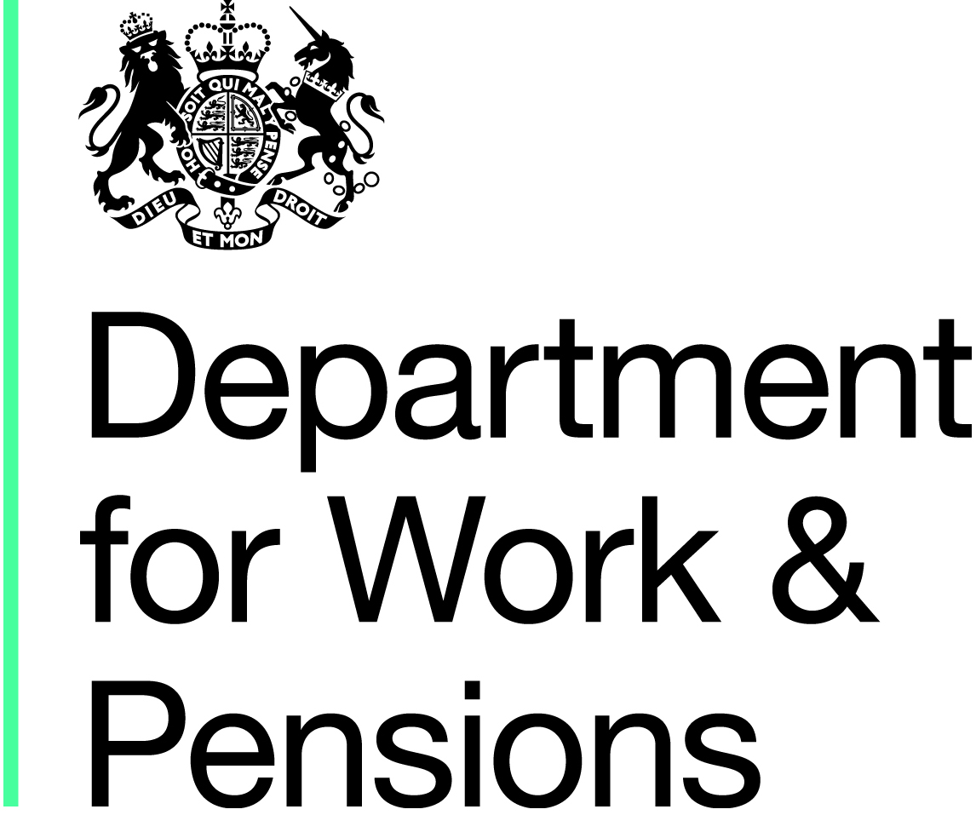

Withdrawn

This publication has been withdrawn

This publication is no longer current and is not being updated. It is published here for reference only.

Annex B

CUSTOMER CONSENT FORM

Access to Work Mental Health Support Service (AtW MHSS) - consent to share information.
[Name of Provider] is working with Access to Work MHSS customers on behalf of the Department for Work and Pensions (DWP) to provide support for customers experiencing mental health conditions and issues within the workplace.
Consent for [Name of Provider] to Contact your Employer (Stage 1)
If you consent, [Name of Provider] will engage with your employer where appropriate and offer employer education. The education provided could include, but is not limited to:
- advice and guidance for employers on how to support employees who have a mental health condition, or issue help to resolve practical and organisation factors related to the work environment that may be contributing to the customer’s mental health issues
- awareness session for the employer and/or colleagues on mental health conditions in the workplace
- employer toolkit
- signposting to the other useful tools, including self-help tools
- job analysis, including temporary adjustment that could support people with mental health conditions or issues
- first aid training for mental health conditions or issues.

Consent for DWP to Contact your Employer (Stage 2)
[Name of Provider] may claim a payment from DWP for every Access to Work customer who remains in work whilst being supported by [Name of Provider].
To validate these claims, DWP may need to confirm details of your employment. Where appropriate, this may involve confirming details with your employer(s).
DWP may contact your employer(s) using your name and national insurance number to confirm details of your employment. To achieve this, DWP requests your consent to share information about you with your employer(s) as follows;
- The date you began each period of your employment;
- Whether your employment is continuing;
- If not continuing, the date each period of your employment ended;
- whether you were employed during a specific period;
- the number of hours you worked each week;
Customer Declaration

Participant name…………………………………………. (Please print name in full)

Please note: you will still receive full support under the AtW MHSS if you choose to withhold your consent for your employer to be contacted.

I give/do not give (delete as appropriate) consent for [Name of Provider] to engage with my employer as described in stage 1 above.
I give/do not give (delete as appropriate) consent for DWP to contact my employer and share information as described in stage 2 above.
I confirm that:
I have read the information above and understand why this information sharing is requested and how this information will be used.
I understand that:
I can change my declaration at any time by writing to [Name of Provider]

Signature …………………………………….
Date………………………………

