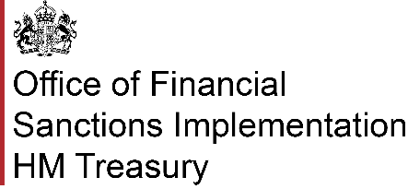

# **Report frozen asset**

**Before Submission:**

Please ensure you have downloaded the Excel element of [this form](https://assets.publishing.service.gov.uk/media/6878a4b1a52cca025ef5bd6f/Reporting_Frozen_Assets_Excel.xlsx).

You will be asked to upload the completed Excel document at the end of the online form.

**Using the form:**

This form should be used to report that you have frozen the assets of a designated person. Please complete a separate form for each designated person whose assets you have frozen.

If you know or suspect that a person is a designated person, [please complete a suspected designated person report.](https://submit.forms.service.gov.uk/form/5371/report-a-suspected-designated-person) If you are also reporting a suspected breach of financial sanctions, please [complete a suspected breach report.](https://submit.forms.service.gov.uk/form/6158/financial-sanctions-suspected-breach-reporting-form)

**1. Please provide your full name**

|  |
| --- |
|  |

**2. Please provide your job title**

|  |
| --- |
|  |

**3. Please provide the name of your company or organisation**

|  |
| --- |
|  |

**4. Which country are you or your organisation based in?**

|  |
| --- |
|  |

**5. Please provide the address of the company or organisation**

|  |
| --- |
|  |

**6. Please provide a contact number**

|  |
| --- |
|  |

**7. Please provide an email address**

|  |
| --- |
|  |

**8. Please provide the Designated Persons OFSI Group ID**

Please indicate the Group ID of Designated Person (DP) involved in the transaction. The DP's name and five digit Group ID number can be found on the UK [Consolidated List.](https://www.gov.uk/government/publications/financial-sanctions-consolidated-list-of-targets)

|  |
| --- |
|  |

**9. Please provide the name of the designated person**

|  |
| --- |
|  |

**10. Are you reporting on behalf of a person or entity, owned or controlled by a designated person?**

If Yes, please fill out the details of the person or entity on the excel sheet.

Yes

No

**11. Please specify the sanction regime**

Please select the regime the designated person is listed under.

Afghanistan

Belarus

Bosnia and Herzegovina

Central African Republic

Chemical weapons

Cyber

Democratic People’s Republic of Korea

Democratic Republic of the Congo

Global Anti-Corruption

Global Human Rights

Guinea

Republic of Guinea-Bissau

Haiti

Iran

Iran relating to nuclear weapons

Iraq

Lebanon (Assassination of Rafiq Hariri and others)

Libya

Mali

Myanmar

Nicaragua

Russia

Somalia

South Sudan

Sudan

Syria

Unauthorised Drilling Activities

Venezuela

Yemen

Zimbabwe

Or

None of the above

**12. Please upload the completed Excel document**