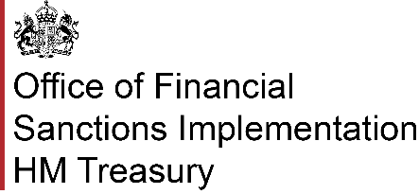

**Complying with the exception: "Investments in relation to Russia"**

**1. What is your name?**

|  |
| --- |
|  |

**2. What is the name of your organisation?**

|  |
| --- |
|  |

**3. What is your address?**

|  |
| --- |
|  |

**4. What is your phone number?**

|  |
| --- |
|  |

**5. What is your email address?**

|  |
| --- |
|  |

**6. Required information**

For more context on this exception, please refer to ‘7. Investments in Russia’ in OFSI’s [Financial sanctions guidance for Russia](https://www.gov.uk/government/publications/financial-sanctions-guidance-for-russia/financial-sanctions-guidance-for-russia#investments-in-relation-to-crimea).

OFSI expects you to include the following information in your compliance notification:

1. Full name of “P”

2. The date that the contract was concluded;

3. Details of what “act” P is doing which would otherwise contravene regulation 18;

4. Confirmation of what obligation under the contract is being satisfied by P in undertaking that act.

|  |
| --- |
|  |