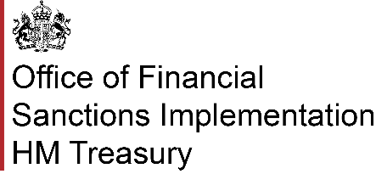

**Complying with the exception: "Exception for required payments"**

**1. What is your name?**

|  |
| --- |
|  |

**2. What is the name of your organisation?**

|  |
| --- |
|  |

**3. What is your address?**

|  |
| --- |
|  |

**4. What is your phone number?**

|  |
| --- |
|  |

**5. What is your email address?**

|  |
| --- |
|  |

**6. Required information**

For more context on this exception, please refer to ‘Regulatory Payments Exception’ in OFSI’s [UK Financial Sanctions FAQs](https://www.gov.uk/government/publications/uk-financial-sanctions-faqs/uk-financial-sanctions-faqs#regulatory-payments-exception).

OFSI expects you to include the following information in your compliance notification:

1. The UK DP (including the Consolidated List Group ID);

2. The type(s) of required payment made or, in the case of a reimbursement payment, the type(s) of required payment to which the reimbursement payment relates;

3. The amount(s) paid or, in the case of a reimbursement payment, received;

4. The date on which the funds were paid or, in the case of a reimbursement payment, received.

|  |
| --- |
|  |