NOTICE OF ORDER
Town and Country Planning Act 1990
West Northamptonshire Council

PUBLIC BRIDLEWAY STOPPING UP ORDER 2024 (PUBLIC BRIDLEWAY SB32 IN THE PARISH OF TOWCESTER (PART BETWEEN TIFFIELD
ROAD AND THE A43))

Notice is hereby given that the above referenced Order has been submitted to the Secretary of State for Environment, Food and Rural Affairs for determination. An Inspector will be appointed by the Secretary of State to determine the Order.
The start date for the above Order is 10 JUNE 2025.

Consideration of the Order will take the form of a public local inquiry.

The Inquiry will be held at Council Chamber, West Northants Council, The Forum, Moat Lane, Towcester, NN12 6AD on 9 DECEMBER 2025 at 10.00am.

The effect of the Order, if confirmed without modifications, will be to stop up the part of public bridleway SB32 between Tiffield Road and the A43, shown by a bold black line on the order map attached to this Notice, running from Point A on the order map at national grid reference (NGR) SP6918 5007, in a generally easterly and then south easterly direction to Point B on the order map at NGR SP6943 4997 having a length of 271 metres and has no recorded width.
For the avoidance of doubt the dotted bold black line on the order map attached to this order is part of the Public Right of Way SB32 that is to be retained.

Any queries relating to this Order should be referred to Paul Scrivener by email: Paul.Scrivener@planninginspectorate.gov.uk quoting reference number ROW/3362535 on all correspondence. Alternatively, queries may be sent in writing to The Planning Inspectorate, Rights of Way Section, Room 3/A Eagle Wing, Temple Quay House, 2 The Square, Temple Quay, Bristol, BS1 6PN. Telephone: 0303 444 5000.

Any person wishing to view the statements of case and other documents relating to this Order may do so by appointment at West Northamptonshire Council, The Forum, Moat Lane, Towcester NN12 6AD. Contact: Andrew Longbottom email: andrew.longbottom@westnorthants.gov.uk tel: 07435 615829 and on the Council’s website at: https://wnc.planning- register.co.uk/Planning/Display/2023/5102/FPATH#undefined

Timetable for sending in statements of case and proofs of evidence Within 8 weeks of the start date by 5 August 2025
The Order Making Authority must ensure their statement of case is received by the Secretary of State. As soon as possible after the deadline, the Secretary of State will send a copy (excluding copies of any supporting documents - these will be available to view at the Authority’s offices) to everyone who has made an objection or representation and the applicant and any other person who has written to us in respect of the Order.

Within 14 weeks of the start date 16 September

Everyone who has made an objection or representation and anyone who wishes to give evidence at the Inquiry must ensure their statement of case1 is received by the Secretary of State. As soon as possible after the deadline, the Secretary of State will send full copies to the Authority. Copies will also be sent to the applicant, every person who has made an objection or representation and any other person who has written to us in respect of the Order (excluding copies of any supporting documents - these will be available to view at the Authority’s offices).

Within the same period the applicant (if applicable) must ensure their statement of case is received by the Secretary of State. As soon as possible after the deadline, the Secretary of State will send a full copy to the Authority. Copies will also be sent to everyone who has made an objection or representation and any other person who has written to us in respect of the Order (excluding copies of any supporting documents - these will be available to view at the Authority’s offices).

4 weeks before the date of the inquiry by 11 November 2025
The Authority, everyone who has made an objection or representation, the applicant (if applicable) and anyone who wishes to give evidence at the Inquiry must ensure their proof of evidence (together with any summary) is received by the Secretary of State. As soon as possible after the deadline, the Secretary of State will send copies of:

- the Authority’s proof of evidence to everyone who has made an objection or representation, the applicant and anyone who has submitted a statement of case (including copies of any supporting documents – although none should be submitted with a proof of evidence);

1 If you wish to make a legal submission, this should be submitted at the same time as your statement of case. Otherwise legal submissions will have to be submitted in writing on the day of the inquiry.
- the applicant’s proof of evidence to the Authority, everyone who has made an objection or representation and anyone else who has submitted a statement of case (including copies of any supporting documents – although none should be submitted with a proof of evidence); and

- all other proofs of evidence to the Authority, the applicant, everyone who has made an objection or representation and anyone else who has submitted a statement of case (including copies of any supporting documents – although none should not be submitted with a proof of evidence).
All parties must keep to the timetable set out above and ensure that statements of case and proofs of evidence are received by the Secretary of State on time. Late documents will be returned.
We cannot accept any inflammatory, discriminatory or abusive comments. Any documents containing such comments will be returned.

If you use Artificial Intelligence (AI) to create or alter any part of your documents, information or data, you should tell us that you have done this when you provide the material to us. See the detailed guidance for further information.

Notice of order for inquiry
Public Path Order

WEST NORTHAMPTONSHIRE COUNCIL PUBLIC BRIDLEWAY STOPPING UP ORDER 2024
(PUBLIC BRIDLEWAY (SB32) IN THE PARISH OF TOWCESTER (PART BETWEEN TIFFIELD ROAD AND THE A43))
TOWN AND COUNTRY PLANNING ACT 1990: SECTION 257

This order is made by West Northamptonshire Council under section 257 of the Town and Country Planning Act 1990 because it is satisfied that it is necessary to stop up the bridleway to which this order relates in order to enable development to be carried out in accordance with planning permission granted under Pait III of the Town and Country Planning Act 1990 namely: Hybrid planning application comprising: Outline application with all matters reserved for an employment park comprising Bia, Bib, Blc, B2 and/or BB uses, including ancillary offices (Bia), Sid Generis (selling and/or displaying motor vehicles, showrooms and petrol filling station), and/or Al and A3 uses, service yards and HGV parking, plant, vehicular and cycle parking, earthworks and landscaping. Full planning application for a new roundabout access from the A43, internal spine road, substation, lighting infrastructure, engineering operations including foul pumping station, earthworks (including creation of development plot plateaus), pedestrian and cycle infrastructure and strategic landscaping including drainage infrastructure. (Application accompanied by an Environmental Statement) at Land to the east of Tiffield Road and to the north west of the A43 Towcester (Planning application reference: S/2020/1644/E/A)
BY THIS ORDER:
  - The bridleway over the land shown by a bold black line on the attached map and described in Part l of the Schedule to this order shall be stopped up as provided below.
  - The stopping up of the bridleway shall have effect on the confirmation of this order.


  - Where immediately before the date on which the bridleway is stopped up there is apparatus under, in on, over along or across it belonging to statutory undettakers for the purpose of carrying on their unde1taking, the unde1takers shall continue to have the same rights in respect of the apparatus as they then had.

The COMMON SEAL of the said WEST NORTHAMPTONSHIRE

COUNCIL was hereunto affixed this l�. day of��2024 in the presence of:
-tl

uthorised officer

Appendix 2 Page 2
Public Path Order

SCHEDULE

PARTl
Description of site of existing path or way
The part of public bridleway SB32 between Tiffield Road and theA43, shown by a bold black line on the order map attached to this Order, running from Point A on the order map at national grid reference (NGR) SP6918 5007, in a generally easterly and then south easterly direction to Point B on the order map at NGR SP6943 4997 having a length of 271 metres and has no recorded width.
For the avoidance of doubt the dotted bold black line on the order map attached to this order is pa1t of the Public Right of Way SB32 that is to be retained.

Appendix 2 Page 3
I I\JI//. �
f
tr
I ~

)

0 ,._ ,, I'

Key:
- Planning Application Boundary (S/2020/1644EIA)
- Part of Public Right of Way SB32 to be stopped up - A-8 having a length of271m with no recorded width
-- Part of Public Right of Way S832 to be retained
- Public Right of Way S81
//ij//�'\'�Vf

///$//
'I
w
� I ///"LIi �
- ,.� \ '
I,1'......
� � I'• NGR SP6918 S007

I
\
� / I

)>
"O
"O
(D
::::,
0x.. ·
N
i \ I•II-
11p161/f
'i

;
� I
/
�,, ,.,
\1
�
I
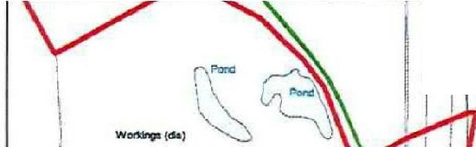
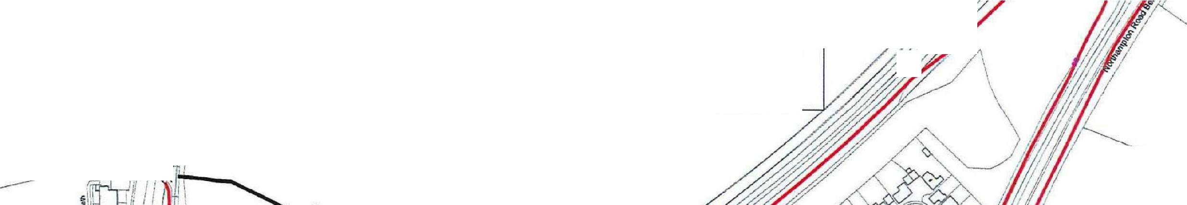
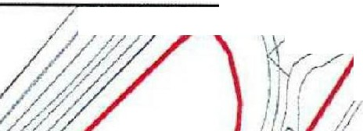
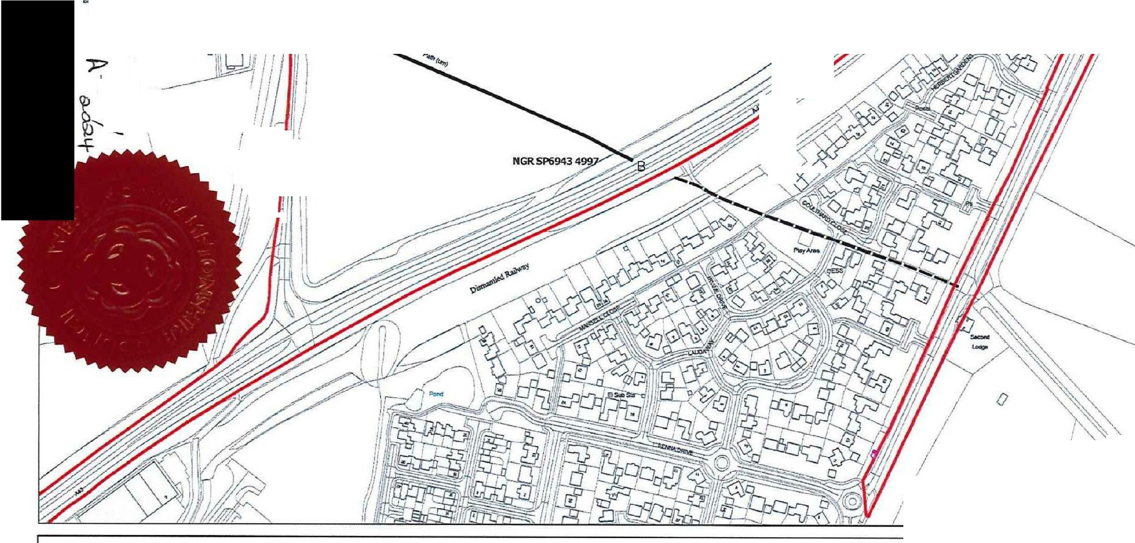
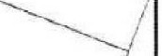
{l}
West North�mptonshire Council
Title: PUBLIC BRIDLEWAY STOPPING UP ORDER 2024, (PUBLIC BRIDLEWAY (SB32) IN THE PARISH OF TOWCESTER (PART BETWEEN TIFFIELD ROAD AND THE A43)) TOWN AND COUNTRY PLANNING ACT 1990: SECTION 257
© Crown copyright and database rights 2023 Ordnance Survey licence no. 100063706

7J
Ill
co
(D
.;:,.

/ I I
j �
Th&Rookory
I
\ /
I1./
/,I
I

Date: 18-01-2024

Scale: 1:2,500 @A3

Drawn: LP

7J
C
S1:
c5·
-
7J
Ill
:::r
0-,
0..
(-D,

