NOTICE OF ORDER
Wildlife and Countryside Act 1981 Section 53
Lake District National Park Authority
Definitive Map Modification Order 2022

1 Bridleway 520070, Occupation Lane between Broughton Park & Station Road, Broughton West Parish PINS ref: ROW/3326575

2 Bridleway 520071, Occupation Lane between Broughton Park & Bush Green, Broughton West Parish PINS ref: ROW/3326576

Notice is hereby given that the above referenced Order has been submitted to the Secretary of State for Environment, Food and Rural Affairs for determination. An Inspector will be appointed by the Secretary of State to determine the Order.

The start date for the above Order is Wednesday 4 June 2025.

Consideration of the Order will take the form of a public local inquiry.

The Inquiry will be held at Victory Hall, Station Road, Broughton-in-Furness, Cumbria, LA20 6HN on Tuesday 13 January 2026 at 10.00am.

The effect of the Orders, if confirmed without modifications, will be to modify the Definitive Map and Statement for the area by modifying the definitive map by adding two sections of bridleway along Occupation Lane between Station Road in Broughton (SD 2122 8742), and Bush Green on the A595 (SD 2091 8664) as shown on the order plans.

Any queries relating to this Order should be referred to Zoe McPhail by email: zoe.mcphail@planninginspectorate.gov.uk quoting reference number ROW/3326575 and ROW/3326576 on all correspondence. Alternatively, queries may be sent in writing to The Planning Inspectorate, Rights of Way Section, Room 3/A Eagle Wing, Temple Quay House, 2 The Square, Temple Quay, Bristol, BS1 6PN. Telephone: 0303 444 5481.

Any person wishing to view the statements of case and other documents relating to this Order may do so by appointment at Broughton Library, The Victory Hall, Station Road, Broughton-in-Furness LA20 6HN and LDNPA, Wayfaring House, Murley Moss, Oxenholme Road, Kendal, LA9 7RL.. Please contact Nick Thorne on nick.thorne@lakedistrict.gov.uk, Tel 01539 729621 or follow this link: https://tinyurl.com/occupationlanedmmo.

Timetable for sending in statements of case and proofs of evidence

Within 8 weeks of the start date by [by 30 July 2025]

The Order Making Authority must ensure their statement of case is received by the Secretary of State. As soon as possible after the deadline, the Secretary of State will send a copy (excluding copies of any supporting documents - these will be available to view at the Authority’s offices) to everyone who has made an objection or representation and the applicant and any other person who has written to us in respect of the Order.

Within 14 weeks of the start date [by 10 September 2025]

Everyone who has made an objection or representation and anyone who wishes to give evidence at the Inquiry must ensure their statement of case is received by the Secretary of State. As soon as possible after the deadline, the Secretary of State will send full copies to the Authority. Copies will also be sent to the applicant, every person who has made an objection or representation and any other person who has written to us in respect of the Order (excluding copies of any supporting documents - these will be available to view at the Authority’s offices).

Within the same period the applicant (if applicable) must ensure their statement of case is received by the Secretary of State. As soon as possible after the deadline, the Secretary of State will send a full copy to the Authority. Copies will also be sent to everyone who has made an objection or representation and any other person who has written to us in respect of the Order (excluding copies of any supporting documents - these will be available to view at the Authority’s offices).

4 weeks before the date of the inquiry [by 16 December 2025]

The Authority, everyone who has made an objection or representation, the applicant (if applicable) and anyone who wishes to give evidence at the Inquiry must ensure their proof of evidence (together with any summary) is received by the Secretary of State. As soon as possible after the deadline, the Secretary of State will send copies of:

- the Authority’s proof of evidence to everyone who has made an objection or representation, the applicant and anyone who has submitted a statement of case (including copies of any supporting documents – although none should be submitted with a proof of evidence);

- the applicant’s proof of evidence to the Authority, everyone who has made an objection or representation and anyone else who has submitted a statement of case (including copies of any supporting documents – although none should be submitted with a proof of evidence); and

- all other proofs of evidence to the Authority, the applicant, everyone who has made an objection or representation and anyone else who has submitted a statement of case (including copies of any supporting documents – although none should not be submitted with a proof of evidence).

All parties must keep to the timetable set out above and ensure that statements of case and proofs of evidence are received by the Secretary of State on time. Late documents will be returned.

NOTE: If you use Artificial Intelligence (AI) to create or alter any part of your documents, information or data, you should tell us that you have done this when you provide the material to us. See the detailed guidance for further information.

We cannot accept any inflammatory, discriminatory or abusive comments. Any documents containing such comments will be returned.

Notice of order for inquiry

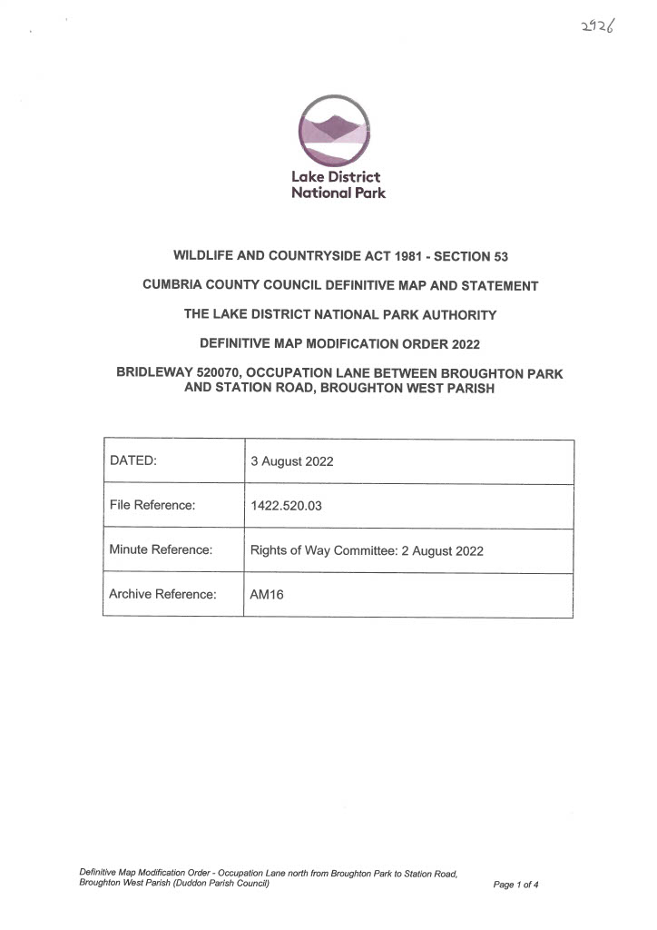
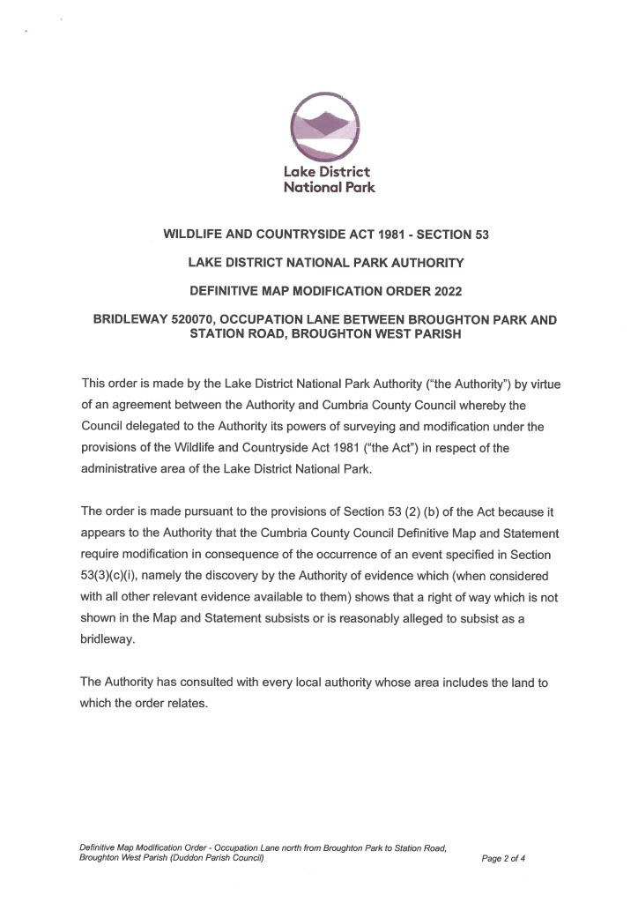
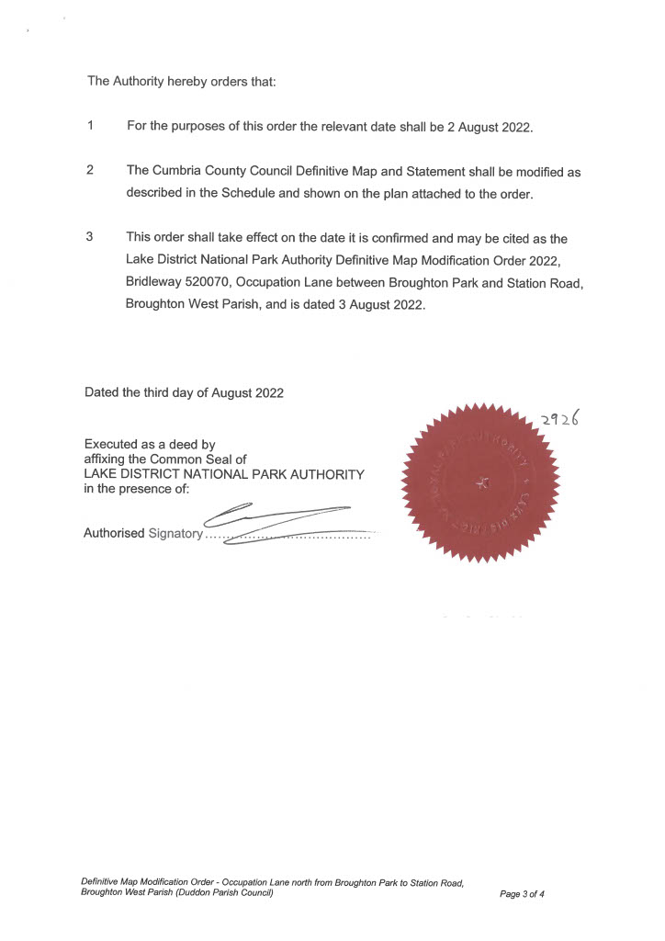
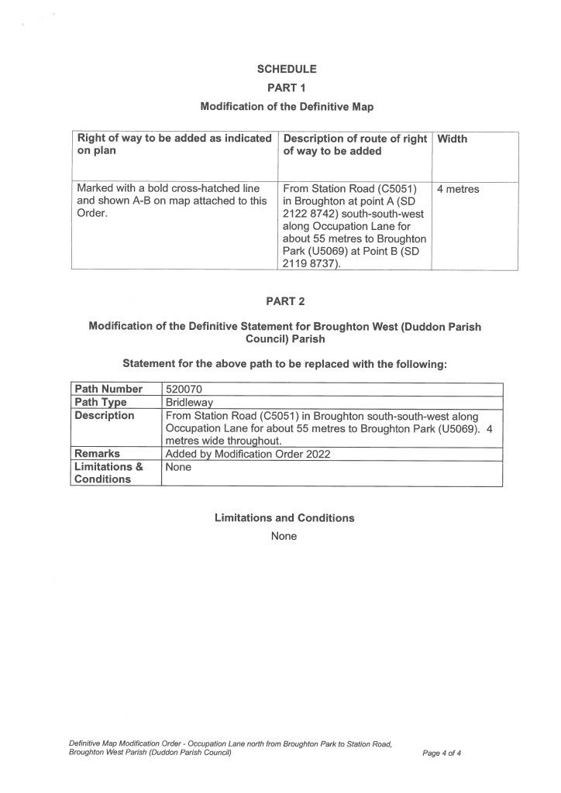
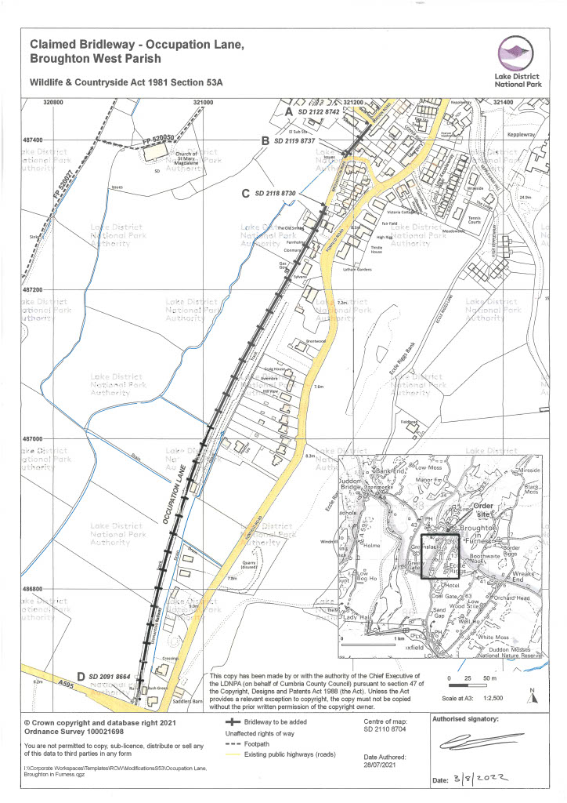
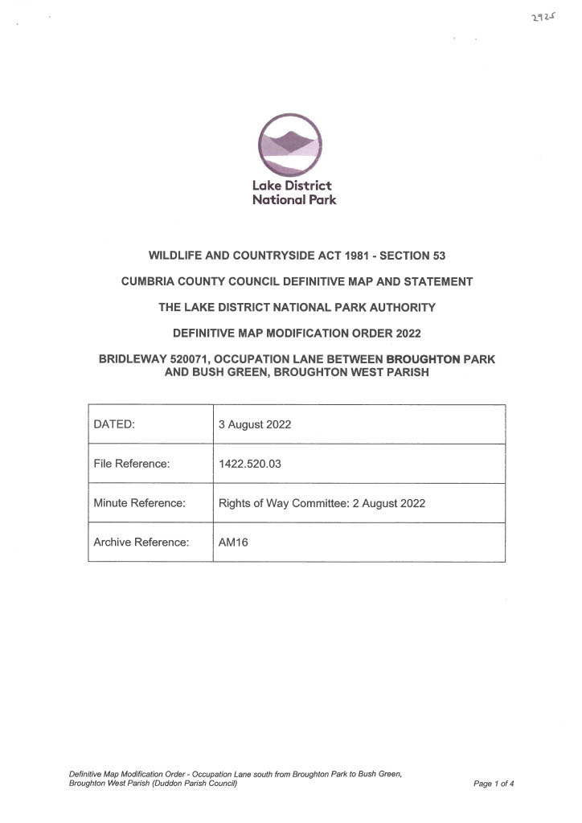
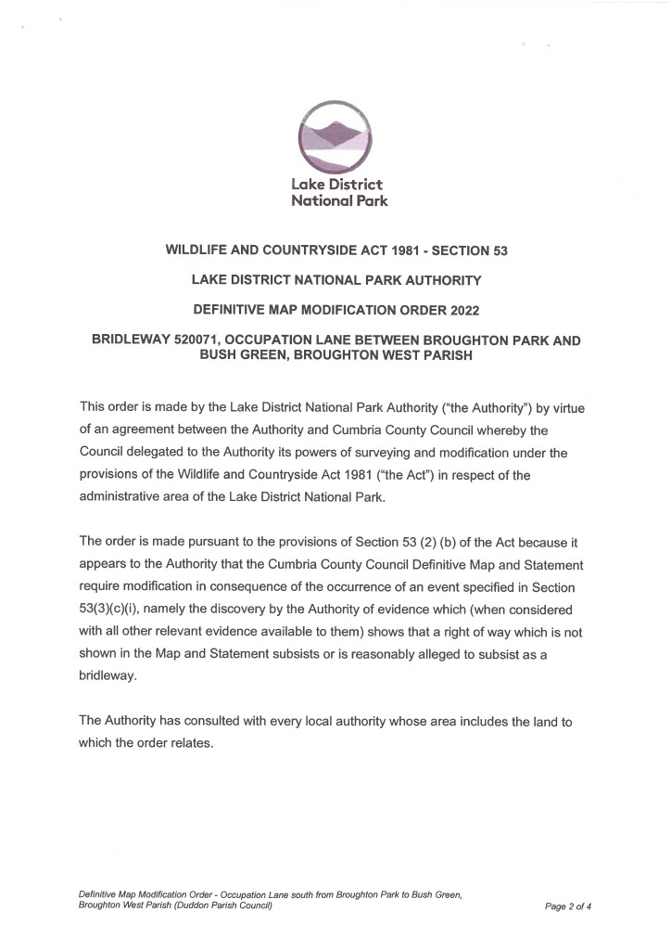
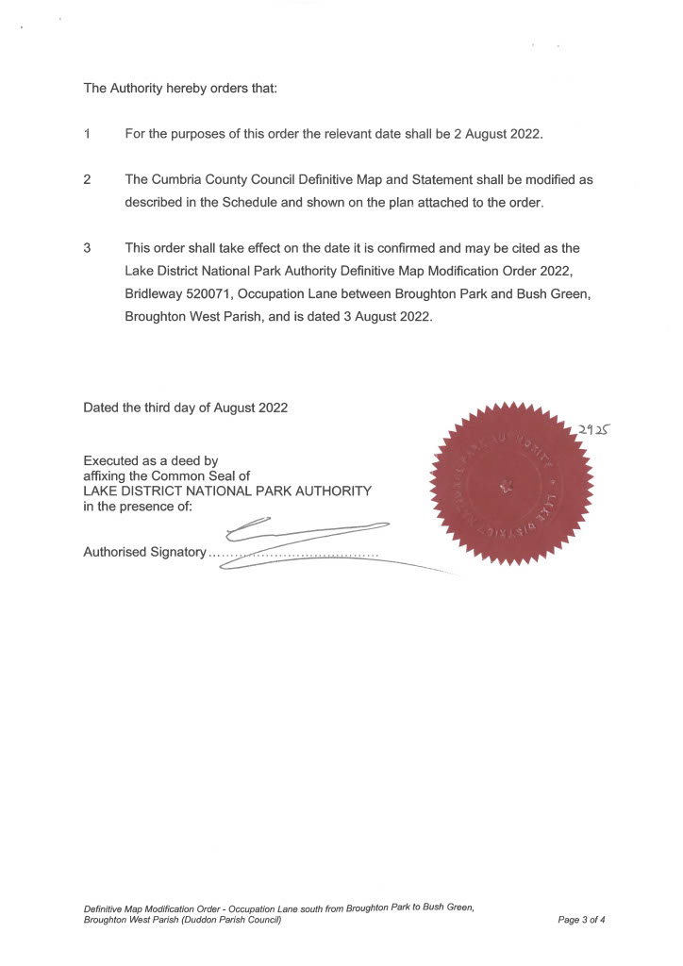
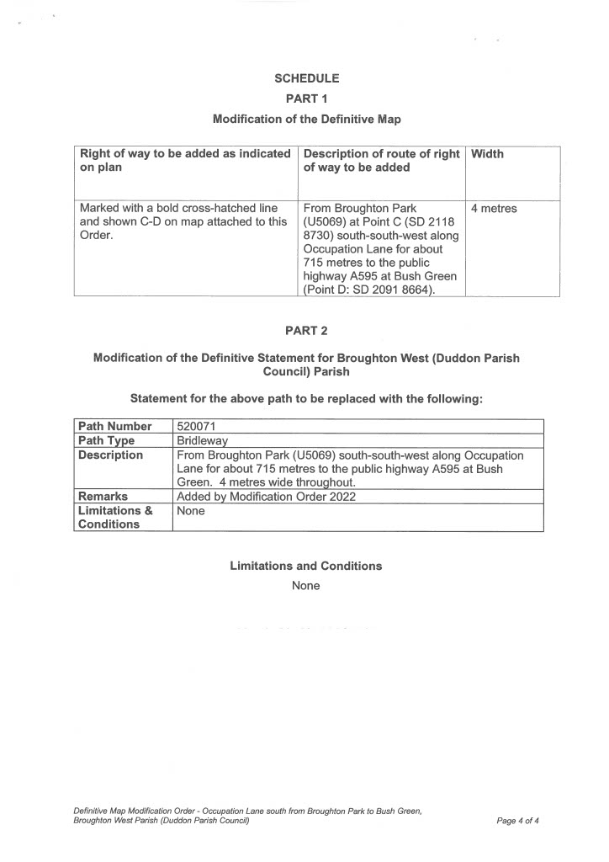
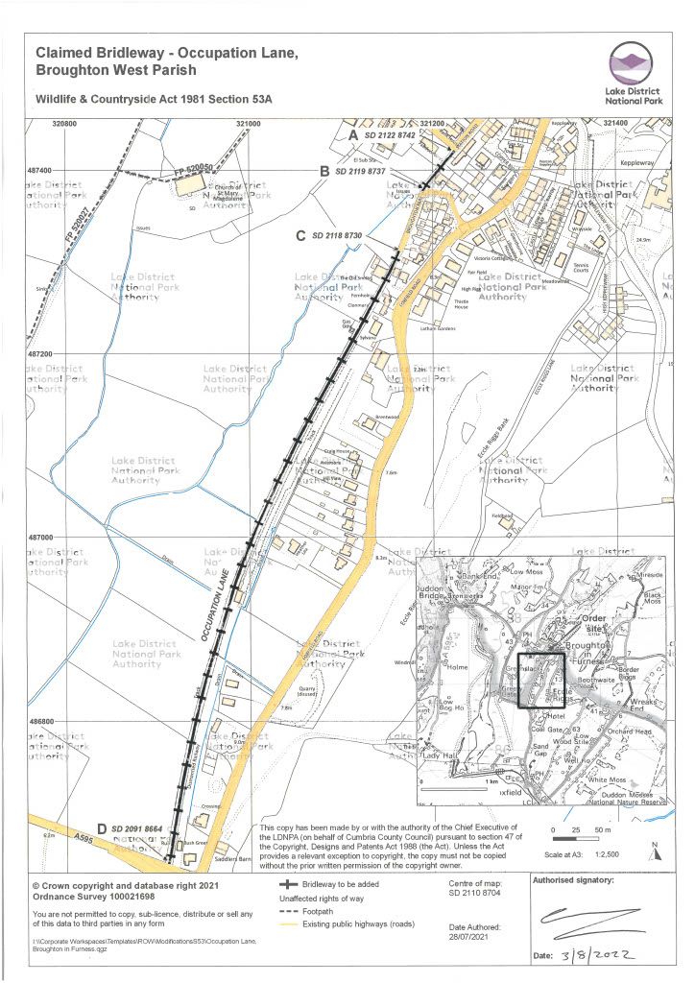

If you wish to make a legal submission, this should be submitted at the same time as your statement of case. Otherwise legal submissions will have to be submitted in writing on the day of the inquiry.

