NOTICE OF ORDER

Wildlife and Countryside Act 1981
Lancashire County Council

THE LANCASHIRE COUNTY COUNCIL RESTRICTED BYWAY BETWEEN LIVERPOOL ROAD AND NORTHERN AVENUE, MUCH HOOLE DEFINITIVE
MAP MODIFICATION ORDER 2022

Notice is hereby given that the above referenced Order has been submitted to the Secretary of State for Environment, Food and Rural Affairs for determination. An Inspector will be appointed by the Secretary of State to determine the Order.
The start date for the above Order is 1st JULY 2025

Consideration of the Order will take the form of exchanges of statements of case and comments on statements of case.
The effect of the Order, if confirmed without modifications, will be to upgrade a Footpath to a Restricted Byway from a junction with Liverpool Road (A59) (point A on the Order Map) in a generally easterly direction to the south of the residential properties on Brooklawns and continuing east to a point at the south east corner of the boundary of the property known as Greenfield at point B. The way then continues through the boundary hedge and along the eastern edge of the property known as Greenfield to the access road to the property at point C. From point C the way continues east to the junction with Northern Avenue at point D.

The route is shown on the Order Map between points A-B-C-D as a broken green line. The total length of the route is 0.45km and the width of the route varies between
2.5m and 11m.

Any queries relating to this Order should be referred to Paul Scrivener by email: paul.scrivener@planninginspectorate.gov.uk quoting reference number ROW/3346478 on all correspondence. Alternatively, queries may be sent in writing to The Planning Inspectorate, Rights of Way Section, Room 3/A Eagle Wing, Temple Quay House, 2 The Square, Temple Quay, Bristol, BS1 6PN. Telephone: 0303 444 5000.
Any person wishing to view the statements of case and other documents relating to this Order may do so by appointment at County Hall, Fishergate, Preston, PR1 0LD, for further information please contact Simon Moore at simon.moore@lancashire.gov.uk or on 01772 531280. Documents have also been made available online. To access the documents, please use the following URL address: https://www.lancashire.gov.uk/council/transparency/dmmos/liverpool-road- 2022.
Timetable for sending in statements of case and comments Within 2 weeks of the start date by 15th JULY 2025
The Order Making Authority must ensure their statement of case is received by the
Secretary of State. As soon as possible after the deadline, the Secretary of State will
send a copy (excluding copies of any supporting documents - these will be available to view at the Authority’s offices) to everyone who has made an objection or representation, the applicant and any other person who has written to us in respect of the Order.
Within 8 weeks of the start date by 26th August 2025
Everyone who has made an objection or representation or any other written representation or any other person wishing to make representations in writing must ensure their statement of case is received by the Secretary of State. As soon as possible after the deadline, the Secretary of State will send full copies to the Authority. Copies (excluding copies of any supporting documents - these will be available to view at the Authority’s offices) will also be sent to the applicant, every person who has made an objection or representation and any other person who has written to us in respect of the Order.

Within the same period the applicant (if applicable) must ensure their statement of case is received by the Secretary of State. As soon as possible after the deadline, Secretary of State will send a full copy to the Authority. Copies will also be sent to everyone who has made an objection or representation and any other person who has written to us in respect of the Order (excluding copies of any supporting documents - these will be available to view at the Authority’s offices).
Within 14 weeks of the start date by 7th September 2025
Everyone who has made an objection or representation, the Authority, the applicant (if applicable) and anyone who has written to us in respect of the Order must ensure that their comments on any or every other statement of case is received by the Secretary of State. As soon as possible after the deadline, the Secretary of State will send copies of these comments to everyone else.

In fairness to the other parties everyone should keep to the timetable to ensure that statements of case and comments are received on time. Late documents will be returned.

We cannot accept any inflammatory, discriminatory or abusive comments. Any documents containing such comments will be returned.

If you use Artificial Intelligence (AI) to create or alter any part of your documents, information or data, you should tell us that you have done this when you provide the material to us. See the detailed guidance for further information.

Notice of order for w/r
. '

WILDLIFE AND COUNTRYSIDE ACT 1981

THE DEFINITIVE MAP AND STATEMENT OF PUBLIC RIGHTS OF WAY FOR THE COUNTY OF LANCASHIRE

THE LANCASHIRE COUNTY COUNCIL
RESTRICTED BYWAY BETWEEN LIVERPOOL ROAD AND NORTHERN AVENUE, MUCH HOOLE
DEFINITIVE MAP MODIFICATION ORDER 2022

This Order is made by Lancashire County Council ("the authority") under Section 53(2)(b) of the Wildlife and Countryside Act, 1981 (''the Act") because it appears to that authority that The Definitive Map and Statement of Public Rights of Way for the County of Lancashire require modification in consequence of the occurrence of an event specified in Section 53(3)(b) and 53(3)(c)(i) and 53(3)(c)(ii) namely the discovery by the Surveying Authority of evidence which (when considered with all other relevant evidence available to them) shows that a right of way which is not shown in the map and statement subsists or is reasonably alleged to subsist over land in the area to which the map relates, namely a restricted byway and that a highway shown in the map and statement as a highway of a particular description ought to be there described as a highway of a different description, namely a public footpath when it ought be a restricted byway.

The authority have consulted with every local authority whose area includes the land to which the Order relates. Lancashire County Council hereby order that:

- For the purposes of this Order, the "relevant date" is 19th January 2022.

- The Definitive Map and Statement of Public Rights of Way for the County of Lancashire shall be modified as described in Part I and Part II of the Schedule and shown on the map attached to the Order.

- This Order shall take effect on the date it is confirmed and may be cited as The Lancashire County Council Restricted Byway between Liverpool Road and Northern Avenue, Much Hoolet Definitive Map Modification Order 2022.

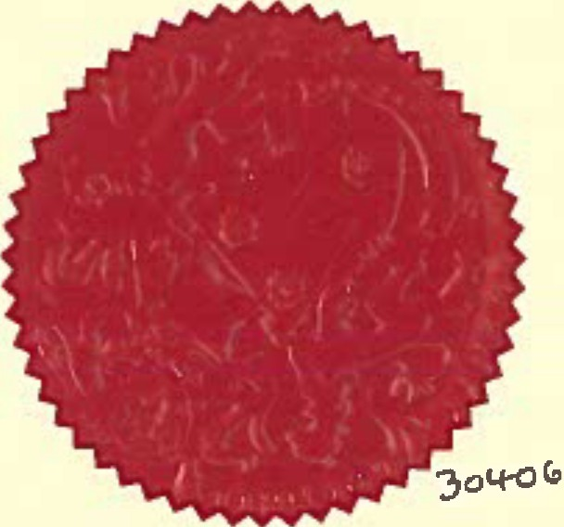
Dated this 19th day of January 2022. THE COMMON SEAL of the )

Lancashire County Council ) was hereunto affixed in the presence of )

�

Authorised Signatory
SCHEDULE
PARTI

MODIFICATION OF THE DEFINITIVE MAP

DESCRIPTION OF PATH OR WAY TO BE ADDED AND UPGRADED

Restricted Byway from a junction with Liverpool Road (A59) (point A on the Order Map) in a generally easterly direction to the south of the residential properties on Brooklawns and continuing east to a point at the south east corner of the boundary of the property known as Greenfield at point B. The way then continues through the boundary hedge and along the eastern edge of the property known as Greenfield to the access road to the property at point C. From point C the way continues east to the junction with Northern Avenue at point D.

The route is shown on the Order Map between points A-B-C-D as a broken green line.

The total length of the route is 0.45 km and the width of the route varies between 2.5m and 11m.

PART II

MODIFICATION OF DEFINITIVE STATEMENT VARIATION OF PARTICULARS OF PATH OR WAY
The Statement to be added for Much Hoole 32 to read as follows:

Much Hoole 32:

No. of path: 113211

Kind of path: 11Restricted Byway"

Position: "Restricted Byway from a junction with Liverpool Road (A59) at Grid Reference SD 4660 2266 running in a generally easterly direction to the south of the residential properties on Brooklawns and continuing east to a point at the south east corner of the boundary of the property known as Greenfield at SD 4683 2269. The restricted byway then continues through the boundary and inside the eastern edge of the property known as Greenfield to the access road which provides access to the property at SD4684 2273 and then east along the access road passing through the junction with Footpaths 27 and 28 at SD 4687 2274 and continuing east to the junction with Northern Avenue and Footpath 29 at SD 4699 2274.AII compass directions given are approximate."

Length: 110.45 km11

Width: "Width varies between 2.5 and 11 metres as shown on the Ordnance Survey 25 inch Sheet LXVlll.15 Surveyed in 1892 and published in 1893.
'

Limitations: None"

The Statement for Footpaths 27, 28, 29 and 30 to be varied to read:

Much Hoole 27:

No. of Path: 021•

Kind of Path: 11Footpath"

Position: "Town Lane to junction with Footpath 28 and Restricted Byway 32 at SD 4687 227411

Length: 110.14 miles"

Much Hoole 28:

No. of Path: 112811

Kind of Path: "Footpath"

Position: "Howards Row (Liverpool Old Road) to junction with Footpath 27 and Restricted Byway 32 at SD 4687 2274."
Length: 110.08 miles"

Much Hoole 29:

No. of Path: 112911

Kind of Path: 11Footpath"

Position: •[1] Liverpool Road at SD 4659 2265 to junction with Restricted Byway 32 at SD 4660 2266 and
- from a point on Restricted Byway 32 at SD 4683 2269 to a further point on Restricted Byway 32 at SD 4684 2273 and
- from junction with Restricted Byway 32 at SD 4699 2274 to Moss Lane" Length: N0.17 miles11

',',
"
I"I
....
,",
--
,,
,,
,,
""" ""
- ■ ■ 1 Order Route A-8-C-D-E ,I
- - - • Public Footpaths
.
r

N

,r + •i 1 t t•
C/)
(0
:,
cu

Rights of Way

Wildlife and Countryside Act 1981
0 37.5 75 150 Meters
I
PROW@lancashlre.gov.uk
01n2s30311
Upgrading of Footpath and addition of Restricted Byway between Liverpool Road and Northern Avenue, Much Hoole 1:2,000
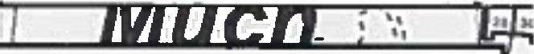
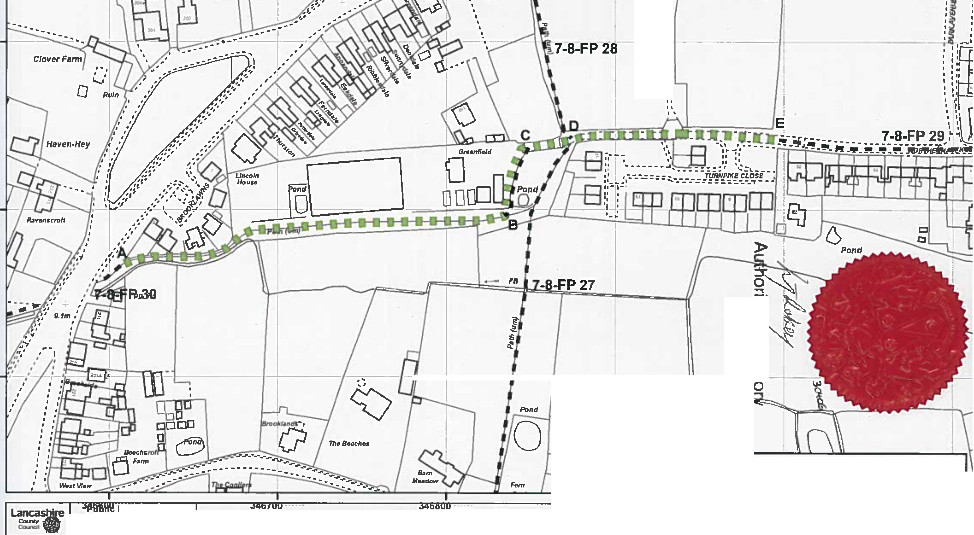

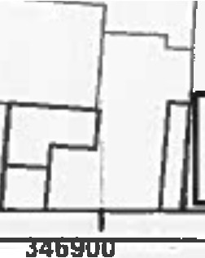
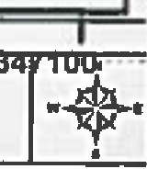
The dlglllsed Rights of way lnfonnallon &hould be 11slld for uuld•�• only H 119 accuracy cannot be guaranteed. Right• at Way Information muat ba vllflfllld an the currant Deflnlllve Map befon, being aupplled or uud for any pufPOM. Thi• Map I• ,-produced from O!"llnAnc• SufVe)' mataflal wtth lhe permission at Onlnanc:a s. , on behalf of lhe controllet at Her Majesty's Sletlon"fY Ofllc:e (Cl Crown Copy,tghL Unaulhortud reptoducllon lnfnngn Crawn Copy,tghl
and may lead la Prosecution or clvll proceedings. l•�•hlnt County CouncH Uc8f1Ce No. 100023320

