PINS LOGO

|  |
| --- |
| **Order Decisions** |
| Site visits made on 1 & 4 December 2023 |
| **by J Burston BSc(Hons) MA MRTPI AIPROW** |
| **an Inspector appointed by the Secretary of State for Environment, Food and Rural Affairs** |
| **Decision date: 12 May 2025** |

|  |
| --- |
| **Order Ref: ROW/3328591** |
| * This Order is made under the Acquisition of Land Act 1981 Section 32 and is known as the Environment Agency (Oxford Flood Alleviation Scheme) (Footpath 320/16 Hinksey Causeway) Acquisition Extinguishment Order 2023. |
| * The Order is dated 30 March 2023 and proposes to extinguish the public right of way shown on the Order plan and described in the Order Schedule. |
| * There was one objection outstanding when the Environment Agency submitted the Order to the Secretary of State for Environment, Food and Rural Affairs for confirmation. |
| **Summary of Decision: The Order is confirmed subject to the modification set out below in the Formal Decision.** |

|  |
| --- |
| **Order Ref: ROW/3328592** |
| * This Order is made under the Acquisition of Land Act 1981 Section 32 and is known as the Environment Agency (Oxford Flood Alleviation Scheme) ( Footpath 352/1 Devil’s Backbone) Acquisition Extinguishment Order 2023. |
| * The Order is dated 30 March 2023 and proposes to extinguish the public right of way shown on the Order plan and described in the Order Schedule. |
| * There was one objection outstanding when the Environment Agency submitted the Order to the Secretary of State for Environment, Food and Rural Affairs for confirmation. |
| **Summary of Decision: The Order is confirmed subject to the modification set out below in the Formal Decision.** |

|  |
| --- |
| **Order Ref: ROW/3328593** |
| * This Order is made under the Acquisition of Land Act 1981 Section 32 and is known as the Environment Agency (Oxford Flood Alleviation Scheme) (Footpath 320/18 South East of Weirs Mill Lane) Acquisition Extinguishment Order 2023. |
| * The Order is dated 30 March 2023 and proposes to extinguish the public right of way shown on the Order plan and described in the Order Schedule. |
| * There was one objection outstanding when the Environment Agency submitted the Order to the Secretary of State for Environment, Food and Rural Affairs for confirmation. |
| **Summary of Decision: The Order is confirmed subject to the modification set out below in the Formal Decision.** |

|  |
| --- |
| **Order Ref: ROW/3328594** |
| * This Order is made under the Acquisition of Land Act 1981 Section 32 and is known as the Environment Agency (Oxford Flood Alleviation Scheme) (Footpath 352/3 South Hinksey to Abingdon Road) Acquisition Extinguishment Order 2023. |
| * The Order is dated 30 March 2023 and proposes to extinguish the public right of way shown on the Order plan and described in the Order Schedule. |
| * There was one objection outstanding when the Environment Agency submitted the Order to the Secretary of State for Environment, Food and Rural Affairs for confirmation. |
| **Summary of Decision: The Order is confirmed subject to the modification set out below in the Formal Decision.** |

Procedural Matters

1. These Extinguishment Orders form part of a wider Compulsory Purchase Order (CPO) and Planning Application submitted by the Environment Agency (the Agency). The CPO decision will be made by the Secretary of State (SoS), following a recommendation made by a Planning Inspector. These Extinguishment Order decisions will be attached to the CPO report as an addendum to assist the SoS.
2. The Orders, at paragraph 1 (a) reference the “*Environment Agency (Oxford Flood Alleviation Scheme) Compulsory Purchase Order 2022*”. However, this is incorrect and should state the ‘*Environment Agency (Oxford Flood Alleviation Scheme) Compulsory Purchase Order 2023’*.
3. The Environment Agency accepts that the reference is incorrect. Therefore, if confirmed, the Order should be modified accordingly to ensure there is no ambiguity regarding when the footpaths noted in the orders will be extinguished. I am satisfied that no-one has been prejudiced by this typographical error.
4. Given the similarity of matters and the commonality of the background to these Orders they have been considered together within a single decision letter.
5. Following a written representation procedure initiated by the Planning Inspectorate, eleven letters of objection have been received in total to the Orders. This includes:

* Footpath 352/3 Acquisition Extinguishment Order 2023 – 7 objections
* Footpath 320/18 Acquisition Extinguishment Order 2023 – 8 objections
* Footpath 352/1 Acquisition Extinguishment Order 2023 – 8 objections
* Footpath 320/16 Acquisition Extinguishment Order 2023 – 9 objections

1. The Agency has confirmed that they have the consent of statutory undertakers whose apparatus would be affected by the order.
2. If the CPO scheme gains approval from the SoS along with the required planning permission, Oxfordshire County Council as the Highway Authority will designate the alternative routes for the footpaths in accordance with their duties under the Highways Act 1980.
3. Despite extensive enquiries, the Agency have been unable to ascertain the ownership of some of the Order land in question. Accordingly, the Agency requested dispensation from the SoS in an email, dated 7 August 2023. In these circumstances and in accordance with paragraph 3(4) of Schedule 15 to the Wildlife and Countryside Act 1981, the SoS directed (letter dated 7 August 2023) that it is not necessary for the Agency to serve notice on the owners and occupiers of the land in question.
4. In this respect the Agency affixed notices addressed to “*the owners and any occupiers*” of each footpath to a conspicuous object or objects on the land. Notices were also provided to the relevant local authorities for public display from the 21 August 2023.
5. Whilst objectors’ comment on the lack of consultation or whether appropriate channels of consultation were used, given the evidence before me the Agency correctly followed the procedures as set out in the relevant legislation. In terms of site notices, the Agency has confirmed that the notices were placed at either end of the Order routes and were checked on a weekly basis and replaced if they had been damaged or removed.
6. In this decision I have found it useful to refer to the various points annotated on each of the Order maps. For ease of reference a copy of the Order maps is attached at annex A.

The Main Issues

1. The Orders are made under Section 32 of the Acquisition of Land Act 1981, that enables the Agency, and others, empowered to acquire land compulsorily to make orders extinguishing non-vehicular public rights of way over land that has been or is being acquired compulsorily. This order-making power also applies where the land is being acquired by agreement, but only if it is also possible for the land to have been acquired compulsorily.
2. Before confirming an order, the decision maker must be satisfied that:
3. Section 32 of the Acquisition of Land Act 1981 applies; and if it does,
4. a suitable alternative way has been or will be provided or is not required.

**Reasons**

*Background to the overarching Oxford Flood Alleviation Scheme (OFAS)*

1. Many properties in Oxford, both residential and commercial, as well as roads, the railway and utility infrastructure are at risk of flooding from the rivers in Oxford. If nothing was done to manage flood risk, approximately 2,200 properties would be at risk from internal flooding in a major flood that has a 1% chance of happening each year (1% Annual Exceedance Probability (AEP)). The Agency’s existing flood risk management activities reduce this, but around 1,600 properties still remain at risk. The OFAS is designed to reduce the likelihood of flooding for all of these properties currently at risk of flooding from the River Thames in Oxford.
2. Moreover, climate change is not only increasing the extent of flooding but also the frequency and scale of disruption to Oxford and the wider area. If no action is taken the modelling results highlight that approximately 5,600 properties will be at flood risk by 2080. The results of the detailed design modelling completed for OFAS show that all properties in Oxford that are currently at risk of flooding from the River Thames, will have their flood risk reduced when the scheme is in place.
3. The purpose of OFAS is to manage the flood risk to Oxford over the next 100 years, reducing the frequency of flooding by creating more space for water within the existing western floodplain of the city. The scheme addresses flooding from the main channel of the River Thames and from the Hinksey and Bulstake Streams.
4. The proposed scheme would be approximately 5km long and would run from north of Botley Road down to south of the A423 southern by-pass where it would re-join the River Thames.
5. The first stage would consist of a new stream that would look natural and connect with the existing braided network of streams at different points. The new stream would be permanently wet and carry flowing water all of the time.
6. The second stage would consist of a wide shallow sloped channel created by lowering the ground between 0.5m and 1.2m to one or both sides of the first stage stream. This would blend in with the floodplain and would remain dry for most of the time. When river levels are sufficiently high, water would flow along the second stage channel. In some local areas, a second stage channel will be constructed without a first stage stream and vice versa.
7. The scheme also proposes the:

* Provision of new flood defences (embankments and walls) to protect properties which would otherwise continue to flood even with the reduced river levels;
* Provision of new culverts and bridges to cross highways and footpaths to maintain access routes;
* Installation of flood gates for access (open under normal, non-flood, conditions) through the new defences noted above;
* A new track along much of the scheme to allow access for maintenance. A proportion of the track will be made into a permissive path that the public are allowed to use, except when maintenance or other activities would conflict with this.
* Creation of new and/or improved habitat for flora, fauna and fisheries. This habitat creation/restoration forms part of the integrated design of the scheme to help mitigate habitat losses, to meet Water Framework Directive Regulations and support Environment Act 2021 biodiversity net gain targets e.g. new wetland habitat within the footprint of the second stage channel, new channel connecting the Bulstake and Hinksey Streams, habitat improvements including scrapes, ponds and backwaters. The wetland features in the second stage channel will incorporate a variety of profiles and gradients, to include marginal shelves, steep banks and undulating bed profiles to maximise wetland habitat diversity;
* Removal of Towles Mill Weir will facilitate unimpeded fish passage around Oxford for the first time in over a century;
* Change of use of land for public recreation to provide exchange for existing open space if required;
* Change of use of land to provide allotments;
* There will be 3 telemetry cabinets located at different points across the scheme to monitor flows; and
* Eastwyke Ditch flood control structure.

1. It is acknowledged that temporary flood defences would continue to be deployed, albeit less frequently than at present, as a part of a permanent solution.
2. Subject to the necessary approvals the Agency states that construction of the scheme is planned to start in 2024 and is expected to take between 3 years and 5 years. The final programme is dependent on the delivery of the replacement A423 Kennington Railway Bridge by Oxfordshire County Council.

*Does Section 32 of the Acquisition of Land Act 1981 apply*

1. A CPO for the OFAS was executed as a deed by the Agency on 18 February 2023. Schedule 1 of the CPO sets out the ‘*land to be purchased (except exchange land or additional land) and new rights*’. Schedule 2 of the CPO sets out ‘*the exchange and additional land to be purchased and vested*’. Accompanying the CPO were a number of maps showing the affected areas.
2. Given that the Extinguishment Order Routes subsist over the land included within the CPO, it follows that section 32 of the Acquisition of Land Act 1981 would apply. In this respect it should also be acknowledged that the alternative routes put forward by the Agency would also run over land contained in the CPO. No objections have been raised that would challenge this finding.

*Whether an alternative way has, or will be provided, or is not required*

Footpath 352/3 Acquisition Extinguishment Order 2023

1. The existing route heads in a broadly north westerly direction from Old Abingdon Road (Point G) to Barleycott Lane (Point E). The footpath then turns towards the south for approximately 230 metres where it joins a path adjoining the A34.
2. The Agency proposes two sections of alternative route at Points G and E. At Point G the alternative route commences some 30 metres to the south of the existing route at Point C and creates a ‘dog leg’ to rejoin the existing footpath at Points D/H. The alternative route sections would increase walking distance by up to 200 metres.
3. At Point E to Point F some 70 metres of footpath will become redundant and will be subject to a further Order to be made by Oxfordshire County Council. To link the two sections of footpath a link will be provided at point F/B which will travel broadly southwest to meet the existing footpath at Point A.
4. Between points H and G, the Environment Agency will construct the main flood alleviation channel which forms the OFAS. The existing alignment of the footpath will be within the channel and consequently will no longer be useable.
5. The rationale for this extinguishment is that in the location of the footpath closure between points E and F, the Environment Agency would be constructing a raised earth embankment to protect the village of South Hinksey during flood events.

Footpath 320/18 Acquisition Extinguishment Order 2023

1. The present route runs over the carriageway of an existing private road (Point C), from which it crosses the Weir (Point D), towards Iffley Meadows. The Order relates to the extinguishment of 13 metres of this path between Points C-D.
2. The alternative route moves the alignment of the existing footpath to the southwest to run alongside the western boundary of the private track as shown on the Order map between Points A-B. The alternative route would increase walking distance by up to 14 metres.
3. The rationale for the need for the Order is set out at paragraph 3.2 of the Agency’s Statement of Grounds “*The private road where the footpath closure and diversion is located, is the only vehicular access that the Environment Agency can use to install and maintain large flap valves on the two culvert pipe outfalls that lie immediately to the east of this private road. These flap valves will form part of the Oxford FAS. The outfall pipes run below the B4495 Donnington Bridge Road and facilitate the drainage of the ditch which runs along the rear of the properties on Fox Crescent and Cowmead Allotments. This ditch is located on the dry side of the new flood defences in this area. The flap valves are required to prevent high water levels in Weirs Mill Stream flowing back up through the culverts and to reduce flood risk to properties in the Fox Crescent area*.”

Footpath 352/1 Acquisition Extinguishment Order 2023

1. The present route crosses a grassed paddock, from John Piers Lane in a northly direction, for a distance of 51 metres.
2. The alternative route retains the same termination points as the existing route. However, the alternative path forms a dog leg, offset approximately 15 metres to the east of the existing route. Due to the presence of grazing animals in the field, the area close to the proposed route would need to be fenced. The fencing would include a gate for pedestrian use. The alternative route would provide an increase in walking distance of some 4 metres.
3. The rationale for the need for the Order is set out at paragraph 3.2 of the Agency’s Statement of Grounds “*In this location, the Environment Agency will construct a raised earth embankment to protect the village of South Hinksey during flood events. The embankment is part of the Oxford FAS and follows the line of the existing low raised area on which temporary defences are mobilised during each flood event. This embankment will remove the need to mobilise the temporary defences each time a flood warning is issued. The embankment will be approximately 1.2m high in the area of the existing public footpath, with side slopes of 1 in 3*.
4. Whilst the footpath could be retained on its current alignment the Agency considered that this would be impractical due to the steepness of the side slopes. Instead the path would be realigned along the proposed vehicle access ramp.

Footpath 320/16 Acquisition Extinguishment Order 2023

1. The present route follows the Ferry Hinksey Road and then the Hinksey Causeway and runs in a broadly northeast to southwest direction.
2. Two sections of the existing footpath are shown to be extinguished as part of the Order. The footpath between Points E-F will be moved to the southeast by approximately 10 metres but following the same alignment. The footpath between Points G-H will be moved to the southeast by approximately 5 metres, also following the same alignment. These changes would result in the path being some 20 metres longer in length.
3. In the location of the footpath closure between points E and F, the Agency would need to construct a low flood wall and raised defences adjacent to Osney Mead Industrial Estate to protect the Industrial Estate during flood events.
4. In the location of the footpath closure between points G and H, the Agency propose to construct a foot bridge which will cross the new channel beneath. The bridge will be 2.8 metres wide to allow pedestrians to easily pass each other and consist of 24 metre span arched steel main beams with a non-slip timber decking and composite steel and timber handrailing.

*Comment on Objections*

1. It is common ground that the existing footpaths are all currently used by members of the public and that the Agency has put forward alternative routes for these affected footpaths. As such it is reasonable for me to consider the disadvantages to present users of the highway and to the general public and take them into account. This might (for example) be as a result of an unacceptably long alternative route through traffic, convenience or increased noise and disturbance for residents on an alternative route and highway safety.
2. Many of the public rights of way across the Oxford Floodplain are historical routes, particularly the Hinksey Causeway. Heritage surveys have been undertaken and confirm that there are no permanent impacts predicted on the historic landscape during operation of the OFAS. Given the evidence before me I do not consider that the proposed changes to the rights of way network would significantly alter the ability for walkers to appreciate or interpret the historic landscape.
3. As I observed on my site visits the local footpath network is well used for both recreational walking and for commuting purposes. I also note that, in terms of recreational walking, many of the footpaths link up to provide circular routes, that the evidence highlights are important to local people. Nevertheless, the alternative routes are, in the main, small sections of a longer route and the termination points continue to facilitate links to other paths and the highway network so that circular routes can continue to be enjoyed. Moreover, the proposed alternative route would maintain, and in some cases improve the options for and the convenience of connectivity with the rights of way network.
4. It is accepted that during construction operations a number of paths may be unavailable for public use due to safety reasons. However, the Agency has developed a construction methodology which aims to minimise disturbance to footpath users and provide communication as to timescales for any proposed works. This document was submitted with the Planning Application for the OFAS and would form part of the planning conditions for the scheme should permission be granted.
5. I note the points about the Order and its effect on the ability of the public to use the rights of way network in the area. The Order would mean that members of the public would not be able to use the Order Route and there would be a gap between it being extinguished and the new paths being made available for use. These will take time to deliver due to the scale of development involved and the engineering works entailed, but diversions would be made available during the construction period for users.
6. I do not accept that the alternatives routes will change the character of the area. Indeed, in some cases the surface treatment of paths will be advantageous to users and facilitate year-round accessibility, where current use can be curtailed in times of flood. Furthermore, users would still experience the attractive panoramas that are available over the floodplain. Accordingly, I do not consider that the alternative routes proposed would significantly impact on the public enjoyment of the path.
7. Two objectors mention that the Order would restrict vehicle access to their property and garages. However, the CPO makes it clear that all rights of access would be regranted to ‘qualified persons’.
8. Objectors’ are concerned about that impact of the wider OFAS scheme on biodiversity. However, I must consider matters that relate solely to the Orders. There is no evidence before me that the alternative routes contained in the Orders would materially impact upon the biodiversity of the area and the alternative routes are unlikely to have any adverse impact upon the natural beauty of the area. I also note that a Habitat Regulation Assessment accompanied the planning Application for the OFAS and that Natural England have not raised any objections, subject to the imposition of suitable planning conditions.

*Weighing the advantages and disadvantages*

1. There are minor advantages to the walking public flowing from the Orders and there are very considerable benefits of the OFAS. Balanced against these is the limited disadvantage to the general public and/or individuals from the extinguishments. The effects, however, would be temporary and felt mostly during the construction phase. The affected rights of way will continue to legally exist and whilst there may be a limited change to how the public access and travel across the area, the improvements to the network would facilitate greater use. Overall, the disadvantage that arises from the Orders are not sufficient to outweigh the advantages of the OFAS and they are not individually or collectively significant enough to prevent the confirmation of the Orders.

**Conclusion**

1. Having regard to these, and all other matters raised in the written representations, I conclude that the Orders should be confirmed with the modification described in paragraphs 2 and 3 above, which does not require advertising.

**Formal Decision**

1. I confirm the Orders subject to the following modification:

* **Order Ref ROW/3328591 Footpath 320/16** Acquisition Extinguishment Order 2023 – Delete “*2022*” from paragraph 1(a) of the Order and insert with ‘*2023*’.
* **Order Ref ROW/3328592 Footpath 352/1** Acquisition Extinguishment Order 2023 – Delete “*2022*” from paragraph 1(a) of the Order and insert with ‘*2023*’.
* **Order Ref ROW/3328593 Footpath 320/18** Acquisition Extinguishment Order 2023 – Delete “*2022*” from paragraph 1(a) of the Order and insert with ‘*2023*’.
* **Order Ref ROW/3328594 Footpath 352/3** Acquisition Extinguishment Order 2023 – Delete “*2022*” from paragraph 1(a) of the Order and insert with ‘*2023*’.

J Burston

INSPECTOR

**ANNEX A**

**Order Route 320/16**

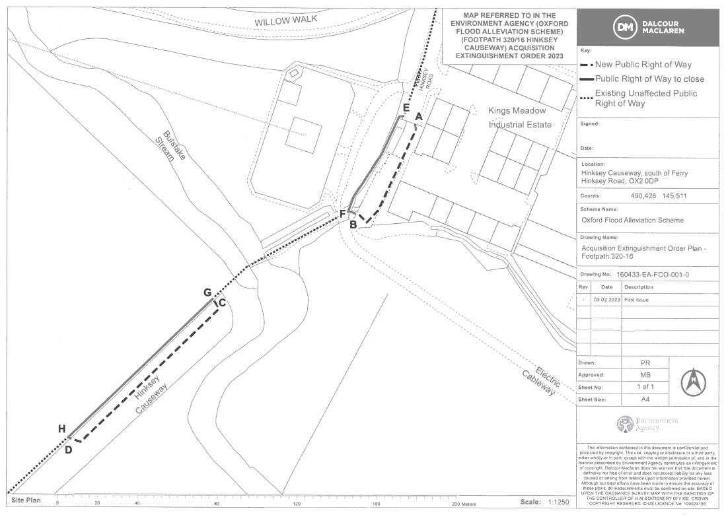

**Order Route 352/1**

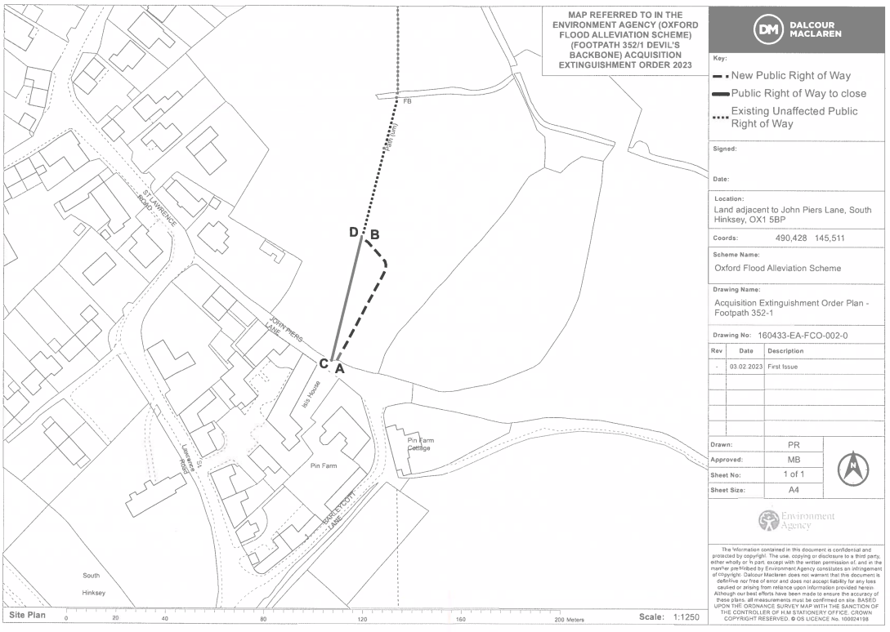

**Order Route 320/18**

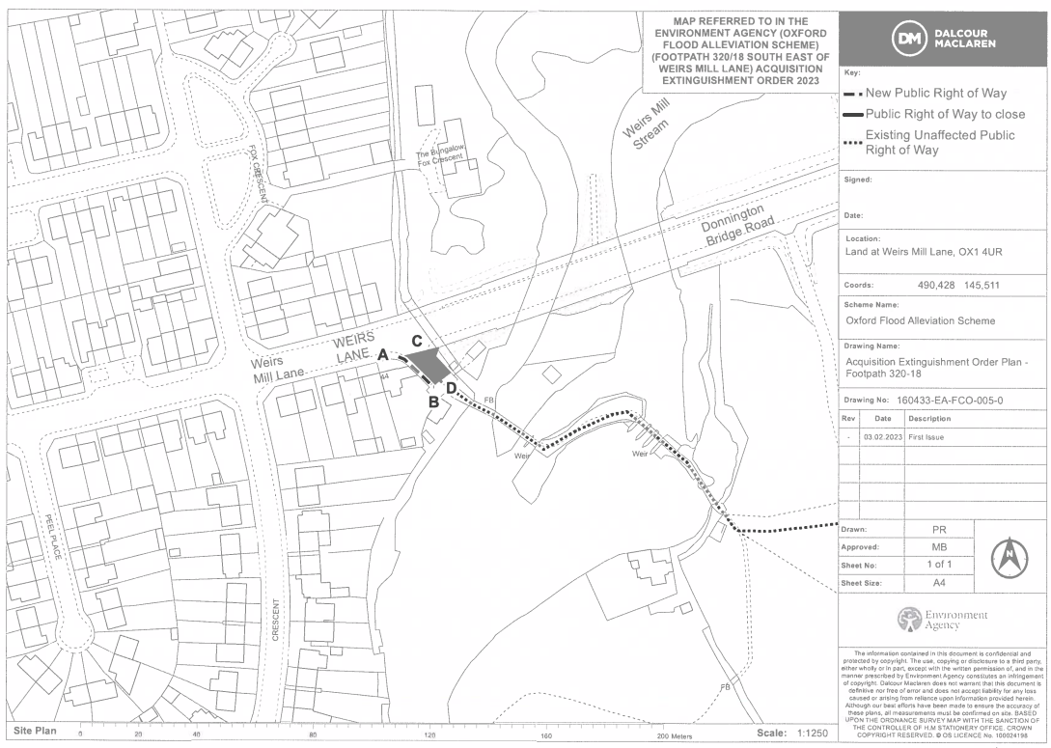

**Order Route 352/3**

map 4
