

|  |
| --- |
| **Order Decisions** |
| Papers on File |
| **by Claire Tregembo BA (Hons) MIPROW** |
| **An Inspector appointed by the Secretary of State for Environment, Food and Rural Affairs** |
| **Decision date: 23 June 2025** |

|  |
| --- |
| **Order Ref: ROW/3346922 Order No. 4** |
| * This Order is made under section 53(2)(b) of the Wildlife and Countryside Act 1981 and is known as the Lancashire County Council Definitive Map and Statement of Public Rights of Way (Definitive Map Modification Order) (No. 4) Order 2011. |
| * The Order is dated 12 January 2011 and proposes to modify the Definitive Map and Statement for the area by deleting part of footpath Chipping 129 from the Definitive Map and Statement as shown in the Order plan and described in the Order Schedule. |
| * There was one objection outstanding Lancashire County Council submitted the Order to the Secretary of State for Environment, Food and Rural Affairs for non-confirmation. |
| **Summary of Decision: The Order is not confirmed.** |
|  |
|  |

|  |
| --- |
| **Order Ref: ROW/3346923 Order No. 5** |
| * This Order is made under section 53(2)(b) of the Wildlife and Countryside Act 1981 and is known as Lancashire County Council Definitive Map and Statement of Public Rights of Way (Definitive Map Modification Order) (No. 5) Order 2011. |
| * The Order is dated 11 January 2011 and proposes to modify the Definitive Map and Statement for the area by adding a footpath as shown in the Order plan and described in the Order Schedule. |
| * There was one objection outstanding Lancashire County Council submitted the Order to the Secretary of State for Environment, Food and Rural Affairs for non-confirmation. |
| **Summary of Decision: The Order is not confirmed.** |
|  |
|  |

Background

1. Lancashire County Council (the Council) made the Orders in 2011 following an application to delete part of Chipping 129 (FP129) from the Definitive Map and Statement (DMS). Part of FP129 ran through several properties and the applicant considered there was no evidence to indicate the footpath was ever on this line. Following investigations, the Council determined that part FP129 was incorrectly shown and actually ran on a different line. They made Order No. 4 to delete the incorrectly shown section of FP129 from the DMS and Order No. 5 to add the correct line to the DMS.
2. An objection was made to Order No. 4 on the grounds that there was insufficient evidence to support the deletion. The Council responded with a copy of the decision report explaining the background and referred to Order No. 5 adding the correct line of FP129. The objector then questioned why two Orders were made rather than one positional correction Order. The objector cited *R oao Leicestershire County Council v Secretary of State for Environment Food and Rural Affairs [2003] EWHC 171* which dealt with a similar application and considered one Order to correct the alignment of a highway should be made rather than two.
3. After considering the objection, the Council subsequently made the ‘Lancashire County Council Deletion of Part of Footpath No. 129 Chipping and Addition of a Footpath from Fish House Lane to Footpath No. 129 Chipping (Definitive Map Modification) Order 2014’ (the 2014 Order) on 30 December 2014. The 2014 Order included the section of FP129 intended to be deleted by Order No. 4 and the new footpath intended to be added to the DMS by Order No. 5. No objections were received, and the Council confirmed the 2014 Order on 12 November 2015.
4. As the 2014 Order amended the DMS to show the correct line of FP129 when it was confirmed, the Council considers that Order No. 4 and Order No. 5 are now obsolete. Therefore, they have submitted the 2011 Orders for determination and requested that they are not confirmed.

The Main Issues

1. Order No. 4 has been made under section 53(2)(b) of the Wildlife and Countryside Act 1981 (the 1981 Act) in consequence of an event under section 53(3)(c)(iii) which requires me to consider if, on the balance of probabilities there is no public footpath over the land shown in the map and statement as a highway of any description.
2. Order No. 5 has been made under section 53(2)(b) of the 1981 Act in consequence of an event under section 53(3)(c)(i) which requires me to consider if, on the balance of probabilities, the evidence shows that a public footpath subsists along the Order route.

Reasons

1. The 2014 Order modified the DMS by deleting the section of FP129 included in Order No. 4 and added the footpath shown in Order No. 5 when it was confirmed in 2015. As FP129 is now shown in its correct position on the DMS, Order No. 4 is no longer needed to delete part of FP129 from the DMS because it has already been deleted. Order No. 5 is no longer needed to add a footpath between Fish House Lane and FP129 to the DMS because it has already been added.
2. Taking this into account, I consider Order No. 4 and Order No. 5 should not be confirmed.

Conclusions

1. Having regard to these and all other matters raised in the written representations I conclude that Order No. 4 and Order No. 5 should not be confirmed.

Formal Decision

1. I do not confirm Order No. 4.
2. I do not confirm Order No. 5

Claire Tregembo

INSPECTOR

Order No.4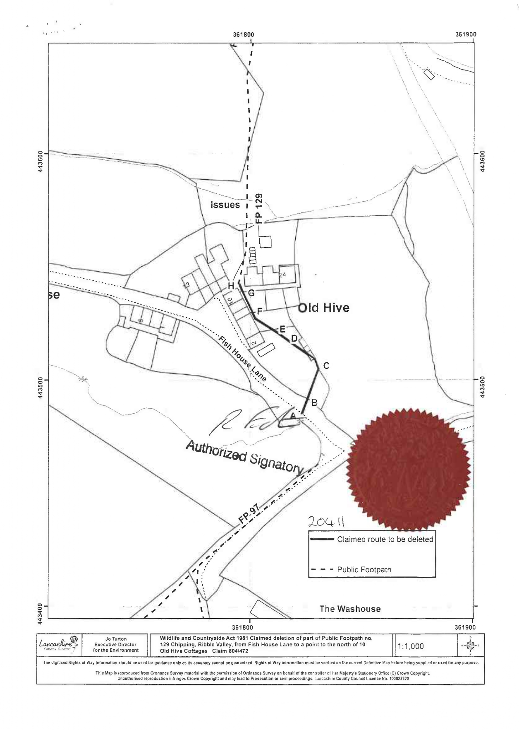

Order No.5

order 5
