Import of Services among VAT Unregistered Businesses
HMRC
March 2019


His Majesty’s Revenue and Customs Research Report: 824

Disclaimer
The views in this report are the authors’ own and do not necessarily reflect those of HM Revenue & Customs.

© King’s Printer and Controller of HMSO 2025

This publication is licensed under the terms of the Open Government Licence v3.0 except where otherwise stated. To view this licence, visit nationalarchives.gov.uk/doc/open-government-licence/version/3.

Where we have identified any third party copyright information you will need to obtain permission from the copyright holders concerned.

Published by HM Revenue and Customs, June 2025

Contents
1 Glossary of terms 4
2 Executive summary 5
Introduction 5
Importing services 5
Importing and exporting goods 6
3 Introduction 8
Background and objectives 8
Methodology 8
Sample 9
Approach to analysis 10
Reporting Conventions 10
Report structure 10
4 Importing Services: Behaviour over the last 12 months 11
Trade behaviour 11
The types of services imported over the last 12 months 11
The value of services imported over the last 12 months 12
The origin of services imported over the last 12 months 13
The frequency of service imports over the last 12 months 14
The reasons for importing services 15
The use of intermediaries to import services over the last 12 months 16
5 Importing services: Recent and expected changes 17
Experiences over last 12 months 17
Expectations over next 12 months and after EU exit 17
6 Importing services: Place of supply 20
Whether treated as business or individual 20
Reverse charge 22
7 Importing and exporting goods 24
Sources and destinations of traded goods 24
Trade of finished and unfinished goods 24
8 Appendix 25
Profile of businesses that imported services 25

Glossary of terms
VAT
Value added tax (VAT) is an indirect tax placed on goods or services and is charged when the transaction occurs.

VAT unregistered business
If a business has a turnover of under £85,000 they are not required to register for VAT payments, although they can voluntarily register to pay VAT.

Place of supply
Place of supply rules indicate who is responsible for paying VAT when a business based inside the UK purchases services from outside the UK. The place of supply general rule states that when a supply of services takes place from one business to another (B2B), VAT is due where the receiving business is located. When the receiving business and the supplying business are both in the UK then it is the supplying business who will charge and account for VAT. Whether the receiving business is VAT registered does not alter whether VAT is charged. When the receiving business is located in the UK and the supplying business is located overseas then the VAT rules are different. In these circumstances it is the receiving UK business who is responsible for calculating and remitting VAT. This is known as the ‘reverse charge.’

Reverse charge
When a VAT unregistered business purchases services from a business outside of the UK, place of supply rules dictate that the UK business is responsible for calculating and remitting VAT. They are then required to add the value of the supply to their own taxable turnover. If the VAT unregistered business is still under the VAT registration threshold they do not need to remit any VAT to HMRC.

Intermediary
A person who conducts a transaction on behalf of a purchasing business from a supplier. Examples include agents and brokers.

EU
Member countries of the European Union, in this context not including the United Kingdom.

Rest of World (RoW)
All other countries not in the EU, in this context not including the United Kingdom.

Executive summary

Introduction
This research was commissioned by HMRC to provide more information on the nature and scale of services imported by VAT unregistered businesses (from both inside and outside the European Union). In the context of the UK’s exit from the EU the research had two principal objectives:
- to understand overseas trade behaviour of VAT unregistered businesses; and
- to understand the impact that EU exit might have on small UK businesses buying in services from overseas.
A total of 196 telephone interviews were conducted with owners of VAT unregistered businesses that had imported services in the preceding 12 months.

Importing services

Behaviour over the last 12 months
For most of the businesses that had imported services over the last 12 months, this was the only form of overseas trade they had conducted: 82% had only traded services (and not goods), while 18% had traded goods in addition to services. Looking specifically at the type of service trade conducted, 94% had only imported services (and not exported services), while 6% that had imported services had also exported services. Typically, the number of services that businesses imported was also limited: half of businesses (52%) had only imported one type of service in the last 12 months.
Three types of services stood out as being the most commonly imported: 45% of businesses imported website design and hosting (for example, storage on an external server or providing internet access), 41% imported e-commerce services (for example, using a website or app as a platform to sell to customers), and 37% imported marketing services (for example, social media advertising or search engine optimisation). While a variety of other services had also been imported, each other type had only been imported by less than 10% of businesses.
The value of imported services was quite low, 57% of businesses had imported less than £1,000 worth of services in the last 12 months. E-commerce services had the highest average value amongst the three main types of imported services, with a median annual value of £750.
Businesses were more likely to have imported services only from countries outside of the EU (43%) than from inside the EU (25%) or from both inside and outside the EU (25%). This pattern was more pronounced among businesses that imported website design and hosting: 71% of businesses had imported these services from non-EU countries. The origin of e-commerce and marketing services were both closely aligned to the overall pattern of service origin.
E-commerce and marketing services were imported more frequently than website services. Two thirds of businesses imported e-commerce (65%) and marketing services (64%) at least monthly. More than half (56%) of businesses that had imported website services had only purchased them once over the last 12 months.
The most common reason that businesses chose to import website services was that importing provided better value for money (53%). The most common reason given for importing e-commerce and marketing services was due to them being unavailable in the UK (49% and 50%).
Few businesses (12%) used an intermediary to import services. Of these, most used an agent or broker and engaged with them through an online platform or app.

Recent and expected changes
Most businesses had seen the value of imported services remain the same over the 12 months prior to their participation in the research. Although, a significantly higher proportion of those that had imported from outside the EU reported that this was the case (71%) than those that had imported from inside the EU (57%). The value of services for both origins was more likely to have increased (29% EU; 21% non-EU) than decreased (12% EU; 6% non-EU).
When asked about expectations over the next 12 months, over half of businesses expected that the value of imported services would remain the same (57% EU and 58% non-EU). A slightly higher proportion of businesses that imported from outside the EU (30%) anticipated an increase in the value of imported services than those that had imported from inside the EU (23%). Less than one in ten anticipated that the value of imported services would decrease (10% for EU and 7% for non-EU).
Considering the UK’s planned departure from the EU, 45% of businesses importing from the EU anticipated no effect on their trade behaviour. Conversely, 40% expected that the UK’s exit would have an impact on their EU service imports, citing expected price increases and changes to regulation. The remaining 15% reported that they did not know whether to expect a change to their EU service imports.
Only 21% of businesses that had imported from outside the EU anticipated that the UK’s exit would have an impact on those service imports. 67% anticipated that the exit would not have an impact, and 12% did not know what to expect.

Place of supply
When importing services, 60% of businesses reported they were treated as a business (and not an individual) for tax purposes. Overall, 29% of businesses were asked to provide proof that they were a business.
The majority (82%) of businesses reported that they include the value of imported services when calculating annual turnover, in accordance with reverse charge rules. However, awareness and understanding of the term ‘reverse charge’ was low: only 19% of businesses were aware of this term and even fewer understood how it applied to their business (8%).

Importing and exporting goods
An additional 322 short telephone interviews were conducted with owners of VAT unregistered businesses that had imported or exported goods (but had not imported services) in the preceding 12 months. Due to the sampling approach taken to narrow the industry (SIC) sectors in scope (see paragraph 3.9 for more detail), the results of this survey are not representative of the overall population of VAT unregistered businesses that trade goods. For this reason, this report will discuss these findings at an overview level only.
Within the selected sectors, the majority of businesses that had conducted overseas trade of goods over the last 12 months (and not imported services) had imported goods over that period. Only a minority had exported goods. A similar proportion of businesses had imported from EU and non-EU countries, although slightly more from outside the EU. The majority had imported finished (as opposed to unfinished) goods.
The value of exported goods was on average higher than the value of imported goods, and the value of goods that had been imported from the EU was higher than goods imported from outside the EU.

Introduction

Background and objectives
In the context of the UK’s exit from the European Union (EU), it is not known how purchase and supply of goods and services from the EU and Rest of World (RoW) might change. This being the case, HMRC required more information on the nature and scale of services currently bought by VAT unregistered businesses (from both inside and outside the EU).
This research has two principal objectives:
- to understand overseas trade behaviour of VAT unregistered businesses; and
- to understand the impact that EU exit might have on small UK businesses buying in services from overseas.
A secondary objective of this research was to explore the prevalence of importing and exporting goods among VAT unregistered businesses. However, due to the approach taken to sampling (see Sample section below) these findings are not representative of the overall population of VAT unregistered businesses that import or export goods. For this reason, this report will not discuss these findings in detail but at an overview level only.

Methodology
The research sought to speak to two groups of VAT unregistered businesses:
- those that had imported services in the preceding 12 months; and
- those that had imported or exported goods in the preceding 12 months but had not imported services.
A total of 196 telephone interviews were conducted with owners of VAT unregistered businesses that had imported services in the preceding 12 months. The survey lasted an average of 15 minutes. Table 1.1 provides a breakdown of businesses interviewed by sector.
Table 1.1 Profile of achieved interviews among VAT unregistered businesses that imported services in the preceding 12 months
 | Achieved interviews
Total | 196
By sector
Accommodation and Food Service Activities (I) | 65
Professional, Scientific and Technical Activities (M) | 63
Other Service Activities (S) | 21
Arts, Entertainment and Recreation (R) | 17
Education (P) | 9
Administrative and Support Service Activities (N) | 8
Transportation and Storage (H) | 4
Information and Communication (J) | 1
Financial and Insurance Activities (K) | 1
Public Administration and Defence (O) | 1
Real Estate Activities (L) | 1
Human Health and Social Work Activities (Q) | 1
Refused | 4

A further 322 telephone interviews were conducted with owners of VAT unregistered businesses that had imported or exported goods (but had not imported services) in the preceding 12 months. This survey lasted an average of five minutes.
All fieldwork was conducted by IFF Research using Computer Assisted Telephone Interviewing (CATI) between 17th September and 12th October 2018.

Sample
Sample was obtained through Market Location, a commercial primary data owner in the UK who independently verify and collect business data. The sample consisted of 50,000 records of UK businesses with actual or modelled turnover less than £85,000.
Initially, a random sample was drawn, with the aim of gaining a representative picture of VAT unregistered businesses that import and export services and goods. However, the incidence rate of businesses that imported services was found to be extremely low, so a decision was made to narrow down the SIC sectors in scope with the aim of achieving more interviews with the main businesses of interest. Table 3.2 outlines the sectors that were included in the targeted approach. These sectors were selected as they were considered to be the most likely to import services.
Table 3.2 Sectors included and excluded after sampling changes during early fieldwork
Sectors included | Sectors excluded
- Transportation and Storage (H) | - Agriculture, Forestry and Fishing (A)
- Accommodation and Food Service Activities (I)  - Information and Communication (J)  - Financial and Insurance Activities (K)  - Real Estate Activities (L)  - Professional, Scientific and Technical Activities (M)  - Administrative and Support Service Activities (N)  - Education (P)  - Arts, Entertainment and Recreation (R)  - Other Service Activities (S) | - Mining and Quarrying (B)  - Manufacturing (C)  - Electricity, Gas, Steam and Air Conditioning Supply (D)  - Water Supply; Sewerage, Waste Management and Remediation Activities (E)  - Construction (F)  - Wholesale and Retail Trade; Repair of Motor Vehicles and Motorcycles (G)  - Public Administration and Defence; Compulsory Social Security (O)  - Human Health and Social Work Activities (Q)  - Activities of Households as Employers; Undifferentiated Goods- and Services-producing Activities of Households for Own Use (T)  - Activities of Extraterritorial Organisations and Bodies (U)

Approach to analysis
The analysis process following the fieldwork included:
- ‘coding’ of verbatim responses into categories for analysis;
- checking for and removal of outliers on numeric variables; and
- sample information (for example, SIC codes) was appended to survey data to allow sub-group analysis.
All data presented in the report are unweighted, due to the lack of authoritative data on VAT unregistered businesses that conduct overseas trade.

Reporting Conventions
In this report, we follow a number of analysis conventions. Firstly, to be sure that all data reported is sufficiently robust, we only report data where the total base is more than 50.
Sub-group results which are significantly different to each other, or the rest of the sample are clearly marked in charts and tables. This indicates that we can be 95% confident that a ‘real’ difference exists between this sub-group and all other sub-groups in the distribution.
It is important to bear in mind an overall sample size of 196 limits the extent to which sub-group analysis can be conducted, particularly by the types of services imported. As such, throughout this report only differences by the top three most commonly imported services have been shown.
In many cases the base sizes for sub-group analysis are relatively small and as such should be treated as indicative.
Finally, figures may also not add to a total of 100% if the response was multi-coded. Where all responses have been included, figures may not sum to exactly 100% due to rounding.

Report structure
The remainder of this report explores the findings from the research as follows:
- Chapter 4 covers the trade behaviour of VAT unregistered businesses that import services;
- Chapter 5 explores changes to service imports over the preceding and following 12 months, including the anticipated impact of the UK’s exit from the EU;
- Chapter 6 focuses on the current implementation of the place of supply rule when VAT unregistered businesses import services; and
- Chapter 7 provides an overview of findings from the research into VAT unregistered businesses that import and export goods (and do not import services).

Importing Services: Behaviour over the last 12 months
This chapter explores the behaviour of VAT unregistered businesses that imported services over the last 12 months. Specifically, the chapter describes the types of services imported, the value of imported services, the origin of imported services, the frequency at which they were imported, and the reasons why they were imported.

Trade behaviour
Four fifths (82%) of businesses interviewed that had imported services over the last 12 months had only traded services internationally (as opposed to trading goods and services). The remaining fifth (18%) of businesses had traded goods in addition to services; 16% had only imported goods and services, and 2% had imported and exported goods and imported services.
Focusing specifically on the direction of trade in services conducted over the last 12 months, nearly all businesses (94%) had only imported services. Just 6% of businesses interviewed that had imported services had also exported services.

The types of services imported over the last 12 months
As presented in Figure 4.1, three types of services stood out as being the most commonly imported over the preceding 12 months: website services (45%), e-commerce services (41%) and marketing services (37%). Other services imported by more than 5% of businesses were services related to software (10% imported software design services and 6% imported software on a subscription basis) and accounting and bookkeeping services (7%).
The list below provides more detail on the nature of the top three most commonly imported services.
- Website services imported over the last 12 months included services relevant to the design and ‘hosting’ of websites (i.e. storage on an external service and providing internet access).
- E-commerce services imported over the last 12 months related to the use of online platforms that host and process transactions. For example, a few businesses in the accommodation sector said that they imported services which enabled them to advertise and sell vacancies via websites and apps.
- Marketing services imported by businesses over the last 12 months covered a range of services purchased to promote their businesses, including social media advertising and Search Engine Optimisation (SEO).

Figure 4.1 The types of services imported over the last 12 months
Base: All businesses that import services (196).

Half (52%) of business that had imported services over the last 12 months had only imported one type of service. 26% of businesses had imported two types of service and 18% had imported three or more types of service. Businesses that imported more than one type of service typically imported a selection of the top three services.

The value of services imported over the last 12 months
Figure 4.2 shows that the total value of services imported over the last 12 months ranged from £100 or less (17%) to more than £20,000 (4%). However, despite this range in total value, 57% of businesses spent a total of £1,000 or less on imported services over the last 12 months. The median total value of imported services was £750. Owing to the wide range in the total value of imported services, the mean total value of imported services was much higher than the median: £3,650.
Figure 4.2 The value of services imported over the last 12 months

Base: All businesses that import services (196); businesses that import website services (89); businesses that import e-commerce services (80); businesses that import marketing services (72). Note: Means and medians are based on businesses that provided a proportion of value and have been rounded to the nearest 10 (all services: 188; website services: 83; e-commerce services: 67; marketing services: 59).
The average value of e-commerce services imported over the last 12 months was the highest of the three most commonly imported services, with a median value of £750 and a mean value of £3,730. The average value of website services imported over the last 12 months was the lowest of the three most commonly imported services, with a median value of £150 and a mean value of £680. This was caused by a significantly higher proportion of businesses spending £1,000 or less compared to the total value of all imported services (83% vs 57%).

The origin of services imported over the last 12 months
The remainder of this chapter covers the overall behaviour of businesses that imported services over the last 12 months, with a focus on the top three most commonly imported services (website services, e-commerce services and marketing services).
As presented in Figure 4.3, businesses interviewed were more likely to have imported services from non-EU companies than EU companies over the last 12 months. Overall, 43% of businesses had only imported services from non-EU companies, 25% had imported services from only EU companies and a further 23% had imported services from both EU and non-EU companies.
Figure 4.3 The origin of services imported over the last 12 months

Base: All businesses that import services (196); businesses that import website services (78); businesses that import e-commerce services (63); businesses that import marketing services (56).
The origin of imported e-commerce and marketing services were similar. Around two fifths of businesses had imported these two services from non-EU companies (e-commerce: 41%, marketing: 45%) and a similar proportion had imported these two services from EU companies (e-commerce: 37%, marketing: 38%). Only a small proportion of businesses had imported these services from both EU and non-EU companies (e-commerce: 14%, marketing: 13%).
By contrast, website services were significantly more likely to be imported from non-EU companies; nearly three quarters (71%) of businesses that had imported website services had done so from companies based outside the EU. Only 13% had imported website services from EU companies and even fewer (9%) had imported website services from EU and non-EU companies.

The frequency of service imports over the last 12 months
Figure 4.4 shows how frequently website, e-commerce and marketing services were imported over the last 12 months. E-commerce and marketing services were imported more frequently than website services, with two thirds having imported these services monthly or more often (65% and 64%). By comparison, 37% of businesses that had imported website services had purchased them monthly or more often. 56% of businesses that had imported website services had only purchased them once over the last 12 months.
Given the nature of website services it is perhaps unsurprising that they were imported less often than e-commerce and marketing services over the last 12 months. Typically, the design or re-design of a website is a service procured by businesses relatively infrequently. Meanwhile e-commerce and marketing services are often used on a daily basis.

Figure 4.4 How frequently services were imported over the last 12 months

Base: Businesses that import website services (78); businesses that import e-commerce services (63); businesses that import marketing services (56).

The reasons for importing services
Figure 4.5 presents the reasons why businesses chose to import website, e-commerce and marketing services rather than buying them from domestic suppliers.
The most common reason for importing website services was because they were cheaper or better value for money (53%). Around a third of businesses that imported either e-commerce or marketing services did so because it was cheaper or better value for money (e-commerce: 32% and marketing: 29%).
Among those that imported e-commerce and marketing services over the last 12 months, the most common reason for doing so was unavailability in the UK. Around half of businesses that imported either of these services highlighted this as a reason (e-commerce: 49%, marketing: 50%). By contrast, only 14% that imported website services said they chose to do this because of unavailability in the UK.
Other prominent reasons for importing website, e-commerce and marketing services were because the services were better quality (website: 45%, e-commerce: 30%, marketing: 41%) and because businesses had long-standing relationships with the service providers (website: 37%, e-commerce: 32%, marketing: 27%).

Figure 4.5 The reasons why businesses chose to import services

Base: Businesses that import website services (78); businesses that import e-commerce services (63); businesses that import marketing services (56).

The use of intermediaries to import services over the last 12 months
Overall, only 12% of businesses used an intermediary to import services rather than importing them directly from the service provider. These intermediaries offer businesses assistance with identifying suppliers of their required service and brokering deals. For example, a business interested in importing e-commerce services may use an intermediary to identify the most appropriate platform for them to host and process transactions through.

Importing services: Recent and expected changes
Businesses that imported services in the last 12 months were asked about changes to the value of these imports over the last 12 months, and if they expect the value of their imports to increase over the next 12 months. Following this, they were asked specifically whether the UK’s exit from the EU would affect the value of their service imports.

Experiences over last 12 months
The majority of businesses reported that the value of their service imports had not changed over the last 12 months. This was significantly more likely to be the case for businesses that had imported services from non-EU countries (71%) than businesses importing from the EU (57%).
Overall, the value of imports from the EU were more likely to have changed over the last 12 months than the value of imports from outside the EU. Of those who had imported from the EU, the value of imported services had:
- increased for 29%;
- decreased for 12%.
And for those that imported from outside the EU, the value of imported services had:
- increased for 21%;
- decreased for 6%.
Among businesses who had imported from non-EU countries, those who had imported web design and hosting services were more likely to have seen the value of their imports remain stable (79%). This is likely to be linked to the fact that the importing of web design and hosting was relatively infrequent compared to other services (the less frequently a service is purchased, the fewer opportunities to observe a fluctuation in price).

Expectations over next 12 months and after EU exit
A small proportion of businesses reported that they did not know what they expected to happen to the value of their imported services over the next 12 months.
Figure 5.1 Expected change in monetary value of imported services over next 12 months
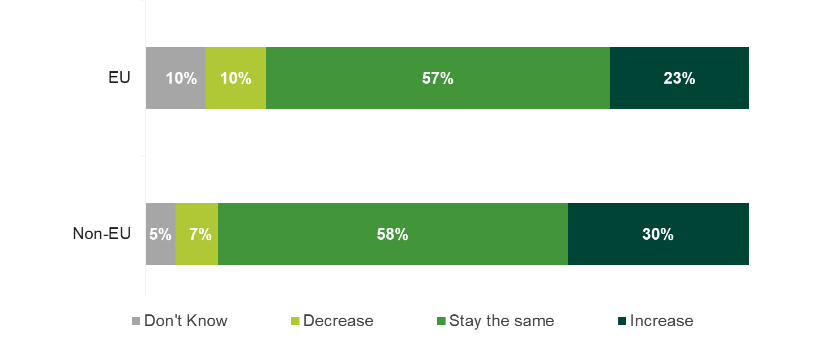
Bases: Businesses importing from inside the EU (94); businesses importing from outside the EU (129).

40% of businesses who imported services from the EU in the last 12 months expected that the UK’s exit from the EU will have an impact on the services that they import. 45% anticipated that EU exit will not have an impact.
Businesses that expected leaving the EU to have an impact on the services they import, were significantly more likely (than those that did not expect an impact) to anticipate an increase in the value of their EU service imports over the next 12 months: 42% of these businesses reported they expect an increase, while only 12% of businesses that did not expect an impact anticipated an increase in value. While the reason behind the expected increase is unclear, it is possible that it is related to increases in price (as opposed to increased volume of imports), as this was the most commonly expected effect of EU exit.
“With all the uncertainty surrounding exiting the EU, and the effect this has on exchange rates it will most likely increase costs for me”
Importer of marketing and software design services, from both inside and outside the EU

When compared to those importing from inside the EU, a much lower proportion of businesses importing from outside the EU anticipated that the UK’s exit from the EU will affect those service imports: 21% expected a change, and 67% felt there will not be an impact. Businesses that expected EU exit will affect their non-EU service imports were significantly more likely to expect their non-EU service import value will increase (44%) than remain the same (9%) over the next 12 months.
Figure 5.2 Businesses expecting a change to service imports after UK’s exit from the EU
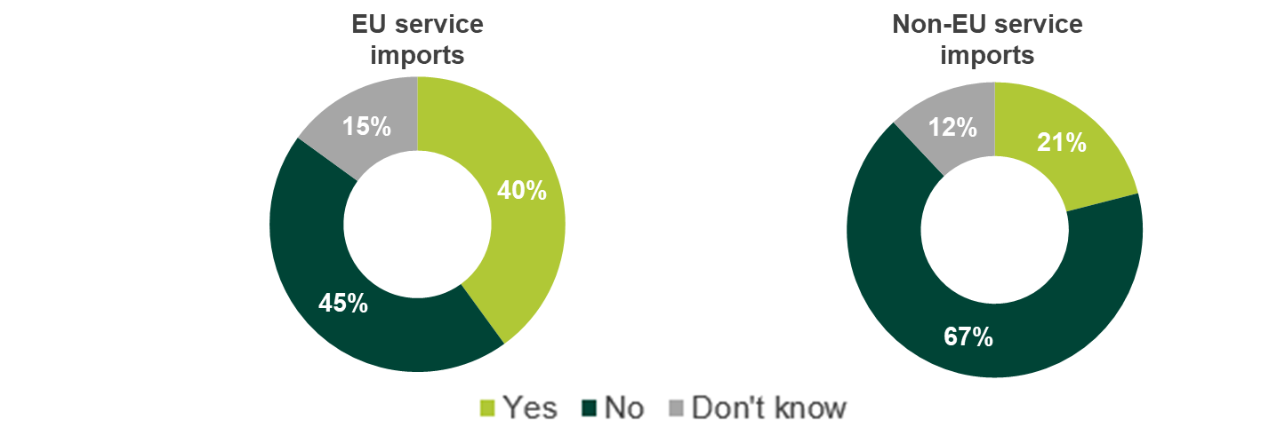
Bases: Businesses importing from inside the EU (94); Businesses importing from outside the EU (129).

Importing services: Place of supply
This chapter covers the current experiences of VAT unregistered businesses in relation to the place of supply rules that govern who is responsible for paying VAT on overseas transactions. These rules state that if the supply is business-to-business (B2B) and the supplier is overseas, the receiving business is responsible for VAT. When a receiving business is not VAT registered they are required to add the value of the services to their own taxable turnover. This is known as the ‘reverse charge’.
However, some EU member states will treat small UK businesses as individual private customers if they cannot provide a VAT registration number. In such circumstances, the business-to-consumer (B2C) place of supply rule is applied in which the supplier is responsible for the VAT.
VAT unregistered businesses who have imported services were asked whether they were treated as a business (B2B) or an individual (B2C) and whether they were asked to provide proof they are a business. Following this, businesses were asked about their behaviour regarding reverse charge, and their awareness and understanding of the term.

Whether treated as business or individual
60% of businesses interviewed reported they were treated as a business when importing services, with 30% reporting they were treated as an individual. The remaining 10% did not know how they were treated during these transactions. There were no clear patterns around which businesses were treated as businesses or individuals.
Figure 6.1 How businesses were treated during transactions
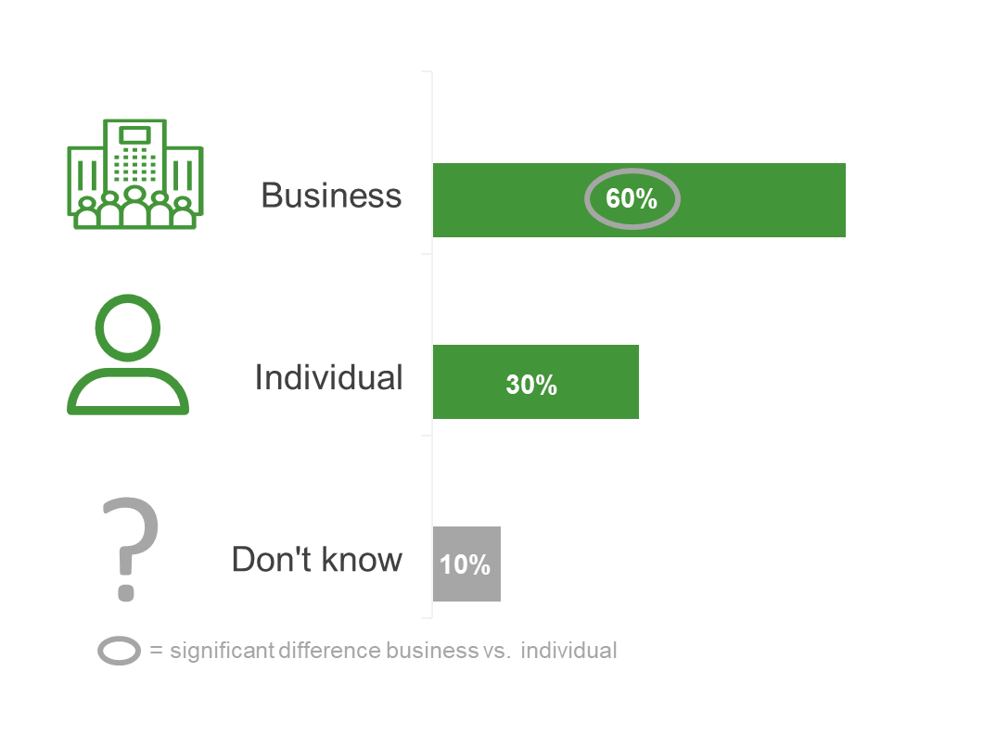

Base: Businesses that import services (196).

Overall, 29% of businesses importing services from outside of the UK had been asked to provide proof that they were a business, with 64% never having been asked. 80% of businesses treated as an individual were not asked for identification. However, 12% of businesses treated as individuals reported being asked to provide proof they were a business. This may suggest the reason these businesses were treated as individuals was they were not able to provide an acceptable form of identification when asked. The remaining 8% of businesses that had been treated as an individual were unable to recall if they had been asked for identification.
Figure 6.2 Proportion asked for identification by treatment during transactions
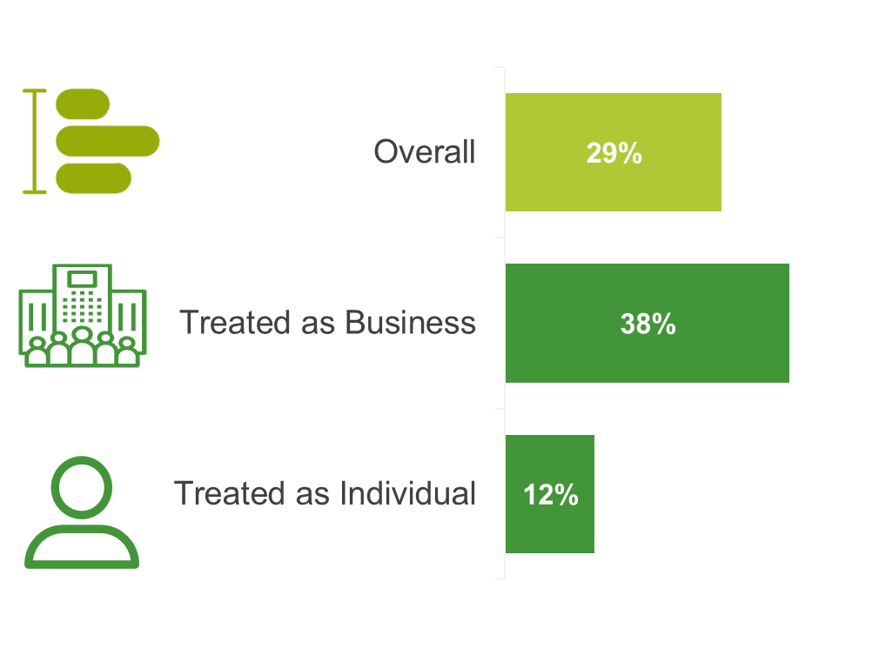
Base: Businesses that import services overall (196); those treated as a business (117); those treated as an individual (59).
Businesses were significantly more likely to be asked for proof they were a business when importing marketing (42%) and e-commerce (40%) services compared with website design and hosting (22%). It is not clear why this is the case, although it could be related to the fact that overall website design and hosting services were imported less frequently so there were fewer opportunities for them to be asked to provide proof. Alternatively, it could be due to the nature of the service being imported: for example, when designing a company website it would be apparent to the supplier that the customer is a business. Additionally, businesses importing three or more services were significantly more likely to be asked for identification (44%) when compared to those importing a single service (23%). Again, this is likely to be related to the frequency of opportunities to be asked to provide proof.
The most common type of identification requested of businesses was website information (32%).
Figure 6.3 Types of identification businesses were asked for to provide proof they are a business and not an individual consumer

Base: Businesses that were asked to provide proof (57).

Reverse charge
When calculating annual turnover, 82% of businesses interviewed included the value of imported services. This suggests that most businesses are being taxed appropriately. Businesses that spent over £1,000 on imported services were significantly more likely to have included the value of those services when calculating their annual turnover than businesses that spent £1,000 or less (90% vs 77%).
Despite the high proportion including the value in their annual turnover, 80% of businesses importing services were unaware of the term reverse charge. Only one in five (19%) reported that they were aware of the term, however half of these (10%) felt they were only slightly aware.
Figure 6.4 Awareness of the term ‘reverse charge’
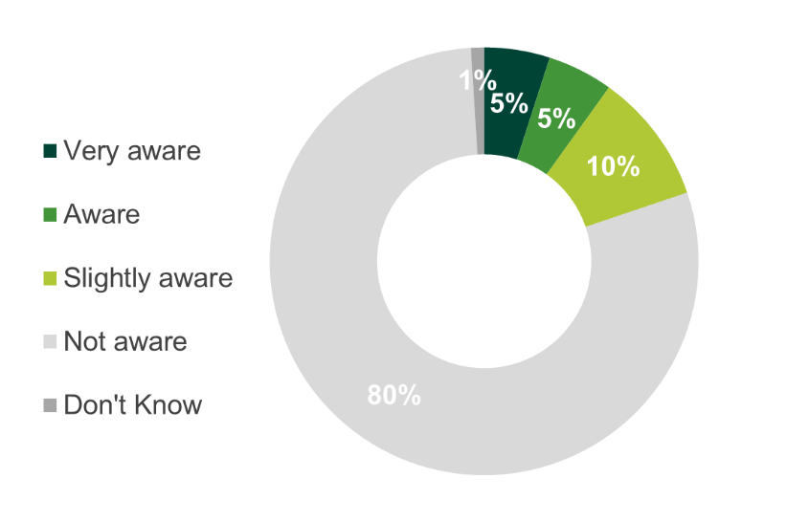
Base: Businesses that import services (196).
Awareness did not differ according to how businesses were treated during service importing activities, with no significant difference between those treated as a business (20%) or individuals (22%). The origin of imported services also had no effect, with overall awareness for businesses importing from within the EU (21%) having a similar level of awareness as those importing from outside the EU (22%).
Understanding of the application of reverse charge was also low: overall only 8% of businesses felt they understood how reverse charge applies to their business. Whilst just under half of those with an awareness of the term reverse charge felt they understood how it applied to their business, approximately a third were unsure. This suggests that very few businesses are aware of the term reverse charge and among those who were, only a few understood how it applied to their business.

Importing and exporting goods
VAT unregistered businesses that had imported or exported goods in the preceding 12 months (but not imported services) completed a short interview. This interview covered the source of imported goods, the destination of exported goods, whether the trade was of finished or unfinished goods, and the value of the traded goods. Due to the sampling approach taken to narrow the industry (SIC) sectors in scope (see paragraph 3.9 for more detail), the results of this survey are not representative of the overall population of VAT unregistered businesses that trade goods. For this reason, this chapter will discuss these findings at an overview level only.
From the sectors interviewed, 88% of VAT unregistered businesses that had conducted overseas trade of goods had only imported goods. Under a tenth (7%) had only exported goods, and only 5% had both imported and exported.

Sources and destinations of traded goods
A slightly higher proportion of businesses from the sectors interviewed had imported goods from outside the EU than had imported from inside the EU (61% EU; 70% non-EU). Businesses were equally likely to have imported from only countries in the EU, only countries outside the EU, or from both inside and outside the EU.
Of those who had exported goods, a similar proportion from the sectors interviewed had exported those goods to countries inside the EU as had exported to countries outside the EU. Around half of businesses had exported to both EU and non-EU destinations, and businesses were twice as likely to have exported to both rather than only one or the other.
The value of goods traded by the sectors interviewed (whether imported or exported) was higher on average for trade with countries in the EU than countries outside the EU. For businesses that had imported goods from both inside and outside the EU, the value was roughly equal from EU and non-EU sources.

Trade of finished and unfinished goods
The vast majority of overseas trade conducted by businesses from the sectors interviewed was of finished goods, both when importing (91% of those that imported from inside the EU, and 92% of those that imported from outside the EU) and when exporting. A minority of businesses had imported unfinished goods, around half of which had also imported finished goods as well. Of the businesses that had exported goods, only a very small minority had exported unfinished goods, and when they did it was in addition to exporting finished goods.

Appendix

Profile of businesses that imported services
Figure 8.1 Business location

Base: Businesses that import services (196).
Figure 8.2 Business size (number of employees)
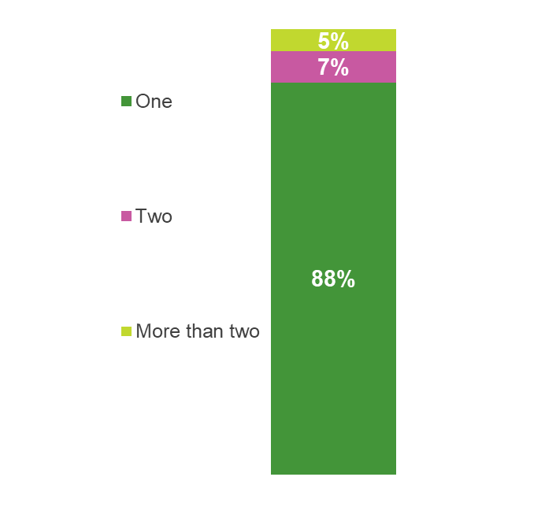
Base: Businesses that import services (196).

Figure 8.3 Annual turnover
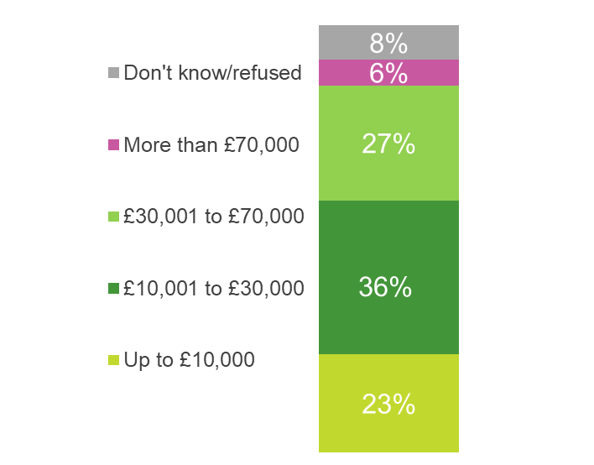
Base: Businesses that import services (196).

“

IFF Research illuminates the world for organisations businesses and individuals helping them to make better-informed decisions.”

Our Values:

1. Being human first:
Whether employer or employee, client or collaborator, we are all humans first and foremost. Recognising this essential humanity is central to how we conduct our business, and how we lead our lives. We respect and accommodate each individual’s way of thinking, working and communicating, mindful of the fact that each has their own story and means of telling it.

2. Impartiality and independence:
IFF is a research-led organisation which believes in letting the evidence do the talking. We don’t undertake projects with a preconception of what “the answer” is, and we don’t hide from the truths that research reveals. We are independent, in the research we conduct, of political flavour or dogma. We are open-minded, imaginative and intellectually rigorous.

3. Making a difference:
At IFF, we want to make a difference to the clients we work with, and we work with clients who share our ambition for positive change. We expect all IFF staff to take personal responsibility for everything they do at work, which should always be the best they can deliver.

Two respondents were removed from the dataset that had reported a particularly high value of imported services.
Other services imported over the last 12 months were: administrative services (5%); training/consultation services (4%); translation services (3%); transport or delivery services (2%); and event management services (2%).
For example, a third (36%) of businesses that had imported website services had also imported marketing services and a third (35%) had also imported e-commerce services.
Means and medians rounded to the nearest 10.
Although this is a quantitative report, this question was asked as an open response question. This verbatim quote has been added to illustrate the point.
Due to the low base size of businesses that exported goods (40) these findings should be treated as indicative and figures have not been included.

