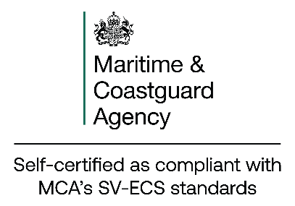

#Insert OEM logo#

SMALL VESSEL ECS (SV-ECS)
STATEMENT OF COMPLIANCE

- To be completed by the OEM
OEM/Supplier:
OEM Contact:
Hardware Model:
Software Version:
Operational Limitations: | Protected Bridge/Wheelhouse ☐  Exposed Cockpit ☐
The OEM/Supplier confirm that the hardware model and/or the software version indicated in this form, in line with the assessed operational limitations (if applicable), complies with the requirements stipulated within the SV-ECS performance standard and all other requirements as identified in MGN 319 (as amended), “Acceptance of Electronic Chart Systems for fishing vessels and small vessels in commercial use (code boats) up to 24 metres in load line length (SV-ECS).”
Name and Position of Issuer:
Signature of Issuer:
- To be completed by the Master
Vessel Name:
Vessel Identification Number:
Hardware S/N:
Software S/N:
Backup Arrangement: | Secondary SV-ECS (Appendix 5 – Option A) ☐  Suitable paper charts (Appendix 5 – Option B) ☐  Portable Solution (Appendix 5 – Option C) ☐
The Master confirms that the SV-ECS onboard the vessel:
- Is used in conjunction with electronic navigational charts (ENCs), which have been published by an accepted National Hydrographic Office.
- Such ENCs are suitably corrected up-to-date and
- Backup arrangements identified on this form are available and in compliance with the requirements stipulated within MGN 319 (as amended).
Date:
Name of Master:
Signature of Master:

This statement, or a certified copy, must be kept on board the vessel at all times

Where the hardware and software are provided by separate OEM’s, two statements are required to be maintained.

SV-ECS conforming to the MCA published performance standard are not a substitute for approved Electronic Chart Display and Information Systems (ECDIS) and they are not accepted for use other than as prescribed within MGN 319 (as amended).

For further details please contact MCA via navigationsafety@mcga.gov.uk

