+++
September 2023
Customs Admin Burden research
Summary report
HM Revenue and Customs Research Report

Rebecca Klahr, Ben Swannell and Jacob Bellamy

Disclaimer

The views in this report are the author’s own and do not necessarily reflect those of HM Revenue and Customs.

© King’s Printer and Controller of HMSO 2025
This publication is licensed under the terms of the Open Government Licence v3.0 except where otherwise stated. To view this licence, visit nationalarchives.gov.uk/doc/open-government-licence/version/3.
Where we have identified any third party copyright information you will need to obtain permission from the copyright holders concerned.
Published by HM Revenue and Customs, June 2025

22-081614-01 Customs Admin Burden Research | Version 1 | Public | Internal Use Only | Strictly Confidential | This work was carried out in accordance with the requirements of the international quality standard for Market Research, ISO 20252, and with the Ipsos Terms and Conditions which can be found at http://www.ipsos.com/terms. © HMRC 2023
Contents
Glossary and abbreviations 4
1 Executive summary 1
Trader overview 1
Cost of completing individual declarations 1
Additional costs of completing customs declarations 2
2 Introduction 4
2.1 Methodology 4
2.2 Reporting notes 4
3 Declaration usage 5
3.1 Business characteristics 5
3.2 Use of intermediaries 5
3.3 Number of declarations for business overall 6
3.4 Types of customs declaration completed 6
3.5 Mean and median number of each customs declaration type 6
4 Declaration level data 8
4.1 Staff cost per declaration 9
4.2 Time spent per declaration 10
4.3 Submitting declarations in-house or via a third-party 12
4.4 Ease of preparing information for declarations 14
4.5 Staff members responsible for completing declarations 15
4.6 Average number of items covered by each declaration type 16
4.7 Preparing declarations for EU and rest of the world (RoW) 17
4.8 Agent cost per declaration 17
4.9 Costs of completing declarations for those who did not know that specific declaration types they submitted 19
5 Additional costs of customs declarations 22
5.1 Prevalence and cost of training on customs declarations 22
5.2 Prevalence of software used to submit customs declarations 23
5.3 Software being used for customs declarations 23
5.4 Experience of delays clearing customs 23
5.5 Experience of customs warehouses 24
Annex 1: Additional information 25
Annex 2: Additional data tables 32
Annex 3: Fieldwork outcomes 41
Annex 4: Data cleaning and weighting 42
Annex 5: Margins of error 44

Glossary and abbreviations
Term | Definition
Bulk Import Reduced Dataset (BIRDS) | A Bulk Import Reduced Dataset is a form that is used to declare one or more low value postal packets in a single import declaration. This includes goods sent by:  - Letter  - Parcel  - Packet  - Any other article transmissible by post
C21 form | C21 form is used to request the release of goods at a location with an inventory system for CHIEF/CDS.
Customs Declaration Service (CDS) | The Customs Declaration Service (CDS) is a HMRC system designed to replace the Customs Handling of Import and Export Freight (CHIEF) system (please see definition in the row below). CDS replaced CHIEF for most import declarations on 30th September 2022, and most export declarations are expected to have migrated to CDS by the end of March 2024 when CDS will become the UK’s single customs platform. During the fieldwork for this research, CDS was in place for import declarations and CHIEF in place for export declarations.
Customs Handling of Import and Export Freight (CHIEF) | The Customs Handling of Import and Export Freight (CHIEF) system records the movement of goods by land, air and sea. It allows importers, exporters, and freight forwarders to complete customs formalities electronically and automatically checks entry errors. CHIEF was closed for most import declarations at the end of September 2022, and most export declarations are expected to have migrated to CDS by the end of March 2024 when CDS will become the UK’s single customs platform. During the fieldwork for this research, CDS was in place for import declarations and CHIEF in place for export declarations.
Customs agent or broker | Customs brokers complete declaration forms on behalf of businesses importing and/or exporting goods. Ensuring goods moving to and from the country are accurately declared for customs. They do not primarily deal with the physical movement of goods.
Customs declaration | A mandatory form listing the details of all goods being imported or exported to be submitted to the relevant government agency i.e., HMRC.
Customs intermediary | Someone that a trader hires to deal with customs on their behalf. Options for intermediaries include freight forwarders, customs agents, brokers or fast parcel operators.
Customs requirements | Customs requirements refers to handling declarations that need to be submitted when moving goods, these include: import declarations, export declarations and safety and security declarations, amongst others.
Customs software | Customs software are IT systems used to allow an authorised user e.g., Community System Provider to submit declarations into HMRC.
Customs warehouse | This is a warehouse that allows traders to store goods with duty or import VAT payments suspended. Warehouse keepers authorised by HMRC can run a customs warehouse.
Goods Vehicle Movement Service (GVMS) | The Goods Vehicle Movement Service (GVMS) is an IT platform managed by government to facilitate border movements at certain port locations. If you move goods through these ports, the businesses must register with it.
Entry in declarant’s records | An authorisation to declare goods by entering them in your commercial records and sending other details to customs with a supplementary declaration
European Union (EU) | The EU countries are Austria, Belgium, Bulgaria, Croatia, Cyprus, Czech Republic, Denmark, Estonia, Finland, France, Germany, Greece, Hungary, Ireland, Italy, Latvia, Lithuania, Luxembourg, Malta, Netherlands, Poland, Portugal, Romania, Slovakia, Slovenia, Spain, and Sweden.
Exit summary declaration | An exit summary declaration is required when goods:  - have remained in temporary storage for more than 14 days  - have remained in temporary storage for less than 14 days, but the import safety and security declaration details are unknown, or the destination or consignee has changed  - are moved under transit and there is no full export declaration
Export(ing) | Selling goods or services to a customer in a different country.
Express operator | Express operators, an umbrella term including couriers and fast parcel operators (FPOs), offer a range of customs services for low and high value parcels. Examples include DHL and UPS.
Freight forwarder | Freight forwarders, also known as shipping agents, facilitate the movement of goods between countries and handle all aspects of the movement, including shipping and customs. They cover the movement of goods via all different mediums: road, rail, air, and sea. They help traders to move goods directly (where they have their own fleet of vehicles) or indirectly (where they contract haulage operators or shipping lines to move goods).
Full export declaration | A full export declaration is an official document in which a business specifies all the details of the goods that a business is exporting.
Full import declaration | A full import declaration is an official document in which a business specifies all the details of the goods that a business is importing.
Generalized System of Preferences (GSP) | Generalized System of Preferences is a preferential tariff system that reduces customs duties and other tariffs associated with exporting goods
Goods | Tangible products such as books, clothes, tools etc.
Haulier | Hauliers deal mainly with the physical transportation of goods.
Import(ing) | Purchasing goods or services from sellers in a different country. This research focused purely on goods as customs declarations are not required for services.
Large trader | Firms with 250+ employees.
Local clearance procedure | The local clearance procedure is the process that needs to be completed by businesses to release goods to another customs procedure.
Micro trader | Firms with 1-9 employees.
Medium trader | Firms with 50-249 employees.
Merchandise in baggage (MIB) | Commercial goods carried in accompanied baggage or small vehicles. These are non-freight. For goods valued over £1,500 which are controlled goods or weigh over 1,000kg - travellers need to make a full customs declaration electronically into CHIEF/CDS before arriving at a GB port of entry.
Nano trader | Firms with 0 employees (sole traders)
Obtaining transit authorisation | An application for transit authorisation is permission from a government to move goods internationally.
Request for binding tariff information | The amount of duty payable on imported goods is based on the tariff classification assigned to those goods. Upon request, the Customs authorities will provide binding tariff information. This is confirmation that the goods fall into a particular tariff category.
Rest of the world (RoW) | Countries outside of the UK and EU.
Rules of origin | Rules of origin are the criteria needed to determine the national source of a product. Their importance is derived from the fact that duties and restrictions in several cases depend upon the source of imports.
Safety and security entry summary (ENS) declaration | Safety and security declarations provide advanced data on consignments to customs authorities for risk analysis.
Small trader | Firms with 10-49 employees.
Simplified export declaration procedure | The simplified export declaration procedure is a form that contains the minimum amount of information for an exported good to clear at a border.
Simplified frontier declaration | A simplified frontier declaration is an authorisation to use a form that contains the minimum amount of information for an imported good to clear at a border.
Submission of proof of origin (certificate of origin Form A) | Products originating in GSP countries (Generalized System of Preferences, a preferential tariff system that reduces customs duties and other tariffs associated with exporting goods) are eligible for a preferential rate of duty upon submission of a completed Certificate of Origin Form A to the Customs authorities.
Supplementary declaration | A supplementary declaration is a declaration that is made after having moved a good using a simplified declaration or EIDR. This provides HMRC with any additional information that has not already been submitted during the customs process.
Supplementary notification of removal of goods from a custom warehouse | The warehouse removal declaration is the form that needs to be filled out to ensure that a good is removed from a Customs warehouse.
Trader | Businesses who import goods or services to the UK and/or export to other countries.
Unique consignment number/reference to be supplied for all electronic declarations | A trader must quote the relevant unique consignment number/reference (UCR) on all electronic declarations, for both imports and exports.
Valuation declaration (form DV1) | The customs entry made in respect of imported goods shall be accompanied by a valuation declaration (form DV1), where the value of the imported goods exceeds EUR 10,000.

- Executive summary
HM Revenue and Customs (HMRC) commissioned Ipsos to conduct research among businesses based in Great Britain (GB) that trade internationally to understand the processes involved and the administrative cost of complying with customs obligations. The data from this research will be used to inform updates to HMRC’s customs admin burden estimates. Please note that the following report presents analysis of the data from the survey conducted by Ipsos, and is separate to the work produced independently by HMRC which uses different segmentations and calculation methods, as well as additional data sources. In total, 1,003 interviews were conducted by telephone, based on a random probability sampling design, between 24 January and 3 March 2023.
The survey focused on the individual declarations completed, with each trader asked about up to two declaration types or obligations relating to declarations. This included the amount of time to gather and submit information to HMRC to complete the declaration or obligation, the staff involved, as well as the use of intermediaries and associated costs. The survey also examined other areas that may contribute additional costs, including training on how to submit customs declarations, software used to complete declarations, use of customs warehouses for storing goods and experience of delays when clearing customs.

Trader overview
The majority of businesses taking part in the survey used an agent or intermediary only to complete customs declarations (78%). In the survey, 11% completed their customs declarations in-house and 9% completed their declarations both in-house and using an agent. The most commonly used intermediaries were freight forwarders (44%), express operators (32%) and customs agents/brokers (26%).
Most traders in the survey (80%) completed a small volume of declarations per year (i.e. fewer than 300) and 3% completed more than 3,000 declarations per year.
The most common declarations traders reported dealing with were submission of proof of origin, full import and full export declarations (each being completed by around 30% of traders). By contrast, merchandise in baggage declarations and the Bulk Import Reduced Dataset were completed by a very small proportion of traders (approximately 2%).

Cost of completing individual declarations
For this survey, businesses were asked about the time taken to complete a series of activities involved with completing their customs declarations, as well as the seniority of the person mostly responsible for preparing these declarations. Using this data, along with data matched from the Annual Survey of Household Earning (ASHE), an internal staff cost was estimated for each participating business.
The survey showed the median total internal staff cost per declaration was highest for simplified frontier declarations, with a median cost of £29 per declaration. For the other types of declaration, the median total internal staff cost per declaration was between £12 (for a full export declaration) and £25 (for local clearance procedures). The most frequently completed declarations, such as full export and import declarations, did not have the highest internal staff cost and time for traders.
The time spent per declaration was also highest for simplified frontier declarations, which took 114 minutes per declaration on average among surveyed businesses. For the other types of declaration, the average amount of time spent per declaration ranged from 72 minutes (simplified export declaration procedure) to 108 minutes (for local clearance procedures).
For the declarations with the largest internal staff cost and time, businesses in the survey were most likely to use a third party agent. Local clearance procedures and import C21 forms were outsourced by 64% and 74% of traders respectively, while simplified export declarations, which took less time, were outsourced by around 4 in 10 (42%). More traders in the survey spent time gathering relevant figures and information and making or settling payments such as taxes or charges compared to the other activities, while the median time taken across different activity categories was generally between 15 and 30 minutes.
Most often intermediaries were used to complete full import declarations (75%) and C21 forms for imports (74%). By contrast, agents were least likely to be used for simplified export declaration procedures (42%). Across all declarations, the type of agent used varied by declaration and were typically customs brokers, freight forwarders and express operators.
Traders in the survey largely reported that preparing and providing the information for declarations was very or fairly easy, even amongst those declarations with the greatest internal staff time and cost -61% of those asked about local clearance procedures found the information easy or very easy to prepare, with the same proportion for C21 export forms.
Manager level staff were most commonly responsible for preparing the information required for all the declarations covered in the survey (ranging from 20% of staff mainly responsible for preparing information for full export declarations being managers, through to 36% of the staff preparing information for import unique consignment numbers being managers). Along with managers, many traders reported that more senior staff also had a role in preparing and providing information for submitting customs declarations (ranging from 15% for local clearance procedures through to 31% for simplified frontier declarations).
The survey also collected data on the cost to traders of using a third party or agent where applicable. Across declarations with sufficient sample size (C21 import forms, local clearance procedures, full import declarations, full export declarations and submission of proof of origin forms) the median cost for a single declaration was around £50.

Additional costs of completing customs declarations
The survey covered several other costs associated with submitting customs declarations and found that 10% of traders used customs warehouses, where goods can be stored without paying duties for a fixed time period. Training on submitting customs declarations, either in-house or delivered by an external organisation, was undertaken by a small proportion of traders (25%).
Traders were asked how they submitted the information to complete their customs declarations, and were able to select multiple responses. Overall, most respondents submitted information online. Among those that handled all or some declarations in-house, 53% said they submitted the information to complete their customs declarations online via software. For those that outsourced all declarations, 18% provided information to intermediaries online via software and 66% online without software (including email), while 22% said that an intermediary dealt with all the paperwork for them.
Most traders reported experiencing delays when clearing customs (12% said they never experienced delays) which may present additional costs to the sector and individual businesses. The survey did not ascertain the reason for the delays, and they may not be directly attributable to HMRC.

- Introduction
HMRC commissioned Ipsos to conduct research focusing on customs declaration obligations to help update HMRC’s customs admin burden estimates. The research focused on understanding the processes involved and the administrative cost and burden to traders of complying with HMRC customs obligations. This included the tasks that businesses are required to do and how long these take, as well as those outsourced to intermediaries.
  - Methodology
Telephone interviews were conducted between 24 January and 3 March 2023 with a sample of 1,003 businesses based in Great Britain (GB) who traded internationally. The sample of traders was drawn from a database provided by HMRC. The survey was based on a random probability sampling design. Weights have been applied to the data to ensure the survey is representative of GB based businesses who trade internationally (with the EU only, or EU and rest of the world). A more detailed account of the methodology, including the response rate, data cleaning and weighting is in the Annex. All data in this report references the surveyed sample, not population-wide estimates.
  - Reporting notes
Survey results are subject to margins of error, which vary with the sample size and the percentage figure concerned. Findings with base sizes less than 50 are not shown. Where base sizes are less than 100, findings should be treated with caution. All findings are aggregated, and no individual participant can be identified. There is a further guide to statistical reliability in Annex 4 of this report.
Where figures do not sum to 100% this is due to rounding of percentages or because the questions allowed more than one response. Similarly, figures based on aggregating categories may not always reflect the sum of the individual answer categories due to rounding. Figures between 0% and 0.5% are denoted by ^.
Average figures are reported using mean and median values to demonstrate the full scale of responses. Mean values were derived by taking the average of the actual figure given or the midpoint of banded responses. Median values were derived by taking the midpoint of the frequency distribution of the values. Median figures are useful where very high or low outlying figures were reported, to provide a more accurate and balanced account.
Outliers in the dataset were identified and trimmed mean averages calculated for the time and cost variables. More details are provided in Annex 3.
- Declaration usage
This section provides an overview of the declarations completed by traders in the survey. It starts by summarising the characteristics of businesses in the sample and their use of intermediaries to handle their trading requirements. It then examines the overall number of declarations completed per year, and the prevalence of different types of declarations.
Please note that although collectively referred to as ‘declarations’ or ‘declaration types’, proof of origin forms, unique consignment numbers and local clearance procedures are declaration-related activities and not declarations in their own right.

Key findings
Most traders in the survey used solely an intermediary to handle their trading requirements (78%). Around one in ten (11%) handled customs declarations in-house, while 9% used a combination of handling declarations in-house and working with an intermediary.
In total, 80% of surveyed traders handled fewer than 300 declarations per year, while 13% completed between 300 and 3,000 declarations and 3% completed more than 3,000 declarations per year. 3% of traders did not know how many declarations they submitted.
Respondents were asked which of the declaration types they completed. The three most prevalent types of declaration were submissions of proof of origin (certificate of origin Form A) (33%), full import declarations (32%) and full export declarations (27%).
  - Business characteristics
62% of traders in the survey said they both imported and exported goods outside the UK. A further 28% only imported goods, while 10% only exported goods outside the UK.
The majority of traders had fewer than 50 employees. This included 8% that were nano businesses no employees), 50% micro businesses (1-9 employees) and 28% small businesses (10-49 employees). 10% were medium-sized businesses (50-249 employees) and 3% were large businesses with 250 or more employees.
When asked the types of products exported or imported, 21% of traders said they were manufacturing products, while 16% exported or imported electronic or electrical equipment. Other most common types of goods included food or drink products (10%), component parts (10%), furniture or homeware (9%) and motor vehicles or transport (8%).
  - Use of intermediaries
The majority of traders used solely an intermediary to handle their customs requirements when trading internationally (78%). The most common types of intermediaries were freight forwarders (44%), express operators (32%) and customs agents or brokers (26%).
11% of firms handled customs declarations only in-house, while 9% used a combination of handling declarations in-house and working with an intermediary.
  - Number of declarations for business overall
Businesses were asked how many declarations they completed per year in total, either in-house or through an intermediary. The mean number of declarations was 132 and the median was 50. Businesses have been divided into three groups, for analysis purposes, depending on the number of declarations they completed per year (3% of businesses did not know how many declarations they completed per year).
      - ‘low’ (fewer than 300 declarations per year): 80%
      - ‘medium’ (between 300 and 3,000 declarations per year): 13%
      - ‘high’ (more than 3,000 declarations per year): 3%
  - Types of customs declaration completed
Traders were asked which types of declaration they dealt with in their business and Figure 3.1 shows the results. The three most prevalent types of declaration among surveyed traders were submissions of proof of origin (certificate of origin Form A) (33%), full import declarations (32%) and full export declarations (27%).
A further six types of declaration were dealt with by at least 1 in 10 surveyed businesses: unique consignment numbers (import only) (14%), valuation declaration forms (form DV1) (14%), unique consignment numbers (export only) (12%), requests for binding tariff information (11%), supplementary declarations (11%) and simplified export declaration procedures (10%).
Figure 3.1: Prevalence of customs declarations submitted by traders in the survey, both in raw counts and as a percentage
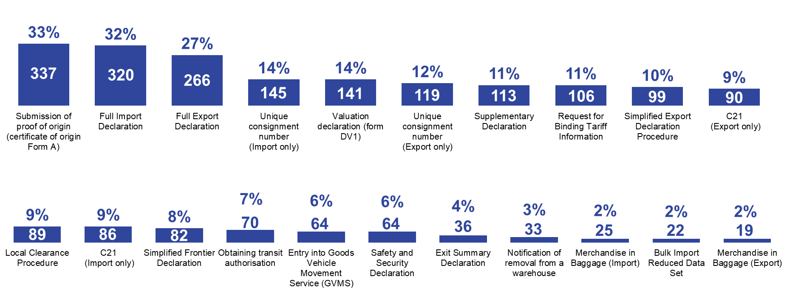
Base (unweighted): All traders (1,003).
  - Mean and median number of each customs declaration type
Table 3.1 shows the mean and median number of declarations completed per month by businesses in the survey. The mean number was highest (14 per month) for simplified export declaration procedures and unique consignment numbers (export), and was lowest (4 per month) for requests for binding tariff information. The median number per month ranged from 2 to 5 for the various types of declaration.
Table 3.1: Average number of declarations completed per month for each declaration type in the survey
 | Base | Median | Mean
Simplified export declaration procedure | 85 | 5 | 14
Unique consignment number (exports) | 103 | 5 | 14
Full export declaration | 238 | 4 | 11
Local clearance procedure | 69 | 3 | 11
Supplementary declaration | 92 | 5 | 10
Unique consignment number (imports) | 122 | 3 | 10
C21 (export) | 72 | 5 | 9
Obtaining transit authorisation | 59 | 4 | 9
Simplified frontier declaration | 60 | 4 | 8
Full import declaration | 277 | 3 | 8
Entry into Goods Vehicle Movement Service (GVMS) | 51 | 3 | 7
Valuation declaration | 121 | 2 | 7
C21 (import) | 70 | 3 | 6
Submission of proof of origin (certificate of origin Form A) | 297 | 2 | 6
Request for binding tariff information | 83 | 2 | 4
Base (unweighted): All that dealt with each type of declaration (varies).

- Declaration level data
This section examines how much it costs surveyed businesses to handle different types of customs declarations. It starts by looking at the average cost of each type of declaration, as well as the average amount of time spent dealing with each declaration. It summarises data on the nature and experience of completing declarations at a declaration type level. The section also examines the general costs of completing declarations, among traders in the survey that were unable to give details about specific types of declaration.
The survey was designed to collect data on up to two declarations each business submits However, this resulted in the sample size for some declarations being limited, and analysis in this section refers only to declarations where there is a sufficiently large sample size of traders that were asked about each declaration type. This includes the following declarations:
- full import declaration
- full export declaration
- C21 form (import)
- C21 form (export)*
- simplified frontier declaration*
- simplified export declaration procedure*
- supplementary declaration*
- local clearance procedure*
- unique consignment number (export)*
- submission of proof of origin

Although analysed at the overall level, declarations marked with an * have small sample sizes and should be treated with caution as discussed in Section 2.2. As a result, some subcategories of data have been suppressed.
Please note that all data in this section, unless explicitly stated, combines findings from traders who outsource their declarations and those who handle declarations in-house. Traders who outsourced their declarations were asked about the internal time and cost associated with preparing information for their intermediaries. This does not include the time intermediaries then spent on submitting declarations. Data has been combined to account for low base sizes, particularly amongst traders who submitted declarations in-house.

Key findings
The median internal total staff cost per declaration was highest for simplified frontier declarations, with a median cost of £29 per declaration. For the other types of declaration, the median internal staff cost per declaration was between £12 (for a full export declaration) and £25 (for local clearance procedures).
The time spent per declaration was also highest for simplified frontier declarations, which took 114 minutes per declaration on average. For the other types of declaration, the average amount of time spent per declaration ranged from 108 minutes (for local clearance procedures) to 72 minutes (simplified export declaration procedure).
Traders who did not know the specific declaration types they submitted were asked about the general overall cost and experience of submitting all customs declarations. The median per declaration cost of using an intermediary for these businesses was £60.
  - Staff cost per declaration
To update HMRC’s custom admin burden estimates, information is required on the range of activities that traders may need to carry out in order to complete declarations. For each declaration, the average length of time spent by businesses undertaking the activities and the median salary of the employees completing the activities, along with additional associated overhead costs, were used to estimate the staff cost of making customs declarations. Please note that traders were asked about up to two declaration types, meaning the bases for each specific declaration type in this section do not reflect the overall proportion who dealt with that declaration type.
The cost calculation uses 5 grouped activity categories and 12 occupational categories (with additional categories depending on answers that were provided as “other”) (see Tables A.1 and A.2 in the Annex and the Annual Survey of Hours and Earnings (ASHE) categories themselves in Table A.3). The occupation categories correspond to the Standard Occupational Classification used in the ASHE.
Figure 4.1 shows the median staff cost for each type of declaration. This is the total cost for all activities associated with gathering and submitting information required by HMRC for a single customs declaration. The highest internal staff cost was for simplified frontier declarations, with an average cost of £29 per declaration. For the other types of declaration, the total internal staff cost per declaration was between £12 (for full export declarations) and £25 (for local clearance procedures).
Figure 4.1: Total internal staff cost per declaration (£) among surveyed businesses for each declaration type
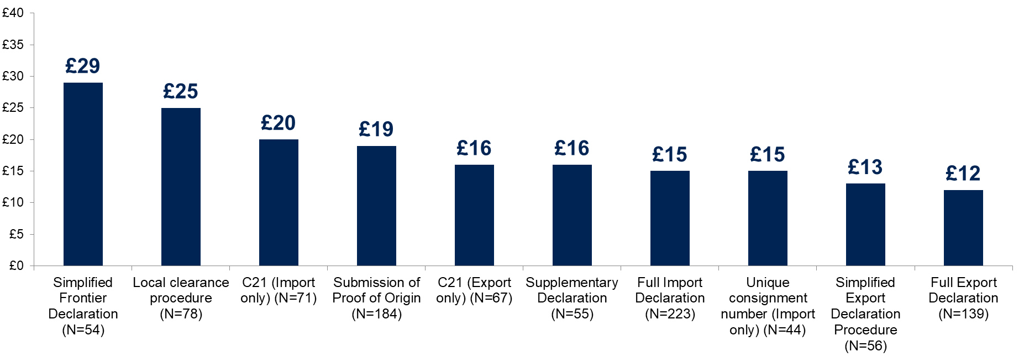Base: All who answered for each declaration type. Bases are denoted by N. Declarations with a base size of 50 or more have been reported. Base sizes of less than 100 should be treated with caution.
  - Time spent per declaration
The time spent per declaration was typically 1 to 2 hours among surveyed traders. Figure 4.2 shows the average amount of time required for all activities associated with preparing and submitting information for a single customs declaration. This was highest for simplified frontier declarations, which took 114 minutes per declaration on average. For the other types of declaration, the average amount of time spent per declaration ranged from 66 minutes) (for unique consignment numbers) to 108 minutes (for local clearance procedures).
Figure 4.2: Overall mean time for activities associated with gathering and submitting information for customs declarations among surveyed businesses, in minutes

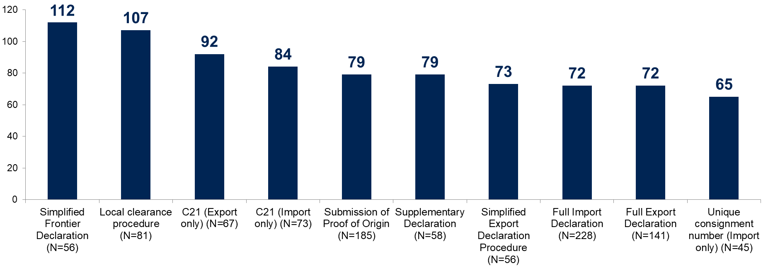
Base: All who answered for each declaration type. Bases are denoted by N. Declarations with a base size of 50 or more have been reported. Base sizes of less than 100 should be treated with caution.
The staff time traders spent on processes linked to gathering or submitting information for a given declaration, used in the time and cost calculations, was broken down into several different activities (listed in full in the Annex). Table 4.1 shows the proportion of businesses in the survey undertaking these activities to complete a given declaration. For example, 19% of traders asked about full import declarations said they spent time holding meetings when preparing information for a full import declaration. Generally, businesses in the survey most commonly spent time gathering relevant figures and information across declaration types, ranging from 53% for unique consignment numbers to 82% for supplementary declarations. Simplified frontier declarations were the only declaration type where another activity category was around as common, with 71% undertaking reporting compared to 69% gathering figures.
Declaration types with higher levels of automation were generally the most common, including full import declarations and proof of origin submission (14% said the process was automated for both). Simplified export declarations were the least automated, with 3% saying they automated the process.
Table 4.1: Percentage of businesses in the survey undertaking each activity to complete declarations by declaration type.
Declaration | Gathering relevant figures and information | Preparing figures | Reporting | Making settlements or other payments | Holding meetings | Other | None (automation) | Don’t know | Base
Full import declaration | 71% | 57% | 45% | 58% | 19% | ^ | 14% | 1% | 239
Full export declaration | 79% | 65% | 53% | 39% | 14% | 0% | 12% | 3% | 147
C21 forms (import) | 74% | 61% | 56% | 71% | 29% | 2% | 10% | 4% | 77
C21 forms (export) | 80% | 76% | 61% | 55% | 28% | 3% | 13% | 0% | 67
Simplified frontier declarations | 69% | 71% | 56% | 65% | 28% | 0% | 7% | 6% | 58
Simplified export declarations | 76% | 68% | 54% | 53% | 18% | 0% | 3% | 6% | 60
Supplementary declarations | 82% | 72% | 58% | 56% | 36% | 2% | 12% | 0% | 60
Local clearance procedures | 76% | 64% | 61% | 65% | 31% | 1% | 11% | 2% | 89
Unique consignment numbers (import) | 53% | 42% | 36% | 55% | 16% | 0% | 13% | 8% | 51
Proof of origin submissions | 73% | 55% | 49% | 52% | 25% | 1% | 14% | 2% | 192
Base: Please note that traders were asked about two declaration types. Bases refer to all traders who were asked about the specific declaration type. Declarations with a base size of 50 or more have been reported. Data derived from base sizes of less than 100 should be treated with caution.
The median time spent by businesses for each of the activity categories is shown in Table 4.2. Gathering relevant figures and information generally took the longest for all declarations, at a median time of 30 minutes for full import declarations and proof of origin submissions and 20 minutes for full export declarations. The least time was spent on making settlements and other payments, with a median of 15 minutes across all three declarations with sufficient base size (full import declarations, full export declarations and submission of proof of origin forms).
Table 4.2: Median time, in minutes, spent on each activity category for a given declaration type for businesses in the survey
Declaration | Gathering relevant figures and information  n (base) | Preparing figures  n (base) | Reporting  n (base) | Making settlements or other payments  n (base)
Full import declaration | 30  (160) | 20  (124) | 15  (99) | 15  (126)
Full export declaration | 20  (113) | 17  (92) | 20  (73) | 15  (51)
Proof of origin submissions | 30  (135) | 30  (103) | 20  (87) | 15  (91)
Base: Bases are shown in brackets. Please note that traders were asked about two declaration types. Bases refer to all traders who were asked about the specific declaration type and completed the given activity. Declarations and data with a base size of 50 or more have been reported. Data derived from base sizes of less than 100 should be treated with caution.
  - Submitting declarations in-house or via a third-party
Traders were asked whether they used someone outside of their business the last time they submitted a given declaration type, or whether it was managed in-house, as shown in Table 4.3. Across all declaration types, businesses in the survey were more likely to outsource the submission of declarations to an intermediary. Full import declarations (75%), C21 import forms (74%) and import unique consignment numbers (69%) were the most likely declaration types to be fully outsourced. The declaration types respondents were most likely to be fully completed in-house were C21 export forms (33%), simplified export declarations (29%) and proof of origin submissions (26%). Generally, declarations associated with importing were more commonly outsourced than those associated with exporting.
Table 4.3: Completion of declarations by a third-party or in-house for businesses in the survey
Declaration | Completely in-house | Partially in-house | Outsourced | Don’t know | Base
Full import declaration | 10% | 14% | 75% | 1% | 239
Full export declaration | 25% | 21% | 50% | 5% | 147
C21 forms (import) | 12% | 11% | 74% | 4% | 77
C21 forms (export) | 33% | 10% | 54% | 3% | 67
Simplified frontier declarations | 15% | 16% | 66% | 2% | 58
Simplified export declarations | 29% | 26% | 42% | 3% | 60
Supplementary declarations | 24% | 21% | 54% | 0% | 60
Local clearance procedures | 14% | 19% | 64% | 2% | 89
Unique consignment numbers (import) | 18% | 10% | 69% | 3% | 51
Proof of origin submissions | 26% | 17% | 53% | 3% | 192
Base: Please note that traders were asked about two declaration types. Bases refer to all traders who were asked about the specific declaration type. Declarations with a base size of 50 or more have been reported. Data derived from base sizes of less than 100 should be treated with caution.
Traders who partly or entirely outsourced their last declaration were asked what type of third-party they used. Generally, the most common third party used were freight forwarders as seen in Table 4.4. (50% for full import declarations, and 55% for C21 import forms and proof of origin submissions).
Table 4.4: Type of third party used when last submitting a declaration among surveyed businesses
Declaration | Customs agent / broker | Freight forwarder | Express operator | Base
Full import declaration | 37% | 50% | 21% | 211
Full export declaration | 22% | 53% | 34% | 104
C21 forms (import) | 32% | 55% | 19% | 64
Local clearance procedures | 22% | 53% | 32% | 74
Proof of origin submissions | 32% | 55% | 16% | 134
Base: Please note that traders were asked about two declaration types. Bases refer to all traders who outsourced their declarations in some capacity and were asked about the specific declaration type. Declarations with a base size of 50 or more have been reported. Data derived from base sizes of less than 100 should be treated with caution.
  - Ease of preparing information for declarations
Traders in the survey were asked how easy or difficult it was to prepare information for a declaration, either in-house or when passing this to a third party. Generally, businesses found it easy to prepare information for a given declaration, with around two-thirds of businesses considering the process easy across all declaration types as shown in Table 4.5. The easiest declaration types to prepare information for were import unique consignment numbers and proof of origin submissions, with 71% answering ‘easy’ to both. Traders in the survey generally found full export declarations more difficult to prepare information for, with 18% noting it was difficult, along with simplified frontier declarations (17%) and supplementary declarations (17%).
Table 4.5: Ease of preparing information for declarations among surveyed businesses
Declaration | Easy | Neutral | Difficult | Don’t know | Base
Full import declaration | 67% | 16% | 13% | 4% | 239
Full export declaration | 66% | 15% | 18% | 1% | 147
C21 forms (import) | 69% | 15% | 11% | 5% | 77
C21 forms (export) | 61% | 20% | 15% | 4% | 67
Simplified frontier declarations | 67% | 15% | 17% | 0% | 58
Simplified export declarations | 65% | 24% | 8% | 2% | 60
Supplementary declarations | 64% | 20% | 17% | 0% | 60
Local clearance procedures | 61% | 23% | 12% | 2% | 89
Unique consignment numbers (import) | 71% | 19% | 6% | 4% | 51
Proof of origin submissions | 71% | 13% | 14% | 2% | 192
Base: Please note that traders were asked about two declaration types. Bases refer to all traders who outsourced their declarations in some capacity and were asked about the specific declaration type. Declarations with a base size of 50 or more have been reported. Data derived from base sizes of less than 100 should be treated with caution.
  - Staff members responsible for completing declarations
Traders were asked for the job title of the staff member mainly responsible for preparing the information for a given declaration type, either to complete in-house or to pass onto a third party. Table 4.6 shows that finance staff were generally less likely to be responsible for completing declarations, although there was variation by declaration type. Managers were most likely to be involved in completing import unique consignment numbers (36%). Senior staff (not managers) were most likely to be involved in simplified frontier declarations (31%). A high proportion of ‘other’ members of staff were involved in completing local clearance procedures (37%) and C21 export forms (38%). Please note that ‘other’ members of staff represent an aggregation of several answer options and varies by declaration type, with the full breakdown of occupations listed in the annex.
Table 4.6: Staff members mostly responsible for completing declarations, by declaration type, among surveyed businesses
Declaration | Managers | Finance | Senior Staff | Other members of staff | Don’t know | Base
Full import declaration | 26% | 20% | 27% | 22% | 4% | 239
Full export declaration | 20% | 17% | 27% | 34% | 2% | 147
C21 forms (import) | 26% | 20% | 27% | 21% | 5% | 77
C21 forms (export) | 23% | 9% | 29% | 38% | 0% | 67
Simplified frontier declarations | 31% | 13% | 31% | 23% | 3% | 58
Simplified export declarations | 35% | 23% | 19% | 21% | 2% | 60
Supplementary declarations | 32% | 20% | 21% | 22% | 5% | 60
Local clearance procedures | 34% | 9% | 15% | 37% | 4% | 89
Unique consignment numbers (import) | 36% | 13% | 28% | 18% | 4% | 51
Proof of origin submissions | 28% | 14% | 27% | 28% | 3% | 192
Base: Please note that traders were asked about two declaration types. Bases refer to all traders who were asked about the specific declaration type. Declarations with a base size of 50 or more have been reported. Data derived from base sizes of less than 100 should be treated with caution.
  - Average number of items covered by each declaration type
Businesses were asked about the average number of goods types covered by a typical declaration. Due to small sample sizes, the only declarations with data presented are full export declarations and proof of origin submissions. For both these declaration types, the median number of items covered by a single declaration was 2, as shown in Table 4.7.
Table 4.7: Number of goods types covered by a single declaration among surveyed businesses
Declaration | Median | Base
Full export declaration | 2 | 54
Proof of origin submissions | 2 | 69
Base: Please note that traders were asked about two declaration types. Bases refer to all traders who were asked about the specific declaration type and completed declarations in-house in some capacity.
  - Preparing declarations for EU and rest of the world (RoW)
Table 4.8 shows that businesses generally felt that it took about the same time to prepare declarations for the EU compared to the rest of the world, but around a third felt that it was longer when preparing for the EU (between 27% and 31%).
Table 4.8: Whether the declaration takes longer to prepare for trading with the EU compared to the rest of the world (RoW) among surveyed businesses
Declaration | Longer for EU goods vs RoW | About the same between EU and RoW | Shorter for EU goods vs RoW | Don’t know | Base
Full import declaration | 28% | 45% | 13% | 15% | 58
Full export declaration | 31% | 52% | 7% | 10% | 68
Proof of origin submissions | 27% | 42% | 12% | 18% | 84
Base: Please note that traders were asked about two declaration types. Bases refer to all traders who completed declarations in-house in some capacity and were asked about the specific declaration type. Declarations with a base size of 50 or more have been reported. Data derived from base sizes of less than 100 should be treated with caution.
  - Agent cost per declaration
Traders who outsourced their declarations in some capacity were asked about the cost of using an agent for submitting a single, typical declaration. There was sufficient base size to analyse three declarations: full import declarations, full export declarations and submission of proof of origin forms. The median per-declaration cost was £50 for Full Export Declarations and Submission of Proof of Origin and £51 for Full Import Declarations as shown in Figure 4.3.
Figure 4.3: Median agent cost for submitting a single, typical declaration among surveyed businesses
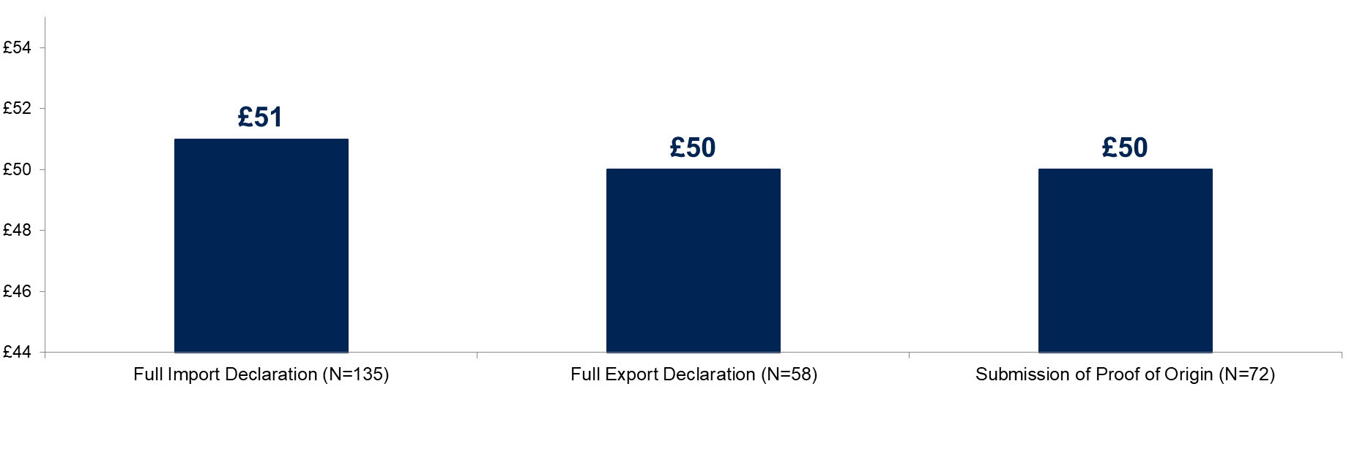Base: All who outsourced declarations and answered for each declaration type. Bases are denoted by N. Declarations with a base size of 50 or more have been reported. Base sizes of less than 100 should be treated with caution.
Submitting paperwork was most likely to be covered in outsourcing costs, with between 66% and 77% of surveyed traders reporting it was included in the cost they paid to agents, as shown in Table 4.9.
Table 4.9: Type of tasks covered by agent costs among surveyed traders able to confirm the cost of outsourcing their customs declarations
Declaration | General advice | Submitting paperwork | Addressing HMRC queries | Other | Base*
Full import declaration | 62% | 77% | 45% | 1% | 133
Full export declaration | 61% | 66% | 55% | 4% | 56
Proof of origin submissions | 56% | 72% | 46% | 4% | 71
*Base: Bases refer to all traders who outsourced declarations and could provide a value on agent cost. Declarations with a base size of 50 or more have been reported. Data derived from base sizes of less than 100 should be treated with caution.
Respondents were also asked what type of representation they were offered by agents. This could be direct representation, where a customs agent makes any declarations in the name of the business, or indirect representation, where they make declarations in their own name but do so on behalf of the business. Table 4.10 shows that direct representation was generally more common, with around half of surveyed traders reporting to be represented directly (46%). Proof of origin submissions were the only declaration type where indirect representation was more common, with 51% reporting indirect representation and 41% reporting direct representation.
Table 4.10: Type of representation provided by an intermediary or agent among surveyed traders outsourcing their customs declarations
Declaration | Direct representation | Indirect representation | Don’t know | Base*
Full import declaration | 46% | 44% | 12% | 211
Full export declaration | 49% | 37% | 15% | 104
C21 import forms | 54% | 33% | 13% | 64
Local clearance procedures | 51% | 46% | 7% | 74
Proof of origin submissions | 41% | 51% | 11% | 135
*Base: Bases refer to all traders who outsourced declarations and answered for each declaration type. Declarations with a base size of 50 or more have been reported. Data derived from base sizes of less than 100 should be treated with caution.
  - Costs of completing declarations for those who did not know that specific declaration types they submitted
Around 2 in 10 respondents (22%) either did not know the details of their specific customs declarations or chose not to respond to the question. These businesses were instead asked about their overall experience of submitting all declarations providing at least some information on their admin burden. All the findings in this section are based only on these businesses which accounts for 223 respondents. It should be noted that, the data presented in this section is not an aggregation of the declaration level data that was collected in the survey.
These businesses were asked firstly about the activities linked to gathering or submitting information required by HMRC in relation to a declaration. This was asked separately for those that used a customs intermediary and those that completed at least some declarations in-house.
As seen in Figure 4.4, making settlements or other payments (57%) and gathering relevant figures or information (53%) were the most common activities. Among those using an intermediary, the most common activities were making settlements or other payments (58%) and gathering relevant figures or information (53%). These were also the most common activities among surveyed businesses that completed declarations in-house (48% and 52% respectively).

Figure 4.4: Activities associated with preparing and submitting information for declarations among surveyed traders who did not know what specific type of declarations they submitted
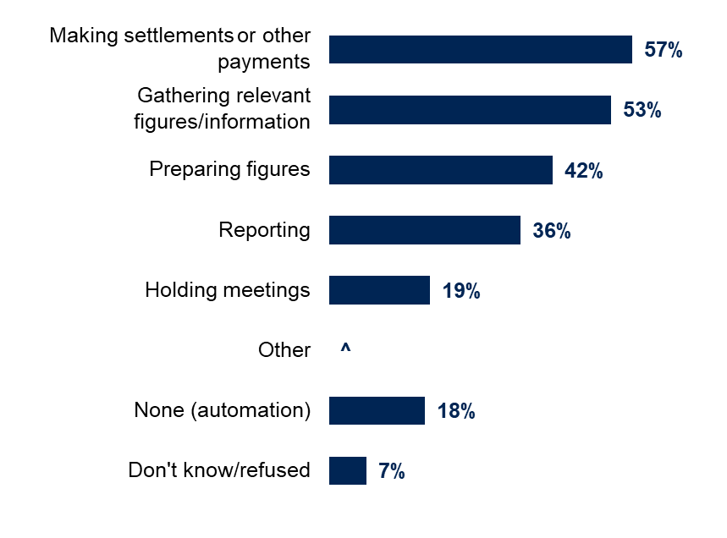
Base: All not able to provide individual declaration information (223).
Respondents were then asked to estimate the amount of time they spent on each activity. This ranged from an average of 56 minutes per declaration for gathering relevant figures or information, to 33 minutes for preparing figures and for making settlements or other payments. The median time taken across all activities was 30 minutes as shown in Figure 4.5.
Figure 4.5: Mean and median amount of time spent on each activity (minutes) among surveyed traders who did not know what type of declarations they submitted
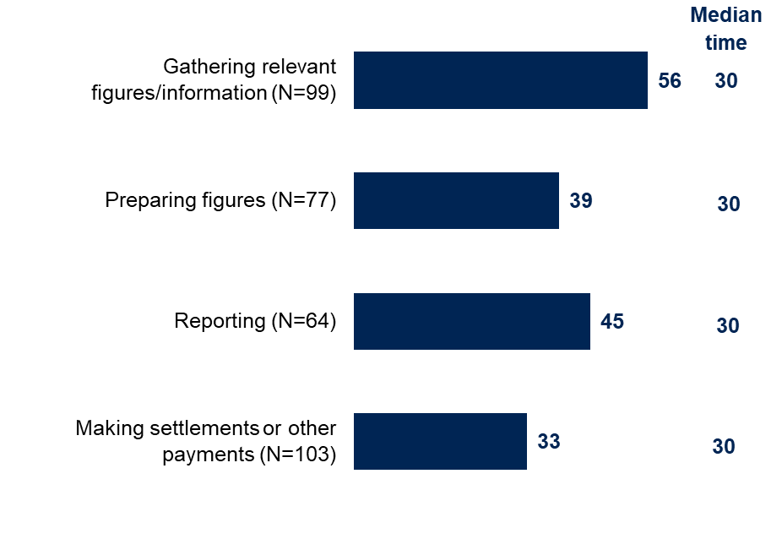
Base: All not able to provide individual declaration information (223).
Businesses that were asked about the general costs of completing declarations were then asked how many staff were involved in submitting declarations or preparing information for agents. Typically, one or two members of staff were involved. The average number of staff was 1.5 for firms that completed declarations in-house, and 1.3 for those that used an intermediary.
Among traders that did not know the specific declarations they submitted, businesses that used an intermediary were asked about the costs of using an agent. In the survey, the median per-declaration cost of using the intermediary was £60.

- Additional costs of customs declarations
This section looks at several areas that could contribute towards additional costs for traders. Firstly, it examines the prevalence of staff training on how to submit declarations and the cost of this training. It then looks at the use of online software to prepare information and submit customs declarations. This section also examines traders’ experience of delays when clearing customs, as well as their use of customs warehouses.

Key findings
Across all businesses responding to the survey, 25% said that staff had received training on how to submit customs declarations, either in-house or provided by an external organisation. In firms where staff had received training and where the training was not free, the mean overall annual cost to the business was £1,096 and the median was £700.
For traders who completed at least some declarations in-house, the main mechanism for submitting declarations was online via software (53%). For traders who entirely outsourced their declarations, 66% submitted information to agents online without software.
Most businesses said that they had experienced delays when clearing customs while exporting or importing goods (with 46% reporting they experienced delays ‘regularly’ or ‘sometimes’). Typically, these delays lasted about one working week (5 days). The survey did not ascertain the reason for the delays, and they may not be directly attributable to HMRC. In the survey, 10% of traders said they used customs warehouses for storing goods.
  - Prevalence and cost of training on customs declarations
Across all businesses surveyed, 25% said that staff had received training on how to submit declarations, either in-house or provided by an external organisation. Overall, 73% had not received any training while 2% did not know, as shown in Figure 5.1.
Figure 5.1: Staff training on how to submit customs declarations among surveyed traders
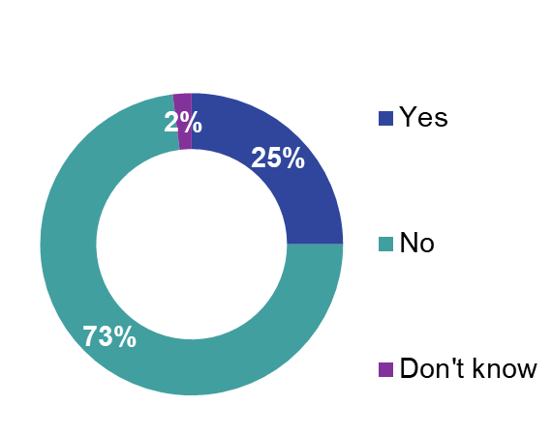
Base: All traders (1,003).

Businesses that said staff had received training on how to submit declarations were asked how much they spent on this training. Of the 25% that received training in the survey, 55% of these received training at no cost, with 45% having some costs associated with training. Among all traders that have received training, the average annual training cost was £364. Excluding businesses who said that training came at no cost, the mean annual cost of training was £1,096 and the median was £700.
  - Prevalence of software used to submit customs declarations
Traders were asked how they submitted the information to complete their customs declarations. Among those that handled all or some declarations in-house, 53% said they submitted the information to complete their customs declarations online via software, while 12% did so on paper via the post, 5% online via email and 2% online via a website.
Among businesses that used an intermediary to handle all their customs requirements, the majority submitted information to the intermediary online; specifically, 18% said they provided information online via software and 66% online without software. A small proportion (4%) provided information on paper via the post, while 22% said that an intermediary dealt with all the paperwork for them.
  - Software being used for customs declarations
If businesses completed declarations in-house using online software, they were asked whether the software covered export declarations, import declarations or both. Figure 5.2 shows that in the survey, 45% said the software covered both export and import declarations, while 31% said the software covered only export declarations and 12% that it covered only import declarations. 12% of businesses did not know.
Figure 5.2: Declaration type covered by software among surveyed traders
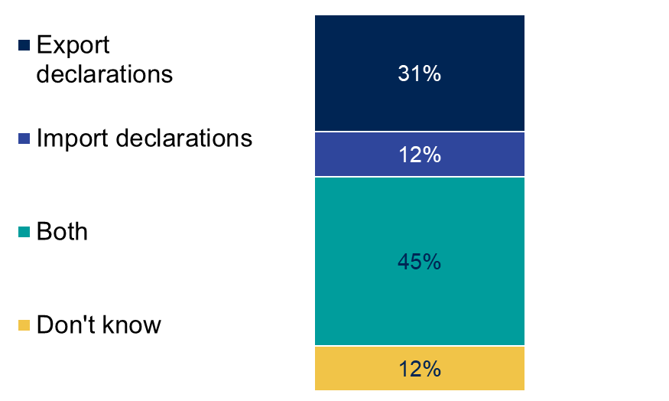
Base: All who complete declarations in-house in some capacity using online software (100).
  - Experience of delays clearing customs
Traders were asked how often their business experiences delays when clearing customs or exporting or importing goods. Please note that the reasons for these delays were not specified and may not relate to HMRC. Figure 5.3 shows that most traders said that they had experienced delays: 26% said they ‘regularly’ experienced delays, while 20% experienced delays ‘sometimes’, and 39% ‘occasionally’ and 12% said they never experienced delays. On average, traders that had experienced delays said that the length of a typical delay was 5 days. The median typical delay was 4 days.
Figure 5.3: Frequency of surveyed traders experiencing delays
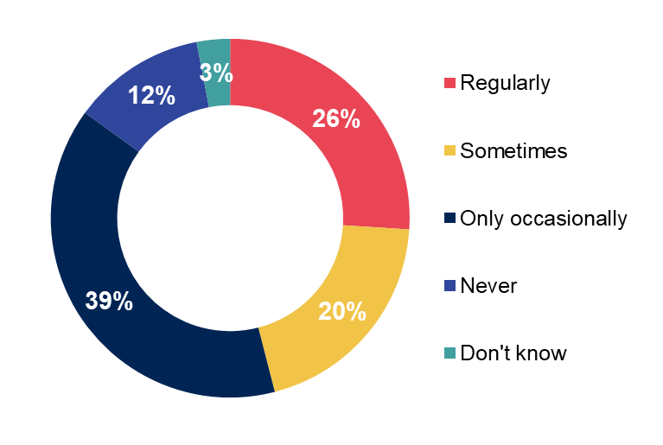
Base: All traders (1,003).

  - Experience of customs warehouses
10% of traders surveyed said they used customs warehouses where goods can be stored without paying duties for a fixed time period.

Annex 1: Additional information
All declaration types:
- notification of removal from warehouse
- local clearance procedure
- merchandise in baggage (import only)
- merchandise in baggage (export only)
- C21 (import only)
- C21 (export only)
- exit summary declaration
- simplified export declaration procedure
- supplementary declaration
- simplified frontier declaration
- full import declaration
- full export declaration
- submission of proof of origin (certificate of origin Form A)
- unique consignment number to be supplied for all electronic declarations (import only)
- unique consignment number to be supplied for all electronic declarations (export only)
Activity categories in relation to submitting a customs declaration
To support HMRC update their admin burden estimates, information was required the range of activities that businesses might need to carry out in order to complete customs declarations. For each declaration, the average length of time spent by businesses undertaking the activities and the average salary of the employees completing the activities, along with any costs paid to intermediaries are used by HMRC to estimate the time and money spent by businesses meeting their customs declarations. The information also gives an indication of the activities that are most time-consuming and/or costly. For the survey, the SCM used grouped activity categories based on earlier research as set out below:
- gathering relevant figures/information
- preparing figures (including calculating figures, presenting, checking and correcting)
- reporting (including preparing written descriptions of data, copying, filing, distributing or submitting information/reports)
- making settlements or payments (e.g. taxes or charges)
- holding meetings and working with external businesses to prepare customs declarations
- other activities not mentioned (specified)
- none of these activities as the process is automated
Activity categories in relation to submitting a customs declaration
The occupations used to categorise staff undertaking each activity are set out below. The categories correspond to Standard Occupational Classification used in the Annual Survey of Hours and Earnings Survey (ASHE), including specific occupations mentioned by respondents not listed in the core categories.
For all declarations
Group for analysis: Senior
- owner or proprietor, code 1
- partner, code 2
- chief executives and senior officials, code 3
Group for analysis: Finance
- taxation experts, code 4
- chartered and certified accountants, code 5
- business, finance and related associate professionals, code 6
- bookkeepers, payroll managers and wages clerks, code 8
Group for analysis: Managers
- functional managers and directors, code 7
- office managers, code 9
- human resources and industrial relations officers, code 10
Group for analysis: Other
- other administrative occupations, code 11
- another occupation (specify job title and description of the work they do), code 12
C21 import only
Group for analysis: Finance
- buyers and procurement officers, code 13
- sales accounts and business development managers, code 17
Group for analysis: Other
Import/export staff and transport
- importers and exporters, code 14
- transport and distribution clerks and assistants, code 18
Customer service, planning and protective services
- planning, process and production technicians, code 15
- protective service associate professionals N.E.C, code 16
- transport and distribution clerks and assistants, code 18
C21 export only
Group for analysis: Finance
- sales administrators, code 16
Group for analysis: Other
Import/export staff and transport
- importers and exporters, code 13
- transport and distribution clerks and assistants, code 17
- warehouse operatives, code 18
Customer service, planning and protective services
- planning, process and production technicians, code 14
- protective service associate professionals N.E.C., code 15

Simplified frontier declarations
Group for analysis: Finance
- sales accounts and business development managers, code 15
Group for analysis: Other
Import/export staff and transport
- importers and exporters, code 14
Customer service, planning and protective services
- customer service occupations N.E.C., code 13
Simplified export declarations
Group for analysis: Finance
- buyers and procurement officers, code 13
- sales accounts and business development managers, code 15
Group for analysis: Other
Customer service, planning and protective services
- customer service occupations N.E.C., code 14
Import/export staff and transport
- transport and distribution clerks and assistants, code 16
- warehouse operatives, code 17
Supplementary declaration
Group for analysis: Finance
- buyers and procurement officers, code 13
- sales accounts and business development managers, code 16
Group for analysis: Other
Customer service, planning and protective services
- customer service occupations N.E.C., code 14
Import/export staff and transport
- warehouse operatives, code 17
Local clearance procedure
Group for analysis: other
- warehouse operatives, code 13
Group for analysis: refused
- prefer not to say, code 14
Full import declarations
Group for analysis: Finance
- buyers and procurement officers or managers, code 13
- sales accounts and business development managers, code 15
Group for analysis: Other
Import/export staff and transport
- importers and exporters, code 14
- warehouse operatives, code 16
Full export
Group for analysis: Finance
- buyers and procurement officers or managers, code 14
- sales accounts and business development managers, code 17
- sales administrators, code 18
Import/export staff and transport
- importers and exporters, code 16
- warehouse operatives, code 19
Group for analysis: Don’t know
- don’t know, code 13
Unique consignment number (import only)
Group for analysis: Finance
- sales administrators, code 14
Group for analysis: Don’t know
- don’t know, code 13
Proof of origin submissions
Group for analysis: Finance
- buyers and procurement officers or managers, code 13
- sales accounts and business development managers, code 16
Group for analysis: Other
Customer service, planning and protective services
- customer service occupations N.E.C., code 14
Import/export staff and transport
- importers and exporters, code 15
- transport and distribution clerks and assistants, code 17
- warehouse operatives, code 18

Table A.3: Job description coding from ASHE
Having collected the level of seniority of traders that have the main responsibility for completing customs declarations, the survey data was matched to the Annual Survey of Household Earnings (ASHE) to calculate an hourly income figure. The table below outlines the ASHE categories that the data has been matched to.
ASHE Code | Job description
111 | Chief Executives And Senior Officials
113 | Functional Managers And Directors
353 | Finance Associate Professionals
2421 | Chartered And Certified Accountants
2423 | Taxation Experts
2481 | Quality Control And Planning Engineers
3116 | Planning, Process And Production Technicians
3319 | Protective Service Associate Professionals N.E.C.
3542 | Importers And Exporters
3551 | Buyers And Procurement Officers
3556 | Sales Accounts And Business Development Managers
3571 | Human Resources And Industrial Relations Officers
4122 | Book-Keepers, Payroll Managers And Wages Clerks
4134 | Transport And Distribution Clerks And Assistants
4141 | Office Managers
4151 | Sales Administrators
4159 | Other Administrative Occupations N.E.C.
7219 | Customer Service Occupations N.E.C.
9252 | Warehouse Operatives - Dispatch (Warehouse)Etc.

Annex 2: Additional data tables
Table A.4: Business sector among traders in the survey
Sector from sample frame | Count
Wholesale and retail trade; repair of motor vehicles and motorcycles | 492
Manufacturing | 251
Professional, scientific and technical activities | 68
Information and communication | 36
Administrative and support service activities | 35
Construction | 25
Agriculture, Forestry and Fishing | 18
Transportation and storage | 15
Arts, entertainment and recreation | 14
Accommodation and food service activities | 8
Education | 7
Water supply, sewerage, waste management and remediation activities | 4
Real estate activities | 3
Human health and social work activities | 3
Financial and insurance activities | 2
Other service activities | 19
Unknown | 3

Base: All traders (1003).

Table A.5: Exporter/Importer status among traders in the survey
Status | Frequency | Percentage
Exporter | 102 | 10%
Importer | 278 | 28%
Both | 624 | 62%

Table A.6: Business size among traders in the survey
Size bands | Frequency | Percentage
Nano (0 employees) | 77 | 8
Micro (1-9 employees) | 505 | 50
Small (10-49 employees) | 281 | 28
Medium (50-249 employees) | 105 | 10
Large (250+ employees) | 26 | 3
Don’t Know | 5 | ^
Prefer not to say | 3 | ^

Base: All traders (1003).

Table A.7: Overall intermediary usage among traders in the survey
Intermediary | Frequency | Percentage
Customs agent or broker | 259 | 26%
Freight Forwarder | 444 | 44%
Express Operator | 323 | 32%
Other type of customs intermediary | 3 | ^
Handle customs declarations in-house | 111 | 11%
Both - work with a customs intermediary and handle declarations in-house | 92 | 9%
Chamber of Commerce | 3 | ^
External / outsourced | 3 | ^
Logistics company | 4 | ^
Shipping agent | 2 | ^
Via customers | 2 | ^
Via manufacturer | 2 | ^
Don't know | 20 | 2%
Prefer not to say | 2 | ^

Base: All traders (1003).

Table A.8: Overall prevalence of customs declaration types from the survey
Declaration | Frequency | Percentage
Submission of proof of origin form (certificate of origin Form A) | 334 | 33%
Full import declaration | 319 | 32%
Full export declaration | 268 | 27%
Unique consignment number to be supplied for all electronic declarations (import only) | 145 | 14%
Valuation declaration (form DV1) | 143 | 14%
Unique consignment number to be supplied for all electronic declarations (export only) | 117 | 12%
Supplementary declaration | 111 | 11%
Request for binding tariff information | 107 | 11%
Simplified export declaration procedure | 99 | 10%
C21 form (export only) | 91 | 9%
Local clearance procedure | 90 | 9%
C21 form (import only) | 86 | 9%
Simplified frontier declaration | 82 | 8%
Obtaining transit authorisation | 68 | 7%
Entry into Goods Vehicle Movement Service (GVMS) | 64 | 6%
Safety and security declaration | 64 | 6%
Exit summary declaration | 37 | 4%
Supplementary notification of removal of goods from a custom warehouse | 33 | 3%
Merchandise in baggage declaration (import only) | 24 | 2%
Bulk Import Reduced Data Set | 22 | 2%
Merchandise in baggage declaration (export only) | 19 | 2%
Don't know | 213 | 21%
Prefer not to say | 9 | 1%

Base: All traders (1003).

Table A.9: Total internal staff cost among traders in the survey
Declaration | Cost | Base
Simplified frontier declaration | £29 | 54
Local clearance procedure | £25 | 78
C21 (import only) | £20 | 71
Submission of proof of origin forms | £19 | 184
C21 (export only) | £16 | 67
Supplementary declaration | £16 | 55
Full import declaration | £15 | 223
Simplified export declaration procedure | £13 | 56
Full export declaration | £12 | 139
Base: All who answered for each declaration type. Bases are denoted by N. Declarations with a base size of 50 or more have been reported. Base sizes of less than 100 should be treated with caution.

Table A.10: Activities associated with preparing and submitting information for traders who did not know what specific declarations they submitted
Activity | Frequency | Percentage
Making settlements or payments (eg. taxes or charges) | 126 | 57%
Gathering relevant figures/information | 117 | 53%
Preparing figures (including calculating figures, presenting, checking and correcting) | 93 | 42%
Reporting (including preparing written descriptions of data, copying, filing, distributing or submitting information/reports) | 81 | 36%
Holding meetings and working with external businesses to prepare customs declarations | 42 | 19%
None of these activities as the process is automated | 41 | 18%
Other | 1 | ^
Don't know | 15 | 7%
Prefer not to say | 1 | ^
Base: All not able to provide individual declaration information (223).

Table A.11: How information was submitted by surveyed traders handling at least some declarations in-house
Mode | Frequency | Percentage
Online via software | 106 | 53%
An agent or intermediary deals with it | 69 | 35%
On paper via the post | 24 | 12%
Online via email | 10 | 5%
Online via website | 4 | 2%
Other | 1 | 1%
Don't know | 8 | 4%
Base: All who handle declarations in-house in some capacity (203).

Table A.12: How information was submitted by surveyed traders who outsourced declarations
Mode | Frequency | Percentage
Online without software (eg. files sent over email) | 512 | 66%
An agent or intermediary deals with all the paperwork | 169 | 22%
Online via software | 142 | 18%
On paper via the post | 32 | 4%
Online via website | 5 | 1%
Online via phone | 3 | ^
Don't know | 22 | 3%
Base: All who outsource declarations (779).

Table A.13: Monthly cost of storing goods in a customs warehouse among traders in the survey
Cost band (£’s) | Frequency | Percentage
0-49 | 2 | 6%
50-99 | 9 | 24%
100-249 | 7 | 20%
250-499 | 7 | 21%
500-999 | 4 | 12%
1000-2499 | 1 | 3%
2500-4999 | 3 | 9%
>5000 | 2 | 5%
Base: All who use a customs warehouse (35).

Table A.14: Type of third party used when last submitting a declaration among traders in the survey
Declaration | Customs agent / broker | Freight forwarder | Express operator | Base*
Full import declaration | 37% | 50% | 21% | 211
Full export declaration | 22% | 53% | 34% | 104
C21 forms (import) | 32% | 55% | 19% | 64
C21 forms (export) | 36% | 52% | 31% | 44
Simplified frontier declarations | 37% | 46% | 30% | 48
Simplified export declarations | 30% | 37% | 40% | 41
Supplementary declarations | 12% | 74% | 20% | 45
Local clearance procedures | 22% | 53% | 32% | 74
Unique consignment numbers (import) | 34% | 56% | 11% | 40
Proof of origin submissions | 32% | 55% | 16% | 134
*Base: Please note that traders were asked about two declaration types. Bases refer to all traders who outsourced their declarations in some capacity and were asked about the specific declaration type. Declarations with a base size of 50 or more have been reported. Data derived from base sizes of less than 100 should be treated with caution.

Annex 3: Fieldwork outcomes
    - Table A.15: Fieldwork outcomes and response rate calculation
- Outcome | Number | %
- Total sample called | - 13,815 | - 100%
- Completed interviews | - 1,003 | - 7%
- Ineligible leads | - 2,324 | - 17%
- Refusals | - 2,414 | - 17%
- Unusable leads with working numbers | - 3,712 | - 27%
- Unusable numbers | - 2,583 | - 19%
- Working numbers with unknown eligibility | - 1,779 | - 13%
- Eligibility of screened respondents |  | - 30%
- Unadjusted response rate |  | - 7%
- Adjusted response rate |  | - 44%
- Cooperation rate |  | - 58%

Annex 4: Data cleaning and weighting

Outliers
The initial approach taken to review outliers was to flag cases that were greater than 4 standard deviations. This helped to identify any values that were very different to other businesses within the same question. The flagged values were then reviewed manually. Each potential outlier was compared to other answers that respondents had provided to make sure that they made logical sense given this additional context (for example, a high number of declarations is compared against business size to make sure the number is appropriate for the type of business). This meant for a result to be cleaned from the data, it had to be substantially different from the overall mean and misaligned from other results. This was a conservative approach that resulted in a very small number of responses being trimmed. A further round of trimming was undertaken which involved reviewing the distributions and identifying further responses that required cleaning for example, values that were given as hours but would be more sensible as minutes).

Weighting
Two sets of weights were generated. This included: 1) a business level non-response weight and 2) a declaration level grossing weight. A set of business weights were generated to weight the responding sample of businesses to look like the population. The first step was a selection weight to correct the sample for over-sampling medium and larger businesses relative to smaller ones. These were generated using the size variable from the sampling frame and calculated as the population distribution divided by the distribution of the selected sample.
The second step was to adjust the selection weight to reduce potential biases caused by non-participation. Random iterative method (RIM) weighting was used to correct the profile of achieved interviews by business size and sector, relative to the profile of the original HMRC-provided sample. These weights adjusted the sample (weighted by the selection weight) to ensure the profile of the weighted sample matches that of the population figures. There are no population figures relating to this specific population of businesses that trade internationally. As a result, it is not possible to weight directly to the corresponding population. The screened sample – cases that completed the screener questionnaire – is comparable with the sampling frame as it comprises both eligible responding cases (who go on to complete the questionnaire) and ineligible cases (who were present on the sampling frame but deemed ineligible and screened out of the survey). This screened sample was weighted to the population targets taken from the sampling frame. These weights reduce bias caused by non-response to the screener questions, which forms the bulk of non-response to the survey, since the majority of refusals occur before the screener questions are asked. It is not unreasonable to assume that screened cases will go on to be full respondents.
All screened cases were therefore given a non-response weight. The ineligible cases were later excluded from the final data, whilst the eligible cases with completed interviews are retained along with their weights to create the final, weighted dataset. Figure A.1 demonstrates this in visual form.
    - Figure A.1: Summary of weighting approach

Annex 5: Margins of error
The respondents to the research were a sample of the total ‘population’ of Great Britain based businesses trading internationally, so we cannot be certain that the figures obtained are exactly those we would have if all in the population had been interviewed (the ‘true’ values). As part of the screening process, we confirmed with respondents that they were still trading.
However, the variation between the sample results and the ‘true’ values can be predicted from the knowledge of the size of the samples on which the results are based and on the number of times that a particular answer is given. The confidence with which this prediction can be made is usually chosen to be 95% - that is, the chances are 95 in 100 that the ‘true’ value will fall within a specified range.
For example, based on a sample size of 1,003 GB based respondents, where 50% gave a particular answer, the chances are that the ‘true’ value (which would have been obtained if the whole population had been interviewed) will fall within the range of ± 3.1 percentage points from the sample result (i.e., between 46.9% and 53.1%).

Table A.16: Total Trader sample sizes and 95% confidence intervals

 | Unweighted base (N) | Weighted base (N) | Effective base (N) | 95% confidence interval for a survey estimate
 |  |  |  | 10% | 30% | 50%
Total trader | 1003 | 1003 | 979 | 1.9 | 2.9 | 3.1

    - Table A.17: Trader sample sizes, business size and 95% confidence intervals

Size | Unweighted base (N) | Weighted base (N) | Effective base (N) | 95% confidence interval for a survey estimate
 |  |  |  | 10%  + / - | 30%  + /- | 50%  + / -
Nano (0 employees) | 73 | 77 | 72 | 7.0 | 10.7 | 11.6
Micro (1-9 employees) | 464 | 505 | 459 | 2.7 | 4.2 | 4.6
Small (10-49 employees) | 314 | 281 | 310 | 3.3 | 5.1 | 5.6
Medium - Large (50+ employees) | 147 | 131 | 144 | 4.9 | 7.5 | 8.2

    - Table A.18: Trader sample sizes, individual trader sample sizes and 95% confidence intervals

Individual level declaration | Unweighted base (N) | Weighted base (N) | Effective base (N) | 95% confidence interval for a survey estimate
 |  |  |  | 10%  + / - | 30%  + /- | 50%  + / -
C21 form import | 77 | 77 | 75 | 6.8 | 10.4 | 11.4
C21 form export | 67 | 67 | 65 | 7.4 | 11.2 | 12.2
Simplified frontier declaration | 58 | 58 | 57 | 7.9 | 12.0 | 13.1
Supplementary declaration | 60 | 58 | 59 | 7.7 | 11.8 | 12.9
Local clearance procedure | 89 | 90 | 86 | 6.4 | 9.7 | 10.6
Full import declaration | 239 | 239 | 232 | 3.9 | 5.9 | 6.4
Full export declaration | 147 | 149 | 143 | 4.9 | 7.5 | 8.2

Our standards and accreditations
Ipsos’s standards and accreditations provide our clients with the peace of mind that they can always depend on us to deliver reliable, sustainable findings. Our focus on quality and continuous improvement means we have embedded a “right first time” approach throughout our organisation.
ISO 20252
This is the international market research specific standard that supersedes
BS 7911/MRQSA and incorporates IQCS (Interviewer Quality Control Scheme). It covers the five stages of a Market Research project. Ipsos was the first company in the world to gain this accreditation.
Market Research Society (MRS) Company Partnership
By being an MRS Company Partner, Ipsos endorses and supports the core MRS brand values of professionalism, research excellence and business effectiveness, and commits to comply with the MRS Code of Conduct throughout the organisation. We were the first company to sign up to the requirements and self-regulation of the MRS Code. More than 350 companies have followed our lead.
ISO 9001
This is the international general company standard with a focus on continual improvement through quality management systems. In 1994, we became one of the early adopters of the ISO 9001 business standard.
ISO 27001
This is the international standard for information security, designed to ensure the selection of adequate and proportionate security controls. Ipsos was the first research company in the UK to be awarded this in August 2008.
 | The UK General Data Protection Regulation (GDPR)  and the UK Data Protection Act (DPA) 2018  Ipsos is required to comply with the UK GDPR and the UK DPA. It covers the processing of personal data and the protection of privacy.
 | HMG Cyber Essentials  This is a government-backed scheme and a key deliverable of the UK’s National Cyber Security Programme. Ipsos was assessment-validated for Cyber Essentials certification in 2016. Cyber Essentials defines a set of controls which, when properly implemented, provide organisations with basic protection from the most prevalent forms of threat coming from the internet.
 | Fair Data  Ipsos is signed up as a “Fair Data” company, agreeing to adhere to 10 core principles. The principles support and complement other standards such as ISOs, and the requirements of Data Protection legislation.

For more information
3 Thomas More Square
London
E1W 1YW
t: +44 (0)20 3059 5000
www.ipsos.com
http://twitter.com/Ipsos
About Ipsos Public Affairs
Ipsos Public Affairs works closely with national governments, local public services and the not-for-profit sector. Its c.200 research staff focus on public service and policy issues. Each has expertise in a particular part of the public sector, ensuring we have a detailed understanding of specific sectors and policy challenges. Combined with our methods and communications expertise, this helps ensure that our research makes a difference for decision makers and communities.

Refers to number of businesses that were asked about their volume of declarations per month for a given declaration type. The median is the middle number of declarations made per month by businesses asked about this declaration, and the mean is the average number.
Please note that automation has been removed, as automated processes were assumed to take 0 minutes.
Ineligible leads were businesses who do not trade internationally nor deal with customs declarations.
This includes sample where there was communication difficulty making it impossible to carry out the survey (either a bad line, or language difficulty), numbers called 7 or more times over fieldwork without ever being picked up and numbers called at least 12 times without a definitive outcome.
This is sample where the number was in a valid format, so was loaded into the main survey sample batches, but which turned out to be wrong numbers, fax numbers or disconnected.
This includes sample that had a working telephone number but where the respondent was unreachable or unavailable for an interview during the fieldwork period, so eligibility could not be assessed.
Eligibility has been calculated as: (completed interviews) / (completed interviews + leads established as ineligible during screener).
The unadjusted response rate has been calculated as completed interviews / total sample loaded.
The adjusted response rate has been calculated as completed interviews / (completed interviews + incomplete interviews + (refusals x eligibility) + (working numbers with unknown eligibility x eligibility))
The cooperation rate has been calculated as: (completed interviews) / (completed interviews + refusals). Refusals have been based on expected eligibility.

