

Business plan
2025 - 2026

Contents
Contents 2
Foreword 3
Who we are 5
Our values 6
What we do 7
Our commitments in 2025-2026 8
Our corporate functions 14
Our finances 19

Foreword

This business plan sets out a bold and credible roadmap for how the Youth Justice Board will continue to contribute to a safer, fairer society by preventing offending and delivering better outcomes for children, victims, and communities, in a way that upholds the values of public service.
We begin this new business year on the foundation of a completed Public Bodies Review. The review is an essential milestone to make sure we are match fit and heading into the next five years with a clear sense of purpose and ambition. I look forward to working with ministers to determine our role in shaping the future of youth justice in England and Wales when the Government’s response to the final report and recommendations is published. I am confident the review will confirm the value of our role and our response to the review will ensure that we remain effective, efficient, and aligned with the Government’s ambitions for reform.
We recognise the importance of this moment: a new government with new energy, new ministers with renewed focus, and clear missions that resonate with our own long-standing priorities - creating Safer Streets and unlocking Opportunity for Children. This plan sets out exactly how we will support those aims, from helping to develop Prevention Partnerships and Young Futures Hubs, to sharing the best practice that reduces violence against women and girls and protects children from exploitation and violence.
What gives us confidence that this plan will deliver is the clarity and depth of our commitments. We are:
- Driving standards and improvement across all local youth justice services, backed by robust oversight and performance reviews.

- Advancing equity through a focused commitment to address persistent racial disparity and support children with special educational needs.

- Grounding everything we do in evidence, ensuring that our advice to government, use of grant funding, and support for the sector are all informed by what works.
We are not starting from scratch. Through the delivery of our statutory function to monitor, advise, fund, research and share best practice, we are building on a strong platform. The detailed commitments from pages 8 to 11 link directly to both our strategic objectives and the Government’s wider missions, making it easy to track our contribution and impact.
We also know how to measure progress. This plan includes clear benefits and internal performance indicators to keep us accountable and on course, with transparency through regular reporting and external audits.

Alongside all of this, our corporate functions - spanning finance, digital innovation, anti-racism, and people development - ensure that we operate as a high-performing public body, capable of adapting and leading the youth justice system in a changing environment.
Above all, this plan reflects our unwavering belief in children’s potential. By seeing them as children first, treating them fairly, and helping them to thrive, we help create the conditions for safer communities and fewer victims.
We know what needs to be done. This plan shows how we’re doing it. I look forward to working with all of you, who read this plan, to continue to make a difference over the next year.
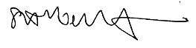
Steph Roberts-Bibby
Chief Executive of the Youth Justice Board

Who we are
As well as establishing the Youth Justice Board, the Crime and Disorder Act 1998 defined the principal aim of the youth justice system as preventing offending by children. Working towards achieving this is at the heart of what we do and our mission and vision.
Our mission

“The Youth Justice Board is the only statutory body to have oversight of the entire youth justice system. We provide independent, evidence-based advice and leadership to drive improvements that increase children’s positive outcomes and prevent offending.”

Our vision

“A youth justice system that sees children as children first, treats them fairly and helps them to build on their strengths so they can make a constructive contribution to society. This will prevent offending and create safer communities with fewer victims.”

Our mission
Our mission defines our unique role and purpose within the youth justice system. Our approach reflects three aspects of the role defined for us when we were established:
- Supporting improvement throughout the youth justice system and in the provision of local youth justice services.
- Informing the public, practitioners, and policymakers, including ministers, about the operation of the youth justice system.
- Influencing practitioners and policymakers to adopt the Child First evidence. This means treating children as children and upholding their rights, building pro-social identity, collaborating with children and diverting them from stigma, in order to deliver positive outcomes for children, victims and our communities.

Our vision
Our vision sets out a broad ambition for the youth justice system by describing how it can have wider impact on the communities in which children live, beyond the principal aim of preventing offending.
Decades of national and international research is summarised in our Child First framework1, and we seek to translate it into policy and practice across the youth justice system. It reflects evidence that the most effective way to reduce offending is by empowering children to be the best versions of themselves and contribute positively to the world around them.

Our values
Our culture is based around five values which define our beliefs and what it means to work for the organisation.
Our collective commitment to these values is driving us towards our ambition of becoming an exemplary and high performing public sector organisation and we are embedding these core values into every aspect of our organisation. Everyone at the Youth Justice Board is encouraged to breathe life into these values in our daily work.
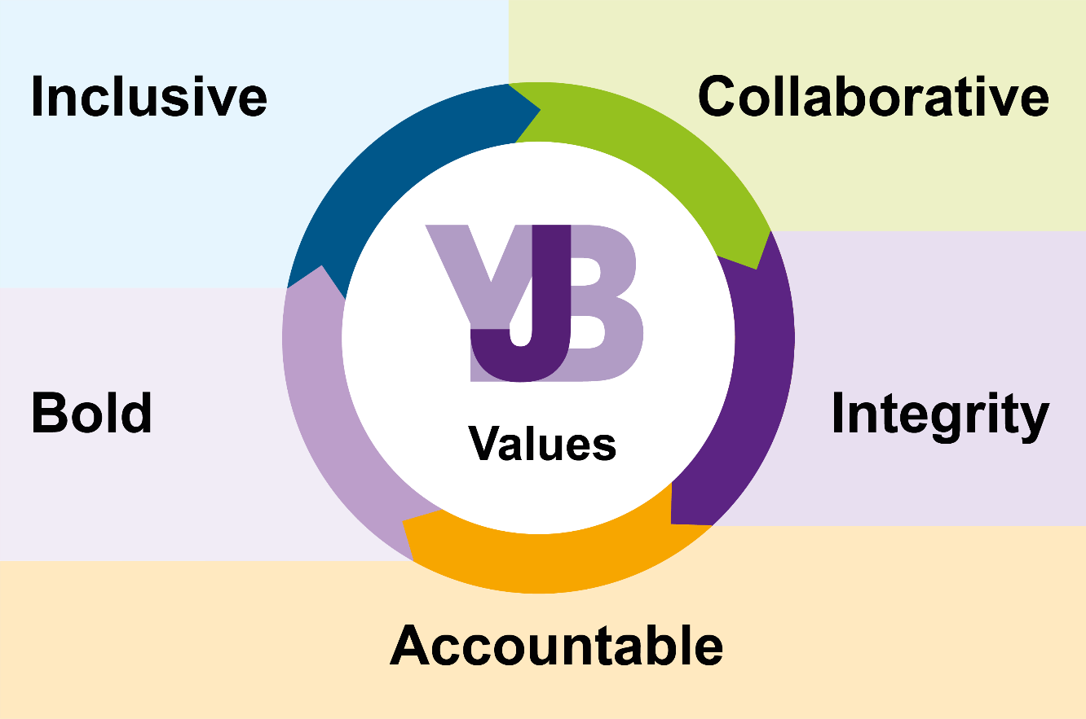

Inclusive – challenging discrimination and promoting inclusivity and equity in all that we do, as well as eliminating bias within the Youth Justice Board and the youth justice system.
Collaborative – collaborating with our youth justice partners and encouraging partnership working to meet the needs of children, victims and their communities.
Integrity – showing integrity by fulfilling our duties responsibly and always behaving in a professional manner.
Accountable – being accountable in our actions and our performance in supporting the sector to improve.
Bold – ensuring we remain evidence-based and boldly championing the voice of the child.

What we do
The Youth Justice Board’s seven statutory functions are also defined in the Crime and Disorder Act 1998, and we are accountable to ministers for delivering them.
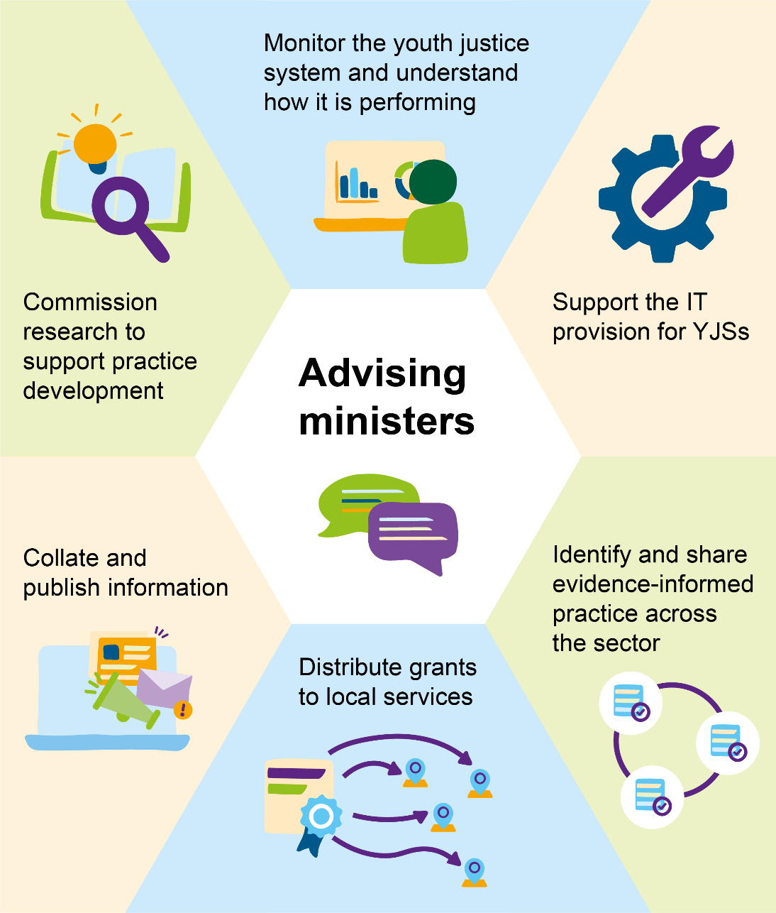
The approach to meeting these statutory functions has evolved over the past 25 years in response to the political and cultural landscape in which the youth justice system operates, and developments in the evidence about what is most effective in meeting the needs of children to prevent offending, reducing victims and creating safer communities.
We are also influenced by recommendations from internal and external reviews and any steer that we receive from the ministers responsible for youth justice.
The Act set out the requirement that each local authority should establish a youth offending team (now commonly referred to as youth justice services) and a local youth justice management board responsible for co-ordinating services in its area. The Youth Justice Board is responsible for monitoring those services and setting strategic direction for the youth justice system.

Our commitments in 2025-2026
Our Board’s current three-year strategy sets objectives which guide us in meeting our statutory functions.
The table which follows at pages 8-11 describes the activity we will deliver in 2025 - 2026 towards meeting those objectives and the workstreams which will support the current Government Missions which are relevant to the youth justice system.
Our strategic objectives 2024 - 2027 (see columns 1 – 3 below)
Objective 1: Supporting the improvement of local youth justice services
Objective 2: Focussing on addressing disparities
Objective 3: Advancing adoption of evidence-based policy
Government Missions (see columns A – J below)
Safer Streets | Cracking down on anti-social behaviour (A)
Safer Streets | A plan to get knives off our streets (B)
Safer Streets | A network of Young Futures hubs (C)
Safer Streets | Development of local Prevention Partnerships (D)
Safer Streets | Tackling Violence Against Women and Girls (E)
Safer Streets | Protection for victims (F)
Breaking Down Barriers to Opportunity | Providing security for families (G)
Breaking Down Barriers to Opportunity | Supporting the best start to life (H)
Breaking Down Barriers to Opportunity | Raising school standards (I)
Breaking Down Barriers to Opportunity | Improving access to arts, music and sport (J)

COMMITTED ACTIVITY & OUTCOME | YOUTH JUSTICE BOARD STRATEGIC OBJECTIVES 2024 - 2027 |  |  |  |  |  |  |  |  |  |  |  |  |  |  | GOVERNMENT MISSIONS
COMMITTED ACTIVITY & OUTCOME |  |  |  |  |  |  |  |  |  |  |  |  |  |  |  | “SAFER STREETS” |  |  |  |  |  |  |  |  |  |  |  |  |  |  |  |  |  |  |  |  |  |  |  |  |  |  |  | “BREAKING DOWN BARRIERS TO OPPORTUNITY”
COMMITTED ACTIVITY & OUTCOME | 1 |  | 2 |  |  |  |  |  |  |  | 3 |  |  |  |  | A |  |  |  |  |  |  |  | B |  |  |  |  | C |  |  |  | D |  |  | E |  |  | F |  |  |  |  | G |  |  |  |  |  | H |  |  |  |  |  |  | I |  |  |  |  | J
STATUTORY FUNCTION 1: Monitoring and overseeing the operation of the youth justice system.

Monitor youth justice services in line with expectations in the Oversight Framework  Review performance of youth justice services and partnerships against evidence-based expectations and standards and provide support to drive up standards in delivery and replicate best practice. | ✅ |  | ✅ |  |  |  |  |  |  |  | ✅ |  |  |  |  | ✅ |  |  |  |  |  |  |  | ✅ |  |  |  |  | ✅ |  |  |  | ✅ |  |  |  |  |  | ✅ |  |  |  |  | ✅ |  |  |  |  |  | ✅ |  |  |  |  |  |  | ✅ |  |  |  |  | ✅
Develop our information and insights platforms and products  Provision of analysis to support oversight, planning, decision-making and advice. | ✅ |  | ✅ |  |  |  |  |  |  |  | ✅ |  |  |  |  |  |  |  |  |  |  |  |  | ✅ |  |  |  |  | ✅ |  |  |  | ✅ |  |  | ✅ |  |  | ✅ |  |  |  |  | ✅ |  |  |  |  |  | ✅ |  |  |  |  |  |  | ✅ |  |  |  |  | ✅
Monitor, analyse and share findings from serious incidents involving children  Annual publication with analysis of serious incident notifications submitted to the Youth Justice Board. | ✅ |  | ✅ |  |  |  |  |  |  |  |  |  |  |  |  |  |  |  |  |  |  |  |  | ✅ |  |  |  |  | ✅ |  |  |  | ✅ |  |  | ✅
STATUTORY FUNCTION 2: Providing independent evidence-based advice to ministers and officials in Whitehall and the Welsh Government.
Develop clear evidence-based positions on youth justice matters  Provide high quality, independent evidence-based advice on themes including online harms, victims and girls. | ✅ |  | ✅ |  |  |  |  |  | ✅ |  |  |  |  |  |  | ✅ |  |  |  |  |  |  |  | ✅ |  |  |  |  | ✅ |  |  |  | ✅ |  |  | ✅ |  |  | ✅ |  |  |  |  | ✅ |  |  |  |  |  | ✅ |  |  |  |  |  |  | ✅ |  |  |  |  | ✅
Informing policy and legislative change  Collaboration and engagement with key stakeholders with interest in the youth justice system through our established forums to drive an evidence-led approach. |  |  | ✅ |  |  |  |  | ✅ |  |  |  |  |  |  | ✅ |  |  |  |  |  |  |  | ✅ |  |  |  |  |  | ✅ |  |  |  | ✅ |  |  | ✅ |  |  | ✅ |  |  |  | ✅ |  |  |  |  |  | ✅ |  |  |  |  |  |  | ✅ |  |  |  |  |  | ✅
STATUTORY FUNCTION 3: Administering and distributing grant funding.

Allocate core grant funding to local authorities  Prompt allocation of youth justice core grant funding to 157 local authorities in England and Wales. | ✅ |  |  |  | ✅ |  |  |  |  |  |  |  |  |  |  |  |  |  |  |  | ✅ |  |  |  |  |  | ✅ |  |  |  |  | ✅ |  |  | ✅
Renew grant terms and conditions  Develop and implement new terms and conditions which reflect the aims and objectives of the youth justice system. | ✅ |  |  |  | ✅
Youth justice core grant funding  Support Ministry of Justice ministers and officials to develop proposals for a new fairer, evidence-based formula for allocating funding. | ✅ |  |  |  | ✅ |  |  |  |  | ✅
Administer targeted funding to support innovation through pathfinder projects  Support delivery of thematic projects on disproportionality, accommodation for children and enhancing use of temporary release from custody. | ✅ |  |  |  | ✅ |  |  |  |  | ✅
STATUTORY FUNCTION 4: Providing assistance in the use of information technology and equipment for the youth justice system.

Deliver, maintain and enhance data and information systems provided to youth justice services  Continue contracts to deliver, maintain and enhance the Youth Justice Application Framework (YJAF) system. |  | ✅ |  |  |  |  |  |  |  |  |  |  |  |  |  |  | ✅ |  |  |  |  | ✅ |  |  |  |  |  | ✅ |  |  |  | ✅ |  |  | ✅ |  |  | ✅ |  |  |  | ✅ |  |  |  |  | ✅ |  |  |  |  |  |  | ✅ |  |  |  |  |  |  | ✅
STATUTORY FUNCTION 5: Collating and publishing information about the performance of the youth justice system.

Analyse and utilise data from Key Performance Indicators (KPIs)  Publish KPI Quality and Methodology Information Paper and apply KPIs to the Oversight Framework. |  | ✅ |  | ✅ |  |  |  | ✅ |  |  |  |  |  | ✅ |  |  |  |  |  | ✅ |  |  |  |  |  |  |  |  |  |  |  |  |  |  |  | ✅ |  |  |  | ✅ |  |  |  |  |  |  |  |  |  |  |  |  |  |  |  |  |  | ✅
Youth Justice Annual Statistics 2024 - 2025  Annual statistical release with data on the youth justice system in England and Wales. |  | ✅ |  | ✅ |  |  |  | ✅ |  |  |  |  |  | ✅ |  |  |  |  |  | ✅ |  |  |  |  |  | ✅ |  |  |  |  | ✅ |  |  |  |  | ✅ |  |  |  | ✅ |  |  |  |  | ✅ |  |  |  |  |  | ✅ |  |  |  |  |  |  | ✅ |  |  |  | ✅
Data workbooks, toolkits and dashboards  Produce quarterly Youth Justice Data Summary workbook and share with youth justice services. |  | ✅ |  | ✅ |  |  |  | ✅ |  |  |  |  |  |  |  |  |  |  |  | ✅ |  |  |  |  |  | ✅ |  |  |  |  | ✅ |  |  |  |  | ✅ |  |  |  | ✅ |  |  |  |  | ✅ |  |  |  |  |  | ✅ |  |  |  |  |  |  | ✅ |  |  |  | ✅
Data exploration, automation and linkage  Explore options for linking Assetplus data to Ministry of Justice and wider datasets. |  | ✅ |  | ✅ |  |  |  | ✅ |  |  |  |  |  | ✅ |  |  |  |  |  | ✅ |  |  |  |  |  | ✅ |  |  |  |  | ✅ |  |  |  |  | ✅ |  |  |  | ✅ |  |  |  |  | ✅ |  |  |  |  |  | ✅ |  |  |  |  |  |  | ✅ |  |  |  | ✅
Publish a periodic review of how racial disparity affects children in their early years and within the youth justice system  Publish report on disproportionality at different stages of the youth justice system. |  | ✅ |  | ✅ |  |  |  | ✅ |  |  |  |  |  |  |  |  |  |  |  | ✅ |  |  |  |  |  | ✅ |  |  |  |  |  |  |  |  |  | ✅
STATUTORY FUNCTION 6: Commissioning research to support practice development.

Commissioned and in-house research  Scope, undertake and publish in-house and externally commissioned research, including projects which will evaluate the prevention / diversion tool; application of the Child First approach to practice; and child exploitation. |  | ✅ |  | ✅ |  |  |  | ✅ |  |  |  |  |  | ✅ |  |  |  |  |  | ✅ |  |  |  |  |  | ✅ |  |  |  |  |  |  |  |  |  |  |  |  |  | ✅ |  |  |  |  | ✅ |  |  |  |  |  |  | ✅ |  |  |  |  |  | ✅ |  |  |  | ✅
Coordinate our Academic Liaison Network  Maintain mutually beneficial relationships and collaboration between the Youth Justice Board and academia. |  | ✅ |  | ✅ |  |  |  | ✅ |  |  |  |  |  | ✅ |  |  |  |  |  | ✅ |  |  |  |  |  | ✅ |  |  |  |  | ✅ |  |  |  |  | ✅ |  |  |  | ✅ |  |  |  |  | ✅ |  |  |  |  |  |  | ✅ |  |  |  |  |  | ✅ |  |  |  | ✅
STATUTORY FUNCTION 7: Identifying and sharing evidence-informed practice across the sector.

Maintain Case Management Guidance  Support adoption of Case Management Guidance and undertake thematic updates. |  | ✅ |  | ✅ |  |  |  | ✅ |  |  |  |  |  | ✅
Youth Justice Leaders Summit 2026  Organise the annual summit. |  | ✅ |  | ✅ |  |  |  | ✅ |  |  |  |  |  |  |  |  |  |  | ✅ |  |  |  |  |  |  | ✅ |  |  |  |  | ✅ |  |  |  |  | ✅ |  |  |  | ✅ |  |  |  |  | ✅ |  |  |  |  |  |  | ✅ |  |  |  |  |  | ✅ |  |  |  | ✅
Youth justice sector Workforce  Facilitate the workforce development council. |  | ✅ |  | ✅ |  |  |  | ✅
Elevate  Review the programme delivery model to ensure it meets the needs of participants. |  | ✅ |  | ✅ |  |  |  | ✅ |  |  |  |  |  | ✅
Disseminate promising practice  Maintain our communications strategy and share evidence-informed practice with the youth justice sector. |  | ✅ |  | ✅ |  |  |  | ✅ |  |  |  |  |  | ✅ |  |  |  |  | ✅ |  |  |  |  |  |  | ✅ |  |  |  |  | ✅ |  |  |  |  | ✅ |  |  |  | ✅ |  |  |  |  | ✅ |  |  |  |  |  |  | ✅ |  |  |  |  |  | ✅ |  |  |  | ✅
Wales: Collaborate with the Welsh Government and with devolved and non-devolved services in Wales to meet our strategic objectives and statutory functions

Monitor performance of youth justice services; identify and promote evidence and research; and work in partnership to deliver the vision in the Youth Justice Blueprint for Wales, the Anti-Racist Wales Action Plan and other areas of strategic focus. |  | ✅ | ✅ |  |  |  | ✅ |  |  |  |  |  | ✅ |  |  |  |  | ✅ |  |  |  |  |  |  | ✅ |  |  |  |  | ✅ |  |  |  | ✅ |  |  | ✅ |  |  |  | ✅ |  |  |  |  |  |  | ✅ |  |  |  |  |  |  | ✅ |  |  |  | ✅

Our corporate functions
Our corporate functions enable the Youth Justice Board to operate as an efficient, inclusive and effective high-performing organisation. They manage essential business-critical functions which are necessary for the functioning of the organisation and ensure that our policies and procedures are up-to-date and being applied in as efficient way as possible.

Public Bodies Review
In 2025 - 2026 we are ready to respond to the findings and recommendations of the public bodies review of the Youth Justice Board to ensure that that our functions remain useful and necessary to deliver the Government’s priorities for the youth justice system, and that we are operating effectively and delivering value for money.

Corporate activity | What we will do
Our commitment to actively oppose racism and discrimination, and promote racial equity | Anti-Racist Statement: Update our published statement to reflect progress we have made in 2024 - 2025 and set out our commitments for the year ahead.  Anti-Racist Strategy: Review our strategy to monitor activity that is underway or completed and identify opportunities for new activities.  Criminal Justice Board for Wales Anti Racist Action Plan: Support implementation of the Anti-Racist Action Plan to eliminate racism and advance race equity across all public services in Wales and Welsh society.
Financial management | Manage and monitor all financial activity for the Youth Justice Board through liaison with Ministry of Justice finance teams and Grants Centre of Excellence to provide strategic financial advice and robust reporting to the Accounting Officer; foster a culture of value-for-money and productivity; ensure budget efficiency; promote financial compliance; and support informed decision-making by our Board and Senior Leadership Team.

People Strategy | Deliver our People Strategy for 2025 – 2027 to support our aim to be an exemplary public sector organisation and employer, which will be achieved through:  - Attracting, recruiting and retaining the diverse talent we need within the constraints of our budget.  - Promoting a sense of belonging as an inclusive, compassionate, and pro-actively anti-discriminatory and anti-racist organisation. An organisation with effective and supportive leadership, which values the strengths of its people, and its people are encouraged to value each other.  - Embedding a culture of high achievement, accountability and responsibility, rooted in our values with inspiring and empowering leadership.  - Developing and supporting our people to help build and maintain individual and organisational, resilience.
Digital and Data Strategy | Apply our Digital and Date Strategy to set out how we will use the high-quality data and tools to derive insights and aid decisions to support our legal duty of overseeing and improving the youth justice system and improve the experience of children who come into contact with it.  We will produce regular internal insights products which draw on the information and intelligence accessed through the Insights Platforms, designed to inform our Board and Senior Leadership Team to support oversight, planning, decision-making and advice.  To deliver this we will work in partnership across government and consider how new technologies and developments such as artificial intelligence can help us achieve efficiencies and support our work.
Welsh Language Act | Work with the Welsh Language Commissioner to ensure that we are compliant with the provisions of the Welsh Language Act 1993.

Benefits and measuring impact
Our work is led by the benefits we provide to the youth justice system. We are determined to ensure that everything we do contributes to the achievement of four overarching benefits which are closely aligned to our statutory functions and strategic objectives.
1. Improved youth justice service performance to prevent offending.
2. Reduced racial disparity.
3. Treating children as children and upholding their rights, building pro-social identity, collaborating with and diverting them from stigma, in order to deliver positive outcomes for children, victims and our communities.
4. Improved Youth Justice Board performance.
These benefits are ambitious and (apart from benefit 4) are dependent on the performance of the wider youth justice system, not just the Youth Justice Board. As a result of their scope and scale, benefits 1-3 are tracked over an extended period rather than just within a single business year.
To evaluate progress in delivering these benefits, we use a range of quantitative and qualitative indicators including metrics and insight from our oversight about the performance of the system and local youth justice services, ratings from inspections of youth justice services conducted by HM Inspectorate (Probation), youth justice sector key performance indicators, outcomes from targeted funding projects and research projects, and ratings from Government Internal Audit Agency thematic audits.
For benefit 4 (Improved Youth Justice Board performance) we have developed a draft set of internal key performance indicators to evaluate our own performance and enable us to evidence our successes and highlight areas where we need to improve. We will further develop these indicators and how they will be monitored following the conclusion of the public bodies review of the Youth Justice Board and confirmation of our functions.
KPI | Baseline measure | Target measure | Source of measure | Frequency of evaluation
Average working days lost to sickness are below the Civil Service average | 7.8 per year (year ending March 2024) | Less than 7.8 for year ending 2026 | Civil Service and Youth Justice Board data | Bi-annually
People engagement score is equal to or more than Civil Service benchmark | 63% (2024) | 64% (Civil service benchmark) | Civil Service People Survey | Annually
Employee attrition rate is equal to or lower than the UK average | 27.8% (2023/24) | Equal to or lower than 16% (2024) | Youth Justice Board data/Chartered Institute of Personnel and Development | Annually
Inclusion and fair treatment score to equal or exceed the benchmark for Civil Service | 77% (2024) | Equal to or more than 80% for 2025 which is the Civil Service benchmark | Civil Service People Survey | Annually
Reduction in the number of people who say yes to having been discriminated against at work | 9% (2024) | Less than 9% for 2025 | Civil Service People Survey | Annually
Reduction in the number of people who report being bullied and harassed at work | 16% (2024) | Less than 16% for 2025 | Civil Service People Survey | Annually
Gender and ethnicity pay gaps to be below 5% | Average Youth Justice Board earnings:  Gender: -2%  Ethnicity: 5% | Gender and ethnicity pay gaps to be below 5%. | Pay gap report | Annually
Increase the level of our diversity declaration  reporting | Youth Justice Board non-declaration:  Ethnicity: 11%  Disability: 11% | Less than 11% for ethnicity and disability not declared in 2025 | Youth Justice Board internal data | Annually

Monitoring and managing risk
We use our Risk Management Framework to identify, monitor and mitigate risks which may have an impact on our efforts to realise our intended benefits, achieve our statutory functions and strategic objectives. Senior and Board-level structures and our Finance, Audit, Risk and Assurance Committee provide further oversight to ensure that our response is being managed appropriately.
We have identified the following strategic risks for 2025 - 2026, and we have a detailed control and mitigation plan in place for each one.
Risk
Strategic risk 1: Insufficient evidence base to provide sound and effective advice.
Strategic risk 2: Failure to deliver our statutory monitoring function.
Strategic risk 3: Failure to deliver our statutory function to support the information technology provision for youth justice services.
Strategic risk 4: Failure to realise benefits and evidence the full impact of our work.
Strategic risk 5: Failure to adhere to our organisational-wide governance processes leading to a lack of corporate discipline and ability to maximise our resources.
Strategic risk 6: Ineffective relationship with the sponsoring department, Welsh Government and wider partnerships affecting collaboration and delivery of objectives.
Strategic risk 7: Failure to manage the budget effectively to ensure that our resources, including capital, targeted investment, and core grant, are utilised to maximise impact on driving system improvement and delivering statutory functions.
Strategic risk 8: Failure to have sufficient and/or appropriately skilled staff to effectively deliver our strategic and business plans.
Strategic risk 9: Ineffective/insufficient leadership at senior and Board level.

Our finances
Each year, we publish our Annual Report and Accounts in which we reflect on our achievements during the year and the value we provide with the public funds that we receive.
Our budget allocation for 2025 - 2026 is expected to be as follows:
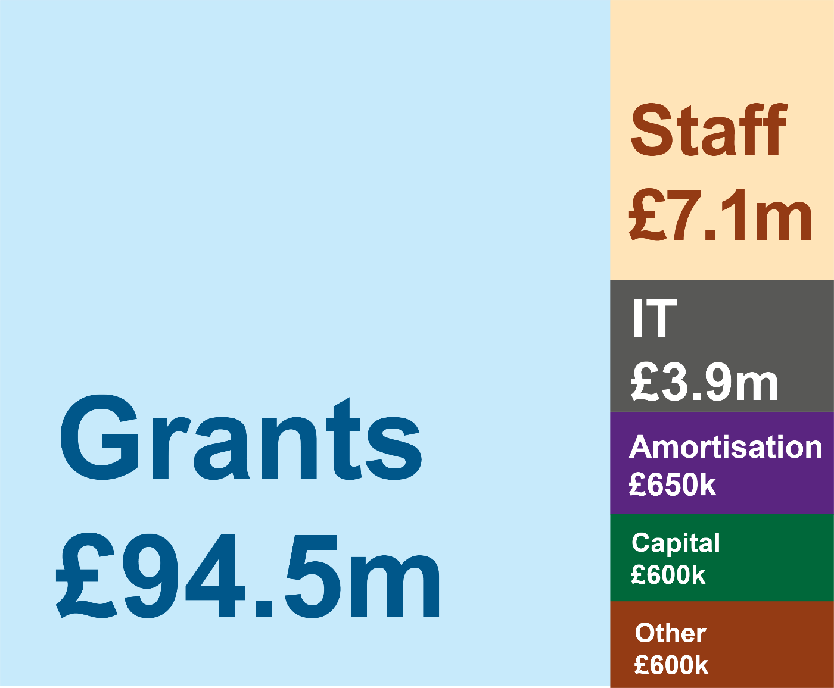



Youth Justice Board / Bwrdd Cyfiawnder Ieuenctid

10 South Colonnade  Canary Wharf  London  E14 4PU | Welsh Government Buildings  Llys-y-ddraig Penllergaer  Business Park  Penllergaer  Swansea  SA4 9NX
YJB.Enquiries@yjb.gov.uk



A Guide to Child First - Youth Justice Board for England and Wales (October 2022) - Youth Justice Resource Hub
Youth Justice Board for England and Wales Strategic Plan 2024-27 - GOV.UK
Youth justice oversight framework - GOV.UK
Women on average earning 2% more than men.
Across whole of Youth Justice Board, white colleagues earning on average 5% more than minority ethnic colleagues.

