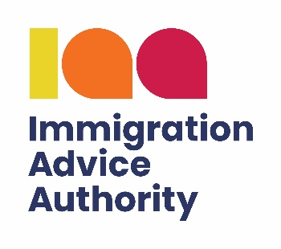

Supervision logbook

All Authorised supervisors must complete the supervision logbook below for each supervisee and a copy of this should be stored for inspection by the IAA.
The Supervision log is only intended to be a summary of the supervisor/supervisees’ discussions and files reviewed. Detailed supervision records must be kept on individual clients’ files and the supervisee’s personal file. Such records must be available for inspection by the Commissioner.
Organisation name |  | IAA Registration  Number
Supervisor’s name |  | Supervisor’s IAA  adviser number
Supervisee’s name |  | Authorised  supervision period
Supervision  commencement  date |  | Signature of supervisor:

Review of work  Date and duration of meeting | Type of application reviewed | Summary of findings and learning points | Agreed action and training identified

