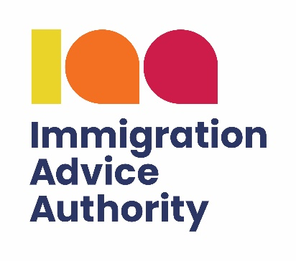

**Complaint form:**

**Complain about an immigration adviser**

**Complaint form: Complain about an immigration adviser**

About you

1. **Your details (person completing the form):**

|  |  |
| --- | --- |
| Name |  |
| Address |  |
| Email address |  |
| Telephone number |  |

1. **Are you making the complaint on behalf of another person?**

*Yes*

*No*

If ‘yes’, please tell us who you are making the complaint on behalf of below.

If ‘no’, please go to question 3.

|  |  |
| --- | --- |
| Name |  |
| Address |  |
| Email address |  |
| Telephone number |  |

About Your Immigration Adviser

1. **Please provide details of the organisation/adviser who you are complaining about:**

|  |  |
| --- | --- |
| Adviser name |  |
| Organisation name |  |
| IAA reference number (if applicable) |  |
| Address (including postcode) |  |
| Email address |  |
| Telephone number |  |

1. **Please provide details of your complaint. Include as much information as possible.**
2. **How would you like to see your complaint resolved?**

Please tick the relevant options and add any further information in the box below.

* Return of documents
* Refund (please note that the IAA only has the regulatory power to recommend that an adviser provides a refund. The IAA cannot force the adviser to make a refund)
* Service improvement
* Apology
* Other

1. **Have you already made a complaint directly to the adviser/organisation?**

*Yes No*

If yes, what was the outcome?

Consent and Disclosure

1. **Disclosure of client’s name**

The Immigration Advice Authority (IAA) will consider all complaints received. However, your complaint may be affected if we cannot disclose the complainant’s identity. This may mean the IAA is unable to investigate your complaint further.

**I give the IAA permission to disclose my name/the name of the person on whose behalf I am complaining, to the adviser/organisation who is the subject of the complaint or their regulatory body. Please tick the relevant box.**

*Yes No*

1. **Consent to share complaint form with the adviser/organisation**

The IAA would also like your permission to pass this completed complaint form to the adviser/organisation (or their regulatory body where applicable) to ensure that they fully understand your complaint.

**I give the IAA permission to disclose the completed complaint form to the adviser who is the subject of the complaint or their regulatory body. Please tick the relevant box.**

*Yes No*

1. **For internal monitoring purposes, please tell us how you heard about the IAA?**

Friend/relative

Home Office

Internet

IAA adviser

Citizens Advice

MP

Community group

Legal Ombudsman

Law Society/Solicitors Regulation Authority (SRA)

Solicitor

Other

Submit your complaint

Once you have completed this complaints form, there are three ways in which you may submit your complaint form to the IAA:

1. [The IAA complaints portal](https://portal.immigrationadviceauthority.gov.uk/s/complaints) - this is the preferred method to ensure your complaint is recorded timeously and responded to in accordance with our stated guidelines.
2. Email it to [complaints@immigrationadviceauthority.gov.uk](mailto:complaints@immigrationadviceauthority.gov.uk)
3. Post it to:

IAA Complaints Team  
 PO Box 567  
 Dartford  
 DA1 9WX