2025 national curriculum tests
Key stage 2
Mathematics
Paper 3: reasoning
48pt MODIFIED LARGE PRINT

Note to markers
This paper should be marked using the standard mark schemes for KS2 Mathematics: Paper 2.
There is additional guidance on marking some questions in this paper in the Key stage 2 Mathematics amendments to mark schemes –
MLP document.
First name
Middle name
Last name
Date of birth
Day Month Year
School name
DfE number

Instructions
You must not use a calculator to answer any questions in this test.
Questions and answers
You have 40 minutes, plus your additional time allowance, to complete this test.
Follow the instructions for each question.
Work as quickly and as carefully as you can.
If you need to do working out, you can use any space on the page.
Method questions
Some questions say: ‘Show your method.’
For these questions, you may get a mark for showing your method.
If you cannot do a question, go on to the next one. You can come back to it later, if you have time. If you finish before the end, go back and check your work.
- Tick or mark the numbers that have 8 in the thousands place.

84 623

28 436

683 052

8 325

608 231
- Tick or mark all the numbers that are less than one million and fifty thousand.

1 400 000

1 049 900

1 060 000

1 030 900
- There were 15 961 people at a
football game.

Round 15 961 to the nearest hundred.

- Jack buys 2 kilograms of pears.

He spends £3 • 28

What is the cost of one kilogram
of pears?
£

[BLANK PAGE]

The test continues on the next page.

- Look at the grid on the opposite page.

Point P is located at (5, 8) on the grid.
Point P is translated 4 units right,
6 units down and 2 units left.

What is the location of point P
after the three translations?
( , )
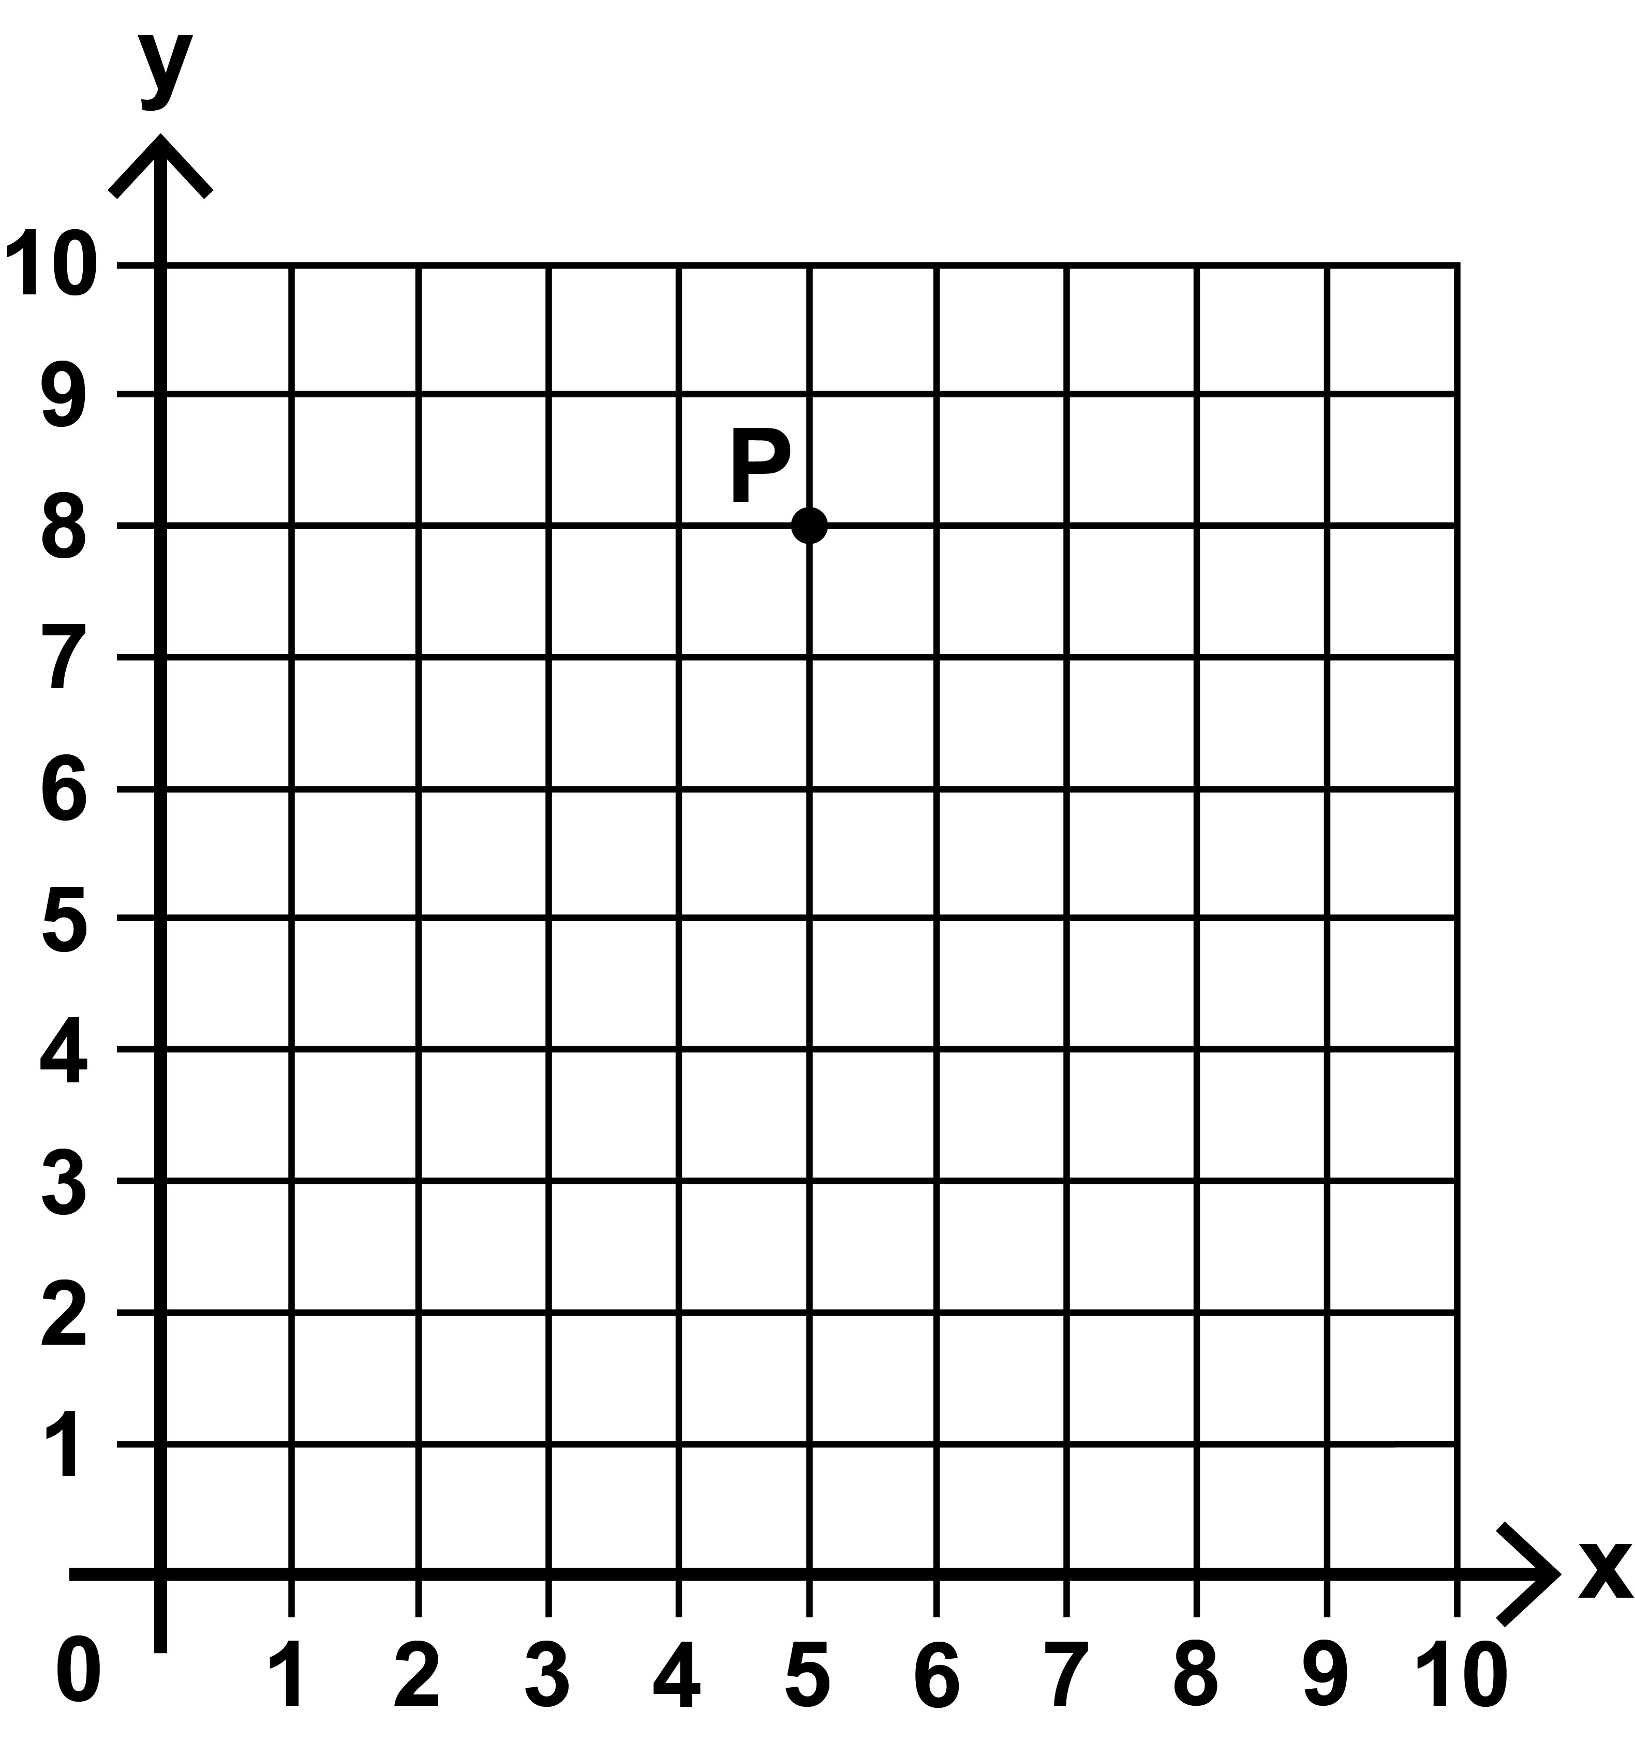

- The mass of an empty truck is
2 250 kilograms.

It is then loaded with 8 boxes.

The mass of each box is 25 kilograms.

What is the total mass of the truck and
its load?

Show your method.

kilograms
- Draw four lines to match each improper fraction to its equivalent
mixed number.

[Go to next page]

5 | 2
 | 5

26  4 |  | 4 2  5
27  5 |  | 6 2  4
30  4 |  | 4 2  4
32  5 |  | 7 2  4
6 | 2
 | 5

- Ken buys three items.
The prices are shown below.

Milk: 80p
Cereal: £2 • 50
Bread: £1 • 15

He pays with a £20 note.
How much change does Ken get?

Show your method.

£
- The diagram below shows part of a number line with one arrow.
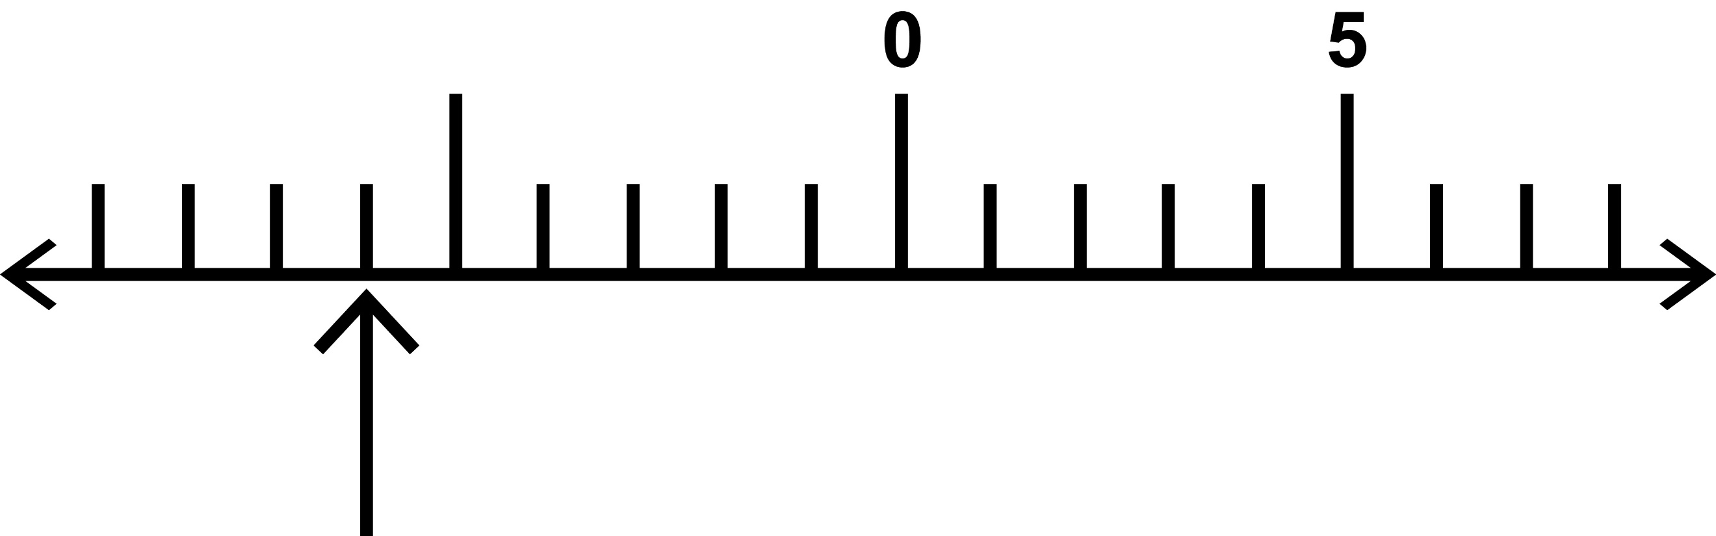
- Write the number that the arrow is
pointing to.

- Write the number that is 16 less than 7

- The table below shows some information about four animals in a zoo.

 | Mass | Height
Elephant | 6 300 kg | 3 • 4 m
Hippo | 1 100 kg | 1 • 5 m
Rhino | 2 400 kg | 1 • 7 m
Giraffe | 1 200 kg | 6 • 0 m

Look at the four statements below.
Tick or mark the statements that are true.

The elephant is exactly three times heavier than the rhino.

The hippo is a quarter of the height of
the giraffe.

The rhino is 20 cm taller than the hippo.

The tallest animal is also the heaviest.
- Look at the four number sentences
on the following page.

Tick or mark the number sentence that
is correct.
4
10
3
1000

0 • 304 = +
43
1000

0 • 43 =
4
10
3
1000

0 • 403 = +
3
10
4
1000

- • 034 = +
- Look at the six digital times below.

12:35
04:05
21:45
07:20
22:45
19:20

Write the digital time from the list that is equivalent to each written time on the opposite page.

One has been done for you.

five past 4 in the morning

_04:05_

- 25 minutes to 1 in the afternoon

- 20 minutes past 7 in the morning

- quarter to 11 in the evening
- Write these numbers in order, starting with the least.
99
100
9
100

0 • 999 0 • 009

least
- Look at this expression y + 4

- Tick or mark the value for y that gives
a prime number value for y + 4

y = 8 y = 9 y = 10

- Tick or mark the value for y that gives
a square number value for y + 4

y = 5 y = 6 y = 7
[BLANK PAGE]

The test continues on the next page.

- A factory makes T–shirts and dresses.
They pack them in boxes.

There are 50 T–shirts in a box.

- How many T–shirts are there in
250 boxes?

There are 40 dresses in a box.

- How many boxes are needed for
3 000 dresses?

- Look at the two pie charts on the
opposite page.

The pie charts show the biscuits in two tins.

Tin B has more chocolate biscuits than Tin A.

Explain why this is incorrect.
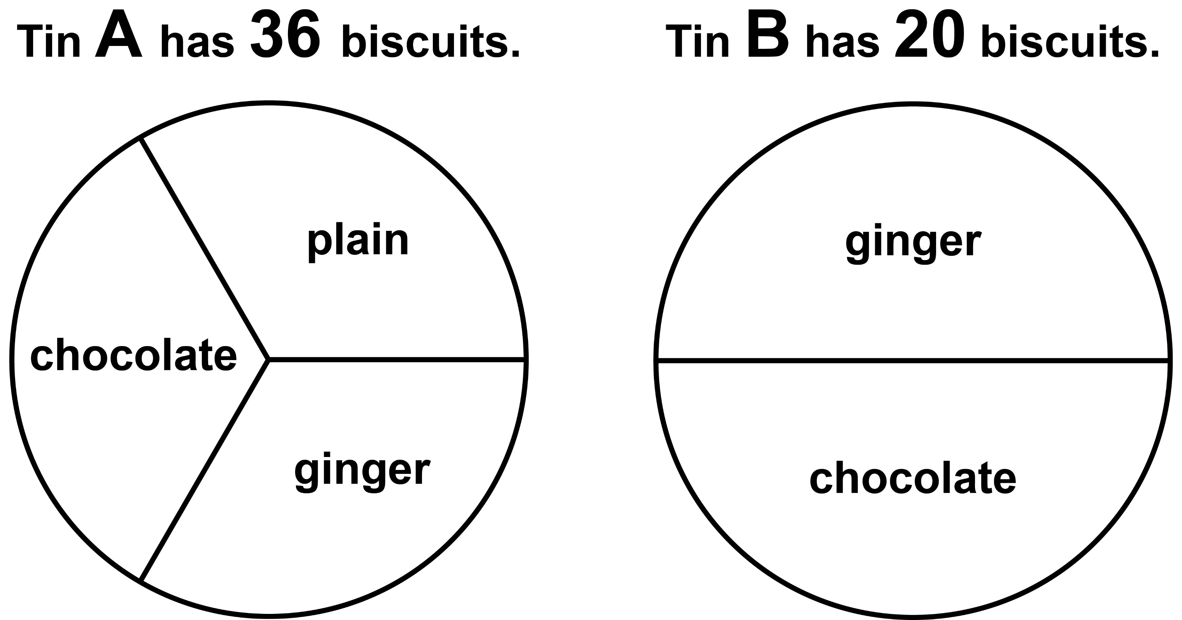

- A shop buys 35 boxes of crisps.

Each box contains 48 packets of crisps.

On average, the shop sells 56 packets of crisps each day.

How many days will it take for all of the crisps to be sold?

Show your method.

days

- (a) Convert 5 • 65 km to metres.

m

(b) Convert 35 • 5 cm to metres.

m
[BLANK PAGE]

The test continues on the next page.

- Jacob has some wooden blocks that are all the same size.
He uses the blocks to make two towers.
Not actual size

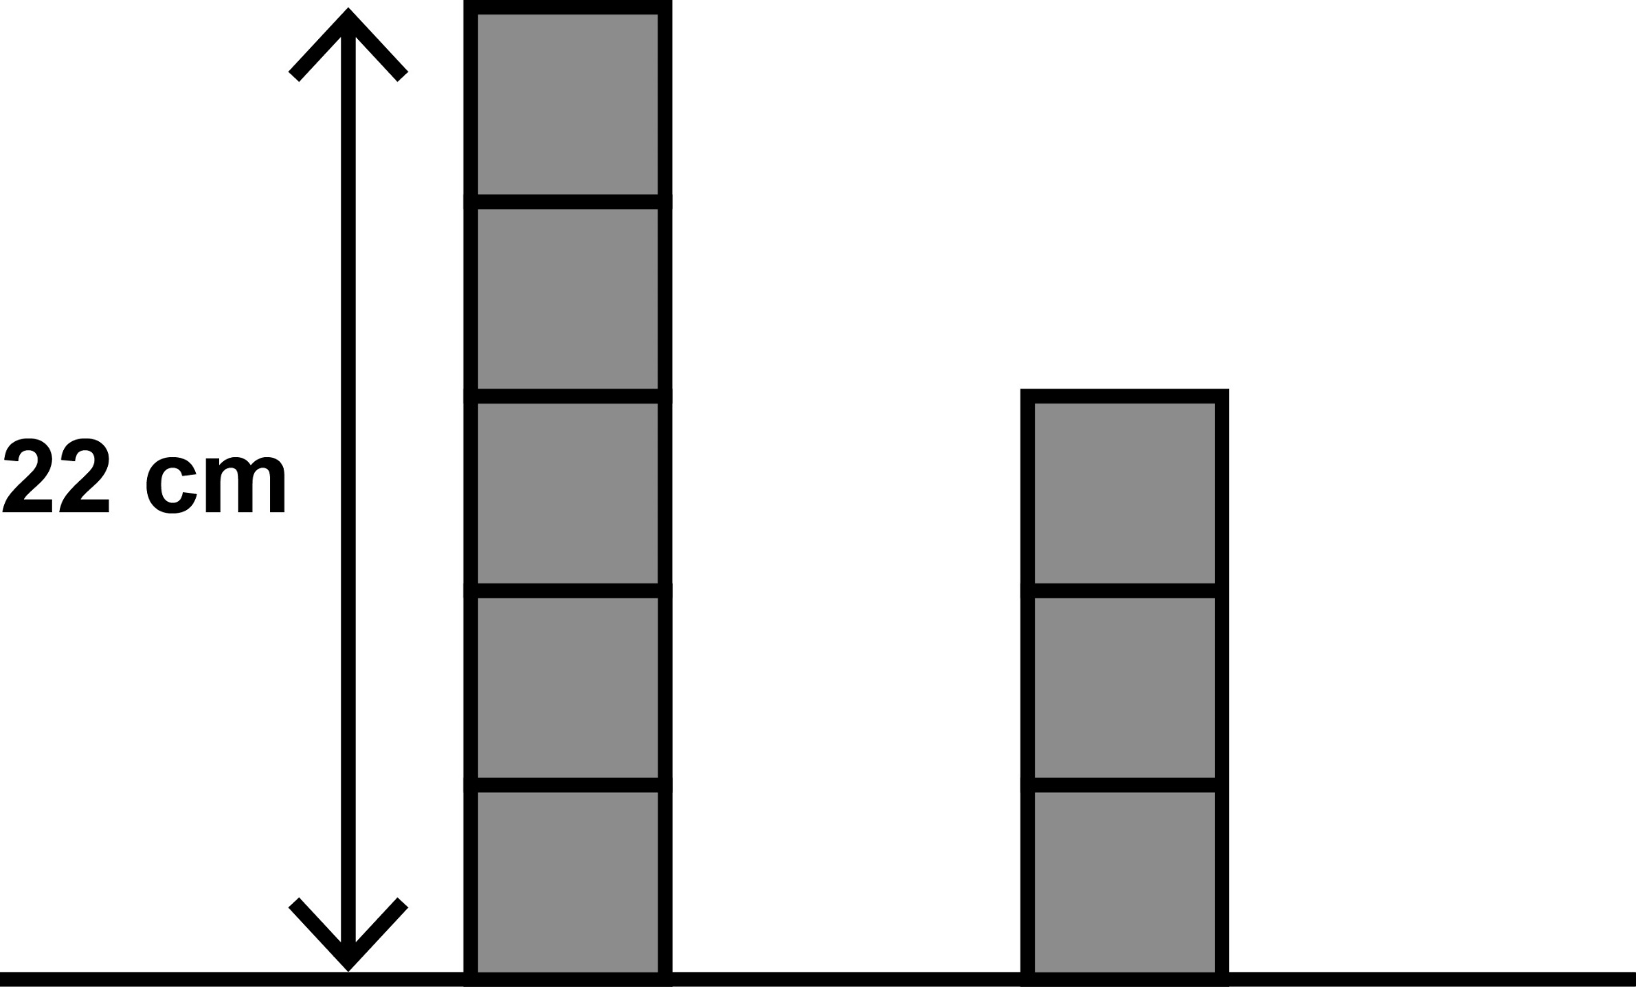

The height of the taller tower is
22 centimetres.

What is the height of the smaller tower?

Show your method.

cm
- The shape on the next page is made from two large equilateral triangles.

One of the large triangles is divided into four smaller equilateral triangles.

One of the smaller triangles is shaded.

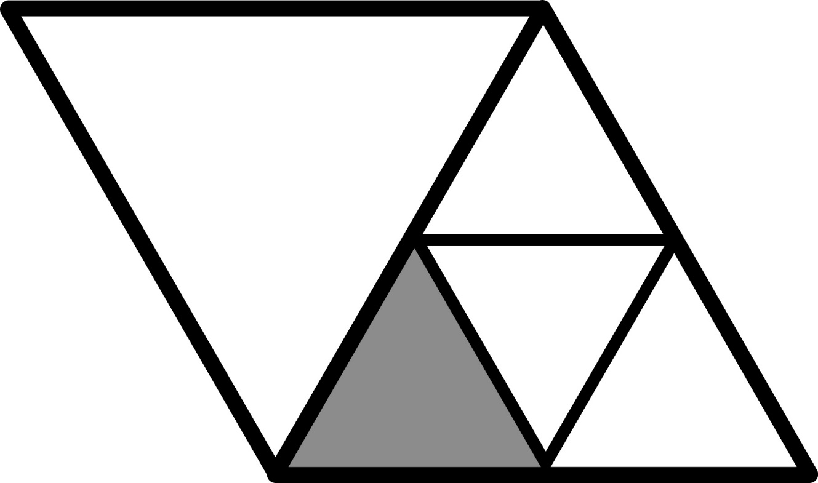

What fraction of the whole shape
is shaded?

- Here is some information about a number:
- It has two digits
- It is a multiple of 7
- One of the digits is 8

Write all the possible numbers that the number could be.

[BLANK PAGE]

The test continues on the next page.

- This diagram shows four identical parallelograms and a rhombus.

Not to scale.
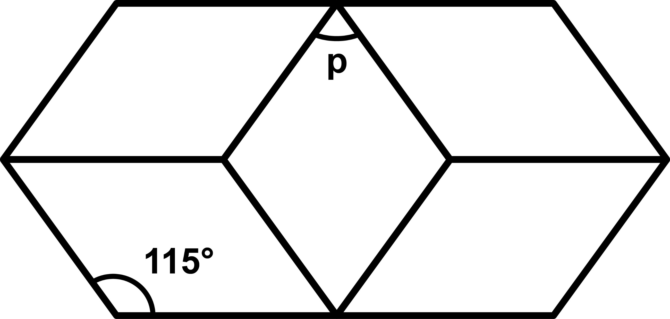

Calculate the size of angle p.

Show your method.

°

Key stage 2 mathematics
48 point A3 modified large print Paper 3: reasoning
For more copies
Additional copies of this modified large print test paper can be ordered by contacting the national curriculum assessments helpline on 0300 303 3013. After the test window, it can be downloaded from www.gov.uk/government/collections/national-curriculum-assessments-past-test-materials.
© Crown copyright
The materials in this booklet are Crown copyright. You may re-use them (not including logos) free of charge in any format or medium in accordance with the terms of the Open Government Licence v3.0, which can be found on the National Archives website and accessed via the following link: www.nationalarchives.gov.uk/doc/open-government-licence.
If you have any queries regarding these test materials, please contact the national curriculum assessments helpline on
0300 303 3013 or email assessments@education.gov.uk.

