2025 national curriculum tests
Key stage 2
Mathematics
Paper 2: reasoning
48pt MODIFIED LARGE PRINT

Note to markers
This paper should be marked using the standard mark schemes for KS2 Mathematics: Paper 2.
There is additional guidance on marking some questions in this paper in the Key stage 2 Mathematics amendments to mark schemes –
MLP document.
First name
Middle name
Last name
Date of birth
Day Month Year
School name
DfE number

Instructions
You must not use a calculator to answer any questions in this test.
Questions and answers
You have 40 minutes, plus your additional time allowance, to complete this test.
Follow the instructions for each question.
Work as quickly and as carefully as you can.
If you need to do working out, you can use any space on the page.
Method questions
Some questions say: ‘Show your method.’
For these questions, you may get a mark for showing your method.
If you cannot do a question, go on to the next one. You can come back to it later, if you have time. If you finish before the end, go back and check your work.
- Look at the four angles below.
Tick or mark the angle that is closest in size to a right angle.
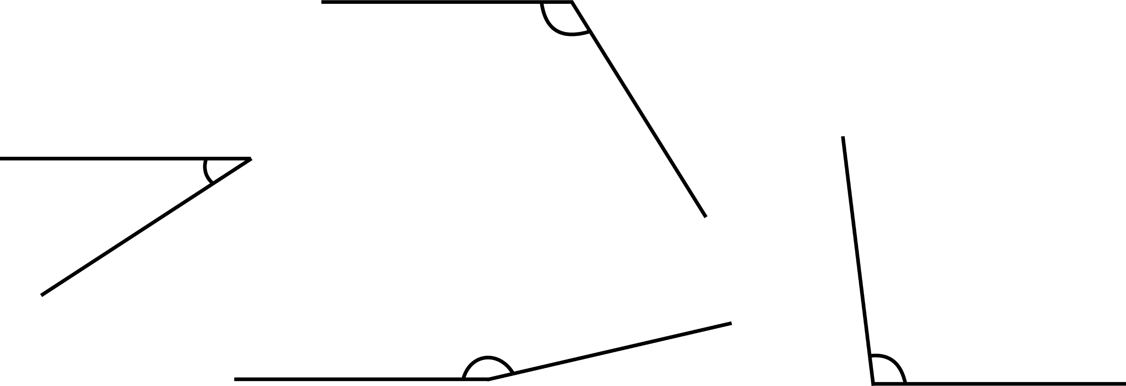

- Look at the diagram on the following page.

It shows part of a number grid with some missing numbers.

Write the missing numbers P and Q.

P

Q
 | Add 1000
Add  100 | P
 | 5 350 | 6 350
 | 5 450 | 6 450 |  | 7 450
 |  |  |  | 7 550 | Q

- Layla’s money
£2
50p
20p
Adam’s money
50p
50p
50p
20p
20p
How much more money does Layla have than Adam?

- Look at the diagram on the opposite page.
Match each point to its coordinates.

A |  |  |  |  | (6, 2)
B |  |  |  |  | (2, 6)
C |  |  |  |  | (0, 3)
D |  |  |  |  | (8, 8)

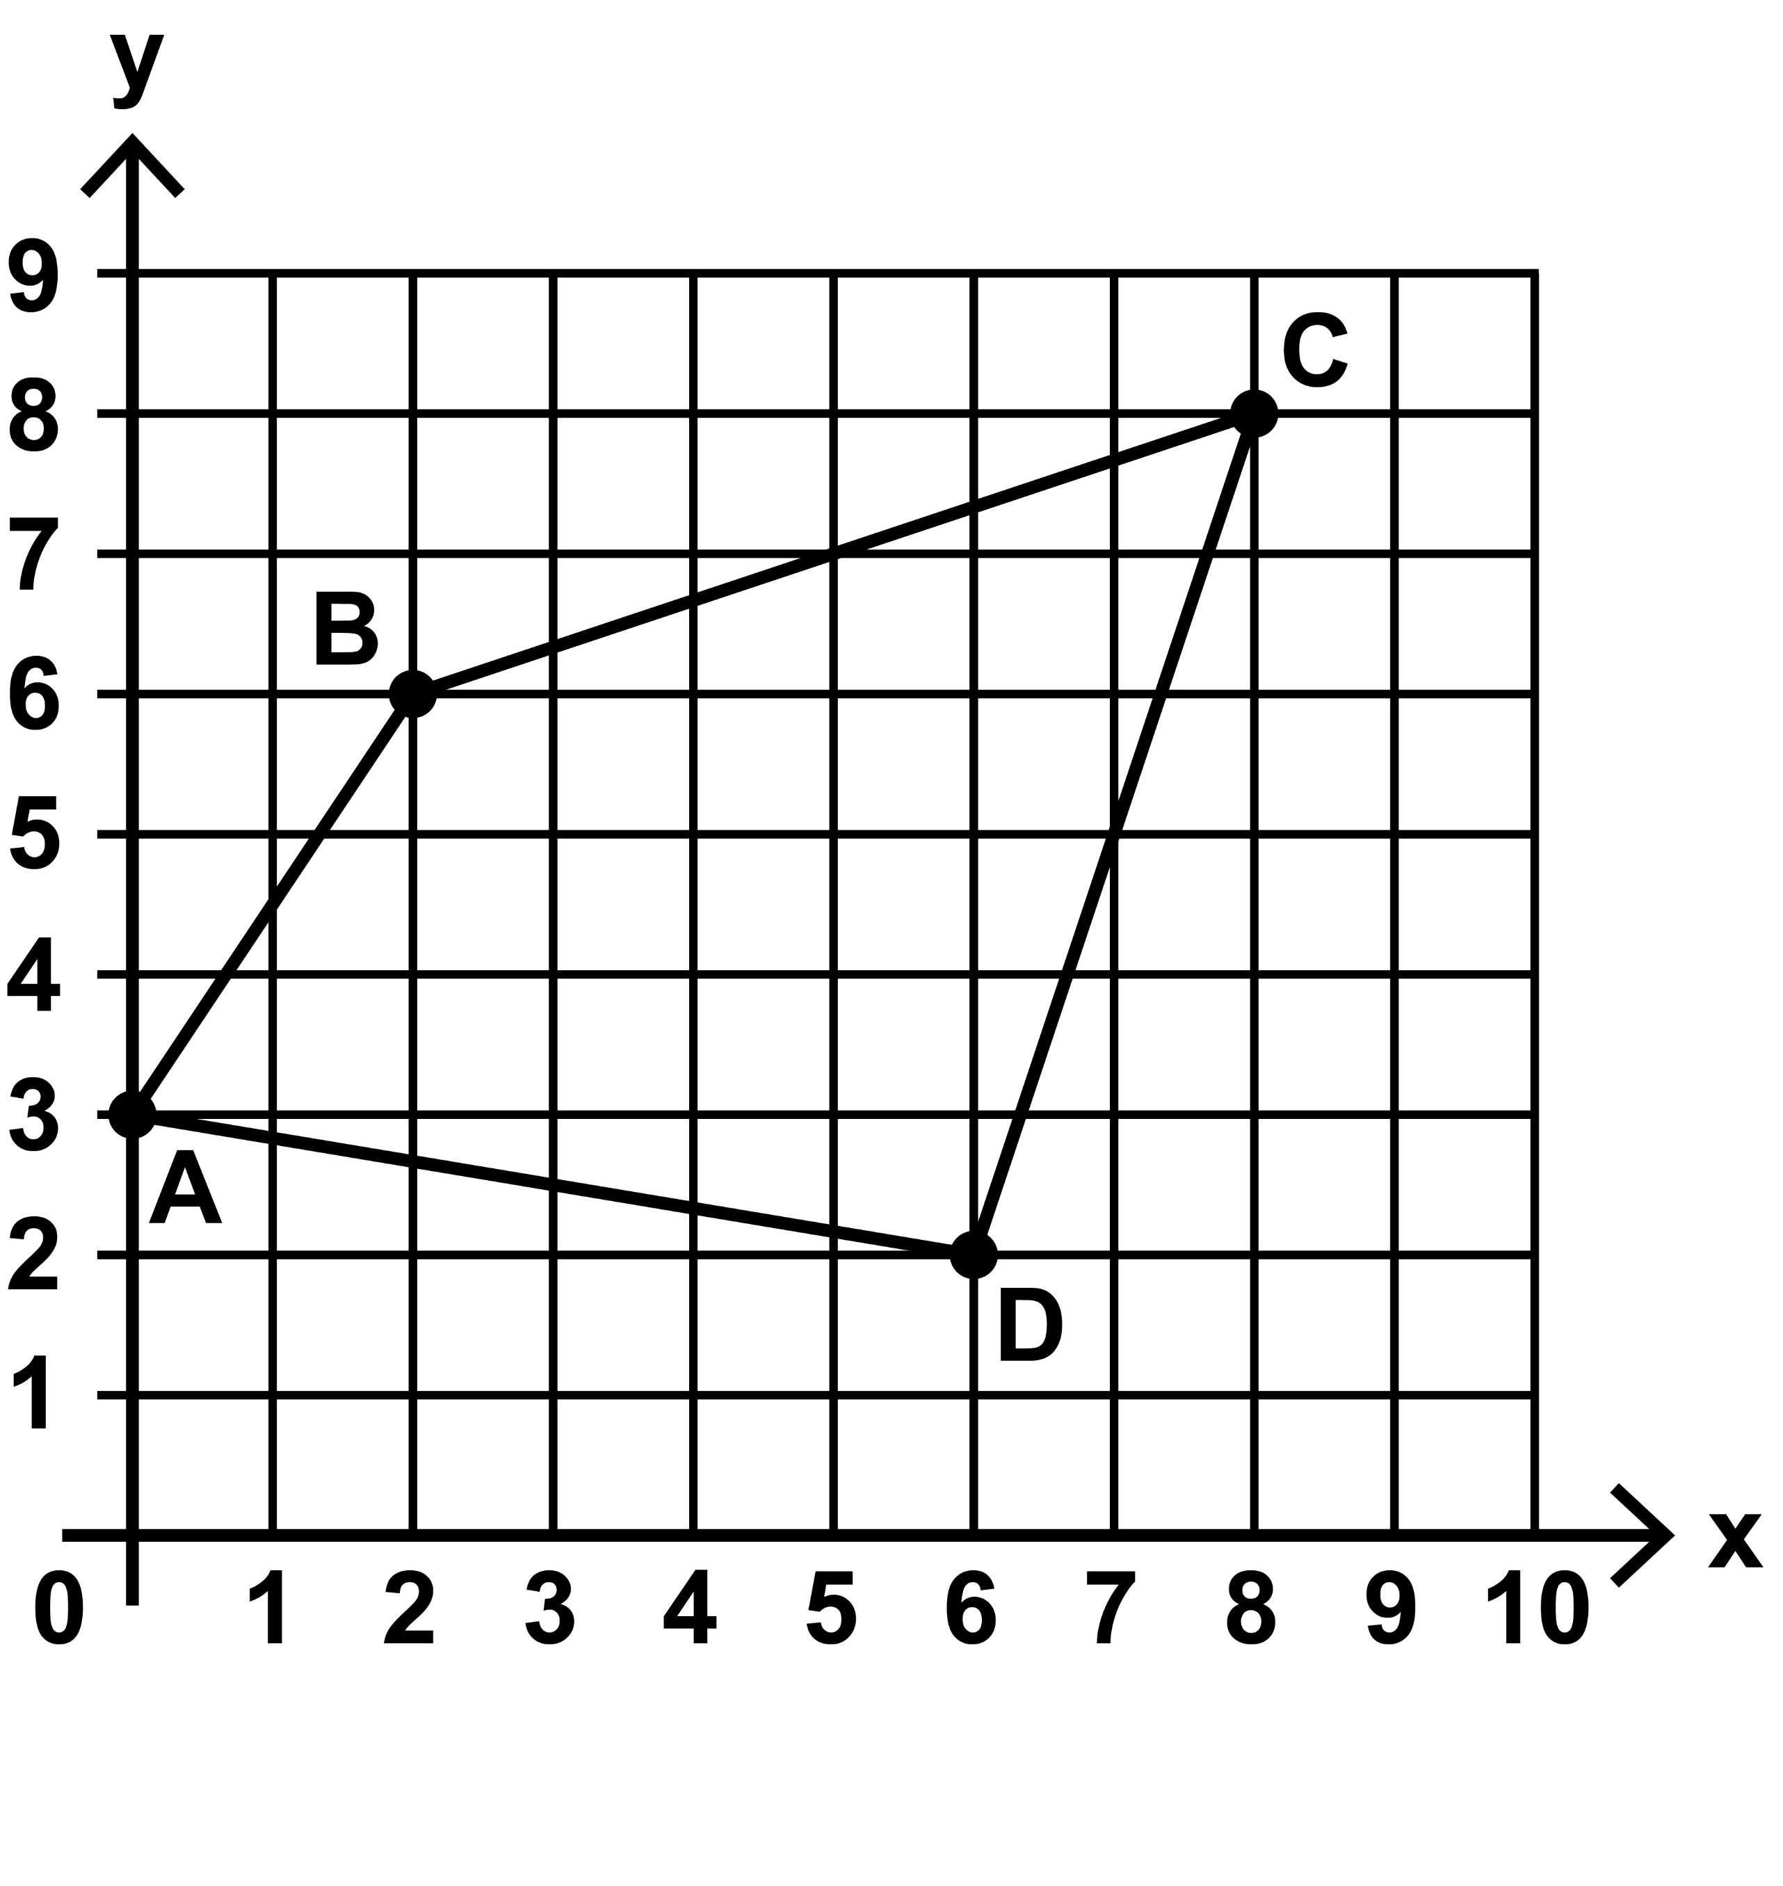

- Olivia counts in eights, starting at zero.
Tick or mark all the numbers Olivia
should say.

24

42

78

112
[BLANK PAGE]

The test continues on the next page.

- Look at the number below.

5 639 728

- Which digit is in the hundred thousands place?

- Write the number that is two thousand more than 5 639 728

- Look at the graph on the following page.
It is for converting kilograms and pounds.

- Use the graph to convert 5 kilograms
to pounds.

pounds

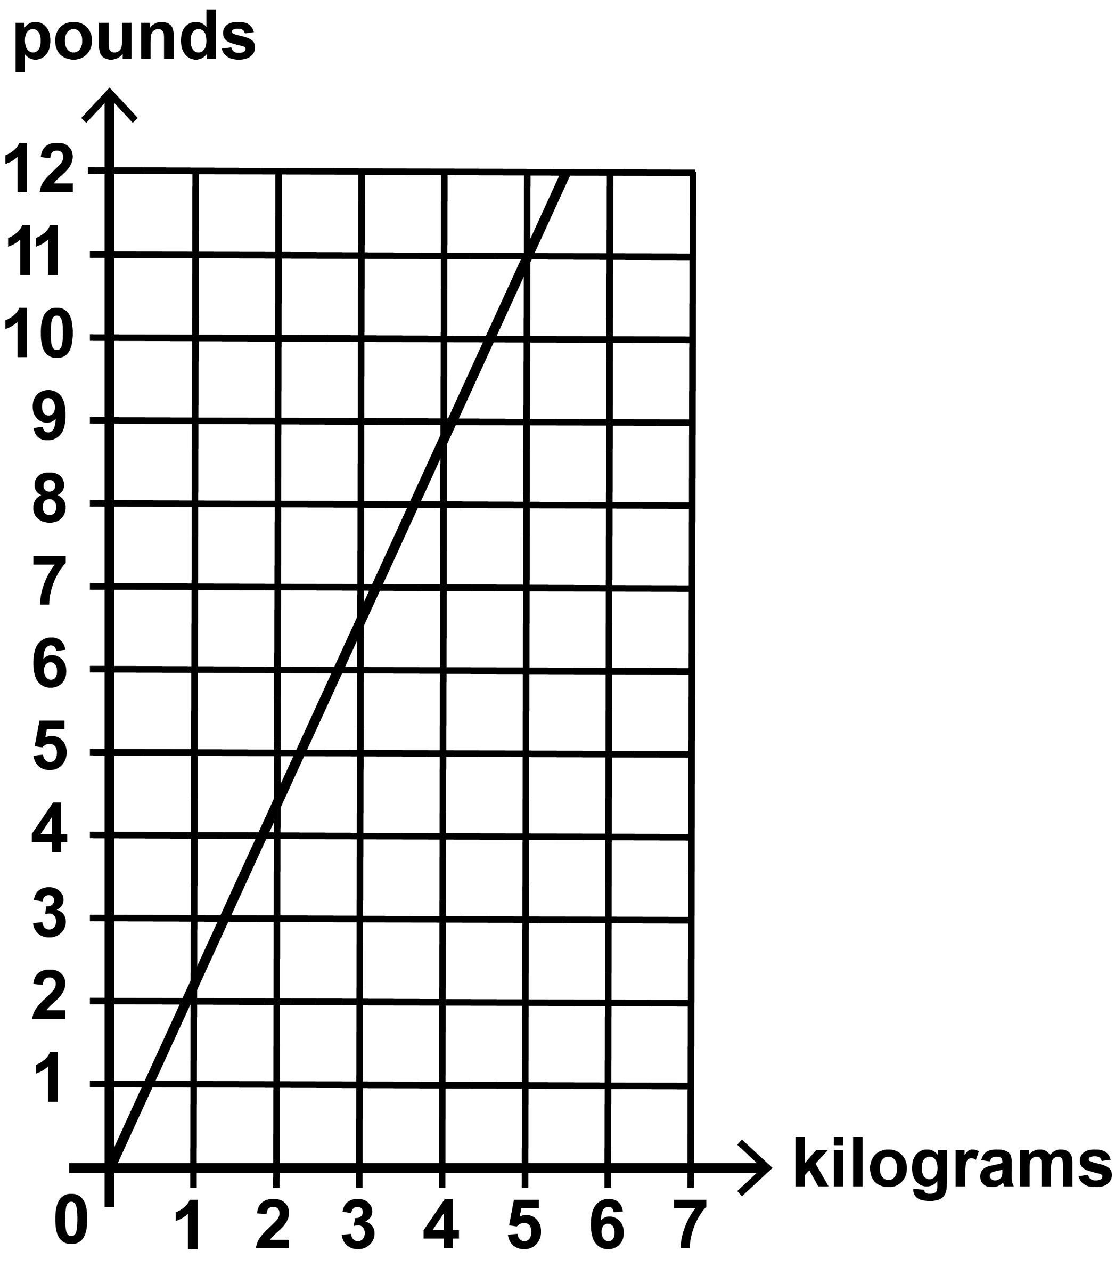

- Use the previous graph to convert
7 pounds to the nearest kilogram.

kg
[BLANK PAGE]

The test continues on the next page.
- You have a shape for this question.

Look at the shape on the opposite page.

Draw the reflection of the shaded shape about the mirror line.

Use a ruler.

mirror line

- Ali has 35 red counters.
He divides them into groups of 3

What is the greatest number of groups
of 3 he can make?

Maria has 35 green counters.
She divides them into groups of 4

How many green counters does she have left over?

- Olivia is making a cube from a net.

She wants the cube to have two circles on opposite faces.

Tick or mark the face that Olivia should draw the circle on to complete the net on the following page.

- The total distance from Paris to Munich by road is 860 kilometres.

There are three sections.

The distance from Paris to Metz is 331 km.

The distance from Metz to Stuttgart is 295 km.

Stuttgart to Munich is the last section.
How many kilometres is the last section from Stuttgart to Munich?

Show your method.

km
- Amina says 600 millimetres is longer than 1 metre.

Amina is not correct.

Explain how you know.

[BLANK PAGE]

The test continues on the next page.

- Jack buys four concert tickets.
Each ticket costs £28

One calculation Jack could use to work out the total cost is
28 + 28 + 28 + 28

Tick or mark each calculation on the next page that Jack could use to work out the total cost.
(20 × 4) + (8 × 4)

(4 × 20) + 8

(4 × 30) − (4 × 2)

(4 × 30) – 2

- The table on the opposite page shows the distances Kirsty cycled last week.
What is the total distance Kirsty cycled last week?

Show your method.

miles
Day | Miles
Monday | 4 • 3 | 4 • 3 | –
Tuesday | 4 • 3 | 4 • 3 | –
Wednesday | 4 • 3 | 2 • 6 | 3 • 1
Thursday | 4 • 3 | 4 • 3 | –
Friday | 4 • 3 | 2 • 6 | 3 • 1

- Here is a diagram made from ten squares.
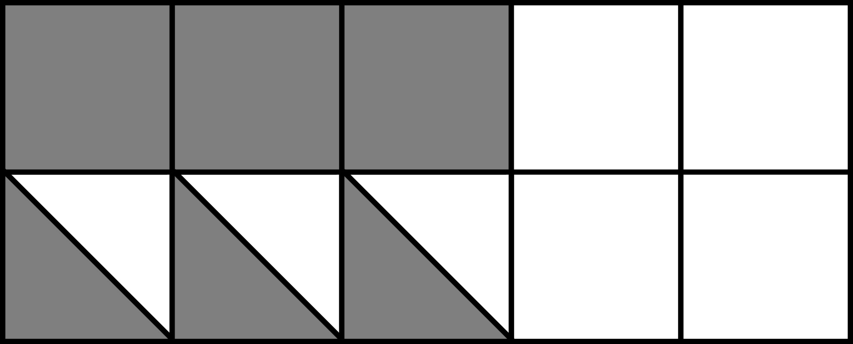

What percentage of the diagram is shaded?

%
[BLANK PAGE]

The test continues on the next page.

- There are two boxes.
1
4

The mass of the first box is 1 kilograms.

The mass of the second box is 1 • 4 kilograms.

What is the difference in mass of the two boxes?
Give your answer in kilograms.

Show your method.

kg
- A 4 kilogram bag of rice costs £6

What is the cost of 500 grams of
the rice?

- Tick or mark the fractions that are
2
3

greater than

5 |  | 4 |  | 9 |  | 11 |  | 10
6 |  | 9 |  | 12 |  | 15 |  | 21

- The total cost of a school trip for
12 pupils is £780

The total cost includes travel, food
and hotel.
For one pupil, the travel cost is £27
and the food cost is £16

How much is the hotel cost for one pupil?

Show your method.

£
- Sophie thinks of two prime numbers.

She adds them together.

Her answer is 24

[Go to next page]

Write the three different pairs of prime numbers that Sophie could think of.

and
and
and

- The mass of a 1p coin is 3 • 56 g

The mass of a 10p coin is 6 • 5 g

What is the difference in mass between
£1 in 1p coins and £1 in 10p coins?

Show your method.

g
- A cuboid has these measurements:

Height: 2 cm

Length: 12 cm
1
2

Width: 1 cm

Calculate the volume of this cuboid.

cm3

- Look at the diagram below. It shows a straight line labelled ABC.

It is not to scale.

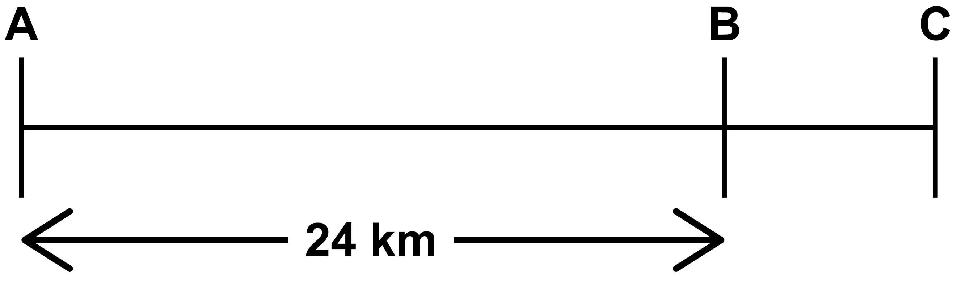

The distance from A to B is 24 km.
3
4

The distance from A to B is the distance from A to C.

What is the distance from B to C?
km

Key stage 2 mathematics
48 point A3 modified large print Paper 2: reasoning
For more copies
Additional copies of this modified large print test paper can be ordered by contacting the national curriculum assessments helpline on 0300 303 3013. After the test window, it can be downloaded from www.gov.uk/government/collections/national-curriculum-assessments-past-test-materials.
© Crown copyright
The materials in this booklet are Crown copyright. You may re-use them (not including logos) free of charge in any format or medium in accordance with the terms of the Open Government Licence v3.0, which can be found on the National Archives website and accessed via the following link: www.nationalarchives.gov.uk/doc/open-government-licence.
If you have any queries regarding these test materials, please contact the national curriculum assessments helpline on
0300 303 3013 or email assessments@education.gov.uk.

