Evaluation of the Employment Allowance
  - HMRC Research Report 722
Rebecca Klahr, Krishna Dabhi, Andrew Whitehead, Claire Weil, Adam Behailu, Kath Bailey, Chris Hale

Evaluation of the Employment Allowance
  - HMRC Research Report XXX
Rebecca Klahr, Krishna Dabhi, Andrew Whitehead, Claire Weil, Adam Behailu, Kath Bailey, Chris Hale

Evaluation of the Employment Allowance
  - HMRC Research Report
Rebecca Klahr, Krishna Dabhi, Andrew Whitehead, Claire Weil, Adam Behailu, Kath Bailey, Chris Hale

Evaluation of the Employment Allowance
  - HMRC Research Report XXX
Rebecca Klahr, Krishna Dabhi, Andrew Whitehead, Claire Weil, Adam Behailu, Kath Bailey, Chris Hale

Evaluation of the Employment Allowance
  - HMRC Research Report XXX
Rebecca Klahr, Krishna Dabhi, Andrew Whitehead, Claire Weil, Adam Behailu, Kath Bailey, Chris Hale

Evaluation of the Employment Allowance
  - HMRC Research Report XXX
Rebecca Klahr, Krishna Dabhi, Andrew Whitehead, Claire Weil, Adam Behailu, Kath Bailey, Chris Hale

Evaluation of the Employment Allowance
  - HMRC Research Report
Rebecca Klahr, Krishna Dabhi, Andrew Whitehead, Claire Weil, Adam Behailu, Kath Bailey, Chris Hale

Evaluation of the Employment Allowance
  - HMRC Research Report XXX
Rebecca Klahr, Krishna Dabhi, Andrew Whitehead, Claire Weil, Adam Behailu, Kath Bailey, Chris Hale

Evaluation of the Employment Allowance
  - HMRC Research Report XXX
Rebecca Klahr, Krishna Dabhi, Andrew Whitehead, Claire Weil, Adam Behailu, Kath Bailey, Chris Hale

Evaluation of the Employment Allowance
  - HMRC Research Report XXX
Rebecca Klahr, Krishna Dabhi, Andrew Whitehead, Claire Weil, Adam Behailu, Kath Bailey, Chris Hale

Evaluation of the Employment Allowance
  - HMRC Research Report
Rebecca Klahr, Krishna Dabhi, Andrew Whitehead, Claire Weil, Adam Behailu, Kath Bailey, Chris Hale

Evaluation of the Employment Allowance
  - HMRC Research Report XXX
Rebecca Klahr, Krishna Dabhi, Andrew Whitehead, Claire Weil, Adam Behailu, Kath Bailey, Chris Hale

Evaluation of the Employment Allowance
  - HMRC Research Report XXX
Rebecca Klahr, Krishna Dabhi, Andrew Whitehead, Claire Weil, Adam Behailu, Kath Bailey, Chris Hale

Evaluation of the Employment Allowance
  - HMRC Research Report XXX
Rebecca Klahr, Krishna Dabhi, Andrew Whitehead, Claire Weil, Adam Behailu, Kath Bailey, Chris Hale

Evaluation of the Employment Allowance
  - HMRC Research Report
Rebecca Klahr, Krishna Dabhi, Andrew Whitehead, Claire Weil, Adam Behailu, Kath Bailey, Chris Hale

Evaluation of the Employment Allowance
  - HMRC Research Report XXX
Rebecca Klahr, Krishna Dabhi, Andrew Whitehead, Claire Weil, Adam Behailu, Kath Bailey, Chris Hale

Evaluation of the Employment Allowance
  - HMRC Research Report XXX
Rebecca Klahr, Krishna Dabhi, Andrew Whitehead, Claire Weil, Adam Behailu, Kath Bailey, Chris Hale

Evaluation of the Employment Allowance
  - HMRC Research Report XXX
Rebecca Klahr, Krishna Dabhi, Andrew Whitehead, Claire Weil, Adam Behailu, Kath Bailey, Chris Hale

Evaluation of the Employment Allowance
  - HMRC Research Report
Rebecca Klahr, Krishna Dabhi, Andrew Whitehead, Claire Weil, Adam Behailu, Kath Bailey, Chris Hale

Evaluation of the Employment Allowance
  - HMRC Research Report XXX
Rebecca Klahr, Krishna Dabhi, Andrew Whitehead, Claire Weil, Adam Behailu, Kath Bailey, Chris Hale

Evaluation of the Employment Allowance
  - HMRC Research Report XXX
Rebecca Klahr, Krishna Dabhi, Andrew Whitehead, Claire Weil, Adam Behailu, Kath Bailey, Chris Hale

Evaluation of the Employment Allowance
  - HMRC Research Report XXX
Rebecca Klahr, Krishna Dabhi, Andrew Whitehead, Claire Weil, Adam Behailu, Kath Bailey, Chris Hale

Evaluation of the Employment Allowance
  - HMRC Research Report
Rebecca Klahr, Krishna Dabhi, Andrew Whitehead, Claire Weil, Adam Behailu, Kath Bailey, Chris Hale

Evaluation of the Employment Allowance
  - HMRC Research Report XXX
Rebecca Klahr, Krishna Dabhi, Andrew Whitehead, Claire Weil, Adam Behailu, Kath Bailey, Chris Hale

Evaluation of the Employment Allowance
  - HMRC Research Report XXX
Rebecca Klahr, Krishna Dabhi, Andrew Whitehead, Claire Weil, Adam Behailu, Kath Bailey, Chris Hale

Evaluation of the Employment Allowance
  - HMRC Research Report XXX
Rebecca Klahr, Krishna Dabhi, Andrew Whitehead, Claire Weil, Adam Behailu, Kath Bailey, Chris Hale

Evaluation of the Employment Allowance
  - HMRC Research Report
Rebecca Klahr, Krishna Dabhi, Andrew Whitehead, Claire Weil, Adam Behailu, Kath Bailey, Chris Hale

Evaluation of the Employment Allowance
  - HMRC Research Report XXX
Rebecca Klahr, Krishna Dabhi, Andrew Whitehead, Claire Weil, Adam Behailu, Kath Bailey, Chris Hale

Evaluation of the Employment Allowance
  - HMRC Research Report XXX
Rebecca Klahr, Krishna Dabhi, Andrew Whitehead, Claire Weil, Adam Behailu, Kath Bailey, Chris Hale

Evaluation of the Employment Allowance
  - HMRC Research Report XXX
Rebecca Klahr, Krishna Dabhi, Andrew Whitehead, Claire Weil, Adam Behailu, Kath Bailey, Chris Hale

Evaluation of the Employment Allowance
  - HMRC Research Report 722
Rebecca Klahr, Krishna Dabhi, Andrew Whitehead, Claire Weil, Adam Behailu, Kath Bailey, Chris Hale

Evaluation of the Employment Allowance
  - HMRC Research Report XXX
Rebecca Klahr, Krishna Dabhi, Andrew Whitehead, Claire Weil, Adam Behailu, Kath Bailey, Chris Hale

Evaluation of the Employment Allowance
  - HMRC Research Report
Rebecca Klahr, Krishna Dabhi, Andrew Whitehead, Claire Weil, Adam Behailu, Kath Bailey, Chris Hale

Evaluation of the Employment Allowance
  - HMRC Research Report XXX
Rebecca Klahr, Krishna Dabhi, Andrew Whitehead, Claire Weil, Adam Behailu, Kath Bailey, Chris Hale

Evaluation of the Employment Allowance
  - HMRC Research Report XXX
Rebecca Klahr, Krishna Dabhi, Andrew Whitehead, Claire Weil, Adam Behailu, Kath Bailey, Chris Hale

Evaluation of the Employment Allowance
  - HMRC Research Report XXX
Rebecca Klahr, Krishna Dabhi, Andrew Whitehead, Claire Weil, Adam Behailu, Kath Bailey, Chris Hale

Evaluation of the Employment Allowance
  - HMRC Research Report
Rebecca Klahr, Krishna Dabhi, Andrew Whitehead, Claire Weil, Adam Behailu, Kath Bailey, Chris Hale

Evaluation of the Employment Allowance
  - HMRC Research Report XXX
Rebecca Klahr, Krishna Dabhi, Andrew Whitehead, Claire Weil, Adam Behailu, Kath Bailey, Chris Hale

Evaluation of the Employment Allowance
  - HMRC Research Report XXX
Rebecca Klahr, Krishna Dabhi, Andrew Whitehead, Claire Weil, Adam Behailu, Kath Bailey, Chris Hale

Evaluation of the Employment Allowance
  - HMRC Research Report XXX
Rebecca Klahr, Krishna Dabhi, Andrew Whitehead, Claire Weil, Adam Behailu, Kath Bailey, Chris Hale

Evaluation of the Employment Allowance
  - HMRC Research Report
Rebecca Klahr, Krishna Dabhi, Andrew Whitehead, Claire Weil, Adam Behailu, Kath Bailey, Chris Hale

Evaluation of the Employment Allowance
  - HMRC Research Report XXX
Rebecca Klahr, Krishna Dabhi, Andrew Whitehead, Claire Weil, Adam Behailu, Kath Bailey, Chris Hale

Evaluation of the Employment Allowance
  - HMRC Research Report XXX
Rebecca Klahr, Krishna Dabhi, Andrew Whitehead, Claire Weil, Adam Behailu, Kath Bailey, Chris Hale

Evaluation of the Employment Allowance
  - HMRC Research Report XXX
Rebecca Klahr, Krishna Dabhi, Andrew Whitehead, Claire Weil, Adam Behailu, Kath Bailey, Chris Hale

Evaluation of the Employment Allowance
  - HMRC Research Report
Rebecca Klahr, Krishna Dabhi, Andrew Whitehead, Claire Weil, Adam Behailu, Kath Bailey, Chris Hale

Evaluation of the Employment Allowance
  - HMRC Research Report XXX
Rebecca Klahr, Krishna Dabhi, Andrew Whitehead, Claire Weil, Adam Behailu, Kath Bailey, Chris Hale

Evaluation of the Employment Allowance
  - HMRC Research Report XXX
Rebecca Klahr, Krishna Dabhi, Andrew Whitehead, Claire Weil, Adam Behailu, Kath Bailey, Chris Hale

Evaluation of the Employment Allowance
  - HMRC Research Report XXX
Rebecca Klahr, Krishna Dabhi, Andrew Whitehead, Claire Weil, Adam Behailu, Kath Bailey, Chris Hale

Evaluation of the Employment Allowance
  - HMRC Research Report
Rebecca Klahr, Krishna Dabhi, Andrew Whitehead, Claire Weil, Adam Behailu, Kath Bailey, Chris Hale

Evaluation of the Employment Allowance
  - HMRC Research Report XXX
Rebecca Klahr, Krishna Dabhi, Andrew Whitehead, Claire Weil, Adam Behailu, Kath Bailey, Chris Hale

Evaluation of the Employment Allowance
  - HMRC Research Report XXX
Rebecca Klahr, Krishna Dabhi, Andrew Whitehead, Claire Weil, Adam Behailu, Kath Bailey, Chris Hale

Evaluation of the Employment Allowance
  - HMRC Research Report XXX
Rebecca Klahr, Krishna Dabhi, Andrew Whitehead, Claire Weil, Adam Behailu, Kath Bailey, Chris Hale

Evaluation of the Employment Allowance
  - HMRC Research Report
Rebecca Klahr, Krishna Dabhi, Andrew Whitehead, Claire Weil, Adam Behailu, Kath Bailey, Chris Hale

Evaluation of the Employment Allowance
  - HMRC Research Report XXX
Rebecca Klahr, Krishna Dabhi, Andrew Whitehead, Claire Weil, Adam Behailu, Kath Bailey, Chris Hale

Evaluation of the Employment Allowance
  - HMRC Research Report XXX
Rebecca Klahr, Krishna Dabhi, Andrew Whitehead, Claire Weil, Adam Behailu, Kath Bailey, Chris Hale

Evaluation of the Employment Allowance
  - HMRC Research Report XXX
Rebecca Klahr, Krishna Dabhi, Andrew Whitehead, Claire Weil, Adam Behailu, Kath Bailey, Chris Hale

Evaluation of the Employment Allowance
  - HMRC Research Report
Rebecca Klahr, Krishna Dabhi, Andrew Whitehead, Claire Weil, Adam Behailu, Kath Bailey, Chris Hale

Evaluation of the Employment Allowance
  - HMRC Research Report XXX
Rebecca Klahr, Krishna Dabhi, Andrew Whitehead, Claire Weil, Adam Behailu, Kath Bailey, Chris Hale

Evaluation of the Employment Allowance
  - HMRC Research Report XXX
Rebecca Klahr, Krishna Dabhi, Andrew Whitehead, Claire Weil, Adam Behailu, Kath Bailey, Chris Hale

Evaluation of the Employment Allowance
  - HMRC Research Report XXX
Rebecca Klahr, Krishna Dabhi, Andrew Whitehead, Claire Weil, Adam Behailu, Kath Bailey, Chris Hale

Disclaimer

The views in this report are the author’s own and do not necessarily reflect those of HM Revenue and Customs.

Contents

Glossary 1
Executive summary 2
Background 2
Experiences of claiming 2
Self-reported impact 2
Proportionality of the Employment Allowance 3
Econometric analysis 3
Conclusions 4
1 Introduction 7
1.1 Context to the relief 7
1.2 Research objectives and evaluation questions 7
1.3 Summary of the methodology 8
1.3.1 Quantitative survey 9
1.3.2 Econometric analysis 10
1.3.3 Qualitative in-depth interviews 10
1.4 Interpreting the findings 11
1.4.1 Quantitative survey results 11
1.4.2 Econometric analysis 11
1.4.3 Qualitative findings 12
2 Theoretical framework 14
2.1 Inputs 14
2.1.1 Tax revenues foregone 14
2.1.2 Administrative burdens 14
2.2 Take-up of the Employment Allowance 14
2.3 First order effects 15
2.3.1 Employment impacts 15
2.3.2 Capital investment 15
2.3.3 Output, turnover, and productivity 16
2.4 Second order effects 16
2.4.1 Equilibrium wage and employment 16
2.4.2 Profits and prices 16
2.4.3 Effects at low wages 17
2.4.4 Displacement 17
2.5 Key hypothesis to be tested 19
3 Experiences of claiming the Employment Allowance 21
3.1 Claiming the Employment Allowance 21
3.1.1 About the survey population 21
3.1.2 Use of agents 22
3.2 Awareness and understanding 22
3.3 Drawbacks of the Employment Allowance 26
3.4 Value of claims 29
3.5 Use of other business tax relief 30
4 Self-reported impact of the Employment Allowance 33
4.1 Using the money saved 33
4.2 Impact of the money saved 34
4.3 Impact on redundancies 37
4.4 Impact on growth prospects 38
4.5 Impact on the labour market 41
4.6 Impact on reducing the effects of COVID-19 43
5 Proportionality and appropriateness of the scheme 46
5.1 Increases in the amount that employers can claim 46
5.2 Decreases in the amount that employers can claim 48
5.3 Changes to how the Employment Allowance is paid 50
5.4 Views on the £100,000 NICs threshold and eligibility 51
5.5 Likelihood of claiming next year 52
6 Econometric analysis 58
6.1 Methodology 58
6.1.1 Data 58
6.2 Overview of analytical approaches 61
6.3 Approach 1: Employers just above and below the Employment Allowance threshold 63
6.3.1 Comparison between groups 63
6.3.2 Econometric model specification 67
6.3.3 Results 67
6.4 Approach 2: Dose response models 69
6.4.1 Results 69
6.5 Social Value 71
6.5.1 Employment 71
6.5.2 Output, turnover and productivity and profit 72
6.5.3 Capital investment 72
6.5.4 Competitive distortions by business size 73
6.6 Proportionality 73
6.7 Generalisability to current policy context 74
6.7.1 Introduction of the upper threshold 74
6.7.2 Marginal impact of increases in the threshold 74
7 Conclusions 77
7.1 Uptake and experience of claiming the Employment Allowance 77
7.2 Self-reported impact of the Employment Allowance 78
7.3 Effectiveness of the Employment Allowance 78

Glossary
Term | Definition
Agent | Individuals such as accountants or tax agents who either made an application for claiming the Employment Allowance on an employer’s behalf or provided support during the application process. No agents took part in this research
Claimants | Organisations that claimed Employment Allowance in the 2020 to 2021 tax year
Class 1 National Insurance contributions (NICs) | Class 1 National Insurance contributions (NICs) are paid on earnings by employees and employers, depending on how much the employee earns. In the 2020 to 2021 tax year (the first year considered by the research), employees would start paying Class 1 NICs if they earned over £183 per week and were under the state pension age of 66 (primary threshold), while employers pay if employees earned over £169 per week (secondary threshold)
Employment Allowance | Employment Allowance was originally introduced by the National Insurance contributions (NICs) Act 2014. The allowance aims to reduce the barriers faced by small businesses, charities and Community Amateur Sports Clubs which wish to grow by supporting them with the costs of employment. At the time of the research, It allowed claimants in the UK to reduce their annual National Insurance liability by up to £5,000 each tax year
National Insurance contributions (NICs) | National Insurance contributions (NICs) enable people to qualify for certain benefits and the State Pension. They are paid on earnings and self-employed profits by employees, employers and those who are self-employed
Non-claimants | Organisations that had never claimed the Employment Allowance
PAYE | Pay as you earn (PAYE) is a HM Revenue and Customs system designed to collect Income Tax and National Insurance from employment
Past claimants | Organisations that had previously claimed since 2018, were still eligible to claim, but did not claim in the 2020 to 2021 tax year
Previously eligible claimants | Organisations that had previously claimed since 2018, but in April 2020 were no longer eligible to claim because their employer secondary Class 1 NICs were over £100,000 in the previous tax year

Executive summary

Background
The Employment Allowance aims to reduce the barriers faced by small businesses, charities and Community Amateur Sports Clubs which wish to grow, by supporting them with the costs of employment . As of April 2022, the Employment Allowance enables eligible employers to reduce their annual National Insurance contributions (NICs) liability by up to £5,000.
HM Revenue and Customs (HMRC) commissioned Ipsos to undertake a thorough and independent evaluation of the impact of the Employment Allowance, including the effect it had on employment and business growth. The evaluation comprised 3 strands of research which included a quantitative survey, econometric analysis, and qualitative in-depth interviews.

Experiences of claiming
In terms of initial awareness of the Employment Allowance, around 4 in 5 claimants (82%) had heard of the scheme, as did 9 in 10 previously eligible claimants (92%) and 4 in 5 past claimants (78%), while awareness was lowest amongst non-claimants (39%).
Participants in the qualitative research who were aware of the Employment Allowance felt that information on the scheme was easily accessible and available, especially for those in payroll, accounting, and finance. However, such information was reported to be less visible for those not regularly managing these aspects of the business. The qualitative research also highlighted participants’ positive recollection of the process of claiming the Employment Allowance, which they deemed to be simple and straightforward. This was relatively in line with the survey which found that more than half of claimants (56%) said that that the Employment Allowance had no drawbacks.

Self-reported impact
More than 4 in 5 claimants (86%) that were aware of the Employment Allowance said they absorbed the money claimed into general revenue or expenditure, rather than using it for a specific purpose (8%). The qualitative research similarly found that participants struggled to recall exactly what the saved money from the allowance had been spent on, given that they reported the amount was relatively small in comparison to turnover, and spread across the year. Receiving the Employment Allowance was also not perceived to be an easily noticeable set amount of additional cash to re-invest directly into specific aspects of their business.
When surveyed about more specific impacts on their business, around half of claimants who had heard of the Employment Allowance (48%) agreed that it had been important to the growth and development of their organisation. Claimants were more likely to say the money had helped them to retain members of staff (54% compared with 22% of previously eligible
claimants and 37% of past claimants). Although most employers told us that the Employment Allowance did not impact staff permanency or hours, around half of employers who said it did have an impact reported that without the Employment Allowance they would have been unable to make staff permanent or increase hours.

Proportionality of the Employment Allowance
Prospective increases or decreases in the Employment Allowance had little bearing on changing claimants’ decisions to absorb the saved money into general revenue or expenditure. The majority of claimants said that the additional money would be absorbed into general revenue or expenditure (66% for a prospective £1,000 increase in the allowance, 56% for a £2,000 increase and 58% for a £1,000 or £2,000 decrease).
Claimants who said they would likely continue to claim the Employment Allowance in the scenario of a prospective reduction reported this was partly because they believed they would internally be able to make up for the shortfalls from a potential decrease.

Econometric analysis
The econometric analysis specifically looking at small employers with NICs liabilities close to £2,000 did not find conclusive evidence of statistically significant effects of the increase in the Employment Allowance for small employers in terms of employment, turnover, output and profit. Furthermore, the evidence on the effect of the increase in the generosity of the Employment Allowance on wage per employee were mixed, while no evidence was found of an effect on employers’ capital expenditure.
These results have limited generalisability as the model approach used is specific to comparing employers with NICs liabilities around the threshold of £2,000. A second set of analyses was undertaken examining the relationship between the changes in employer’s NICs liabilities as a share of their labour costs and the outcomes of the analysis. This provided more generalisable findings and is subsequently the stronger model.
The results did not find any economically significant effects when considering all employers claiming the Employment Allowance. However, applying the approach to a sub-set of smaller employers did find economically significant effects on a number of key outcome variables including employment, turnover, output (Gross Value Added (GVA)) and profit. The most economically significant effects were found for employers with NICs liabilities between £4,000 and £10,000, decaying to close to 0 for employers with NICs liabilities over £30,000.
Considering both sets of analysis suggested that while the overall effect of the Employment Allowance on all employers was minimal, it did have economically significant effects on smaller employers (for instance those with NICs liabilities below £20,000).
The findings implied that the increase in the generosity of the Employment Allowance encouraged employers with NICs liabilities between £2,000 and £20,000 to increase their employment levels by around 2% on average. When aggregated across the population of relevant employers across all years of analysis, it is estimated that the increase in the Employment Allowance led to the creation of around 8,700 ongoing jobs and 35,000 employment years.
Based on the average annual wages of workers employed by the relevant population of employers (£16,700 in 2020 prices), it might be inferred that many positions created were either part-time or associated with relatively low skilled occupations. This would indicate that the Employment Allowance may provide support for the ’tail-end’ of the labour market and could produce important social benefits - for example, by enabling workers that would have otherwise been inactive to take up paid employment, or providing ‘stepping stones’ to enable such workers to progress to positions with higher wages or hours.
The findings also indicated that the increase in the Employment Allowance led to employers with NICs liabilities between £2,000 and £20,000 to expand their output (GVA) by around 1.2% on average which equates to just over £2,000 per employer. The same group of employers experienced a fall in capital expenditure of 1.6% which could be explained by the possibly distortionary effects of the Employment Allowance on factor prices of capital relative to labour.

Conclusions
Prospective reductions in the amount of Employment Allowance of £1,000 and £2,000 were indicated to have little bearing on changing whether employers would claim or the way they would use the money saved from claiming. Claimants’ likelihood to continue claiming were partly reflected in their belief that they would internally be able to make up for the shortfalls from a potential decrease. Similarly, prospective increases to the Employment Allowance were also found to have a lesser bearing on claimant’s use of the additional money in the future. While there was additional evidence to suggest that increases in the amount of Employment Allowance could help to encourage more non-claimants to claim, the difference between a £1,000 or £2,000 increase was found to have a minimal impact on their future intentions.
The survey also provided some evidence that the Employment Allowance supported its original intentions around employment outcomes. For example, previously eligible and past claimants were less likely than claimants to associate the Employment Allowance with specifically helping them to retain staff.
The econometric findings showed that while the overall effect of the Employment Allowance on all employers was minimal, it did have economically significant effects on smaller employers; the evidence on other variables such as wage per employee remained less conclusive. These findings presented a similar story to the perspective of organisations who shared their feedback in the qualitative interviews. The effects of the Employment Allowance were small which may help to explain why interview participants reported that the impacts of the Employment Allowance were unnoticeable. This could explain why they could not clearly distinguish the effects of the Employment Allowance on their business growth. A small percentage increase in employment for a small business would likely be very difficult to perceive for most employers, as employment tends to change in increments rather than fractions. The econometric findings were largely consistent with the survey findings, which suggested that employers typically absorbed the Employment Allowance into general revenue and expenditure, and some invested the money into retaining staff or increasing wages.

01
  - Introduction

1. Introduction
Employers’ National Insurance contributions (NICs) are a form of payroll tax and the largest single source of revenue into the National Insurance Fund. The government introduced the Employment Allowance in April 2014. This aimed to reduce the barriers faced by small businesses, charities and Community Amateur Sports Clubs which wished to grow by supporting them with the costs of employment. The Employment Allowance initially gave employers a £2,000 allowance against their secondary Class 1 NICs liability. The Employment Allowance has since increased over time, most recently to £5,000 in April 2022. When it was introduced, some employers did not qualify, including those who employed workers for personal or domestic work (unless they were a care or support worker), public bodies or businesses doing more than half their work in the public sector (except charities), or service companies with only deemed payments of employment income under ‘IR35 rules’.

Since then, the government has introduced several changes:

- the eligibility of the relief was extended to domestic employers of care and support workers
- the maximum amount employers could claim rose to £3,000 between April 2016 and April 2020, but single director companies were excluded
- the maximum amount employers could claim increased to £4,000 between April 2020 and April 2022, but claiming was restricted to employers whose secondary Class 1 NICs liabilities in the previous tax year were under £100,000 (to better target smaller employers)
- the maximum amount employers could claim increased to £5,000 in April 2022

Research objectives and evaluation questions
HMRC commissioned Ipsos to conduct an evaluation of the Employment Allowance. The overarching aim of the study was to provide a thorough and independent evaluation of the impact of the Employment Allowance, including the effect on employment and business growth.
Specifically, the evaluation aimed to:
- assess whether the Employment Allowance is helping organisations that wish to grow with the cost of employment
- assess whether the relief is encouraging business growth and overall levels of UK employment
- identify the direct and indirect effects of the Employment Allowance on the labour market
- explore whether the Employment Allowance is appropriate (whether other forms of support would have been better)
- establish if the Employment Allowance is proportionate
- assess whether the relief generates wider economic impacts
- understand the impact of the Employment Allowance during the COVID-19 pandemic
- provide an evidence base to review the policy and inform decisions on future improvements of the Employment Allowance
The study focused on understanding the differences between 4 groups of interest:
- claimants (organisations that claimed Employment Allowance in the 2020 to 2021 tax year)
- non-claimants (eligible organisations that had never claimed the Employment Allowance)
- past claimants (organisations that had previously claimed since 2018, were still eligible to claim, but did not claim in the 2020 to 2021 tax year)
- previously eligible claimants (organisations that had previously claimed since 2018, but in April 2020 were no longer eligible to claim because their employer secondary NICs Class 1 liabilities were over £100,000 in the previous tax year)

Summary of the methodology
To address the aims and objectives, Ipsos undertook a mixed-methods evaluation which was informed by an initial scoping stage. This included a telephone (CATI) survey with employers, follow-up in-depth interviews and econometric analysis. A summary of each is provided below. Further detail can be found in the Technical Report
Table 1.1: approach to addressing the evaluation questions
Evaluation questions | Evaluation sub-questions | Approach used
What impact did the Employment Allowance have on growth and employment? | To what extent does the Employment Allowance incentivise employers to hire additional staff? Does claiming the Employment Allowance lead to better business outcomes? | Econometric analysis of employment, turnover and output growth using a counterfactual design – in conjunction with primary research (surveys and in-depth interviews) to explore underlying mechanisms.
What was the uptake and experience of claiming employment allowance? | How appropriate and proportional is the Allowance? What are key enablers and barriers of claiming, and how can these be reduced? Is there a locational/sectorial bias for Employment Allowance claimants? | Review of HMRC management information, survey research and in-depth interviews. Econometric analysis examining the relative effect of the £2,000 and £3,000 threshold.
What was the impact of the Employment Allowance during COVID-19? | What impact has the Allowance had during COVID-19? Have perceptions changed following COVID-19? | Survey research and in-depth qualitative interviews.
Does the Employment Allowance generate wider economic impacts? | Does the Allowance create market distortions, affect the allocation between capital and labour in the production process, affect the types of employment contracts offered, or cause employers to increase staff working hours? Does it cause any other direct economic impacts? Does the Allowance have any indirect economic impacts? | Descriptive statistics for survey research, in-depth interviews and extension of the econometrics approach used for the impact evaluation on growth and employment.

    - Quantitative survey
Ipsos conducted an initial pilot telephone (CATI) survey between 2 March and 11 March 2022, with a total of 70 interviews completed (including 25 claimants, 15 previously eligible claimants, 21 non-claimants, and 9 past claimants). Feedback from the pilot informed subsequent changes to the questionnaire and sample design ahead of the main stage survey.

For the mainstage survey, Ipsos undertook a random probability telephone (CATI) survey, with a total of 1,264 employers (including 655 claimants, 104 previously eligible claimants, 402 non-claimants, and 100 past claimants) between 30 May and 28 July 2022.

Survey respondents were randomly selected from HMRC records held since 2018. The final survey data was weighted to remove skews from any disproportionate stratifications and adjust for non-response bias. Different weighting approaches were taken for each of the surveyed groups; further detail can be found in the technical report.
    - Econometric analysis
The aim of the econometric analysis was to establish the causal effects of the Employment Allowance on the key outcomes of interest.
The approach to the econometric analysis was based on the findings of a literature review (included in Appendix 12 of the Technical Report). The aim of the literature review was to provide the theoretical background on the potential impact of reductions in payroll taxes, empirical studies exploring their effects, and identify methodological issues involved in developing estimates of causal effects.
It was not possible to construct a perfect comparison group which did not receive the Employment Allowance intervention (see Chapter 6 for more detail). Therefore, Ipsos exploited an increase in the Employment Allowance threshold from £2,000 to £3,000 introduced in 2016 to 2017. Employers operating with NICs liabilities just below the £2,000 threshold would not see any reduction in their effective labour costs as a result of this change but might be considered to have similar characteristics to employers with NICs liabilities just above this threshold.
In addition, a second set of analyses were undertaken using the ratio of the employer’s NICs liabilities to their labour costs as the treatment variable.
    - Qualitative in-depth interviews
The qualitative research aimed to generate insights around the appropriateness and proportionality of the Employment Allowance, as well as more nuanced feedback on the impact of the Employment Allowance. It explored what would have changed if the Employment Allowance had not been available, or if it had been delivered in a different form. The data collected from this strand aimed to complement the quantitative and econometrics findings.
Interviewees for the qualitative research were selected from survey respondents that agreed to be re-contacted for follow-up research and were screened to verify suitability to take part in the qualitative strand. Interviews were conducted with individuals that had responsibility for financial decisions and budget setting around recruitment and retention within the business. This varied between organisations, and included the owner or senior manager, Finance or HR Director or either a member of the executive or senior team, for example. In some cases, responsibility for the handling of the Employment Allowance and/or payroll was outsourced to an accountant, and the participant was less involved in the day-to-day administration. Ipsos conducted 20 in-depth, semi-structured interviews between 10 August and 1 September 2022, including:
- 8 claimant interviews with organisations that claimed the Employment Allowance in the tax year (2020 to 2021)
- 6 past claimants/previously eligible claimant interviews with organisations that had previously claimed Employment Allowance but did not claim in the tax year (2021 to 2022)
- 6 non-claimant interviews with organisations that never claimed Employment Allowance but were aware of it
The sample was purposively selected to include a mix of employers by region, use of agents, size and sector, to try and gain a range of views and perspectives. However, given the small number of interviews conducted, it was not possible to undertake more detailed subgroup analysis beyond the claimant status. The sample was also skewed towards employers from small and medium-sized enterprises who were aware of the Employment Allowance, given the evaluation focus of the research study.

Interpreting the findings

    - Quantitative survey results
Survey results are subject to margins of error, which vary with the sample size and the percentage figure of the individual survey finding concerned. The report only comments on subgroup differences where these were found to be statistically significant at the 95% level of confidence. Where figures do not sum to 100% in the charts, or to an associated net score, this is due to rounding of percentages, exclusion of ‘don’t know’ or ‘refused’ responses, or because the questions allowed more than 1 response.
Mean and median values have been additionally used to report average figures. Mean values were derived by taking the average of the actual figure given or the midpoint of banded responses. Median values were derived by taking the midpoint of the frequency distribution of the values.
    - Econometric analysis
The results of the econometric analyses are presented for a range of econometric models which differ by the number of controls included in the model. Unless stated otherwise the outcome variables are included in logarithmic form. For each set of results the coefficient on the treatment variable is presented alongside the standard error and number of observations. The statistical significance of the result is indicated with asterisks.
    - Qualitative findings
Qualitative findings aimed to provide more nuanced insights and context into perceptions of the Employment Allowance. Findings reported here represent common themes emerging across the interviews and are not intended to be statistically representative of the wider population.
The qualitative findings are presented in the report alongside the quantitative and econometrics findings and are not designed to be read independently of these.

The qualitative findings should also be taken as illustrative of wider themes that arose in the quantitative survey but are not comprehensive given the limited sample available. Findings from the qualitative research were neither direct confirmation nor in contradiction of the quantitative findings, but rather indicated possible reasons for, and thinking processes behind, participant responses to the survey.

02

Theoretical framework

2. Theoretical framework
The following section sets out the Theory of Change underpinning the evaluation of the impact of the Employment Allowance. It provides details of the inputs, activities, outputs, outcomes, and long-term impacts related to this policy intervention. Subsections 2.1 to 2.6.4 detail what can be seen at Figure 2.1.

Inputs
The inputs involved in the administration of the Employment Allowance related to the NICs foregone as a result of the allowance and any administrative burdens associated with claiming the allowance:
- 2.1.1 Tax revenues foregone
HMRC estimates of the cost of non-structural tax reliefs that the costs associated with the Employment Allowance increased from £1.5 billion to £2.2 billion between 2015 to 2016 and 2019 to 2020 as the allowance and the number of claimants increased. Costs in 2020 to 2021 increased to £2.4 billion following the increase the allowance to £4,000 and the restriction in eligibility to businesses with a NICs liability of up to £100,000.
- 2.1.2 Administrative burdens
Employers may also incur transaction costs as a result of claiming the Employment Allowance. A HMRC report on the awareness and impact of the Employment Allowance suggested that its introduction was not expected to result in any increase in the administrative burdens faced by employers. The findings of the underpinning survey indicated that most claimants found making the claim straightforward (with just over 10% reporting problems in checking and determining eligibility). This suggested that the additional administrative burden is relatively small.

Take-up of the Employment Allowance
The number of employers claiming the Employment Allowance increased from 1,100,000 to 1,200,000 between 2014 to 2015 and 2019 to 2020. The profile of claimants broadly follows the distribution of employers in the broader economy. In 2020 to 2021, most employers claiming Employment Allowance had fewer than 10 employees (86%). Those with between 10 to 49, 50 to 249, or 250 employees or more account for 14%, 1%, and 0% of claimants respectively.
Figures are not published on the take-up rate due to uncertainties around robustly estimating the number of employers who are eligible for the Employment Allowance.. However, HMRC estimates based on survey research with claimants and non-claimants found that the take-up rate for eligible businesses with fewer than 50 employees was 69%, while for those with fewer than 10 employees it was 59%. Concerns over eligibility were the most often cited reason for non-take-up by employers.

First order effects
As highlighted in the literature review, the first order effect of the Employment Allowance will be to reduce labour costs faced by employers. This will create the following incentives:

Employment impacts
A profit maximising employer in equilibrium will set employment levels so that its marginal labour costs (the wages - including payroll taxes paid - associated with employing 1 or more worker) equal to the marginal revenue product of labour (the additional revenues earned associated with employing 1 or more worker).
The introduction of the Employment Allowance will reduce marginal labour costs below the marginal revenue product of labour for those employers whose NICs liabilities are below the threshold for the relief. Assuming diminishing marginal returns to factors of production, this will create an incentive for the employer to employ additional workers, or for existing workers to work longer hours. The nature of the scheme (an allowance rather than a rate reduction) creates larger reductions in tax costs as a share of labour costs for smaller employers, so the magnitude of employment impacts could also be expected to be larger for smaller employers. Larger employers with NICs liabilities exceeding the allowance threshold will not see any change in their marginal labour costs (and may have little incentive to alter their employment levels).
Past HMRC research into the Employment Allowance in 2015 suggested that a small share of claimants intended to hire additional staff members (9% of claimants) as a result of the Employment Allowance, suggesting these types of effects can be expected at least in the short run.

Capital investment
At the same time, the Employment Allowance will reduce the cost of labour relative to the cost of capital (for those employers whose marginal labour costs are affected). The change in relative prices would be expected to encourage employers to substitute capital for labour, resulting in a reduction in the share of capital in production (other things being equal). However, the net effect on capital investment levels is ambiguous as any substitution effects may be offset by income effects (the effect of the reduction in input costs on the overall output of the employer).
- 2.5.1 Output, turnover, and productivity
The reduction in input costs resulting from the Employment Allowance will mean that employers will be profit-maximising at higher levels of overall output (GVA) and turnover. However, if this is driven by an expansion in employment and a reduction in the share of capital in production, this will reduce average labour productivity (GVA per worker).

Second order effects
The net effects of the Employment Allowance will arise from its macroeconomic effects on wages and other prices:
- 2.6.1 Equilibrium wage and employment
Additional demand for labour stimulated by the Employment Allowance can be expected to put upward pressure on equilibrium wages. This pressure will offset the reduction in labour costs brought about by the Employment Allowance and will limit the incentives of employers to recruit new workers. The effect of the Employment Allowance will depend on the elasticity of labour supply short and the long run (which will determine how quickly the economy responds to reductions in labour costs).
If labour supply is inelastic (the number of workers looking for work does not depend on the wage offers made by employers), then workers will capture the benefit of the tax reduction through higher wages. Employment, productivity, and capital investment levels will be unaffected. A similar scenario would play out if labour demand is inelastic (for workers with scarce or employer specific skills that cannot be easily replaced). The literature review indicated that empirical research into the effects of payroll taxes have tended to show that they predominantly have limited net employment impacts.
On the other hand, if labour supply is elastic (the number of workers looking for work increases in response to higher equilibrium wages), then this will limit pressure on equilibrium wages and aggregate economic activity rates, hours worked, and employment will increase. This will also occur if labour demand is elastic (for example, employers can easily substitute workers for other factors of production). The literature review suggested this occurred in examples where reductions in payroll taxes have been used as a targeted stimulus measure to benefit a specific group of workers or to boost the growth of lagging regions.
The employment impacts of payroll tax reductions are also stronger in recessionary conditions. This may be because labour is more elastic during recessions. The Employment Allowance was introduced in April 2014 and at that stage unemployment levels remained above those that were obtained prior to the 2008 financial crisis but were falling rapidly as the economy recovered. The employment impacts of the Employment Allowance may vary with time and be stronger when it was introduced than between 2015 and 2019 (and clearly, may promote more rapid recovery from the COVID-19 pandemic).
- 2.6.2 Profits and prices
Any savings arising from the Employment Allowance that are not captured by workers through higher wages could potentially be passed on to shareholders (via higher profits) or to consumers (through lower prices) or used for capital expenditure. These outcomes will depend on the price elasticity of demand in product markets (and the degree of competition between employers), which will determine the ability of employers to pass on payroll taxes to consumers.
- 2.6.3 Effects at low wages
Payroll tax reductions can also be expected to interact with minimum wage legislation. Minimum wage legislation potentially makes the employment of low productivity workers unprofitable in theory (as wages may exceed the marginal revenue product of the worker) though empirical evidence is mixed on this point. As such, reductions in payroll taxes could theoretically be expected to have their largest effects on the employment of workers whose marginal revenue products are close to the minimum wage. In the UK, for 2020 to 2021, employer NICs were levied on earnings above the Secondary Threshold of £169 per week. In the tax year 2021 to 2022 employers began to pay NICs for minimum wage workers aged 23 and over once when they work more than 19 hours a week (at a minimum hourly wage of £8.72). This implies that the job creation incentives created by the Employment Allowance could be strongest for full-time workers on minimum wages.
- 2.6.4 Displacement
The Employment Allowance has the potential to produce competitive distortions by giving an advantage to smaller employers and encouraging the reallocation of workers from larger to smaller employers. Where larger employers tend to be more productive, the Employment Allowance could cause broader social costs in the form of reductions in the productive capacity of the economy.
Figure 2.1: Employment Allowance Theory of Change
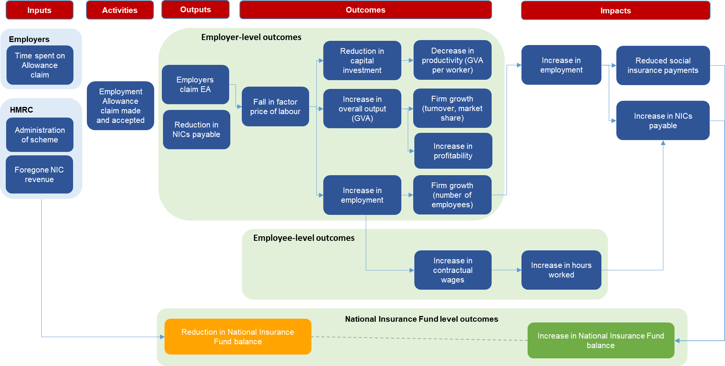

Key hypothesis to be tested
The key hypotheses to be tested in the impact evaluation are set out in the following table.
Table 2.1: hypotheses to be tested
Number | Description
#1 | In the short-term, reductions in labour costs created by the increase in the Employment Allowance will (a) increase employment, (b) reduce the share of capital in production, (c) increase output, (d) increase profits and (e) reduce average labour productivity
#2 | In the medium term, if labour supply is inelastic, the increase in the Employment Allowance will lead to (a) increased wages, but (b) there will be no effects on capital investment, output, average labour productivity, or profits
#3 | In the medium term, if labour supply is elastic, the increase in the Employment Allowance will lead to (a) increased employment, hours worked and economic activity rates. This will be accompanied by (b) increased output and profits. However, there will also be (c) reductions in capital investment and average labour productivity
#4 | The employment impacts of the increase in the Employment Allowance will be largest for workers on low wages whose earnings exceed the Secondary Threshold
#5 | The employment impacts of the increase in the Employment Allowance will be larger in areas and times of high unemployment
#6 | The impacts of the increase in the Employment Allowance will be (a) largest for smaller employers with lower NICs liabilities. There may also be (b) negative effects on larger employers with larger NICs liabilities resulting from competitive distortions

03

Experiences of claiming the Employment Allowance

3. Experiences of claiming the Employment Allowance
This chapter examines the experience of claiming the Employment Allowance. It starts by setting out the characteristics of the 4 claimant groups, and then examines the use of agents for payroll administration, and the amount that was claimed. It then gauges levels of awareness and understanding of the Employment Allowance, before assessing any perceived drawbacks of the scheme. The chapter also examines employers’ use of other types of business tax relief.

Claiming the Employment Allowance
3.1.1 About the survey population
This section examines the characteristics of the 4 groups included in the survey: claimants, non-claimants, previously eligible claimants and past claimants. The 4 groups had different profiles with regards to size and sector. These profiles need to be considered when interpreting differences between the findings throughout this report.
Around a third of claimants (36%) had 1 or 2 employees, while 20% had 10 or more employees. Non-claimants were typically smaller; 76% had 1 or 2 employees while just 7% had 10 or more.
Figure 3.1 shows previously eligible claimants tended to be larger in size than those in the other groups. Nearly all (98%) had 10 or more employees.
In terms of industry sector, claimants most commonly operated in the ‘Wholesale, retail or repair of motor vehicles’ sector (18%) or in the ‘Professional, scientific and technical activities’ sector (15%). The most common sectors for both non-claimants and past claimants were ‘professional, scientific and technical activities’ (25% and 22% respectively) and ‘Information and communications technology’ (17% and 14% respectively). The profile of previously eligible claimants was different, with relatively high proportions in the ‘manufacturing’ (25%) and ‘education, human health, and arts and recreation’ sectors (23%).
The regional profile was similar across the 4 groups. Amongst claimants, 41% were based in the South of England, 21% in the East of England, 20% in the North of England and 9% in the West of England. Only 1 in 10 claimants (10%) were based in Wales, Scotland or Northern Ireland.

Figure 3.1: Number of employees
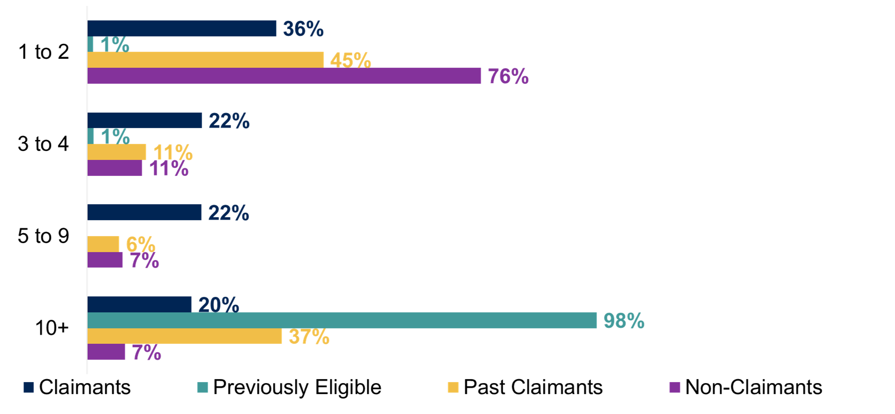
Base: All claimants (655), previously eligible claimants (104), past claimants (103) and non-claimants (402)
Q: How many employees are on your organisation's payroll in the UK, including yourself?

- 3.1.2 Use of agents
Non-claimants were more likely than claimants to use an agent to deal with PAYE and NICs administration for their staff. More than half of non-claimants (58%) fully outsourced this activity (compared with 42% of claimants), while 14% of non-claimants partly outsourced it (compared with 12% of claimants). The majority of previously eligible claimants (60%) and around half of past claimants (51%) dealt with PAYE and NICs internally.
Smaller-sized businesses were more likely than larger businesses to outsource the administration of PAYE and NICs. Amongst claimants, around half (53%) of Micro organisations (with 1-2 employees) fully outsourced the administration of PAYE and NICs, but this was much lower (19%) amongst Large organisations (with 10 or more employees). Similarly, amongst non-claimants, organisations with 1-2 employees were more likely to outsource payroll administration fully than those with 3 or more employees (64% compared with 40%). This pattern helps to explain the overall differences by claimant group, with non-claimants (that were typically smaller) being more likely to outsource this activity.

Awareness and understanding
Around 4 in 5 claimants (82%) said they had heard of the Employment Allowance before the survey interview, as did 9 in 10 previously eligible claimants (92%) and 4 in 5 past claimants (78%). Awareness was lower amongst non-claimants (39%).
Almost half of claimants (47%) who had heard of the Employment Allowance had a good understanding of it. This was similar to the proportion of previously eligible claimants (54%) and past claimants (49%). Again, the proportion was lower amongst non-claimants (17%).
Figure 3.2 shows knowledge of the Employment Allowance was greater amongst organisations that dealt with payroll internally, either fully or partly. Amongst claimants, 94% of these types of organisations had heard of the Employment Allowance (compared with 71% of those who fully outsourced their payroll) and 68% expressed a good understanding of it (compared with 29% respectively).
A similar pattern applied to non-claimants. Amongst those who dealt with payroll internally (fully or partly), 75% had heard of the Employment Allowance (compared with 26% of non-claimants who fully outsourced their payroll) and 42% expressed a good understanding of it (compared with 8% respectively).
Figure 3.2: Knowledge of the Employment Allowance
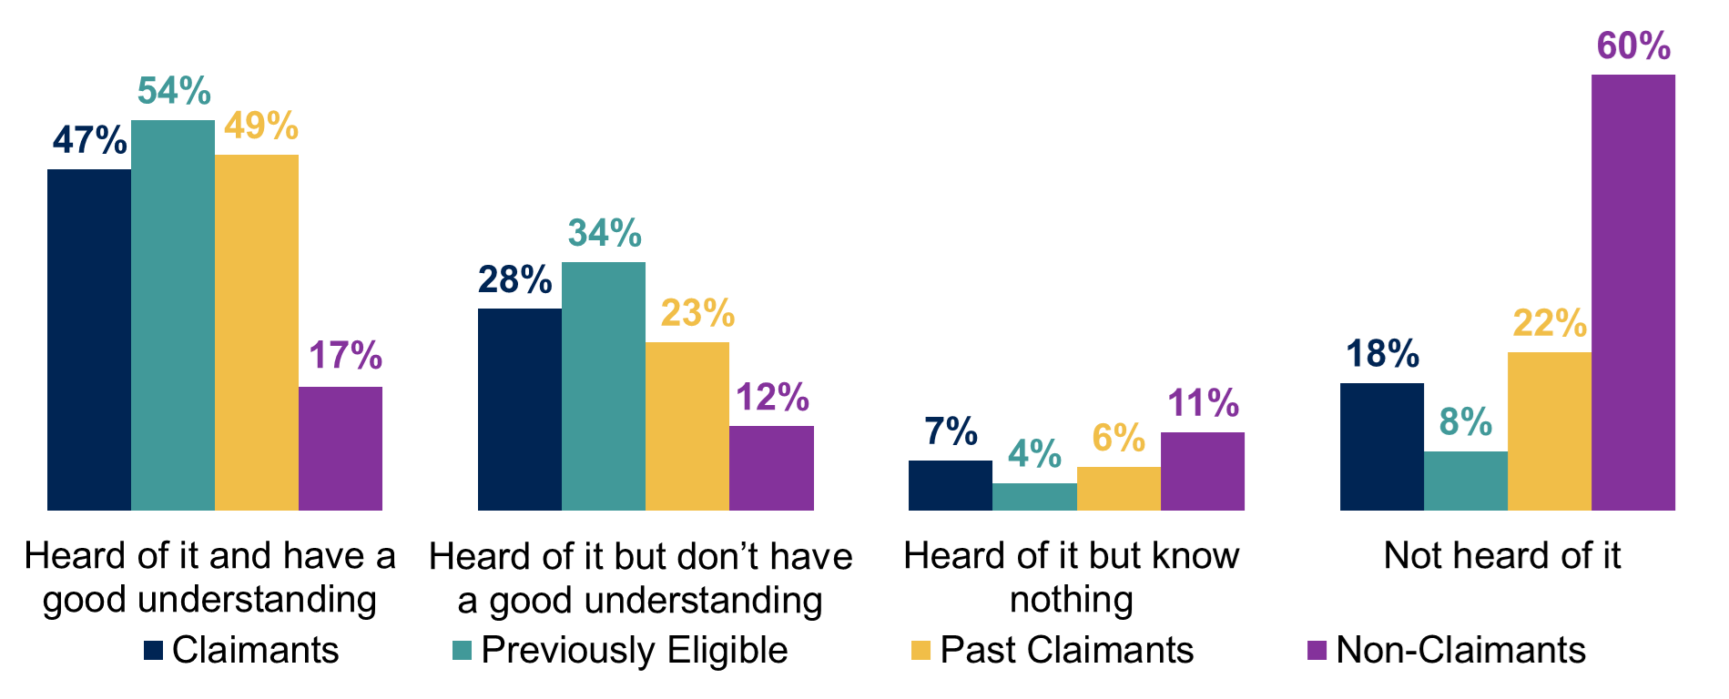
Base: All claimants (655), previously eligible claimants (104), past claimants (103) and non-claimants (402)
Q: Before today, had you ever heard of the Employment Allowance scheme?

Survey respondents who had heard of the Employment Allowance were asked some more detailed questions to gauge their understanding of it. Figure 3.3 shows the majority (78%) of claimants who had heard of the Employment Allowance said they knew that employers could claim back up to £4,000 of their NICs bill in the 2020 to 2021 tax year. Non-claimants who had heard of the Employment Allowance were less likely to know this (46%).
Claimants with more employees were more likely to be aware that employers could claim back up to £4,000 of their NICs bill in the 2020 to 2021 tax year (87% amongst those with 5 or more employees, compared to 70% of those with 1-2 employees and 72% of those with 3-4 employees). Awareness was also higher amongst claimants who dealt with their payroll internally (89%) than amongst claimants who outsourced all or part of their payroll (66%).
Figure 3.3: Awareness of claiming back up to £4,000 of NICs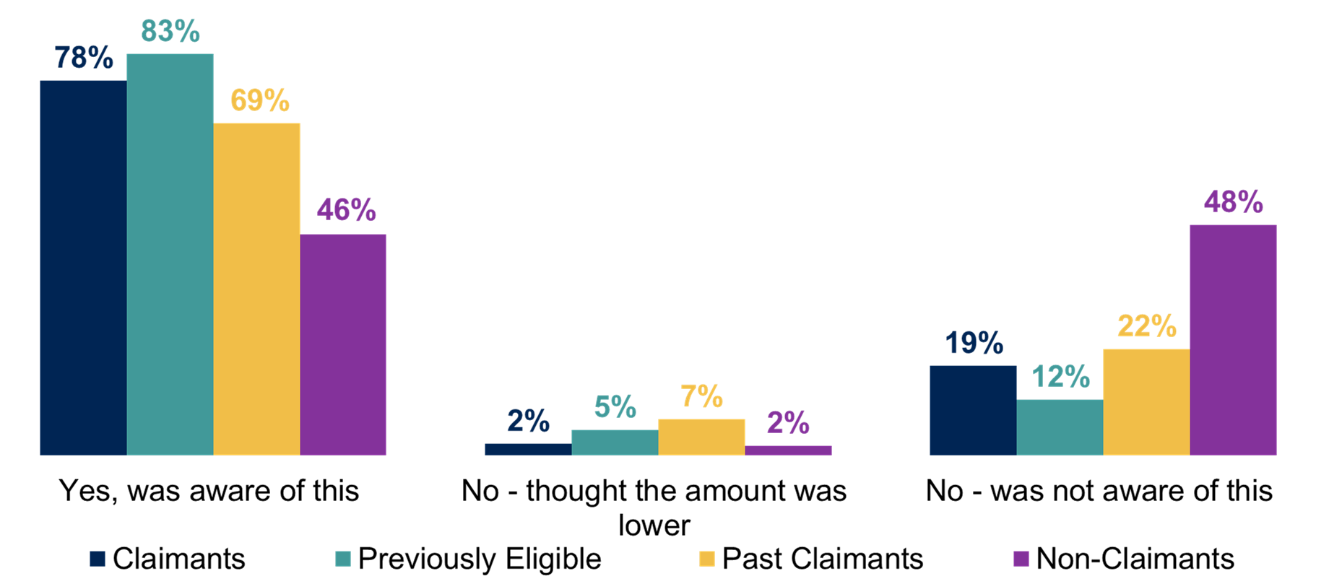
Base: All aware of the Employment Allowance; claimants (541), previously eligible claimants (95*), past claimants (74*) and non-claimants (159)
* Note small base sizes
Q: Before today, were you aware that in the 2020 to 2021 tax year, employers could claim back up to £4,000 of their National Insurance bill each year, through the Employment Allowance?

The survey then examined knowledge of specific aspects of the Employment Allowance, amongst those who had heard of it and knew at least something about it. Figure 3.4 shows claimants who were aware of the Employment Allowance expressed high levels of knowledge of some aspects: that it ‘directly reduces the amount of employer National Insurance you have to pay’ (94%) and that ‘you need to claim for Employment Allowance every tax year’ (87%). Knowledge of other aspects were somewhat lower, especially the frequency of those who knew that ‘you cannot claim if you are a Director who is the only employee, and you are paid more than £170 a week’ (49%).
Knowledge levels tended to be higher amongst claimants than non-claimants, specifically in relation to the following aspects: ‘Employment Allowance directly reduces the amount of employer National Insurance you have to pay’ (94% compared with 86%); ‘you need to claim for Employment Allowance every tax year’ (87% compared with 75%); and ‘relief cannot be carried forward from 1 year to the next’ (75% compared with 60%).
However, non-claimants were more likely than claimants to say they knew that ‘you cannot claim if you are a Director who is the only employee, and you are paid more than £170 a week’ (62% compared with 49%), which was the secondary threshold in the 2021 to 2022 tax year.
Non-claimants in the qualitative research expressed a degree of confidence in their ability to find out and access information about the Employment Allowance, even if they did not currently claim or were ineligible to do so. They felt the information on the Employment Allowance was readily available and accessible.
Figure 3.4: Awareness of specific aspects of the Employment Allowance
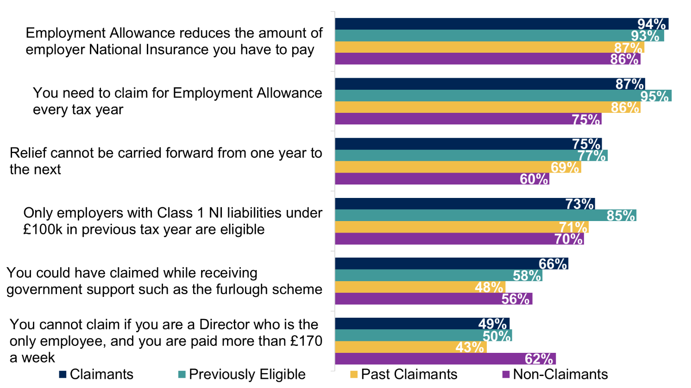
Base: All aware of the Employment Allowance and know something about it: claimants (499), previously eligible claimants (91*), past claimants (66*) and non-claimants (115)
* Note small base sizes
Q: Before today, were you aware…?

However, generally, those participating in the qualitative research felt that the scheme was not very well advertised.
“I don't think it's been advertised by government and agencies... there's not enough public information provided by the government for these things. [...] There is not enough public information provided via media outlets for people to question whether they are claiming, what they should do, and what they will do.”
(Non-claimant)
In the survey, claimants awareness of the various aspects tended to be higher amongst those who dealt with their payroll internally, particularly if they handled all of it themselves. For example, 82% of claimants who handled their payroll internally were aware that ‘relief cannot be carried forward from 1 year to the next’, compared to 64% amongst claimants who outsourced all or part of their payroll. This was supported by the qualitative findings, where claimants with an accountancy background or payroll managers expressed reasonably strong knowledge of the Employment Allowance and its purpose. It was felt to be a relatively ‘low-profile’ benefit, where information may be less accessible and visible for others not regularly involved in accounting, payroll, finance and human resources.
“If you were to talk to ‘Bill Bloggs’ who has a painting and decorating company with 10 people on the books, he will have heard of it, but will have a third party who does payroll. They will claim the Employment Allowance for him, all he will be aware of is ‘this is your PAYE to pay this month.”
(Claimant)
Non-claimants who were involved in payroll or finance also had good understanding of the Employment Allowance.
Both claimants and non-claimants in the qualitative research reported that they received information about the Employment Allowance from the following sources:
- directly from their payroll software
- HMRC newsletters and guidelines
- professional bodies and external experts
- proactive online searches
- accounting training courses
These sources of information seem to be targeted towards finance and accounting professionals and were thought to be more accessible to people with expertise in this area, regardless of whether they were a claimant or not.

Drawbacks of the Employment Allowance
Organisations that had heard of the Employment Allowance and knew something about it were asked to describe what they thought were the main drawbacks of the Employment Allowance. More than half of claimants (56%) said that the Employment Allowance had no drawbacks. Claimants who handled all of their payroll internally were more likely to say there were no drawbacks of the Employment Allowance (67%), compared to claimants who outsourced all or part of their payroll (46%). The same view was held by 54% of past claimants and 46% of non-claimants, although previously eligible claimants were less likely to say it had no drawbacks at all (33%).
As seen in Figure 3.5 below according to claimants, the main drawbacks were that it was not automatically applied (6%) and that information on the scheme was not clear or detailed enough (5%). The most common drawback for previously eligible claimants was that the NICs liability threshold was too low (26%).
Figure 3.5: Perceived drawbacks of the Employment Allowance
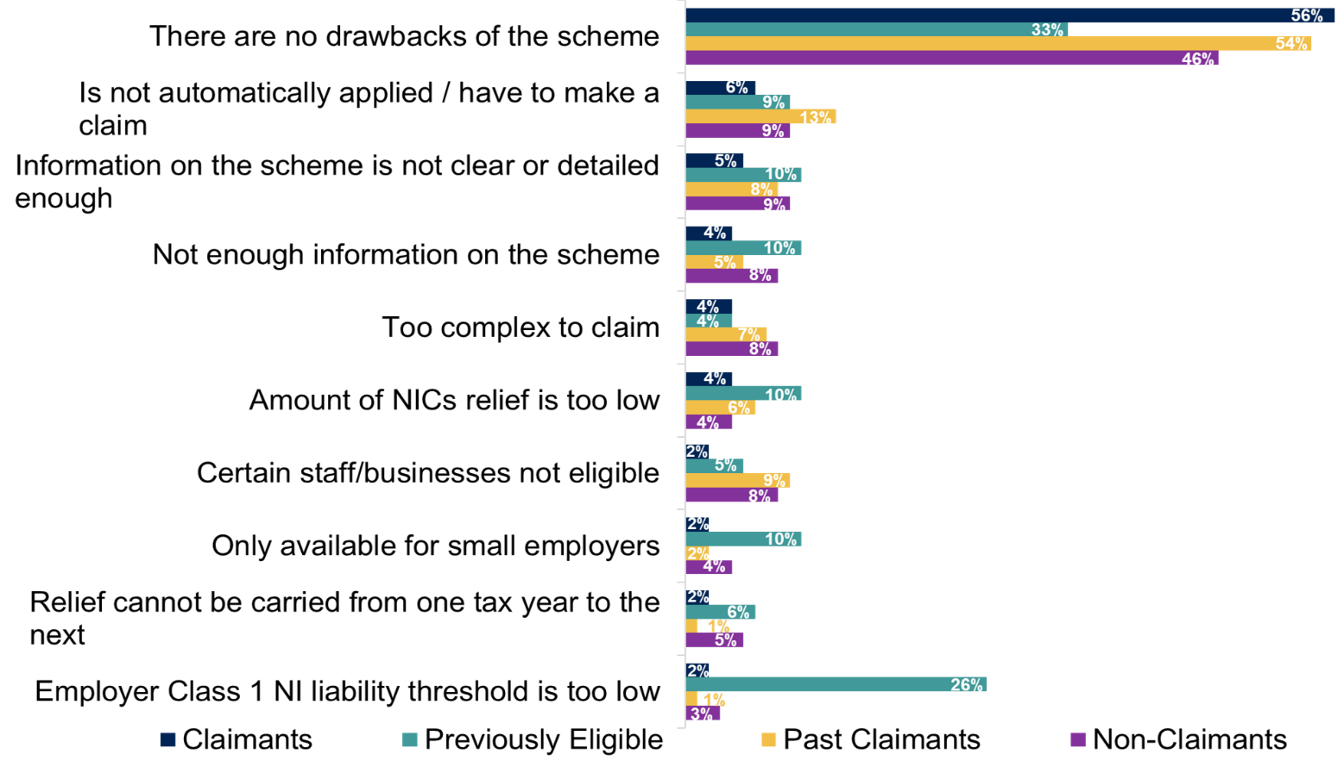
Base: All claimants (655), all previously eligible claimants (104), past claimants who know something about the Employment Allowance (66*), and non-claimants who know something about the Employment Allowance (155)
* Note small base size
Top answers shown only
Q: What, if anything, do you think are the main drawbacks of the Employment Allowance?

Past claimants were asked why they did not claim the Employment Allowance in the 2020 to 2021 tax year, as shown in Figure 3.6 below. The most common reason, cited by a third (34%), was that they thought the business was no longer eligible. Other reasons included a perceived lack of information or awareness about it (10%), that their Employer Class 1 NICs liability threshold was too low (7%) or that they missed the deadline or forgot to claim (6%).
The qualitative research supported these findings, with employers expressing positive sentiments about the Employment Allowance. They did not feel there were many drawbacks to the scheme, particularly around the claiming process, which was depicted as simple and straightforward.
“It works well, for us. We don't claim it as such, we just net off what we owe? It's not like we have to pay it out, and then wait for it to come back. Like other things...it's just done for me.”
(Claimant)
However, employers also felt there were a few elements of the Employment Allowance that could be improved in the future. Whilst many felt the eligibility criteria were acceptable and adequate, some employers indicated that the £100,000 threshold may be too high. The amount of Employment Allowance received was generally felt to be ‘better than nothing’, but depending on the size of the business, the amount received and spread across the year, the impact was sometimes unnoticeable. For businesses with a higher turnover, the amount of the Employment Allowance was often negligible.
“I think it’s [the Employment Allowance is] absolutely fine. It’s helpful for small to medium sized businesses. £100,000 as the limit is very generous. I think it’s a fair system. Certainly, for smaller companies, it’s a big saving.”
(Non-claimant)
Further, some employers viewed the current targeting of the Employment Allowance scheme as too broad. Some explained it supported businesses who did not need the relatively small allowance amount, and others said it excluded businesses from receiving needed support if they were slightly above the eligibility threshold of £100,000. These employers felt that Employment Allowance eligibility could be more focused on the employers most in need of support or employers that would most benefit from the support, for example, based on the number of employees, wages paid or business structure. This theme is discussed in more detail in chapter 5.
Figure 3.6: Reasons for not claiming Employment Allowance in 2020 to 2021
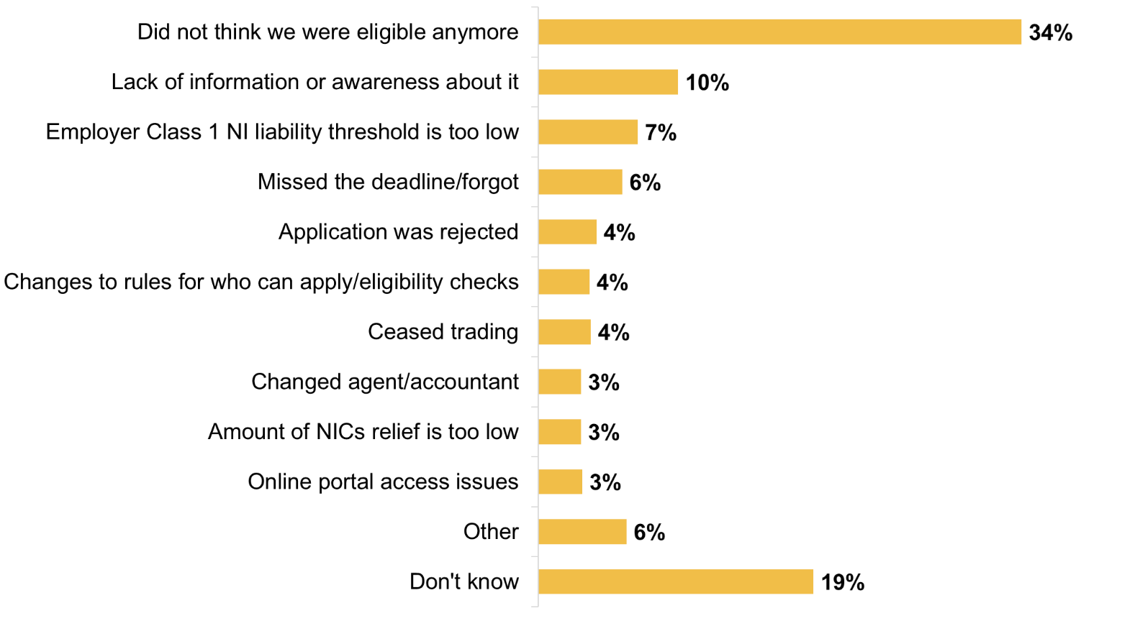
Base: All past claimants (103)
Q: For what reasons did you not claim the Employment Allowance in 2020 to 2021?

The qualitative research suggested that the main reasons for not claiming were due to a lack of awareness of the Employment Allowance scheme and uncertainty around eligibility. Reasons given for a lack of awareness of the Employment Allowance included: the scheme not being flagged by payroll software or an accountant, or that employers did not read government newsletters which provided this information. A lack of awareness could have led to a missed opportunity for businesses to take advantage of a useful employment support scheme. For example, a past claimant noted that their lack of awareness would be a detriment to claiming it.
“I guess it's like most businesses, if there's an allowance out there, which will help with cash flow and things like that, you're going to take it.”
(Past claimant)

Value of claims
As of April 2022, the maximum amount that employers could claim from the Employment Allowance was £5,000. This increased from £3,000 in April 2016 and £4,000 in April 2020.
As seen in Figure 3.7 most claimants said that their latest claim had been for more than £3,000 (54%), while 22% said the claim had been for up to £1,000 and 21% said it had been for between £1,000 and £3,000. The amount claimed by previously eligible and past claimants tended to be lower, reflecting the maximum amount that was available at the time of their last claim.
Figure 3.7: Most recent amount claimed in Employment Allowance
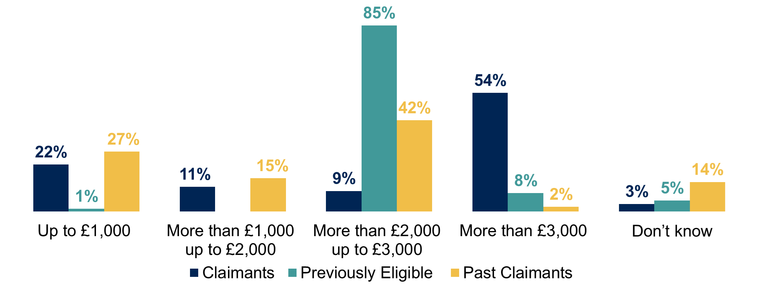
Base: All respondents; claimants (655), previously eligible claimants (104), past claimants (103) and non-claimants (402)
Q: The last time that you claimed Employment Allowance, approximately how much did you claim?

Claim amounts were linked to the size of the business. The proportion that claimed more than £3,000 ranged from 86% amongst claimants with 10 or more employees, down to 22% amongst claimants with 1-2 employees. Related to size, those with a higher turnover were also more likely to claim more than £3,000 (82% amongst those with a turnover of £1,000,000 or more in the 2021 to 22 tax year, compared with 16% amongst those with a turnover of under £85,000).
There were also differences by region. Claimants in the West of England were most likely to claim more than £3,000 (72%) and those in the South of England least likely to claim the full amount (47%).

Use of other business tax relief
As shown in Figure 3.8 below, around 2 in 5 claimants (42%) said that they had claimed or benefitted from other types of tax relief in the 2020 to 2021 tax year, such as Business Rates Relief or Annual Investment Allowance for qualifying expenditure on plant and machinery. The proportion was similar amongst previously eligible claimants (47%) but was lower amongst past claimants (29%) and non-claimants (24%).
These results were linked to business size; larger organisations were more likely to say they had claimed or benefitted from other types of tax relief. Amongst claimants, 47% of organisations with 3 or more employees said they had claimed other types of relief, compared to 33% of those with 1-2 employees. Similarly, amongst non-claimants, 39% of organisations with 3 or more employees said they had claimed other types of relief, compared to 19% of those with 1-2 employees. This pattern helps to explain why non-claimants were less likely to have benefitted from other types of tax relief, as they typically were smaller-sized organisations.
Claimants with a higher turnover were also more likely to say they had claimed or benefitted from other types of tax relief. The proportion ranged from 50% amongst claimants with a turnover of £500,000 or more in the 2021 to 2022 tax year to 33% amongst claimants with a turnover below £85,000.
Claimants in the ‘wholesale and retail or repair of motor vehicles’ sector were more likely to have claimed other types of relief (60%) than those in other sectors.
Figure 3.8: Claiming other types of tax relief in the 2020 to 2021 tax year
Base: All respondents; claimants (655), previously eligible claimants (104), past claimants (103) and non-claimants (402)
Q: Have you claimed or benefitted from any types of tax relief in the 2020 to 2021 tax year?

04

Impact of the Employment Allowance

4. Self-reported impact of the Employment Allowance
This chapter examines the self-reported impact of the Employment Allowance on organisations that have claimed it. It starts by assessing how the saved money was used, before examining the perceived impact of the scheme on recruitment, retention, hours and wages. It then looks at the perceived impact on growth prospects, the labour market and on reducing the effects of the COVID-19 pandemic.

Using the money saved
The money that businesses saved from the Employment Allowance was typically absorbed into general revenue or expenditure. This applied to more than 4 in 5 claimants (86%) that were aware of the Employment Allowance, and similar proportions of previously eligible claimants and past claimants who were aware of the scheme (85% in each case).
Employers in the qualitative research explained that the Employment Allowance was absorbed into general revenue and was not a discrete pot of money. Most employers could not articulate exactly what the saved money had been spent on; sometimes because they were not close enough to the finances, but, in other cases, because the amount was so small in proportion to turnover that it was unnoticeable.
“It just means costs are £4,000 less a year. It goes into the overall pot as to whether a company is doing well or not.”
(Claimant)
“It’s not used for a specific purpose within the business. It’s just treated as an overall contribution towards costs.”
(Claimant)
In the survey, a small proportion of claimants (8%) used the saved money for a specific purpose, using either all of the money in this way (6%) or just some of it (2%). Results were similar for previously eligible claimants and past claimants, as shown in Figure 4.1 below.
Figure 4.1: How businesses used money saved as part of the Employment Allowance
Base: All who had heard of the Employment Allowance and had claimed it: claimants (547), previously eligible claimants (95*) and past claimants (74*)
* Note small base sizes
Q: Did you use the saved money for a specific purpose or was it absorbed into general revenue or expenditure?

Impact of the money saved
Organisations that had claimed the Employment Allowance (claimants, previously eligible claimants and past claimants) were asked to assess the benefits they had gained from the money that they had saved. Questions in this section were only asked of businesses that had heard of the Employment Allowance, and the analysis excludes businesses that said the question did not apply to them.
More than half of claimants (54%) said that the saved money had helped them to retain members of staff. This included 25% who said it helped them ‘a lot’ and 29% who said it helped them ‘a little’.
For the other types of impact, the Employment Allowance was more likely to be seen as helping ‘a little’ rather than ‘a lot’. For example, 10% of claimants said that the money had helped them ‘a lot’ to increase the wages of staff, while 41% said it had helped them ‘a little’. This aligns with the qualitative research, which found that the small amount and format of the Employment Allowance made it unnoticeable for many employers. Receiving the Employment Allowance as a relief, as opposed to a grant, also meant it was not considered a discrete and noticeable set amount of additional cash to invest in a business. Therefore, it was difficult for employers to identify a clear or distinct change or impact as a result of claiming the Employment Allowance.
As illustrated in Figure 4.2 the survey identified other benefits; at least a quarter of claimants reported it helped them ‘a lot’ or ‘a little’ with purchasing new equipment, machinery, technology or computers (33%); taking on additional members of staff (31%); or increasing hours of existing staff (27%). Claimants were least likely to say that the saved money had helped them with making temporary or short-term staff permanent (20%) or with research and development spending (18%).
The results were generally consistent across the 3 claimant groups. However, claimants were more likely to say the money had helped them (either ‘a lot’ or ‘a little’) to retain members of staff (54% compared with 22% of previously eligible claimants and 37% of past claimants). Claimants were also more likely than previously eligible claimants to say the money had helped them to increase staff wages, either ‘a lot’ or ‘a little’ (50% compared with 26%).
Amongst claimants, those with 1-2 employees were less likely to say the saved money helped them in various ways, compared with those employing 3 or more staff. For example, 15% said it helped them to take on additional members of staff (compared with 38% of those with 3 or more employees).
Figure 4.2: Self-reported impact of the money saved
Base: All who had heard of the Employment Allowance and claimed, excluding those giving a ‘not applicable’ answer. Base sizes shown on chart
* Note small base sizes
Q: How much do you think the money saved helped you with…?

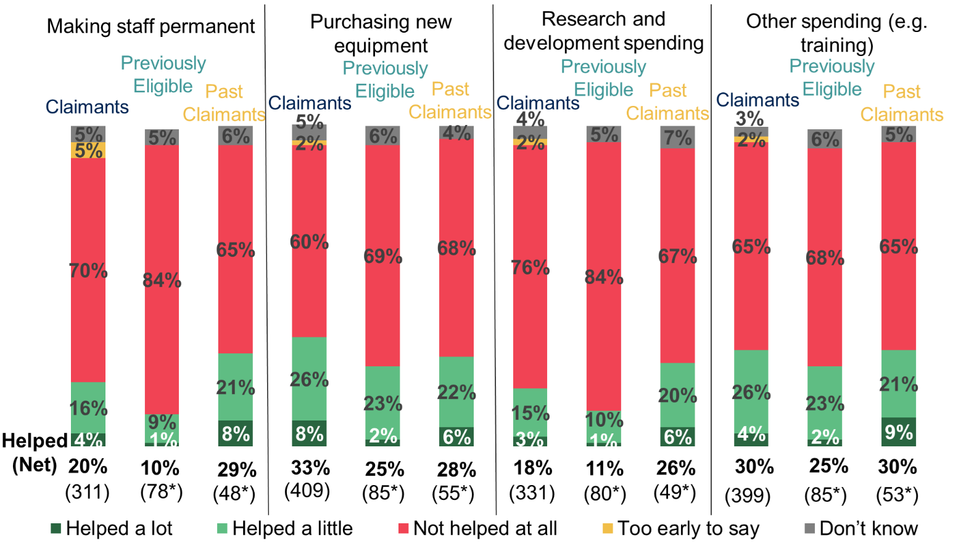
Base: All who had heard of the Employment Allowance and claimed, excluding those giving a ‘not applicable’ answer. Base sizes shown on chart
* Note small base sizes
Q: How much do you think the money saved helped you with…?

Claimants who had reported benefits from the money they saved were asked whether they would have been able to realise those benefits if they had not received the Employment Allowance. Figure 4.3 shows around half (49%) of claimants who said it helped to make temporary or short-term staff permanent said that they would not have been able to do this without the Employment Allowance. Just under half (46%) of claimants who stated it helped to increase hours for existing staff said that this would not have been possible without the saved money. More than a third (36%) of claimants who said it helped with taking on new staff expressed that they would not have done this without the Employment Allowance.
Figure 4.3: Ability for changes without Employment Allowance, claimants
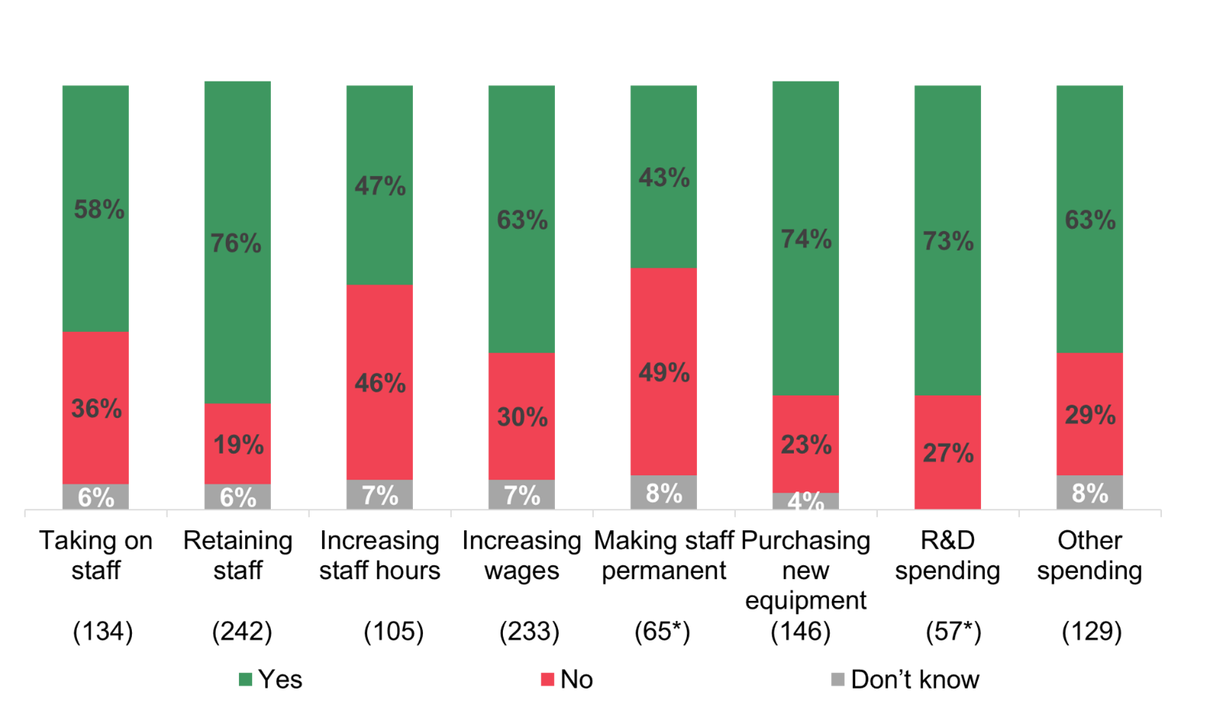
Base: All who had heard of the Employment Allowance and claimed, excluding those giving a ‘not applicable’ answer. Base sizes shown on chart
* Note small base sizes
Q: How much do you think the money saved helped you with…?

Impact on redundancies
Claimants, previously eligible claimants and past claimants who had heard of the Employment Allowance were asked whether they had made any redundancies since they started claiming it. As shown in Figure 4.6 below less than 1 in 5 claimants (16%) and previously eligible claimants (15%) had made redundancies, and only 1% of past claimants.
Claimants were more likely to have made redundancies if they were larger (28% of claimants with 10 or more employees, compared to 9% of those with 1-2 staff), had a higher turnover (26% of those with a turnover of £1,000,000 or more in the 2021 to 2022 tax year compared with 9% with a turnover of under £250,000), if they were located in the West of England (28%) or if they had current vacancies (30% compared 12% of those without vacancies).
Of the claimants who had made redundancies since they started claiming the Employment Allowance, 15% said they would have made these employees redundant sooner if the Employment Allowance was not available, while 6% said they would have made more employees redundant in the absence of the Employment Allowance. In total, 19% said they would have done one or both of these things.

Impact on growth prospects
Figure 4.4 shows around half of claimants who had heard of the Employment Allowance (48%) agreed that it had been important to the growth and development of their organisation, and this included 17% that agreed strongly. A third (32%) were neutral, while 18% disagreed that the Employment Allowance had been important to growth and development. The qualitative research findings, however, suggested that the impact of the Employment Allowance on their business’s growth was difficult to see. A few indicated that a reduction in NICs helped their company as it was a simple reduction in expenses which led to increased cashflow. A few noted there were likely knock-on effects of this increased cashflow elsewhere that were not clearly felt or visible.
In the survey, claimants with 3 or more employees were more likely than those with 1 or 2 employees to agree that claiming the Employment Allowance was important to growth and development (53% compared with 39%). Attitudes were similar amongst past claimants (40% of whom agreed), whereas previously eligible claimants were less likely to agree that the Employment Allowance had been important to growth and development (11%).
Figure 4.4: Whether claiming has been important to growth and development
Base: All who had heard of the Employment Allowance and claimed it: claimants (547), previously eligible claimants (95*) and past claimants (74*)
* Note small base sizes
Q: To what extent do you agree or disagree claiming the Employment Allowance has been important to the growth and development of your organisation?

A third of claimants (33%) said they expected their organisation to grow over the next 12 months, while half (50%) expected it to remain about the same and 12% expected it to contract. Claimants with 5 or more employees were more likely to say they expected to grow than those with fewer than 5 employees (39% compared with 29%). Past claimants had similar expectations (38% expected growth), while previously eligible claimants were more likely to expect growth (48%).
However, Figure 4.5 shows non-claimants were as likely as claimants to anticipate growth in the next 12 months (30% compared with 33%).
Figure 4.5: Expectations for growth over the next 12 months
Base: Claimants (652), previously eligible claimants (103), past claimants (97) and non-claimants (389) that are currently trading or are temporarily closed
Q: Which of the following statements best applies to your outlook for the organisation over the next 12 months?

As seen in Figure 4.6 claimants were more likely to have seen their total number of employees decrease (27%) than increase (16%) over the previous 3 years. The pattern was the same for past claimants (12% increased, 28% decreased), whereas previously eligible claimants were slightly more likely to have seen their workforce increase (31%) rather than decrease (26%).
Figure 4.6: Change in number of employees in past 3 years
Base: All claimants (655), previously eligible claimants (104) and past claimants (103)
Q: How, if at all, has the total number of employees in your organisation changed in the past 3 years?
Where claimants had increased their workforce over the previous 3 years, this was often an increase of 1-2 employees (44%), although 12% had taken on 10 or more staff during the past 3 years.
Amongst claimants who had seen a reduction in their workforce in the previous 3 years, the majority (66%) said there had been a decrease of 1-2 employees, while 12% had seen a decrease of 10 or more staff. In the qualitative research, employers described facing ongoing challenges with recruitment in the past few years. Some reported a key factor was EU Exit, particularly in sectors such as ‘Manufacturing’ and ‘Hospitality’, where a high proportion of staff would have previously come from abroad. Employers also noted shifts in the post-pandemic labour market, as a result of the cost-of-living crisis and inflation, which reduced the competitiveness of their offers to candidates and affected the cost of inputs, including labour.
“[It’s] manufacturing so no one really wants to do it. Hard to get people who are prepared to work.”
(Claimant)
Given that employers in the qualitative research explained that the Employment Allowance was typically absorbed into general revenue, they did not draw out direct links between the Employment Allowance and growth of their organisation, except through acknowledging that ‘every bit helps’.
“Extra income is always helpful for small companies.”
(Past claimant)

Impact on the labour market
Most claimants (78%) said that all of their current employees were on a permanent contract, while 16% had a mixture of permanent and other types of contract, and 7% had no employees on a permanent contract. Non-claimants were different in that 20% had no employees on a permanent contract.
As with the other findings in the report, the differing profiles of the claimant groups need to be considered when analysing the results. In particular, non-claimants tended to be smaller in size than claimants, and this was a factor in the types of contract offered to staff. In the sample of claimants, for example, organisations with 1 or 2 employees were more likely to have no employees on a permanent contract (13%) than organisations with 3 or more employees (3%).
Figure 4.7 shows the minority of claimants (29%) said they had employees aged under 25, and the proportion was lower amongst non-claimants (13%) . Previously eligible claimants were different to the other groups, with around 78% having employees aged under 25. Again, these findings are related to business size as 74% of claimant organisations with 10 or more staff had at least 1 employee aged under 25, whereas the proportion was much smaller (18%) amongst claimants with fewer than 10 employees.
Figure 4.7: Number of current employees aged under 25

Base: All claimants (655), previously eligible claimants (104), past claimants (103) and non-claimants (402)
Q: How many of these employees are aged under 25?
Claimants were more likely than non-claimants to have recruited in the last 12 months (41% compared with 18%). Almost all previously eligible claimants had recruited (95%). These results were related to size, as larger organisations were more likely than smaller ones to have recruited new staff. Amongst claimants, the proportion who had recruited ranged from 89% amongst those with 10 or more employees, to 17% amongst those with 1-2 employees.
Claimants were also more likely than non-claimants to have staff vacancies (19% compared with 8%), while the majority (63%) of previously eligible claimants had vacancies, as shown in Figure 4.8. Once again, these findings were linked with business size; larger organisations were more likely than smaller ones to have current vacancies.
Figure 4.8: Number of current vacancies
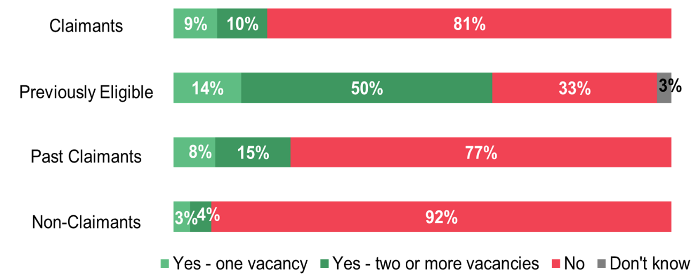
Base: All claimants (655), previously eligible claimants (104), past claimants (103) and non-claimants (402)
Q: Do you currently have any vacancies at your organisation?

As shown in Figure 4.9, claimants who had current vacancies said that the main impacts of these were an increased workload for other staff (65%) or difficulties meeting customer needs (43%).
Figure 4.9: Impact of having staff vacancies
Base: Claimants who had current staff vacancies (163)
Q: Is the fact that you have vacancies causing your company to ...?

The qualitative findings did not reveal any other effects of recruitment and retention on staff as a result of claiming the Employment Allowance. Employers did not feel it was a strong driving factor or deciding factor in how they approached employment and recruitment.
“We have had extra employment. The Employment Allowance, though, I’m not sure what sort of impact that would have had on having the individual employees. I suppose not having to pay quite so much tax and then each month, for 1 or 2 months of the year, it would have helped a little. But I’m not quite sure [of the impact].”
(Past claimant)

Impact on reducing the effects of COVID-19
Figure 4.10 shows claimants were more likely than non-claimants to have applied for other government support schemes during the COVID-19 pandemic (77% compared with 57%). The proportion that applied for government support was highest amongst previously eligible claimants (87%), while the proportion for past claimants (71%) was similar to claimants.
The results were related to size. Across the claimant groups, larger organisations were more likely than smaller organisations to have applied for government schemes during the pandemic. Amongst claimants, the proportion ranged from 86% amongst those with 10 or more employees to 69% amongst those with 1-2 employees. Amongst non-claimants, those with 3 or more employees were more likely to have applied for government schemes during the pandemic (74%) than those with 1-2 employees (52%).
Figure 4.10: If applied for government support schemes during the COVID-19 pandemic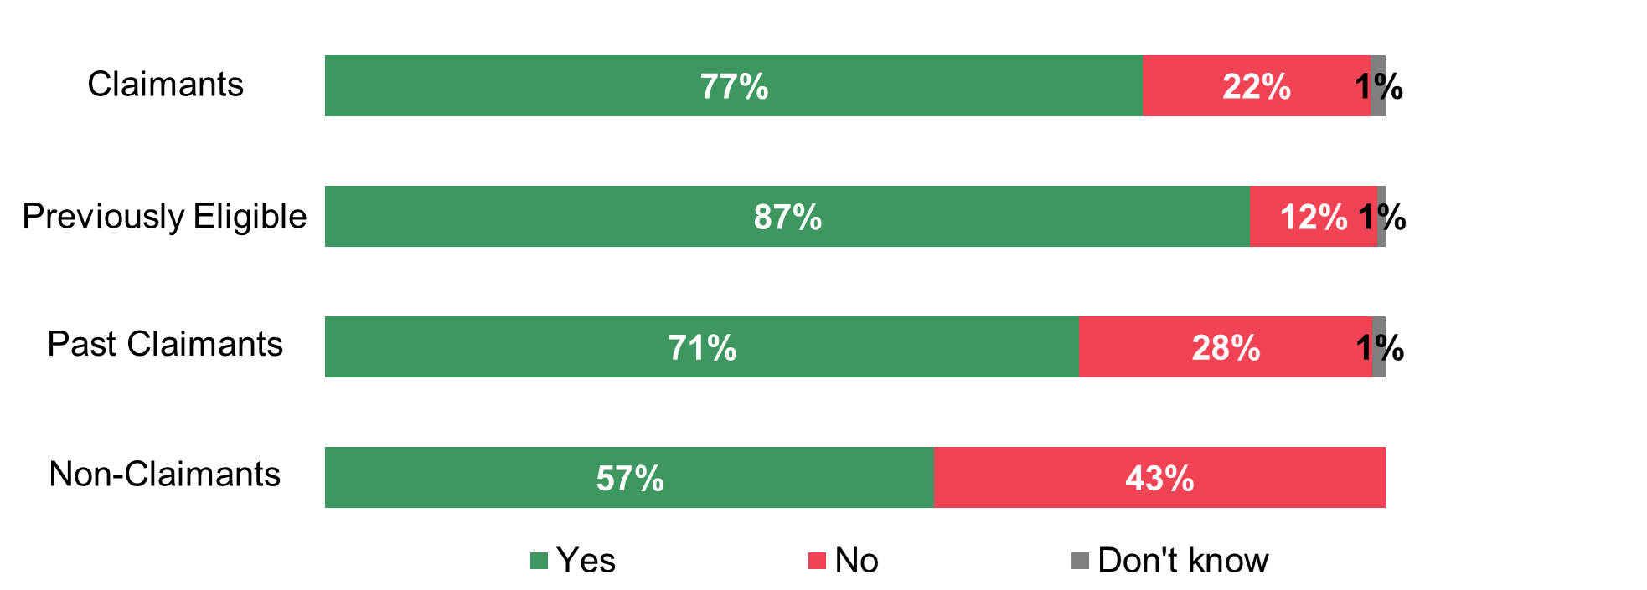
Base: All claimants (655), previously eligible claimants (104), past claimants (103) and non-claimants (402)
Q: Did your business apply for any government schemes designed to provide support during the COVID-19 pandemic, or not?

The majority (72%) of claimants who were aware of the Employment Allowance said that claiming it had helped their business during the pandemic. This included 30% who said the Employment Allowance had helped them ‘a lot’ and 42% who said it had helped ‘a little’. Around a quarter (27%) said that it had made no difference. Claimants with 3 or more employees were more likely to say the Employment Allowance had helped them (‘a lot’ or ‘a little’) than those with 1-2 staff (78% compared with 60%).
Although the self-reported impact was negligible in the qualitative interviews, employers explicitly expressed gratitude and appreciation for the Employment Allowance during the COVID-19 pandemic. It enabled increased cashflow and reserves during a challenging time. Some were conscious that their NICs during the pandemic would have been heavier burdens without the Employment Allowance. The Employment Allowance was indirectly felt to support business resilience.
“It certainly would have helped at that point [during the pandemic] to have the extra cash flow. Certainly, in those months.”
(Past claimant)

05

Proportionality and appropriateness of the scheme

5. Proportionality and appropriateness of the scheme
In the survey, organisations responded to hypothetical scenarios for increasing or reducing the amount of money available from the Employment Allowance, as well as changes to how it is paid. This chapter assesses whether raising or lowering the amount employers can claim would affect the impacts of the scheme. The chapter then examines their likelihood of claiming the Employment Allowance next year and how employers expect to use the money saved.

Increases in the amount that employers can claim
Claimants were presented with some hypothetical scenarios to help understand the value of the Employment Allowance to their organisation. The overall sample of claimants was divided randomly into 2 groups; the first group was asked to imagine that the maximum amount of the Employment Allowance increased by £1,000 (from £5,000 to £6,000); the second group was asked to imagine an increase of £2,000 (from £5,000 to £7,000).
In both scenarios, the majority of claimants said that the additional money would still be absorbed into general revenue or expenditure, indicating no change from the way the money is currently used. However, figure 5.1 shows claimants were more likely to say the additional money would be used for a specific purpose if they were told the amount would increase by £2,000 rather than £1,000. If told the amount would increase by £2,000, 28% said they would use the additional amount wholly for a specific purpose, while 6% said they would use some of the money for a specific purpose. On the other hand, if they were told the amount would increase by £1,000, 22% said they would use the additional amount wholly for a specific purpose and 2% that they would use some of the money for a specific purpose.
Figure 5.1: How claimants would use additional money

Base: All claimants, half randomly asked about an increase of £1,000 (325), half randomly asked about an increase of £2,000 (330)
Q: If the maximum Employment Allowance you can claim increased by £1,000/£2,000, would you use the additional £1,000/£2,000 saved for ...?

Claimants who said they would use the additional money (£1,000 or £2,000) for a specific purpose were asked how they would use it. Figure 5.2 illustrates they were most likely to say they would use the additional money to retain members of staff (54%), take on new staff (48%) or purchase new equipment, machinery, technology or computers (42%).
Figure 5.2: Ways in which additional saved money would be used
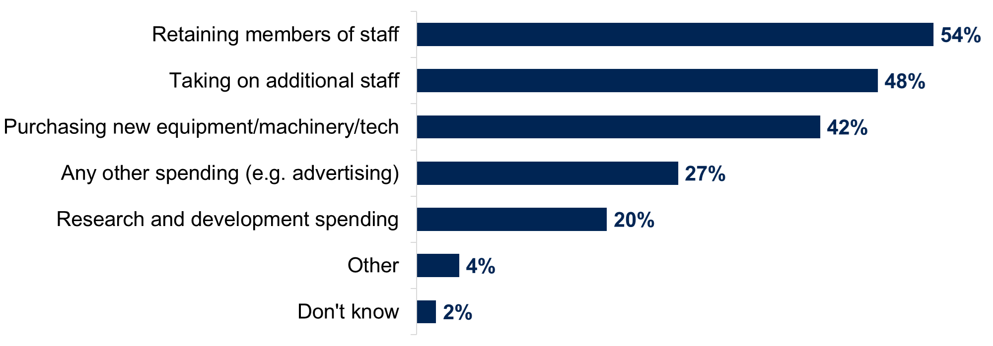
Base: Claimants who would use the money saved for a specific purpose (188)
Q: Would you use the additional saved money for any of the following?

The qualitative findings indicated that if the amount that could be claimed increased, claimants would take advantage of the additional funds but use the money in a similar manner, most likely absorbed into their general revenue or expenditure. A charity explained that this increase would help to reduce the general amount of money they needed to raise for their activities. A private sector business indicated that they would maybe consider buying new equipment or dedicate the additional amount to general maintenance costs.
More specifically, the qualitative findings showed that the decision to use a hypothetically increased amount of Employment Allowance was not straightforward. There were felt to be other considerations that might come into play. For example, dedicating the additional amount to providing small pay rises or covering staff costs would only be possible if it did not attract other costs or additional tax elsewhere.
The qualitative research ultimately showed that the hypothetical increase of £1,000 or £2,000 would not fundamentally change the way organisations used the money claimed. This may be due to the fact that organisations are only eligible to claim part of that amount. As such the hypothetical amount change was considered too small to affect the way they would use the additional money claimed.

Decreases in the amount that employers can claim
In the survey, the sample of claimants were again divided into 2 groups; the first group were asked to imagine that the maximum Employment Allowance they could claim had decreased by £1,000, and the second group were asked to imagine a decrease of £2,000. Both groups were asked how likely they would have been to claim the Employment Allowance in the 2021 to 2022 tax year. These questions were limited to organisations whose last claim had been for more than £3,000.
Figure 5.3 shows the amount of the decrease appeared to make little difference to whether claimants would have claimed the Employment Allowance. In both scenarios, the majority of claimants said they definitely would still have claimed it (72% if they were told the amount would decrease by £1,000 and 74% if told it would decrease by £2,000). Very few claimants said that they would have been unlikely to claim or would definitely not have claimed (4% if they were told the amount would decrease by £1,000 and 2% if told it would decrease by £2,000).
Figure 5.3: If claimants would claim Employment Allowance if the amount decreased
Base: All claimants who claimed more than £3,000, half randomly asked about a decrease of £1,000 (220), half randomly asked about a decrease of £2,000 (229)
Q: If the maximum Employment Allowance you could claim had decreased by £1,000/£2,000, how likely or unlikely would you have been to claim in the 2021 to 2022 tax year?

Claimants who would still have claimed the Employment Allowance if the amount was reduced were asked whether they thought their organisation would have been able to make up the shortfall. The majority of claimants said they would have made up the shortfall. As seen in Figure 5.4 this was the case whether they were told to imagine the amount decreasing by £1,000 (74%) or £2,000 (80%). However, around 1 in 5 claimants said their organisation would not have been able to make up the shortfall under these scenarios (22% if the amount was decreased by £1,000 and 17% if it was decreased by £2,000).
Figure 5.4: Whether claimants would have made up for shortfall
Base: Claimants who claimed more than £3,000 and would still have claimed last year if it had decreased by £1,000 (203); claimants who claimed more than £3,000 and who would still have claimed last year if it had decreased by £2,000 (213)
Q: In this scenario, do you think your organisation would have been able to make up for this shortfall, or not?

Claimants who were asked about a hypothetical reduction in the amount of the Employment Allowance (of either £1,000 or £2,000) were then asked what impact this would have on their business. The majority of claimants (58%) said that they would absorb the additional cost, although 2 in 5 (38%) said they would seek to increase their revenue, while a similar proportion (37%) said they would reduce expenditure, as shown in Figure 5.5. The amount of the reduction presented to claimants (£1,000 or £2,000) made no difference to their responses.
Figure 5.5: Impact of reducing the Employment Allowance, claimants
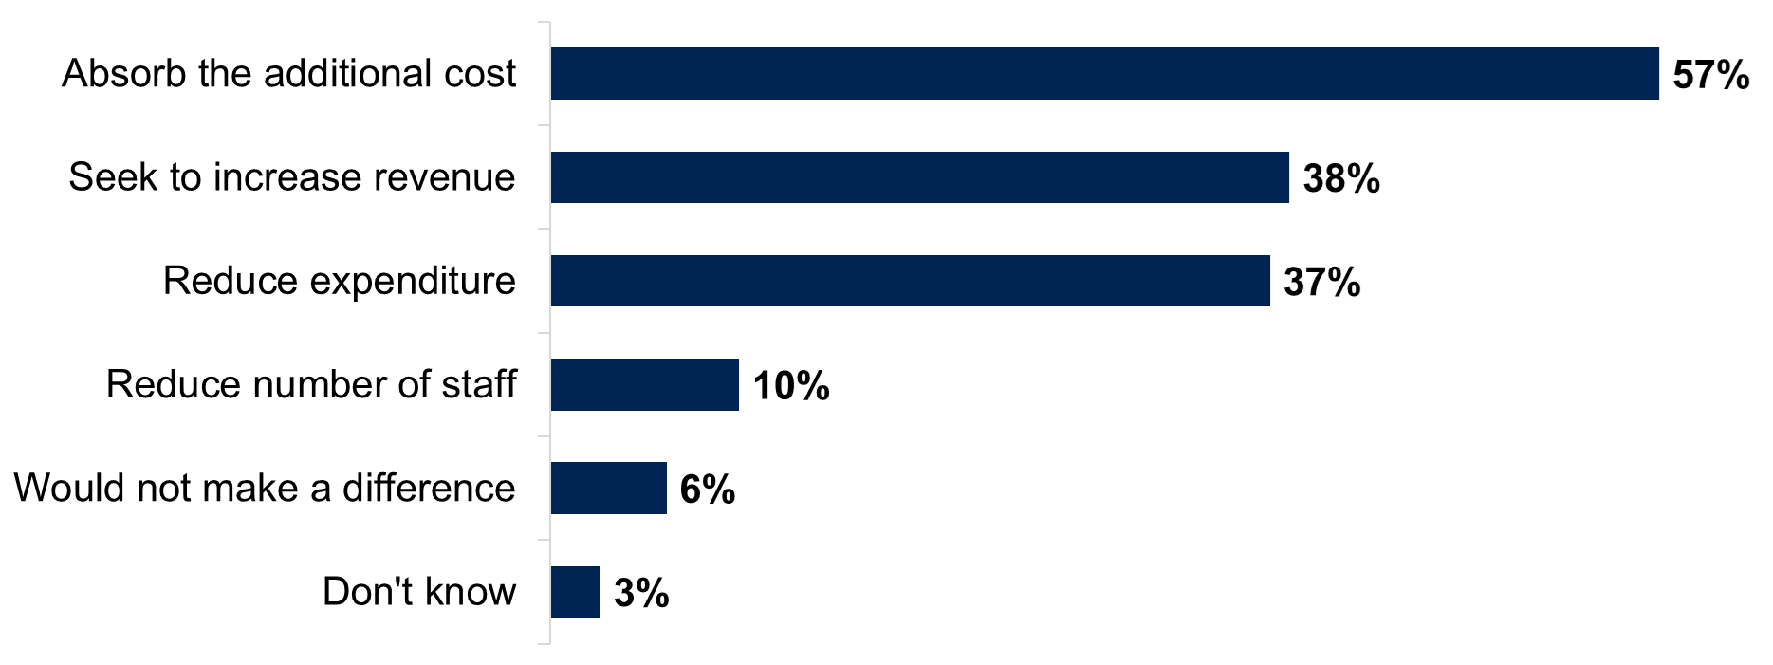
Base: Claimants who claimed more than £3,000 and were asked about a reduction in the Employment Allowance (478)
Q: What impact, if any, would this have on your business? Would you ...?
In the qualitative research claimants suggested they would still claim the Employment Allowance even if the amount decreased, because the process of claiming was considered straightforward, quick, and easy. Similar to how they felt about increases affecting their organisation, the qualitative findings showed that a decrease in the amount would be too small to significantly affect the way the amount claimed is used. Organisations would find ways to fill the gap and the decrease would not have any strong bearing.
“It’s not big enough that companies would be going under because they don’t have it.”
(Claimant)
“We would probably just soldier on […] We got it for a while, nothing lasts forever, you just have to get on with it. You would not say, who's going to get the chop because we don't get the £5k, we'd just absorb it into business costs.”
(Claimant)

Changes to how the Employment Allowance is paid
Claimants who had heard of the Employment Allowance were asked if they would change the way they used the money if they received it as an upfront grant or discount rather than it being offset against their employer’s NICs liabilities. Around 1 in 5 claimants (21%) said that they would change the way they used the saved money under this scenario.
The qualitative findings showed that organisations had many considerations when thinking of the Employment Allowance as a grant or discount. As a grant, organisations would be able to more easily ‘visualise’ the money and dedicate it to a specific purpose. It would make the allowance much more noticeable, and the allowance amount could be used in a more targeted way. Organisations mentioned using the lump-sum for specific productivity expenses, such as new piece of software or machinery, an overdue maintenance expense, or ad hoc training, etc. Many were unsure about whether the amount could be best used for staffing, recruitment, or hiring costs.
“Being honest, I don't think giving us [a grant] up front, as opposed to reducing what we pay every month would be material enough for us to be, you know, different?"
(Claimant)
“It’s money you’re actually getting in rather than you’re saving—but…there’s no real difference, is there? I just think that grant income is more effective if the money were targeted more at specific areas.”
(non-claimant)
The disadvantage of a grant would be around the process of claiming. Some organisations felt that the administrative burden might be more complicated for a grant, whereas, in its current form, claiming was easy and straightforward as it was often handled directly by payroll software. Questions around how the grant would be administered were also raised in the qualitative research and an employer queried if a grant would be taxed. Some were concerned the Employment Allowance would be misused if provided as an upfront grant with no conditionality or specificity to be directed at employment costs. They felt there would be a risk that the funds could be misappropriated and used for personal expenses.
“I think the approach is easy the way it is done at the minute. […] As a grant, there would be more paperwork for me to fill out. When it’s done through the payroll system, it is a little bit more automated and I prefer that.”
(Past claimant)
However, the qualitative findings showed that organisations were less concerned about how the allowance was paid and the amount, but more concerned about eligibility criteria to claim the allowance.

Views on the £100,000 NICs threshold and eligibility
In terms of proportionality and appropriateness, the feedback in the qualitative research showed that organisations’ main concern was around the eligibility threshold of the Employment Allowance. Some felt that the NICs threshold for eligibility was too low while others felt it was appropriate. However, some, when prompted, expressed the need to revisit the eligibility criteria to better target smaller organisations most in need of the Employment Allowance. A few expressed this need for better targeting unprompted during the interview, largely because they felt there was a high proportion of organisations receiving the Employment Allowance who didn’t need it.
As voiced by some responses from the quantitative survey, claimants and past claimants in the qualitative research felt that the NICs liability threshold was too low. Some qualitative respondents felt the threshold could be adjusted for appropriateness, in order to reflect increasing NICs bills and the needs of smaller businesses with different staffing structures.
“I think the [National Insurance liability threshold] needs to increase [as] it hasn’t increased since its implementation but the NI bill has.”
(Past claimant)
Solutions suggested in the qualitative interviews included: a tapered or staggered threshold to avoid a sudden drop-off, or increasing the threshold to reflect changing context, rise in costs, and prices of inputs including labour.
Other organisations felt that the threshold was appropriate but perhaps ill-suited to the types of organisations that would most benefit from the Employment Allowance. For example, an organisation explained that, rather than basing eligibility and amount claimed on NICs, it would be more helpful to shift the focus of eligibility on the number of employees, types of wage earners, or sector of operations (Hospitality, Food services, etc.). Some organisations may only have 1 employee to meet the eligibility threshold whereas others might have 10 employees generating the same NICs. The amount they would be eligible to claim would remain the same, but how much that amount could help the organisation could be very different. Respondents sensed that some organisations benefitting from it did not need it or appreciate it as much as others would.
“If you're paying £100,000 in Employers NICs, £4,000 is nothing. If you're that size, paying £4,000 will not turn a struggling business into a successful one.”
(Claimant)
“Perhaps they should look at the number of employees on payroll - maybe up to 10 or 15? Once above that you're more than a small company.”
(Claimant)
When discussing the proportionality and appropriateness of the eligibility criteria in this sense, the qualitative findings reflected questions around how keeping the same overall amount of Employment Allowance but allocating it to fewer or a select number of organisations might produce more meaningful impact.

Likelihood of claiming next year
Survey respondents were also asked about whether or not they planned to claim the Employment Allowance in the 2022 to 2023 tax year. It is worth noting that the mainstage survey was conducted in the 2022 to 2023 tax year, hence it is likely that some survey respondents were already claiming the Employment Allowance.
In the survey, most claimants said they planned to claim the Employment Allowance in the 2022 to 2023 tax year, with 60% saying they definitely would claim it and a further 26% saying they were very or fairly likely to claim.
As shown in Figure 5.6 more than half of past claimants (55%) said they would definitely or would be likely to claim the Employment Allowance in 2022 to 2023, while this applied to 35% of non-claimants and 22% of previously eligible claimants.
Figure 5.6: Intention to claim the Employment Allowance in 2022 to 2023
Base: claimants (655), previously eligible claimants (104), past claimants (103) and non-claimants (402)
Q: How likely or unlikely are you to claim Employment Allowance in the next tax year (2022 to 2023)?

The qualitative findings showed that all participants would claim if eligible, independent from the amount they could claim. Past claimants indicated that they would claim again if they were eligible. Claimants did not see a reason not to claim unless they were no longer eligible.
“I guess it's like most businesses… There's an allowance out there, which will help with cash flow and things like that, you're going to take it.”
(Past claimant)
“Extra income is always helpful for small companies.”
(Past claimant)
claimants who said they ‘definitely will’ claim the Employment Allowance in the 2022 to 2023 tax year were more likely to be:
- larger in size (65% of those with 3 or more employees compared with 51% of those with 1-2 employees)
- organisations with a higher turnover (ranging from 69% amongst those with a turnover of £1,000,000 or more in the 2021 to 2022 tax year, to 39% amongst those with a turnover of less than £85,000)
- those who used an agent for all of their payroll administration (67% compared with 54% of those who dealt with all or part of their payroll internally)
- organisations that claimed a higher amount of the Employment Allowance (67% amongst those that claimed £3,000 or more compared with 45% of those that claimed less than £1,000)
- organisations that said they had a good understanding of the Employment Allowance (70% compared with 35% of those who had not heard of it before the survey)
On the other hand, non-claimants were more likely to say they ‘definitely will’ claim the Employment Allowance in the 2022 to 2023 tax year if they were larger (37% of those with 3 or more employees compared with 13% of those with 1-2 employees) or if they had claimed other types of business tax relief (28% compared with 16% of those who had not done so).
Claimants and non-claimants who planned to claim the Employment Allowance in 2022 to 2023 were asked how they were likely to use the saved money. Overall, 3 in 4 claimants (76%) said that the saved money would be absorbed into general revenue or expenditure, while 1 in 5 said that they would use either all of the money (15%) or some of it (4%) for a specific purpose (Figure 5.7). Non-claimants were more likely than claimants to say they would use the money for a specific purpose (22% said they would use all of the money and 8% some of it in this way) and were less likely to say the money would be absorbed into general revenue or expenditure (64%).
Claimants with 3 or more employees were more likely than those with 1-2 employees to say the saved money would be absorbed into general revenue (81% compared with 68%).
Figure 5.7: How businesses planned to use money from the Employment Allowance
Base: Claimants (569) and non-claimants (141) that planned to claim the Employment Allowance in 2022 to 2023
Q: If you were to claim the Employment Allowance next tax year (2022 to 2023), how are you likely to use the money saved?

Non-claimants who planned to claim the Employment Allowance in 2022 to 2023 were asked about the specific ways in which the saved money would be used. Non-claimants were most likely to say that they would use the money to purchase new equipment, machinery, technology, or computers (52%), while other uses included increasing staff wages (32%), retaining staff (31%), and taking on additional staff (29%), as shown in Figure 5.8.
Figure 5.8: How non-claimants planned to use money from the Employment Allowance
Base: Non-claimants who planned to claim the Employment Allowance in 2022 to 2023 (141)
Q: Do you think the saved money would be used for any of the following?

Non-claimants were asked whether an increase in the amount of the Employment Allowance would influence their likelihood of claiming. They were first asked about an increase of £1,000 and then of £2,000 to see how this would affect their responses. Figure 5.9 compares the responses of non-claimants at different questions, to assess the effect of the extra payment on their likelihood of claiming. The results are presented for the total sample of non-claimants.
As seen earlier in this section, 35% of non-claimants said initially that they would definitely or be likely to claim the Employment Allowance in the 2022 to 2023 tax year. This proportion increased to 48% when they were given the scenario of a £1,000 increase. In particular, there was an increase in the proportion of non-claimants who said they would ‘definitely’ claim, from 19% initially to 30% with a £1,000 increase.
However, increasing the amount of the Employment Allowance by £2,000 rather than £1,000 made no apparent difference to non-claimants’ responses. If the amount was increased by £2,000, around half of non-claimants (49%) said they would definitely or likely claim in 2022 to 2023, very similar to the proportion responding to a £1,000 increase (48%).
Figure 5.9: Likelihood of claiming the Employment Allowance if the amount increased
Base: All non-claimants (402)
Q: If the amount you could claim was increased by £1,000/£2,000 per year, how likely or unlikely would you be to claim the Employment Allowance in the next tax year (2022 to 2023)?

06
  - Econometric analysis

6. Econometric analysis
This chapter presents a summary of the key results from the econometric analysis which are presented in full in Section 2 of the technical report. The econometric analysis aims to provide estimates of the causal effects of the Employment Allowance on employment levels and other key measures of business activity.

Methodology
The approach to the econometric analysis was based on the findings of a literature review (included in Appendix 12). The aim of the literature review was to provide the theoretical background on the potential impact of reductions in payroll taxes, review empirical studies providing estimates of their impacts in practice, and to identify methodological issues involved in developing estimates of causal effects.

6.1.1 Data

A variety of administrative data sources were combined to enable a test of the impacts of the Employment Allowance. The following table provides an overview of the datasets used, how they were linked, and any issues raised by their quality or coverage. RTI and Capital Allowance data is collected by HMRC, while FAMECOM is collected privately. All financial variables were rebased to 2020 to 2021 prices using the HM Treasury GDP Deflator.

Table 6.1: overview of datasets
Dataset | Description and role in the study
Real Time Information (RTI), employer | RTI employer data provides data on employers’ NICs, including their total NICs liabilities, the amount of NICs paid and Employment Allowance claimed. The dataset covered the period between 2014 to 2015 and 2020 to 2021 and comprised 14,330,864 annual observations across this period, for a total of 3,353,489 employers (with a share of employers exiting and entering the panel over time).  The dataset also provided an indicator of whether the employer was ‘inactive’ (based on tests looking at the employer’s employment and turnover). Observations for years in which employers were inactive were removed from the dataset on the basis that changes to the Employment Allowance would not incentivise changes in employer behaviour for this group. This reduced the number of observations available for analysis by 746,445.  This dataset was used to derive information on how employers’ NICs liabilities changed in response to changes to the Employment Allowance. It should be noted that the RTI employer data was not available for years prior to 2014 to 2015. This places some constraints on how the Employment Allowance can be evaluated, as data prior to its introduction is unavailable.
Real Time Information (RTI), employee | RTI employee level data was also supplied providing worker level data on wages. Data was available between 2014 to 2015 and 2020 to 2021 and included an employer level identifier enabling linkage to the employer dataset. The information was aggregated to an employer level to provide (a) the employers level of employment (the data did not include a measure of hours worked so it was not possible to derive FTEs) and (b) the employers’ total wage expenditure. This was also used to calculate average annual wages paid to employees.  The dataset provided 65,104,976 employee-year observations across 3,348,600 employers (again, with a share of employers entering and exiting the panel over time). The data was then linked to the RTI employer dataset using a correspondence table mapping the employers’ PAYE reference numbers to their enterprise reference number. The matching achieved a 99% success rate.  It should be noted that information on hours worked was not available. As such, it was not possible to discriminate between increases in wages driven by an increase in working hours or increases in the hourly wage.
FAMECOM (Forecasting Analysis and Modelling Environment) and Companies | The dataset was further enriched with information on the activity levels of employers derived from the FAME and Companies dataset, which provided data on turnover and profit for a sample of employers. The data covered the period between 2014 to 2015 and 2019 to 2020 and provided 8,631,099 observations for 2,375,139 employers. The dataset was merged with the RTI datasets using the employers’ enterprise reference number with 60% of employers successfully matching.  Records of turnover and profits are ultimately sourced from published annual accounts filed with Companies House. While filing accounts is mandatory for most enterprises, filing requirements vary by size of employer. Smaller employers are only required to file balance sheet information (providing details of their assets and liabilities) while larger employers are also required to file information on their profit and loss account (which provides information on turnover and profits). This means that the sample of employers is biased towards larger employers and analyses focused on turnover and profits should be reviewed with this caveat in mind.  Data from the FAME and Companies and RTI datasets were also combined to derive a variable for employers’ output (GVA) which is approximated by the sum of profits and wages. A limitation of the data was that employer’s operating losses were not provided with the dataset. Where information on operating losses was unavailable, it was assumed that profit was 0 for these employers (implying that the output of loss-making employer was overstated). This could also lead to biased findings (for example, if there was a correlation between the propensity of employers to earn trading losses and their size).
Capital Allowances (CA) | The Capital Allowances dataset provides variables used to derive employers’ capital expenditure (the specific variables used are specified in Table 2.16 included in the Appendix). The data covered the period between 2014 to 2015 and 2019 to 2020 and the dataset contains 8,395,323 observations across this period. The dataset was merged using the employers’ enterprise number with 51% of employers successfully matched.  Information on capital investment is derived from data captured when employers make a claim for tax relief on capital expenditures. As such, information is not available for employers that do not claim tax reliefs on capital expenditures. This could also bias findings in relation to the effects of the Employment Allowance on capital expenditures. If employers that do not claim these reliefs tend to operate with low levels of capital investment, then the findings are likely to overstate the sensitivity of employers to changes in NICs liabilities.
Business lookup table (BLT) | The BLT provided data on employer location (first section of the employers’ postcode) and employer sector (SIC code). These variables are used as controls for regional and industry trends as well as for assessing how the impact of the Employment Allowance differ by region. Data coverage is between 2014 to 2015 and 2020 to 2021 and the dataset contains 14,754,722 observations across this period. A limitation of this data is that location is defined as the employer’s headquarters and as such might not accurately reflect cases where the employer has multiple locations. However, as the analyses focuses on small employers this is not considered to be a significant limitation in the dataset.  The dataset was merged using the employers’ enterprise number with 66% of employers successfully matched. As in the case of capital expenditure this results in the analysis of models using sectoral and regional controls being undertaken with a reduced sample. If employers with missing data have different characteristics from those included in the dataset then this could bias the regression results.

Overview of analytical approaches
A robust quantitative assessment of causal effects of the Employment Allowance requires both:
observations of the outcomes of interest before and after the introduction of the Employment Allowance. Comparisons between those employers eligible for the relief and a group of equivalent employers that were ineligible (a control or comparison group) to establish what may have happened in its absence. This created challenges in the context of the Employment Allowance as (a) its introduction predates the key data available for this analysis (specifically the RTI data) and (b) eligibility was broadly universal meaning it is not possible to construct a natural comparison group who did not receive the intervention.

To find a solution to these issues, 2 complementary econometric approaches were employed, both exploiting an increase in the Employment Allowance from £2,000 to £3,000 introduced in tax year 2016 to 2017. The time period for both datasets was between 2014 to 2015 and 2019 to 2020 which included 2 years of data preceding the change in the Employment Allowance and 4 years of data following the change.

Approach 1: Employers just above and below the Employment Allowance Threshold
As can be seen in Figure 6.1 below, employers with NICs liabilities not exceeding £2,000 do not benefit from the increase in the Employment Allowance threshold. Those with NICs liabilities above £2,000 benefit to an increasing degree, with employers with NICs liabilities of £3,000 and above see a £1,000 reduction in their NICs liabilities (though the marginal costs of employing additional workers would not change for this group).

Figure 6.1: Graphic illustration of how different sizes employers benefit from the increase in the Employment Allowance from £2,000 to £3,000

The first econometric approach assigns binary treatment status to groups of employers based on whether they were above the £2,000 NICs liabilities threshold in 2015 to 2016 (the treatment group that is impacted by the increase in the Employment Allowance) or had NICs liabilities below £2,000 in 2015 to 2016 (the comparison group that are not impacted by the increase in the Employment Allowance). The effect is inferred from relative changes in the outcomes of interest across 2 groups, following the change in the Employment Allowance threshold (with the analysis covering all years between 2014 to 2015 and 2019 to 2020).

This approach assumed that while large employers may differ systematically from small employers, those immediately above and below the £2,000 threshold can be considered to have similar characteristics. Thus, they can be used as a treatment and comparison group for the effect of the increase in the Employment Allowance (this assumption is tested in the Technical Report and summarised in Section 6.2.1).

It should be noted that this approach is limited in that, strictly, it assesses an increase in the generosity of the Employment Allowance rather than the policy itself, and the findings are limited to its effects on the smallest employers (those employers operating with NICs liabilities of close to £2,000).

Approach 2: NICs liabilities as a share of total labour costs
To address the second of these limitations and assess the impact of the Employment Allowance on larger employers, a second set of analyses was undertaken using the ratio of the employer’s NICs liabilities to their labour costs as the treatment variable. The rationale behind this approach is that the increase in the generosity of the Employment Allowance will reduce this ratio (as it results in a fall in employer’s NICs liabilities) and the size of this reduction will change depending on the employer size.
On the assumption that the impact of the Employment Allowance is linked to the strength of the incentives created by the relief, the impacts of the policy are inferred by comparing employers seeing greater and smaller reductions in NICs liabilities (as a share of labour costs) as a result of the increase in the Employment Allowance.

Approach 1: Employers just above and below the Employment Allowance threshold
As outlined above, the first approach to assessing the impact of the Employment Allowance utilises the increase in the Employment Allowance threshold from £2,000 to £3,000 which took place in April 2016. As employers with total NICs liabilities of less than £2,000 did not benefit from this increase in the Employment Allowance, they were used as a control group for employers with total NICs liabilities of more than £2,000 (that do see a reduction in labour costs because of the increase in the threshold).

6.2.1 Comparison between groups

As part of robustness checks ahead of conducting the analysis, comparisons between different groups of employers above and below the £2,000 threshold were undertaken to test the extent to which they can be considered equivalent. The results of these comparisons can be found in Appendix 9 of the Technical Report.
The distribution of employers in the treatment and control group by industry and region is compared, in addition to mean comparison tests of key outcome variables (real GVA per worker, real capital expenditure by worker, real wage per employee and employment and turnover growth rates). These comparisons are made in the years preceding the change in the allowance threshold to ensure that any differences in employer characteristics are not the result of the policy change itself. Due to data availability these comparisons are limited to just 2 years of data. This limitation impacts most significantly on the growth rate comparisons which rely on only 1 year of data.

An initial set of comparisons (not included in this report) were made between employers with NICs liabilities of £2,000 to £4,000 (the treatment group) in 2015 to 2016 to employers with NICs liabilities of £0 to £2,000 (the comparison group). These comparisons indicated the presence of a variety of significant differences in the baseline characteristics of the 2 groups. These included regional differences (a greater share of employers in the treatment group were based in London) and sector differences (a greater share of employers in the treatment group were active in the professional services sectors and a smaller share active in the ‘Construction’ sector). Additionally, the comparison group tended to be characterised by lower levels of productivity (GVA per worker) but saw stronger employment and turnover growth between 2014 to 2015 and 2015 to 2016. These differences could raise concerns regarding the robustness of comparisons between the 2 groups and as such this group of sample and control was not included in the analysis.

Further analysis indicated that differences between the treatment and comparison groups were reduced by narrowing the group of employers included in the analysis to those with NICs liabilities closer to the allowance threshold (as demonstrated in Appendix 9 of the Technical Report). This analysis resulted in the identification of 3 comparisons of employers which are included in the analysis:

Comparison 1: Employers with NICs liabilities of £1,500 to £2,000 vs employers with NICs liabilities of £2,000 to £2,500

This narrows the comparison of employers included in the analysis under the assumption that comparing employers close to the threshold will lead to lead to more homogenous treatment and control groups. In particular, the exclusion of employers with NICs liabilities of £0 or close to £0 will exclude many single person operations which may have characteristics (including growth ambitions) that differ systematically from those of other small employers.

Comparison 2: Employers with NICs liabilities of £1,500 to £1,750 vs employers with NICs liabilities of £2,250 to £2,500

This group includes the same range of employers as those included in Comparison 1 but excludes employers with NICs liabilities very close to the £2,000 threshold. This is to address the risk that employers clustered at the £2,000 threshold before it was increased. This could imply that employers just below the threshold systematically differ from those just above, leading to biased comparisons. The results of the analysis can therefore be compared with the results of Comparison 1 to assess whether the exclusion of employers close to the threshold significantly changes the results.

Comparison 3: Employers with NICs liabilities between £1,000 and £2,000 and between £3,000 and £4,000

A limitation of measuring the effects of the Employment Allowance on a narrow band of employers around the £2,000 threshold is that the effect of the increase in the generosity of the allowance will be minimal for employers close to the threshold (as can be seen in Figure 6.1).

For instance, an employer with NICs liabilities of £2,500 will see their NICs liabilities fall by £500 as a result of the change. This fall represents only half of the total increase in the Employment Allowance. On the other hand, employer’s with NICs liabilities of over £3,000 will capture the full increase in the Employment Allowance. The potential weakness of this comparison is that employers with NICs liabilities between £3,000 and £4,000 may differ more significantly to employers just below the threshold compared to the employers in Comparison 1 or 2.
The results of mean comparison tests for the 3 sets of employers are presented in the table below. These show that statistically significant differences (p-values below 0.05) exist between groups on the baseline levels of all key outcome variables (see rows 1 to 3).

However, when looking specifically at growth rates of these outcome variables (the variables of interest for the analysis), differences between the treatment and comparison groups are less likely to be significant (implying they have followed similar trends).

For all 3 Comparison groups the differences in turnover growth rates (row 6) are statistically insignificant (p-values above 0.05). Differences in employment growth rates between treatment and control samples for Comparison 1 and 2 remain statistically significant, however these differences are not persistent for Comparison 3.

As such, while focusing on employers closer to the allowance threshold reduced pre-policy differences between the proposed treatment and comparison groups, it was not possible to fully eliminate these differences. This suggested that there may be systematic differences between groups that could lead to biased findings (though groups followed common trends between 2014 to 2015 and 2015 to 2016). As described below, the econometric analysis sought to control for both observable and unobservable differences between group.
Employer outcome variables (2014 to 2015 – 2015 to 2016) | Comparison 1: Employers with NICs liabilities of £1,500 to £2,000 vs employers with NICs liabilities of £2,000 to £2,500 |  |  | Comparison 2: Employers with NICs liabilities of £1,500 to £1,750 vs employers with NICs liabilities of £2,250 to £2,500 |  |  | Comparison 3: Employers with NICs liabilities between £1,000 and £2,000 and between £3,000 and £4,000
Employer outcome variables (2014 to 2015 – 2015 to 2016) | Mean comparison group (employers with NICs liabilities of £1,500 to £2,000) | Mean treatment group (employers with NICs liabilities of £2,000 to £2,500) | p-value | Mean comparison group (employers with NICs liabilities of £1,500 to £1,750) | Mean treatment group (employers with NICs liabilities of £2,250 to £2,500) | p-value | Mean comparison group (employers with NICs liabilities between £1,000 and £2,000) | Mean treatment group (employers with NICs liabilities between £3,000 and £4,000) | p-value
1) Real GVA per worker | 30,789  (n=63,873) | 29,889  (n= 77,511) | 0.08* | 28,721  (n=29,655) | 29,992  (n=40,072) | 0.00*** | 31,469  (n= 80,442) | 30,612  (n= 176,397) | 0.04**
2) Real capital expenditure per worker | 2,512  (n=59,325) | 2,212  (n=71,658) | 0.01** | 2,664  (n= 27,353) | 2,125  (n= 37,203) | 0.00*** | 2,782  (n=75,444) | 2,331  (n=164,057) | 0.00***
3) Real wage per employee | 13,269  (n=104,301) | 11,971  (n=132,510) | 0.00*** | 13,459  (n= 48,613) | 11,699  (n= 69,311) | 0.00*** | 14,894  (n= 122,076) | 11,179  (n= 307,498) | 0.00***
4) Employment growth | 0.18  (n= 49,673) | 0.20  (n= 62,241) | 0.00*** | 0.18  (n= 23,217) | 0.20  (n= 32,547) | 0.02** | 0.20  (n= 58,772) | 0.20  (n= 143,226) | 0.87
6) Turnover growth | 9.7  (n=26,252) | 5.4  (n=31,365) | 0.56 | 19.3  (n= 12,121) | 8.6  (n= 16,287) | 0.47 | 8.1  (n= 33,971) | 11.9  (n= 71,217) | 0.76
Table 6.2: results of t-test (mean-comparison test)
Note: ***, **, * indicate significance at 1%, 5% and 10% respectively. The dependent variable is shown in column on

6.2.2 Econometric model specification

Possible biases arising from differences between the employers being compared can partly be accounted for by applying appropriate econometric methods. The analyses employed a fixed effects model (analogous to a Difference-to-Difference approach) which is robust to differences between employers that do not change over time. Allowances were also made for differential trends across sectors and regions. As a robustness check, a second model (Model 2) was employed that also controlled for time-specific ‘shocks’ that may have affected all employers in the sample ( such as COVID-19). The specifications of the 2 models are summarised in the table below.

These controls help to mitigate against biases that could result from the differences between the control and treatment group. However, biases can still remain in the fixed effect model, particularly if there are time-varying factors which are not accounted for through these controls (unobserved variables) that affect the outcome variables of interest.

Table 6.3: summary of the models used in the analyses
Model |  |  | Model 1 | Model 2
Fixed effects |  |  | Yes | Yes
Sector/region trends |  |  | Yes | Yes
Time fixed effects |  |  | No | Yes

6.2.3 Results

The results of the analysis on each of the outcome variables of interest can be seen in Table 6.4 and are summarised below. The table presents the range of results for the different sample groups described above from 2 econometric models. Note that results without an asterisk were not statistically significant.

6.2.4 Effects on employment

Overall, the findings on the effect of the increases in the Employment Allowance were inconclusive. While the basic fixed effects model (Model 1) found the Employment Allowance encouraged recipient employers to increase employment levels by between 2.7 and 3.0%, these results were not robust to the inclusion of time fixed effects. Once time fixed effects were included in the model, no statistically significant effect on employment were found.

6.2.5 Effects on output, turnover, wages, profit and productivity
The findings from Model 1 indicated that the increase in the Employment Allowance encouraged employers to expand their turnover by between 2.0% and 3.6%. This effect was reduced when time fixed effects were added to the model specification but remained statistically significant for Comparisons 2 and 3 (2.3% and 2.5% respectively) but not for Comparison 1.

The results for GVA followed a similar pattern, Model 1 found an effect size of between 4.0% and 5.8%, this remained statistically significant for Comparison 2 and 3 but the size of the effect was reduced to 2.1% and 2.4% respectively.
The analysis also did not find consistent evidence to suggest that the increase in the Employment Allowance led to an increase in the annual wages of employees or on employee productivity.

The results were similarly inconclusive on the effect of the Employment Allowance on employers profits with the analysis suggesting an effect size of between 0% and 2.8% depending on the model specification.

It should be noted that findings are not fully consistent with the stronger evidence for a positive effect on turnover (which would imply that employers supplied a greater quantity of goods or services). These inconsistencies are likely to be at least partly driven by inconsistency in the samples available for these analyses. As such, it is difficult to draw strong conclusions from this analysis.

6.2.6 Capital investment
There was no strong evidence that the increase in the Employment Allowance altered capital investment levels.

Table 6.4: estimated impacts of changes to the Employment Allowance threshold
Outcome variable | Range of estimates from the 2 models
Employment | 0.0% to 3.0%***
Turnover | 0.6% to 3.6%***
GVA | 0.1% to 5.8%***
GVA per employee | 0.0% to 2.9%***
Capital expenditure | (-)0.5% to 0.8%
Wage per employee | (-)1.0%*** to 2.4%***
Profit | 0.0% to 2.8%**
Note: ***, **, * indicate significance at 1%, 5% and 10% respectively. The dependent variable shown in column 1. Figures without significance thresholds should not be considered different from 0.

Approach 2: Dose response models
In order to address the limitations to Approach 1 (see Technical Report for further discussion on the limitations), the model can also be given a dose-response specification that estimates treatment effects based on changes to NICs liabilities as a share of labour costs (frozen at 2015 levels to avoid possible endogeneity problems) brought about by the increase in the Employment Allowance.

6.2.7 Results
Results from this analysis for employers of different sizes are shown in Table 6.5. Overall, the largest effects were found for employers with NICs liabilities between £4,000 and £10,000. Employers in this range experienced an increase in employment (2.4%), turnover (3.6%), GVA (2.3%), wage per employee (2.0%), and profit (1.2%) while capital expenditure fell (-2.0%) and no statistically significant effect was found on GVA per employee. For employers with NICs liabilities over £30,000 the effect of the increase of Employment Allowance was close to 0 in percentage terms for all outcome variables, although in some cases remained statistically significant. Similarly, the effects of the Employment Allowance for all employers found that the effect size was close to 0 in percentage terms.

The magnitude of effects for all outcome variables fell as employers with higher NICs liabilities were analysed. Generally, the effects of the largest magnitude in percentage terms were seen in employers with NICs liabilities below £20,000, particularly in terms of employment effects which were found to be very small or statistically insignificant for employers with NICs liabilities above £20,000. The final column presents the results of the analysis for all employers with NICs between £0 and £20,000. For this group of employers, the analysis found a small positive impact on employment (0.5%), turnover (0.8%), GVA (0.3%) and profit (0.2%) and a small negative impact of GVA per employee (-0.2%) and capital expenditure (-0.2%).
Table 6.5: results of analysis for all treatment variables based on the ratio of employers’ NICs liabilities to labour costs showing percentage change in outcome variables
 | All employers | Employers with NICs liabilities between £0 and £4,000 | Employers with NICs liabilities between £4,000 and £10,000 | Employers with NICs liabilities between £10,000 and £20,000 | Employers with NICs liabilities between £20,000 and £30,000 | Employers with NICs liabilities above £30,000 | Employers with NICs liabilities between £0 and £20,000
Employment | 0.0% | 0.0%*** | 2.4%*** | 1.6%*** | 0.0% | 0.0%** | 0.5%***
Turnover | 0.2%*** | 0.5%*** | 3.6%*** | 2.4%*** | 0.7%*** | 0.0%*** | 0.8%***
GVA | 0.1%*** | 0.0% | 2.3%*** | 1.7%*** | 1.3%*** | 0.3%*** | 0.3%***
GVA per employee | 0.0%*** | -0.3%*** | -0.3% | 0.0% | 0.2%* | 0.1%*** | -0.2%***
Capital expenditure | -0.1%*** | -0.2%*** | -2.0%*** | -1.0%*** | -0.2% | 0.0% | -0.4%***
Wages per employee | 0.0%*** | -0.1%*** | 0.5%*** | 0.0%*** | 0.0%*** | 0.1%*** | 0.0%
Profit | 0.0%*** | 0.0% | 1.2%*** | 0.7%*** | 0.6%*** | 0.1%* | 0.2%***
Note: ***, **, * indicate significance at 1%, 5% and 10% respectively

Social Value
For the social value assessment, the analyses are restricted to just employers that receive the treatment and are therefore associated with a cost (this excludes employers with NICs liabilities of below £2,000 from the analysis).

The table below presents the percentage effect size for each outcome variable for this group of employers alongside the corresponding absolute effect per employer based on the baseline value for each outcome variable. To note that relationships between different variables may not be consistent due to the use of different data sets used in the analysis.

Table 6.6: effects of treatment on employers with NICs liabilities between £2,000 and £20,000 (NICs liabilities fixed at 2016 levels)
Outcome variable | Percentage effect | Baseline level | Absolute effect per employer
Employment | 2.0%*** | 10.2 | 0.23
Turnover | 3.4%*** | £790,092 | £26,547
GVA | 1.2%*** | £175,516 | £2,106
Capital expenditure | -1.6%** | £16,876 | -£268
Wage per employee | 0.4%*** | £16,700 | £66
GVA per employee | -0.2%*** | £31,630 | -£63
Profit | 0.9%*** | £89,698 | £807

6.3.1 Employment
The results of the econometric analysis presented above indicated that the increase in the relief encouraged smaller employers (those with NICs liabilities of £2,000 to £20,000) to increase their employment levels by around 2% on average. This represents roughly 0.23 employees per employer given that the average employer had 10.2 employees in the baseline year.

In 2016 to 2017 there were around 427,000 employers in this size range. Therefore, when aggregated across the population of relevant employers across all 4 years of analysis, it is estimated that the increase in the Employment Allowance led to the creation of around 8,700 jobs and 35,000 employment years over the 4 years of analysis.

It is not possible to provide detailed analysis of the characteristics of the 35,000 jobs created given the constraints on the data available. However, based on the average annual wages of workers employed by the relevant population of employers (£16,700 in 2020 prices), it might be inferred that many positions created were either part-time or associated with relatively low skilled occupations. This indicated that the Employment Allowance may provide support for the ’tail-end’ of the labour market and could produce important social benefits - for example, by enabling workers that would have otherwise been inactive to take up paid employment, or providing ‘stepping stones’ to enable such workers to progress to positions with higher wages or hours.
The extent to which these effects can be interpreted as socially beneficial also requires consideration of the effect on output and productivity, capital investment and any competitive distortions created by the allowance.

6.3.2 Output, turnover and productivity and profit
The results for the impact of the increase in the allowance indicated an increase in turnover by 3.4%. It is also worth noting that the data used in the analysis of turnover also has limitations as it is biased towards larger employers (see Section 1.4). This represents an increase in turnover of around £26,500 which could have been generated by the additional 0.23 employees that were hired as a result of the increase in the Employment Allowance.

The findings indicated that the increase in the Employment Allowance also encouraged employers with NICs liabilities between £2,000 and £20,000 to expand their output (GVA) by around 1.2% on average which represents just over £2,000 on average for employers included in the sample. The effect on employment was larger than the effect on GVA and the analyses also indicated that the Employment Allowance reduced average labour productivity (GVA per worker) by around 0.2%. While this result is consistent with the relevant economic theory, confidence in this conclusion is partly reduced by weaknesses in the availability of the data needed to approximate GVA at the employer level.

This increased output resulted in an increase in profit of 0.9% which equated to roughly £800 for employers in the sample.

6.3.3 Capital investment
The results in Table 6.6 (a fall in capital expenditure of 1.6%) could be explained by the possibly distortionary effects of the Employment Allowance on factor prices. The Employment Allowance reduces the cost of labour relative to the cost of capital, and the models indicated that the increase in the allowance threshold encouraged employers to reduce their levels of capital investment (a substitution effect).

As such, the expansion in employment levels achieved by the Employment Allowance may have come at the expense of socially suboptimal levels of capital investment and a reduction in the overall productivity of the economy. Again, it should be noted that the strength of this conclusion is weakened by data availability (with observations of capital investment only available for around half of employers).

6.3.4 Competitive distortions by business size
The Employment Allowance may also introduce competitive distortions owing to its format as a ‘lump-sum’ relief. The design of the relief results in smaller employers seeing larger reductions in their NICs liabilities (as a share of total labour costs) than larger employers, potentially giving them a competitive advantage at the margins.

As such, the degree to which the employment impacts described above can be understood as socially beneficial at the national level will depend on how far they represent a net increase in labour supply (rather than a reallocation of output and employment from larger to smaller employers resulting from these competitive advantages).

This is not fully testable with the data available, though it should be noted that the findings did not show that the increase in the Employment Allowance threshold had any adverse effects on larger businesses.

Proportionality
Microdata provided by HMRC indicated that total Employment Allowance claims increased from £1.5 billion to £2 billion between 2015 to 2016 and 2016 to 2017 (an increase of £500,000,000). Assuming that this can be attributed as the approximate annual cost of the increase in the allowance threshold (in the form of tax revenue foregone), it is estimated that the total cost of the policy change was around £2.5 billion between 2016 to 2017 and 2020 to 2021.
Based on these approximate costs of the relief, the (4 year) cost per job created is estimated as roughly £71,500. Estimates of jobs created do not account for the likelihood that many jobs were part-time or low paid.

Assuming the average annual wage per employee (£16,700) is a reasonable approximation of the additional output produced by the relevant workers, it is estimated that the Employment Allowance led to an annual increase in GVA of £584,500,000. Comparing this GVA increase to the annual cost of the increase in the threshold for the Employment Allowance (£500,000,000) implies that the policy changes delivered £1.17 in additional GVA per £1 of tax revenue foregone. However, this calculation ignores the range of potential benefits of integrating individuals into the labour market (including a range of potential offsetting Exchequer benefits). In addition, the calculation excludes any profits earned by the employer and is not adjusted for production taxes or subsidies.

The key factor reducing the value for money associated with the increases in the Employment Allowance threshold was the high rates of deadweight associated with larger employers (for whom the lump sum saved is a relatively trivial fraction of their overall labour costs). The findings of the analysis indicated that the increase in the Employment Allowance introduced in 2016 to 2017 had no economically significant effects on employment or wages in employers with NICs liabilities exceeding £20,000. A number of outcome variables including turnover and output remain economically significant above £20,000 though in these cases the percentage effect becomes close to 0 for employers with NICs liabilities of above £30,000.

The value for money associated with the changes in the threshold for the Employment Allowance could have been increased through excluding employers with NICs liabilities of above £30,000. Based on the increase in Employment Allowance claims of this group of employers between 2015 to 2016 and 2016 to 2017, it is estimated that this could have saved just under 40% of the annual costs of the programme. As noted above the introduction of any threshold will have distortionary impacts that benefit those below the cut-off point in relation to those above it.

Generalisability to current policy context

6.5.1 Introduction of the upper threshold
The findings suggested that a lump sum relief on employment taxes only produces economically significant effects on employment if the savings represent at least 5% of an employer’s overall NICs liabilities. In this respect, it can be anticipated that the introduction of the upper threshold will have improved the value for money associated with the relief, by excluding those employers for whom the savings represent less than 5% of their NICs liabilities (and whose behaviour was unlikely to be altered by the relief). Furthermore, as far as it is possible to extrapolate from the findings, it is possible that the upper threshold may have been set at the optimal level to maximise value for money.

6.5.2 Marginal impact of increases in the threshold
It is more challenging to extrapolate the findings to the additional increases in the Employment Allowance threshold for employers with NICs liabilities of less than £100,000.
The increase in the threshold will have further reduced labour costs for employers with NICs liabilities of less than £20,000.

However, the results of the evaluation only provide ‘point’ estimates of the effect of the increase in the Employment Allowance threshold from its initial level of £2,000. It does not necessarily follow that increasing the threshold to £5,000 will increase the impact of Employment Allowance by a similar proportion (particularly if there are diminishing returns).

As additional data becomes available for years after the changes in the threshold it will be possible to quantify the marginal effects of increases in the Employment Allowance threshold by replicating the methodology adopted in this evaluation.

It is also possible that the increases in the threshold expanded the population of employers for whom the relief induces changes in behaviour, as the savings now represent a larger fraction of labour costs for employers whose NICs liabilities exceed £20,000. Again, future research is recommended to explore this possibility in quantitative detail.

07
  - Conclusions

7. Conclusions

Uptake and experience of claiming the Employment Allowance
Claimants typically claimed the most that they were able to in the 2021 to 2022 tax year they claimed in. More than half of claimants (54%) said that their latest claim for the Employment Allowance was for more than £3,000, while 22% claimed up to £1,000 . Previously eligible claimants (85%) and past claimants (42%) tended to claim a lower amount of more than £2,000 up to £3,000. The lower amount of claims by previously eligible and past claimants in comparison to claimants reflected changes to the maximum limit of Allowance since the latter 2 groups made their last claim.
Claimants (86%) and past claimants (55%) were more likely than non-claimants (35%) and previously eligible claimants (22%) to report they ‘definitely will’ or will be ‘likely’ to claim the Employment Allowance in the 2022 to 2023 tax year. Business size played a role with a larger proportion of claimant (65% with 3 or more employees) and non-claimant (37% with 3 or more employees) organisations who reported they ‘definitely will’ claim.
When presented with scenarios of potential reductions in the Employment Allowance these indicated little change in whether employers would claim or the way in which the money is currently used. Around 7 in 10 (72%) claimants who claimed more than £3,000 reported they ‘definitely would’ claim in the 2022 to 2023 tax year in the event of a £1,000 decrease and 74% said they would with a prospective £2,000 decrease. Claimant’s likelihood to continue claiming was partly reflected in their belief that that they would internally be able to make up for shortfalls from a potential decrease. This was the case whether they were told to imagine the amount decreasing by £1,000 (74%) or £2,000 (80%), with nearly 3 in 5 claimants (57%) who claimed over £3,000 and asked about prospective reductions reporting they would absorb any additional costs.
Likewise, prospective increases to the Employment Allowance were also found to have a lesser bearing on claimant’s use of the additional money in the future. For example, 66% of claimants presented with the £1,000 increase scenario and 56% of claimants in the £2,000 increase scenario reported they would still absorb additional money into general revenue or expenditure. On the other hand, claimants who said they would use the money for a specific purpose reported they would most likely retain members of staff (54%), take on additional staff (48%), and purchase new equipment (42%), in line with the original intentions of the Employment Allowance. Some employers in the qualitative research explained they could not articulate exactly what the saved money had been spent on, because the amount was so small in proportion to turnover that it was unnoticeable.
While there was evidence to suggest that increases in the amount of Employment Allowance could help to encourage more non-claimants to claim, the difference between a £1,000 or £2,000 increase was found to have a minimal impact on their future intentions. With regard to non-claimants, 49% said they ‘definitely will’ or would be ‘likely’ to claim in 2022 to 2023 with a £2,000 increase and a very similar proportion (48%) reported they would do the same in the event of a £1,000 increase. This suggested that increasing the amount of the Employment Allowance by £2,000 rather than £1,000 posed no apparent differences to non-claimants’ intentions. However, there was evidence that such increases could encourage non-claimants to claim in the future, when considering 35% said they ‘definitely would’ or would be ‘likely’ to claim before being presented with the increase scenarios.
Findings based on the estimated effects derived through the econometric analysis suggested that the value for money of the Employment Allowance could be increased through further lowering the threshold for qualifying for the allowance (currently the threshold is set at £100,000). This increase in value for money would be achieved through a reduction in the deadweight associated with larger employers (for whom the lump sum saved is a relatively trivial fraction of their overall labour costs).

Self-reported impact of the Employment Allowance
The survey provided some evidence that the relief supported its intentions around employment outcomes. For instance, previously eligible(22%) and past claimants (37%) were less likely than claimants (54%) to associate the Employment Allowance with specifically helping them to retain staff.
There was mixed evidence with regard to the allowance encouraging business growth. Claimants (48%) and past claimants (40%) were more likely than previously eligible claimants (11%) to agree with the notion that claiming the Employment Allowance was important to the growth and development of their organisation. In addition, non-claimants were just as likely as claimants to anticipate growth over the next 12 months (30% compared with 33%).
The survey suggested that the Employment Allowance supported businesses during the pandemic. Most claimants aware of the Employment Allowance (72%) felt that claiming the Employment Allowance had helped their business during the pandemic. This was illustrated in the qualitative research where some organisations reported that the Employment Allowance enabled them to increase cashflow and monetary reserves, particularly with reducing National Insurance contributions, amid the financial strains from the pandemic.

Effectiveness of the Employment Allowance
The results from the first econometric approach were inconclusive on the effects on the Employment Allowance on employers with NICs liabilities around £2,000. The most robust model used in the analysis did not find any statistically significant employment effect of the Employment Allowance on this group of small employers. While there was stronger evidence for a positive effect on output and turnover, the analysis did not find any effect on wages, or capital investment. The evidence on the effect of the Employment Allowance on profit was inconclusive.
The second approach used in the econometric analysis was more generalisable and thus applicable to employers of all sizes. The strongest results were found amongst employers with NICs liabilities between £4,000 and £10,000 with the effect size generally disappearing for employers with NICs liabilities above £20,000. Once again, the strongest effect sizes were found for output and turnover, with less conclusive evidence found for the effect on capital expenditure, wages and productivity. However, this model did find evidence to suggest that the Employment Allowance had a positive employment effect for small employers.

Our standards and accreditations
Ipsos’ standards and accreditations provide our clients with the peace of mind that they can always depend on us to deliver reliable, sustainable findings. Our focus on quality and continuous improvement means we have embedded a “right first time” approach throughout our organisation.
  - ISO 20252
This is the international market research specific standard that supersedes
BS 7911/MRQSA and incorporates IQCS (Interviewer Quality Control Scheme). It covers the five stages of a Market Research project. Ipsos was the first company in the world to gain this accreditation.
  - Market Research Society (MRS) Company Partnership
By being an MRS Company Partner, Ipsos endorses and supports the core MRS brand values of professionalism, research excellence and business effectiveness, and commits to comply with the MRS Code of Conduct throughout the organisation. We were the first company to sign up to the requirements and self-regulation of the MRS Code. More than 350 companies have followed our lead.
  - ISO 9001
This is the international general company standard with a focus on continual improvement through quality management systems. In 1994, we became one of the early adopters of the ISO 9001 business standard.
  - ISO 27001
This is the international standard for information security, designed to ensure the selection of adequate and proportionate security controls. Ipsos was the first research company in the UK to be awarded this in August 2008.
  - The UK General Data Protection Regulation (GDPR)
and the UK Data Protection Act (DPA) 2018
Ipsos is required to comply with the UK GDPR and the UK DPA. It covers the processing of personal data and the protection of privacy.
 | - HMG Cyber Essentials  This is a government-backed scheme and a key deliverable of the UK’s National Cyber Security Programme. Ipsos was assessment-validated for Cyber Essentials certification in 2016. Cyber Essentials defines a set of controls which, when properly implemented, provide organisations with basic protection from the most prevalent forms of threat coming from the internet.
 | - Fair Data  Ipsos is signed up as a “Fair Data” company, agreeing to adhere to 10 core principles. The principles support and complement other standards such as ISOs, and the requirements of Data Protection legislation.

For more information
3 Thomas More Square
London
E1W 1YW
t: +44 (0)20 3059 5000
www.ipsos.com/en-uk
http://twitter.com/IpsosUK
About Ipsos Public Affairs
Ipsos Public Affairs works closely with national governments, local public services and the not-for-profit sector. Its c.200 research staff focus on public service and policy issues. Each has expertise in a particular part of the public sector, ensuring we have a detailed understanding of specific sectors and policy challenges. Combined with our methods and communications expertise, this helps ensure that our research makes a difference for decision makers and communities.

For more information
3 Thomas More Square
London
E1W 1YW
t: +44 (0)20 3059 5000
www.ipsos.com/en-uk
http://twitter.com/IpsosUK
About Ipsos Public Affairs
Ipsos Public Affairs works closely with national governments, local public services and the not-for-profit sector. Its c.200 research staff focus on public service and policy issues. Each has expertise in a particular part of the public sector, ensuring we have a detailed understanding of specific sectors and policy challenges. Combined with our methods and communications expertise, this helps ensure that our research makes a difference for decision makers and communities.

HMRC, 2013, National Insurance: £2000 Employment Allowance
HYPERLINK "https://www.gov.uk/government/publications/national-insurance-2000-employment-allowance" HMRC, 2013, National Insurance: £2000 Employment Allowance.
HMRC, 2013, National Insurance: £2000 Employment Allowance.
Note: ***, **, * indicate significance at 1%, 5% and 10% respectively.
Ibid
Although this relationship holds only in a perfectly competitive labour market. Where employers face an upward sloping labour supply curve, the marginal cost of labour is above its average cost - a profit maximising employer which is unable to discriminate between potential employees according to their individual supply prices sets its level of employment by equating the marginal cost of labour to its marginal revenue product, paying a wage rate which is equal to the average cost of labour - so that the wage rate will be below the marginal product of labour.
Subsequently increased to £8.72 in 2021 to 2022, £9.50 in 2022-23, and £10.42 in 2023 to 2024
Findings for previously eligible claimants and past claimants should be treated with caution due to small base sizes (95 and 74 respectively).
The statement ‘Only 1 company in a group can claim the allowance’ was asked only of businesses that were part of a group. Findings have been excluded due to the small base size (109 across the 4 groups).
The original limit was £2,000, before it was increased to £3,000 in April 2016, £4,000 in April 2020, and £5,000 from April 2022 onwards.
Findings for previously eligible claimants and past claimants should be treated with caution due to small base sizes (95 and 74 respectively).
This question was also asked of previously eligible claimants and past claimants, but base sizes are too small for analysis.
Findings for making staff permanent should be treated with caution due to small base size (65).
This question was also asked of previously eligible claimants and past claimants, but base sizes are too small for analysis.
Findings for previously eligible claimants and past claimants should be treated with caution due to small base sizes (95 and 74 respectively).
This question was also asked of previously eligible claimants, past claimants and non-claimants, but base sizes are too small for analysis.
This question was also asked of previously eligible claimants and past claimants, but base sizes are too small for analysis.
Questions about a hypothetical increase in the Employment Allowance were not asked of non-claimants who would definitely claim in 2022 to 2023 or if they said they were not eligible. For these respondents, answers have been carried forward from the initial question to provide an overall comparison of the non-claimant sample.
The coefficients from the regression have been converted into percentage terms using the average change in the ratio of NICs liabilities to labour costs before and after the change in the Employment Allowance amount, this is explained in detail in Section 2.4 of the Technical Report.
The 2.03% effect size of the increase in the Employment Allowance applied to the 427,005 employers with NICs liabilities between £2,000 and £20,000 implies a yearly increase in employment in these employers of 8,668 which multiplied across the 4 years included in the analysis results in a total of 34,673 jobs created.
Whilst most of the additional cost can be attributed to the increase in EA, it is dampened a little by the restriction for Sole Traders brought in at the same point in time (April 2016). The increase in EA would have made the relief cost more. The restriction around sole traders would have made the relief cost less.
This would broadly assume that workers on minimum wages earn their marginal product.
Annual wage per worker multiplied by additional employment created. £16,700 x 35,000 = £584,500,000
The increase in GVA divided by the estimated cost of the intervention. £584,500,000 / £500,000,000 = 1.17
Between 2015 to 2016 and 2016 to 2017 there were 1,345,000 employers with NICs liabilities greater than £30,000 and 2,235,000 employers with NICs liabilities equal to or below £30,000. 1,345,000 / (1,345,000 + 2,235,000) = 0.38

