

IAA Continuing Professional Development (CPD) Scheme
and
Practice Note Booklet

INDEX
INDEX.......................................................................................................................... INTRODUCTION......................................................................................................... THE CPD SCHEME EXPLAINED…………………………………………………………
- CPD and the Commissioner’s Code of Standards………………………………
- Compliance with Codes 4.1, 4.3 and 4.4………………………………………..
- Who has to comply with the scheme?..............................................................
- Who does not have to comply with the scheme…………………………………
- Plan your CPD………………………………………………………………………
- Relevant Learning and Development…………………………………………….
HOW THE COMMISSIONER WILL MONITOR COMPLIANCE WITH CODE………………………………………………………………………………………..
- When will the Commissioner Monitor Compliance with Code 4.4?................
- Review and Inspection of CPD Records and Documentation………………..
- Failure to Demonstrate Compliance with Code 4.4………………………………
- Possible Sanctions for Non-Compliance with Code 4.4………………………….
ANNEX A…………………………………………………………………………………. APPROACHING CPD - A SUGGESTED MODEL
- CPD Learning and Development Model…………………………………………..
- Identify Skills / Knowledge Required………………………………………………
- Set learning and development objectives (SMART)……………………………..
- What are SMART Objectives?.........................................................................
- Schedule when / where / how……………………………………………………..
- Produce a Learning and Development Plan……………………………………….
- Complete Learning and Development……………………………………………
- Produce a Learning and Development Record………………………………….
- Reflect / Apply / Identify Outcomes of Learning and Development Undertaken
- Record Outcomes...............................................................................................

Introduction

The Immigration Services Commissioner has a statutory responsibility to “promote good practice by those who provide immigration advice and services” and is committed to ensuring that those advisers, who the Commissioner has assessed as being competent, remain so in a sector where the Immigration rules and legislation change frequently.
Registered advisers, like other professionals, need to continue learning and developing as they keep up to date with best practice and must remain alert to ways in which they can improve the services they provide to their clients and run their businesses effectively.
A way to achieve this is through continuing professional development (CPD), with the benefits ranging from fewer complaints due to a more professional service, a more profitable and efficient business, and an enhanced reputation leading to more satisfied clients.
Our CPD Scheme is not prescriptive as to how much or little CPD activity is undertaken by authorised advisers, but a principle-based scheme which focuses on the outcomes of learning and development. It places the responsibility on advisers and organisations to demonstrate to the Commissioner that they are taking action to remain fit and competent in the areas they are authorised to operate in.
This booklet contains two sections: the first section details the CPD requirements of the Commissioner’s scheme, whilst the second section (Annex A) offers a suggested model on how to approach CPD for those authorised advisers who may need guidance and whose organisation does not already have a suitable process in place.

The CPD Scheme Explained
- CPD and the Commissioner’s Code of Standards

It is the statutory duty of the Commissioner to ensure that authorised advisers are fit and competent to provide immigration advice and services and this is reflected in the Commissioner’s Code of Standards at Codes 4.1, 4.3 and 4.4.

You must:

Code 4.1: Be fit to provide immigration advice and/or services

Code 4.3: Maintain the required level of competence in your immigration and/or asylum work and ensure that your immigration and asylum knowledge is current and of sufficient depth for your role

Code 4.4 Be able to demonstrate that you are compliant with the Commissioner’s Continuing Professional Development requirements

- Compliance with Codes 4.1, 4.3 and 4.4
Individual advisers are authorised by the Commissioner at different Levels and in different categories of work. Authorised advisers are expected to maintain the skills, knowledge and aptitudes relevant to their Level and category as set out in the Commissioner’s Guidance on Competence. The registered organisation additionally needs to ensure that it is operating an effective business which continues to develop and can meet its clients’ needs, along with any regulatory obligations it is subject to.
The Commissioner’s CPD Scheme requires registered organisations to focus on the quality of service it currently provides and the service it aims to provide in the future; its strengths and weaknesses; and what the registered organisation needs to do to ensure each authorised adviser’s skills and knowledge are up to date.
In order to be compliant with Code 4.4 the scheme requires registered organisations to:
a. Consider the needs of the organisation and its authorised advisers in relation to the outcomes sought.
b. Plan appropriate CPD activities that will allow these outcomes to be achieved.
c. Evaluate whether outcomes have been achieved.
Each organisation can decide how much and in what format each authorised adviser should undertake any required learning and development as long as it contributes to each authorised adviser remaining fit and competent.
Although authorised advisers are free to choose what areas they undertake their CPD in, the Commissioner may recommend specific areas that should be improved upon. For example, further learning identified through competence assessment, a complaint investigation or following an audit inspection.
Advisers seeking registration with the Commissioner will be asked at the application stage about their proposed CPD plans in their first year of registration.
Organisations granted registration will be required to indicate their compliance with the CPD scheme when they apply for continued registration.

- Who has to comply with the scheme?
All registered advisers are required to demonstrate that they use CPD to remain fit and competent from the date of their registration.

- Who does not have to comply with the scheme?

- Advisers who are qualified to provide immigration advice and services in the UK by a Designated Qualifying Regulator or Designated Professional Body.
- Those exempt by Ministerial Order under Section 84(4)(d) of the Immigration and Asylum Act 1999 (as amended)
- Authorised advisers on maternity leave and long-term illness.

- It is the registered organisation's responsibility to inform the Commissioner of any authorised adviser who is on maternity leave or long-term illness as this constitutes a change of circumstances and relates to Code 3.6.
- Registered organisations must ensure that on return from maternity leave or long-term illness an evaluation of training needs is conducted and CPD plans are made, so as to ensure that the authorised adviser is fit and competent to commence providing immigration advice and services.

- Plan your CPD

CPD is an ongoing process for all authorised advisers. Registered organisations should work with the authorised adviser to determine when an initial meeting to plan CPD activity should take place. This is likely to take place at the start of the registered organisation’s business year, at the start or end of the organisation’s registration year. Applicant advisers seeking IAA registration will be asked about their CPD plans so will need to have discussed this with the regulated organisation. Each registered organisation can decide what works best for their organisation and authorised advisers. However, it would be contrary to the spirit of the scheme if an authorised adviser’s initial CPD meeting was unnecessarily delayed. All CPD activity should be reviewed for each authorised adviser, at a minimum, on an annual basis following the initial planning meeting.

The review meeting will be an opportunity for the authorised adviser to discuss and reflect on the work they have undertaken, to consider areas of change within immigration law and practice or changes to requirements that are placed on them as authorised advisers and whether they want to widen or change their areas of work and how this can be achieved. In light of these discussions the authorised adviser’s new CPD plan for the subsequent year can be agreed.

For Sole advisers it is suggested that this process can also be adapted to suit your needs. However, it may be beneficial for you to also utilise networking opportunities with other advisers to discuss topical training and development needs for personal and business development.

- Relevant Learning and Development

It is for the individual authorised adviser’s benefit, as well as for the registered organisation, that all learning and development undertaken is relevant to the advice and services provided by the registered organisation. This ensures that authorised advisers are making the best use of their skills and knowledge which in turn will improve the registered organisation’s overall service. Registered organisations may need to demonstrate to the Commissioner the relevance of CPD activity undertaken if this is not immediately apparent.

How the Commissioner will Monitor Compliance with Code 4.4

- When will the Commissioner Monitor Compliance with Code 4.4?

Review and inspection of a registered organisation’s compliance with Code 4.4 will take place during a compliance audit, as part of a complaint investigation where it is relevant to do so and by dip sampling.

- Review and Inspection of CPD Records and Documentation
Registered organisations must keep records of individual authorised advisers’ CPD activities along with supporting evidence of activities and records of CPD review meetings and/or planning. This will allow the registered organisation the opportunity to demonstrate to the Commissioner that they are complying with Code 4.4 by considering, planning, undertaking and reviewing CPD activity for each authorised adviser. It is important to recognise that the duty is on the organisation and adviser to demonstrate to the Commissioner that they have considered CPD and not for the Commissioner to demonstrate that they have not.
- Failure to Demonstrate Compliance with Code 4.4

The circumstances where the Commissioner may deem a registered organisation and/or individual authorised adviser to be in breach of Code 4.4 may include where:

a no evidence exists that an annual programme of planned CPD activity has been produced; or
b planned activity cannot be shown to be relevant to the individual or the business in terms of ensuring the fitness and competence of the advice and services provided; or
c planned activities have not been undertaken without a justifiable explanation.
d the organisation fails to complete recommended learning and development where it has been requested to do so by the Commissioner.

- Possible Sanctions for Non-Compliance with Code 4.4

If the Commissioner determines that there has been a minor breach of Code 4.4, this will be discussed with the registered organisation. In such cases it is likely that the Commissioner will make specific recommendations in relation to setting future CPD activity. Where it is evident that a failure to plan or complete appropriate CPD has resulted in a failure by the registered organisation and/or the authorised adviser to deliver fit and competent advice and services, the possible sanctions could include:

a) to require the authorised adviser to undertake specific training or development immediately;
b) the authorised adviser being required to take a competence assessment;
c) to vary the registration of an adviser (this may in turn affect the Level and categories in which the organisation is regulated); and
d) to cancel the registration of the individual authorised adviser and/or the organisation.

Annex A
Approaching CPD - A Suggested Model
This section provides information and guidance for authorised advisers on how to undertake CPD in order to achieve and maintain fitness and competence. This may not be suitable or relevant to all authorised advisers as some registered organisations will already have a process in place to undertake CPD. For authorised advisers who work in small registered organisations or on their own, this practice note on approaching and undertaking CPD should be an effective tool to use.
- CPD Learning and Development Model

The CPD model shown below is considered by the Commissioner to be an effective method for planning and undertaking CPD. This includes the use of SMART objectives (Specific, Measurable, Achievable, Realistic, Timely). It is advisable to use all aspects of the model as this will lead to meeting the planned outcomes.

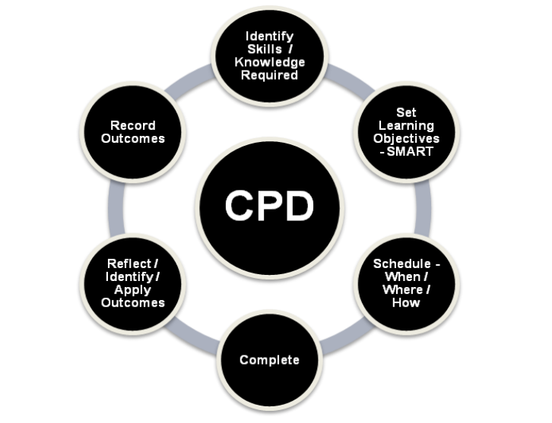
- Identify Skills / Knowledge Required
This should ideally take place during the first months of your employment and then at the end of each appraisal period or agreed timescale. This review should look at the specific knowledge that you need to review or to learn, such as certain areas in immigration or asylum law or policy that may be changing; and skills or knowledge you may need in order to take on new business or meet changing demands in relation to client needs and regulatory requirements.
a. Areas of learning and development to consider can include:
- personal values and standards such as ethics and professional conduct;
- legal knowledge and skills in immigration and asylum law;
- business management;
- working with others; and
- customer service and quality

b. Relevant Learning and Development
Learning and development must be relevant to the business and work undertaken by you and your organisation. You must be able to demonstrate relevance when asked to do so by the Commissioner.
c. What Method of Learning and Development to Choose
It is up to you, with support from your organisation, to choose how the required learning and development should be undertaken. Consideration should be given to your preferred learning method and how the desired outcomes will be met. Learning can include formal, informal and blended learning. Choose a combination that suits your learning style.
Formal Learning is when there is a set timetable, programme, aims and objectives. A qualified teacher, a confirmed date and time and specified classroom. There is also usually an end of class assessment with feedback.
Informal Learning is when there is no set timetable, programme, aims or objectives. There is no teacher, no classroom and no feedback, and in certain cases no set date or time. This can include self-study, meetings or networking.
Blended Learning is a mixture of both formal and informal learning. Learning methods could include the following but it is not an exhaustive list:-
- classroom training;
- on-line training;
- in-house training; iv. conference or meeting;
- webinar;
- review of the .GOV and Home Office website;
- reading material and blogs from reputable sources; and
- supervision, coaching and teaching.

- Obtaining Quality Learning and Development

It is strongly recommended that all learning and development should be obtained through reputable providers to ensure quality of standards and value for money. For example, formal training accredited by the CPD Standards Office is subject to a rigorous quality assessment with a focus on learning outcomes.

For informal training, you should conduct independent research to verify quality and credible content and be wary of websites such as Wikipedia and some personal blogs, as the content's accuracy cannot be guaranteed.

- Set learning and development objectives (SMART)

SMART objectives are explained in detail below. When setting your objectives you should consider your organisation’s business plan and how your skills and knowledge are linked to it. Identify the learning and development required to achieve these objectives.

For example: Your organisation has plans to raise its’ regulatory level from Level 1 to Level 2 and therefore you need to undertake training in how to lodge notice of appeal and further training to undertake the Level 2 Competence Assessment.

4. What are SMART Objectives?

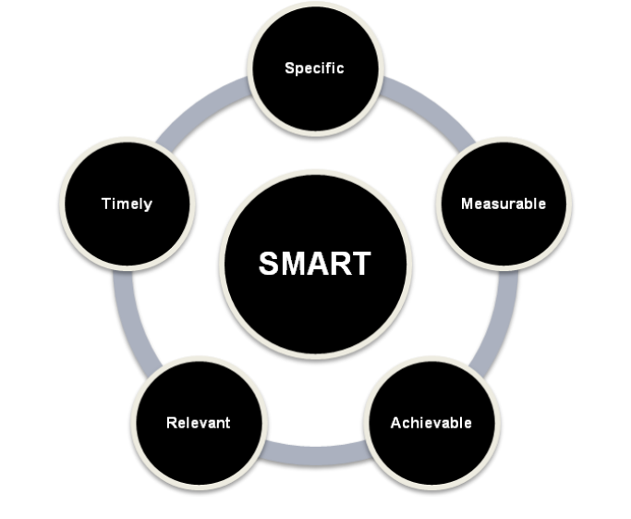

- Specific

What exactly do you want to achieve? The more specific your description, the greater the chance of achieving the objective.

Questions to consider:

- What exactly do you want to achieve?
- Where?
- How?
- When?
- With whom?
- What are the conditions and limitations?
- Why exactly do you want to reach this objective and are their alternative ways of achieving the same objective?

- Measurable
Measurable means to identify exactly what it is you need to learn and that there will be evidence of this learning to confirm that the objective has been reached.

- Achievable Is the objective achievable? Is there a reputable provider for the learning and development that has been identified? Is it achievable when consideration is given to the costs and time involved?

- Relevant

Is the learning and development identified relevant to you and the organisation? If you are lacking certain skills or knowledge, plan training to rectify this. Consider what achieving this objective will mean.

- Timely

Learning and development should take place at an appropriate time. For example, attending an immigration training course that includes the latest updates and changes coming into force. Install deadlines for the training that are realistic and flexible. Short or inappropriate deadlines can result in stress and anxiety and may even lead to cancellation of the learning.

- Schedule when / where / how

It is essential to schedule training to avoid known busy periods within your organisation and take into account when changes to the law are made or implemented. Complete a Learning and Development Plan and schedule the training. Plan in advance when to put into practice any learning completed.

- Produce a Learning and Development Plan

A Learning and Development Plan is a useful way to identify and prioritise the skills and knowledge needed in order to offer an improved service to clients and to the organisation. A template Learning and Development Plan CPD_Learning_and_Development_Plan.doc is available to download from our website if required. Evidencing a well considered completed learning and development plan is a good way of demonstrating to the Commissioner that you have thought through how you are going to maintain your competence.

- Complete Learning and Development

Complete learning and development according to the Plan and then put into practice as soon as possible any learning gained so that the knowledge is not lost.

- Produce a Learning and Development Record
Once the learning and development identified in the Plan has been undertaken, the Learning and Development Record should be completed. This includes details of what, how and when the learning and development was completed together with supporting evidence. This should be maintained for monitoring and review purposes by the organisation and the Commissioner. A template Learning and Development Record CPD_Learning_and_Development_Record.doc is available to download from the our website if required. This is another document that, when properly completed, will demonstrate to the Commissioner that CPD has been considered and the adviser is maintaining their competence.

- Reflect / Apply / Identify Outcomes of Learning and Development Undertaken

- How to Evaluate Learning and Development Undertaken

Were the SMART objectives met and have the desired outcomes been achieved? If not, what was the reason and what is the remedy to meet the objectives. Consider conducting file reviews to measure any improvements in performance.

- How to Apply Learning and Development Obtained to the Business and Casework

Utilise the learning and development that has been completed. For example by improving business processes or by taking on new responsibilities. You may feel confident following new learning and development and apply to the Commissioner for authorisation in new areas or levels of work. If it is not utilised soon after completion, learning and development will be forgotten and therefore wasted.

- Record Outcomes

Decide whether the planned outcomes were achieved by reflecting on what was learnt in each case and whether any follow-up is required. These outcomes should be noted in the Learning and Development Record

