

|  |
| --- |
| **Application Decision** |
|  |
| **by Harry Wood** |
| **Appointed by the Secretary of State for Environment, Food and Rural Affairs** |
| **Decision date: 16 May 2025** |

|  |
| --- |
| **Application Ref: COM/3349983**  **Chesil Beach, Dorset**  Register Unit Number: CL2  Commons Registration Authority: Dorset County Council |
| * The application, dated 29 July 2024, is made under Section 38 of the Commons Act 2006 (the 2006 Act) for consent to carry out restricted works on common land. * The application is made by Dorset Wildlife Trust. * The works comprise:  1. The instillation of a low roped fence measuring approximately 80m long. The fence will comprise of wooden posts measuring approximately 0.6m high above ground level. |

**Decision**

1. Consent is granted for the works in accordance with the application dated 29 July 2024 and the plans submitted with it subject to the following conditions:
2. the works shall begin no later than three years from the date of this decision;

REASON: To provide certainty to users of Chesil Beach.

1. the land shall be fully reinstated within one month from the completion of the works (note that this does not apply to any physical changes or permanent features introduced as part of the works for which consent is granted);

REASON: To retain access for commoners, public and livestock across Chesil Beach.

1. The fencing shall be removed and the land shall be fully reinstated within ten years from the date of this decision;

REASON: To review the need for the fencing to remain in place.

1. For the purposes of identification only the location of the works is shown in red on the attached plan.

**Preliminary Matters**

1. I have had regard to Defra’s Common Land Consents Policy Guidance (November 2015) in determining this application under section 38, which has been published for the guidance of both the Planning Inspectorate and applicants. However, every application will be considered on its merits and a determination will depart from the guidance if it appears appropriate to do so. In such cases, the decision will explain why it has departed from the guidance.
2. This application has been determined solely on the basis of written evidence. I have taken account of the representations made by the Open Spaces Society (OSS) and Natural England (NE).
3. I am required by section 39 of the 2006 Act to have regard to the following in determining this application:
4. the interests of persons having rights in relation to, or occupying, the land (and in particular persons exercising rights of common over it);
5. the interests of the neighbourhood;
6. the public interest; Section 39(2) of the 2006 Act provides that the public interest includes the public interest in; nature conservation; the conservation of the landscape; the protection of public rights of access to any area of land; and the protection of archaeological remains and features of historic interest;
7. any other matter considered to be relevant.

**Reasons**

1. The applicant explains that Chesil Beach forms part of the Chesil and Fleet SSSI and that a study completed in 2019 has shown the detrimental impact of recreational activities in the area. The fencing is planned to help reduce disturbances to sensitive areas of the nature reserve.

***The interests of those occupying or having rights over the land***

1. The Crown Estate are the owners of the land and have not provided comment on the application. The Common land register records multiple rights of pasture over the Common as well as rights of turbary, piscary and estovers. There are also rights to dig and remove stones and pebble and to gather fuel clots from cow dung on the Common.
2. I am satisfied that the applicant has carried out the required consultation and no further comments were received and the planned works would not interfere with the interest of those occupying or having rights over the land.

***The interests of the*** ***neighbourhood and public access***

1. The interests of the neighbourhood relate to whether the works will unacceptably interfere with the way the common land is used by local people and is closely linked with interests of public access.
2. The Common land at Chesil Beach is a stretch of land running along the south coast of the UK in Dorset between Weymouth and Fortuneswell near the Isle of Portland. The application area is for a small 80m stretch of land the applicant has identified as being at risk.
3. The applicant explains that the proposed rope fencing will consist of wooden posts and rope connecting the posts. This will introduce a new impediment to access to the Common and impact people’s access to the Common by introduction of a new barrier. However, the impact will be minimal when considering the overall size of the Common, which will also remain accessible via other routes.
4. Overall, I do not believe the works as planned would create any unacceptable impediment to people’s access to and across the Common.
5. I am of the view that this area of Common land has recreational value as an open area of space for walking and for open air activities, as well as a location with a high landscape value along the coastline. The aim of these works is linked with protecting a section of the beach from the effects of recreational walking and other activities and although this would restrict the above uses of the Common in this area, I do not believe the implementation of these works would interfere with the way the Common is currently used overall.
6. NE have been consulted on the application and stated that “We anticipate that the type of fencing proposed will have a very low level of impact on the landscape and in view of the benefits to the site’s conservation status Natural England are supportive of the proposals.”
7. In conclusion, I believe the works will have a minimal impact on people’s ability to access the Common or to the recreational value of the Common.

***The public interest***

1. As well as having regard to the public interest in the protection of public rights of access, I must also have regard to the public interest in nature conservation, the conservation of the landscape and the protection of archaeological remains and features of historic interest.

***Nature conservation and conservation of the landscape***

1. NE have stated that they are “of the opinion that that over time there will be benefits to nature conservation due to a reduction in the main recreational impacts which affect the sites SAC, SPA, Ramsar and SSSI status”. NE suggest that the consent be limited to 10 years so the benefits of the fencing can be recorded and reviewed. This is a sensible and proportionate proposal, and I have included a condition to this effect. If the applicant wishes this scheme to be extended beyond the 10 year period, then it would be necessary for them to submit another section 38 application within an appropriate timeframe.
2. The proposed works within this application are permanent in nature and will introduce a new permanent artificial feature onto the Common for the duration of the consent. However, the materials used are mostly natural and will be in keeping with the wider visuals of the Common. They are also only being used in a small area of the Common and overall will have a minimal impact on its landscape value. The impact of the fencing will also be reviewed after a 10 year period.
3. I am of the view that the works will not negatively impact on nature conservation interests of the Common or impact the landscape interests of the Common.

***Protection of archaeological remains and features of historic interest.***

1. Historic England have been consulted on the application and have not commented.
2. There is no evidence before me to suggest that these interests will be harmed by the proposed works if the above conditions are applied by the applicant.

***Conclusion***

1. In this case I conclude that the works will not introduce an unacceptable barrier to public access to the Common and the works will not seriously harm the other interests set out in paragraph 5 above. Consent for the works is therefore granted subject to the conditions set out at paragraph 1 above.

Harry Wood

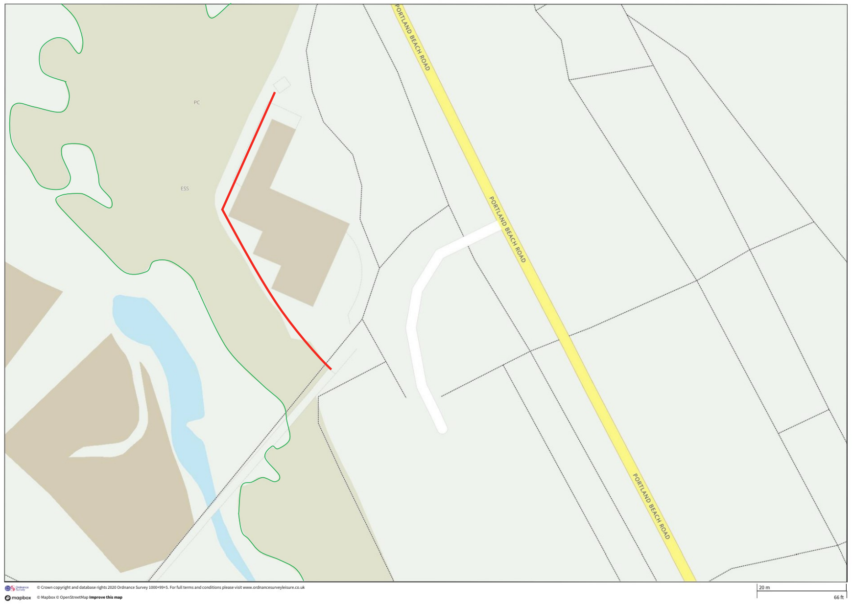Plan1 – Location of the fence on the Common