

|  |
| --- |
| **Application Decision** |
| Site visit made on 31 October 2024 |
| **by Paul Freer BA (Hons) LLM PhD MRTPI** |
| **an Inspector appointed by the Secretary of State for Environment, Food and Rural Affairs** |
| **Decision date: 14 May 2025** |

|  |
| --- |
| **COM/3336312**  **Yateley Common, Yateley GU46 6BE** |
| Register Unit: CL24 |
| Registration Authority: Hampshire County Council |
| * The application, dated 21 December 2023, is made under Section 16 of the Commons Act 2006 (“the 2006 Act”) to deregister and exchange common land. * The application is made by Falcon Propco 4 Ltd. * The release land comprises a total of 142,854 m² within the operational boundary of Blackbushe Airport, Camberley, Surrey GU17 9LQ. * The replacement land comprises 142,854 m² of land at Cobbetts Lane, Yateley GU46 6AT.  |  | | --- | |  | |

**Decision**

1. Consent is granted and an Order of Exchange given in accordance with the application dated 21 December 2023, to deregister and exchange common land at Blackbushe Airport, Camberley, Surrey GU17 9LQ. As part of the Order of Exchange a copy of the application plans showing the areas for deregistration and exchange are attached to these decision.

**Preliminary matters**

1. Section 16(1) of the Commons Act 2006 (‘the 2006 Act’) provides, amongst other things, that the owner of any land registered as Common Land may apply for the land (‘the release land’) to cease to be so registered. If the area of the release land is greater than 200m² a proposal must be made to replace it with other land to be registered as Common Land (‘the replacement land’). However, even if the land to be deregistered is not more than 200m² the Secretary of State will usually expect land to be offered in exchange for the land being deregistered so that stock of Common Land will not diminish.
2. I carried out an inspection of the release land and the exchange land on Thursday 31 October 2024 in the company of representatives of the applicants, Yateley Town Council and the Yateley Society, and as well as other interested individuals.
3. Following advertisement of the applications, a total of 229 representations were received.
4. The applications have been determined on the basis of the written evidence and my own observations of the sites and surroundings.

**Main Issues**

1. I am required by sections 16(6) and 39(1) of the 2006 Act to have regard to the following in determining these applications:

(a) the interests of persons having rights in relation to, or occupying, the land

(and in particular persons exercising rights of common over it);

(b) the interests of the neighbourhood;

(c) the public interest, including the public interest in nature conservation; the conservation of the landscape; the protection of public rights of access to any area of land; and the protection of archaeological remains and features of historic interest; and

(d) any other matter considered to be relevant.

1. In considering these tests, regard should be given to the Department for Environment, Food and Rural Affairs Common Land Consents Policy of November 2015 (“the Consents Policy”) which has been published for the guidance of both the Planning Inspectorate and applicants.

***The application***

1. The Release Land currently forms part of the operational licensed area of Blackbushe Airport. The applicants are seeking to deregister the Release Land in order to facilitate improvement works to develop the airport as a general aviation centre of excellence. The applicant explains that the current airport facilities are past their intended lifespan, are not energy efficient and are becoming increasingly difficult to maintain. The applicant goes on to explain that there is currently little provision for the hangarage of aircraft, such that most aircraft are parked in the open and consequently exposed to corrosion.
2. Blackbushe Airport has set out a vision for the airport’s future, which includes a new terminal, café and function space, as well as new facilities for the flying schools based on the airport and the airport support services. Hangarage and office space would also be provided to support the needs of general aviation businesses and aircraft operators.
3. I have been provided with a copy of the Masterplan All Phases, which shows the potential location of these proposed facilities. For the avoidance of doubt, the planning merits of the proposed development of the airport are not before me and I make no comment on them. In the event that a planning application is submitted for the development of the airport, consideration would then be given by the Local Planning Authority to all relevant matters, including to any impact upon the Thames Basin Heaths Special Protection Area (TBHSPA), the Site of Special Scientific Interest (SSSI) and the Castle Bottom National Nature Reserve (CBNNR). The need or otherwise for an Environmental Impact Assessment would also be considered at that time.
4. Purely as a matter of principle, I reject entirely the suggestion made in some representations that planning permission will never be granted for the expansion of Blackbushe Airport, including for reasons relating to climate change. It is a fundamental principle of planning control that each development must be considered on its own merits. Therefore, whilst I make no comments on the proposal as shown on the Masterplan All Phases, I cannot discount the possibility that planning permission for the development of Blackbushe Airport could be granted on its own merits at some point. It follows that as a matter of principle the application to exchange the land is not futile.
5. I am, however, mindful that at this time no planning permission is in place for development of the airport. I also recognise that there can be no guarantee that such planning permission will be forthcoming. It follows that, at this time, there are no tangible benefits arising from the development that is envisaged at the airport. Similarly, pending the determination of any such application by the Local Planning Authority, there are no harms associated with the proposed development of the airport. For present purposes, I must therefore treat the proposed development of the airport as being neutral in terms of its planning merits. Nevertheless, the Vision Document and the Masterplan All Phases provide helpful background to this application to deregister land within the operational licensed area of Blackbushe Airport.

**Reasons**

1. Under this heading I propose to examine whether the exchange land that is offered is at least equally advantageous to the interests set out in section 16(6) of the 2006 Act.

***The interests of those occupying or having rights over the land***

1. There are 23 rights of common entries within the register of common for CL24. These rights include grazing rights for cattle, sheep, pigs, ponies, donkeys and horses, as well as cutting and taking turf and peat; digging and taking gravel and sand; and cutting and taking sapling trees, bracken, heather, gorse and deadwood.
2. The release land forms part of an operational airport. Access to a licensed aerodrome is restricted by the Air Navigation Order 2016 which, through the Civil Aviation Act 1982, makes trespass upon it a criminal offence. These restrictions effectively prevent any commoners with rights of common from exercising those rights.
3. The rights within the register of common for CL24 would all be available to commoners holding those rights in relation to the Replacement Land. Those holding rights live relatively close to the Replacement Land, in some cases closer than the Release Land. I am therefore satisfied that, looked at in the round, the interests of those having rights over the land are not adversely affected by the proposals.

***The interests of the neighbourhood***

1. The settlements of Yateley and Blackwater are the closest to the Release Land and the Replacement land. The latter is some 700m for Yateley and some 950m from Blackwater. There is an extensive network of public rights of way that link both Yateley and Blackwater with the Replacement Land.
2. Currently, the only public right of way that crosses the release land is a Bridleway (Number 260/16/1) that runs across parts of the Release Land, before crossing the main runway of Blackbushe Airport and into the British Car Auctions (BCA) site to the northwest of the airport. This bridleway is known locally as the ‘Welsh Drive’ because it was former historic drove road. I am advised by the applicant that Blackbushe Airport accommodates the public who wish to use that route and will cease activity across the airfield to facilitate this when requested to do so, albeit I am told that such requests are rare. I am also advised that these arrangements would remain in place if a Consent Order was granted.
3. Hampshire County Council (HCC) consider that Bridleway 260/16/1 is maintainable at public expense. This is disputed by the applicant. Nevertheless, the section 16 application land includes land maintained by the Highways Authority (HA). Although the HA had not joined in with application initially, in a letter dated 3 March 2025 HCC confirmed that it has now joined in with the application.
4. The Replacement Land is not currently accessible to the public. The proposal would provide a number of public rights of way across the Replacement Land, albeit the application is silent as to what status those rights of way would have (in terms of being footpaths or bridleways). The application is, however, clear that the public rights of way would be clearly waymarked and would connect with existing public rights of way in the area.
5. I recognise that the Replacement Land is some distance from Yateley, albeit closer to Blackwater than the release land. However, in the context of recreational walking, riding and/or cycling, I do not perceive those distances as being problematic. The provision of these new rights of way, without extinguishing the existing bridleway known as the Welsh Drive (whatever its limitations), is therefore a significant benefit to the neighbourhood arising from the proposal.
6. Any benefits arising from the proposal in terms of other forms of recreation are less clear cut. The Environmental Management Plan (EMP) submitted with the application proposes the natural regeneration of the Replacement Land from grazed paddocks towards a matrix of heathland, gorse and grassland. There is no provision for other forms of recreation that might require a relatively large parcel of open space. Nevertheless, to the extent that the proposal would provide new public access to an environment potentially rich in fauna and flora, I conclude overall that the proposal would be in the interest of the neighbourhood.

***The public interest***

*The conservation of the landscape*

1. The Release Land currently forms part of an operational airfield. Irrespective of whether the development of Blackbushe Airport is ultimately approved or not, the Release Land will remain part of an operational airfield. Consequently, it is unlikely that there would be a significant change to the landscape, which would therefore be conserved.
2. The same cannot be said in relation to the Replacement Land. The applicant explains that the EMP has been developed with the goal of ensuring that the Replacement Land will provide an extension to the habitats located within the TBHSPA. The EMP focuses on the natural regeneration of the Replacement Land from grazed paddocks towards a matrix of heathland, gorse and grassland after the cessation of grazing.
3. The Replacement Land is currently used as a series of paddocks associated with the livery at Cottage Farm. The land is relatively flat and is mostly improved grassland, with the grass being deliberately kept short. The individual paddocks are defined by post and rail fencing but the low height and open design of the fencing permits wide-ranging views across the land. As a result, the land has a very open feel to it, only being enclosed by the trees that line the perimeter. Overall, the Replacement Land currently has an overtly man-made character and appearance commensurate with the use in association with the livery.
4. The consequence of the approach adopted in the EMP is that there would be a gradual, but eventually wholescale, change in the landscape of the Replacement Land to a matrix of heathland, gorse and grassland. It would then exhibit a more natural character and appearance. Furthermore, it is likely that views across the replacement land would then be truncated by vegetation. Taking into account the totality of these changes, the character and appearance of the land would be very different to what it is now.
5. Section 16(6) of the Commons Act 2006 provides that, in determining applications for exchanges and works one of the matters that needs to be considered is ‘public interest’. The Consents Policy defines public interest as including the *conservation* of the landscape (emphasis added). The Oxford English Dictionary defines ‘conserve’ as the protection from harm or destruction. The wholescale and fundamental change that would occur as a result of the implementation of the EMP would result in the destruction of, or at the very least harm to, the existing landscape of the replacement land. Accordingly, the landscape of the Replacement Land would not be conserved. For that reason, notwithstanding any benefits that might accrue from the proposal, it would not accord with the Consents Policy in this respect although I recognise that the proposals would conserve the landscape of the existing common land.

*Nature conservation*

1. Natural England (NE) raises no objection to the release land being deregistered.
2. The Replacement Land does not form part of the adjacent THBSPA or the SSSI. The TBHSPA comprises a range of remnant heathland and associated habitats located across Berkshire, Hampshire and Surrey. The TBHSPA is designated under Article 4.1 of the Birds Directive (2009/147/EC) as supporting populations of European importance as listed in Annex 1 of the Directive. The identified species present in the TBHSPA, referred to as “Interest Feature Birds”, are Dartford Warbler, Nightjar and Woodlark. The Conservation Objectives for the THBSPA published by Natural England in 2019 seek to ensure that the site (i.e. the THBSPA as a whole) contributes to achieving the aims of the Wild Birds Directive by, amongst other things, maintaining or restoring the extent and distribution of the habitats of the qualifying features.
3. The focus in the EMP on the natural regeneration of the Replacement Land from grazed paddocks towards a matrix of heathland, gorse and grassland after the cessation of grazing would increase the amount of habitat that would be suitable for the Interest Feature Birds. On that basis, NE concludes that the overall biodiversity value of the common would be improved/enhanced and that nature conservation benefits would accrue from the exchange.

*The protection of archaeological remains and features of historic interest*

1. Historic England (HE) have not commented on the application. It is suggested in some representations that there is the possibility of some archaeological remains dating from the First and Second World Wars being found beneath the Release Land. However, the Hampshire Historic Environment Record does not contain any entries in relation to the Release Land itself. Consequently, on the evidence available to me, there is no indication that any archaeological remains would be lost or damaged as a result of the proposed land swap itself or any works directly associated with that.
2. The Yateley Society point out that the field system at Cottage Farm is the last surviving example in the area of the ancient field system that arose from the practice of ‘assarting’: the clearing of a piece of land of trees to enable cultivation. The Yateley Society go on to point out that the historic field system at Cottage Farm is divided by a system of ancient lanes that run from the Welsh Drive at its junction with Lomer’s Lane. It is therefore the view of the Yateley Society, supported by the Hampshire County Archaeologist, that the ancient field system at Cottage Farm is inexorably linked with the system of ancient lanes in the area.
3. As a consequence of the natural regeneration from grazed paddocks towards a matrix of heathland, gorse and grassland, the landscape of the replacement land would change significantly. The historical association of the replacement land with the ancient field system of Cottage Farm and the practice of assarting would be gradually eroded and ultimately lost entirely. It would then become indistinct from the surrounding common. That would diminish the association of the feature of historic interest (i.e the boundary feature of medieval ditches and mounds) with the that the ancient field system and the system of ancient lanes in the area. This would then relate to the way in which the historic feature would be experienced.
4. It is, however, notable that although the internal structure of the fields at Cottage Farm has been lost over the years, the medieval perimeter survives. The transfer of the replacement land to common land would not alter that. The historically important boundary enclosed by medieval ditches and mounds would remain unaltered, such that the boundary of the assarted land as a whole would still be apparent. The important relationship between the historical feature and the surrounding system of ancient lanes would therefore also remain apparent. The Yateley Society also accepts that the distinctive curved corners of the fields, which is a characteristic of the assarted field system, is still apparent from outside of the replacement land.
5. The applicant has suggested that information boards could be installed on the replacement land describing the ancient field system and the practice of assarting. The installation of information boards would enhance the understanding of the historical feature and its relationship to the surrounding landscape, and to some extent would compensate for erosion of the relationship of the historic feature to the landscape. That would be benefit arising from the proposal which could be secured through a condition.
6. The Consent Policy is expressed in terms of the ‘protection’ of the historical feature. The OED defines ‘protection’ as the action or state of being protected, and ‘protect’ as keeping safe from harm or injury. In that content, I am mindful that whilst the relationship of the historic feature would be eroded, the historic feature itself would not be affected by the proposals in the EMP and would remain intact. On balance, I consider that this feature of historic interest would be protected in the terms of the Consents Policy.

*The protection of public rights of access to any area of land*

1. Concern is expressed in representations that access to the bridleway known locally as the ‘Welsh Drive’ needs to be addressed concurrently with this application to release the land from its Common Land status. However, the diversion of that Bridleway (assuming that is the preferred solution) would be an entirely separate process to this application and has no bearing on the matter that is before me.
2. As it currently stands, the removal of the Release Land from the register of Common Land would have no impact on the availability and/or use of the Welsh Drive or any other public right of way. On the other hand, the Replacement Land would bring with it the opening up of new footpaths (at least) in an area to which the public currently has no access. Moreover, the replacement land would be linked by new signposted footpaths to other public rights of way and with land to which the public already has access. Consequently, the proposal before me would result in no loss of public rights of access but would result in new rights of access being created. That is a significant benefit arising from the proposal.

**Other matters considered to be relevant**

1. The Consents Policy makes it clear that the Secretary of State’s primary objective in determining applications under section 16(1) is to ensure the adequacy of the exchange of land in terms of the statutory criteria. Therefore, even where an applicant makes an otherwise compelling case for an exchange, the Secretary of State’s expectation will be that the interests (notably the landowner, commoners, and the wider public) will be no worse off in consequence of the exchange than without it, having regard to the objectives set out above. The expectation is more likely to be realised where the replacement land is at least equal in area to the release land, and equally advantageous to the interests. I must evaluate the exchange in terms of both quality and quantity. The Consents Policy indicates that an inadequate exchange will seldom be satisfactory, whatever the merits of the case for deregistration might otherwise be.
2. In quantitative terms, the application proposes the release of 142,854 m² of CL24, all within the operational boundary of Blackbushe Airport. The area of the proposed replacement land is variously measured as 143,580 m² (taken from OS/Land Registry data) or 142, 850 m² (as surveyed in May 2022). This excludes the area between the two boundary fences and therefore in practice the area of the proposed Replacement Land may slightly exceed those figures. In any event, the area of the proposed replacement land either equates to a small net gain in the area of common land or is essentially a like-for-like replacement. Either way, this accords with the expectation in the Consents Policy of the replacement land being at least equal in area to the release land.
3. In qualitative terms, the proposed replacement land is currently all used as pasture for the gazing of horses in connection with the livery at Cottage Farm. There would be a fundamental change in the character and appearance of the Replacement Land, and possibly in the character of the use of that land. Nonetheless, the replacement land would provide new opportunities for public access albeit in the evidence before me that is likely to be confined to recreational walking. In qualitative terms, it is likely that the Replacement Land would exceed the expectation in the Consents Policy of being at least equal to that of the Release Land.
4. It is suggested in some representations that the use of the replacement land proposed by the applicants would constitute a material change of use of that land. It is no part of my remit to determine whether the use of the Replacement Land would constitute a material change of use of that land for the purposes of the Town and Country Planning Act 1990 (the 1990 Act) and I have no authority to do so under this process. That would be a matter for the Local Planning Authority in the first instance. The value of the Replacement Land in qualitative terms is, however, an important consideration in the applications that are before me. The lawful planning use of the replacement land, and any benefits that might accrue from such a use, are significant factors in that.
5. The applicant explains there is no extant planning permission specifically for the Replacement Land itself. That may be so but I understand that the use of the paddocks currently on the Replacement Land is subject to planning permissions relating to the livery at Cottage Farm. I understand that these planning permissions are subject to conditions, including a tie to equine use. The applicant has not explained how (if at all) these permissions might affect the use of the replacement land as set out in the EMP.
6. Moreover, the application itself stops short of indicating what the lawful planning use of the Replacement Land would be. In that respect, apart from reference to the occasional grazing of animals by commoners with rights to do so, the application is silent on how the land would be used and the character of that use. Consequently, I am not in a position to make an informed judgment as to whether, as a matter of fact and degree, the proposals set out in the EMP would result in some significant difference in the character of the activities from what has gone on previously.
7. The applicant has subsequently indicated that measures included in the EMP which will allow the Replacement Land to return to its natural state are not measures which involve development, either operational development or a material change of use of the land within the meaning of section 55 of the 1990 Act.  In particular, the applicant notes that section 55(2) of that Act excludes ‘the use of any land for the purposes of agriculture’ from the meaning of development under section 55 of the 1990 Act. On that basis, the applicant does not consider that a separate planning permission is required for the Replacement Land to enable the land to return to its natural state and be used as common land, a use which the applicant considers falls within the wide definition of agriculture.
8. I have great difficulty in reconciling the approach adopted in the EMP with the land being used for agriculture, as defined in section 336 of the 1990 Act. At the very most, once the proposals in the EMP become fully established, only small pockets of that land (the grassland) would be suitable for agricultural use. Even then, they would only be suitable for use as grazing land. In the absence of further details, it seems to me that simply allowing the Replacement Land to return to its natural state would not encompass any of the definitions of agriculture set out at section 336 of the 1990 Act. I reiterate that I am not making any formal determination on that point but, for present purposes, I am not in a position to assess what benefits, if any, would accrue from the use of the Replacement Land for agriculture.
9. All that being said, for present purposes it is sufficient to note that the lawful planning use of the replacement land remains undetermined. In applications under section 16 of the 2006 Act it is often the case that either the planning permission comes first or the commons application come first. It is the responsibility of the landowner (in this case, Cottage Farm Holdings Ltd) to ensure that all the necessary consents and permissions are in place before the measures in the EMP are implemented. That includes obtaining planning permission for the use of the Replacement Land if such is required, and the potential implications of entering into a section 106 Agreement to implement the EMP in the event that planning permission (if required) is subsequently not forthcoming for the proposals within it.

***Other matters raised in representations***

1. A number of other matters have been raised in representations, including issues surrounding the numbers and routeing of aircraft and the volume of vehicular traffic generated by the airport. There is also speculation around the future of Blackbushe Airport itself, the possibility of other land uses coming forward for both the Release Land and the Replacement Land, and the potential for financial gain from the release of land from the common. The Yateley Society raises issues regarding the fire risk associated with the proposals set out in the EMP and puts forward an alternative proposal in the form of a wildflower meadow.
2. I recognise that all of these matters and others raised are of genuine concern and importance to the authors of those representations. Nevertheless, they are not matters that fall to be considered against the Consents Policy and I am therefore not able to take those matters into account.

**Conclusion**

1. The Replacement Land proposed would be of at least equal area to the Release Land and would be of greater value in terms of offering potential for recreation. There would also be some significant benefits to ecology and biodiversity. The works proposed would be in accordance with the consents policy in other respects including, on balance, that a feature of historic interest would at least be protected.
2. However, the measures in the EMP would fail to conserve the landscape of the Replacement Land. The proposal would therefore fail to meet one of the tests set out in the Consents Policy.
3. The Consents Policy indicates that every application must be considered on its merits, and that a determination may depart from the policy if it appears appropriate to do so. In my view, the significant benefits that would accrue from the proposal in terms of biodiversity and increased public access outweigh the failure to conserve the landscape that would result from the measures in the EMP. Consequently, in weighing the overall balance, I conclude that consent should be granted.

Paul Freer

INSPECTOR

**CONSENT ORDER**

1. On behalf of the Secretary of State for Environment, Food and Rural Affairs and pursuant to section 17 (1) and (2) of the Commons Act 2006, **I** **HEREBY** **ORDER** the Hampshire County Council, as Commons Registration Authority for the area in which the release land and the replacement land are situated:
   1. to remove the release land from its register of common land, by amending register unit CL 24 to exclude the release land;
   2. to register the replacement land as common land, by amending the register unit CL 24 to include the replacement land; and
   3. to register as exercisable over the replacement land (in addition to remaining exercisable over the remainder of the land comprised in register unit CL24) any rights of common which, immediately before the date on which the release land is removed from the register, are registered as exercisable over the release land and the remainder of the land comprised in register unit CL24.

Supplementary Provisions

1. On behalf of the Secretary of State for Environment, Food and Rural Affairs and pursuant to section 17 (7) (b) (ii) and (8) and section 59(1) of the Commons Act 2006, **I** **FURTHER** **ORDER** that:
   1. Section 193 of the Law of Property Act 1925 (public right of access for air and exercise) shall apply irrevocably to the replacement land pursuant to the Deed dated 23 January 2025 deposited by Cottage Farm Holding Ltd (as the Owner of the replacement land) and the Commons Registration Authority shall enter a note of the irrevocable application of the right to the replacement land in the land section of the register; and
   2. Cottage Farm Holding Ltd shall remove the fences demarcated on Drawing C attached to this consent order from the replacement land in accordance with the Section 106 Agreement between Cottage Farm Holding Ltd to Hampshire County Council, dated 23 January 2025.
   3. Within three months of the date of this Consent Order, Cottage Farm Holding Ltd shall submit to Hampshire County Council details of information boards to be placed on the replacement land describing the ancient field system and the practice of assarting. The information boards shall then be placed on the replacement land in accordance with the locations, specification, details and timing agreed with Hampshire County Council, and shall thereafter be retained on the land unless otherwise agreed in writing by Hampshire County Council.

**First Schedule** – the release land

|  |  |  |
| --- | --- | --- |
| **Colour On**  **Plan** | **Description** | **Extent** |
| Edged in red on Drawing A | Land located adjacent to the southern  boundary of Blackbushe Airport,  Camberley, Surrey GU17 9LQ. | 142,854 m2 |

**Second Schedule** – the replacement land

|  |  |  |
| --- | --- | --- |
| **Colour On Plan** | **Description** | **Extent** |
| Edged in green  on Drawing B | Land located at Cottage Farm, Cobbetts  Lane, Yateley, GU46 6AT. | 142,854  m2 |

Drawing A – Release Land (Not to scale)

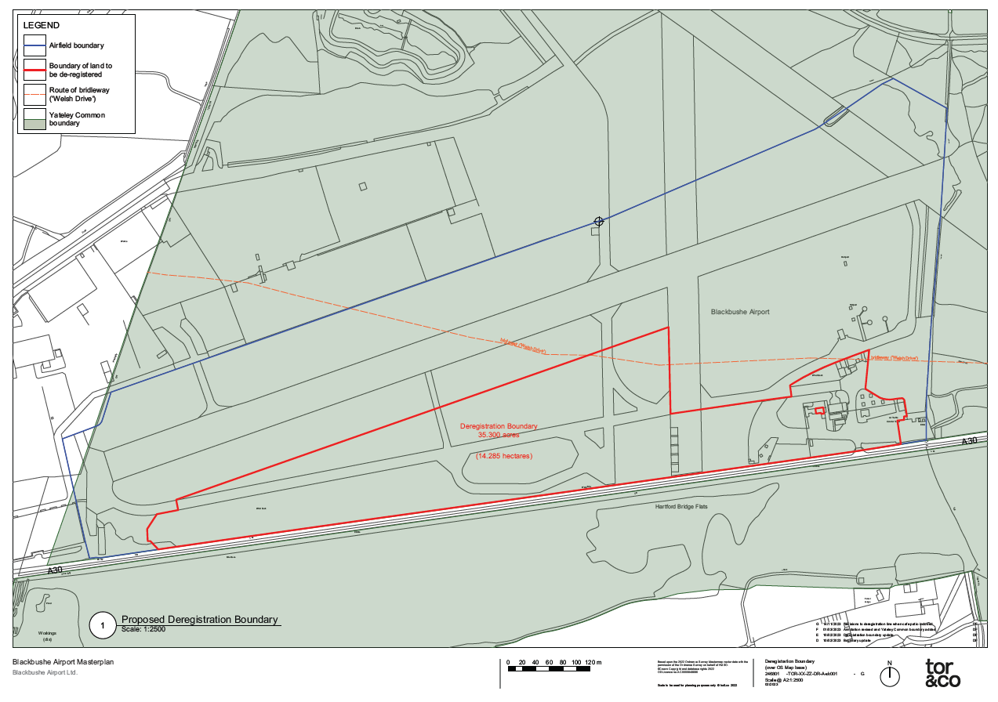

Drawing B – Replacement Land (Not to scale)

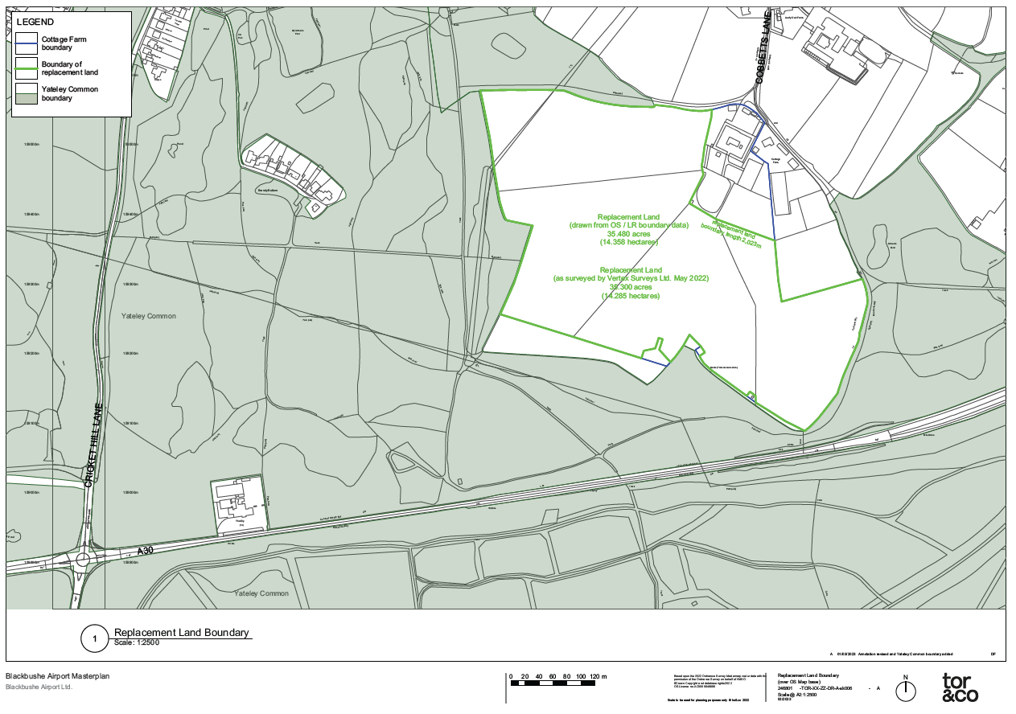

g

Drawing C – Replacement Land Proposed Works (Not to scale)

