|  |
| --- |
| **liverpool bay asset**    **PARTIAL decommissioning programmeS** |

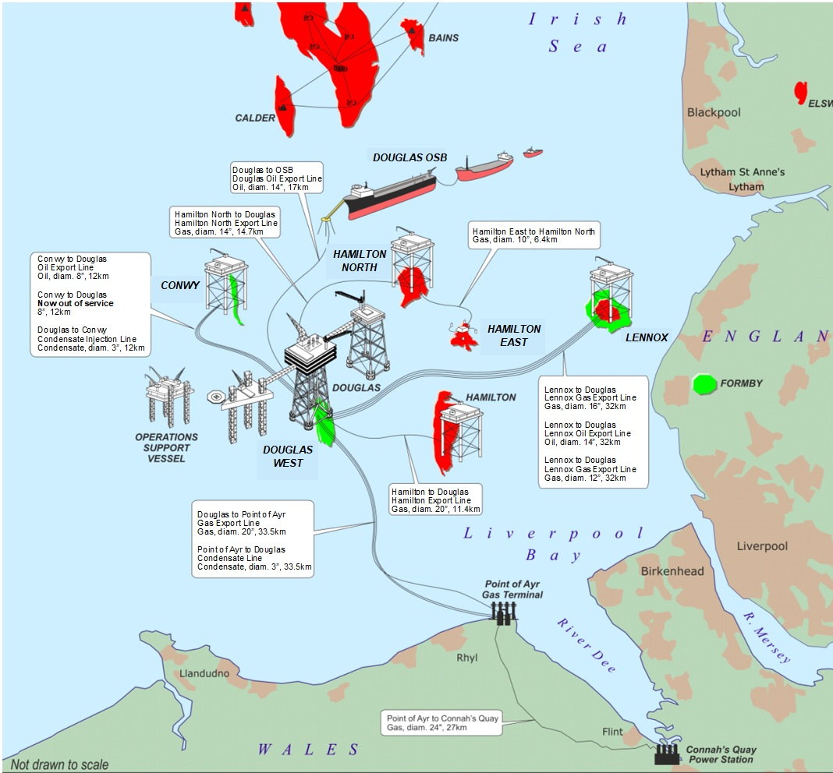

**Final**

**9 April 2025**

**Document Verification**

|  |  |  |
| --- | --- | --- |
|  | **Name** | **Date** |
| Prepared by | EPUK Project Team | 09/04/2025 |
| Reviewed by | Eni UK Project Manager | 09/04/2025 |
| Approved by | Eni UK General Manager | 09/04/2025 |

**Revision History**

|  |  |  |  |
| --- | --- | --- | --- |
| **Rev.** | **Date** | **Nr. of sheets** | **Description** |
| 00 | 02/12/2022 | 68 | Pre-Draft submission for discussion with BEIS (OPRED) |
| 01 | 20/10/2023 | 67 | Revised LBA CCS Project Concept – newbuild NUI at Douglas |
| 02 | 12/02/2024 | 80 | Updated to address OPRED comments of 18/12/2023 |
| 03 | 25/03/2024 | 79 | Updated to address OPRED comments of 05/03/2024 |
| 04 | 26/04/2024 | 80 | Updated to address OPRED comments of 03/04/2024 |
| 05 | 21/06/2024 | 82 | Updated to address OPRED comments of 17/05/2024 |
| 06 | 09/07/2024 | 83 | Updated to address OPRED comments of 26/06/2024 |
| 07 | 12/07/2024 | 83 | Updated to address OPRED comments of 12/07/2024 |
| 08 | 13/03/2025 | 84 | To address OPRED comments of 21/01/2025 and 05/03/2025 |
| 09 | 14/03/2025 | 83 | To address OPRED comments of 14/03/2025 |
| 10 | 19/03/2025 | 83 | To address OPRED comments of 17/03/2025 |
| 11 | 09/04/2025 | 85 | Final |

**Distribution List**

|  |  |  |
| --- | --- | --- |
| **Name/Addressee** | **Organization** | **No of Copies** |
| ODU OPRED | DESNZ | 1 |

**Hold Record**

|  |  |  |  |
| --- | --- | --- | --- |
| **HOLD** | **Sheet** | **Section** | **Description** |
|  |  |  |  |
|  |  |  | . |

**Table of Contents**

|  |  |  |
| --- | --- | --- |
| INST = Installations; P/L = Pipelines | **INST** | **P/L** |
| 1. **EXECUTIVE SUMMARY 10**    1. PARTIAL DECOMMISSIONING PROGRAMMES SCOPE 10    2. REQUIREMENT FOR A DECOMMISSIONING PROGRAMMES 12    3. INTRODUCTION 13    4. OVERVIEW OF INSTALLATIONS BEING DECOMMISSIONED 15    5. SUMMARY OF PROPOSED DECOMMISSIONING SOLUTIONS 21    6. FIELD LOCATION INCLUDING FIELD LAYOUT AND ADJACENT FACILITIES 24    7. INDUSTRIAL IMPLICATIONS 28 2. **DESCRIPTION OF ITEMS TO BE DECOMMISSIONED 29**    1. INSTALLATION(S): SURFACE FACILITIES 29    2. PIPELINES AND STABILISATION FEATURES 33    3. WELLS 38    4. DRILL CUTTINGS 42    5. INVENTORY ESTIMATES 43 3. **REMOVAL AND DISPOSAL METHODS 47**    1. WASTE HIERARCHY AND PRINCIPLES 47    2. TOPSIDES 48    3. PIPELINES STABILISATION FEATURES 53    4. WELLS – P&A 66    5. DRILL CUTTINGS DECOMMISSIONING OPTIONS 66    6. WASTE STREAMS 67 4. **ENVIRONMENTAL APPRAISAL 69**    1. ENVIRONMENTAL SENSITIVITIES 69    2. POTENTIAL ENVIRONMENTAL IMPACTS AND THEIR MANAGEMENT 73 5. **INTERESTED PARTY CONSULTATIONS 76** 6. **PROGRAMME MANAGEMENT 78**    1. PROJECT MANAGEMENT AND VERIFICATION 78    2. POST-DECOMMISSIONING DEBRIS CLEARANCE AND VERIFICATION 78    3. SCHEDULE 78    4. COSTS 79    5. CLOSE OUT 79    6. POST-DECOMMISSIONING MONITORING AND EVALUATION 79 7. **SUPPORTING DOCUMENTS 80** 8. **SECTION 29 NOTICE HOLDER LETTERS OF SUPPORT** **81**   **APPENDIX A PUBLIC NOTICE 84**  **APPENDIX B PIPELINE CUT POINT COORDINATES……………………………………….85** | **✓**  **✓**  **✓**  **✓**  **✓**  **✓**  **✓**  **✓**  **✓**  **✓**  **✓**  **✓**  **✓**  **✓**  **✓**  **✓**  **✓**  **✓**  **✓**  **✓**  **✓**  **✓**  **✓**  **✓**  **✓**  **✓**  **✓**  **✓**  **✓**  **✓**  **✓**  **✓**  **✓**  **✓**  **✓** | **✓**  **✓**  **✓**  **✓**  **✓**  **✓** |

**Terms and Abbreviations**

|  |  |
| --- | --- |
| **Abbreviation** | **Explanation** |
| BEIS | Department for Business, Energy & Industrial Strategy |
| CALRAM | Catenary Anchor Leg Rigid Arm Mooring |
| CAF | Compressed Asbestos Fibre |
| CCS | Carbon, Capture and Storage |
| CDM | Construction (Design and Management) Regulations |
| CoP | Cessation of Production |
| COT | Cargo Oil Tank |
| CY | Conwy Platform |
| DA | Douglas Accommodation Platform |
| DESNZ | Department for Energy Security and Net Zero |
| DP | Douglas Production Platform |
| DW | Douglas Wellhead Platform |
| EA | Environmental Appraisal |
| E&I | Electrical and instrumentation |
| EMT | Environmental Management Team |
| Eng | Engineering |
| Eni UK | Eni UK Limited: the Section 29 Holder |
| Eni ULX | Eni ULX Limited: the Section 29 Holder |
| EPRD | Engineering, Preparation, Removal and Disposal |
| EU | European Union |
| EUNIS | European Nature Information System |
| EWC | European Waste Codes |
| FEM | Finite Element Model |
| FMS | Facilities Making Safe |
| GMS | Global Marine Systems |
| HC | Hydrocarbon |
| HE | Hamilton East (Subsea Well) |
| HH | Hamilton Platform |
| HN | Hamilton North Platform |
| HSE | Health Safety & Environment |
| ID | Internal Diameter |
| ISP | Irish Sea Pioneer |
| ITT | Invitation to tender |
| km | Kilometre |
| LAT | Lowest Astronomical Tide |
| LD | Lennox Platform |
| m3 | Cubic Metre |
| N/A | Not Applicable |
| NORM | Naturally Occurring Radioactive Materials |
| NPS | Nominal Pipe Size |
| NRW | Natural Resources Wales |
| NSTA | North Sea Transition Authority |
| NUI | Normally Unmanned Installation |
| ODU | Offshore Decommissioning Unit |
| OEUK | Offshore Energy UK |
| OGUK | Oil & Gas UK |
| OPF | Organic Phase Fluid |
| OPRED | Offshore Petroleum Regulator for Environment & Decommissioning |
| OSB | Oil Storage Barge |
| PLANCS | Permit, Licences, Authorisations, Notifications and Consents |
| PLEM | Pipe Line End Manifold |
| PoA | Point of Ayr |
| P&A | Plugging and Abandonment |
| PSR | Pipelines Safety Regulations |
| PWA | Pipeline Work Authorization |
| SOW | Scope of Work |
| SSI | Special Scientific Interest |
| SSBV | Subsea Barrier Valve |
| SUTU | Subsea Umbilical Termination Unit |
| Te | Metric Tonnes |
| T&S | Transportation and Storage |
| UK | United Kingdom |
| UKCS | United Kingdom Continental Shelf |
| WBT | Water Ballast Tank |
| WBM | Water-Based Mud |

**Appendices**

|  |  |  |
| --- | --- | --- |
| **Appendix** | **Description** | **Page** |
| A | Copy of Public notice | 84 |
| B | Pipeline cut point coordinates | 85 |

**List of Figures**

|  |  |  |
| --- | --- | --- |
| **Figure number** | **Description** | **Page** |
| 1-1 | Liverpool Bay Schematic - Partial Decommissioning Scope | 12 |
| 1-2 | Liverpool Bay Asset Field Location in UKCS | 24 |
| 1-3 | Liverpool Bay Asset Facilities Schematic | 25 |
| 2-1 | Hamilton (HH) Platform Overview | 30 |
| 2-2 | Hamilton North (HN) Platform Overview | 31 |
| 2-3 | Lennox (LD) Platform Overview | 32 |
| 2-4 | Subsea Barrier Valves - Dimensions and GAs | 38 |
| 2-5 | Indicative Well Sequence | 39 |
| 3-1 | Hamilton (HH) Platform - Deck Removal | 48 |
| 3-2 | Hamilton North (HN) Platform - Deck Removal | 49 |
| 3-3 | Lennox (LD) Platform - Deck Removal | 50 |
| 3-4 | Seabed Removals around Douglas Production (DP) Platform | 53 |
| 3-5 | Seabed Removals around Hamilton (HH) Platform | 54 |
| 3-6 | Seabed Removals around Hamilton North (HN) Platform | 55 |
| 3-7 | Seabed Removals around Lennox (LD) Platform | 56 |
| 4-1 | Marine and Coastal Protected Areas in the Vicinity of the LBA Assets | 72 |
| 4-2 | Offshore Windfarms, Cables and Aggregates in the LBA Project Area | 72 |
| 6-1 | Liverpool Bay Asset Execution Schedule | 78 |

**List of Tables**

|  |  |  |
| --- | --- | --- |
| **Table number** | **Description** | **Page** |
| 1-1 | Partial Decommissioning Programmes Milestones | 13 |
| 1-2 | Liverpool Bay Asset – Field Characteristics | 15 |
| 1-3 | Installation(s) and Pipeline(s) Being Decommissioned – Douglas Complex | 15 |
| 1-4 | Installation(s) and Pipeline(s) Being Decommissioned – Hamilton (HH) | 15 |
| 1-5 | Installation(s) and Pipeline(s) Being Decommissioned – Hamilton North (HN) | 16 |
| 1-6 | Installation(s) and Pipeline(s) Being Decommissioned – Lennox (LD) | 16 |
| 1-7 | Douglas Installation Section 29 Notice Holders Details | 17 |
| 1-8 | Hamilton Installation Section 29 Notice Holders | 17 |
| 1-9 | Hamilton North Installation Section 29 Notice Holders | 17 |
| 1-10 | Lennox Installation Section 29 Notice Holders | 18 |
| 1-11 | Liverpool Bay Complex (Douglas, Lennox & Hamilton fields) Pipelines Section 29 Notice Holders Details | 19 |
| 1-12 | Hamilton Pipeline Section 29 Notice Holders | 19 |
| 1-13 | Hamilton North Pipeline Section 29 Notice Holders | 19 |
| 1-14 | Hamilton East Pipeline Section 29 Notice Holders | 20 |
| 1-15 | Lennox Pipeline Section 29 Notice Holders | 20 |
| 1-16 | Douglas Pipeline Section 29 Notice Holders | 20 |
| 1-17 | Summary of Decommissioning Solutions | 21 |
| 1-18 | Adjacent Facilities | 26 |
| 2-1 | Surface Facilities Installations | 29 |
| 2-2 | Pipelines and Stabilisation Features | 33 |
| 2-3 | SSBV Decommissioning Strategy | 37 |
| 2-4 | Wells | 40 |
| 2-5 | Hamilton HH Platform – Overall Materials Summary | 43 |
| 2-6 | Hamilton HH Platform – Topside Inventory | 43 |
| 2-7 | Hamilton North HN Platform - Overall Materials Summary | 44 |
| 2-8 | Hamilton North HN Platform – Topside Inventory | 44 |
| 2-9 | Lennox LD Platform - Overall Materials Summary | 45 |
| 2-10 | Lennox LD Platform - Topside Inventory | 45 |
| 2-11 | Pipelines and Stabilisation Features - Overall Materials Summary | 46 |
| 2-12 | Pipelines and Stabilisation Features – Inventory | 46 |
| 3-1 | Topsides Preparation and Cleaning | 51 |
| 3-2 | Satellite Platforms HH, HN and LD – Removal Methods | 52 |
| 3-3 | Pipelines and Umbilicals Removal Methods | 57 |
| 3-4 | Pipelines and Stabilisation Features Removal Methods and Disposal Routes | 64 |
| 3-5 | Well Plug and Abandonment Method | 66 |
| 3-6 | Waste Stream Management Methods | 67 |
| 3-7 | Inventory Disposition | 68 |
| 4-1 | Environmental Sensitivities | 69 |
| 4-2 | Environmental Impact Management | 73 |
| 5-1 | Summary of Stakeholder Comments | 76 |
| 6-1 | Partial Decommissioning Programmes Milestones | 79 |
| 6-2 | Provisional Decommissioning Programmes Costs | 79 |

# EXECUTIVE SUMMARY

## **Partial Decommissioning Programmes**

This document describes the scope covered by the Partial Decommissioning Programmes (PDP) to facilitate the repurposing of the Liverpool Bay Asset into a Carbon Dioxide Transportation and Storage project. This project forms part of the HyNet North West project, aimed at unlocking a low carbon economy for the North West of England and North East Wales.

The term Decommissioning Programmes, plural, has been used throughout the document for consistency, as this document is covering several Section 29 Notices (S29). The relevant installation and pipeline S29s are included below for information:

* Douglas Installation – 12.04.06.06/119C
* Hamilton Installation – 12.04.06.06/162C
* Hamilton North Installation – 12.04.06.06/164C
* Lennox Installation – 12.04.06.06/203C
* Liverpool Bay Complex (Douglas, Lennox & Hamilton fields) Pipelines - 12.04.06.05/225C
* Hamilton Pipelines – 12.04.06.05/137U (electrical power cables PL6424, PL6426)
* Hamilton North Pipeline – 12.04.06.05/138U (electrical power cable PL6423)
* Hamilton East Pipeline – 12.04.06.05/178C (PL1860, PLU1861)
* Lennox Pipelines – 12.04.06.05/141U (control umbilicals PLU6435, PLU6436, PLU6437, PLU6438)
* Douglas Pipeline – 12.04.06.05/150U (umbilical PLU6445)

Liverpool Bay Asset includes the following existing facilities:

* Douglas Complex
* Satellite Platforms (Lennox, Hamilton, Hamilton North)
* Hamilton East Subsea well
* Oil Storage Barge
* Conwy Platform
* Offshore Pipelines
* Subsea Facilities
* Onshore Pipeline
* Point of Ayr onshore Gas Plant
* Connah’s Quay Gas Reception Facility

The present Partial Decommissioning Programmes are focused on the scope of the following existing facilities only, identified as necessary for the repurposing of the Liverpool Bay Asset as part of the HyNet North West project:

* Satellite Platforms (Lennox, Hamilton, Hamilton North) – Topsides removal
* Platform wells P&A (Douglas, Douglas West, Hamilton, Hamilton North and Lennox)
* Removal of expansion spools and exposed stabilisation features (mattresses and grout bags) in the near platform area which do not meet the 0.6 meters depth of burial criterion (at Douglas, Hamilton, Hamilton North and Lennox). A table summarising the pipelines / spools section, control umbilical and cables part of the removal works is included as Table 2-2 in Section 2.2. Please note that the umbilicals are being removed in their entirety.
* Please note that the pipeline riser sections on Hamilton, Hamilton North and Lennox will remain on the jackets and will be decommissioned alongside the platforms at a later date.

Further separate Decommissioning Programmes will cover the following remaining facilities part of Liverpool Bay Asset and out of the present scope:

* Oil Storage Barge (unless alternative re-use options are found to be viable and more appropriate)
* Conwy Platform (Jacket, Topsides, Wells, and Pipelines)
* Douglas Production platform
* Douglas Accommodation platform
* Douglas Wellhead platform
* Hamilton East subsea well and integral protection structure
* Offshore Pipelines
* Umbilicals
* Flexible Lines
* Subsea valves and components

The onshore pipelines, Point of Ayr Gas Plant, and Connah’s Quay Gas Reception Facility are not subject to a decommissioning programme, as they fall out of OPRED’s remit.

The future Decommissioning Programmes (DP) envisaged are:

* **Installations DP** covering the full removal of three platform production complex of Douglas Accommodation, Douglas Process, and Douglas Wellhead, the Oil Storage Barge and Catenary Anchored Leg Mooring (CALM), and Hamilton East subsea well and protection structure. These assets are not required for the LBA CCS project.
* **Pipelines DP** covering the full decommissioning option for all pipelines (and mattresses and umbilicals) not identified for re-use. These will be subject to a full Comparative Assessment. This will include umbilicals PLU2942 (Douglas to Conwy) and PLU1861 (Hamilton North to Hamilton East).
* **Conwy DP** covering the topsides, jacket, wells, and pipelines.

The scope of the present Partial Decommissioning Programmes are represented in **Figure 1‑1**:

**Figure 1‑1 - Liverpool Bay Schematic - Partial Decommissioning Scope**

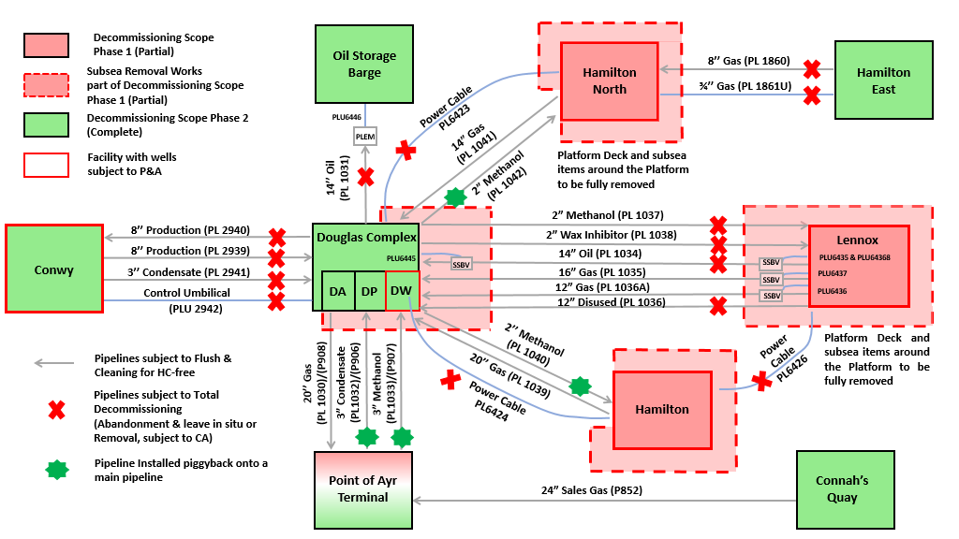

The decommissioning programmes are submitted without derogation and in compliance with OPRED guidelines.

## **Requirement for Decommissioning Programmes**

In accordance with the Petroleum Act 1998, the Section 29 notice holders of the Hamilton, Hamilton North, Lennox and Douglas Installations (Ref. to Tables 1.3, 1.4, 1.5, and 1.6) are applying to the Offshore Petroleum Regulator for Environment & Decommissioning (OPRED) to obtain approval for decommissioning the Topsides detailed in Section 1.1. Details of the relevant S29 notices are provided in Tables 1.7 to 1.10 below. (See also Section 8 – Section 29 Notice Holder Letter(s) of Support).

Also, in accordance with the Petroleum Act 1998, the Section 29 notice holders of the Hamilton, Hamilton North, Lennox and Douglas pipelines (Ref. to Tables 1.3, 1.4, 1.5, and 1.6) are applying to the Offshore Petroleum Regulator for Environment & Decommissioning (OPRED) to obtain approval for decommissioning the Pipelines detailed in Section 1.1. Details of the relevant S29 notice is provided in Tables 1.11 to 1.16 below. (See also Section 8 - Section 29 Notice Holder Letters of Support).

The scope of work described in Tables 1.3 to 1.6 includes the removal of pipelines, spools, control umbilicals and power cables in the near platform areas around Douglas, Hamilton, Hamilton North, Hamilton East and Lennox. A desktop Comparative Assessment has been prepared with the objective of demonstrating that these near Platform removals will not prejudice against the future decommissioning options for the pipelines. The pipeline removals will be the subject of a dedicated Decommissioning Programme and a full Comparative Assessment. Please note that the umbilicals are being removed in their entirety.

In conjunction with public, stakeholder, and regulatory consultation, these Decommissioning Programmes are submitted in compliance with national and international regulations and OPRED guidelines.

The schedule outlined in this document is for the Partial Decommissioning of the Liverpool Bay Asset, as described below.

The End of Gas sales (gas from offshore facilities to Point of Ayr) occurred on 30 June 2023, while the Cessation of Oil Production was on 20 December 2024.

Hamilton North Platform produced fuel gas until 30 June 2023, whilst Lennox and Hamilton Platforms continued to produce fuel gas to 20 December 2024, when oil production ceased from Douglas and Conwy.

The Decommissioning schedule outlined in this document includes both the onshore and offshore facilities subject to the Partial Decommissioning (as described in Section 1.1), as per the expected starting dates:

Onshore facilities (Point of Ayr, Connah’s Quay facilities and onshore pipeline) – 2024

Offshore facilities (Topsides and pipelines) – 2024

Currently foreseen major project milestones are provided in **Table 1‑1**:

**Table 1‑1 - Partial Decommissioning Programmes Milestones**

|  |  |
| --- | --- |
| **Milestones** | **Approx. Date** |
| Issue ITT Package for Platform Decommissioning | 2023 |
| Award Platform Decommissioning Contract | 2025 |
| Start of Platform Decommissioning Preparation Works window | 2025 |
| Satellite Platforms (LD, HH, HN) Deck Removal Window Start  (First Platform Available) | 2027 |
| Platforms Removal & Disposal Window End | 2027 |
| Platforms Decommissioning Programmes Close-Out Report Submission | 2028 |

## **Introduction**



Liverpool Bay Asset is located in the East Irish Sea, in close proximity to the Lancashire, Merseyside and North Wales coastlines:

* Hamilton - block 110/13a
* Hamilton North – block 110/13a
* Hamilton East – block 110/14a
* Lennox – blocks 110/14c and 110/15a
* Douglas and Douglas West – block 110/13b
* Conwy – block 110/12a

The Offshore Installations present in the Liverpool Bay Asset are the following:

* Douglas Complex, including a wellhead platform (DW), a central production platform (DP) and an accommodation platform (DA);
* Lennox Platform: unmanned oil and gas platform (LD);
* Hamilton Platform: unmanned oil and gas platform (HH);
* Hamilton North Platform: unmanned oil and gas platform (HN);
* Hamilton East subsea well and protection structure (HE);
* Conwy Platform: unmanned oil and gas platform (CY);

Offshore operations are centred on the Douglas complex – a three-platform facility that monitors and controls the development’s four unmanned satellite platforms at Lennox, Hamilton, Hamilton North, and Conwy

Produced oil is exported from Douglas via a sub-sea pipeline to the Oil Storage Barge, which is located 17km north of Douglas. Produced gas is exported from Douglas via a sub-sea pipeline to the onshore terminal at Point of Ayr. It is then sent by onshore pipeline to Uniper’s combined cycle gas turbine power station at Connah’s Quay.

Hamilton East field was developed by a single subsea production well with the gas exported to the Hamilton North, for onward transmission to Douglas DP, and then Point of Ayr.

A network of power cables provide power to the Satellite Platforms from Douglas Complex. Power cables are currently trenched with a natural back-fill after the installation.

## **Overview of Installations and Pipelines Being Decommissioned**

This section provides an overview of the main characteristics of the installations and pipelines covered by these Partial Decommissioning Programmes:

**Table 1‑2 – Liverpool Bay Asset – Field Characteristics**

|  |  |  |  |
| --- | --- | --- | --- |
| **Liverpool Bay Asset – Field Characteristics** | | | |
| **Field** | Liverpool Bay Asset | **Production Type** | Oil & Gas |
| **Water Depth (m)** | 7.2 to 30.5 | **Offshore UKCS blocks** | 110/13a, 110/13b, 110/14c & 110/15a |
| **Distance to median (km)** | 106 | **Distance from nearest UK Coastline (km)** | 23 |

**Table 1‑3 - Installation(s) and Pipeline(s) Being Decommissioned – Douglas Complex**

|  |  |  |  |
| --- | --- | --- | --- |
| **Surface Installation – Douglas Complex** | | | |
| Douglas Complex surface installations are not part of this Decommissioning Programme. | | | |
| **Associated Pipelines** | | **Associated Number of Wells** | |
| **Number** | **Type** | **Platform** | **Subsea** |
| 17  *(Note 1)* | Pipelines and spools Sections 13  Control Umbilical Sections 1  Power Cables Sections 2  SSBV 1 | 22  *(Note 2)* | Not applicable to this DP |

Note 1: Associated Pipelines refers to the number of pipelines approaching the Douglas Complex (ref. to Table 2-2).

Note 2: Associated Number of Wells refers to the number of wells present at Douglas Complex

**Table 1‑4 - Installation(s) and Pipeline(s) Being Decommissioned – Hamilton (HH)**

|  |  |  |  |  |
| --- | --- | --- | --- | --- |
| **Surface Installation – Hamilton (HH)** | | | | |
| **Name** | **Type** | **Water Depth**  **(relative LAT)** | **Topsides Weight (Te)** | **Jacket Weight (Te)** |
| Hamilton Platform (HH) | Fixed steel jacket | 25.8 m | 502 | 747.4 |
| **Associated Pipelines** | | | **Associated Number of Wells** | |
| **Number** | **Type** | | **Platform** | **Subsea** |
| 3  *(Note 1)* | Pipelines and Spools Sections 1  Power Cable Sections 2 | | 4  *(Note 2)* | Not applicable to this DP |

Note 1: Associated Pipelines refers to the number of pipelines approaching Hamilton (ref. to Table 2-2).

Note 2: Associated Number of Wells refers to the number of wells present at Hamilton

**Table 1‑5 - Installation(s) and Pipeline(s) Being Decommissioned – Hamilton North (HN)**

|  |  |  |  |  |
| --- | --- | --- | --- | --- |
| **Surface Installation – Hamilton North (HN)** | | | | |
| **Name** | **Type** | **Water Depth**  **(relative LAT)** | **Topsides Weight (Te)** | **Jacket Weight (Te)** |
| Hamilton North Platform (HN) | Fixed steel jacket | 22.1 m | 497 | 712.5 |
| **Associated Pipelines** | | | **Number of Wells** | |
| **Number** | **Type** | | **Platform** | **Subsea** |
| 3  *(Note 1)* | Pipelines and Spools Sections 1  Flexible Line Sections 1  Power Cable Sections 1 | | 3  *(Note 2)* | Not applicable to this DP |

Note 1: Associated Pipelines refers to the number of pipelines approaching Hamilton North (ref. to Table 2-2).

Note 2: Associated Number of Wells refers to the number of wells present at Hamilton North

**Table 1‑6 - Installation(s) and Pipeline(s) Being Decommissioned – Lennox (LD)**

|  |  |  |  |  |
| --- | --- | --- | --- | --- |
| **Surface Installation – Lennox Platform (LD)** | | | | |
| **Name** | **Type** | **Water Depth**  **(relative LAT)** | **Topsides Weight (Te)** | **Jacket Weight (Te)** |
| Lennox Platform (LD) | Fixed steel jacket | 7.2 m | 1,194 | 451.4 |
| **Associated Pipelines** | | | **Number of Wells** | |
| **Number** | **Type** | | **Platform** | **Subsea** |
| 12  *(Note 1)* | Pipelines and Spools Sections 4  Control Umbilical Sections 4  Power Cable Sections 1  SSBV 3 | | 13  *(Note 2)* | Not applicable to this DP |

Note 1: Associated Pipelines refers to the number of pipelines approaching Lennox (ref. to Table 2-2).

Note 2: Associated Number of Wells refers to the number of wells present at Lennox

**Table 1‑7 – Douglas Section 29 Notice Holders Details**

|  |  |  |
| --- | --- | --- |
| **Douglas Installation Section 29 Notice Holders Details** | | |
| OPRED Ref: 12.04.06.06/119C, UKOP Doc Ref:1164914 | | |
| **Section 29 Notice Holder(s)** | **Registration Number** | **Equity Interest (%)** |
| Eni UK Limited | 00862823 | 100.0 |
| Eni ULX Limited | 00936223 | 0.0 |
| BHP Billiton Petroleum Great Britain Limited | 00810819 | 0.0 |
| Woodside Energy (Great Britain) Limited | 01064509 | 0.0 |

**Table 1‑8 – Hamilton Section 29 Notice Holders Details**

|  |  |  |
| --- | --- | --- |
| **Hamilton Installation Section 29 Notice Holders Details** | | |
| OPRED Ref: 12.04.06.06/162C, UKOP Doc Ref:1164856 | | |
| **Section 29 Notice Holder(s)** | **Registration Number** | **Equity Interest (%)** |
| Eni UK Limited | 00862823 | 100.0 |
| Eni ULX Limited | 00936223 | 0.0 |
| BHP Billiton Petroleum Great Britain Limited | 00810819 | 0.0 |
| Woodside Energy (Great Britain) Limited | 01064509 | 0.0 |

**Table 1‑9 – Hamilton North Section 29 Notice Holders Details**

|  |  |  |
| --- | --- | --- |
| **Hamilton North Installation Section 29 Notice Holders Details** | | |
| OPRED Ref: 12.04.06.06/164C, UKOP Doc Ref:1164896 | | |
| **Section 29 Notice Holder(s)** | **Registration Number** | **Equity Interest (%)** |
| Eni UK Limited | 00862823 | 100.0 |
| Eni ULX Limited | 00936223 | 0.0 |
| BHP Billiton Petroleum Great Britain Limited | 00810819 | 0.0 |
| Woodside Energy (Great Britain) Limited | 01064509 | 0.0 |

**Table 1‑10 – Lennox Section 29 Notice Holders Details**

|  |  |  |
| --- | --- | --- |
| **Lennox Installation Section 29 Notice Holders Details** | | |
| OPRED Ref: 12.04.06.06/203C, UKOP Doc Ref:1164882 | | |
| **Section 29 Notice Holder(s)** | **Registration Number** | **Equity Interest (%)** |
| Eni UK Limited | 00862823 | 100.0 |
| Eni ULX Limited | 00936223 | 0.0 |
| BHP Billiton Petroleum Great Britain Limited | 00810819 | 0.0 |
| Woodside Energy (Great Britain) Limited | 01064509 | 0.0 |

**Table 1‑11 – Liverpool Bay Complex (Douglas, Lennox & Hamilton fields) Pipelines Section 29 Notice Holders Details**

|  |  |  |
| --- | --- | --- |
| **Liverpool Bay Complex (Douglas, Lennox & Hamilton fields) Pipelines Section 29 Notice Holders Details** | | |
| OPRED Ref: 12.04.06.05/225C, UKOP Doc Ref:1177415 | | |
| **Section 29 Notice Holder(s)** | **Registration Number** | **Equity Interest (%)** |
| Eni UK Limited | 00862823 | 100.0 |
| Eni ULX Limited | 00936223 | 0.0 |
| BHP Billiton Petroleum Great Britain Limited | 00810819 | 0.0 |

**Table 1‑12 – Hamilton Pipeline Section 29 Notice Holders Details**

|  |  |  |
| --- | --- | --- |
| **Hamilton Pipeline Section 29 Notice Holders Details** | | |
| OPRED Ref: 12.04.06.05/137U, UKOP Doc Ref:1323874 | | |
| **Section 29 Notice Holder(s)** | **Registration Number** | **Equity Interest (%)** |
| Eni UK Limited | 00862823 | 100.0 |
| Eni ULX Limited | 00936223 | 0.0 |

**Table 1‑13 – Hamilton North Pipeline Section 29 Notice Holders Details**

|  |  |  |
| --- | --- | --- |
| **Hamilton North Pipeline Section 29 Notice Holders Details** | | |
| OPRED Ref: 12.04.06.05/138U, UKOP Doc Ref:1323871 | | |
| **Section 29 Notice Holder(s)** | **Registration Number** | **Equity Interest (%)** |
| Eni UK Limited | 00862823 | 100.0 |
| Eni ULX Limited | 00936223 | 0.0 |

**Table 1‑14 – Hamilton East Pipeline Section 29 Notice Holders Details**

|  |  |  |
| --- | --- | --- |
| **Hamilton East Pipeline Section 29 Notice Holders Details** | | |
| OPRED Ref: 12.04.06.05/178C, UKOP Doc Ref:1177408 | | |
| **Section 29 Notice Holder(s)** | **Registration Number** | **Equity Interest (%)** |
| Eni UK Limited | 00862823 | 100.0 |
| Eni ULX Limited | 00936223 | 0.0 |
| BHP Billiton Petroleum Great Britain Limited | 00810819 | 0.0 |

**Table 1‑15 – Lennox Pipeline Section 29 Notice Holders Details**

|  |  |  |
| --- | --- | --- |
| **Lennox Pipeline Section 29 Notice Holders Details** | | |
| OPRED Ref: 12.04.06.05/141U, UKOP Doc Ref:1327350 | | |
| **Section 29 Notice Holder(s)** | **Registration Number** | **Equity Interest (%)** |
| Eni UK Limited | 00862823 | 100.0 |
| Eni ULX Limited | 00936223 | 0.0 |

**Table 1‑16 – Douglas Pipeline Section 29 Notice Holders Details**

|  |  |  |
| --- | --- | --- |
| **Douglas Pipeline Section 29 Notice Holders Details** | | |
| OPRED Ref: 12.04.06.05/150U, UKOP Doc Ref: 1338629 | | |
| **Section 29 Notice Holder(s)** | **Registration Number** | **Equity Interest (%)** |
| Eni UK Limited | 00862823 | 100.0 |
| Eni ULX Limited | 00936223 | 0.0 |

Please note tha the transfer of ownership to Eni UK Limited took place in 2024. However, the associated PWA (HUOO (Holder, User(s), Operator, Owner(s)) Variation consent process for the Pipeline Section 29 Notices is still ongoing at the time of writing.

## **Summary of Proposed Decommissioning Solutions**

The decommissioning solutions covered in this section are aimed to achieve the Partial Decommissioning of those Liverpool Bay Asset facilities which will be repurposed for the Liverpool Bay CO2 Transportation and Storage project. **Table 1-17** provides a summary of the strategy proposed for each facility in order to achieve the above objectives:

**Table 1‑17 - Summary of Decommissioning Solutions**

|  |  |  |
| --- | --- | --- |
| **Selected Option** | **Reason for Selection** | **Proposed Decommissioning Solution** |
| 1. **Satellite Platforms (Lennox LD, Hamilton HH, Hamilton North HN) – Deck Removal** | | |
| Platforms Decks  Removal  (Partial Decommissioning of the Platforms) | The disconnection and removal of the platforms decks is selected to allow the existing platform jackets to be re-used to support new topsides dedicated for CCS purposes.  The replacement of the deck is dictated by the limited capacity of the existing jackets.  This complies with UK and international obligations. | The Satellite Platforms topsides and the interconnecting Pipelines will be subject to flushing and cleaning to remove hydrocarbons. Well P&A will also take place to enable Hydrocarbon Safe status.  Satellite Platforms decks will be disconnected and removed to allow the installation of a new one for CCS purposes.  Preparation works for deck removal will be performed prior to removal by lift vessel. The removed deck will be transported ashore for dismantling, recycling, and disposal at a suitable onshore facility.  Pipeline risers, control umbilicals and power cables will be disconnected prior the deck removal.  Pipelines to be re-used for CCS purpose will be subject to a dedicated cleaning and preservation process to guarantee the integrity until the CCS start-up.  Part of the stabilisation features related to the pipelines will be re-used for CCS purpose, will be retained together the pipelines.  Platform’s structure will be maintained and re-used to allow new installation for CCS purposes. |
| 1. **Pipelines and Stabilisation Features** | | |
| Spools and Control Umbilicals exposed on the seabed in the near platform area to be removed together with stabilization features  (Partial Decommissioning of the Pipelines and Stabilisation Features) | The disconnection and removal of pipelines sections and related stabilisation features is selected to allow the existing pipelines network to be partially re-used for CCS purpose.  Partial re-use of the stabilisation features is to guarantee protection and stability of the pipelines to be re-used for CCS purpose.  Seabed to be cleared from any object not to be re-used and subject to removal, to avoid hazards to the nearby still operating facilities.  This complies with UK and international obligations. | Pipelines spools and Control Umbilicals that are exposed on the seabed and to be removed will be flushed and cleaned to achieve Hydrocarbon Safe status and disconnected from platform risers / j-tubes. The disconnected sections will be cut and removed from the seabed, together with related stabilization features (e.g., concrete mattress, grout bags).  The removed pipelines will be transported ashore for dismantling, recycling, and disposal at a suitable onshore facility.  The material currently present on the spools will be re-distributed to fill the excavated trenches, and so cover the cut ends.  The umbilicals will be completely removed, with the exception of PLU1861 (Hamilton North to Hamilton East). |
| 1. **Wells** | | |
| Temporary and Permanent Abandoned in accordance with Offshore Energies UK Guidelines for the Suspension and abandonment of Wells. | All platform wells need to be temporarily and/or permanently abandoned prior to platform removal to meet NSTA and HSEx regulatory requirements  This complies with UK and international obligations. | Well abandonment will be undertaken in accordance with approved well designs, applicable legislation,  Permits Licences , Consents, Notifications and Approvals will be applied for commensurate with the work, and any associated conditions will be complied with and verified.  **Hamilton HH** - Conductors will not be decommissioned. All wells will be side-tracked for CCS project.  **Hamilton North HN** - Conductors will not be decommissioned. All wells will be side-tracked for CCS project.  **Lennox LD** - There are 13 conductors at Lennox. 4 of these will be side-tracked as CO2 injectors or used as sentinel wells for CCS project. The remaining will be cut and recovered from 10ft below mudline. It is possible that 1 of these 9 conductors may be saved for a future well side track.  Please note that Douglas and Douglas West wells are included for completeness in Tables 2-4 (Indicative Well P&A sequence) and 2-5 (Wells), but the decommissioning of the Douglas Complex will be the subject of a separate decommissioning programme. |
| 1. **Drill cuttings** | | |
| Leave in place to degrade naturally. | Cuttings pile is small, thin and widely dispersed and falls below both of OSPAR 2006/5 thresholds.  This complies with UK and international obligations. | Left undisturbed on seabed |
| 1. **Interdependencies** | | |
| Flushing of the pipelines will take place as part of the “making safe” work scopes on all platforms. After flushing short spool sections will be removed from both ends of the pipelines and flowlines to ensure isolation of the pipelines from the jackets and subsea wells (water gapping), subject to appropriate consents (e.g., PWA, PSR notifications).  After completion of the well P&A campaign, each of the Satellite platforms (LD, HH, HN) will be put into cold stack or lighthouse mode pending preparation for the removal of the existing Topsides and the installation of the new deck for CCS service. | | |

## **Field Location Including Field Layout and Adjacent Facilities**

**Figure 1‑2 – Liverpool Bay Asset Field Location in UKCS**

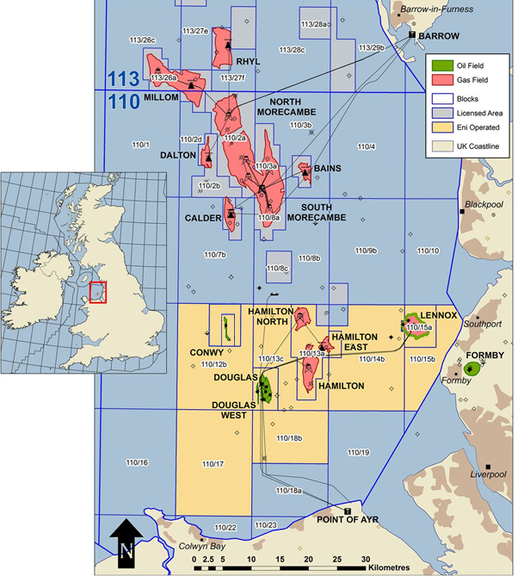

**Figure 1‑3 - Liverpool Bay Asset Facilities Schematics**

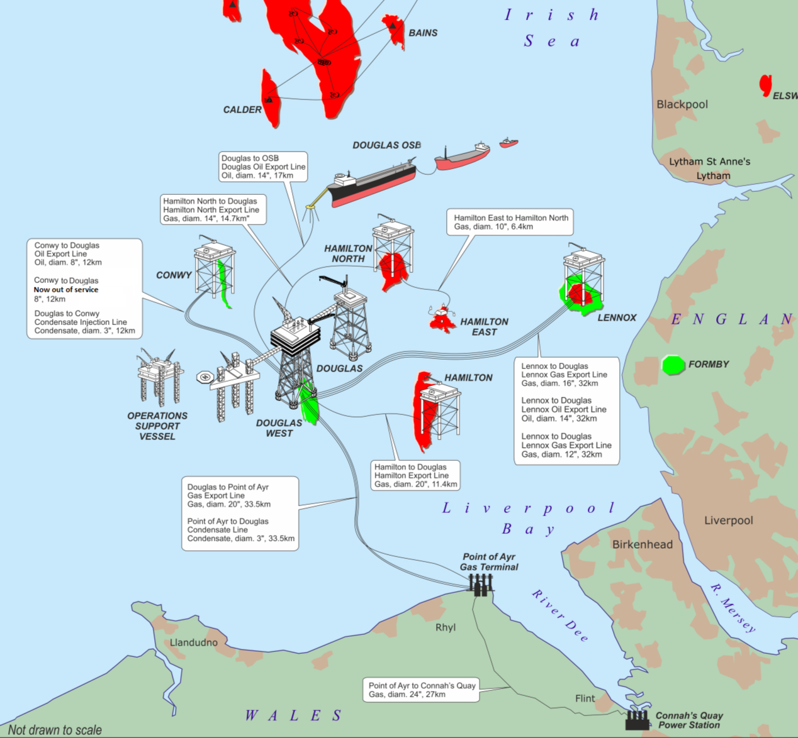

Any remaining pipelines and umbilicals (specifically PLU2942 (Douglas to Conwy) and PLU1861 (Hamilton North to Hamilton East) associated with the LBA fields will be subject to their own Decommissioning Programmes. They will be prepared, isolated and separated from the platforms, but no other impact upon subsea field infrastructure is anticipated.

The listing of relevant adjacent facilities is therefore limited to the pipelines connected to the platforms.

A listing of the adjacent pipeline and surface facilities in the LBA fields, both those directly connected to infrastructure and those which are included for information only, can be found in **Table 1-18**:

**Table 1‑18 - Adjacent Facilities**

|  |  |  |  |  |  |  |
| --- | --- | --- | --- | --- | --- | --- |
| **Adjacent Facilities** | | | | | | |
| **Owner** | **Name** | **Type** | | **Distance / Direction** | **Information** | **Status** |
| Eni UK | Douglas Production (DP) | | Jacket Platform | Bridge-connected with DA and DW  Part of Douglas Complex | Production Platform of Douglas Complex | Operating |
| Eni UK | Douglas Wellhead (DW) | Jacket Platform | | Bridge-connected with Douglas Production (DP)  Part of Douglas Complex | Wellhead Platform of Douglas Complex | Operating |
| Eni UK | Douglas Accommodation (DA) | Jack-up | | Bridge-connected with Douglas Production (DP)  Part of Douglas Complex | Accommodation for Douglas Complex | Operating |
| Eni UK | Conwy (CY) | Jacket Platform | | Located 12km on the north-west of Douglas Complex | Wellhead Platform | Operating |
| Eni UK | Hamilton East (HE) | Subsea X-Tree | | Located 17km on the south-east of Hamilton North (HN) | Subsea X-Tree | Not Operating |
| Eni UK | Oil Storage Barge | Floating Installation | | Located 17km on the north of Douglas Complex | Purpose-built barge permanently moored | Operating |
| Eni UK | Catenary Anchor Leg Mooring (CALM) | Floating Installation | | Located 17km on the north of Douglas Complex | Purpose-built buoy permanently moored | Operating |
| Eni UK | Irish Sea Pioneer (ISP) | Offshore Service Vessel | | LBA Offshore field | Offshore Service Vessel | Operating |
| Eni UK | PL1030 | Offshore Pipeline | | Douglas Platform (DP) to Point of Ayr (PoA) | Gas Pipeline | Operating |
| Eni UK | PL1032 | Offshore Pipeline | | Point of Ayr (PoA) to Douglas Platform (DP) — piggybacked to PL1030 | Condensate Pipeline | Operating |
| Eni UK | PL1033 | Offshore Pipeline | | Point of Ayr (PoA) to Douglas Platform (DP) — piggybacked to PL1030 | Methanol Line | Operating |
| Eni UK | PL2940 | Offshore Pipeline | | Conwy Platform (CY) to Douglas Platform (DP) | Production Line (was former Water Injection) | Operating |

|  |  |  |  |  |  |
| --- | --- | --- | --- | --- | --- |
| Eni UK | PL2939 | Offshore Pipeline | Douglas Platform (DP) to Conwy Platform (CY) | Production Line | Non-operational |
| Eni UK | PL2941 | Offshore Pipeline | Douglas Platform (DP) to Conwy Platform (CY) | Condensate Line | Operating |
| Eni UK | PLU2942 | Umbilical | Douglas Platform (DP) to Conwy Platform (CY) | Power and Control | Operating |
| Eni UK | PL1031 | Offshore Pipeline | Douglas Platform (DP) to Oil Storage Barge | Oil Export Pipeline & Flexible Riser | Operating |
| Eni UK | PL1041 | Offshore Pipeline | Hamilton North Platform (HN) to Douglas Platform (DP) | Gas Export Pipeline | Operating |
| Eni UK | PL1042 | Offshore Pipeline | Douglas Platform (DP) to Hamilton North Platform (HN) | Methanol Line | Operating |
| Eni UK | PL1037 | Offshore Pipeline | Douglas Platform (DP) to Lennox Platform (LD) | Methanol Line | Operating |
| Eni UK | PL1038 | Offshore Pipeline | Douglas Platform (DP) to Lennox Platform (LD) | Wax Inhibitor Line | Operating |
| Eni UK | PL1034 | Offshore Pipeline | Lennox Platform (LD) to Douglas Platform (DP) | Oil Pipeline | Operating |
| Eni UK | PL1035 | Offshore Pipeline | Lennox Platform (LD) to Douglas Platform (DP) | Gas Export Pipeline | Operating |
| Eni UK | PL1036 | Offshore Pipeline | Lennox Platform (LD) to Douglas Platform (DP) | Gas Export Pipeline | Non-operational |
| Eni UK | PL1036A | Offshore Pipeline | Lennox Platform (LD) to Douglas Platform (DP) | Gas Production Pipeline | Operating |
| Eni UK | PL1039 | Offshore Pipeline | Hamilton Platform (HH) to Douglas Platform (DP) | Gas Export Pipeline | Operating |
| Eni UK | PL1040 | Offshore Pipeline | Douglas Platform (DP) to Hamilton Platform (HH) | Methanol Line | Operating |
| Eni UK | PL1860 | Flexible Line | From HE to HN | Flexible Line | Non-operational |
| Eni UK | PL1861U | Umbilical | From HE to HN | Transfer Line | Operating |
| Eni UK | PLU6445 | Umbilical | From DP to  SSBV (PL1034) | Production Umbilical | Operating |
| Eni UK | PLU6435 | Umbilical | From SUTU (LD area) to SSBV (PL1034) | Control Umbilical | Operating |
| Eni UK | PLU6436 | Umbilical | From SUTU (LD area) to  SSBV (PL1036A) | Control Umbilical | Operating |
| Eni UK | PLU6437 | Umbilical | From SUTU (LD area) to  SSBV (PL1035) | Control Umbilical | Operating |
| Eni UK | PLU6438 | Umbilical | From LD Platform to  SUTU (LD Area) | Control Umbilical | Operating |
| Eni UK | PL6423 | Cable | From DP to HN | Electrical Power Cable | Operating |
| Eni UK | PL6424 | Cable | From DP to HH | Electrical Power Cable | Operating |
| Eni UK | PL6426 | Cable | From HH to LD | Electrical Power Cable | Operating |
| **Impacts of Decommissioning Proposals** | | | | | |
| Decommissioning Proposals are specifically designed to facilitate the repurposing of assets for the CO2 Transportation and Storage project, including the removal of expansion spools, umbilicals, and exposed stabilisation features in the near platform areas.  The decommissioning proposals will not impact any of the adjacent facilities listed in the table above. A Comparative Assessment has been prepared to demonstrate that the seabed removals proposed in this programme will not prejudice against subsequent removal options.  Oil Cessation of Production took place on 20 December 2024. Decommissioning activities ahead of that time were the P&A of those wells which are not contributing to oil production, or fuel gas production. | | | | | |

## **Industrial Implications**

The procurement needs of the Partial Decommissioning phase have been combined with the LBA CO2 Transportation and Storage project requirements, such that the work packages (WP) has been tendered as follows:

WP1 – Drilling rig, P&A plus CCS development sidetracking and recompletion

WP2 – Offshore Decommissioning for CCS, CCS & Cable Installation EPC Package

WP3 – Onshore Decommissioning and CCS EPC Package at Point of Ayr

It is anticipated that this approach will achieve synergies which will result in a cost-effective execution of the decommissioning works.

# DESCRIPTION OF ITEMS TO BE DECOMMISSIONED

## **Installation(s): Surface Facilities**

**Table 2‑1 - Surface Facilities Installations**



|  |  |  |  |  |  |  |  |  |  |
| --- | --- | --- | --- | --- | --- | --- | --- | --- | --- |
| **Surface Facilities Installations** | | | | | | | | | |
| **Name** | **Facility Type** | **Location**  **(WGS84)** | | **Topside** | | **Jacket Weight** | | | |
| **Weight to be removed (Te)** | **No of modules** | **Weight (Te)** | **Nr. of**  **legs** | **Nr. of piles** | **Weight of piles (Te)** |
| Hamilton Platform (HH) | Topsides  Jacket Platform | 53°33.958 N | 03°27.270’ W | 502 | 1 | 747 | 4 | 4 | 406 |
| Hamilton North Platform (HN) | Topsides  Jacket Platform | 53°38.782’ N | 03°28.686’ W | 497 | 1 | 713 | 4 | 4 | 633 |
| Lennox Platform (LD) | Topsides  Jacket Platform | 53°37.881’ N | 03°10.595’ W | 1,194 | 1 | 451 | 4 | 4 | 425 |

Notes on **Table 2‑1**:

The overall weight to be removed represents the complete weight of the Topsides. The Jackets and Piles are not part of this Decommissioning Programme.

## **Hamilton (HH) Platform**

Hamilton (HH) platform has been installed in 1995 in a water depth of about 25.8 m LAT. Its substructure is a skirtpile type steel jacket with four (4) legs. Jacket base and top dimensions are 14 m x 10 m and 12 m x 10 m, respectively.

Hamilton (HH) platform topside is composed of four decks:

* Weather Deck El. +33,500
* Access Platform Deck El. +30,300
* Cellar Deck El. +27,000
* Underdeck Platform El. +23,500

The elevations are referred to Platform Level Datum (+0.00) coinciding with Lowest Astronomical Tide (LAT).

Platform foundation is provided by four 60 skirt-piles. Penetration depth is 26.4 m for all piles. There are six conductors (20’’), two risers (20” & 2), one 28 caisson and two 10 J-tubes. The Topsides are composed by a two levels integrated deck (cellar deck and a weather deck) with an underdeck platform, with a helipad located on the main deck.

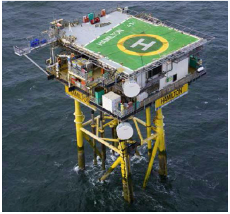

**Figure 2‑1 - Hamilton (HH) Platform Overview**

## **Hamilton North (HN) Platform**

Hamilton North (HN) platform has been installed in 1995 in a water depth of about 22.1 m LAT. Its substructure is a skirt-pile type steel jacket with four (4) legs. Jacket base and top dimensions are 14 m x 10 m and 12 m x 10 m, respectively.

Hamilton North (HN) platform topside is composed of four decks:

* Weather Deck El. +33,500
* Access Platform Deck El. +30,300
* Cellar Deck El. +27,000
* Underdeck Platform El. +23,500

The elevations are referred to Platform Level Datum (+0.00) coinciding with Lowest Astronomical Tide (LAT).

Platform foundation is provided by four 60” skirt-piles. Penetration depth is 24 m for all piles. There are six conductors (20”), two risers (14” and 10”), one 28” caisson and two 10” J-tubes. The Topsides are composed by a two levels integrated deck (cellar deck and a weather deck) and an underdeck platform, with a helipad located on the main deck.

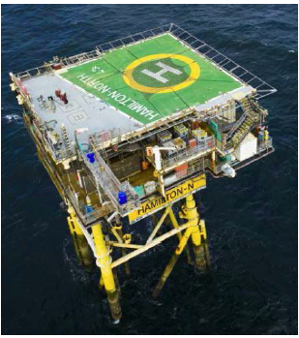

**Figure 2‑2 - Hamilton North (HN) Platform Overview**

## **Lennox (LD) Platform**

Lennox (LD) platform has been installed in 1995 in a water depth of about 7.2 m LAT. Its substructure is a mainpile type steel jacket with four (4) legs. Jacket base and top dimensions are 16 m x 16 m.

Lennox (LD) platform topside is composed of four decks:

* Weather Deck El. +35,700
* Access Platform Deck El. +32,500
* Cellar Deck El. +29,200
* Underdeck Platform El. +25,700

The elevations are referred to Platform Level Datum (+0.00) coinciding with Lowest Astronomical Tide (LAT).

The Topsides are composed by a two levels integrated deck, with a helipad located on the main deck. It provides wellhead and processing facilities, with the separated oil and gas being exported to the Douglas Complex.

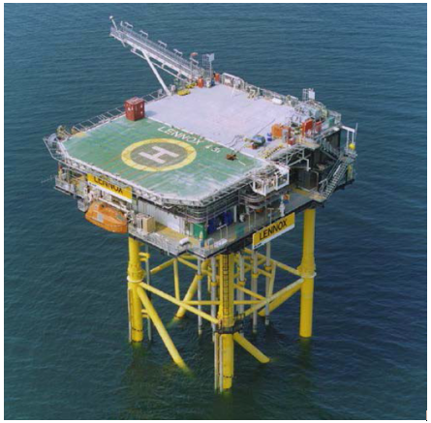

**Figure 2‑3 - Lennox (LD) Platform Overview**

## **Pipelines and Stabilisation Features**

Located in the seabed areas surrounding the platforms (see Section 2.1) are pipelines spools, control umbilicals, SSBVs and cables sections.

These pipelines and related stabilisation features such as concrete mattresses are summarised in **Table 2‑2**, showing ‘Existing Total Quantities’, ‘Quantities to be retained’ for re-use as scope of CCS project, and ‘Quantities to be removed’ as scope of Partial DP:

**Table 2‑2 – Pipelines and Stabilisation Features**

|  |  |  |  |  |  |  |  |  |  |
| --- | --- | --- | --- | --- | --- | --- | --- | --- | --- |
| **Pipelines and Stabilisation Features** | | | | | | | | | |
| **Progr.**  **Nr.** | **Item** | **Status** | **Burial Status** | **Description** | **Type** | **Existing**  **Total**  **Quantities** | **Quantities**  **to be**  **retained** | **Quantities**  **to be removed** | **Removal Location** |
| **01** | **PL1030** | Operating | Buried | 20” from Point of Ayr to Douglas | Pipeline section | 32,121m | 31,936m | 130 m | Douglas Complex approach |
| Spools | 55m |
| Concrete Mattress  (6m x 3m each) | 26 | 0 | 26 |
| Grout bags | Unknown | Unknown | Unknown |
| **02** | **PL1032** | Operating | Buried | 3" Condensate Pipeline  Point of Ayr to Douglas | Pipeline section | 32,100m | 31,902m | 162m | Douglas Complex approach |
| Spools | 36m |
| Concrete Mattress  (6m x 3m each) | 11 across PL1032 and PL1033 | 0 | 11 across PL1032 and PL1033 |
| Grout bags | Unknown | Unknown | Unknown |
| **03** | **PL1033** | Operating | Buried | 3" Methanol Pipeline  Point of Ayr to Douglas | Pipeline section | 32,100m | 31,893m | 170m | Douglas Complex approach |
| Spools | 37m |
| Concrete Mattress  (6m x 3m each) | 11 across PL1032 and PL1033 | 0 | 11 across PL1032 and PL1033 |
| Grout bags | Unknown | Unknown | Unknown |
| **04** | **PL1034** | Operating | Buried | 14" Oil Pipeline  Lennox to Douglas | Pipeline section | 32,048m | 31,549m | 228m | Douglas Complex approach |
| Spools | 135m |
| Concrete Mattress  (6m x 3m each) | 40 across PL1034 and PL1037 | 0 | 14 across PL1034 and PL1037 |
| Grout bags | Unknown | Unknown | Unknown |
| SSBV  DD-ESV-20002 | 1 | 0 | 1 |
| Pipeline section | As above | As above | 23m | Lennox Platform approach |
| Spools | 113m |
| Concrete Mattress  (6m x 3m each) | As above | As above | 26 across PL1034 and PL1037 |
| Grout bags | Unknown | Unknown | Unknown |
| SSBV  DD-ESV-20001 | 1 | 0 | 1 |
| **05** | **PLU6445** | Operating | Buried | Control Umbilical for PL1034 SSBV | SSBV Control Umbilical | 100m | 0m | 100 m | Douglas Complex approach |
| Concrete Mattress  (6m x 3m each) | (incl. in PL1034) | (incl. in PL1034) | (inc. in PL1034) |
| Grout bags | Unknown | Unknown | Unknown |
| **06** | **PLU6435** | Operating | Buried | Control Umbilical  from SUTU  to SSBV (PL1034) | Control Umbilical | 15m | 0m | 15 m | Lennox Platform approach |
| Concrete Mattress  (6m x 3m each) | (incl. in PL1034) | (incl. in PL1034) | (inc. in PL1034) |
| Grout bags | Unknown | Unknown | Unknown |
| **07** | **PLU6436** | Operating | Buried | Control Umbilical  from SUTU for PL1036A SSBV | SSBV Control Umbilical | 210m | 0m | 210 m | Lennox Platform approach |
| Concrete Mattress  (6m x 3m each) | (inc. in PL1036A) | (inc. in PL1036A) | (inc. in PL1036A) |
| Grout bags | Unknown | Unknown | Unknown |
| **08** | **PLU6437** | Operating | Buried | Control Umbilical  from SUTU for PL1035 SSBV | SSBV Control Umbilical | 35m | 0m | 35 m | Lennox Platform approach |
| Concrete Mattress  (6m x 3m each) | (inc. in PL1035) | (inc. in PL1035) | (inc. in PL1035) |
| Grout bags | Unknown | Unknown | Unknown |
| **09** | **PLU6438** | Operating | Buried | Control Umbilical  from  LD Platform  to SUTU  (LD Area) | SSBV Control Umbilical | 170m | 0m | 170 m | Lennox Platform approach |
| Concrete Mattress  (6m x 3m each) | (inc. in PL1034 and 1036A) | (inc. in PL1034 and 1036A) | (inc. in PL1034 and 1036A) |
| Grout bags | Unknown | Unknown | Unknown |
| SUTU Subsea Umbilical Termination Unit | 1 | 0 | 1 |
| **10** | **PL1035** | Operating | Buried | 16" Gas Pipeline  Lennox to Douglas | Pipeline section | 32,045m | 31,789m | 176m | Douglas Complex approach |
| Spools | 80m |
| Concrete Mattress  (6m x 3m each) | 17 | 4 | 13 |
| Grout bags | Unknown | Unknown | Unknown |
| SSBV  DD-ESV-20022 | 1 | 0 | 1 |
| **11** | **PL1036**  **Disused** | Non-Operational | Buried | 12” Gas Injection  Douglas to Lennox | Pipeline section | 32,038m | 31,472m | 352m | Douglas Complex approach |
| Spools | 84m |
| Concrete Mattress  (6m x 3m each) | 109 across PL1036 and PL1038 | 15 across PL1036 and PL1038 | 90 across PL1036 and PL1038 |
| Grout bags | Unknown | Unknown | Unknown |
| Pipeline section | As above | As above | 40m | Lennox Platform approach |
| Spools | 90m |
| Concrete Mattress  (6m x 3m each) | As above | As above | 4 across PL1036 and PL1038 |
| Grout bags | Unknown | Unknown | Unknown |
| **12** | **PL1036A** | Operating | Buried | 12" Gas Pipeline  Lennox to Douglas | Pipeline section | 31,738m | 31,499m | 143m | Douglas Complex approach |
| Spools | 96m |
| Concrete Mattress  (6m x 3m each) | 94 | 83 | 11 |
| Grout bags | Unknown | Unknown | Unknown |
| SSBV  LD-ESV-30001 | 1 | 0 | 1 |
| **13** | **PL1037** | Operating | Buried | 2" Methanol Pipeline  Douglas to Lennox  (piggyback  onto PL1034) | Pipeline section | 32,010m | 31,511m | 228m | Douglas Complex approach |
| Spools | 135m |
| Concrete Mattress  (6m x 3m each) | 40 across PL1034 and PL1037 | 0 | 14 across PL1034 and PL1037 |
| Grout bags | Unknown | Unknown | Unknown |
| Pipeline section | As above | As above | 23m | Lennox Platform approach |
| Spools | 113m |
| Concrete Mattress  (6m x 3m each) | As above | As above | 26 across PL1034 and PL1037 |
| Grout bags | Unknown | Unknown | Unknown |
| **14** | **PL1038** | Operating | Buried | 2" Wax Inhibitor Pipeline  Douglas to Lennox  (piggyback  onto PL1036 Disused) | Pipeline section | 32,010m | 31,444m | 352m | Douglas Complex approach |
| Spools | 84m |
| Concrete Mattress  (6m x 3m each) | 109 across PL1036 and PL1038 | 15 across PL1036 and PL1038 | 90 across PL1036 and PL1038 |
| Grout bags | Unknown | Unknown | Unknown |
| Pipeline section | As above | As above | 40m | Lennox Platform approach |
| Spools | 90m |
| Concrete Mattress  (6m x 3m each) | As above | As above | 4 across PL1036 and PL1038 |
| Grout bags | Unknown | Unknown | Unknown |
| **15** | **PL1039** | Operating | Buried | 20” Gas Pipeline Hamilton to Douglas | Pipeline section | 11,479m | 11,250m | 174m | Douglas Complex approach |
| Spools | 55m |
| Concrete Mattress  (6m x 3m each) | 29 across PL1039 and PL1040 | 17 across PL1039 and PL1040 | 12 across PL1039 and PL1040 |
| Grout bags | Unknown | Unknown | Unknown |
| **16** | **PL1040** | Operating | Buried | 2” Methanol Pipeline  Douglas to Hamilton  (piggyback  onto PL1039) | Pipeline section | 11,431m | 11,092m | 174m | Douglas Complex approach |
| Spools | 56m |
| Concrete Mattress  (6m x 3m each) | 29 across PL1039 and PL1040 | 17 across PL1039 and PL1040 | 12 across PL1039 and PL1040 |
| Grout bags | Unknown | Unknown | Unknown |
| Pipeline section | As above | As above | 52m | Hamilton Platform approach |
| Spools | 57m |
| Concrete Mattress  (6m x 3m each) | As above | As above | As above |
| Grout bags | Unknown | Unknown | Unknown |
| **17** | **PL1041** | Operating | Buried | 14” Gas Pipeline  Hamilton North  to Douglas | Pipeline section | 14,576m | 14,362m | 166m | Douglas Complex approach |
| Spools | 48m |
| Concrete Mattress  (6m x 3m each) | 25 across PL1041 and PL1042 | 18 across PL1041 and PL1042 | 7 across PL1041 and PL1042 |
| Grout bags | Unknown | Unknown | Unknown |
| **18** | **PL1042** | Operating | Buried | 2” Methanol Pipeline  Douglas to Hamilton North  (piggyback  onto PL1041) | Pipeline section | 14,531m | 14,318m | 166m | Douglas Complex approach |
| Spools | 47m |
| Concrete Mattress  (6m x 3m each) | 25 across PL1041 and PL1042 | 18 across PL1041 and PL1042 | 7 across PL1041 and PL1042 |
| Grout bags | Unknown | Unknown | Unknown |
| **19** | **PL1860** | Non-operational | Buried | 8” Gas Flexible Line  Hamilton East  to  Hamilton North | Flexible Line section | 6,587m | 6,509m | 78m | Hamilton North Platform approach |
| Concrete Mattress  (6m x 3m each) | 0 | 0 | 0 |
| Grout bags | Unknown | Unknown | Unknown |
| Flexible Line section | As above | As above | 0 | Hamilton East approach |
| Concrete Mattress  (6m x 3m each) | 20 | 20 | 0 |
| Grout bags | Unknown | Unknown | Unknown |
| **20** | **PLU1861** | Operating | Buried | Control Umbilical Hamilton North  to  Hamilton East | Control Umbilical | 6,728m | 6,655m | 73m | Hamilton North Platform approach |
| Concrete Mattress  (6m x 3m each) | 0 | 0 | 0 |
| Grout bags | Unknown | Unknown | Unknown |
| Control Umbilical | As above | As above | 0 | Hamilton East approach |
| Concrete Mattress  (6m x 3m each) | 10 | 10 | 0 |
| Grout bags | Unknown | Unknown | Unknown |
| **21** | **PL6424** | Operating | Buried | Power Cable  Douglas to Hamilton | Cable section | 11,770m | 11,241m | 285m | Douglas Complex approach |
| Concrete Mattress  (6m x 3m each) | 58 | 42 | 8 |
| Cable section | As above | As above | 244m | Hamilton Platform approach |
| Concrete Mattress  (6m x 3m each) | As above | As above | 8 |
| **22** | **PL6423** | Operating | Buried | Power Cable  Douglas to Hamilton North | Cable section | 14,860m | 14,538m | 265m | Douglas Complex approach |
| Concrete Mattress  (6m x 3m each) | 20 | 1 | 11 |
| Cable section | As above | As above | 57m | Hamilton North Platform approach |
| Concrete Mattress  (6m x 3m each) | As above | As above | 8 |
| **23** | **PL6426** | Operating | Buried | Power Cable  Hamilton to Lennox | Cable section | 22,180m | 22,039m | 93m | Hamilton Platform approach |
| Concrete Mattress  (6m x 3m each) | 27 | 12 | 8 |
| Cable section | As above | As above | 48m | Lennox Platform approach |
| Concrete Mattress  (6m x 3m each) | As above | As above | 7 |

**2.2.1 Subsea Barrier Valve (SSBV)**

The Liverpool Bay Asset has four SSBVs installed on the following pipelines:

**Table 2‑3 SSBV Decommissioning Strategy**

|  |  |  |  |  |  |  |  |
| --- | --- | --- | --- | --- | --- | --- | --- |
| **Item #** | **TAG** | **Size** | **Pipeline** | **Service** | **From-To** | **Location** | **Decommissioning Strategy** |
| **001** | DD-ESV-20001 | 14” | PL1034 | Oil | Douglas-Lennox | Lennox end termination | Full removal of the valve together with pipeline section (ref. **Table *2*‑*2***) |
| **002** | DD-ESV-20002 | 14” | PL1034 | Oil | Douglas-Lennox | Douglas end termination | Full removal of the valve together with pipeline section (ref. **Table *2*‑*2***) |
| **003** | DD-ESV-20022 | 16” | PL1035 | Gas | Douglas-Lennox | Lennox end termination | Full removal of the valve together with pipeline section (ref. **Table *2*‑*2***) |
| **004** | LD-ESV-30001 | 12” | PL1036A | Gas | Douglas-Lennox | Lennox end termination | Full removal of the valve together with pipeline section (ref. **Table *2*‑*2***) |

The dimensions of the SSBVs are presented in **Figure *2*‑*4***, extract from SSBVs General Arrangements:

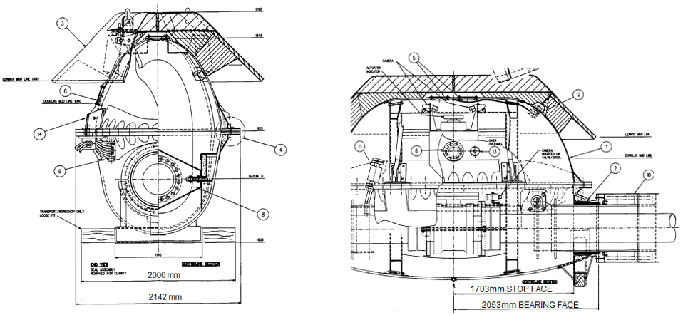

**Figure 2‑4 - Subsea Barrier Valves - Dimensions and GAs**

## **2.3 Wells**

The Liverpool Bay Asset has 42 platform wells spread over 4 platforms: DW – 22 wells, LD – 13 wells, HH – 4 wells, and HN – 3 wells. Conwy wells (5 of) and Hamilton East will be the subject of separate Decommissioning Programmes.

Eni UK’s chosen abandonment scheme has been formulated after consideration of the elements presented in both Eni STAP (Eni standards and procedures) and OEUK. The NSTA Well Operations and Notifications System will be used to apply for consent for abandonment works to be carried out.

At the LBA fields, there is a single ‘zone of flow potential’/’distinct permeable zone’ only. Therefore, the P&A will involve a combination barrier in the caprock (Ansdell Mudstone and Rossall Halite) above this zone. Where required an environmental barrier may also be installed.

**Table 2-4** details all operating and suspended platform wells. Eleven of the wells will be repurposed for the LBA CO2 T&S project, as indicated in the table.

The Category of Wells is as per OEUK Well Decommissioning Guidelines, Issue 7, November 2022.

Eni UK has awarded a contract to Valaris for LBA well P&A. The rig mobilised in December 2023, to commence operations in January 2024. Eni UK is in negotiations for a second rig to commence in the second half of 2025. It is expected that the well P&A programme will extend until 2027, in this two-rig scenario. An indicative well sequence is provided in **Figure 2-5** below:

**Figure 2-5 – Indicative Well Sequence**



**Table 2‑4 - Wells**

| **Wells - Douglas Wellhead (DW) Platform** | | | |
| --- | --- | --- | --- |
| **Well** | **Designation** | **Status** | **Category of Well** |
| 110/13-D1 | Oil Producer | Completed (Operating) | PL-3-3-3 |
| 110/13-D2 | Oil Producer | Completed (Operating) | PL-3-3-3 |
| 110/13-D3 | WAG Injector | Completed (Shut-in) | PL-3-3-3 |
| 110/13-D4 | Water Injector | Completed (Operating) | PL-3-3-3 |
| 110/13-D5Z | Oil Producer | Completed (Operating) | PL-3-3-3 |
| 110/13-D6 | Gas Injector | Completed (Operating) | PL-3-3-3 |
| 110/13-D7 | Oil Producer | Completed (Shut-in) | PL-3-3-3 |
| 110/13-D8 | Oil Producer | Completed (Shut-in) | PL-3-3-3 |
| 110/13-D9Y | Water Injector | Completed (Operating) | PL-3-3-3 |
| 110/13-D10 | WAG Injector | Completed (Shut-in) | PL-3-3-3 |
| 110/13-D11Z | Oil Producer | Completed (Operating) | PL-3-3-3 |
| 110/13-D12 | Producer | Completed (Operating) | PL-3-3-3 |
| 110/13-D13Z | Condensate Disposal | Completed (Shut-in) | PL-3-3-3 |
| 110/13-D14 | Injector | Completed (Operating) | PL-3-3-3 |
| 110/13b-D15Z | Oil Producer | Completed (Shut-in) | PL-3-3-3 |
| 110/13b-D16Z | Oil Producer | Completed (Shut-in) | PL-3-3-3 |
| 110/13b-D17 | Oil Producer | Completed (Operating) | PL-3-3-3 |
| 110/13b-D18 | Oil Producer | Completed (Operating) | PL-3-3-3 |
| 110/13b-D19 | Oil Producer | Completed (Operating) | PL-3-3-3 |
| 110/13b-D20Y | Oil Producer: a single well into Douglas West | Completed (Operating) | PL-3-3-3 |
| 110/13b-D21Z | Oil Producer | Completed (Shut-in) | PL-3-3-3 |
| 110/13b-D22 | Oil Producer | Completed (Operating) | PL-3-3-3 |

| **Wells - Hamilton (HH) Platform** | | | |
| --- | --- | --- | --- |
| **Well** | **Designation** | **Status** | **Category of Well** |
| 110/13-H1 | Gas Producer | Completed (Operating) | PL-4-0-0 – Future CCS Injector Sidetrack |
| 110/13-H2 | Gas Producer | Completed (Operating) | PL-4-0-0 – Future CCS Injector Sidetrack |
| 110/13-H3 | Gas Producer | Completed (Operating) | PL-4-0-0 – Future CCS Injector Sidetrack |
| 110/13-H4 | Gas Producer | Completed (Operating) | PL-4-0-0 – Future CCS Injector Sidetrack |
| Hamilton MMV | N/A – Future Monitoring Well. Not yet drilled | N/A – Future Monitoring Well. Not yet drilled | N/A – Future Monitoring Well. Not yet drilled |
| **Wells - Hamilton North (HN) Platform** | | | |
| **Well** | **Designation** | **Status** | **Category of Well** |
| 110/13-N1 | Gas Producer | Completed (Shut-in) | PL-4-0-0 – Future CCS Injector Sidetrack |
| 110/13-N2 | Gas Producer | Completed (Shut-in) | PL-0-0-0 – Future Sentinel Well |
| 110/13-N3 | Gas Producer | Completed (Shut-in) | PL-4-0-0 – Future CCS Injector Sidetrack |
| Hamilton North MMV | N/A – Future Monitoring Well. Not yet drilled | N/A – Future Monitoring Well. Not yet drilled | N/A – Future Monitoring Well. Not yet drilled |

| **Wells - Lennox (LD) Platform** | | | |
| --- | --- | --- | --- |
| **Well** | **Designation** | **Status** | **Category of Well** |
| 110/15-L1Z | Gas Producer | Completed (Operating) | PL-4-0-0 – Future Monitoring Well |
| 110/15-L2 | Gas Producer | Completed (Shut-in) | PL-4-3-3 |
| 110/15-L4 | Gas Producer | Completed (Shut-in) | PL-0-0-0 – Future Sentinel Well |
| 110/15-L5 | Gas Producer | Completed (Operating) | PL-4-0-0 – Future CCS Injector Sidetrack |
| 110/15-L6Z | Gas Producer | Abandoned Phase 2 | PL-4-3-3 |
| 110/15-L7Z | Gas Producer | Abandoned Phase 2 | PL-4-3-3 |
| 110/15-L8Y | Gas Producer | Abandoned Phase 2 | PL-4-3-3 |
| 110/15-L9 | Gas Producer | Completed (Operating) | PL-4-3-3 |
| 110/15-L10X | Gas Producer | Abandoned Phase 2 | PL-4-3-3 |
| 110/15-L11Z | Gas Producer | Abandoned Phase 2 | PL-4-3-3 |
| 110/15a-L12Y | Gas Producer | Completed (Operating) | PL-4-3-3 |
| 110/15a-L13Z | Gas Producer | Completed (Operating) | PL-4-0-0 – Future CCS Injector Sidetrack |
| 110/15a-L14Y | Gas Producer | Abandoned Phase 2 | PL-4-3-3 |

Please note that the AB2 notifications have been submitted via the NSTA WONS Portal but are subject to approval at the time of writing.

## **Drill Cuttings**

The EBS reports fine sediments located in the proximity of platforms which could be associated with historical mostly dispersed drill cuttings. No piles have been found. The chemical analysis found no associated Polycyclic Aromatic Hydrocarbons (RPS, 2022).

It is believed that the relatively high tidal and wave generated currents in the area, together with the shallowness of the predicted cuttings deposition have caused the cuttings to dissipate in the period since the wells were drilled.

## **Inventory Estimates**

**Table 2‑5 - Hamilton HH Platform – Overall Materials Summary**

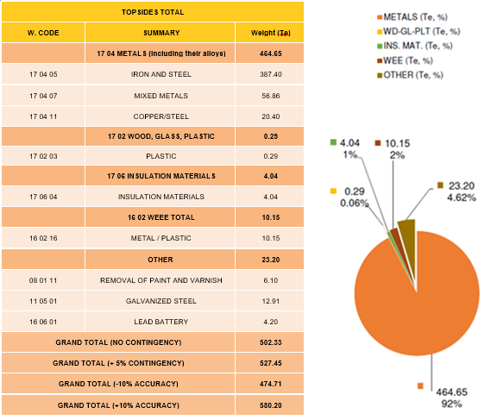

**Table 2‑6 - Hamilton HH Platform – Topside Inventory**

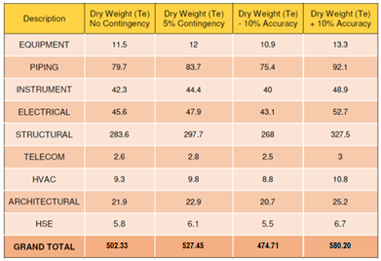

**Table 2‑7 - Hamilton North HN Platform - Overall Materials Summary**

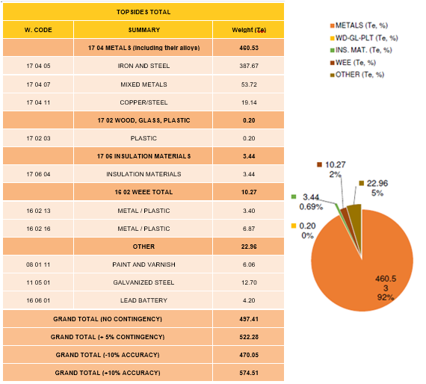

**Table 2‑8 - Hamilton North HN Platform – Topside Inventory**

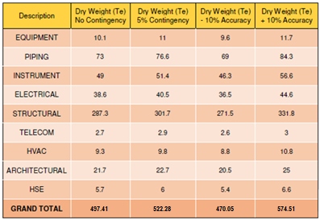

**Table 2‑9 - Lennox LD Platform - Overall Materials Summary**

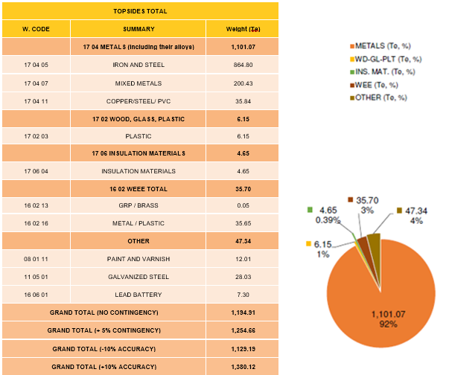

**Table 2‑10 - Lennox LD Platform - Topside Inventory**

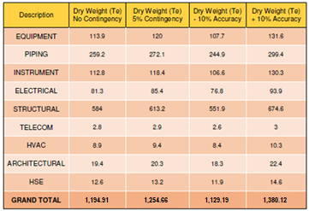

**Table 2‑11 – Pipelines and Stabilisation Features - Overall Materials Summary**

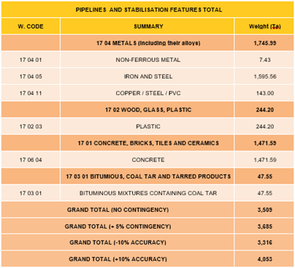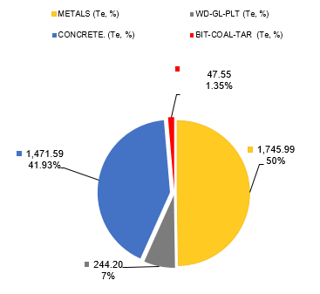

**Table 2‑12 – Pipelines Stabilisation Features – Inventory**

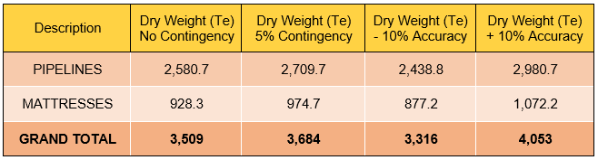

# REMOVAL AND DISPOSAL METHODS

The decommissioning strategy is at an early stage of definition. A number of contractual and technical approaches are under consideration. A final decision on decommissioning methods, including removal and disposal, will be made following a commercial tendering process.

## **Waste Hierarchy and Principles**

Eni UK waste hierarchy aligns with the principles of the EU Waste Framework Directive (Directive 2008/98/EC). Contractor and onshore site selection process will be implemented to ensure compliance with waste hierarchy and all applicable waste regulations and Duty of Care.

Recyclable metals, predominantly steel and iron, are estimated to account for the greatest proportion of the materials inventory. The current plan is to transport the structures to an onshore decommissioning facility for re-use and recycling using an appropriately licensed contractor. Contractor and site selection process is in early stages and thus the potential trans-frontier shipment of waste cannot be dismissed for certainty.

Wastes generated during decommissioning will be segregated and recorded by type and transported to onshore waste facilities through licensed waste contractors for recovery or disposal.

The adoption of the Waste Hierarchy is clearly defined as a principle in the BEIS Guidance Notes (2018) as a requirement of the Decommissioning Programmes to:

*“Describe the decommissioning solution for each item explaining why the solution has been selected, providing appropriate supporting evidence. In doing this the programmes must consider how the principles of the waste hierarchy will be met and show the extent to which the installation, including the topsides and the materials contained within the installation, will be re-used, recycled or disposed of on land”.*

## **Topsides**

## **Hamilton (HH) Platform – Topsides Removal**

Hamilton (HH) Platform’s Topsides will be disconnected and totally removed in order to allow the installation of a new Topsides module with CCS equipment for CO2 injection downhole. The existing jacket will remain in place.

Figure 3-1represents the parts of Hamilton (HH) Platform that will be removed as part ot the Partial Decommissioning:

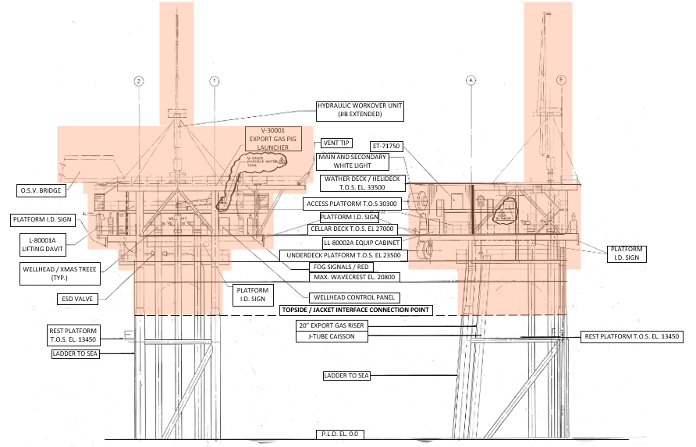

**Figure 3‑1 - Hamilton (HH) Platform - Deck Removal**

*In* ***red*** *the parts subject to removal*

Hamilton (HH) topside will be disconnected from the jacket and removed according to the following sequence:

* Preparatory works at the platform
* Cutlines checking for platform’s deck lifting and removal
* Preparatory work on wellhead and conductors in regard to P&A of platform wells
* Lifting Pad Eyes installation
* HLV Positioning and Mooring
* Transportation and Sea-fastening Manual preparation
* Towing Manual preparation
* Load-out / Load-in Manual
* Disposal of Topside at a dedicated yard

The substitution of the Satellite Platforms topsides (removal of the existing one and installation of the new one) shall not take more than 1 or 2 days each. NavAids shall be installed on the jacket in case the HLV will need to leave the field due to an emergency (e.g. mechanical breakdown as crane failure, repair needed on thrusters, etc).

## **Hamilton North (HN) Platform – Topsides Removal**

Hamilton (HN) Platform’s Topsides will be disconnected and totally removed in order to allow the installation of a new Topsides module with CCS equipment for CO2 injection downhole. The existing jacket will remain in place.

Figure 3-2 represents the parts of Hamilton (HN) Platform that will be removed as part of the Partial Decommissioning:

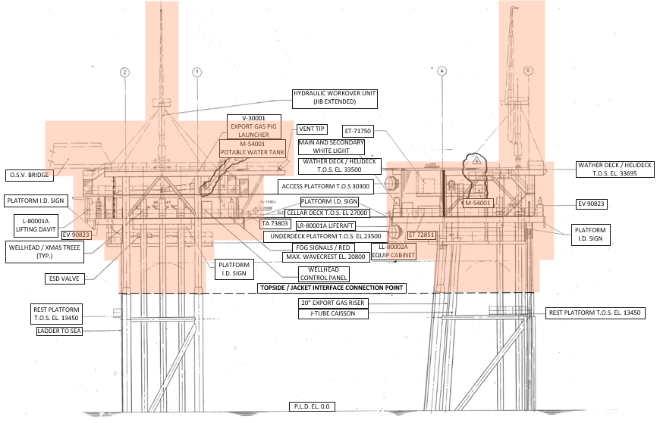

**Figure 3‑2 - Hamilton North (HN) Platform - Deck Removal**

*In* ***red*** *the parts subject to removal*

Hamilton (HN) topside will be disconnected from the jacket and removed according to the following sequence:

* Preparatory works at the platform
* Cutlines checking for platform’s deck lifting and removal
* Preparatory work on wellhead and conductors in regard to P&A of platform wells
* Lifting Pad Eyes installation
* HLV Positioning and Mooring
* Transportation and Sea-fastening Manual preparation
* Towing Manual preparation
* Load-out / Load-in Manual
* Disposal of Topside at a dedicated yard

## **Lennox (LD) Platform – Topsides Removal**

Lennox (LD) Platform’s Topsides will be disconnected and totally removed in order to allow the installation of a new Topsides module with CCS equipment for CO2 injection downhole. The existing jacket will remain in place.

Figure 3-3 represents the parts of Lennox (LD) Platform that will be removed as part of the Partial Decommissioning:

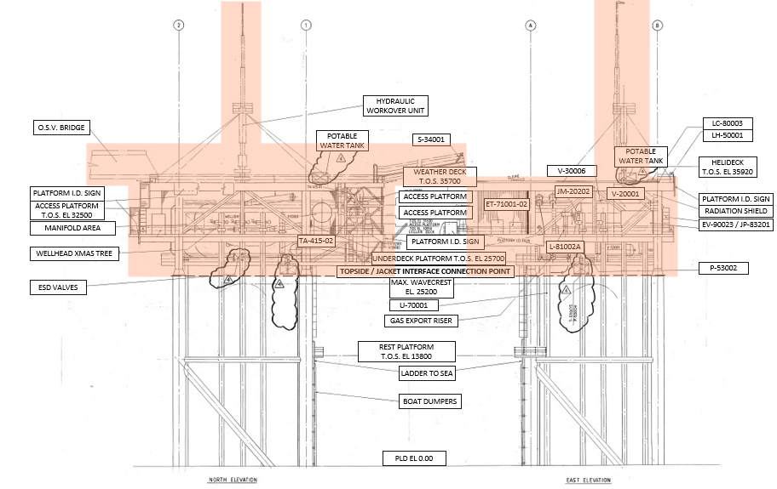

**Figure 3‑3 – Lennox (LD) Platform – Deck Removal**

*In* ***red*** *the parts subject to removal*

Lennox (LD) topside will be disconnected from the jacket and removed according to the following sequence:

* Preparatory works at the platform
* Cutlines checking for platform’s deck lifting and removal
* Preparatory work on wellhead and conductors in regard to P&A of platform wells
* Lifting Pad Eyes installation
* HLV Positioning and Mooring
* Transportation and Sea-fastening Manual preparation
* Towing Manual preparation
* Load-out / Load-in Manual
* Disposal of Topside at a dedicated yard

## **Preparation and Cleaning**

Prior to any system disconnection and removal, the topsides of Hamilton (HH), Hamilton North (HN) and Lennox (LD), will be subject to a sequence of cleaning activities post-CoP, aimed to reduce the levels of hydrocarbon inventory and contaminants within the topsides process systems & pipeline systems and to achieve the “Made Safe” status.

Prior to removal, the topsides will be cleaned of hydrocarbons and, where practical, of other hazardous materials. The cleaning activities are summarized as followings:

* Wells shall be shutdown (either temporarily or permanently)
* All piping systems shall be depressurised and purged.
* All pressure vessels shall be depressurised and purged
* Topsides process systems shall be cleaned and flushed
* Pipelines shall be cleaned and flushed
* Relevant electrical equipment de-energised
* All transformers shall be oil free
* All mechanical equipment (skid, package) shall be free from chemicals

The primary route for disposal of flushed fluids is injection into Douglas Wellhead (DW) wells. Other options may be considered as per **Table *3*‑*1***:

**Table 3‑1 – Topsides Preparation and Cleaning**

|  |  |  |
| --- | --- | --- |
| Waste Type | Composition of waste | Disposal Route |
| On-board Hydrocarbons and liquids arising from flushing during Making Safe | Process fuels, Diesel, lubricants | Where possible, on-board HCs will be re-injected into the reservoir at Douglas Wellhead (DW). Should this approach be unsuccessful or if a suitable well is unavailable, flushed fluids containing HCs will disposed in to a dedicated offshore tanker, subject to appropriate consents. |
| Hydraulic Fluid | Liquids drained from skids and equipment. | Hydraulic fluids will be drained into suitable containers and transported onshore for re-use/disposal |
| NORM | Potentially contained within liquids, scales, residues, and internal contamination to process pipework presence to be identified on breaking of containment | If the presence of NORM is identified, where possible it will be injected into the reservoir via a donor well. Where this approach is not available (bulk NORM solids) it will be transported onshore and disposed of in accordance with the regulations. |
| Asbestos and Ceramic Fibre | CAF Gaskets, panelling, as defined in asset asbestos register and asbestos surveys. | The presence of quantities of asbestos is anticipated in the topsides process systems, in form of compressed asbestos fibre (CAF) gaskets, and within panels of topsides accommodation. Asbestos-containing materials will be managed in line with the control of asbestos regulations 2012 and transported onshore for disposal via an appropriately licenced waste management contractor. |
| Other Hazardous Materials | Liquids, sludges, cleaning chemicals | Where possible, cleaning chemicals will be injected into the reservoir via a donor well together with remaining hydrocarbon inventory and flushing fluids. Should this approach be unsuccessful or if a suitable donor well is unavailable, they will be returned to shore for appropriate disposal. If any H2S is found the primary disposal route will be into a donor well. |

The primary route for disposal of flushed fluids from subsea pipelines preparation and cleaning activities is also injection into Douglas Wellhead (DW) wells. However, in cases where injection downhole is deemed not feasible or unsafe, disposal fluids will be directed to the OSB for settling before being discharged overboard in compliance with the required regulatory permits and consents. Upon verification that systems have been adequately cleaned in compliance with the cleanliness targets according to the Project Cleaning Strategy, the topside and pipelines systems will be positively isolated and made ready for disconnection and removal.

## **Satellite Platforms HH, HN and LD – Removal Methods**

Hamilton (HH), Hamilton North (HN), and Lennox (LD) Platforms will be subject to a customized repurposing, focused on the removal of existing platform’s deck, to allow the installation of a new deck with pre-installed CCS equipment and systems required to achieve initial (free flow) CO2 injection. The removal methods are summarized at **Table *3*‑*2***:

**Table 3‑2 – Satellite Platforms HH, HN and LD – Removal Methods**

|  |  |
| --- | --- |
| Methods | Description |
| Single lift removal of Topsides, by HLV. | Removal of topsides as complete units and transportation to shore for re-use of selected equipment, recycling, break up, and/or disposal |
| Offshore removal ‘piece small’ for onshore reuse/disposal. | Removal of topsides by breaking up offshore and transporting to shore using work barge. Items will then be sorted for re-use, recycling or disposal |
| Proposed removal method and disposal route:  Single lift removal of Topsides,  by HLV. | The Topsides will be separated from the jacket structure by cutting below the main deck level. The complete unit will then be lifted and transported to the onshore disposal yard for re-use of selected equipment, recycling, break up and /or disposal.  A final decision on the decommissioning method will be made following a commercial tendering process. Once a final decision has been made, OPRED will be informed. |

## **Pipelines and Stabilisation Features**

The seabed areas around the Douglas Production (DP), Hamilton (HH), Hamilton North (HN) and Lennox (LD), will be cleared of pipelines and stabilisation features exposed on the seabed.

Figures 3-4, 3-5, 3-6 and 3-7, show the proposed removals. This work is the subject of a dedicated desktop Comparative Assessment (see Section 7).

**Figure 3‑4 Seabed Removals around Douglas Production (DP) Platform**

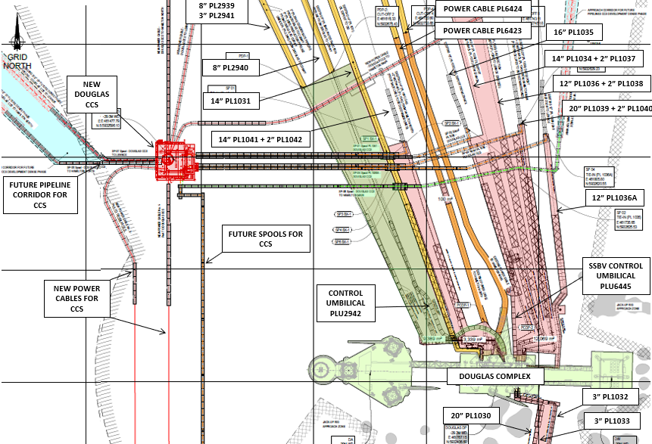

**Figure 3‑5 Seabed Removals around Hamilton (HH) Platform**

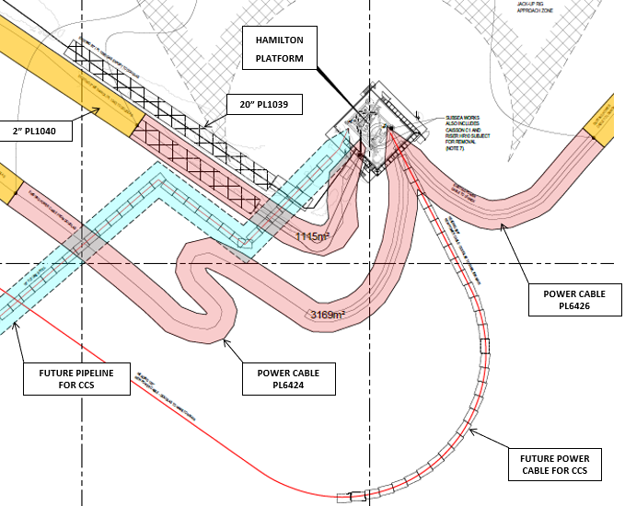

**Figure 3‑6 Seabed Removals around Hamilton North (HN) Platform**

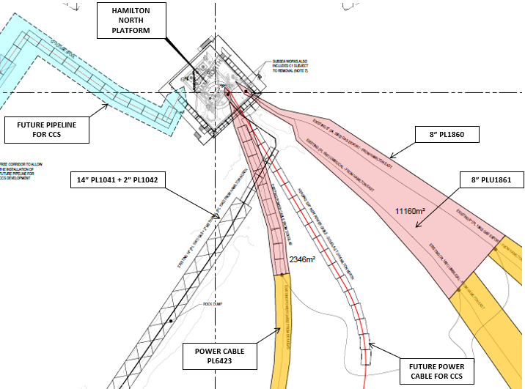

**Figure 3‑7 Seabed Removals around Lennox (LD) Platform**

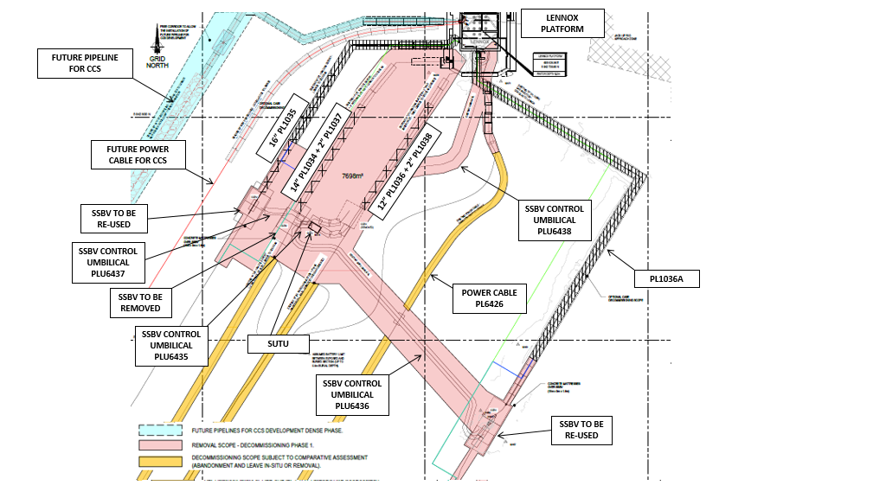

## **3.3.1 Pipelines and Stabilisation Features – Removal Methods**

Pipelines and stabilisation features present in the platforms’ area (see Section 2.2) will be subject to removal and transportation to shore for recycling and/or disposal.

Pipelines and stabilisation features removal methods are summarized in **Table 3-3**:

**Table 3‑3 - Pipelines and Umbilicals Removal Methods**

|  |  |  |  |
| --- | --- | --- | --- |
| **Pipelines and Umbilicals Removal Methods** | | | |
| **Pipeline** | **Condition of line** | **Whole or part of pipeline** | **Decommissioning options considered** |
| **PL1030** | Buried | It is intended that the spools exposed on the seabed will be removed and recovered to shore, from 0.6m BD up to interface with platform (**Note 1**).  Pipelines cut ends will be lowered in the seabed by means of a jet trencher machine to guarantee a full stabilization.  However, in the event of practical difficulties during the removal execution, OPRED will be consulted, and an alternative method of decommissioning will be examined through a comparative assessment process. | 6 |
| **PL1032** | Buried | It is intended that the spools exposed on the seabed will be removed and recovered to shore, from 0.6m BD up to interface with platform (**Note 1**).  Pipelines cut ends will be lowered in the seabed by means of a jet trencher machine to guarantee a full stabilization.  However, in the event of practical difficulties during the removal execution, OPRED will be consulted, and an alternative method of decommissioning will be examined through a comparative assessment process. | 6 |
| **PL1033** | Buried | It is intended that the spools exposed on the seabed will be removed and recovered to shore, from 0.6m BD up to interface with platform (**Note 1**).  Pipelines cut ends will be lowered in the seabed by means of a jet trencher machine to guarantee a full stabilization.  However, in the event of practical difficulties during the removal execution, OPRED will be consulted, and an alternative method of decommissioning will be examined through a comparative assessment process. | 6 |
| **PL1034** | Buried | It is intended that the spools exposed on the seabed will be removed and recovered to shore, from 0.6m BD up to interface with platform (**Note 1**).  Pipelines cut ends will be lowered in the seabed by means of a jet trencher machine to guarantee a full stabilization.  However, in the event of practical difficulties during the removal execution, OPRED will be consulted, and an alternative method of decommissioning will be examined through a comparative assessment process. | 6 |
| **Control Umbilical for PL1034 SSBV**  **(Douglas), PLU6445** | Buried | It is intended that the control umbilical will be fully removed.  However, in the event of practical difficulties during the removal execution, OPRED will be consulted, and an alternative method of decommissioning will be examined through a comparative assessment process. | 4 |
| **PL1034 SSBV**  **(Douglas)** | Buried | It is intended that the SSBV exposed on the seabed will be removed and recovered to shore, from 0.6m BD up to interface with platform (**Note 1**).  However, in the event of practical difficulties during the removal execution, OPRED will be consulted, and an alternative method of decommissioning will be examined through a comparative assessment process. | 4 |
| **Control Umbilical for PL1034 SSBV**  **(Lennox), PLU6435** | Buried | It is intended that the control umbilical will be fully removed.  However, in the event of practical difficulties during the removal execution, OPRED will be consulted, and an alternative method of decommissioning will be examined through a comparative assessment process. | 4 |
| **PL1034 SSBV**  **(Lennox)** | Buried | It is intended that the SSBV exposed on the seabed will be removed and recovered to shore, from 0.6m BD up to interface with platform (**Note 1**).  However, in the event of practical difficulties during the removal execution, OPRED will be consulted, and an alternative method of decommissioning will be examined through a comparative assessment process. | 4 |
| **PL1035** | Buried | It is intended that the spools exposed on the seabed will be removed and recovered to shore, from 0.6m BD up to interface with platform (**Note 1**).  Pipelines cut ends will be lowered in the seabed by means of a jet trencher machine to guarantee a full stabilization.  However, in the event of practical difficulties during the removal execution, OPRED will be consulted, and an alternative method of decommissioning will be examined through a comparative assessment process. | 6 |
| **PL1035 SSBV**  **(Lennox)** | Buried | It is intended that the SSBV exposed on the seabed will be removed and recovered to shore, from 0.6m BD up to interface with platform (**Note 1**).  However, in the event of practical difficulties during the removal execution, OPRED will be consulted, and an alternative method of decommissioning will be examined through a comparative assessment process. | 4 |
| **Control Umbilical for PL1035 SSBV**  **(Lennox), PLU6437** | Buried | It is intended that the control umbilical will be fully removed.  However, in the event of practical difficulties during the removal execution, OPRED will be consulted, and an alternative method of decommissioning will be examined through a comparative assessment process. | 4 |
| **PL1036**  **Disused** | Buried | It is intended that the spools exposed on the seabed will be removed and recovered to shore, from 0.6m BD up to interface with platform (**Note 1**).  Pipelines cut ends will be lowered in the seabed by means of a jet trencher machine to guarantee a full stabilization.  However, in the event of practical difficulties during the removal execution, OPRED will be consulted, and an alternative method of decommissioning will be examined through a comparative assessment process. | 6 |
| **PL1036A** | Buried | It is intended that the spools exposed on the seabed will be removed and recovered to shore, from 0.6m BD up to interface with platform (**Note 1**).  Pipelines cut ends will be lowered in the seabed by means of a jet trencher machine to guarantee a full stabilization.  However, in the event of practical difficulties during the removal execution, OPRED will be consulted, and an alternative method of decommissioning will be examined through a comparative assessment process. | 6 |
| **PL1036A SSBV**  **(Lennox)** | Buried | It is intended that the SSBV exposed on the seabed will be removed and recovered to shore, from 0.6m BD up to interface with platform (**Note 1**).  However, in the event of practical difficulties during the removal execution, OPRED will be consulted, and an alternative method of decommissioning will be examined through a comparative assessment process. | 4 |
| **Control Umbilical from Lennox Platform to SUTU, PLU6438** | Buried | It is intended that the control umbilical will be fully removed.  However, in the event of practical difficulties during the removal execution, OPRED will be consulted, and an alternative method of decommissioning will be examined through a comparative assessment process. | 4 |
| **Control Umbilical for PL1036A SSBV**  **(Lennox), PLU6436** | Buried | It is intended that the control umbilical will be fully removed.  However, in the event of practical difficulties during the removal execution, OPRED will be consulted, and an alternative method of decommissioning will be examined through a comparative assessment process. | 4 |
| **PL1037** | Buried | It is intended that the spools exposed on the seabed will be removed and recovered to shore, from 0.6m BD up to interface with platform (**Note 1**).  Pipelines cut ends will be lowered in the seabed by means of a jet trencher machine to guarantee a full stabilization.  However, in the event of practical difficulties during the removal execution, OPRED will be consulted, and an alternative method of decommissioning will be examined through a comparative assessment process. | 6 |
| **PL1038** | Buried | It is intended that the spools exposed on the seabed will be removed and recovered to shore, from 0.6m BD up to interface with platform (**Note 1**).  Pipelines cut ends will be lowered in the seabed by means of a jet trencher machine to guarantee a full stabilization.  However, in the event of practical difficulties during the removal execution, OPRED will be consulted, and an alternative method of decommissioning will be examined through a comparative assessment process. | 6 |
| **PL1039** | Buried | It is intended that the spools exposed on the seabed will be removed and recovered to shore, from 0.6m BD up to interface with platform (**Note 1**).  Pipelines cut ends will be lowered in the seabed by means of a jet trencher machine to guarantee a full stabilization.  However, in the event of practical difficulties during the removal execution, OPRED will be consulted, and an alternative method of decommissioning will be examined through a comparative assessment process. | 6 |
| **PL1040** | Buried | It is intended that the spools exposed on the seabed will be removed and recovered to shore, from 0.6m BD up to interface with platform (**Note 1**).  Pipelines cut ends will be lowered in the seabed by means of a jet trencher machine to guarantee a full stabilization.  However, in the event of practical difficulties during the removal execution, OPRED will be consulted, and an alternative method of decommissioning will be examined through a comparative assessment process. | 6 |
| **PL1041** | Buried | It is intended that the spools exposed on the seabed will be removed and recovered to shore, from 0.6m BD up to interface with platform (**Note 1**).  Pipelines cut ends will be lowered in the seabed by means of a jet trencher machine to guarantee a full stabilization.  However, in the event of practical difficulties during the removal execution, OPRED will be consulted, and an alternative method of decommissioning will be examined through a comparative assessment process. | 6 |
| **PL1042** | Buried | It is intended that the spools exposed on the seabed will be removed and recovered to shore, from 0.6m BD up to interface with platform (**Note 1**).  Pipelines cut ends will be lowered in the seabed by means of a jet trencher machine to guarantee a full stabilization.  However, in the event of practical difficulties during the removal execution, OPRED will be consulted, and an alternative method of decommissioning will be examined through a comparative assessment process. | 6 |
| **PL1860** | Buried | It is intended that the flexible line section exposed on the seabed will be removed and recovered to shore, from 0.6m BD up to interface with platform (**Note 1**).  Flexible Line cut ends will be lowered in the seabed by means of a jet trencher machine to guarantee a full stabilization.  However, in the event of practical difficulties during the removal execution, OPRED will be consulted, and an alternative method of decommissioning will be examined through a comparative assessment process. | 6 |
| **PLU1861** | Buried | It is intended that the flexible line section exposed on the seabed will be removed and recovered to shore, from 0.6m BD up to interface with platform (**Note 1**).  Umbilical cut ends will be lowered in the seabed by means of a jet trencher machine to guarantee a full stabilization.  However, in the event of practical difficulties during the removal execution, OPRED will be consulted, and an alternative method of decommissioning will be examined through a comparative assessment process. | 6 |
| **Power Cable**  **Douglas to Hamilton, PL6424** | Buried | It is intended that the cables sections exposed on the seabed will be removed and recovered to shore, from 0.6m BD up to interface with platform (**Note 1**).  Cable cut ends will be lowered in the seabed by means of a jet trencher machine to guarantee a full stabilization.  However, in the event of practical difficulties during the removal execution, OPRED will be consulted, and an alternative method of decommissioning will be examined through a comparative assessment process. | 6 |
| **Power Cable**  **Douglas to Hamilton North, PL6423** | Buried | It is intended that the cables sections exposed on the seabed will be removed and recovered to shore, from 0.6m BD up to interface with platform (**Note 1**).  Cable cut ends will be lowered in the seabed by means of a jet trencher machine to guarantee a full stabilization.  However, in the event of practical difficulties during the removal execution, OPRED will be consulted, and an alternative method of decommissioning will be examined through a comparative assessment process. | 6 |
| **Power Cable**  **Hamilton to Lennox, PL6426** | Buried | It is intended that the cables sections exposed on the seabed will be removed and recovered to shore, from 0.6m BD up to interface with platform (**Note 1**).  Cable cut ends will be lowered in the seabed by means of a jet trencher machine to guarantee a full stabilization.  However, in the event of practical difficulties during the removal execution, OPRED will be consulted, and an alternative method of decommissioning will be examined through a comparative assessment process. | 6 |

*Key to Options:

1) Remove – reverse reeling

2) Remove – reverse S lay

3) Trench and bury

4) Remedial removal

5) Remedial trenching

6) Partial removal

**Table 3‑4 - Pipelines and Stabilisation Features Removal Methods and Disposal Routes**

|  |  |  |  |
| --- | --- | --- | --- |
| **Pipelines and Stabilisation Features Removal Methods and Disposal Routes** | | | |
| **Pipelines and stabilization features** | **Number** | **Option** | **Disposal Route**  **(if applicable)** |
| Cables | 3 | It is intended that the cables sections exposed on the seabed will be removed and recovered to shore, from 0.6m BD up to interface with platform (**Note 1**).  Cable cut ends will be lowered in the seabed by means of a jet trencher machine to guarantee a full stabilization.  However, in the event of practical difficulties during the removal execution, OPRED will be consulted, and an alternative method of decommissioning will be examined through a comparative assessment process. | Transportation to shore for recycling and / or disposal |
| Concrete Mats | 264 | Full recovery.  It is intended that the mattresses will be recovered to shore, however in the event of practical difficulties during the removal execution, OPRED will be consulted, and an alternative method of decommissioning will be examined through a comparative assessment process. | Transportation to shore for recycling and / or disposal |
| Control Umbilicals | 6 | It is intended that the control umbilicals sections will be fully removed, with the exception of PLU1861, which will be removed and recovered to shore, from 0.6m BD up to interface with HN platform (**Note 1**).  However, in the event of practical difficulties during the removal execution, OPRED will be consulted, and an alternative method of decommissioning will be examined through a comparative assessment process. | Transportation to shore for recycling and / or disposal |
| Flexible Line | 1 | It is intended that the flexible line section exposed on the seabed will be removed and recovered to shore, from 0.6m BD up to interface with platform (**Note 1**).  Flexible Line cut ends will be lowered in the seabed by means of a jet trencher machine to guarantee a full stabilization.  However, in the event of practical difficulties during the removal execution, OPRED will be consulted, and an alternative method of decommissioning will be examined through a comparative assessment process. | Transportation to shore for recycling and / or disposal |
| Spools / Section of pipelines | 13 | It is intended that the spools exposed on the seabed will be removed and recovered to shore, from 0.6m BD up to interface with platform (**Note 1**).  Pipelines cut ends will be lowered in the seabed by means of a jet trencher machine to guarantee a full stabilization.  However, in the event of practical difficulties during the removal execution, OPRED will be consulted, and an alternative method of decommissioning will be examined through a comparative assessment process. | Transportation to shore for recycling and / or disposal |
| SSBV | 4 | It is intended that the SSBV exposed on the seabed will be removed and recovered to shore, from 0.6m BD up to interface with platform (**Note 1**).  However, in the event of practical difficulties during the removal execution, OPRED will be consulted, and an alternative method of decommissioning will be examined through a comparative assessment process. | Transportation to shore for recycling and / or disposal |

Notes on Table 3-4:

*[1] The removals scope will include spools and cable sections from 0.6m BD up to the interface with the platform (e.g. riser bottom flange or j-tube bellmouth), in accordance with BEIS Guidance Notes “Decommissioning of Offshore Oil and Gas Installations and Pipeline”.* *Please note that the umbilicals are being removed in their entirety, with the exception of PLU1861.*

*[2] Pipeline sections to be removed under this DP are as detailed in table 2.2, removal of the remainder of the pipeline not removed during phase 1 will be subject to a full Comparative Assessment and covered under the LBA Pipelines DP*

## **Wells – P&A**

**Table 3‑5 - Well Plug and Abandonment Method**

|  |
| --- |
| **Well Plug and Abandonment Method** |
| The wells (listed in Table 2.5) will be plugged and abandoned in compliance with the requirements of the Offshore Installations and Wells (Design and Construction, etc.) Regulations 1996 (DCR) and abandoned in accordance with the latest version of the OEUK Well Decommissioning Guidelines (Issue 7, November 2022), and Well Decommissioning for CO2 Storage Guidelines (Issue 1, November 2022).  The NSTA Well Operations and Notifications System will be used to apply for consent for abandonment works to be carried out. |

## **Drill Cuttings Decommissioning Options**

The EBS reports fine sediments located in the proximity of platforms which could be associated with historical mostly dispersed drill cuttings. No piles have been found. The chemical analysis found no associated Polycyclic Aromatic Hydrocarbons (RPS, 2022).

It is believed that the relatively high tidal and wave generated currents in the area, together with the shallowness of the predicted cuttings deposition have caused the cuttings to dissipate in the period since the wells were drilled.

## **Waste Streams**

**Table 3‑6 - Waste Stream Management Methods**

|  |  |
| --- | --- |
| **Waste Stream Management Methods** | |
| **Waste Stream** | **Removal and Disposal method** |
| **Bulk liquids** | Residual hydrocarbons will be removed and transported to shore. Vessels, pipework and sumps will be drained prior to removal to shore and shipped in accordance with maritime transportation guidelines. Further cleaning and decontamination will take place onshore prior to recycling / re-use.  All pipelines will be flushed, cleaned and filled with seawater prior to decommissioning activities taking place. |
| **Marine growth** | Where practicable to allow access, marine growth will be removed in-situ offshore. The remainder will be brought ashore and disposed of in accordance with health, safety and environmental protocols.  With reference to the scope of this Decommissioning Programme, marine growth is expected to be found on pipelines spools, control umbilicals, SSBVs, power cables, and concrete mattresses. |
| **NORM** | Tests for NORM will be carried out offshore and work will be carried out in full compliance with all relevant regulations. NORM may be partially removed offshore under appropriate permit. Where possible NORM will be injected into the reservoir via a donor well. |
| **Asbestos** | Asbestos-containing materials (CAF Gaskets, paneling etc as indicated in the Asbestos Survey) will be transported onshore and disposed of via an appropriately licensed waste management contractor. All asbestos will be managed in line with the Control of Asbestos Regulations 2012. |
| **Other hazardous wastes** | Will be recovered to shore and disposed of under appropriate permit. Where possible, cleaning chemicals will be injected into the reservoir via a donor well together with remaining hydrocarbon inventory and flushing fluids. |
| **Onshore Dismantling sites** | Appropriate licensed sites will be selected. Dismantling sites must demonstrate a proven disposal track record and waste stream management throughout the deconstruction process and the ability to deliver innovative reuse and recycling options. OPRED will be advised when a decision is made. |

As part of the Contracting Strategy, Eni UK will ensure the selection of waste contractor(s), experienced in the handling of all wastes associated with the decommissioning of Oil and Gas infrastructure.

The waste management providers and disposal yards shall follow the waste management hierarchy in the handling of materials from the LBA Area decommissioning Project to maximize the amount of material from the projects which is reused or recovered / recycled.

Eni UK and the selected removal contractor(s) will, monitor and review the disposal route of all materials and waste to the point of final reuse, recycling or disposal. Eni UK reserves the right to audit the service provider, to fulfil its Duty of Care responsibilities. Geographic locations of potential disposal yard options may require the consideration of Trans Frontier Shipment of Waste (TFSW), including hazardous materials. Early engagement with the relevant waste regulatory authorities will ensure that any issues with TFSW are addressed.

**Table 3‑7 - Inventory Disposition**

|  |  |  |  |
| --- | --- | --- | --- |
| **Inventory Disposition** | | | |
|  | **Total Inventory Tonnage** | **Planned tonnage to shore** | **Planned left in situ** |
| **Topsides** | 2,193 tons | 2,193 tons | 0 tons |
| **Pipelines** | 3,509 tons | 3,509 tons | 0 tons |

All recovered material will be transported onshore for re-use recycling or disposal. Reuse is unlikely, but not impossible. Some of the serviceable equipment installed may be reused, and this will be assessed on an item by item basis.

It is not currently possible to predict the market for re-usable materials with confidence however there is a target material recycling rate of better than 95%.

# ENVIRONMENTAL APPRAISAL

Eni UK Limited has prepared a stand-alone Partial Decommissioning Environmental Appraisal Report (see Section 7) describing Environmental Impact Assessment process and assessing environmental impact of the partial decommissioning activities contained within this document.

Section 4.1 below provides an overview of the environmental sensitivities in the area of the LBA Field and Section 4.2 summarises potential impacts associated with the partial decommissioning operations as well as proposed mitigation measures.

## **Environmental Sensitivities**

**Table 4‑1 - Environmental Sensitivities**

|  |  |
| --- | --- |
| **Environmental Receptor** | **Main Features** |
| **Conservation interests** | There are a number of offshore protected areas present in the East Irish Sea (**Figure 4‑1**). The nearest site is the Liverpool Bay Special Protection Area (SPA) which is *c.* 260 m from the Douglas complex. The Hamilton East subsea well and the Lennox Platform lie within LBA SPA.  Other sites that are within 40 km are:   * **Special Protection Areas (SPAs):** Liverpool Bay/ Bae Lerpwl; Anglesey Terns / Morwenoliaid Ynys Môn; The Dee Estuary; Ribble and Alt Estuaries; Mersey Narrows and North Wirral Foreshore; Traeth Lafan/ Lavans Sands, Conwy Bay. * **Special Areas of Conservation (SACs):** Shell Flat and Lune Deep; Y Fenai a Bae Conwy / Menai Strait and Conwy Bay; Dee Estuary / Aber Dyfrdwy. * **Marine Conservation Zones (MCZs):** Fylde; West of Walney. |
| **Seabed** | Sediment types within LBA area vary from course to sandy gravels, and gravelly sand to sand. The main habitat type identified is classified as ‘Offshore circalittoral coarse sediment’ (EUNIS A5.1). Water depths across Liverpool Bay are generally less than 50 m and the seabed is essentially flat and featureless with no discernible bedforms. Seabed formations within Liverpool Bay are predominantly characterised by sand ribbons of heights less than 30 cm and sand wave fields with a height of less than 2 m with lengths between 10 m and 20 m.  Sediment types within LBA area vary from course to sandy gravels, and gravelly sand to sand. The main habitat type identified is classified as ‘Offshore circalittoral coarse sediment’ (EUNIS A5.1). Water depths across Liverpool Bay are generally less than 50 m and the seabed is essentially flat and featureless with no discernible bedforms. Seabed formations within Liverpool Bay are predominantly characterised by sand ribbons of heights less than 30 cm and sand wave fields with a height of less than 2 m with lengths between 10 m and 20 m.  During the subtidal baseline survey undertaken by RPS in October 2022, four notable taxa were recorded across all decommissioning stations in low abundance:   * The ocean quahog, *Arctica islandica,* is protected under the OSPAR list of threatened and/or declining species and habitats and one juvenile specimen was counted at GS38. * The polychaete *G Goniadella gracilis* is an invasive non-native species (INNS) that was first introduced in the UK, Liverpool Bay, in 1970 most likely by shipping from the east coast of North America. Only one specimen was recorded at station GS28. * No evidence of S. spinulosa reef features were noted across all decommissioning stations, as only three individuals were recorded. Two individuals were counted at partial decommissioning station GS31 and one at partial decommissioning station GS37. * The thumbnail crab hia*. scutellata* is a nationally scarce marine species and three individuals were found across all decommissioning stations: one individual each at stations GS26 and GS38 and one specimen at full decommissioning station GS57. |
| **Fish** | The Irish Sea provides spawning and nursery grounds for a number of ecologically and commercially important demersal, pelagic, and shellfish species.  Rare or protected species present in the Liverpool Bay area include basking shark (*C. maximus*), common goby (*Pomatoschistus microps*), sand goby (*P. minutus*), allis shad (*A. alosa*) and Twaite shad (*A. fallax*). Also present in the area are salmon (*S. salar*), river lamprey (*L. fluviatilis*), sea lamprey (*P. marinus*) and smelt or sparling (*Osmerus eperlanus*). |
| **Fisheries** | The LBA project area lies within ICES rectanges 35E6 and 36E6 characterised by spawning and nursery grounds for the following fish species: whiting, plaice, mackerel, sand eel, cod, sole, spurdog, ling, anglefish, tope shark, herring, thornback, sprot, spotted ray *c.*523 days in ICES rectangle 36E6 in 2021, considered to be moderate, constituting *c.* 0.52% of the overall fishing effort in the UK (Scottish Government, 2022). Shellfish species tend to dominate in terms of weight and value followed by demersal species, whilst landings of pelagic species were very low. The primary gear type used in the area are dredges and traps with some trawling. |
| **Marine**  **Mammals** | **EU Habitats Directive Annex II / IV Species:**   * Annex II species common in the LBA field are harbour porpoise (*P. phocoena*) bottlenose dolphin (*Tursiops truncatus*) * Annex IV species common in the LBA field is the common dolphin (*Delphinus delphis*) * Other Annex II / IV species that could be present in the vicinity of the field include white-beaked dolphin (*Lagenorhyncus albirostris*), Risso's dolphin (Grampus griseus), minke whale (*Balaenoptera acutorostrara*), grey seal (*Halichoerus grypus*) and harbour (common) seal (*Phoca vitulina*). |
| **Birds** | The East Irish Sea and its adjacent coastlines are of particular importance for wintering seabirds. Liverpool bay hosts internationally important populations of red-throated divers (Gavia stellata) and common scoter (Melanitta nigra). Seabird sensitivity in Block 110/13 (Douglas, Hamilton and Hamilton North) is recorded as medium and low in the months of May to August. September, October and December have very high sensitivity with January to April and in November having extremely high seabird sensitivity.  Seabird sensitivity in Block 110/15 (Lennox) is recorded as low in the months of June and July. August, September and April have high sensitivity with October to March having extremely high sensitivity.  Kittiwakes are also known to nest on the LBA facilities. |
| **Onshore Communities** | * The Liverpool Bay area hosts a combination of large industrial centers and relatively remote coastal areas. Infrastructure to support the decommissioning activities could be available either locally or from other UK or European ports. |
| **Other Users of the Sea** | The following resource users are located adjacent to the LBA project area (**Figure 4-2**):  Oil and Gas activity  Mineral & Aggregate sites  Offshore Wind Farms  Commercial fishing (ICES rectangles 35E6 and 36E6)  Shipping  Military activity  Archaeology  Tourism & Leisure activities  The HVDC interconnector crosses through the Douglas complex to reach landfall at Flintshire Bridge in North Wales. The Gwynt Y Môr, Rhyl Flats and North Hoyle offshore windfarms are to the south of the Douglas Complex (*c.* 5 km at the nearest point) and include inter-array and export cables. The Awel y Môr windfarm extension (in planning) is to the southeast of the Douglas Complex. Two active telecommunications cables pass through the north-eastern corner of the LBA project area: the active ‘ESAT 2’ telecom cable and the active ‘Hibernia Atlantic’ telecom cable (Figure below).  There are no windfarm cable crossings as part of this DP.  Aggregate production areas lie to the southeast of the Douglas Complex (Hilbre Swash). An aggregates exploration and option area (Liverpool Bay) is to the east of Douglas. MoD firing ranges lie *c.* 50 km north (Eskmeals) and *c.* 33 km east on the coast at Altcar. |

**Figure 4‑1 - Marine and Coastal Protected Areas in the Vicinity of the LBA Assets**

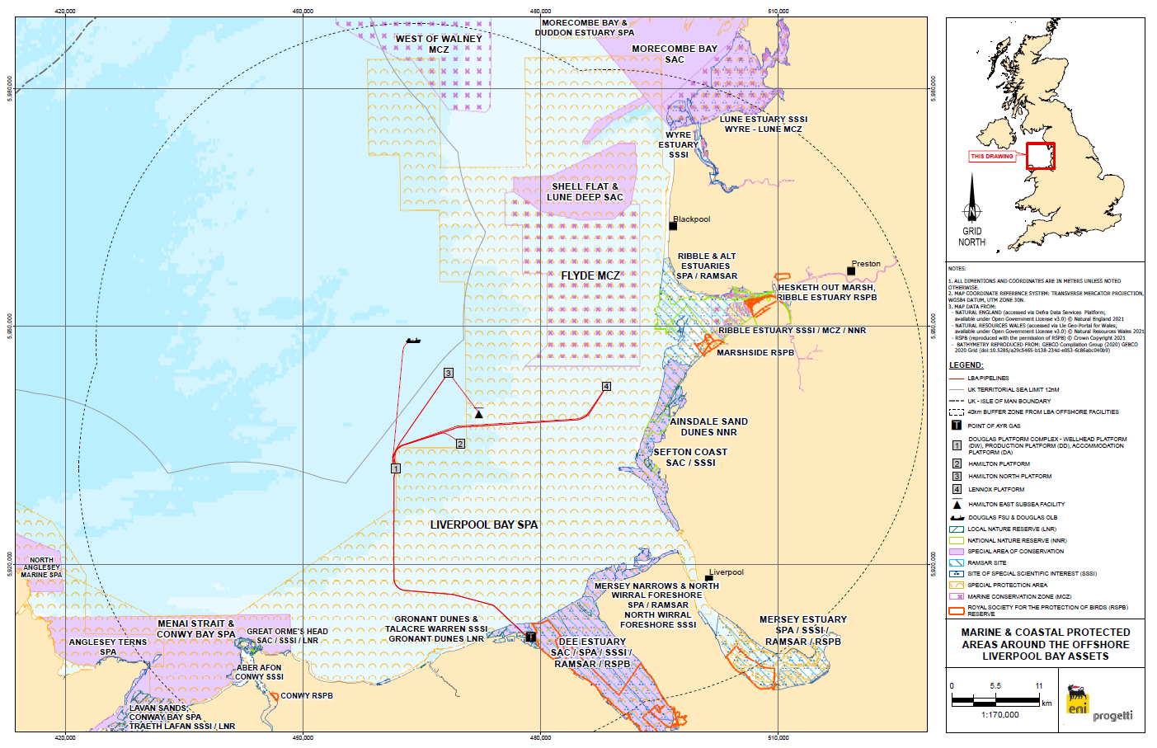

**Figure 4‑2 Offshore Windfarms, Cables and Aggregates in the LBA Project Area**

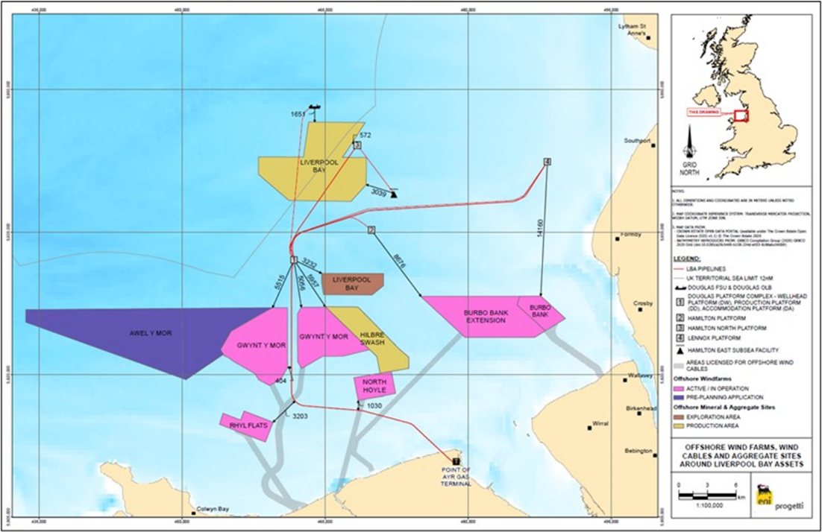

## **Potential Environmental Impacts and their Management**

There will be environmental impacts associated with the removal of the Hamilton, Hamilton North and Lennox topsides; however the impacts will be managed such that they are localised, short-term and of low significance. Long-term environmental impacts are expected to be negligible. Cumulative and trans-boundary environmental impacts are also expected to be negligible.

Based on the findings of the EA, including the identification and subsequent application of appropriate mitigation measured and Project Management according to Eni UK’S HSEQ Policy and EMS, it is considered that the proposed PDP can be executed with no significant impact to the environmental or societal receptors within the UKCS or internationally.

The potential environmental impacts identified for each phase of the project and the associated proposed management can be found in

**Table 4‑2**:

**Table 4‑2 - Environmental Impact Management**

|  |  |  |
| --- | --- | --- |
| **Activity** | **Main Impacts** | **Management** |
| **Flushing and Cleaning Activities** | Flushing and cleaning of the topsides shall result in emissions to air due to venting and depressurisation, potential discharges and spills, generation of waste and potential seabed disturbance due to support vessel. | Flushing and cleaning shall be undertaken following normal operating procedures and with all necessary permits in place.    The base case for the flushing and cleaning activities is to flush the topsides downhole to the Douglas disposal wells, this will reduce waste and minimize the risk of spillages to sea.  An injectivity study has been performed, and a number of candidate wells have been identified. |
| **Topsides Removal and subsea cuttings and removal works** | The presence and activities of vessels executing the cutting and lifting works will result in emissions to air, generation of underwater noise, potential discharges and spills, and potential seabed disturbance due to removals vessel. There is also a potential to disturb nesting seabird on the topsides and disturb overwintering birds of the Liverpool Bay SPA For the short duration of the works, there will be a small increase in the baseline level of these emissions from high shipping activity in the area. | Nesting birds: Eni UK has been engaging EMT and SNCBs on the topic of nesting birds on LBA since 2021. Prior to lifting activities Eni UK will submit a Bird Management Strategy to align with the survey findings, regulations and JNCC advice. In addition, if any deterrents are used these will be deployed early in the season and will be retained for as long is needed.  Eni UK continue to trial mitigation measures across their assets in LBA to reduce the number of nesting birds on the platforms prior to decommissioning. Eni UK will also continue to engage with OPRED on this subject and acknowledge that if wild birds are nesting on the platforms at the time of the platform removal, Eni UK will not be able to proceed without a wild bird licence granted by OPRED covering the required number of birds, nests and eggs.  Overwintering birds:  The following measures will be adopted to ensure that any impacts from seabird disturbance are minimised to as low as reasonably practicable:   * The contractors will implement a Vessel Management Plan. Where winter operations cannot be avoided, Eni UK will impose a number of measures to minimize impacts to the Liverpool Bay SPA i.e. Vessels to approach from the west and if it is not possible to avoid the SPA, where marine operations allow, they will use pre-existing shipping lanes * Use slow transit speeds * Seasonal planning   Continuous engagement with JNCC and OPRED during decommissioning works.The proposed topside removal method is a single lift, by HLV, activities will be planned to be executed as efficiently as possible. Vessels will be managed to minimise the durations required while on board practices will address fuel efficiency, noise and waste management. Where possible works will be undertaken outside of breeding and overwintering seasons of sensitive species. In addition to appropriate planning the following management shall be put in place:   * Seabed disturbance   + Vessel selection   + Anchoring / locating procedures will be developed.   + Post-decommissioning survey to recover any debris.   + All necessary permits will be in place.   + Minimise potential for dropped objects. * Noise   + Plan and execute activities as efficiently as possible and select equipment and removal method to minimise cutting and vessel operations. * Discharges and Spills   + Hydrocarbon inventories to be removed from the topsides prior to commencing removal operations.   + Contain any unpredicted releases.   + OPEP in place to deal with emergency spills. |
| **Seabed removals** | To enable the safe removal of the LBA topsides there is a requirement to undertake some limited seabed removals works as detailed in Section 3.0. These removals works are anticipated to create limited areas of seabed disturbance.    Total area of seabed disturbance is estimated to be:   * Douglas Complex– 32,971m2 * Lennox - 12,465m2 * Hamilton) – 9829m2 * Hamilton North – 18,907m2 * Total – 83,952m2 | All seabed removals work shall be undertaken subject to approved permits including PWAs and associated Marine licenses. The area of seabed disturbance shall be minimized as much as possible and shall be within the 500m zone of the associated asset. Impacts are anticipated to be of a short duration with no long-term effects.  Decommissioning activities will be planned to be executed as efficiently as possible, minimising disturbance of the seabed in order to reduce the impact on the affected areas.  Vessels will be managed to minimise the durations required while on board practices will address fuel efficiency, noise and waste management. |
| **Decommissioning Drill Cuttings** | The EBS found no evidence of cutting piles remaining under the platforms due to the nature of the highly mobile seabed in which the infrastructure lies and the length of time since the drilling was undertaken. | In the event that cuttings are identified OPRED will be notified, and appropriate management processes will be put in place. |
| **Platform well P&A** | All subsea wells need to be abandoned prior to subsea structure removal to meet NSTA and HSEx regulatory requirements. | Well abandonment will be undertaken in accordance with approved well designs, applicable legislation, Permits Licences, Consents, Notifications and Approvals will be applied for commensurate with the work, and any associated conditions will be complied with and verified. |

# INTERESTED PARTY CONSULTATIONS

**Consultations Summary:**

The summary of the key stakeholder engagements is presented in the Table 5-1.

**Table 5‑1 - Summary of Stakeholder Comments**

| **Who** | **Comment** | **Response** |
| --- | --- | --- |
| **Informal Stakeholder Consultations** | | |
| **Joint Nature Conservation Committee**  **(JNCC)** | * JNCC have been engaged to assess the impact of marine biodiversity and ornithology (e.g. nesting birds, especially kittiwakes) | * Eni UK provided all the available information including methods of deterring birds from nesting on the platforms in the LBA field. There will be an ongoing engagement with JNCC to ensure minimal disturbance to any nesting birds offshore, and to ensure that Eni UK will be in full compliance with the relevant regulations. |
| **Health and Safety Executive (HSEx)** | * Ongoing engagement with the HSEx to discuss safety case and CDM requirements throughout the decommissioning phases. | * HSEx have advised that the dismantling can be included in a phased safety case. Safety case strategy in constant review. First material changes approved. * HSEx have advised that CDM regs can be applied offshore. Eni UK are considering this. |
| **Natural Resource Wales and Flintshire County Council Local Planning Authority (Onshore)** | * NRW have been engaged to discuss the surrender of the Point of Ayr Environmental permit. * Onshore decommissioning and dismantling were also discussed in the Town and Country Planning Act (TCPA) application. | * Sampling to be undertaken to support permit surrender. Sampling already undertaken to support TCPA conditions. * Permit surrender strategy submitted to NRW for information. Ongoing consultation. * TCPA approved with conditions, discharge of conditions due to commence imminently. |
| **Shipping and Navigation Organisations** | * Proposed Project overview including baseline shipping and navigational features and navigational risk assessment were presented. * Consultees were asked if there were any other parties to be included in the engagement or information dissemination process. * Port of Liverpool Authority requested the works to be broken down into phases to allow all the necessary permits to be obtained in a timely manner. | * Royal Yachting Association confirmed being contend with the information presented. * Stakeholders confirmed availability of their networks and willingness to disseminate the information as required. * The Port of Liverpool Authority’s request is in line with the Eni activity planning. |
| **Statutory Consultations** | | |
| National Federation of Fishermen’s Organisations | The Eni UK Limited Fisheries Liaison Officer (FLO) has consulted with the NFFO. | It was agreed that further engagement would take place, once schedule of work firmed up. |
| Scottish Fishermen’s Federation | As outside of Scottish waters, the SFF indicated that discussions should be deferred to the NFFO. |  |
| Northern Ireland Fish Producers Organisation | The Eni UK Limited FLO has consulted with the NIFPO. | Response awaited. |
| Global Marine System’s Limited | The Eni UK Limited FLO has consulted with Global Marine Systems. | Response awaited. |
| North Sea Transition Authority | Eni UK Limited has consulted with NSTA under S29(2A) of the Petroleum Act. |  |

| **Who** | **Comment** | **Response** |
| --- | --- | --- |
| **Public Consultation** | | |
|  |  |  |
|  |  |  |
|  |  |  |

# PROGRAMME MANAGEMENT

## **Project Management and Verification**

An Eni UK Decommissioning Project Management team will be set up to manage suitable sub-contractors for the removal of the installation. Standard procedures for operational control and hazard identification and management will be used.

Eni UK has had regular meetings with OPRED and will continue to do so in order to provide verification concerning progress and compliance.

The Management team will monitor and track the process of consents and the consultations required as part of this process. Any variances to the Decommissioning Programmes will be discussed and agreed with OPRED.

## **Post-Decommissioning Debris Clearance and Verification**

Sea bed surveys will establish the extent of any debris or other oilfield related materials on the sea bed.

The environmental baseline seabed survey will provide detailed information on the existence of debris.

If debris is found during the surveys, the removal of this will be assessed and dealt with appropriately during the near platform seabed removal or later pipelines decommissioning scope. One of the objectives of the project is to leave the seabed in a state such that it is safe to other users of the sea.

Following the partial decommissioning of the installations, further post decommission surveys will be undertaken in tandem with LBA CCS T&S project surveys to determine if any debris remains within a 500m radius of installations. Seabed clearance verification will be undertaken, using methods and techniques agreed in prior consultation with OPRED following decommissioning activities.

## **Schedule**

The main milestones of these Partial Decommissioning Programmes are:

**Figure 6‑1 - Liverpool Bay Asset Execution Schedule**

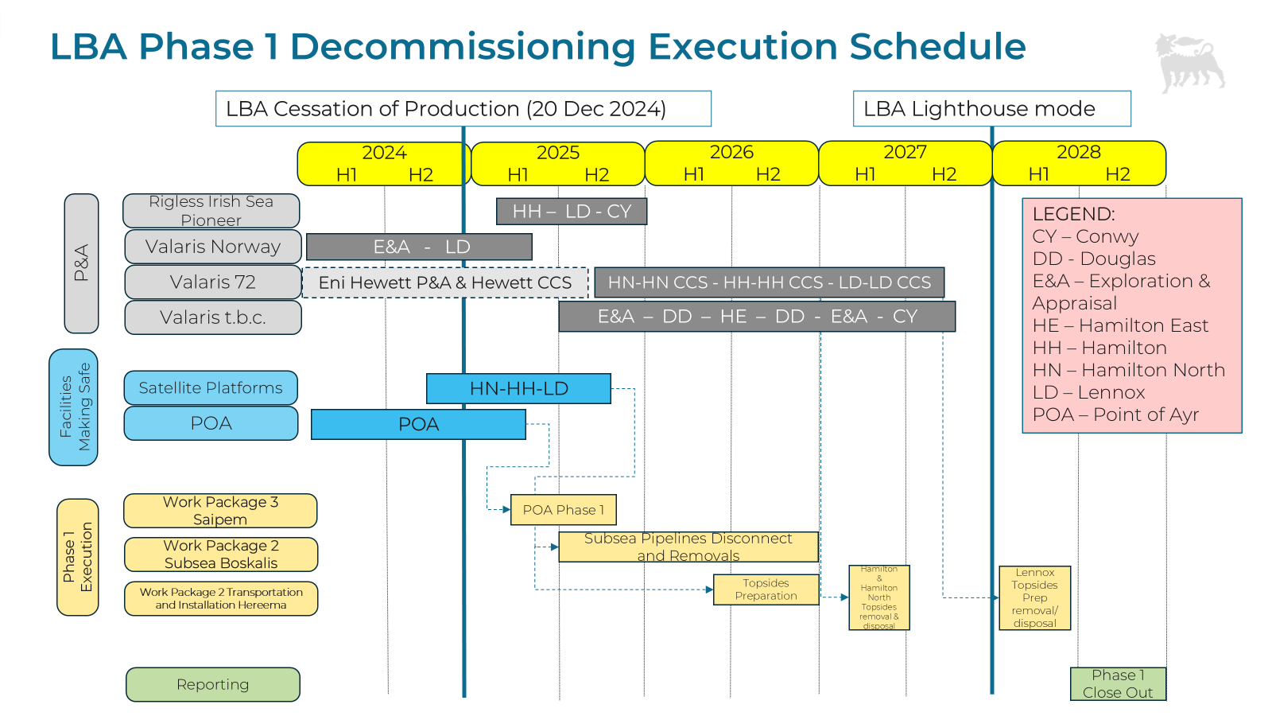

The decommissioning schedule may change subject to agreement of the CCS project schedule with DESNZ.

**Table 6‑1 - Partial Decommissioning Programmes Milestones**

|  |  |
| --- | --- |
| **Milestones** | **Approx. Date** |
| Issue ITT Package for Platform Decommissioning | 2023 |
| Award Platform Decommissioning Contract | 2025 |
| Start of Platform Decommissioning Preparation Works window | 2025 |
| Satellite Platforms (LD, HH, HN) Deck Removal Window Start  (First Platform Available) | 2026/2027 |
| Platforms Removal & Disposal Window End | 2027 |
| Platforms Decommissioning Programmes Close-Out Report Submission | 2028 |

## **Costs**

**Table 6‑2- Provisional Decommissioning Programmes Costs**



* Estimated Costs are confidential and will be provided separately to OPRED

## **Close Out**

A close out report will be submitted to OPRED within 12 months of the completion of decommissioning activities, including debris clearance and post-decommissioning surveys. The close out report will notify OPRED of any variances to outcomes that have been detailed in these Decommissioning Programmes.

## **Post-Decommissioning Monitoring and Evaluation**

This decommissioning programme relates only to the partial decommissioning activities to support the CCS project. The pipeline sections and infrastructure included within this DP will be completely removed and returned to shore for reuse, recycling, or disposal.

The removal of the infrastructure not being re-used for CCS will be undertaken at a later date under a separate DP. After the phase 2 removal works a post-decommissioning environmental seabed survey will be undertaken which will include a further suite of Side Scan Sonar and MBES work. The post-decommissioning survey will also repeat the Sediment Physio-Chemistry and Faunal Analysis to determine whether there has been any change to the marine environment. A clear seabed validation would be sought at this time.

For the infrastructure being reused for the CCS project will be monitored under the inspection repair and maintenance surveys.

The proposed approach will be the subject of further consultations with the Regulatory Authorities and the statutory consultees.

# SUPPORTING DOCUMENTS

1. Eni UK Liverpool Bay Partial Decommissioning Comparative Assessment, Final Version, ERM, July 2024
2. Partial Decommissioning Programme Environmental Appraisal, Final Version, Eniprogetti UK, April 2025

# SECTION 29 NOTICE HOLDERS LETTERS OF SUPPORT

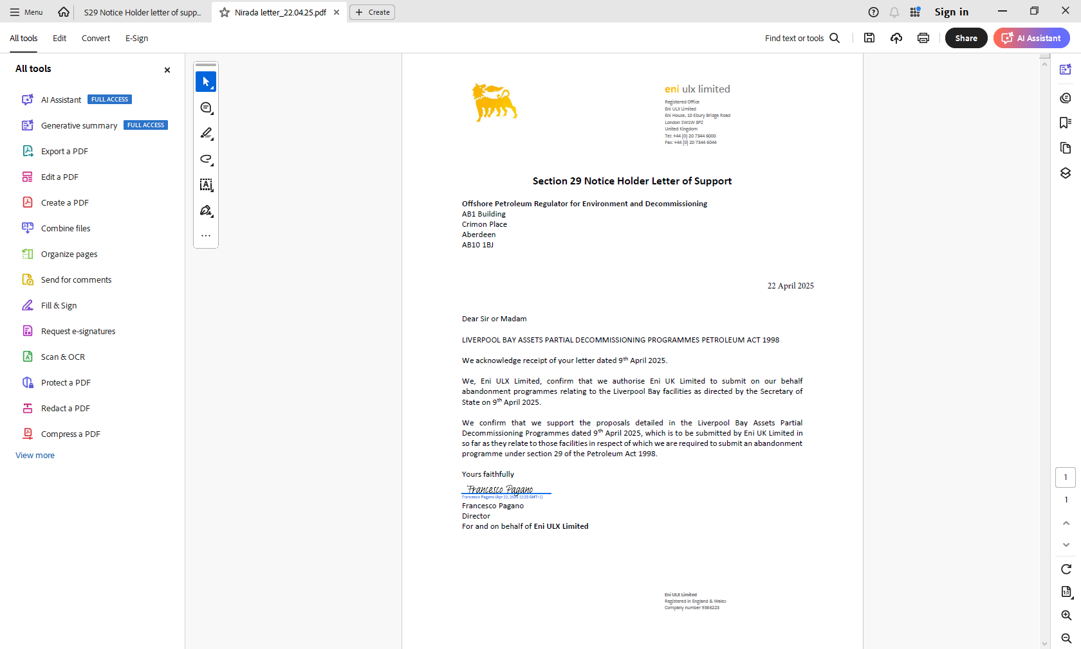

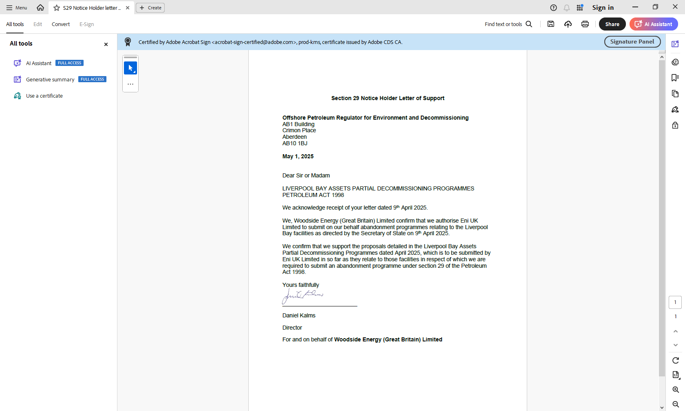

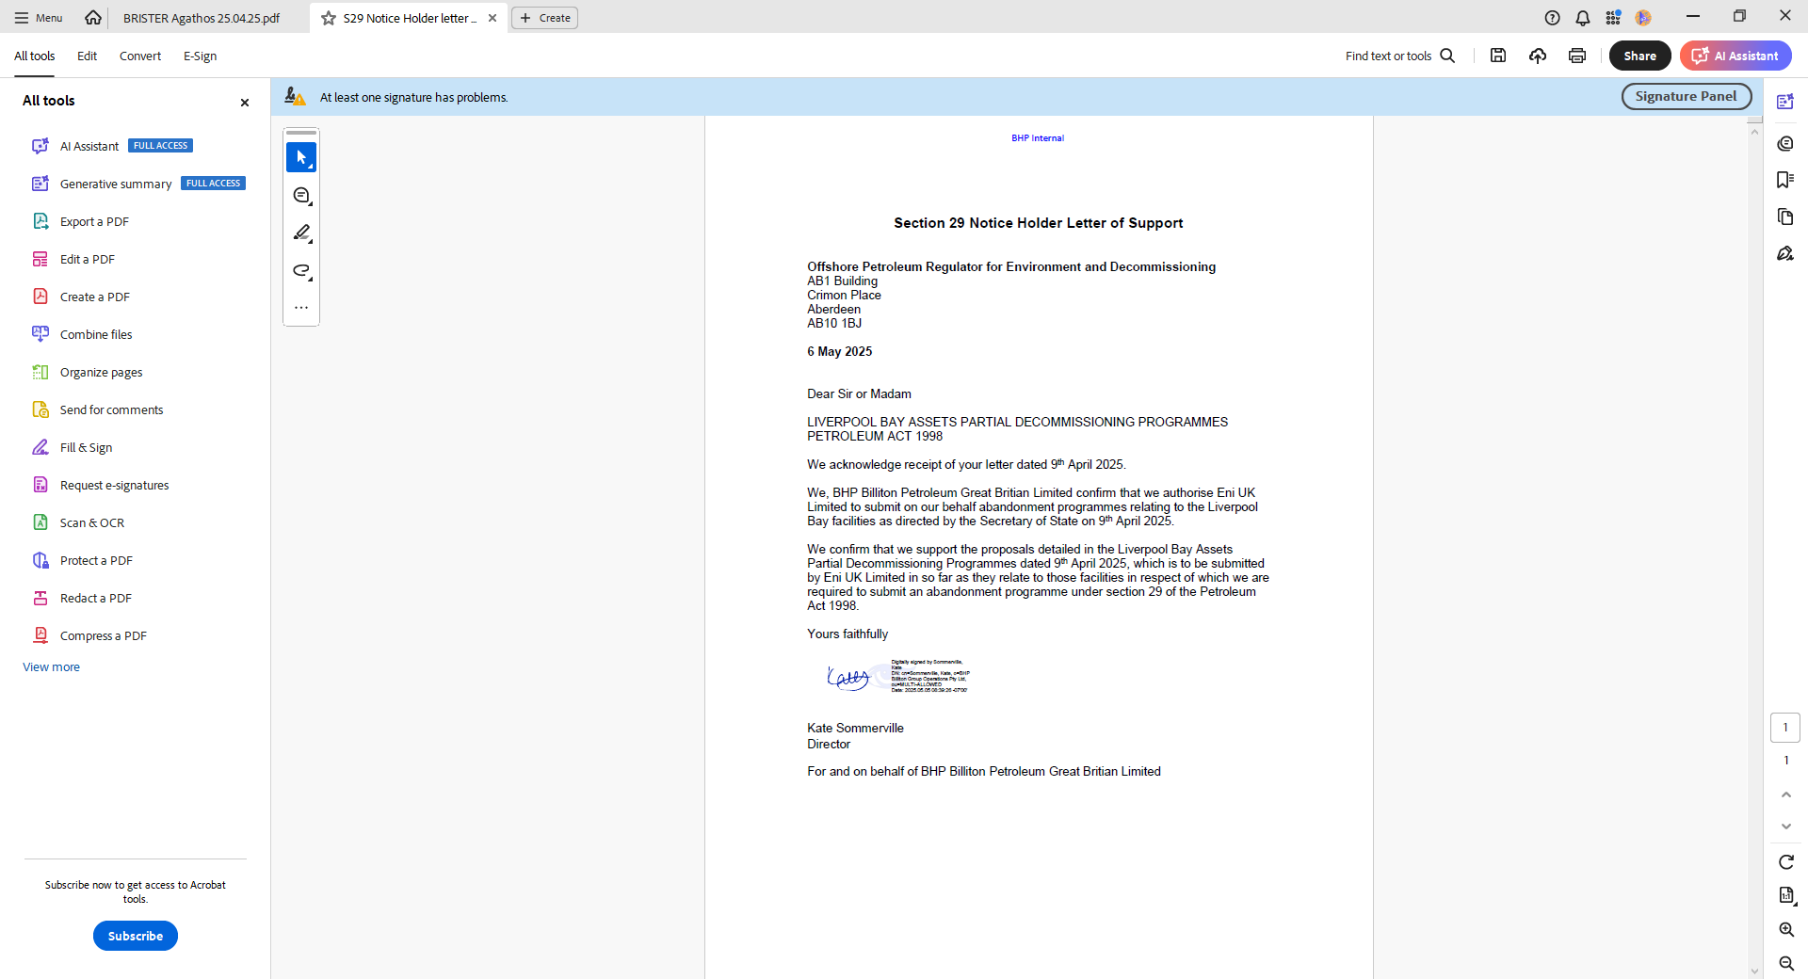

# APPENDIX A - PUBLIC NOTICE

**PUBLIC NOTICE**

The Petroleum Act 1998

**LIVERPOOL BAY ASSET / PARTIAL DECOMMISSIONING PROGRAMMES**

Eni UK Limited has submitted, for the consideration of the Secretary of State for the Department for Energy Security & Net Zero, draft Decommissioning Programmes for the Liverpool Bay Assets (LBA) facilities in accordance with the provisions of the Petroleum Act 1998. It is a requirement of the Act that interested parties be consulted on such decommissioning proposals.

The items/facilities covered by the Decommissioning Programme(s) are:

* The Lennox (Blocks 110/15a and 110/14c), Hamilton (Block 110/13a), and Hamilton North (Block 110/13a) satellite platforms
* Pipelines and stabilisation features at Douglas (Block 110/13b), Hamilton, Hamilton North, Hamilton East (110/13a and 110/14a) and Lennox (Blocks 110/15a and 110/14c)

The three platforms at Lennox, Hamilton and Hamilton North are satellite platforms and are not permanently manned installations (NPAI). Each platform consists of a steel jacket supporting a topsides structure. It is intended to remove the topsides structure, and to re-use the jackets for a carbon dioxide transportation and storage project, which has been the subject of previous public consultations.

The pipelines and stabilisation features are intended be removed in the near platform area to facilitate the laying of new pipelines and cables, and the tie-in to existing pipelines for re-use.

The Liverpool Bay Assets are located in Blocks 110/13a, 110/13b, 110/14a, 110/14c, and 110/15a of the UKCS in the East Irish Sea, approximately 23km north of the Welsh coastline.

Eni UK Limited hereby gives notice that a summary of the Liverpool Bay Assets Partial Decommissioning Programmes can be viewed at the internet address:

<https://www.hynethub.co.uk>

Alternatively, a hard copy of the Decommissioning Programme can be obtained by contacting Cerys Percival with the contact details below.

Representations regarding the LBA Partial Decommissioning Programmes should be submitted in writing to the following address where they should be received by 19 August 2024 and should state the grounds upon which any representations are being made.

Liverpool Bay Assets Decommissioning Team

Eni UK Ltd

Eni House

10 Ebury Bridge Road

London SW1W 8PZ

**Tel**: 01352 842200

**Email**: [cerys.percival@eni.com](mailto:cerys.percival@eni.com)

Date: 22 July 2024

# APPENDIX B – PIPELINE CUT POINT COORDINATES

|  |  |  |  |  |  |
| --- | --- | --- | --- | --- | --- |
| ***Platform*** | ***Description*** | ***Easting*** | ***Northing*** | ***Longitude*** | ***Latitude*** |
| ***Lennox*** | *PL 1035 Tie-in @ Lennox, upstream SSBV* | *488315.2193* | *5942647.694* | *W3° 10' 36.09"* | *N53° 37' 52.85"* |
| *PL 1035 Tie-in @ Lennox, downstream SSBV* | *488340.4248* | *5942689.057* | *W3° 10' 34.73"* | *N53° 37' 54.19"* |
| *PL 1036A Tie-In @ Lennox, upstream SSBV* | *488409.9816* | *5942530.688* | *W3° 10' 30.92"* | *N53° 37' 49.07"* |
| *PL 1036A Tie-In @ Lennox, downstream SSBV* | *488448.4097* | *5942591.273* | *W3° 10' 28.84"* | *N53° 37' 51.04"* |
| *PL 1036 Gas Injection, PL 1038 Wax Inhibitor Lennox to Douglas Production* | *488350.2460* | *5942625.536* | *W3° 10' 34.18''* | *N53° 37' 52.14''* |
| *PL 1034 Oil, PL 1037 Methanol Lennox to Douglas Production* | *488332.3410* | *5942637.172* | *W3° 10' 35.16''* | *N53° 37' 52.51''* |
| *PL 6426 Power Cable – Hamilton to Lennox* | *488431.7769* | *5942684.132* | *W3° 10' 29.75"* | *N53° 37' 54.04"* |
| ***Hamilton North*** | *PL 6423 Power Cable - from Douglas Production to Hamilton North* | *468503.5072* | *5944441.485* | *W3° 28' 35.23''* | *N53° 38' 47.95''* |
| *Umbilical PLU 1861 - from Hamilton East to Hamilton North* | *468563.5287* | *5944453.468* | *W3° 28' 31.97''* | *N53° 38' 48.36''* |
| *Gas Export PL 1860 - from Hamilton East to Hamilton North* | *468571.5058* | *5944463.408* | *W3° 28' 31.54''* | *N53° 38' 48.68''* |
| ***Hamilton*** | *PL 6424 Power Cable from Douglas Production to Hamilton* | *469876.8949* | *5935524.521* | *W3° 27' 17.33''* | *N53° 33' 59.72''* |
| *PL 1040 Methanol from Hamilton to Douglas Production* | *469919.1512* | *5935548.028* | *W3° 27' 15.05''* | *N53° 34' 0.49''* |
| *PL 6426 Power Cable – Hamilton to Lennox* | *470077.6939* | *5935543.721* | *W3° 27' 06.43"* | *N53° 34' 00.38"* |
| ***Douglas Complex*** | *PL 1034 Oil,  PL 1037 Methanol Lennox to Douglas Production* | *461722.6008* | *5932733.654* | *W3° 34' 39.31''* | *N53° 32' 27.51''* |
| *PL 1036 Gas Injection,  PL 1038 Wax inhibitor Lennox to Douglas Production* | *461743.1064* | *5932745.183* | *W3° 34' 38.2''* | *N53° 32' 27.89''* |
| *PL 1041 Gas,  PL 1042 Methanol Hamilton North to Douglas Production* | *461679.8381* | *5932613.323* | *W3° 34' 41.58''* | *N53° 32' 23.6''* |
| *PL 1035 Gas Lennox to Douglas Production* | *461735.6476* | *5932625.530* | *W3° 34' 38.55''* | *N53° 32' 24.01''* |
| *PL 1039 Gas,  PL 1040 Methanol Hamilton to Douglas Production* | *461783.9235* | *5932629.228* | *W3° 34' 35.93''* | *N53° 32' 24.15''* |
| *PL 1036A Gas Lennox to Douglas Production* | *461805.7964* | *5932620.549* | *W3° 34' 34.74''* | *N53° 32' 23.87''* |
| *PL 1030 Gas Douglas Production to Point of Ayr* | *461775.8111* | *5932229.397* | *W3° 34' 36.19''* | *N53° 32' 11.21''* |
| *PL 1032 Condensate,  PL 1033 Methanol Point of Ayr to Douglas Production* | *461788.1790* | *5932227.171* | *W3° 34' 35.52''* | *N53° 32' 11.14''* |
| *PL 6423 Power Cable – Douglas to Hamilton North* | *461673.4678* | *5932705.970* | *W3° 34' 41.96"* | *N53° 32' 26.60"* |
| *PL 6424 Power Cable – Douglas to Hamilton* | *461681.9698* | *5932710.761* | *W3° 34' 41.50"* | *N53° 32' 26.76"* |

Please note that the exact locations will be modified to address any change in seabed elevation over time due to the action of currents on mobile sediments, and subject to further review/updates following the detailed engineering of Boskalis.