ATTORNEY GENERAL’S PUBLIC INTERNATIONAL LAW PANELS COMPETITION 2025

Information Session and Q&A


Please join us for an online information session and Q&A on:
Tuesday 20 May, 5pm to 6pm
The Panel Counsel Secretariat will be holding an event aimed at those who are interested in applying to the Attorney General’s Public International Law (PIL) panels.
Speakers include the Attorney General, a current Panel member and senior government lawyers who will talk about their experiences of instructing PIL panel counsel.

Applications open on Wednesday 14 May and close at midday, Wednesday 18 June. More information is available on GOV.UK.

The PIL panels were created in 2014 and supplement the work of the Attorney General’s existing panels of civil counsel. Members of the panels advise the Government on matters of public international law and undertake cases involving public international law in international courts and in the courts of the UK. The PIL panels are divided into A, B and C panels based on experience in the practical application of international law, whether as an adviser or advocate, or a mix of both.

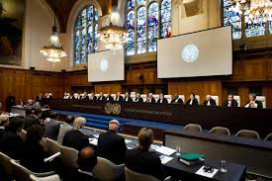

If you would like to attend, please email PanelCounsel@governmentlegal.gov.uk by Friday 16 May.

