

|  |
| --- |
| **Order Decisions** |
| Site Visit 11 March 2025 |
| **by Claire Tregembo BA (Hons) MIPROW** |
| **An Inspector appointed by the Secretary of State for Environment, Food and Rural Affairs** |
| **Decision date: 9 April 2025** |

|  |
| --- |
| **Order Ref: ROW/3317136 Creation Order** |
| * This Order is made under section 26 of the Highways Act 1980 and is known as the Lincolnshire County Council Creation of Public Bridleway Number 1207 Woodhall Spa. |
| * The Order is dated 10 November 2022 and proposes to create a public bridleway as shown on the Order plan and described in the Order Schedule. |
| * There were two objections outstanding when Lincolnshire County Council submitted the Order to the Secretary of State for Environment, Food and Rural Affairs for confirmation. |
| **Summary of Decision: The Order is confirmed.** |
|  |
| **Order Ref: ROW/3317698 Extinguishment Order** |
| * This Order is made under section 118 of the Highways Act 1980 and is known as the Lincolnshire County Council Extinguishment of Woodhall Spa Restricted Byway Number 1125. |
| * The Order is dated 10 November 2022 and proposes to extinguish a restricted byway shown on the Order plan and described in the Order Schedule. |
| * There were two objections outstanding when Lincolnshire County Council submitted the Order to the Secretary of State for Environment, Food and Rural Affairs for confirmation. |
| **Summary of Decision: The Order is confirmed.** |
|  |

Procedural Matters

1. There were two outstanding objections when Lincolnshire County Council (the Council) submitted the Orders to the Secretary of State for confirmation, but these were subsequently withdrawn. As there were no outstanding objections, the planned public inquiry was cancelled, and the Orders were determined with the papers of file.
2. I carried out a site visit on 11 March 2025, where I viewed the Order routes and surrounding areas.

The Main Issues

***The Creation Order***

1. Under section 26 of the Highways Act 1980 (1980 Act), if I am to confirm the Creation Order, I need to be satisfied there is a need for the proposed bridleway and that it is expedient it should be created having regard to:
2. the extent to which the path would add to the convenience or enjoyment of a substantial section of the public, or the convenience of persons resident in the area; and
3. the effect which the creation of the paths would have on the rights of the persons with an interest in the land, account being taken of the provisions for compensation.

***The Extinguishment Order***

1. The Extinguishment Order is made on the grounds that the restricted byway is not needed for public use. By virtue of section 118(2) of the 1980 Act, if I am to confirm the Order, I must be satisfied that it is expedient to extinguish the path having regard to:
2. the extent, (if any) to which it appears that the path would, apart from the Order, be likely to be used by the public; and
3. the effect the extinguishment of the right of way would have as respects land served by the path, account being taken of the provisions for compensation.
4. In accordance with section 118(6), any temporary circumstances preventing or diminishing the use of the path or way by the public shall be disregarded.
5. I have had regard to the judgements of *R v SSE ex parte Stewart* [1980] KPL 537 and *R v SSE (ex parte Cheshire County Council* [1991] JPL537 which clarified the relevant tests to be applied. Whilst the Order Making Authority must consider the need for the path for public use when making the Order, I must look at its likely future use.
6. Where an extinguishment is being considered concurrently with a creation, Section 118(5) provides that I may have regard to the extent to which a path provided by the Creation Order will provide an alternative path or way when considering the likely future use of the path proposed for extinguishment.

***Both Orders***

1. I also need to have regard to any material provision of any rights of way improvement plan (ROWIP) prepared by any local highway authority whose area includes land over which the Order relates.

Reasons

1. Restricted Byway 1125 (RB1125) runs between Mill Lane and the Water Rail Way, part of National Cycle Way Route 1, and is approximately 9 metres wide. It was added to the Definitive Map and Statement (DMS) following the confirmation of a Definitive Map Modification Order (DMMO) on 20 July 2017 following determination by an Inspector appointed by the Secretary of State for Environment, Food and Rural Affairs.
2. RB1125 is obstructed by number 59 Mill Lane at its eastern end. In order to resolve the obstruction, an Order was made to extinguish RB1125 and create a new bridleway along a nearby private road and then along the existing line of RB1125 with a width of 3 metres.

***The Creation Order***

*The need for the proposed bridleway*

1. The Council considers there is a need for the proposed bridleway to connect the Water Rail Way to Mill Lane and the nearby Woodhall Spa. The Water Rail Way runs between Lincoln and Boston on a flat, almost entirely traffic-free route.
2. I note that the Water Rail Way can also be accessed further south at Woodhall Spa Junction, a former railway station. However, this requires use of the B1191. The proposed bridleway allows access from Woodhall Spa along the quieter Mill Lane and Green Lane.
3. Therefore, I consider there is a need for a route between Mill Lane and the Water Rail Way which the proposed bridleway will provide.

*The extent to which the path would add to the convenience or enjoyment of the public or the convenience of residents*

1. The public and residents of the area will be able to access the Water Rail Way from quiet roads. It would also allow short circular walks using the proposed bridleway, the Water Rail Way, and Footpath 149 Woodhall Spa.
2. The proposed bridleway creation will also allow public access to the Water Rail Way without needing to navigate around 59 Mill Lane, which obstructs RB1125. This will also benefit the residents of 59 Mill Lane.
3. Therefore, I consider the proposed bridleway will add to the convenience and enjoyment of the public and residents.

*The effect on persons with an interest in the land*

1. The start of the proposed bridleway runs along an existing private road that provides vehicular access to farmland, a pumping station, and a residential property. The rest runs along the same route as RB1125 which is proposed to be extinguished. RB1125 has a recorded width of approximately 9 metres, and the proposed bridleway will be 3 metres wide.
2. However, the full width of RB1125 is not currently available for most of its length. Mort of it is bounded on the south by trees and a ditch, and on the north by a sheep wire fence. It comprises a stone track of approximately 3 metres, with grass verges of approximately 1 metre on either side. There are also unrecorded gates along RB1125 that were erected before it was added to the DMS and there is no provision to retain them.
3. The creation of the bridleway will allow the retention of the gates, improving security and stock control for the benefit of the landowners and occupiers. The reduced width will also mean the existing fences and trees do not need to be removed. This benefits the landowners and occupiers as they will not have to realign the boundaries, can preserve grazing land, and are able to better use and manage the land.
4. It is suggested the creation of the bridleway along the private road may affect the vehicular side access to number 61 Mill Lane. Recording public rights along the private road will not affect any existing private rights. A drop kerb already exists into the dwelling and use by the public would not affect this access point. Anyone driving along the private road already needs to drive with due care and attention to ensure the safety of anyone else using it.
5. One party considers the creation of the bridleway will negatively impact the permitted development rights of the adjoining properties. Permitted development can be restricted due to the proximity of a dwellinghouse to a highway. However, the Interpretation of Part 1, schedule 2 of The Town and Country Planning (General Permitted Development) (England) Order 2015 as amended states a highway includes an unadopted street or a private way. The proposed bridleway will run along an existing private vehicular road so there will not be any additional impact on permitted development rights.
6. It is stated that a high voltage line has been installed along the proposed bridleway which may be affected. Statutory undertakers were consulted prior to making the Order but no objections were received from them. The Council have also not been informed of any works that affected RB1125.
7. Some parties consider the bridleway creation will encourage future development. The existing private road and RB1125 already provide access to the land. Anyone wishing to develop the land would be using private rights to access it. Under the Town and Country Planning Act 1990, public rights of way can be diverted or extinguished to enable approved development to be carried out. RB1125 already crosses this land so the creation of a bridleway would not change the need for an Order. Therefore, if the Creation Order is confirmed, there is unlikely to be any impact on the likelihood of the land being developed.
8. I consider there will be benefits to some of the owners and occupiers of the land and the rights of those with an interest in the land will not be adversely affected by the proposed bridleway.

*The alignment at the eastern end of the proposed bridleway*

1. It has been suggested that the proposed bridleway should run along the southeastern verge of the private road rather than the northwestern verge as proposed. This would mean it would run along the boundary of number 59 Mill Lane, rather than the boundary of 61 Mill Lane. Therefore, the proposed bridleway would be alongside the property that currently has RB1125 passing through it rather than a neighbouring property.
2. There is currently a kissing gate on the proposed bridleway at point G3 that provides pedestrian access to RB1125 at the northwestern corner of the private road. No date is given for the erection of this kissing gate, but it was installed before 2010 with the agreement of the then owner of number 61 Mill Lane.
3. Although I understand the reasoning behind this suggestion, the verge along the northwestern side of the private road is wider than on the southeastern side making it easier to use. It is also likely that the public have been using this alignment since at least 2010 so public footpath rights may already have come into existence through use. It would not be in the best interests of the landowners to have a bridleway along one of the roadside verges and a footpath along the other. Therefore, I consider it would not be in the interests of the landowner or the public to change the alignment of the proposed bridleway along the private road.

*Conclusions on whether it is expedient to confirm the creation order*

1. I consider the proposed bridleway is needed for public use and would add to the convenience and enjoyment of the public and residents. There are benefits to the landowners and occupiers of the land and limited adverse effects. Having regard to these and all other matters, I consider it is expedient to confirm the Creation Order.

***The Extinguishment Order***

*The extent to which it appears that the path would, apart from the Order, be likely to be used by the public*

1. RB1125 connects to the Water Rail Way at its western end. There are structures along the Water Rail Way that prevent access to larger restricted byway users such as horse and carts. As larger restricted byway users would have limited use of the Water Rail Way, I consider they are unlikely to use RB1125 due to its short length.
2. Pedestrians, cyclists, and horse riders are able to continue along the Water Rail Way, and are likely to use RB1125 if it is available. However, RB1125 is obstructed by a dwelling at its eastern end. Walkers appear to be using the private road, which is part of the proposed bridleway, but a kissing gate prevents access to horse riders and cyclists. However, even if RB1125 were available for use, I consider there are members of the public who would not feel comfortable passing through the grounds of a private dwelling and would prefer to use the proposed bridleway.
3. There is a clear worn line across the cross-field section but only to a width of around 2.5 to 3 metres. The verges along the enclosed section also do not appear to be being used. Therefore, those using RB1125 do not appear to be using the full recorded or available width and are unlikely to do so. Therefore, a width of 3 metres is sufficient for public use and allows two horses to pass each other.
4. I consider RB1125 is unlikely to be used by the public if the Creation Order for a public bridleway is confirmed.

*The extent to which the Creation Order would provide alternative paths*

1. If the Creation Order for the proposed bridleway is confirmed, I consider it would provide a suitable alternative path to RB1125.

*The effect the extinguishment of the path would have as respects land served by the path, account being taken to the provisions as to compensation*

1. The eastern end of RB1125 passes through the house and gardens of 59 Mill Lane. The extinguishment of RB1125 would benefit the landowner by removing a right of way through their house and garden.
2. The reduction in the width of the public path over the agricultural land would benefit those using it for grazing as they would not need to remove the existing boundaries that restrict the width of RB1125. If they wanted to enclose the cross-field section in the future, the reduced width of the bridleway would result in less land being lost to grazing.

*Whether it is expedient that the path should be stopped up*

1. I consider RB1125 is only used to a width of around 2.5 to 3 metres and is only likely to be used by walkers, cyclists, and horse riders. The extinguishment of RB1125 is dependent on the creation of an alternative public bridleway. If the bridleway is created, RB1125 would not be needed for public use. I have already concluded in paragraph 28 that it is expedient to confirm the Creation Order for the bridleway. Accordingly, I conclude it is expedient to confirm the Extinguishment Order.

**Rights of Way Improvement Plan**

1. The Council consider the Orders are compatible with their ROWIP. None of the other parties have raised any matters in relation to the ROWIP.

**Other Matters**

1. Most of the objections to the Orders concerned the existence of RB1125. The DMS is conclusive evidence of the ways recorded on it. Therefore, it is not before me to determine the existence of RB1125. If anyone considers there is evidence to indicate a route should not be recorded on the DMS, a DMMO Application should be made to modify the DMS.

Overall Conclusion

1. Having regard to these and all other matters raised in the written representations, I conclude that the Creation Order and Extinguishment Order should be confirmed.

Formal Decision

***The Creation Order***

1. I confirm the Order.

***The Extinguishment Order***

1. I confirm the Order.

Claire Tregembo

INSPECTOR

**Order Maps**

**Creation Order**

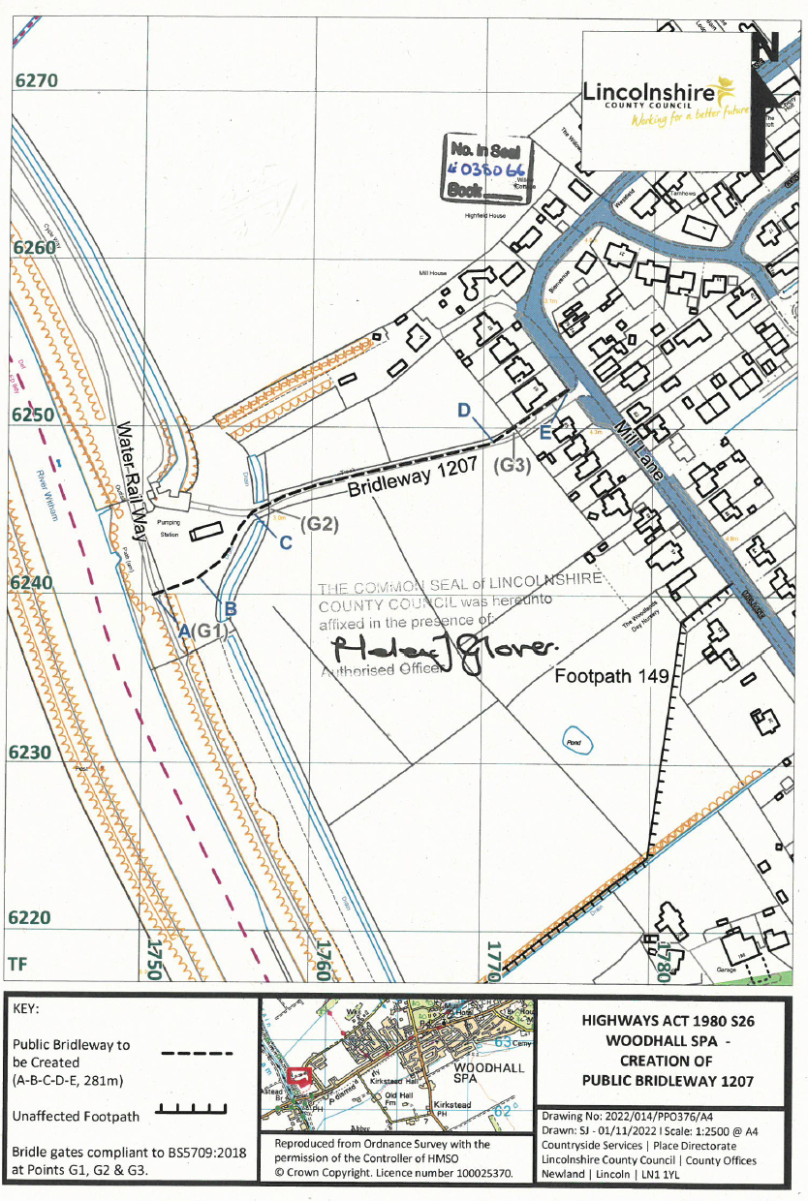

**Extinguishment Order**

