

Serious Incidents Annual Report
2023/24
April 2025

Contents
Executive summary 4
Key findings 6
1. Introduction 8
2. Serious incidents - analysis 9
2.1 Data limitations 9
2.2 Serious incidents by type 10
2.3 Serious incidents by type and area 11
2.4 Serious incidents by age/sex/ethnicity 14
2.5 Ministerial briefings 17
3. Children involved in serious incidents – analysis 19
3.1 Notes on data used 19
3.2 Time to charge 19
3.3 Previous cautions and convictions, bail status 20
3.4 Knife/blade involvement 22
3.4 Exploitation, gang affiliation and the use of the National Referral Mechanism 23
3.5 Experience of Adverse Childhood Experiences (ACEs) or domestic violence 26
3.6 Children with experience of care and accommodation needs 27
3.7 Special education needs and neurodiversity 27
3.8 Contact with other services 28
4. Summary by Incident Type 29
4.1 Murder/Manslaughter 29
4.2 Attempted Murder 29
4.3 Grievous Bodily Harm (GBH) 30
4.4 Rape 30
4.5 Terrorist-related offences 31
4.6 Death of a child 31
5. Serious incidents – impacts on services 32
5.1 Risk management 32
5.2 Emotional toll 33
5.3 Children unknown to services 34
5.4 Additional findings 35
6. Emerging themes and recommendations 36
7. Conclusion 38
8. Frequently Asked Questions 39

Executive summary


This year’s serious incident report – the first published by the Youth Justice Board (YJB) - builds upon the growing body of evidence relating to children involved in serious violence and the increasing need for the sector to work more collaboratively to address this complex issue.
It is our hope that in publishing this report, we empower all those working with children to reflect on its findings and consider what learning can be taken to reduce serious incidents, the numbers of children involved in them, which will in turn reduce the number of victims.
While we must emphasise that this information should not be interpreted as a measure of serious violence as the dataset may be incomplete, the unique nature of Serious Incidents Notifications, which differ from the published Youth Justice Annual Statistics which are based on outcomes, allows the YJB to have improved oversight of the youth justice system, enabling us to not only provide support to youth justice services (YJS), but also amplify the complex backgrounds of some of the children involved along with the impact on victims, which are often children themselves.
This year’s report highlights that children involved in serious incidents are often victims of the challenging circumstances in which they live. While this acknowledgment does not diminish the significant impact that these children can have on others, it underscores the urgent need to address their vulnerabilities and exploitation, and to ensure effective early intervention to safeguard them from harm. The report also draws attention to the over-representation of Black and ethnic minority children in serious incidents, highlighting the importance of targeted, equitable support.
Our commitment to review and improve the notification process for services continues, with changes including moving to an online system for reporting serious incidents and making improvements to the form itself. Future developments include improving the completeness of serious incident reporting, disseminating learning and case review findings back to the sector and improving our analytical reporting mechanisms. We are also interested in understanding how the statistics on serious incidents involving children compare with those involving adults, and in exploring opportunities for greater alignment with the Department for Education’s serious case review process.
We are grateful to all the YJSs that have diligently provided Serious Incident Notifications this year, and to those who participated in interviews and focus groups to share their experiences of serious incidents in their local communities. We appreciate the incredibly sensitive nature of these incidents, and the profound impact they can have on the children involved, their victims, families, communities, and professional staff involved. The YJB is committed to working with partners to reduce serious incidents involving children and we will work with key stakeholders to agree actions to address the themes identified in the report over the coming months. We hope readers will find value in the insights in this report.


Stephanie Roberts-Bibby
Chief Executive Officer
Youth Justice Board for England and Wales

Key findings
The Serious Incident Annual Report provides a comprehensive overview of 438 serious incidents notified to the Youth Justice Board (YJB) in 2023-24 and the 546 children involved, highlighting key themes and recommendations. Whilst serious incident reporting has been mandatory for youth justice services (YJSs) since April 2022, this is the first year of published findings. A summary of the key findings is below.

Whilst there are limitations to this data (please see section 2.1 Data Limitations), this report underscores the importance of addressing exploitation, knife crime, and the vulnerabilities of children with special educational needs or who are neurodivergent. It also highlights the need for timely, effective interventions which address underlying causes, and support to prevent children from being involved in serious incidents.

To learn more about the notification process itself, please see the Serious incidents notification: standard operating procedures for YJSs - GOV.UK

Criminal exploitation
- 41% of all children notified were said to be gang affiliated, criminally exploited, or involved with the National Referral Mechanism (NRM) process; 42% of all boys and 29% of all girls.
- 20% of all children notified had exploitation concerns identified relating to the charge, of these; 58% an NRM referral was due to be made and 42% had a previous NRM referral but were awaiting a decision.

Offence types
- 55% of all notifications were for Grievous Bodily Harm (GBH), 16% for Rape, 13% for Murder/Manslaughter, 9% Attempted Murder and 3% Terrorism offences.
- 56% of incidents notified were knife/blade enabled.
- 92% of Attempted Murder notifications indicated there was knife or blade involvement, 84% of Murder/Manslaughter, and 62% of Grievous Bodily Harm incidents.
- Rape charges increased from 8-13% of overall notifications when compared to the previous year.

Contact with services
- 36% of all children charged were under the supervision of a youth justice service at the time of the incident.
- 24% were not known to YJSs, nor were they engaged in support from any other local authority service at the time of the incident.
- 49% of children notified had no previous cautions and convictions, increasing to 92% for children charged with terrorism offences.
- 71% of children notified for murder were not supervised by a youth justice service at the time of the incident, but were known to other agencies, social care, education, health.
- 63% had some kind of previous contact with a local authority or Children and Adolescent Mental Health Service (CAMHS), of these 24% were engaged with both the youth justice service and one or more other services at the time of the incident.

Safeguarding and vulnerabilities
- Of the 63% who had some kind of previous contact with a local authority or CAMHS service;
  - 29% were identified as Children in Need or in Wales, Children with care and support needs
  - 19% were subject of a Child Protection Plan
  - 27% were in the care of the local authority as a looked after child, with 48% of these reported to have gang involvement and/or exploitation concerns.
- 23% of children reported had identified Special Educational Needs, in Wales Additional Learning Needs/Neurodiversity.
Of these;
  - 19% had an Education Health Care Plan (EHCP) or in Wales Individual Development Plans
  - 48% were diagnosed with Attention Deficit Disorder (ADD) or Attention Deficit Hyperactivity Disorder (ADHD) or Autistic Spectrum Disorder (ASD)
  - 53% reported risks associated with exploitation.
- 43% of children notified due to their death whilst under the supervision of the youth justice service were victims of murder and 19% died by suicide.

Demographics and over-representation
- 96% of the children notified were boys
- 68% of the children notified were 16-17 years old; 99% of these were boys.
- 48% of all children notified were from ethnic minority backgrounds and significantly overrepresented compared to the general 10-17 population (27%)
- 17% of children reported were from Black backgrounds and significantly overrepresented compared to the general 10-17 population (6%)
- 17% of children reported were from Mixed backgrounds and significantly overrepresented compared to the general 10-17 population (6%)

Timeliness of investigations and decision making
- Rape offences took the longest from offence to charge, averaging 380 days, followed by terrorism offences at 230 days.
- 32% of all incidents took longer than 180 days from offence to charge.
- 17% of children notified were reported as being on bail for another matter at the time of the incident.

1. Introduction
From 1 April 2022, as part of the conditions of grant, it has been mandatory for youth justice services (YJS) to submit Serious Incident Notifications.

The Youth Justice Board (YJB) have defined the criteria for serious incident reporting to identify the most indicative levels of serious incidents across the sector. Youth Justice Services (YJSs) are required to notify the YJB of a serious incident within 24 hours if a child aged between 10-17 years is charged with committing one of the following notifiable offences outlined below:

• attempted murder.
• murder/manslaughter
• rape
• grievous bodily harm or wounding with or without intent – section 18/20
• a terrorism related offence
Or
• if a child dies while on the YJS caseload, or up to 20 calendar days following the
end of YJS supervision.

The YJB require a notification for children 10-17 years old, however notifications are also
required for 18-year-olds if the child was under 18 at the time of the incident or had been
known to the youth justice service at the time of their death.

Notifications may relate to more than one child, depending on the number of children charged or children who died whilst on the YJS caseload.

More information on the criteria and process can be found in the Serious incidents notification: standard operating procedures for YJSs.

This annual review forms part of the YJB’s commitment to maintaining oversight of the youth justice system as set out in our business plan for 2024 to 2025, and provides a summary of quantitative and qualitative findings from serious incident notifications submitted between 1 April 2023 and 31 March 2024. Analysis was conducted from the review of 438 notifications relating to 546 children, including the summaries of the offences and the profile of information known at the time regarding the child.

2. Serious incidents - analysis

Data limitations
The analysis contained within this report is collated from the notifications received, and therefore whilst efforts are made to ensure that all relevant notifications are submitted, there may be incidents that have not been reported.
- Whilst the number of notifications received by the YJB has increased by 26% from 2022/23, indicating greater compliance with the serious incident reporting requirements, we do not yet have full confidence that all serious incident notifications have been submitted as required. We continue to work with a small number of youth justice services to improve compliance with reporting requirements. For this reason, it is important that the information presented in this report is not interpreted as levels of serious violence, but rather levels of engagement with the serious incident notification process.
- Notifications are requested at the point of charge. Therefore, this data will not correlate with national data to identify specific numbers of serious incidents as this is based on convictions. The offence can be changed at court to a lesser or higher charge and some incidents may not result in a conviction.
- The date of charge was not requested from the youth justice services until part way through the reporting period and therefore analysis relating to this is only applicable to those notifications where a charge date has been provided.
- Serious incidents data is quite unique; there can be overlap with police data but not always, for example in the case of a death of a child or children who are involved in the incident who have not been charged. Whilst some of the findings align with previous evidence, serious incident notifications provide further context surrounding the incident, as well as the child or children involved.
- The cohort includes 22 18-year-olds and one 19-year-old. Youth justice services (YJSs) are required to send a notification where the child is 18 years old at the point of charge but was 17 years old on the date of the incident. We have included the information relating to these incidents in this review to further our understanding of serious incidents in the community and the children involved with them. For consistency throughout this review, they will be referred to within analysis of the cohort as ‘children’.
The following information relates to a total of 438 Serious Incidents Notifications, involving 546 children reported from 1 April 2023 until the 31 March 2024.
For comparison, in the previous year (1 April 2022 until the 31 of March 2023), there were 325 Serious Incidents Notifications, involving 427 children.
Of the above, in Wales, there were 23 Serious Incident notifications, involving 25 children reported from 1 April 2023 until the 31 March 2024.
For comparison, in the previous year (1 April 2022 until the 31 March 2023), there were 9 Serious Incident notifications, involving 9 children.

2.2 Serious incidents by type
Of the 438 Serious Incident Notifications received during the 12-month period there were:
- 241 (55%) Grievous Bodily Harm (GBH) or wounding with or without intent Section 18/20 offences – 284 children involved. In comparison, in the previous year there were 175 (54%) – 222 children involved.
- 56 (13%) Murder/Manslaughter -109 children involved. In comparison in the previous year there were 55 (17%) - 94 children involved.
- 39 (9%) Attempted Murder - 47 children involved. In comparison, in the previous year there were 36 (11%) - 54 children involved.
- 69 (16%) Rape - 73 children involved. In comparison, in the previous year there were 34 (10%) - 35 children involved.
- 21 (5%) Deaths of Children. In comparison, in the previous year there were 21 (7%).

- 12 (3%) Terrorism -12 children involved. In comparison, in the previous year 4 (1%) - 4 children involved.

Of the above, 23 serious incidents notifications received were from YJSs in Wales:
- 12 (52%) Grievous Bodily Harm or wounding with or without intent Section 18/20 offences, - 13 children involved. In comparison, in the previous year there were 2 (22%) - 2 children involved.

- 2 (9%) related to Murder/Manslaughter - 3 children involved. In comparison in the previous year there was 1 (11%) - 1 child involved.

- 3 (13%) Attempted Murder – 3 children involved. In comparison, there were no notifications relating to incidents of attempted murder in the previous year.

- 2 (9%) Rape - 2 children involved. In comparison, in the previous year there were 3 (33%) - 3 children involved.

- 1 (4%) Deaths of Children. In comparison, in the previous year 3 (33%)

- 3 (13%) Terrorism - 3 children. There were no terrorism incidents notified to us in the previous year.

Chart 1: Serious incident by type of incident, England and Wales, April 2023 - March 2024
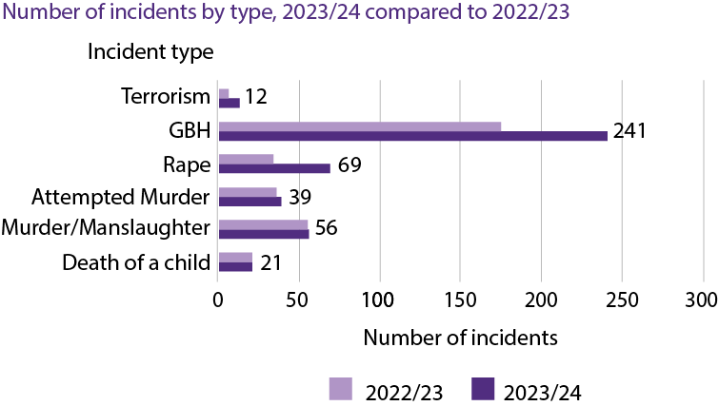

Chart 2 – Serious Incident by type of incident, Wales, April 2023 - March 2024
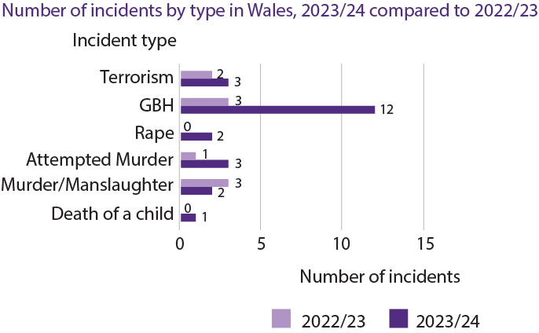

2.3 Serious incidents by type and area
As mentioned in the introduction, the information is based on the number of serious
Incidents reported by YJSs and may not accurately reflect the number of serious incidents occurring. Analysis of serious incident notifications is therefore not used as an indicator of levels of serious violence. We continue to work closely with YJSs across England and Wales to ensure we are receiving all relevant notifications as required.

Chart 3: Serious incident notifications by type and geographical area, April 2023 - March 2024

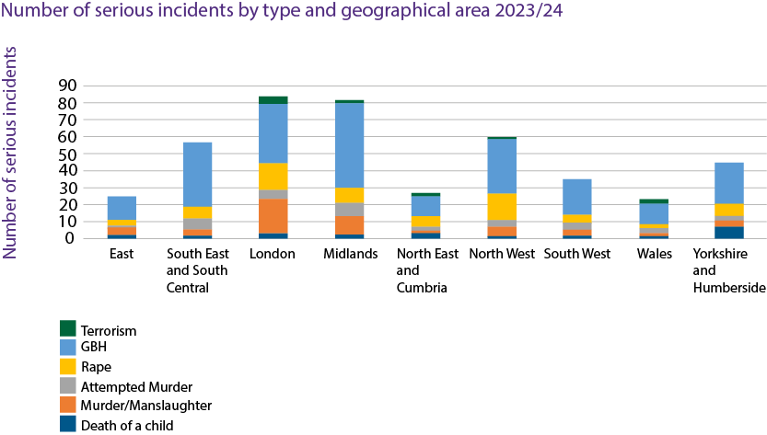

Table 1 – Serious incident notifications by type and geographical area, April 2023 - March 2024

Serious incident | East | South East and South Central | London | Midlands | North East and Cumbria | North West | South West | Wales | Yorkshire and Humberside
Terrorism | 0 | 0 | 4 | 2 | 2 | 1 | 0 | 3 | 0
GBH | 14 | 38 | 36 | 50 | 12 | 33 | 21 | 12 | 25
Rape | 3 | 7 | 15 | 9 | 6 | 15 | 5 | 2 | 7
Attempted Murder | 2 | 7 | 6 | 8 | 3 | 4 | 4 | 3 | 2
Murder/Manslaughter | 4 | 4 | 20 | 11 | 1 | 6 | 4 | 2 | 4
Death of a child | 2 | 1 | 3 | 2 | 3 | 1 | 1 | 1 | 7

London and the Midlands reported the highest numbers of serious incident in 2023/24 - 84 and 82 respectively, both broadly representing 19% each of all serious incident notifications submitted in the period. In the previous year, the Midlands submitted the highest number of serious incident notifications - 63, representing 19% of all notifications submitted, followed by London - 56, representing 17% of all notifications and East and Southeast – 56 representing 17% of all notifications.

England, East and North East and Cumbria reported the lowest numbers of serious incidents – 25 and 27 respectively both broadly representing 6% each of all serious incident notifications submitted in the period. In the previous year, the North East and Cumbria submitted the lowest number of serious incident notifications - 23 representing 7%, and South West and South Central - 35 representing 11% of all notifications submitted by YJSs in England.

There have been noticeable increases in the number of Rape notifications reported.

In Wales, 23 incident notifications were submitted, representing 5% of all notifications submitted in the period. In the previous year, 9 incident notifications were submitted, which represented 3% of all notifications submitted in the period.

The most reported incident type across all areas was GBH, by contrast, the least reported incident type across all areas were Terrorism related offences. This was the same in the previous reporting year.

Table 2: Geographic distribution of reporting - serious incidents by area and 10-17 population (2021 Census)
Region | Total number of serious  incident notifications submitted | 10 to 17-year-old population | Rate of serious incident notifications submitted  per 10,000 10 to 17-year-old population
East | 25 | 631,849 | 0.40
South East and South Central | 57 | 939,412 | 0.61
London | 84 | 853,387 | 0.98
Midlands | 82 | 1,094,729 | 0.75
North East and Cumbria | 27 | 277,225 | 0.97
North West | 60 | 719,072 | 0.83
South West | 35 | 526,480 | 0.66
Wales | 23 | 296,243 | 0.78
Yorkshire and Humberside | 45 | 543,088 | 0.83

Please note, this table is included to provide insight into regional compliance of serious incident reporting and should not be interpreted as an indication of regional levels of serious violence.

2.4 Serious incidents by age/sex/ethnicity

Chart 4: Serious incidents by type of incident in England and Wales and number of children, by age, April 2023 - March 2024
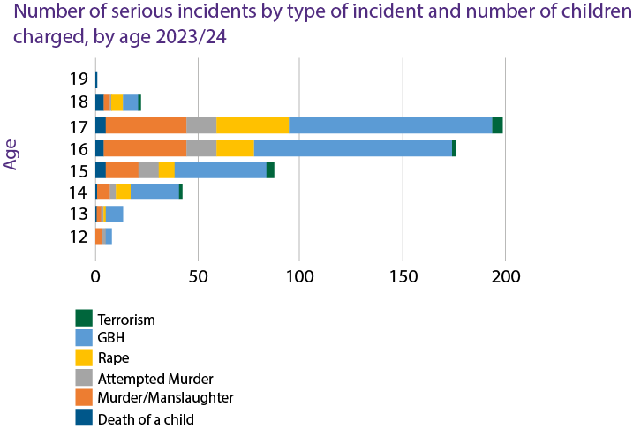

Table 3: Age of children involved in serious incidents in England and Wales, April 2023 – March 2024
Age of children involved in serious incidents, April 2023 - March 2024
Incident type | % of total | Total - all ages |  | 12 |  | 13 | 14 | 15 | 16 | 17 | 18 | 19
Death of a child | 4% | 21 | 0 |  | 1 |  | 1 | 5 | 4 | 5 | 4 | 1
Murder/Manslaughter | 20% | 109 | 3 |  | 2 |  | 6 | 16 | 40 | 39 | 3 | 0
Attempted Murder | 9% | 47 | 2 |  | 1 |  | 3 | 10 | 15 | 15 | 1 | 0
Rape | 13% | 73 | 0 |  | 1 |  | 7 | 7 | 18 | 35 | 5 | 0
GBH | 52% | 284 | 3 |  | 8 |  | 24 | 45 | 97 | 99 | 8 | 0
Terrorism | 2% | 12 | 0 |  | 0 |  | 1 | 4 | 1 | 5 | 1 | 0
Total |  | 546 | 8 |  | 13 |  | 42 | 87 | 175 | 198 | 22 | 1
% proportion of total age |  |  | 1% |  | 2% |  | 8% | 16% | 32% | 36% | 4% | *
Note: ‘*’ denotes less than one percent
GBH represented the most common charge across all age groups except 19-year-olds. By contrast, Terrorism related offences were the least common.
Across all incident types, except Death of a Child, 16–17-year-olds received the most charges. This was broadly the same with findings from the previous year, where 157 17-year-olds received the most charges, representing 37% with the second largest age group being 16-year-olds receiving 112 charges, representing 26% of all children across all age groups.

Chart 5: Age and sex of children involved in serious incidents in England and Wales notified April 2023 – March 2024
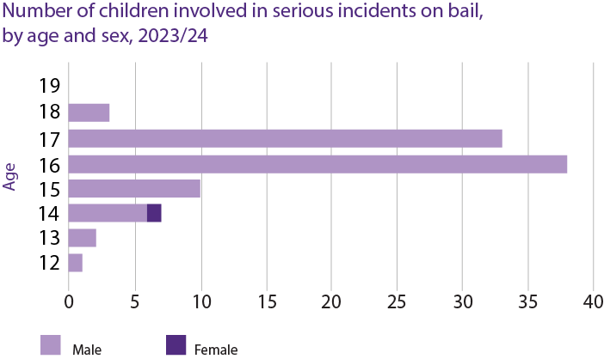

Table 4: Age and sex of children involved in serious incidents in England and Wales notified April 2023 – March 2024
 | 12 | 13 | 14 | 15 | 16 | 17 | 18 | 19
Male | 5 | 12 | 36 | 84 | 171 | 194 | 22 | 1
Female | 3 | 1 | 3 | 3 | 4 | 4 | 0 | 0

Boys made up the majority of children reported, with 525 boys reported, representing 96% of all children. By comparison, in the previous year 2022/23, 411 boys were reported, this also represented 96% of all children. By contrast, 21 girls were reported, representing 4% of all children. In the previous year 2022/23, 16 girls were reported, which represented 4% of all children. 16 and 17-year-olds make up the largest proportion of children reported, representing 68% of all children. In the previous year, 16 and 17-year-olds also made up the largest proportion, representing 63% of all children.

Chart 6: Ethnic breakdown - Serious incidents notified in England and Wales April 2023 – March 2024
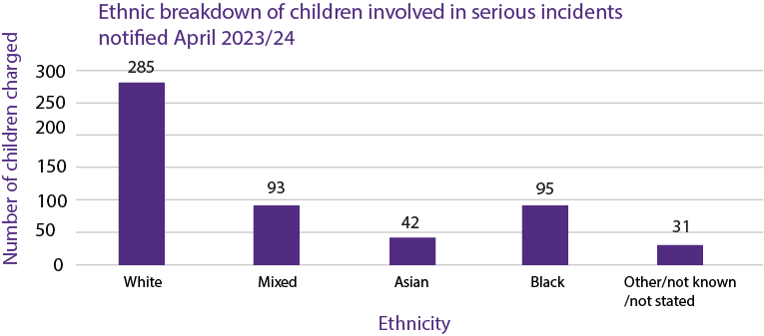
Just over half of all children reported were from a White background, making up 52% of all children.
Children from Mixed or Black backgrounds made up the second highest proportion of children reported, with both groups each representing 17% of all children.

Table 5: Ethnic representation of children charged with serious incidents in England and Wales, April 2023 – March 2024
Ethnic representation - serious incidents, England & Wales, 2023-2024
Ethnicity | White | Mixed | Asian | Black | Other/not known/not stated | Total
Number of children | 285 | 93 | 42 | 95 | 31 | 546
% proportion | 52% | 17% | 8% | 17% | 6%
England and Wales % proportion of 10-17 population (2021 Census) | 74% | 6% | 12% | 6% | 3%

Table 6: Ethnic representation of children charged with serious incidents in Wales, April 2023 – March 2024
Ethnic representation - serious incidents, Wales, 2023-2024
Ethnicity | White | Mixed | Asian | Black | Other/not known/not stated | Total
Number of children | 21 | 1 | 1 | 0 | 2 | 25
% proportion | 84% | 4% | 4% | 0% | 8%
England & Wales % proportion of 10-17 population (2021 Census) | 90% | 3% | 4% | 1% | 1%

Ethnic disparity
48% of all children involved in serious incidents were from an ethnic minority background, whereas they only make up 27% of the 10-17 population. Of these, children of Black backgrounds were over-represented with 17% of all children reported, whereas they only make up 6% of the 10-17 population – this same over-representation is also observed for children from Mixed backgrounds.

2.5 Ministerial briefings
In order to provide timely information of serious incidents in the community and the children involved with them, briefings are sent to the Minister in the most serious cases; these are predominantly incidents where a child has been charged with murder, or any other incident that has received significant media attention and is of public interest. In 2023/24, 30 ministerial briefings regarding serious incidents were submitted, in comparison to 18 in 2022/23.
Additional information is collected from YJSs for the purpose of providing ministerial briefings, whilst full analysis of this additional information was not conducted this year, there are strong themes arising around the lack of education provision for children charged with serious incidents and access to appropriate mental health services.
A summary of circumstances relating to a child who were the subject of one of these briefings demonstrates this:
It would appear that the child had suffered a deterioration in their mental health in the weeks leading up to the incident and it was alleged that the child had committed repeated offences in the days prior to the incident. The child was also on bail at the time of the incident for other offences. The child had multiple diagnosed disorders and additional learning needs, and was receiving support from children's services. He had been permanently excluded from school and was out of formal education at the time of the incident whilst a special education place was being secured for him. There had been previous incidents of self-harm and other high-risk behaviours, such as being found near railway tracks on multiple occasions; but there had been a lack of engagement with mental health services. Despite being known to multiple agencies, this additional information indicated a lack of holistic view of this child’s needs to ensure there was effective safeguarding and risk management.

3. Children involved in serious incidents – analysis

3.1 Notes on data used
Serious Incident Notifications provide information known about the incident and child at the time of the submission of the notification; analysis has therefore been dependent on the depth of detail in the information provided and information known at the time. For this reason, caution must be used when drawing conclusions.
Part way through the 2023-24 notification period (from July 2023) ‘date of charge’ information began to be collected.

3.2 Time to charge
For incidents where charge date was provided, initial findings are presented below.

Table 7: Number of days between incident date and charge date of incidents notified in England and Wales, relating to children reported, April 2023 – March 2024
Time to charge - number of days
Incident type | Shortest | Longest | Average
Murder/Manslaughter | 0 | 660 | 140
Attempted Murder | 0 | 429 | 29
Grievous Bodily Harm (GBH) | 0 | 970 | 132
Rape | 2 | 1106 | 380
Terrorist-related offences | 2 | 723 | 218

- 53% -within 30 days.
- 5% - within 30 - 90 days
- 9% -within 90 - 180 days
- 32% - longer than 180 days
- Rape offences took on average the longest from incident to charge with an average of 380 days after the incident(s) took place.
- Terrorist-related offences took the second longest from incident to charge, with an average of 230 days after the incident took place.

3.3 Previous cautions and convictions, bail status
Details relating to previous cautions and convictions are provided where these are known at the time of the reporting.
Of the 546 children reported in 2023/24, 280 had previous cautions and convictions, representing 51% of all children.
For four out of six serious incident categories, over half the children involved in those incidents had previous cautions and convictions:
- Death of a child (62%, 13 children),
- Murder/Manslaughter (52%, 57 children),
- Attempted Murder (51%, 24 children)
- GBH (55%, 157 children).
In contrast, children charged with Terrorism-related offences had the least, with only 8% (1 child), having previous cautions and convictions.

Table 8: percentage proportion of children with previous cautions and convictions, by incident type, England and Wales, April 2023 – March 2024
Incident type | % proportion with previous cautions and convictions | Number of children with previous cautions and convictions | Total
Death of a child | 62% | 13 | 21
Murder/Manslaughter | 52% | 57 | 109
Attempted Murder | 51% | 24 | 47
Rape | 34% | 25 | 73
GBH | 55% | 157 | 284
Terrorism | 8% | 1 | 12
Total | 51% | 280 | 546

Children on bail for another offence at the time they were charged with the serious incident was also reviewed.
94 children (17% of all children) were on bail for another offence at the time of the incident. The offence for which they were already on bail is not known in all cases. However, where this information was provided, offences children were on bail for included:
- Knife/bladed article possession in public place.
- Possession with intent to supply.

71 children (76% of this group) were reported as being gang affiliated, criminally exploited, or had some involvement with the National Referral Mechanism (NRM) process.

Table 9: Number of children on bail, by incident type, as a proportion of all children reported, England and Wales 2023-24
Incident type | No. of children on bail | % proportion | Total - all children
Death of a child | 5 | 24% | 21
Murder/Manslaughter | 20 | 18% | 109
Attempted Murder | 4 | 9% | 47
Rape | 7 | 10% | 73
GBH | 58 | 20% | 284
Terrorism | 0 | 0% | 12
Total | 94 | 17% | 546

The highest proportion of children on bail at the time of the incident was Death of a child, with 24% of the children being on bail. 20% of all children charged with GBH were on bail for other offences at the time of the incident, and 18% of all children for Murder/Manslaughter.

Chart 7 - Number of children reported on bail, by age and sex, England and Wales, 2023-24
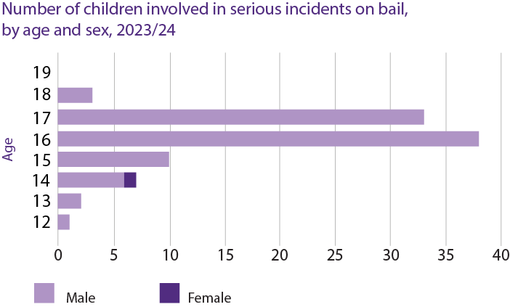
 | 12 | 13 | 14 | 15 | 16 | 17 | 18 | 19
Male | 1 | 2 | 6 | 10 | 38 | 33 | 3 | 0
Female | 0 | 0 | 1 | 0 | 0 | 0 | 0 | 0

Table 10: Number of children reported on bail, by age and sex, England and Wales, 2023-24

16 and 17-year-olds were the age groups with the highest number of children on bail for another offence at the time of the serious incident, with 38 and 33 children on bail in each age group respectively, which correlates with the 16-17 age group being most predominantly charged with serious incidents.

3.4 Knife/blade involvement
246 of 438 serious incidents reported were reported to involve a knife or blade. This represents 56% of all incidents reported in 2023/24. Proportionally, this remains broadly the same as 2022/23 with 187 (58%) of the 325 incidents reported involving a knife or blade.
There were three incident categories where over half of the incidents indicated knife or bladed article involvement. 92% of Attempted Murder notifications indicated there was knife or blade involvement, this was the highest proportion of all incident categories, 84% of Murder/Manslaughter, and 62% of GBH incidents.

Table 11: percentage proportion of knife or bladed article involvement, by incident type, England and Wales, April 2023 - March 2024
Knife or bladed article involvement by incident type
Incident Type | % proportion | Number of incidents | Total
Death of a child | 33% | 7 | 21
Murder/Manslaughter | 84% | 47 | 56
Attempted Murder | 92% | 36 | 39
Rape | 9% | 6 | 69
Grievous Bodily Harm | 62% | 150 | 241
Terrorism | 0% | 0 | 12

3.4 Exploitation, gang affiliation and the use of the National Referral Mechanism
In seeking to understand the extent and nature of risks and vulnerabilities of children reported to be involved in serious incidents, information regarding exploitation, gang affiliations and use of the National Referral Mechanism (NRM) is collected.

Table 12: Number of incidents potentially gang or County Lines related, as a proportion of all serious incidents notified in England and Wales April 2023 - March 2024
Incident Type | Number of incidents potentially gang or county lines related | % proportion | Total incident type
Death of a child | 2 | 10% | 21
Murder/Manslaughter | 10 | 18% | 56
Attempted Murder | 9 | 23% | 39
Rape | 0 | 0% | 69
GBH | 20 | 8% | 241
Terrorism | 0 | 0% | 12

Exploitation concerns amongst children reported to be involved in serious incidents varies but is prevalent within the risks and vulnerabilities reported. 41% of all children reported to be involved in serious incidents were reported as being gang affiliated, criminally exploited, or had some involvement with the NRMs; either having had a positive grounds conclusion previously or awaiting the outcome of a referral due to concerns around exploitation, which represents 226 out of the 546 children notified.

Chart 8 - Children with identified risks of gang affiliation, criminal exploitation and NRM involvement, by age and sex, England and Wales, April 2023 - March 2024
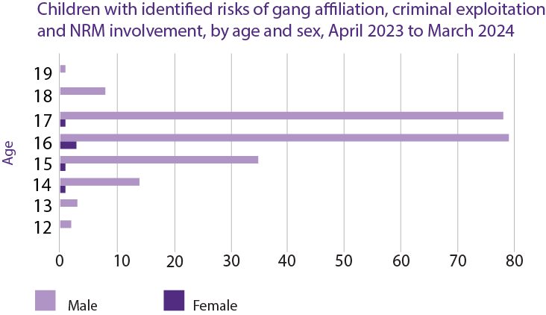
Table 13: Children with identified risks of gang affiliation, criminal exploitation and NRM involvement, by age and sex, England and Wales, April 2023 - March 2024
 | 12 | 13 | 14 | 15 | 16 | 17 | 18 | 19
Male | 2 | 0 | 14 | 35 | 79 | 78 | 8 | 1
Female | 0 | 3 | 1 | 1 | 3 | 1 | 0 | 0

42% of all boys reported in the period had identified risks around being exploited, gang affiliation or NRM involvement (either having had positive grounds conclusion previously or awaiting the outcome of a referral due to concerns around exploitation), representing 220 of 525 boys in total). By contrast, 29% of all girls involved in serious incidents had these identified risks, representing 6 of 21 of girls in total.
Whilst there are identified risks around exploitation, gang affiliation and NRM involvement (either having had positive grounds conclusion previously or awaiting the outcome of a referral due to concerns around exploitation) of boys in all age groups from 12-19, for girls these risks are only identified in 14 to 17-year-old age groups.

Chart 9: Children with identified risks of gang affiliation, criminal exploitation and NRM involvement, by age and ethnicity, England and Wales April 2023 - March 2024
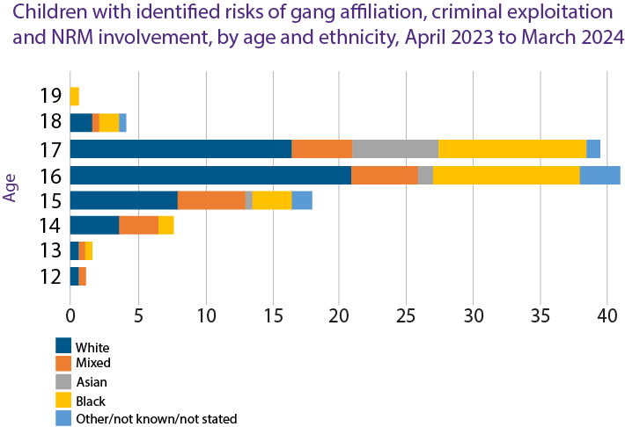

Table 14: Children with identified risks of gang affiliation, criminal exploitation and NRM involvement, by age and ethnicity, England and Wales April 2023 - March 2024
 | 12 | 13 | 14 | 15 | 16 | 17 | 18 | 19
White | 1 | 1 | 7 | 16 | 42 | 33 | 3 | 0
Mixed | 1 | 1 | 6 | 10 | 10 | 9 | 1 | 0
Asian | 0 | 0 | 0 | 1 | 2 | 13 | 0 | 0
Black | 0 | 1 | 2 | 6 | 22 | 22 | 3 | 1
Other/not know/not stated | 0 | 0 | 0 | 3 | 6 | 2 | 1 | 0

Of all children reported to be involved in Serious Incidents, 226 children in total had risks identified relating to gang affiliation, criminal exploitation and NRM involvement. This represents 41% of all children.
16 to 17-year-old children from White backgrounds were the most prominent group of children indicated as having risks of gang affiliations, exploitation or NRM involvement (either having had a positive grounds conclusion previously or awaiting the outcome of a referral due to concerns around exploitation) - 75 children. Children from Black backgrounds were the second most prominent group in this age range indicated as having these risks – 44 children. However, 16 to 17-year-old children from all Black and ethnic minority groups combined made up broadly half of 16 to 17-year-old children indicated as having these risks - 74 children.
In terms of charges which resulted in an NRM referral being made, this applied to 107 children (representing 20% of all children notified to us). Of these 107, an NRM referral had not yet been made but there was a plan to do so for 62 children (58%), and an NRM referral had already been made with a decision awaiting for 45 children (42%).

3.5 Experience of Adverse Childhood Experiences (ACEs) or domestic violence
Instances of known ACEs were prevalent in the identified risks and vulnerabilities relating to children reported to be involved with serious incidents.

Out of 546 children reported as being involved in a serious incident:

156 were reported to have experienced ACEs (representing 29% of all children)

72 had specifically been a victim of, or a witness to domestic violence (representing 13% of all children).

Experiencing ACEs can have an impact on future physical and mental health and can be barriers to healthy attachment relationship forming for children. Some of the effects of ACEs can include but are not limited to:
- An increase in the risk of mental health difficulties, violence and becoming a victim of violence.
- An increase in the risk of mental health problems, such as anxiety, depression, and post-traumatic stress.
- The capacity to make and keep healthy friendships and other relationships.
- The ability to manage behaviour in school settings.
- Difficulties coping with emotions safely without causing harm to self or others.

Within the cohort of children notified to us as being involved in serious incidents, examples of ACEs reported included:

- witnessing domestic violence within the home
- being a victim of physical domestic violence
- being a victim of emotional abuse
- living in accommodation where the child witnessed drug related activities
- experiencing ongoing neglect
- loss of a parent from suicide or other familial bereavement
- homelessness

3.6 Children with experience of care and accommodation needs
145 of 546 children involved in serious incidents were currently looked-after at the time of the incident or charge (in cases where the incident itself is historic). This represents 27% of all children involved in serious incidents.
48% of children with current care experience also had identified risks regarding gang affiliation, exploitation and/or NRM involvement.
In addition to this, information supplied relating to 8 children implied that the child’s accommodation at the time was not appropriate for their needs.

3.7 Special education needs and neurodiversity
Section 20 Children and Families Act 2014 defines a child as having special educational needs (SEN) if they have “a learning difficulty or disability which calls for special education provision to be made for him or her". In Wales, Additional Learning Needs are defined through the Additional Learning Needs and Educations Tribunal (Wales) Act 2018. Children identified with Additional Learning Needs have an Individual Development Plan.
125 of the 546 children reported had confirmed or suspected special education needs which required further assessment, or a diagnosed neurodiversity. This represents 23% of all children.
Of these 125 children, 19% (24 children) had an Education Health Care Plan in place.
The most prevalent neurodiversity mentioned in the notifications was Attention Deficit Hyperactivity Disorder (ADHD) and Autism Spectrum Disorder (ASD)- identified for 60 children, representing 48% of children with identified special education needs or neurodiversity. Other disorders mentioned were:
- conduct disorder
- pathological avoidance disorder
- dyslexia
- global development delay
- unspecified learning difficulties
These disorders, as well as additional needs relating to speech, language and communication were referred to as factors of vulnerability in children who were at risk of being criminally exploited, or already being criminally exploited.
67 children, representing 53% of the children identified with special education needs or neurodiversity, were also identified as having risks associated with gang affiliation, exploitation or NRM involvement.

3.8 Contact with other services
197 children (36%) of all children, were supervised by the youth justice service (YJS) at the time of the incident. according to notifications provided. In the previous year, 157 of the 427 children reported in serious incident notifications (37%) were supervised by the YJS at the time of the incident.
345 children (63%) had some kind of previous contact with another service either prior to, or at the time the incident took place. Notifications identified that these were predominantly children’s services, including Early Help, local Safeguarding and Contextual Safeguarding teams or Health, specifically with Children and Adolescent Mental Health Services (CAMHS),
Of the 345:
- 100 children (29%) who had contact with previous services were identified as Children in Need either currently or historically.
- 67 children (19%) had Child protection plans in place either currently or historically.
Categories for children on Child in Need (known in Wales as Children with care and support needs) or Child Protection plans included neglect, abuse, emotional abuse, contextual safeguarding, child criminal exploitation.
- 129 Children (24%) were engaged with both the YJS and one or more services at the time of the incident.
- 130 (24%) were at the time not known to YJSs, nor were they engaged in support from any other local authority service.

4. Summary by Incident Type

4.1 Murder/Manslaughter
- 56 incidents involving 109 children - 107 boys and 2 girls.
- 23 incidents (41%) involved multiple children.
- 47 incidents (84%) involved a knife or bladed article.
- 1 incident involved a firearm.
- 32 children (29%) were already supervised by the youth justice service (YJS) at the time of the incident.
- 77 children (71%) were not being supervised by the YJS.
- 66 children (61%) had previous contact with children’s services, early help or social services.
- 27 children (25%) were not known to the YJS or any other service within the local authority at the time of the incident.
- 57 children (52%) had previous cautions and convictions.
- 52 children (48%) had no previous cautions and convictions.
- 20 children (18%) were on bail for another offence when the incident took place.
- 38 children (35%) either had a previous NRM referral, or this was due to be made as a result of concerns about criminal exploitation.
- 56 children (51%) had gang affiliation, exploitation and NRM involvement noted as risks and vulnerabilities.

4.2 Attempted Murder
- 39 incidents involving 47 children – 45 boys and 2 girls.
- 5 incidents (13%) involved multiple children.
- 36 incidents (92%) involved a knife or bladed article.
- 2 incidents involved firearms and 1 involved a hammer.
- 21 children (45%) were already supervised by the YJS at the time of the incident.
- 26 children (55%) were not being supervised by the YJS at the time of the incident.
- 30 children (64%) had previous contact with children’s services, early help or social services.
- 11 children (23%) were not known to the YJS or any other service within the local authority at the time of the incident.
- 24 children (51%) of children had previous cautions and convictions,
- 23 children (49%) had no previous cautions and convictions.
- 4 children (9%) were on bail for another offence when the incident took place.
- 11 children (23%) either had a previous NRM referral, or this was due to be made as a result of concerns they were being criminally exploited.
- 21 children (45%) had gang affiliation, exploitation and NRM involvement noted as risks and vulnerabilities.

4.3 Grievous Bodily Harm (GBH)
- GBH is the most frequent reported serious incident, 241 incidents involving 284 children – 268 boys and 16 girls.
- 33 incidents (14%) involved multiple children.
- 168 incidents (70%) involved a knife or bladed article.
- 107 children (37%) were already supervised by the YJS at the time of the incident.
- 173 children (61%) were not being supervised by the YJS.
- 4 children (2%) it was not clear whether they were supervised by a YJS at the time of the incident.
- 185 children (65%) had previous contact with children’s services, early help, or social services.
- 60 children (21%) were not known to the YJS or any other service within the local authority at the time of the incident.
- 159 children (56%) of children had previous cautions and convictions.
- 125 children (44%) of children had no previous cautions and convictions.
- 58 children (20%) were on bail for another offence when the incident took place.
- 51 children (18%) either had a previous NRM referral, or this was due to be made as a result of concerns about criminal exploitation.
- 124 children (44%) had gang affiliation, exploitation and NRM involvement noted as risks and vulnerabilities.

4.4 Rape
- 69 incidents involving 73 children – all boys.
- 3 incidents (4%) involved multiple children.
- 24 children (56%) were charged with multiple counts of historic rape.
- 60 incidents (87%) took place before the notification period (i.e. prior to 31st March 2023)
- 16 children (22%) were already supervised by the YJS at the time of the incident.
- 57 children (78%) were not being supervised by the YJS.
- 45 children (62%) had previous contact with children’s services, early help, or social services.
- 26 children (36%) were not known to the youth justice service or any other service within the local authority at the time of the incident.
- 25 children (34%) of children had previous cautions and convictions.
- 7 children (10%) were on bail for another offence when the incident took place.
- 48 children (66%) had no previous cautions and convictions.

4.5 Terrorist-related offences
- 12 incidents involving 12 children charged – all boys
- None of the incidents involved multiple children.
- 3 children (25%) were already supervised by the youth justice service at the time of the incident.
- 9 children (75%) were not being supervised by the YJS.
- 5 children (42%) had previous contact with children’s services, early help, or social services.
- 4 children (3%) were not known to the YJS or any other service within the local authority at the time of the incident.
- 1 child had previous cautions and convictions.
- No children were on bail for another offence when the incident took place.
- 11 children had no previous cautions and convictions.
- Where sufficient detail was provided, notifications indicated that in 5 incidents (42%), related to extreme right wing Terrorism related material, and in 1 incident (8%) related to Islamic State material.

4.6 Death of a child
21 notifications made under the category of Death of a Child – 20 boys and 1 girl.
Of the children who died:
- 9 (43%) were victims of murder
- 4 (19%) died by suicide
- 6 (28%) died by accidents, vehicular or drowning
- 2 (10%) died from substance misuse

Whilst an incident of ‘Death of a Child’ is not a charge offence like the other serious incident categories, we have highlighted our findings this year as almost half of the children sadly died as victims of murder. As is the case with many of the children within the cohort reviewed, many of them have also been victims of crimes.

5. Serious incidents – impacts on services
In 2024, a series of interviews and focus groups were held with youth justice services (YJSs) with a recent experience of a serious incident, to understand their impact on YJSs and their staff. The discussions generated useful insights, some of which have been shared below.

5.1 Risk management
The steps that are undertaken in the early stages following a serious incident were noted as a priority given the nature and consequences of such offences. This included risk assessment to ensure staff safety, involving a critical incident team and the local police, and then assessing a suitable service response.
“What we have to then do is do some real quick risk assessment work. So we've got a massively tense area here, we've had a shooting, the night before, you know, what do we do? How do we protect the staff?”
The response to serious incidents also lay within the responsibility of service managers. Responses varied on an incident-dependent basis, with certain serious incidents, including those that involved the death of a child, requiring a more refined, careful response considering the impact this has for those involved, as well as the wider community.
“I think around GBH, depending on what kind of GBH it is, that people are fairly comfortable managing that. Obviously, the death of a child or murder, manslaughter, rapes can be a little bit more, you need a bit more nuance and a bit more sensitivity around how you're developing that.”
This wide-reaching approach includes partnership working, reviewing records, briefing local senior leaders, managing a media response, and considering the impact on public protection and community cohesion.
“Dealing with media in terms of, you know, our communications team to brief them in case because of course, particularly in the context of how social media ensures these stories, you know, spread like wildfire.”
Risk management extended beyond professional and media responses to serious incidents, but also to consider those who are involved or affected by the crime, including the safety of witnesses, victims, and families of those involved.
“It's about the fact that some of our children are witnessing it and seeing it and the impact upon them and then us having to manage that and the impact is having on them across the board.”
It was noted that communities may experience fear in the aftermath of a serious incident, for example one respondent had witnessed decreases in school attendance after an occurrence of serious violence.

5.2 Emotional toll
The emotional toll of responding to a serious incident was flagged by service managers to have a massive impact on staff across the YJS, specifically in the instance that it involves the death of a child. For those working with children involved in the serious incident, loss and grief were highlighted as common feelings.

“For us, it's a loss. It's a grief. So, you deal with the, the staff member who may be shocked. I mean, I've had to tell staff members that this has happened, and they just don't believe me… I mean, it's heart-breaking. So, you've got, you've got grief and loss for staff that ripples out across all of that professional network.”
The need for staff to manage their own emotions, whilst also supporting the children who have committed the offences was flagged as difficult for those involved in the process. For example, when in court and viewing evidence of a serious and violent nature, this can have an impact on staff and highlights the need to support staff in their wellbeing. Service managers stated that they must lead by example to encourage staff to acknowledge that it is acceptable to be impacted by serious incidents and the circumstances around them.
YJS managers further reflected upon the idea of blame culture in the instance that the death of a child occurs. Blame can be both internalised by service managers who feel a sense of responsibility and that they could have done more to prevent this from happening, but also from other parties involved, such as families, who may feel that their child has not received adequate safeguarding measures. Such experiences were suggested to cause a significant emotional toll on youth justice practitioners in the process of submitting a serious incident notification.

5.3 Children unknown to services
A wider challenge identified by service managers was that serious incident notifications often involve children who are not known to the YJS. One service manager provided a useful typology of children involved with serious incidents: children with youth justice involvement, children with social care history, and children unknown to YJS and social care services. This service manager identified a trend of an increase in children with no YJS or social care footprint in recent years.
“Then you have the third group which is that children are on neither youth justice or social care databases, so they have no footprint and those are the ones that kind of, we say they come out of nowhere and really, it's not quite, it's not quite true. Children obviously come from somewhere, but it's unusual for children. We've seen children, you know, commit murder offences, go and get remanded into custody where people have no knowledge of and that feels very strange. But I would say that we've seen an increase in those third group of children where there's no information, there's no history, there's no knowledge of any partners around the table to contribute to it.”
Presence of this group of children across serious incident notifications was identified as a trend in both the focus group and other interviews, with service managers questioning how these children were not referred to other services such as Early Help prior to committing the offence.
“The complexity is where are these children that, we call them ‘off the radar’? But it's like they've been on somebody's radar and there's been something happening. They haven't just gone from zero to stabbing somebody, and the question for us is what, why is that? That's the bigger question is like, where is that child? And why haven't other services, universal and maybe slightly like Early Help, why have they not picked up where that child has not been seen or heard of where there may have been low level behaviour?”
However, whilst there was a belief that some children fall through the net and are missed by valuable services, one service manager suggested that some children unfortunately can get caught up in serious youth violence based on factors like peer influence. In those cases, it was suggested the reality is that there was no net to catch them as no vulnerabilities were identified. Where children are seemingly emerging out of the blue, issues with identifying appropriate support for them were identified.
“There's a wider issue here about children, you know, coming out of nowhere. Often, they're 17 and then they have, you know, they're in trouble for a murder or wounding offence and actually, what do you do with those children? They're very hard to place. So, you know, remands into the care of the local authority are very, very difficult to do when you have a 17-year-old that's involved in a serious incident. So, yeah, it does limit your chances to support children in the community potentially.”

5.4 Additional findings
Additional feedback from YJSs around the Serious Incidents Notification reporting system were captured during this research and will be considered as part of future developments of the reporting system, which include:

- Extension of the 24-hour reporting period for serious incident notifications to allow sufficient time to gather the information required.
- Updating the serious incident notification reporting form to capture additional information about the child’s contextual background to improve wider understanding of offending behaviour.

The research also highlighted potential areas for development which could help reduce the occurrence of serious incidents and improve responses following incidents:

- YJSs could collaborate with other services to explore serious incidents locally, to identify missed opportunities to support children and develop actions which might help improve local preventative identification and support in the future.
- Local services should endeavour to build their relationships with neighbouring areas and undertake local reviews of information sharing and collaboration practices. The YJB could share examples of good collaborative cross-area practice.
- The safety and well-being of staff should be considered as a priority. YJSs should ensure that appropriate emotional support is in place for those involved in the management and response to a serious incident.

6. Emerging themes and recommendations

6.1 Criminal exploitation
Earlier intervention and access to support is vital to avoid children becoming victims of criminal exploitation and being involved in serious incidents in the community. This requires a robust multi agency response. This is particularly important for boys from an ethnic minority background, in particular Black and Mixed backgrounds. Earlier identification of exploitation concerns and collaborative working is required across all agencies, alongside increased and timely NRM referrals and outcome decisions, to ensure children are safeguarded and supported at the earliest opportunity when they are at risk of exploitation. National roll out of the Home Office NRM Devolved Decision Making Pilots could further support this.

6.2 Addressing knife crime
There should be a continued focus on what works locally and nationally to address knife crime and incidents involving knives or bladed articles, drawing on the available evidence and this should be promoted and shared widely across the sector. There needs to be a consistent and coherent approach to knife offences, incorporating early intervention and diversion and an individualised response to knife possession offences which provides appropriate support and safeguarding to prevent escalation and reduce further occurrences. This requires the active engagement of universal and criminal justice agencies. The development of national guidance and a clear coherent multi-agency framework to respond to knife offences, will be welcomed.

6.4 Special education needs and neurodiversity
Earlier identification and intervention for children with SEN, additional learning needs or neurodiversity, prior to their contact with the youth justice system could reduce their vulnerability to exploitation and involvement with serious incidents in the community.

6.5 Safeguarding and vulnerability
Improved support and safeguarding for vulnerable children known to services, including Early Help, local Safeguarding and Contextual Safeguarding teams, and Children and Adolescent Mental Health Services could help to prevent vulnerable children’s involvement in serious incidents in the community and recognises that they are often victims themselves. This includes earlier identification of and interventions to address Adverse Childhood Experiences, such as witnessing domestic violence, being a victim of physical or emotional abuse, and experiencing neglect or homelessness. Children looked after should also be provided with suitable accommodation which meets their needs.

6.6 Timeliness of police investigations and charging decisions
Improved timeliness of police investigations and charging decisions where children are suspects of an offence could reduce the number of serious incidents in the community. Children released under investigation or on bail should also be subject to appropriate conditions and levels of support to ensure their safety and that of others.

6.7 Addressing over-representation of ethnic minority children
Reducing ethnic disparities requires the collective efforts across all agencies to take action to address the drivers of ethnic disparities. This includes addressing the root causes including adverse childhood experiences, structural issues and experiences of racial discrimination. Boys from Black and Mixed backgrounds in particular require appropriate support and safeguarding to address additional vulnerabilities and reduce the likelihood of their involvement in serious incidents in the community, including as victims.

6.8 Addressing Over representation of 16 to 17-year-old boys
The system needs to adequately support boys through periods of transition and provide opportunities, particularly beyond compulsory schooling into adulthood. Prior to this they need to be supported to remain in mainstream education wherever possible and where this is not possible alternative provision should be of sufficient quality to meet their needs. Appropriate support and interventions are needed to reduce their vulnerability to exploitation and address their emotional wellbeing. Interventions, for children of all ethnicities, should also address male stereotypes and promote positive perceptions of masculinity.

7. Conclusion
This is now the second year of mandatory reporting, and we therefore have two years data to begin to identify trends and insights in relation to serious incidents involving children.
Whilst there are limitations to this data, this report underscores the importance of a partnership approach with safeguarding at its heart to address exploitation, knife crime, and the vulnerabilities of children including those with SEN/Neurodiversity.
It also highlights the need for timely, effective interventions which address underlying causes, and support to prevent children from being involved in serious incidents. The government’s commitments to develop prevention partnerships and young futures hubs; introduce legislation to keep children safe from exploitation; and address issues around knife crime and violence against women and girls are welcome initiatives. By implementing these initiatives collectively, we can work towards preventing serious incidents involving children and creating safer communities and fewer victims.

8. Frequently Asked Questions

What’s the difference between Serious Incidents Notification analysis and the information published in the Annual Youth Justice Statistics?
Serious incidents are not measured in the same way as annual statistics. The data used for annual statistics is based on case level outcome data which is sent to the YJB from a youth justice service’s (YJS) case management system. The serious incidents analysis in this report is based on notifications which are sent from YJSs when they are made aware of one of the qualifying charges being brought against a child, or the death of a child on a YJS caseload and is not based on any outcome.

Why doesn't the YJB track the outcomes of those children involved in a serious incident?
The purpose of a serious incident notification is to understand the context in which serious incidents take place, and the children involved with them, in a timely manner. Whilst there may be value in tracking the outcomes, this would be a resource intensive process, and an additional burden to YJSs. Outcome based data is captured in the Youth Justice Annual Statistics whereas Serious Incident Reporting at the point of charge enables us to better understand the circumstances of the incident and those children involved, including those who may not go on to be convicted or sentenced.

Does a high level of reporting in an area mean that serious violence is high too?
Whilst this may be the case, this is more likely to indicate a high level of compliance with the serious incident notification process, when compared to other areas. The YJB does not have full confidence that all serious incidents notifications are being reported in all areas as required and we continue to work with a small number of services to improve compliance with the notification process.

Does the YJB track the demographics of victims in serious incident reporting?
The YJB does not currently request specific information on victims, such as age, gender or ethnicity in the serious incident notification. Information relating to victims is sometimes included within the summary of an incident however the quality of victim information is inconsistent as we do not currently formally request it. As a result, we have not provided analysis on the demographics of victims of serious incidents this year, however we recognise that having a greater understanding of the demographics of victims involved in serious incidents could provide additional valuable insights and it is something we will explore further.

The National Referral Mechanism (NRM) is a framework for identifying and referring potential victims of modern slavery and exploitation, ensuring they receive the appropriate support. Please see GOV.UK for further information.
In 2022/23, the East and Southeast regions were grouped together. In 2023/24, the East is its own distinct region, and the Southeast is now grouped with South Central to make the South East & South Central region.

