Privacy notice
Visitors to our buildings
November 2022
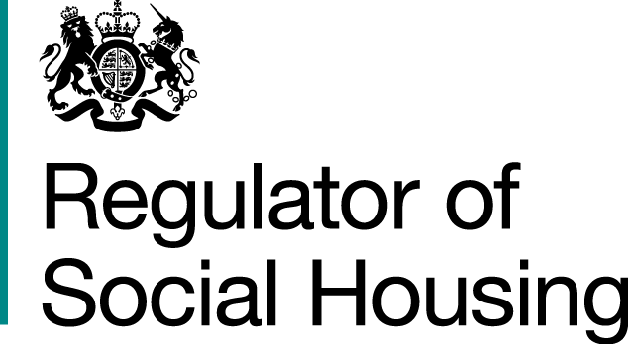


Contents

When do we collect information about people? 2
What personal data we collect about you, why we collect it and on what lawful basis? 2
How do we collect your personal data? 4
Changes to this privacy notice 4
Annex 1: Glossary 5

When do we collect information about people?
This notice should be read alongside the regulator’s main privacy notice, which contains general information relating to how the regulator processes personal data, what your rights are in relation to your personal data and how to make a complaint or contact the regulator’s Data Protection Officer.
This privacy notice is for visitors to our buildings/sites/premises.
Please click back to the main privacy notice page to access any of the other specific privacy notices.

What personal data we collect about you, why we collect it and on what lawful basis?
We set out in the table below descriptions of the ways we process your personal data, for what purposes and the lawful basis we rely on to do so.
We ask you not to provide any special category data unless you believe it to be necessary. Where special category data is provided by you it is likely that this personal data will be processed by the regulator on the lawful basis of your explicit consent. This consent may be withdrawn by you at any time. However, there may be rare circumstances in which the regulator identifies a different lawful basis to continue processing the personal data provided by you, if it is necessary.

Activity and purpose for processing personal data | What personal data we process | Lawful basis for processing | Special category personal data – Condition for processing
To provide a security service, access control logs, security passes, out of hours records | Identity  Health | Necessary for the performance of a task in the public interest (for the safety and security of our employees, contractors, agents and visitors of our buildings/sites/premises)  Processing is necessary for the purpose of legitimate interests (the need to protect the security and integrity of users, their belongings and managed buildings) | Processing for reasons of substantial public interest and meets the condition at Schedule 1 Part 2 paragraph 6 DPA 2018 i.e. it is necessary for the exercise of a function conferred by an enactment, or the exercise of a function of a government department, and is necessary for reasons of substantial public interest and the appropriate policy documents are in place
To ensure where there is a risk to life, injury, or other medical emergency, help and assistance can be provided as appropriate and without delay | Identity  Contact  Health | Processing is necessary in order to protect the vital interests of an individual.  Where there is no risk of life to engage vital interests consent will be obtained or legal obligation will be relied upon as the lawful basis. The special category condition will be substantial public interest to protect an individual at risk and where processing meets the conditions at Schedule 1 Part 2 Paragraph 18 of the Data Protection Act 2018. | Processing is necessary in order to protect the vital interests of an individual.  Where there is not risk to life the special category condition relied on will be substantial public interest to protect an individual at risk, where processing meets the conditions at Schedule 1 Part 2 Paragraph 18 of the Data Protection Act 2018
To enable reasonable adjustments to be made | Identity  Contact  Health | Processing is necessary for the purpose of legitimate interests (ensuring the health and safety of individuals working for or with the regulator and to ensure our smooth and efficient operation and the quality of services we provide) | For the purposes of providing support for individuals with a particular disability and processing meets the conditions at Schedule 1 Part 2, Paragraph 16 of the Data Protection Act 2018

How do we collect your personal data?
We use different methods to collect data from and about you, including through:
- Direct interactions – You may give us your identity and contact data directly, by completing visitor logs for example.

- From third parties, such as the Government Property Agency (providing Office Asset Management services).

- Publicly available sources such as social media profiles, Land Registry, Companies House or news articles.

Changes to this privacy notice
The regulator regularly reviews and, where required, updates this privacy notice.
This privacy notice was last updated in November 2022.

Annex 1: Glossary
Personal data – Information from which individuals can be identified or are identifiable, e.g. name, contact details, location data, identification number.
Data subject – an identified or identifiable individual, from whom or about whom the regulator processes information in connection with our operations.
Special categories of personal data – Personal data revealing race or ethnicity, political opinions, religion or beliefs, trade union membership, health or sex life, sexual orientation, genetic data or biometric data.
Processing – Any operation(s) performed on personal data, e.g. collection, recording, structuring, storage, alteration, retrieval, use, dissemination.
Lawful basis – a lawful ground for processing personal data defined in Article 6 of the UK GDPR and supported by the Framework. There are 6 lawful bases and at least one of these must apply whenever we process personal data: consent, contract, legal obligation, vital interests, public task and legitimate interests.
Public task – As data controller we may process personal data for the performance of a task carried out in the public interest or in the exercise of official authority vested in the regulator.
Performance of contract – means processing your data where it is necessary for the performance of a contract to which you are a party or to take steps at your request before entering into such a contract.
Comply with a legal or regulatory obligation means processing your personal data where it is necessary for compliance with a legal or regulatory obligation that we are subject to.
Third parties
- Professional advisers including lawyers, bankers, auditors and insurers based who provide consultancy, banking, legal, insurance and accounting services.
- The Ministry of Housing, Communities and Local Government who are the sponsor body for the regulator.
- HM Revenue & Customs, regulators and other authorities who require reporting of processing activities in certain circumstances, including those involved in the prevention or detection of fraud and money laundering.
- The Police, HM Treasury, National Audit Office, the Housing Ombudsman and other public authorities with whom we have established a lawful basis for processing your data.
- Registered providers with whom we may share information about customer referrals; Freedom of Information and other requests for information such as subject access requests.
- Suppliers and contractors who process personal data on our behalf, under parameters established by us, to deliver services in pursuit of our public task, or other lawful basis.
- Credit reference, due diligence providers and rating agencies who may help us decide whether to provide you with a service.

Health data – including disability or other medical information.

Identity data – includes first name, last name, username or similar identifier, marital status, title and gender.


© RSH copyright 2022
This publication is licensed under the terms of the Open Government Licence v3.0 except where otherwise stated. To view this licence, visit nationalarchives.gov.uk/doc/open-government-licence/version/3
Where we have identified any third party copyright information you will need to obtain permission from the copyright holders concerned.
This publication is available at: www.gov.uk/rsh
Any enquiries regarding this publication should be sent to us via enquiries@rsh.gov.uk
or call 0300 124 5225.
or write to:
Regulator of Social Housing
Level 2
7-8 Wellington Place
Leeds LS1 4AP
The Regulator of Social Housing regulates registered providers of social housing to promote a viable, efficient and well-governed social housing sector able to deliver and maintain homes of appropriate quality that meet a range of needs.

