Appendix 1

Sample breakdown
Eligibility criteria for participants: All 48 participants worked in small businesses with turnover below £10 million, fewer than 20 employees and were VAT registered. Participants were the person responsible for fulfilling the business’s VAT obligations, including penalties. This tended to be the business owner, managing director or finance director.

Penalty Status | Businesses with one penalty point for late VAT submission | Businesses with more than one penalty point for late VAT submission | Businesses with a penalty for late VAT payment) | Businesses charged late payment interest | Compliant businesses (not received a penalty under the new regime)
TARGET | 10 | 10 | 10 | 10 | 10
COMPLETED | 8 | 8 | 9 | 14 | 9
Penalised under previous regime
TARGET | Min 5 | Min 5 | Min 5 | Min 5 | Min 5
COMPLETED | 5 | 7 | 7 |  | 5
Secondary variables (mix and monitor)
Received multiple types of penalty (late submission, payment and interest) | Must also have penalty for late payment and have been charged late payment interest | Must also have penalty for late payment and have been charged late payment interest | Must also have at least one penalty point for late submission and have been charged late payment interest | Must also have at least one penalty point for late submission and penalty for late payment | NA
TARGET | Monitor | Monitor | Monitor | Monitor | NA
RECRUITED | 3 | 5 | 4 | 0 | -
Turnover | A mix
Up to £85k | 14
£85k to less than £10m | 34
Sector | A mix
Agriculture, forestry and fishing | 1
Mining, quarrying and utilities | 0
Manufacturing | 6
Construction | 1
Motor trades | 1
Wholesale | 4
Retail | 2
Transport and storage (inc. postal) | 2
Accommodation and food services | 1
Information and communication | 4
Finance and insurance | 1
Property | 1
Professional, scientific and technical | 8
Business administration and support services | 5
Public administration and defence | 0
Education | 2
Health | 3
Arts, entertainment, recreation and other services | 3
Other SPECIFY | 3
Time registered for VAT | A mix
1-4 years | 13
5-9 years | 17
10+ years | 18
Location | A mix - including scotland, wales, northern ireland
Greater London | 6
South East | 17
South West | 9
West Midlands | 1
North West | 2
North East | 0
Yorkshire and the Humber | 2
East Midlands | 3
East of England | 2
Scotland | 3
Wales | 1
Northern Ireland | 2

Discussion Guide

HMRC – VAT penalty reform project: Discussion Guide

Background
The new late submission and late payment penalty regimes and changes to the interest rules on late payments and overpayments of VAT came into effect for VAT periods starting on or after 1 January 2023. One of the key changes is that late submission penalties now work on a points-based system. For each return submitted late, a customer receives a penalty point until they reach the penalty point threshold. When they reach the threshold, they receive a £200 penalty, and following this they receive a further £200 penalty for each subsequent late submission when they are at the threshold. In addition, there is also a new penalty regime for late payments. The previous late payment regime was a flat % charge (dependent on how often they had paid or submitted late in a rolling period) based on the amount outstanding the day after the due date. This only applied to payments of amounts declared in a VAT return, while the new penalties also apply to late payment of VAT assessments and reflect the amount outstanding over the whole period. The difference between VAT returns and VAT assessments are that a return is a periodic report businesses are required to submit to HMRC, while assessments are an evaluation initiated by HMRC.
Approximately 2.4 million VAT registered businesses are impacted by these changes. HMRC has not yet conducted any research with customers directly affected by the new penalty reform regime about their experiences and perceptions. This research will provide valuable insight into the experiences of a group where there is currently no social research to inform the evaluation. It also feeds into HMRC’s wider evaluation of the success and impact of the reforms, as well as the wider evaluation of the Making Tax Digital (MTD) programme.

Research aims
The overall aim of this research is to explore the early impacts of the penalty reforms on VAT registered businesses, looking at customers’ understanding and experience of the changes, perceptions of fairness and any behavioural impacts of the reform. This research will provide evidence on how the new regime is working (including identifying areas where it is failing to meet its objectives) and may inform the future roll out of reforms to penalties for other taxes.
The research questions specified in the brief cover 3 broad areas:
- Awareness: For customers aware of the reforms, how did they become aware? If via HMRC, what are their views about the information provided? What is their awareness (and experience, where relevant) of appeals?
- Perceptions: What are customers’ views about the new penalty regime (focusing on each of the changes)? How does it compare to the previous regime (for those aware)? What are their views about the fairness and proportionality of the new regime? What are their views about the ease and value of HMRC’s digital channels in relation to understanding and managing penalties and appeals (e.g. BTA, Agents Services Account), as well as use of wider channels to help understand the new regimes?
- Perceived impact: What are the early impacts of the new regime on customers’ compliance behaviour? Does the late submission penalty encourage customers to submit even if they cannot pay? What impact does the points system have on submission behaviour around timeliness, repeat offending and care taken to meet deadlines? Are there unintended consequences such as late submission when customers are not at the penalty threshold? Is the points system more re-assuring than the previous system? What is the impact on their trust in HMRC? Do customers have an improved understanding of penalties?
By compliance we mean timely VAT returns and payment of VAT bills.

Please note, this guide is not a script and is intended to be used flexibly, with participant responses guiding the flow of the conversation, topics covered in the order that they naturally arise, and probes used only when needed


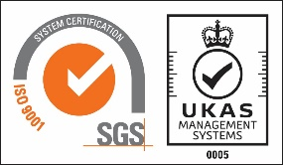

1. Introduction (2 minutes)
Introduce research, re-assure about confidentiality and set tone of discussion
- warm up and introduction
  - introduce moderator and Verian
    - freelancers – introduce yourselves as ‘working on behalf of Verian’ (not ‘from Verian’)
  - research on behalf of HMRC
  - aim of the discussion is to explore the early impacts of penalty reforms on VAT registered businesses. HMRC will use the findings to inform their implementation of the penalty reforms.
  - interview length – 45-60 minutes
  - research is confidential and voluntary. personal details will not be shared with HMRC, participation will not affect current or future relationship with HMRC.
  - your views and experiences will be looked at together with the views of others taking part in interviews across the country. these views will be analysed by theme then a report written based on those themes. your responses will be anonymised before this analysis takes place.
  - there are no right or wrong answers and this is not a test. we would like them to be as honest as possible.
  - as a thank you, participants will receive a £80 voucher
  - thank you leaflet – check if received beforehand (in appointment confirmation email), else email after interview
    - Verian’s privacy policy can be accessed on our website: https://www.veriangroup.com/uk-surveys
  - any questions?

- recording
Ask participant for permission to record, then start recording and confirm consent (Note: Verian shall ensure that recordings of groups or depth interviews are only conducted with consent and only used for the purposes for which the consent was given).
The recorder is encrypted and only the research team will have access to the recordings, data will be deleted within 12 months of the interview.
We will be sending several transcripts to HMRC for quality assurance with all identifiable information removed. We will check for consent at the end of the interview if they are willing to share but there is no obligation.

2. Context (5 minutes)
The aim of this section is to gather context on participants’ personal and business circumstances, and their initial thoughts on HMRC and VAT.
- participant introduction
  - role
  - length of time in business
  - length of time registered for VAT
  - involvement with business finances
  - digital confidence (in relation to dealing with finances and axes)
- business introduction
  - type of business or sector
  - size of business (turnover, number of employees)
  - key business priorities and future plans (brief) – stability, growth, wind-down
  - any recent changes to how the business is run
- views about HMRC
  - what words would they use to describe how they feel about HMRC
  - listen out for references to fairness
- views about VAT
  - what words would they use to describe VAT
  - what do they see as the positives or negatives of VAT

3. Managing VAT obligations (5 minutes)
The aim of this section is to find out information on how the participant manages their VAT obligations, what the challenges are, and any advice they seek.
- managing VAT obligations
Interview note: when asking about change over time, listen out for references to anything linked with penalties
  - what records the business keeps for the purposes of VAT
  - how the business prepares for VAT returns
    - has this changed over time? If so, why?
  - how the business completes VAT returns
    - has this changed over time? If so, why?
  - how the business pays VAT
    - has this changed over time? If so, why?
- challenges or pain points
  - what the participant finds challenging about VAT administration.
- support and advice
  - whether the participant looks for any support or advice around VAT:
    - HMRC guidance
    - use of agents
    - any other source

4. Awareness of current penalty regime (5 minutes)
The aim of this section is to gauge awareness of the current penalty regime for late VAT submission
Make clear that this is for VAT periods starting since 1 January 2023, when the current penalty regime was introduced.
- awareness of current penalty regimes for late VAT submission and payments (unprompted)
  - penalty structures and amount
  - interest rules on late payments and overpayments
  - differences from previous regime
  - awareness of appeals process
- (if aware) how they became aware
  - if via HMRC probe for:
    - channel found through – letters, emails, gov.uk, other
    - views about the information provided

5. Receiving a penalty – journey mapping (15 minutes)
The aim of this section is to gain an in-depth knowledge of their experience of receiving a penalty and any impact on their views about HMRC and compliance behaviour.
Skip this section if the business is compliant (no penalties for VAT periods starting after 1 January 2023)
Moderator note: Tell the participant that we would like to understand their experience of receiving a penalty from HMRC, focusing on the penalty linked to the quota they were recruited against (including those with multiple penalties). Researcher to plot a timeline of events and their reactions and thoughts at each stage.
Note for interviewer on regime technicality
Customers with late payment penalties also need to pay late payment interest.
Operationally, for late payments, when the VAT payment is 3 days late HMRC are supposed to send a LPP4 payment reminder letter to the customer.
- if the customer has signed up for digital non-statutory notifications, they should receive this letter digitally e.g. through their digital tax account, around 4 or 5 days after the payment due date.
- if they have not signed up for digital notifications, a hard copy of LPP4 should be sent in the post, this will land on the customers door mat around day 8 to 12 after the payment due date.
- LPP4 set's out that the VAT payment is now overdue and that penalties will be charged from day 15 (30 under the period of familiarisation) after the payment due date if the obligation remains unpaid or if a time to pay arrangement has not been agreed.
If necessary, re-emphasise that Verian is an independent research organisation and we are interested in their experience, not in catching them out about their taxes. Re-emphasise that this is confidential.
- ask for brief overview of the experience – establish time period, rough steps, then use prompts below (if required) to dig deeper into each stage.
- if participant has received multiple penalties (as flagged in recruitment): how was their journey affected by receiving multiple penalties
  - was there any confusion for customers receiving multiple penalties?

- before receiving the penalty notification
  - how they first became aware there was a problem
    - from whom – HMRC letter or email, accountant, other
  - reactions to becoming aware
  - awareness of penalties (or points) before receiving penalty (or penalty points)
- understanding of penalty at point of notification
  - whether they understood why they had been penalised
  - understanding of how the penalty had been calculated (or how penalty point was applied)
  - views about the information provided with the penalty (or point) notification
- steps taken once received penalty notification
  - whether sought advice or guidance – why or why not
    - if so, what and from whom; how they felt about the advice or guidance
  - engagement with HMRC
    - whether contacted HMRC– if so, how (email, letter, helpline, digital channels); and what for (to understand or resolve penalty (or points) or appeal)
    - If used digital channels (business tax account, online chat) – reactions; what worked well or less well; perceived ease and value of channel
    - If used other digital channels (e.g. webinars) for help with areas like understanding or support.
- how penalty was resolved
  - ask participant to explain how their penalty was resolved (e.g. paid, appealed) or how their points were resolved
  - experience of appeals (if relevant) – what happened; reflections on experience; how resolved
  - whether used digital channels to resolve penalty or points (if not already covered) – reactions; what worked well or less well; perceived ease or value of channel
- reflections
  - spontaneous views – how they feel about being penalised
  - was the penalty (or points) fair when compared to others? was it fair when compared to the previous regime (if aware); reasons for view
  - was the penalty (or points) proportionate; reasons for view
  - impact of penalty (or points) on current or future behaviour around meeting their VAT obligations – why, how
  - if received previous penalty (for VAT periods starting before 1 January 2023, under previous penalty regime):
    - how the experience described compares to previous penalties – better or worse, in what ways and why

6. Impact of penalties (10 minutes)
The aim of this section is to explore the perceived impact of current VAT penalties on compliance behaviour and look at what might affect future compliance (linked to COM-B factors)
If the business is compliant ask questions on effect or impact and impact on perceptions. Frame around regime rather than specific penalties.
- effect or impact of penalty or points on current or future behaviour around meeting VAT obligations (ask compliant)
  - spontaneous
  - then probe why and how
    - whether will file on time
    - whether will pay on time
    - general VAT compliance
  - any changes in behaviour paying or filing?

- whether their penalty or points experience has had any wider effects (capability)
  - on their understanding of VAT obligations
  - knowledge of penalties
  - awareness of purpose and implications of penalties
  - awareness of process around paying and filing
  - what impact penalties had on the business or individuals working in the business
- impact of penalties or points on perceptions of HMRC (ask compliant) (motivation)
  - spontaneous
  - then probe about
    - trust
    - fairness
    - views on accuracy and timeliness of HMRC information

7. Views about current penalty regime (c. 10 minutes)
The aim of this section is to get the prompted viewpoint of the participant about the current penalty regime, looking at each of the changes in turn.
Read out headline for each change and discuss using prompts below. Only use stimulus document when participants have a high level of understanding or engagement with the payments or interest.
- introduction to penalty reform (stimulus A)

- reaction to late submissions penalties (stimulus B)
Interviewer read out: new rules around late submission penalties mean that businesses are not financially penalised for occasional mistakes, but for repeatedly failing to submit on time
  - spontaneous reaction
  - whether the regime is clear
  - whether the regime is fair
  - whether the regime is proportionate
  - how this compares to previous regime
    - under previous default surcharge system if customer did not send in their VAT return failing to submit on time was treated as a “default”, and this could give rise to a financial penalty (a percentage of the amount paid late). those who paid in full on time, or did not owe anything, did not have a financial penalty for submitting late.
- reaction to late payment penalties (stimulus C)
Interviewer read out: changes to late payment penalties mean they reflect how overdue a payment is - the longer a business fails to pay VAT, the higher the penalty they receive. However, businesses have more time to pay VAT or set up a 'time to pay' arrangement before receiving a penalty
  - spontaneous reaction
  - whether the regime is clear
  - whether the regime is fair
  - whether the regime is proportionate
  - explain that in some circumstances customers are able to set up a payment plan if they are not able to pay their tax bill in full. this is called ‘time to pay’. What is their reaction to this?
  - how this compares to previous regime
    - Before filing periods for 1 January 2023, customers were charged a ‘default surcharge’, which was a flat % charge (depending on how often the customer had paid or submitted late in a rolling period) based on the amount outstanding the day after the due date. For the first late payment during a surcharge period the surcharge was 2% of the VAT outstanding at the due date. The rate of surcharge then increased progressively to 5%, 10% and 15% for further payment defaults in a surcharge period.
- reaction to late payment interest (stimulus D)
Interviewer read out: new rules on late payment interest mean that both businesses who declared the incorrect amount of VAT (and paid late as a consequence) and businesses who paid VAT or penalties late are charged interest on the outstanding amount (in the past this applied only to those who declared the incorrect amount)
  - spontaneous reaction
  - whether the regime is clear
  - whether the regime is fair
  - whether the regime is proportionate
  - how this compares to previous regime
    - previously, interest was only charged on VAT assessments, late payment of the amount on a return didn’t give rise to any interest.
    - it was charged from the date the VAT should have been paid to when the VAT was assessed. If the assessment was paid late, customers could be charged more for ‘further interest’.

- reaction to repayment interest (stimulus E)
Interviewer read out: the change to repayment interest means all businesses will now be compensated for late repayments instead of just those few that experience longer delays. The compensation is now an interest payment, consistent with that used in other taxes, rather than a fixed percentage that does not take into account the length of delay
  - spontaneous reaction
  - whether the regime is clear
  - whether the regime is fair
  - whether the regime is proportionate
  - how this compares to previous regime
    - previously a form of compensation, “repayment supplement”, was paid subject to certain conditions if HMRC did not issue a written instruction to pay a return or claim within 30 days of the receipt of the VAT return or claim. This was a flat percentage, irrespective of the length of delay.
- reaction to overall regime
  - spontaneous feelings
  - whether the overall regime is clear
  - whether the overall regime is fair
  - whether the overall regime is proportionate
  - how this compares to previous regime
    - two types of penalty now, plus late payment and repayment interest vs. one type of penalty (default surcharge) previously plus interest or repayment supplement that applied in fewer circumstances.
Prompt with details around previous regime if unaware.

8. Encouraging timely filing and paying VAT in future (5 minutes)
The aim of this section is to explore further what could be done to support compliance.
- what would encourage timely VAT filing in future
  - unprompted first
  - then prompted
    - guidance
    - awareness of regime
    - other HMRC support
    - professional guidance
    - less complexity
    - ease of access (DTA)
- what would encourage the timely payment of VAT in future
  - unprompted first
  - then prompted
    - guidance
    - awareness of regime
    - other HMRC support
    - professional guidance
    - less complexity
    - ease of access (DTA)

Stimulus
To gauge reactions to penalty reforms, changes were outlined briefly, with additional details available for those interested.
New rules around late submission penalties mean that businesses are not financially penalised for occasional mistakes, but for repeatedly failing to submit on time.
Changes to late payment penalties mean they reflect how overdue a payment Is. The longer a business fails to pay VAT, the higher the penalty they receive. However, businesses have more time to pay VAT or set up a 'time to pay' arrangement before receiving a penalty.
New rules on late payment interest mean that both businesses who declared the incorrect amount of VAT (and paid late as a consequence) and businesses who paid VAT or penalties late are charged interest on the outstanding amount (in the past this applied only to those who declared the incorrect amount).
The change to repayment interest means all businesses will now be compensated for late repayments instead of just those few that experience longer delays. The compensation is now an interest payment, consistent with that used in other taxes, rather than a fixed percentage that does not take into account the length of delay.
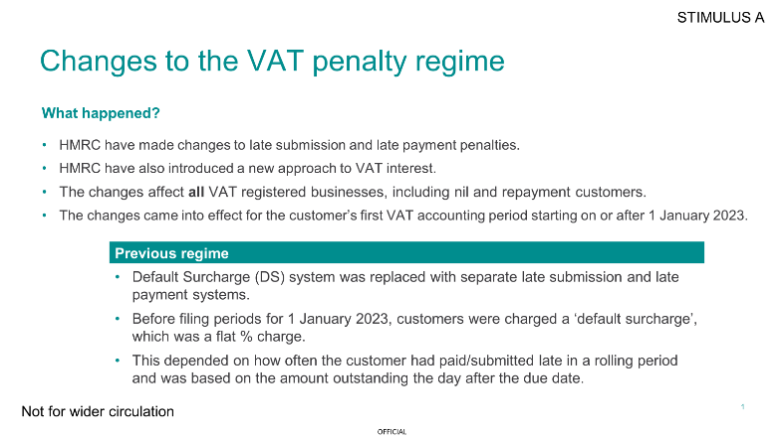
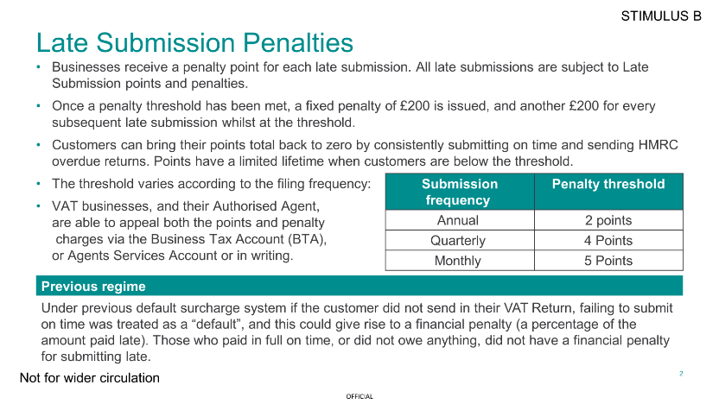
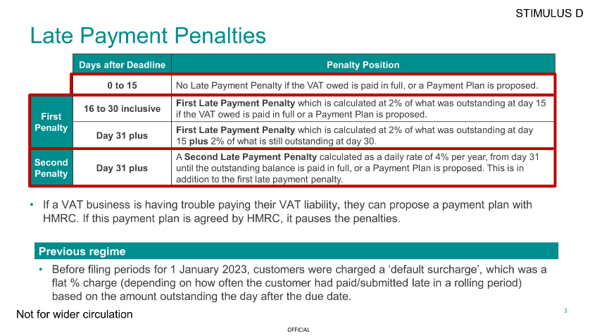
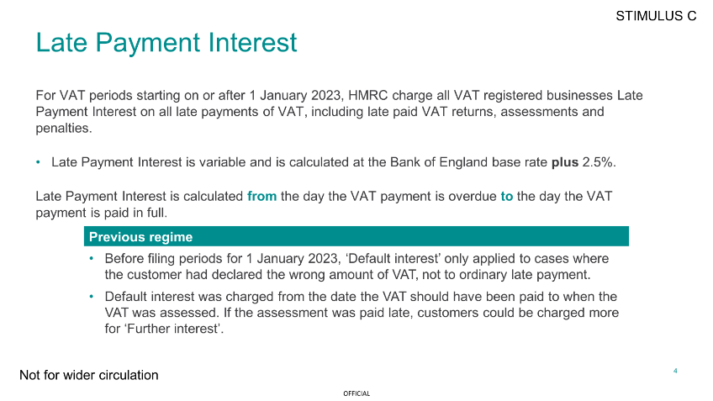
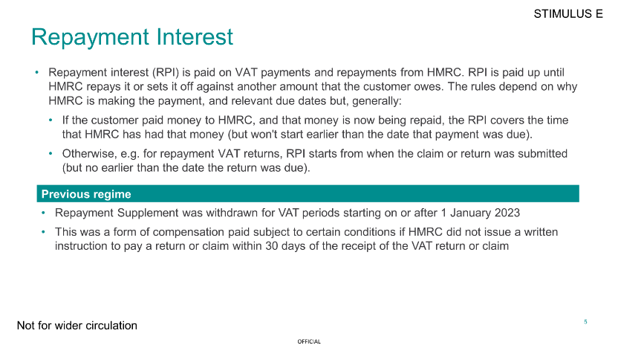

The COM-B behavioural framework
To help explore the role of the new penalty regime on compliance behaviour, the COM-B behavioural model was used to structure research materials and analysis.
The COM-B model of behaviour change proposes that to engage in a behaviour (B) at any given moment, a person must be physically and psychologically able (C), have the opportunity (O) to exhibit the behaviour, as well as the want or need to demonstrate the behaviour at that moment (M).
(Michie et al, 2019, The COM-B Model of Behaviour)

