- 

Understanding the attitudes of HMRC customers to data sharing
June 2023
Research Report Number: 733

Report prepared for:


Authors: Verian (formerly Kantar Public) Karen Bunt, Rachael Holmes, John Morris, Danny Price

The views in this report are the author’s own and do not necessarily reflect those of HM Revenue and Customs (HMRC).

© King’s Printer and Controller of HMSO 2025
This publication is licensed under the terms of the Open Government Licence v3.0 except where otherwise stated. To view this licence, visit nationalarchives.gov.uk/doc/open-government-licence/version/3.
Where we have identified any third-party copyright information you will need to obtain permission from the copyright holders concerned.

Published by HM Revenue and Customs, May 2025

Glossary
ABOS: Address based online surveying – A ‘push to web’ random probability survey approach whereby addresses are drawn from a stratified sample and survey invitations are sent to these addresses in the post, the letter includes unique log in details and the web address to visit to complete the survey.
HMRC: HM Revenue and Customs – The tax authority of the UK government.
MTD: Making Tax Digital – An HMRC initiative that requires businesses to store and maintain financial records relating to tax digitally, and to report taxes digitally via HMRC software.
PAYE: Pay As You Earn – A form of taxation whereby income tax is deducted from a salary before the individual receives it.
PTA: Personal Tax Account – A Personal Tax Account is an online service provided by HMRC that allows individuals to access and manage all of their personal tax information in one place
SA: Self Assessment - A system HMRC uses to collect Income Tax. Individuals complete Self Assessment tax returns to report income and pay Income Tax and National Insurance due from any chargeable gains; including business profits, assets or employment.
SCA: Single Customer Account – An upcoming HMRC initiative that will allow individuals to view their tax position and to tell HMRC anything they need to know through a single online account.
TAS: Tax Administration Strategy – An HMRC vision to modernise tax administration by moving away from a paper-based, time lagged system to fully integrated, digital, real-time processes.
VAT: Value Added Tax - A tax added to most products and services sold by VAT-registered businesses.
FG: Focus group – A qualitative research method that brings together a group of individuals to answer questions in a moderated setting.

Contents

1. Glossary iii
2. Executive summary 1
2.1. Current attitudes toward and understanding of data sharing 1
2.2. Views on HMRC sharing data with or receiving data from third parties 1
2.3. Reactions to the use of data sharing for the Tax Administration Strategy 1
2.4. Drivers of acceptability of data sharing 3
3. Introduction 4
3.1. Background 4
3.2. Objectives 4
3.3. Research method and timing 5
3.4. The report 6
4. Attitudes towards data sharing 7
4.1. Response to concept of data sharing 7
4.2. Digital confidence 8
4.3. Benefits and concerns 9
4.4. Familiarity and ability to make informed decisions 11
5. Attitudes towards data sharing by HMRC 13
5.1. Views on data sharing by HMRC 13
5.2. Trust in HMRC and the government 14
5.3. Trustworthy third parties 15
6. Reactions to data sharing for the Tax Administration Strategy (TAS) 17
6.1. Reactions to the use of data sharing for the Tax Administration Strategy 17
6.2. Data sharing scenarios 24
6.3. Pre-population using customer data 25
6.4. HMRC receiving data from banks and building societies 26
6.5. HMRC receiving information from online sales platforms 29
6.6. HMRC receiving data from online work platforms 30
6.7. Agents having access to HMRC data 31
7. Drivers of acceptability of data sharing 33
7.1. Factors influencing acceptability of data sharing 33
7.2. Permissions: Opt-in versus opt-out approaches 35
7.3. Impact of controls on acceptability of data sharing 35
8. Conclusions 40
9. Technical Annex 41
9.1. Introduction 41
9.2. Qualitative Research 41
9.3. Survey 46
10. Data table annex 51
10.1. Data for Chapter 4 51
10.2. Data for Chapter 5 52
10.3. Data for Chapter 6 53
10.4. Data for Chapter 7 56

Executive summary
This research study aimed to understand the attitudes of individual taxpayers towards data sharing between HMRC and third parties, in light of HMRC’s Tax Administration Strategy (TAS) reforms. The study involved an initial exploratory qualitative stage followed by a quantitative survey. The research involved individual taxpayers paying tax via PAYE and or Self Assessment from a range of employment groups, including employed, self-employed and micro employers and those earning income via online work or sales platforms. It also covered different age groups and those using agents.

Current attitudes toward and understanding of data sharing
Data sharing was spontaneously linked by participants to social media platforms when introduced in the qualitative research.
The biggest perceived benefits of data sharing related to convenience and time saving. Six in ten respondents selected each of ‘it is more convenient if it saves me having to provide information’ and ‘it saves time if I don’t have to provide the same information each time’ as benefits in the survey.
GDPR regulation and opt-in/opt-out options were seen to protect participants’ data in the qualitative research. Despite this recognition, the survey found taxpayers had concerns around data security and fraud (87% selected a related concern).
General digital confidence was high (71% were confident in their own abilities) but respondents’ ‘confidence in their ability to make informed decisions regarding data sharing’ was lower (49% confident). The qualitative research suggested this was often because people lacked any real awareness and understanding of what data sharing is about.

Views on HMRC sharing data with or receiving data from third parties
Participants had limited views on HMRC and data sharing and it was not something they were aware of spontaneously or had considered.
The survey found that confidence in HMRC to keep taxpayers’ data confidential (58% confident, 15% not confident) was high, as it was for government more generally (49% confident, 19% not confident). The low proportion of people who were not confident reflected the qualitative finding that sharing data between government departments was accepted and normalised.
However, the qualitative research found that lower levels of trust in third parties impacted attitudes towards data sharing with HMRC. There were concerns about HMRC gathering data from banks and building societies and online platforms, as well as a nervousness around third-party software. Perceptions of a third-party as a secure data holder was a key driver to acceptance of data sharing, alongside an understanding of why HMRC is sharing or receiving data with them.

Reactions to the use of data sharing for the Tax Administration Strategy
There was a mixed response to HMRC’s use of data sharing in the context of the TAS reforms explored in the qualitative research, with some focusing on benefits and others raising concerns.
Six factors drove this variation in responses:
- level of trust in HMRC: Those with lower levels of trust in HMRC to implement the reforms successfully or to act in their or the public’s best interests identified more concerns and were less amenable to data sharing
- use of an agent: Those currently using an accountant and those who had high levels of trust in their agent, were more open and amenable to them accessing their own single customer account
- complexity of tax circumstances: For PAYE customers, there was an acceptance of data sharing between HMRC and their employer, but data sharing with third parties beyond that could seem unnecessary, whereas self-employed and gig economy workers welcomed some of the benefits that data sharing with third parties would bring
- experience of saving data to a cloud: Those who had already shared data to a secure cloud had higher comfort levels than those with limited experience of saving data this way, who were relatively fearful about data security
- attitude towards data privacy: Those more concerned about data privacy expressed more concern about HMRC sharing and receiving data with third parties and via third-party software
- digital confidence: Those with greater experience and confidence in using technology felt more comfortable and prepared for sharing and receiving data via new software
Respondents in the survey were prompted with 5 specific scenarios of data sharing for tax purposes:
- HMRC using customer data to enable pre-population of online tax or benefits
- HMRC receiving data from banks and building societies about monies coming into accounts, including interest earned on savings and investments, enabling in year adjustments to amount of tax due
- HMRC receiving sales information from online sales platforms (such as eBay and Etsy), so taxpayers do not need to provide this information themselves
- Online work platforms (such as Uber) automatically deducting the tax due each month, enabling taxpayers to pay tax more regularly and within the tax year
- HMRC giving agents access to all their clients’ data and enabling them to do more on their behalf. This element was only asked of those using a tax agent
Respondents who were broadly comfortable with data sharing were more likely to be digitally confident and be more impacted by the concepts introduced in the scenarios.
All respondents were comfortable with at least one element of data sharing, with this driven by high levels of comfort with pre-population and greater data sharing with agents. Two-thirds (69%) of all respondents were comfortable with pre-population. Amongst those using a tax agent, most (81%) were comfortable with agents having more access to their data and being able to do more things on their behalf.
There were lower levels of comfort with the other scenarios. Around half were comfortable with data being shared with HMRC by their bank or building society (50%) and platform-based employers (51%). The lowest level of comfort was seen for data being shared by online sales platforms (38%).
Those directly impacted by the concepts in the scenarios showed higher levels of comfort, but also greater concerns due to their closeness with the scenario. The qualitative research suggested that this particularly applied to people selling or working through online platforms, as they had a better understanding of how and why this would work. However, they also had more concerns, particularly about the quality of the data and the burden of making changes if they believe data to be incorrect. Small numbers of relevant respondents in the survey means this difference was not quantified.

Drivers of acceptability of data sharing
Being asked for permission for data sharing increases levels of comfort, with the ability to opt-in (73%) being by far the preferred option, compared with an opt-out approach (16%).
Being asked for permission offered reassurance even for those who were less digitally confident, or who were not comfortable with each data sharing scenario in principle. The qualitative research suggested that this was because it gave people the opportunity to understand how and why data sharing was needed.
However, the biggest driver of increased comfort across scenarios was the ability for individuals to check and correct their data. In particular, having this control in place for pre-population increased the proportion of respondents who were comfortable with this element of data sharing from 69% to 83% of all respondents.
In conclusion, data sharing is an emotive topic with mixed responses reflecting lack of awareness and understanding of the issues. Reassurances are required on security, control, accuracy and privacy of their data to overcome latent concerns. However, data sharing presents an opportunity to contribute to streamlined and positive digital experiences.

Introduction

Background
HM Revenue and Customs (HMRC) is transforming tax administration. The report ‘Building a trusted modern tax administration system’ sets out a Tax Administration Strategy (TAS) for the next 10 years. It describes a programme of modernisation that moves from a paper-based, time lagged system to fully integrated, digital, real-time processes. It reflects customer and operational demand for a simpler, more transparent system that provides greater certainty and minimises error and burden.
The proposed reforms set out in the strategy are:
- the extension of Making Tax Digital (MTD) to help move the UK towards a fully digital tax system that works closer to real-time
- improving the use of real-time information to allow taxpayers to have a more up-to-date understanding and greater certainty over their tax position, with capacity for real-time risk assessment
- the timely payment of tax to allow people and businesses to pay the right tax with ease, in ways that fit with how they live their lives and go about their business
- delivering a secure and easily accessible single digital account or customer record to give taxpayers a single and complete financial picture, bringing together their different taxes and data sources, and enabling HMRC to deliver more personalised services
- improving services for agents and representatives that will enable HMRC to design in access for appointed agents and representatives from the outset, and support efforts to ensure high standards within the tax advice market
- reform of the tax administration framework to create a simpler, more transparent framework that helps build greater trust and provides greater certainty for taxpayers
The TAS is in alignment with HMRC’s strategic objectives. Individuals are HMRC’s largest customer segment of over 40 million people, including customers who need extra help with their affairs. The majority of UK adults belong to this customer group.
The 2021 ‘Individuals, Small businesses and Agents customer survey’ found that 84% of all adults aged 16 and over in the UK pay personal taxes or receive HMRC benefits or credits, including 80% paying tax, and 18% receiving benefits or credits (15% both). HMRC’s ambition for individuals is to make paying the right tax and receiving the right entitlements increasingly effortless.
To achieve this ambition, customers will need to agree to the transfer and sharing of data between HMRC and third parties, as is already the case for PAYE with employers. Third parties include banks, other government departments, third-party contractors, software developers and agents.
HMRC commissioned Kantar Public to undertake exploratory qualitative research and a follow-on quantitative survey to inform the future of these reforms.

Objectives
The overall research objective was to better understand the attitudes of individual customers towards data sharing between HMRC and third parties. The research explored what drives these attitudes and how they vary between customers. It has also established a baseline measurement for HMRC.
Specifically, the qualitative research aims were to:
- understand HMRC participants’ attitudes towards data sharing
- capture views about third-party data sharing with HMRC
- explore participants’ perceptions of the opportunities and issues related to data sharing across specific strands of the Tax Administration Strategy
- understand what factors affect how participants feel about data sharing and the use of third-party data
- explore how views towards data sharing differ depending on who is sharing the data
- understand what HMRC can do to build respondent comfort with data sharing
The follow-up quantitative survey aims were to:
- determine what individual taxpayers know about data sharing in relation to HMRC
- capture what experiences and expectations respondents have of third-party data sharing
- quantify taxpayers’ perceptions of the perceived opportunities and issues relating to data sharing across specific strands of the Tax Administration Strategy
- capture the prevalence of the factors that affect how respondents feel about data sharing and the use of third-party data, and what can HMRC do to build their level of comfort
- capture the differences in attitudes to data sharing which exist between sub-groups and respondent characteristics

Research method and timing
The qualitative research was carried out in March and April 2022. Participants were recruited from the population of UK personal taxpayers, covering the self-employed, gig economy workers, and PAYE employees (both Self-Assessed and non-Self-Assessed). Recruitment ensured a spread by age, use of a tax agent, region, gender, and socio-economic status.
The qualitative fieldwork consisted of 12 online focus groups, each lasting 90 minutes, conducted via Zoom, with a total of 64 participants. In addition, 6 telephone depth interviews were conducted with less digitally confident individuals, each lasting 60 minutes.
The quantitative survey was carried out in August and September 2022. Respondents were UK adults who pay personal tax or are in receipt of any benefits or credits administered by HMRC. This included the self-employed, those paying tax via PAYE (including Self Assessment), and people in receipt of Child Benefit and Tax Credits. It further included those involved in the gig economy and people obtaining income via online platforms and apps. The sampling approach ensured coverage of a cross section of this population by age and work status, also covering the digitally excluded.
A random survey sample was drawn from Kantar Public’s Public Voice panel: a general population dataset. The majority of respondents completed the survey online, but with telephone interviews offered to ensure coverage of those unable or unwilling to access the questionnaire online. The survey took 20 minutes to complete on average and was conducted with 2,435 respondents.
More detailed information on the research methods used, including achieved sample profiles and analysis approach, is included in the technical annex to this report.

The report
The report draws together the qualitative and quantitative findings to answer the objectives. While the survey was used to quantify the findings of the exploratory qualitative research in relation to most objectives, some objectives are addressed solely using the qualitative research findings.
Results from each source are clearly differentiated within the discussion. All references to ‘participants’ relate to the findings of the qualitative research, while references to ‘respondents’ relate to the survey research data. All data in charts and tables are taken from the survey.

Attitudes towards data sharing
This chapter provides insights into the objectives of both the qualitative and quantitative research to understand attitudes towards data sharing. It examines the factors that affect how respondents feel about data sharing, including levels of digital confidence and, more specifically, confidence in relation to data sharing.

Response to concept of data sharing
The qualitative research explored spontaneous views and understanding of the general concept of data sharing. Participants’ immediate associations were with social media and targeted advertising, and most accepted that social media platforms would share data to inform targeted advertising campaigns.
Whilst some felt wary of this and felt they had a lack of control in how this data was used, there were also perceived benefits in receiving relevant and focused information. Sharing data on shopping habits was not considered harmful and many felt protected by GDPR regulations and the current choice of ‘opting in’ and ‘opting out’ of whether data was shared with third parties.
We also explored the term ‘data gathering’. This was perceived as an exercise for commercial purposes, mining information already in the public domain, with a focus on research, advertising and marketing and communications. There was some awareness that this kind of data sharing gives power to the consumer voice as analytics can be used to improve the customer experience.
“I would genuinely prefer to get targeted information than information that I am not interested in.” (FG, self-employed/micro employer, Completed SA, 18 to 29 years)
It should be noted that on initial discussion the impulse was to be concerned about data sharing. Overall, there was a common fear that data sharing could drive fraud and identity theft. Those who had experienced fraud or had high levels of awareness of where data had been compromised had heightened levels of fear about data sharing.
“Data sharing is used so much nowadays, and it is dangerous.”
(FG, PAYE employee, Not completed SA, 18 to 39 years)
“I did have my eBay account hacked. I do not know how they got that information as you could not guess that password. That was frightening.”
(FG, PAYE employee, Not completed SA, 18 to 39 years)
“For the right price anyone can know anything about you.”
(FG, PAYE employee, Completed SA, 30 to 49 years)
To assuage these fears, participants sought reassurances on security, control and transparency regarding data sharing. There was a strong desire for transparency when data was shared by or with third parties and a desire to know when they were being targeted because of shared data. Related to this, participants wanted to be asked for their consent to data sharing – to be given the choice of opting in or opting out of their data being shared with third parties.
They also expressed a fear of losing control of their personal data when shared with third parties, unsure how far data might travel. Some were afraid that their identity could be stolen, leading to fraud and other criminal activities. Participants were also anxious about being targeted and receiving unwanted marketing.
Discussion of data sharing also raised concerns around data security, and fear of details being leaked from insecure or untrustworthy third parties. Participants recalled examples of BA and Lloyds where customer data had been compromised and felt uncertain about the safety and security of how data is stored and how it is transferred or shared.
"There has to be an opt out and an opt in, depending on what you want to do."
(FG, PAYE, Completed SA, 30 to 49 years)
"They might say it's secured but nowadays we really don't know, it can be prone to cyber attacks."
(FG, PAYE employee, Completed SA, 30 to 49 years)
“We're hearing it all the time that so and so got hacked, it’s just not in our control.”
(FG, PAYE employee, Completed SA, 50+ years)
"I don't think you can really rely on all of these companies to keep your data safe."
(FG, PAYE employee, Completed SA, 50+ years)
Importantly, in situations where it was normalised, and where people could see the benefits of third-party data sharing, their reactions softened. Participants reflected on their own experiences where data sharing felt comfortable and familiar and recognised that it could be both useful and safe. Examples included Covid vaccinations being shared with the NHS, MOT information being shared with DVLA and DBS checks being shared with employers.
They also acknowledged that pre-population of forms on trusted sites and recall of passwords could streamline and speed up processes.
“There are times that I am glad that the website has saved my password, as I am not sure I would remember it!” (FG, PAYE employee, Not completed SA, 30 to 49 years)
“Chrome has all my passwords locked in there and it remembers everything… very helpful.”
(FG, Gig economy worker, multiple platforms, Completed SA, Mixed ages)
Overall, it was felt that there had to be a perceived benefit for sharing data with third parties: participants expressed the need to feel reassured that they would be the main beneficiary of the exercise (rather than the third-party that is sharing or receiving the data).

Digital confidence
Survey respondents were asked to rate their own digital capabilities. Respondents were informed that this covered, for example, the use of devices, apps, software to do things like online banking, making purchases, and paying bills online and communicating online via email and social media.
Most respondents (71%) were confident in their own digital capabilities (a score of 4 or 5 out of 5 – see Figure 1), with 40% rating themselves as very confident (a score of 5 out of 5). Just 12% were not confident in their own abilities (a score of 1 or 2 out of 5). As will be discussed later in the report, digital confidence (defined in this report as a score of 4 or 5 out of 5) was a key driver of comfort with HMRC’s proposed data sharing approaches, suggesting that lack of capability is a key barrier.
Digital confidence varied by employment and tax status (figure 1). Respondents paying tax under PAYE were relatively more confident (79%), but this was higher for those working full-time (81%) than part-time (74%). Respondents who were self-employed (70%) and who paid tax under Self Assessment (70%) were relatively less confident, as were those in receipt of benefits and credits (73%). There were similar patterns of difference in terms of being very confident.
Figure 1: Confidence in own digital capabilities, by employment and tax status
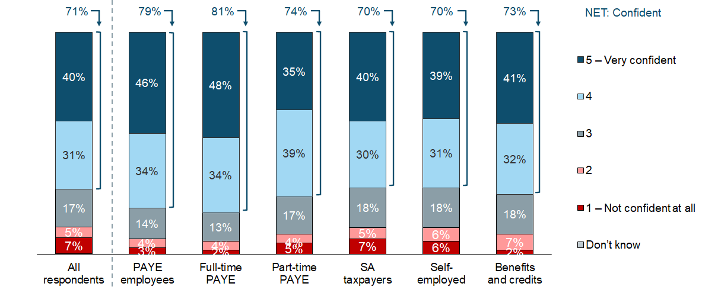
Source: VBQ. Overall, how confident are you in your digital capabilities? (e.g., use of devices, apps, software to do things like online banking, buying and paying bills online and communicating online via email and social media etc.)
Base: All respondents (2434), PAYE (1613), full-time PAYE employees (1232), part-time PAYE employees (312), Self-Assessed (720), self-employed (376), benefits and credits received in past 12 months (518)
The accompanying data table (Table 1) for Figure 1 can be found in the appendix to this report.
Reflecting the lower levels of confidence among respondents paying tax under Self Assessment (who were more likely to use an agent), those who used a tax agent were less digitally confident (59%) compared with those who did not use an agent (72%).
Age was another factor in confidence, with younger people more likely to describe themselves as digitally confident. Of those aged 18 to 34, 85% said they were digitally confident, compared with 77% of those aged 35 to 49, 71% of those aged 50 to 64 and 43% of respondents who are 65+.
Digital confidence was also higher among cloud service users (80%) than non-users (53%), and among those who had used their Personal Tax Account in the past year (84%) compared with those without an account (68%) or not aware of them (67%).

Benefits and concerns
In the qualitative research participants were invited to share their spontaneous thoughts on data sharing, particularly how it could be useful to them and any worries they might have. The survey presented respondents with lists of potential benefits and concerns about data sharing and asked which applied to them.
Specific examples were given to respondents (based on the qualitative research) to clarify the potential benefits of convenience and time saving. Examples of convenience included details of covid vaccinations being shared with the NHS, MOT information being shared with DVLA and credit checks being shared with banks and other credit companies. The example given for timesaving was pre-populating online forms and passwords.
The key benefits identified by respondents were related to convenience and time saving (82% - see Figure 2). The top specific benefits within this category, each selected by 60%, were that ‘it is more convenient if it saves me having to provide information’ and ‘it saves time if I don’t have to provide the same information each time’. The third, lesser factor in this category was that ‘it can help improve customer service and make online interactions quicker and smoother’ (35%).
Fewer respondents (27%) identified the ability of data sharing to drive personalised information, such as targeted adverts or social media content, as a benefit to them, including 17% who felt social media targeting to be a benefit.
Figure 2: Perceived benefits of and concerns about data sharing
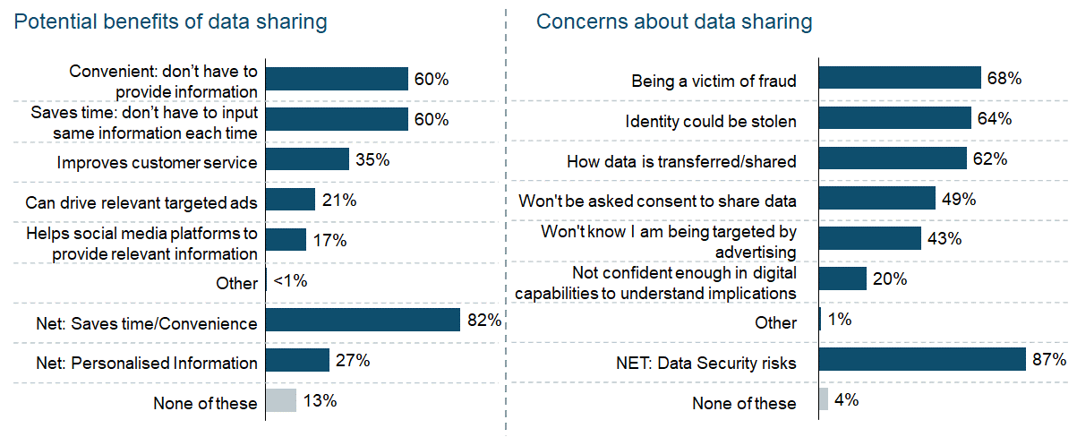
Source: VBW. Thinking about the concept of data sharing... what do you think are the potential benefits to yourself, if any? VBQ. And what potential concerns, if any, do you have?
Base: All respondents (2434)
The accompanying data table (Table 2) for Figure 2 can be found in the appendix to this report.
Those who were not digitally confident were considerably less likely to identify any potential benefits related to data sharing, with 32% selecting ‘none of these’ compared to 13% of all respondents. This reflects findings of the qualitative research, where participants were initially wary of data sharing, with this related to a lack of broader digital understanding.
The key concerns identified were related to data security (87% - Figure 2). This covered 3 issues fairly equally: concern about being a victim of fraud (68%), fear that their identity could be stolen (64%), and concerns about how data is transferred and shared (62%).
Half of respondents (49%) were concerned that they would not be asked for consent before having their data shared. The impact of consent on attitudes towards data security was covered in more detail in later questions in the survey and is discussed further in Chapter 7.
Those who were not digitally confident had similar concerns to those who were more confident. They were, however, more likely to select ‘I am not confident enough in my digital capabilities to understand the implications of data sharing’ (56%) and to have concerns about being targeted by advertising (56%) compared with all respondents (20% and 43% respectively).

Familiarity and ability to make informed decisions
Confidence in their ability to make informed decisions about data sharing was also measured in the survey, and this was, unsurprisingly, strongly related to digital confidence in general (Figure 3).
Half of respondents (49%) said they were confident (a score of 4 or 5 out of 5) in their ability to make informed decisions about data sharing, with just 15% very confident (5 out of 5).
Among those who were digitally confident, 62% said they were confident they could make informed decisions, compared with just 12% of those who were not digitally confident. This highlights directly how a lack of confidence in digital skills is likely to be a barrier to comfort with data sharing.
Figure 3: Confidence in own ability to make informed decisions about data sharing by digital confidence, employment and tax status
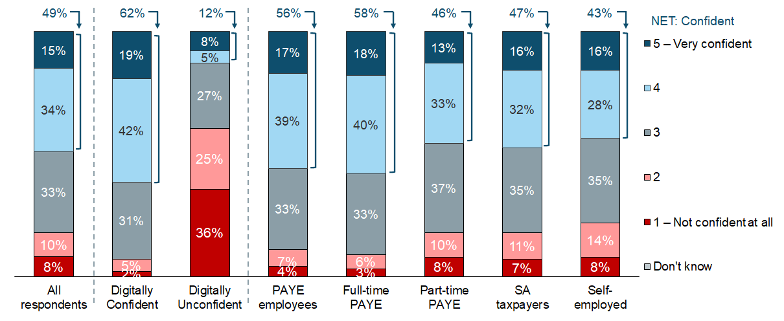
Source: VBY. Overall, how confident are you that you can make informed decisions regarding data sharing and understand the implications of data sharing?
Base: All respondents (2434), digitally confident (1827), digitally unconfident (217), PAYE employees (1613), full-time PAYE employees (1232), part-time PAYE employees (312), self-employed (376), benefits and credits received in past 12 months (518)
The accompanying data table (Table 3) for Figure 3 can be found in the appendix to this report.
There was a strong association between digital confidence and confidence in relation to data sharing. However, far fewer respondents were confident (49%), and particularly very confident (15%), in their ability to make informed decisions about data sharing. This reflects the findings from the qualitative research that taxpayers often have a poor understanding of data sharing, despite having strong digital skills, which limits comfort with data sharing approaches.
Similar to patterns seen for overall digital confidence by employment and tax status, PAYE employees (56%) and particularly full-time employees (58%) were more likely to be confident in relation to data sharing, compared with the self-employed (43%) and part-time employees (46%). Confidence among all respondents paying tax under Self Assessment (47%) was also relatively lower.
Other patterns of difference were also similar to those seen for overall digital confidence. Younger people were more likely to be confident in relation to data sharing. Of those aged 18 to 34, 61% said they were confident, compared with 52% of those aged 35 to 49 and 48% of those aged 50 to 64. Confidence was lowest among those aged 65 and over at 31%. Few in any age group said they were very confident, and this was no higher than average among those aged 18 to 34 (17%), suggesting substantial knowledge gaps at all ages.
Confidence in their ability to make an informed decision was also higher among cloud service users (55%) than non-users (39%), and among those who had used their Personal Tax Account in the past year (64%) than not using their account (54%), without an account (51%) or not aware of Personal Tax Accounts (44%).

Attitudes towards data sharing by HMRC
This chapter provides insights into the qualitative objectives of understanding views about third-party data sharing with HMRC, and how attitudes vary depending on who is sharing the data. The acceptability of such data sharing must also be underpinned by trust in the government and, more specifically, HMRC to handle data confidentially. The survey measured current levels of trust.

Views on data sharing by HMRC
The qualitative research provided insights into views on data sharing by HMRC. Participants had limited views on HMRC and data sharing, as it was not something they had considered spontaneously.
When the concept of HMRC and data sharing was introduced, participants’ initial impulse was to trust HMRC to protect their data. They had confidence in current security measures, and no-one had any personal experience of a data breach. Some saw HMRC as separate or independent of government and saw this as a positive in the context of data security (this is reflected in the trust levels detailed in 5.2).
It should also be noted that some assumed that HMRC would have to ask consent from customers before sharing data, adding reassurance. Equally some felt that data sharing was happening already, as HMRC must receive data to check names, addresses and tax codes.
“When I think of HMRC, it feels safe. That is reinforced by security checks, 7-day password. When you think of HMRC, you think about safety”.
(FG, PAYE employee, Not completed SA, 30 to 49 years)
“I have never been hacked at HMRC.”
(FG, PAYE employee, Not completed SA, 30 to 49 years)
“HMRC are there for one job, we have an idea of what they are there for, so I trust in them to not use our data for marketing or selling.”
(FG, PAYE employee, Not completed SA, 18 to 29 years)
"I don’t think they are allowed to share data with anyone unless they are authorised by us".
(FG, gig economy worker, multiple platforms, Completed SA, Mixed ages)
When prompted, concerns reflected more general anxieties linked to the principle of data sharing rather than concerns specific to HMRC’s involvement in this. These anxieties centred on the risks of fraud, human error, and data breaches. It was acknowledged that other government departments had experienced data breaches - there was some awareness that the NHS had lost data - and that HMRC might face similar risks.
It was assumed that HMRC was already sharing or receiving data with other government departments, such as data on benefits, as well as with employers.
“Once you give permission for HMRC to share data, you give the power away, and then you are dependent on them to make a decision about what is right and wrong.”
(FG, PAYE employee, Not completed SA, 18 to 29 years)
“It makes tax purposes easier if your employer deals directly with HMRC, and also if a parent does not pay child maintenance, HMRC knows exactly how much that parent earns!”
(Self-employed/micro employer, Completed SA, 18 to 29 years)
"There is a link between HMRC and Universal credit and Jobseeker’s allowance, think they are quite linked together, in a good way."
(FG, gig economy worker, multiple platforms, Completed SA, Mixed ages)
The qualitative research also explored the perceived benefits of HMRC sharing data. These centred on prevention of fraud, the likelihood that more accurate data would be shared and streamlining the tax system.
Fraud prevention was related to an assumption that HMRC could access cryptocurrency accounts to ensure that all relevant data is considered and that tax obligations are met (although this is not the case). This was felt to be in the public interest, as it would increase fairness. It was also hoped that data sharing would increase accuracy, through the pre-population of forms that would reduce taxpayer error. Related to this, participants hoped that data sharing would help to streamline HMRC processes, ensuring that these are quicker, simpler and more intuitive.
We will discuss potential benefits further when we share response to data sharing in relation to TAS in 6.1.

Trust in HMRC and the government
The survey aimed to quantify levels of trust in institutions to handle their data confidentially. Respondents expressed relatively high levels of trust in both HMRC and the government, reinforcing the sentiment expressed in the discussion groups that data sharing between and within government departments was seen as normalised.
Over half (58%) of respondents expressed confidence in the ability of HMRC to keep data confidential and half (49%) for the government as a whole. The proportion of respondents saying they were not confident was much lower (HMRC: 15%, government: 19% - see Figure 4).
There was little variation in confidence levels by employment or tax status, but digital confidence was strongly related to confidence in each of HMRC and the government. For HMRC, trust was much higher for the digitally confident (64%) than those not digitally confident (35%), with a similar pattern of difference in confidence in the government (55% among the digitally confident, compared with 25% among those not digitally confident).
Similar questions were asked of respondents in HMRC’s 2021 customer surveys of Individuals, Small businesses and Agents. Among Individuals who paid personal tax or received HMRC benefits and credits, 63% said they were confident in HMRC to store data confidentially, with 7% not confident. This is slightly higher than the levels reported here, probably reflecting the different context in which they were asked, with more questions about data sharing preceding this question in the current survey.

Figure 4: Confidence in the government and in HMRC to keep data confidential
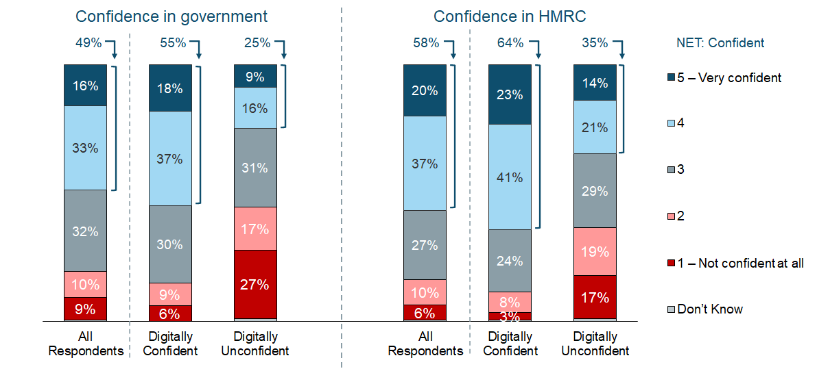
Source: VBN. Overall, how confident are you in the government keeping your data confidential?
VBP. Overall, how confident are you in HMRC keeping your data confidential?
Base: All respondents (2434), digitally confident (1827), digitally unconfident (217),
The accompanying data table (Table 4) for Figure 4 can be found in the appendix to this report.

Trustworthy third parties
The qualitative research provided insights into views on data sharing by HMRC. As has been seen, sharing data between government departments was accepted and normalised. However, we found lower levels of confidence in other third parties, and this impacted attitudes towards data sharing. Importantly, perceptions of a third-party as a secure data holder were a key driver to acceptance of data sharing, alongside an understanding of why HMRC would be sharing or receiving data with them.
Although most trusted in the security of banks and building societies, participants were concerned about HMRC gathering data from them and felt that this could be too intrusive. It created a sense of being ‘followed’ and that HMRC were ‘checking up’ on people, creating perceptions of a ‘Big Brother state’. It was also felt that it would only be appropriate for HMRC to access business accounts, not personal ones.
Participants also voiced concerns about online platforms sharing data with HMRC that was inaccurate or did not reflect the balance of profit to sales. Anxiety levels increased with the idea of HMRC taking tax direct from online platforms, rather than just receiving data to feed into tax calculations.
Participants also expressed some nervousness around third-party software, with unfamiliarity around the term ‘third-party’ in this context and a suspicion around ‘free’ software. Some feared that scammers would pose as software providers and there was a clear need for reassurance about the security of the third-party software.
There were mixed attitudes towards accountants having access to more of their clients' data, underpinned by participants’ individual relationships and experiences.
"In my bank account there are things being paid not concerning my business, so what justification is there for having a look?"
(FG, gig economy worker, multiple platforms, Completed SA, Mixed ages)
"Something people don't want is a Big Brother society."
(FG, gig economy worker, multiple platforms, Completed SA, Mixed ages)
“I would not feel that comfortable [with online platforms], they are more unreliable than HMRC.” (FG, PAYE employee, Not completed SA, 18 to 29 years)
"A lot of [software providers] have good intentions but they might not have the funds to create a secure environment."
(FG, gig economy worker as additional income, Completed SA, Mixed ages)
“You do have to trust an accountant if they are accessing your account, but if you employ them, then surely you trust them in the first place.”
(FG, PAYE employee, Not completed SA, 18 to 29 years)
A further qualitative study of individuals to develop propositions to make tax an effortless experience for individual customers ’ also examined the concept of data sharing and trust in third parties. The findings closely aligned with those in this report.

Reactions to data sharing for the Tax Administration Strategy (TAS)
This chapter discusses the qualitative exploration of opportunities for Tax Administration Strategy reforms and responses in the survey to potential examples of data sharing. This covers level of comfort with 5 scenarios, as well as respondent concerns about each one.

Reactions to the use of data sharing for the Tax Administration Strategy
The qualitative research explored in depth reactions to the use of data sharing to underpin the Tax Administration Strategy reforms. There was a mixed response to data sharing in the context of Tax Administration Strategy reforms, with some focusing on benefits and others raising concerns.
Six factors drove this variation in responses:
- level of trust in HMRC: Those with lower levels of trust in HMRC to implement the reforms successfully or to act in their or the public’s best interests identified more concerns and were less amenable to data sharing
- use of an agent: Those currently using an accountant and those who had high levels of trust in their agent were more open and amenable to them accessing their own single customer account
- complexity of tax circumstances: For PAYE customers, there was an acceptance of data sharing between HMRC and the employer, but data sharing with third parties beyond that could seem unnecessary; whereas self-employed and gig economy workers welcomed some of the benefits that data sharing with third parties would bring
- experience of saving data to a cloud: Those who had already shared data to a secure cloud had higher comfort levels than those with limited experience of saving data this way, who were relatively fearful about data security
- attitude towards data privacy: Those more concerned about data privacy expressed more concern about HMRC sharing and receiving data with third parties and via third-party software
- digital confidence: Those with greater experience of and confidence in using technology felt more comfortable about and prepared for sharing and receiving data via new software
The qualitative research explored HMRC data sharing in the context of the Single Customer Account (SCA), using the persona of ‘Sam’ (a self-employed taxpayer) to bring the details to life. Having explored feelings about HMRC data sharing in principle, we used a range of stimulus material to explore data sharing in a more tangible way.

6.1.1 Single Customer Account (SCA) introduction

The stimulus material used first introduced the SCA as follows:
The Single Customer Account will mean all of your tax administration will be handled together in one place. It will be securely hosted on the cloud

- Sam only needs to log in once to manage all the different taxes he pays in one place
- Registration for the account is simple and quick
- Customer and HMRC data will be used to pre-populate information, reducing what Sam needs to enter within his account – e.g., name, address and tax code will be automatically filled in (pre-populated) on online tax forms
- The account will provide personalised information and generate reminder notifications that are specific to Sam’s tax activities and obligations, e.g. reminders of upcoming payments
- Online secure messages can be sent to customer service staff

The SCA was seen as a necessary progression, and signified the modernisation of HMRC, which was considered to be a positive. Participants drew comparisons with innovation in online banking, with newcomers such as Starling and Monzo. It was also expected to simplify processes for those with complex tax affairs. The main concerns raised were due to high levels of anxiety about saving data on the cloud. Some participants felt that this carried risks of cyber-attacks and data breaches, as well as a concern that if the system crashed, all data would be lost. Some also felt that modernisation could have a negative impact, fearing that if HMRC lost workers through digitisation the level of customer service would be impacted negatively.
“Everything is digital or electronic – it is the future. This is the new alternative – submitting information online.” (Depth, PAYE employee, Not completed SA, 39 years)
“I would jump on something like this - this feels like a modernisation of HMRC, it is following the future of banking.” (FG, Self-employed/micro employer, completes SA, 18 to 29 years)
“I feel worried about storing data on the cloud, what does that mean in terms of security? How secure is that system?” (Depth, PAYE employee, Not completed SA, 40 years)
The offer of pre-population was received positively, with a recognition of the convenience that this would bring. It was expected to save time and reduce effort and it was hoped that it would also reduce taxpayer errors within forms, increasing confidence that submissions would be correct. Participants’ comfort with pre-population was strengthened by their perception that data sharing was already happening between government departments and HMRC, without incident. They felt that comfort would be further increased if they were given the option to opt in or opt out of pre-population.
However, there were still some concerns, in particular the fear that wrong information might be pre-populated – although this could be addressed by a clear process to amend any incorrect data. This raised the issue of HMRC customer service and a fear of losing the ability to speak with someone should information need to be corrected. Participants also had concerns about the security of emails being sent from the SCA.
"I think this is something that they are already currently doing for me and they have my details mostly pre-populated. For me it's fine, it's something that I'm used to and I'm comfortable with."
(FG, gig economy worker as additional income, Completed SA, Mixed ages)
“It just sounds like they are trying to make your life easier.”
(FG, PAYE employee, Not completed SA, 18 to 29 years)
"Maybe I'm just lazy and looking for the easy way out but I'm happy for information to be shared with HMRC. I will double check it, but if they do most of the heavy lifting then I'm game for that… If it's correct then it makes life easier for you, saving you time and if you want to check on it you can, whenever you want to."
(FG, gig economy worker as additional income, Completed SA, Mixed ages)
“I am dyslexic - so I think pre population sounds really helpful, otherwise it is just a big mush of data." (FG, PAYE employee, Not completed SA, 18 to 29 years)
“If wrong information is put into a form, how will we find out where that wrong information actually came from in the first place?” (FG, PAYE employee, Not completed SA, 18 to 29 years)

6.1.2 Third-party data
We then explicitly introduced the use of third-party data in the context of the SCA:
Within the Single Customer Account, HMRC will also be able to draw on third-party data (e.g. data from banks and companies) to further automate processes; for example, HMRC will be able to take tax direct from sales made through online platforms

- Use of other third-party data will further reduce the need for Sam to undertake tax related administration as it will further automate processes
Initial reactions typically concerned fears that third-party data use would be invasive and disruptive. Participants felt that there was a risk that introducing additional parties into the mix would lead to errors and mistakes and could over-complicate, rather than simplify, tax calculations.
There were concerns about data from online platforms and banks specifically. Participants were uncertain about how practical and viable it would be for HMRC to get accurate and up-to-date data from online platforms. They questioned how HMRC would be able to access all online platforms and whether the online platforms could be trusted to provide accurate and relevant data.
There was some level of trust in more established online platforms, such as Uber, Etsy and Deliveroo, but concerns about new start-ups. Concerns were also raised as to how HMRC would handle data about transactions made via online platforms in foreign currencies, and how HMRC would track sellers selling via multiple platforms.
As we have already discussed, participants also felt that HMRC accessing bank accounts was a threat to privacy and would be both invasive and unnecessary. They wanted reassurances that HMRC would access data for tax liability purposes only, rather than to track shopping behaviour, with accusations of this form of data sharing being a bit ‘Big Brother’. They did however see banks as trusted data providers, who took data security extremely seriously.
Participants also voiced concerns that direct deduction of tax by online platform providers would compromise the individual’s control over cash flow. There were high levels of suspicion around HMRC taking tax direct and the potential for errors and loss of control. It was also questioned whether this was appropriate for those offering services via online platforms, as it mirrored the employer dynamic without the employee benefits.
"It doesn't factor in the expenses from that particular sale [on an online platform], he spends something on it and sold it for a certain price. I wouldn't feel comfortable with that."
(FG, PAYE employee, Completed SA, 30 to 49 years)
“It sounds too much like Big Brother – why do we have to do that? It is not the place of the government to access that information.” (Depth, Sole Trader, Completed SA, 50 years)
“It's naughty isn't it! I don't agree with that at all, taking taxes directly. It should be up to the person. That is theft." (FG, PAYE employee, Completed SA, 30 to 49 years)
“With an employer your tax is deducted directly but they also have certain responsibilities towards you as an employee. This is imposing the obligation without the supposed employer having the responsibilities of an employer." (FG, PAYE employee, Completed SA, 30 to 49 years)
"If they take a cut before you see it, it just seems ‘am I actually self-employed or am I working for you [the government]’?" (FG, gig economy worker, multiple platforms, Completed SA, Mixed ages)
Importantly, when individuals focused on the benefits of data sharing, such as ease and speed of use, data sharing with third parties became more palatable. There was greater openness and acceptance of HMRC data sharing with the purpose of calculating tax, compared with HMRC actually taking tax direct via online platforms. Some saw the benefit of banks sharing data with HMRC being that it might reduce the need for an accountant. Looking at the bigger picture, participants recognised that data sharing in this way signified the modernisation of HMRC, which some saw as a positive in itself. It would also offer HMRC a means to hold individuals to account and ensure that all tax obligations are met.

6.1.3 Third-party software
We then explored the use of third-party software in the context of MTD:
MTD for VAT will roll out to all VAT registered businesses from April 2022, Income Tax Self Assessment from April 2024 and potentially Corporation Tax.
MTD will allow payment and provision of digital information from customers to HMRC more regularly (for example, quarterly) using third-party software (free software packages will be available)

- Providing information digitally through software will automate tax administration
- It will reduce the burden of annual tax administration obligations
- It reduces the need to receive and send letters and forms as more activities can be conducted online
- More up to date information will better enable HMRC to be agile when responding to emerging situations, such as the Covid-19 pandemic

Whilst participants were accepting of the digitisation of HMRC processes, some were fearful of third-party software and a potential lack of security.
Looking first at the positive side, reducing the burden of annual tax obligations was appealing. This was particularly the case for sole traders and the self-employed who felt that they would appreciate this greater flexibility and frequency. It was expected that quarterly submissions would help people to become more familiar with how to manage their tax affairs.
Concerns arose first in relation to the use of the term ‘third-party’, which some were unfamiliar with and hence anxious about. There was a fear that scammers might pose as third-party software providers, particularly given the reference to ‘free’ software which aroused greater suspicion than a more generic ‘third-party software’. Participants sought reassurances about the security of any third-party software as well as its compatibility with both HMRC systems and their own. Those already using third-party software were much more comfortable with this scenario, recognising the increased efficiency and streamlining benefits it had brought.
On reflection, participants felt that their levels of trust in HMRC would help them to trust in any recommended third-party software suppliers. However, reassurance on data security would still be appreciated.
“Everyone has their price when it comes to your data, and we don't know how reputable it is… how secure it is." (FG, PAYE employees, Not completed SA, 30 to 49 years)
"I'd want to know who the third-party was - if it was an outside company, I'm not sure I would be all right with it." (FG, gig economy worker, multiple platforms, Completed SA, Mixed ages)

6.1.4 Real time information
We then explored reactions to real time information:
Sam provides information to HMRC regularly via third-party software. HMRC uses this to provide more up to date information to customers about their tax obligations

- Reporting more often will increase the likelihood of Sam getting his tax right first time; e.g. he will be more likely to remember how to provide information if done more regularly
- Reporting more regular information to HMRC will reduce the size of any errors by allowing HMRC to more regularly monitor activities
- It will enable real time updates of Sam’s tax codes throughout the year
- HMRC will use the more regular information to make payment in-year calculations and forecasts to the end of the year for Sam so he understands his present and future tax obligations
Offering real time information was popular because it was recognised that it could aid financial organisation. Participants identified a range of benefits including that it would:
- increase awareness of financial position within the year and enable taxpayers to make more accurate projections, reducing unwanted end of year surprises and helping with financial planning
- reduce the size of submission errors if done more regularly
- reduce the burden of annual submissions which can be a ‘shock to the system’ and a huge stress at the time
- enable the self-employed to pay tax on actual earnings rather than future earnings
Participants also appreciated that real time information could be an important support to those seeking to work in an agile and flexible way. Some also felt that real time data sharing would potentially reduce fraud and hold all taxpayers to account.
“It will be more accurate - assuming that the data will be accurate. It if is provided in real time [it will be] easier to see where there are anomalies.”
(Depth, PAYE employee, Not completed SA, 40 years)
“Quarterly tax allows for better tax planning for big businesses and sole traders."
(Depth, PAYE employee, Not completed SA, 39 years)
“This would be really beneficial as a year is a long time for a business - it means that HMRC may be able to reflect on an actual real time situation and offer some flexibility."
(FG, PAYE employee, Not completed SA, 18 to 29 years)
However, while the tangible benefit of better financial planning was recognised, participants raised concerns about the burden of real time data sharing and the need to manage a possible increase in correspondence and information. Sole traders were concerned that their income fluctuated month on month, while the self-employed were worried about clients not paying on time and the impact of this on cash flow and affordability of more frequent tax.
It was questioned whether HMRC would be able to produce tax codes in real time as the technological infrastructure might not be capable of this. Participants also sought reassurance on how real time information and data would be stored securely by HMRC.
“HMRC needs to need to get their current systems right first, or mistakes will be made.”
(FG, PAYE employees, Not completed SA, 30 to 49 years)

6.1.5 More timely payments
Related to real time information, we then explored the option for more timely payments:
HMRC are exploring appropriate timings and frequency of payments of different taxes to see if different timings and paying taxes more frequently could benefit customers

- Changing the timings certain taxes are paid could help simplify payments by having more taxes paid at the same time
- Paying smaller amounts more regularly could help Sam manage cash-flow
- More regular payments will reduce the size of errors when they happen
- HMRC will also look to improve debt repayment schemes to allow plans to be better tailored to suit individual businesses

More timely payments were seen as a natural extension of real time reporting and prompted similar benefits and concerns. Responses echoed the expectation that timely payment of tax could be a positive trade-off for the self-employed in terms of providing increased certainty of tax liability, helping with business planning and projections. Again, participants felt that more timely payments might result in more engaged customers. As before, reassurance would be needed on the security of data sharing processes, with a desire for full transparency on what data would be shared and how it would be managed. Participants also reiterated their uncertainty as to how HMRC customer service would cope with the management of more timely payments.
Finally, we explored potential changes for agents:
Currently agents are unable to complete all actions on behalf of clients as current systems require clients to take some actions themselves. Proposed changes would allow agents to access their clients’ Single Customer Account, increasing their ability to access information and complete tasks on behalf of their clients

- By giving agents greater access and abilities, it will allow them to do more on Sam’s behalf and further reduce the burden on Sam to complete tax related activities
- Simplification of tax administration processes may reduce the need for Sam to use an agent as its easier for him to manage his tax obligations himself. This could save Sam money.

Those with an agent typically had high levels of comfort with this proposal and were likely to trust and encourage their agent to access their SCA. They felt that it would increase efficiencies if agents could access or share data direct with HMRC, reducing the risk of errors. Some felt that agents could access all relevant information already, and that this would not be a significant change.
However, some participants still wanted the ability to ‘sign-off’ any input by an agent. They raised the risk that agents could make mistakes leaving individual customers liable for any errors. Some were not comfortable with agents having access to all business accounts and suggested that there could be different levels of access, so that an agent could only access relevant information. There was some concern about the risk of fraud or security breaches, and a feeling that data sharing with online platforms, banks and an agent involved was extending access to too many third parties and ‘getting messy’.
"My accountant ends up getting frustrated with me because I do not call them back, they would just have access (with my permission) and it would get them off my back!”
(FG, Self-employed, Completed SA, 18 to 29 years)
"What if agents put in the wrong information, particularly if they have more than one client, mistakes may happen!" (FG, PAYE employee, Not completed SA, 18 to 29 years)
“I do not feel comfortable, if someone else has access it is no longer a single person account.” (FG, PAYE employee, Not completed SA, 18 to 29 years)
Overall, the most compelling benefits of data sharing were those that were felt to streamline and simplify tax administration and those that minimised stress. Of the proposals shared, participants could most clearly see the benefits of real time data and the SCA. Real time data would drive transparency and engagement. It would facilitate the introduction of more regular payments, that would reduce the burden of annual calculations and payments. A Single Customer Account would simplify calculations for those with more complex tax affairs. Where the benefits were harder to identify, some participants responded emotionally and felt more wary about the intentions of data sharing. This reflects the need for HMRC to be transparent and clear about the purpose of data sharing to provide reassurance and drive confidence.

Data sharing scenarios
The survey sought to quantify attitudes to data sharing in the context of the TAS reforms. The survey coverage was restricted to fewer examples of how data sharing might work, and descriptions had to be much shorter and simpler. Five scenarios were presented to respondents for consideration:
- HMRC using customer data to enable pre-population of online tax or benefits
- HMRC receiving data from banks and building societies about monies coming into accounts, including interest earned on savings and investments, enabling in year adjustments to amount of tax due
- HMRC receiving sales information from online sales platforms (such as eBay and Etsy), so taxpayers do not need to provide this information themselves,
- online work platforms (such as Uber) automatically deducting the tax due each month, enabling taxpayers to pay tax more regularly and within the tax year
- HMRC giving agents access to all their clients’ data and enabling them to do more on their behalf
The first 4 scenarios were presented to all respondents, even though only relatively small numbers had any saving or investments or made sales or worked via online platforms. Only those who used an agent were asked about the fifth scenario. Respondents were asked about their level of comfort with each scenario, on a scale from very comfortable to not comfortable at all.
Respondents expressed reasonable levels of comfort with data sharing, with all of them expressing some comfort with at least one of the 5 scenarios; 76% were comfortable with at least 2 scenarios and 50% with at least 3 of them. Those who were digitally confident were more likely to be comfortable with 3 or more scenarios (52%) than those who were not digitally confident (37%), In general, younger people, PAYE employees and those using a Personal Tax Account were also more likely to be comfortable with 3 or more scenarios, as they tended to be more digitally confident.
Of all the scenarios, the level of comfort was highest for tax agents having access to their clients’ data and doing more on their behalf (81% of those using a tax agent - Figure 5). These high levels of comfort in increased data sharing between HMRC and agents, reflects customers’ relationship and trust in their agent.
Levels of comfort were also high for pre-population of online tax and benefit forms (69% of all respondents). This is understandable because they are the aspects of data sharing that customers are most familiar with already. This offers more evidence that lack of understanding was a barrier to comfort with data sharing. Research undertaken at the same time on the Benefits of the TAS reforms on small businesses found that these elements were similarly well received.

Figure 5: Level of comfort with data sharing for each of the 5 scenarios
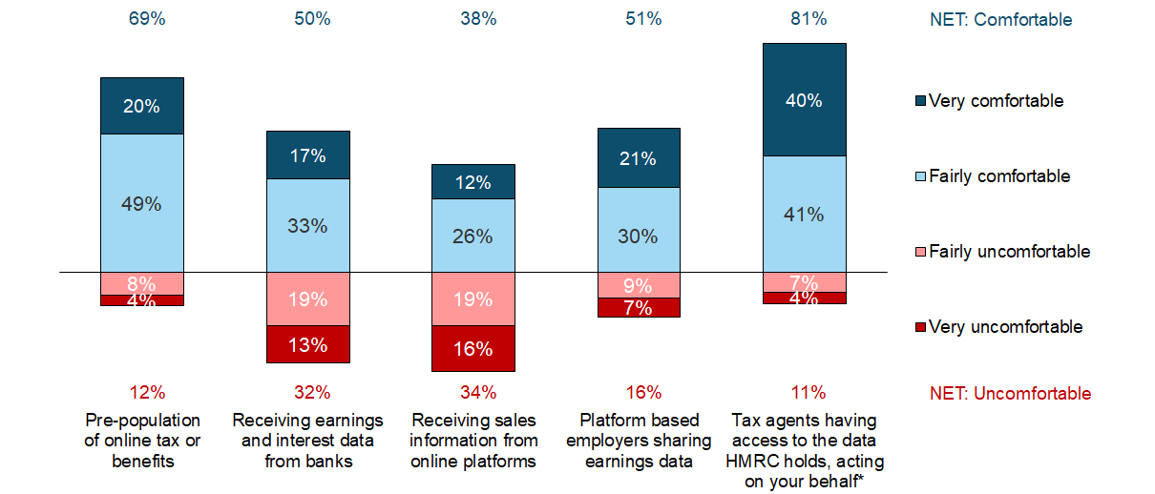
Source: VCD. How comfortable are you with HMRC using your customer data to enable pre-population of your online tax or benefits? VCL. How comfortable are you in principle with HMRC receiving your data from banks/building societies? VCR. How comfortable are you in principle with HMRC receiving (your) sales information from online sales platforms such as, eBay, Etsy, and Airbnb? VCX. How comfortable are you in principle with platform-based employers such as Uber and Deliveroo sharing (your) earnings data with HMRC and deducting any tax due each month? VDD*. How comfortable are you in principle with your agent having access to the data HMRC holds on you and acting on your behalf?
Base: All respondents (2434), * VDD asked of all who use an agent (403)
The accompanying data table (Table 5) for Figure 5 can be found in the appendix to this report.
Levels of comfort with the other scenarios was lower. Half of respondents were comfortable with HMRC receiving earnings data from banks and building societies (50%) and online work platforms (51%) and was lowest for HMRC receiving sales information from online sales platforms (38%).
Response to each scenario is discussed in more detail in the remainder of this chapter, in terms of both comfort levels and concerns.

Pre-population using customer data
The following explanation of pre-population was given to survey respondents before they were asked for their comfort levels: ‘Pre-population means that any online tax or benefit forms can be automatically filled in with relevant information that HMRC already hold on you (e.g., name, address, earnings/income data, tax codes, tax credits and benefits). This aims to make the process of filling in online forms quicker and easier.’
Two-thirds of respondents (69%) were comfortable in principle with HMRC using data they already hold to pre-populate tax or benefit forms (Figure 6). This was much higher among those who were digitally confident (79%) than those who were not confident (35%).

Figure 6: Level of comfort with and concerns about pre-population using customer data
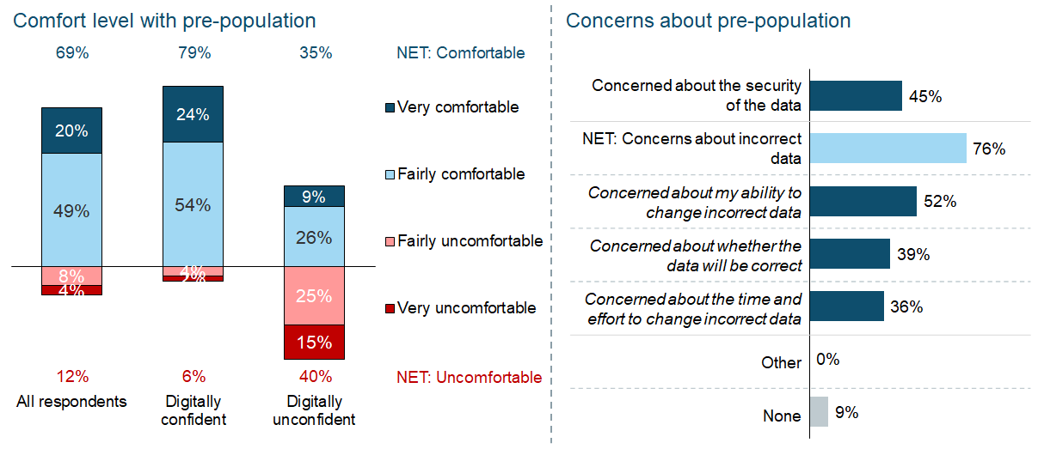
Source: VCD. How comfortable are you with HMRC using your customer data to enable pre-population of your online tax or benefits? VCJ. What concerns, if any, do you have with HMRC using your data to enable pre-population of your online tax or benefit forms?
Base: All respondents (2434), digitally confident (1827), digitally unconfident (217),
The accompanying data table (Table 6) for Figure 6 can be found in the appendix to this report.
There was little difference in comfort levels by employment or tax status or whether they used a tax agent. Other differences reflected levels of digital confidence. For example, those aged 65 and over were less likely than average to be comfortable with pre-population (56%), as were those who were not working (58%) or were not aware of the Personal Tax Account (64%).
The qualitative research found that many participants were already familiar with pre-population, both generally and for HMRC forms. It was seen to save time and be more convenient and reduce scope for customers making errors. However, even those comfortable with the concept had concerns.
In the survey just 9% said they had no concerns (Figure 6) about pre-population. While almost half were concerned about data security (45%), the key concerns were related to the potential for incorrect data (76%). A particular worry in this area was the ability to get incorrect data changed (52%), with the potential burden of trying to do this also a worry (36%).
In the qualitative discussions several participants also spontaneously raised concerns about HMRC not having the resources to deal with the additional queries.
“I don’t know if it's still this way but previously when I tried to talk to HMRC about the wrong tax code or whatever, you sit on the phone for hours and it's horrendous.”
(FG, PAYE employee, Not completed SA, 18 to 29 years)

HMRC receiving data from banks and building societies
The following hypothetical situation was presented to survey respondents before they were asked for their comfort levels:
‘Banks and building societies can share information with HMRC about all the monies coming into your accounts, including earnings and interest on any savings or investments you have. This information can be provided regularly throughout the year, so that any adjustments to the tax you owe can be made within the tax year, meaning that you can end the year having paid all the tax due.’
This is a hypothetical situation because HMRC currently only receive information from banks and building societies relating to interest on savings and investments rather than information about all monies. While the scenario did not apply to all respondents, all were asked for their views in principle.
Half of all respondents (50%) were comfortable in principle with banks and building societies regularly sharing data with HMRC (Figure 7). This was higher among those with savings and investments (62%). It reflects the findings of the qualitative discussions, where participants who had savings and investments were more comfortable with the concept, because they recognised that Banks and Building Societies have traditionally shared this information with HMRC for calculating tax payments.
Comfort levels were fairly similar to the average among those paying tax under Self Assessment (46%), despite them being more likely to be affected. Consistent with the other scenarios, those who were digitally confident were more likely to be comfortable (53%) with HMRC receiving information on all monies coming into their account (including interest and investment information from banks and building societies) than those who were not (34%).
Those aged 65+ were also slightly more likely than average to be comfortable (59%), possibly reflecting the higher likelihood that this population has savings and investment income. For this scenario this factor appears to outweigh this groups’ generally lower level of digital confidence.
In the qualitative discussions participants felt that the main benefits were that this element of the TAS reforms would provide more certainty, as there would be no unexpected surprises at the end of the year. It was also suggested that it would help with cashflow, with more even payments throughout the year. Some also felt that if this data was shared more regularly, any errors could be picked up more quickly.

Figure 7: Level of comfort with and concerns about HMRC receiving data from banks and building societies
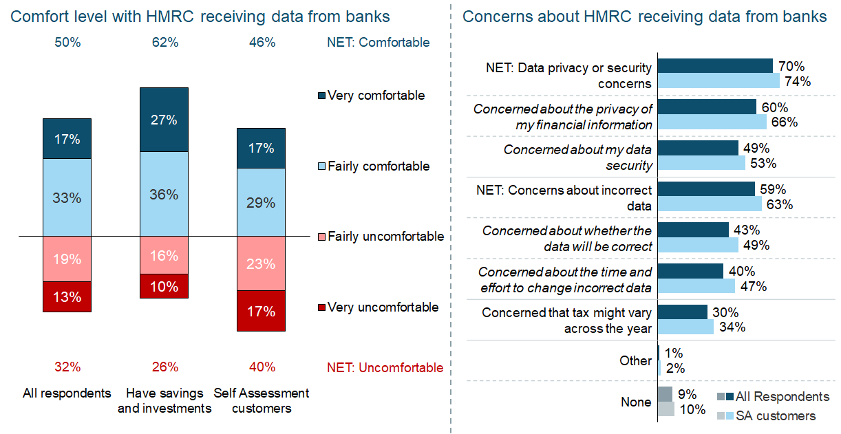
Source: VCL. How comfortable are you in principle with HMRC receiving your data from banks/building societies? VCP. What concerns, if any, do you have with HMRC receiving your data from banks/building societies?
Base: All Respondents (2434), those with savings and investments (544), SA customers (720)
The accompanying data table (Table 7) for Figure 7 can be found in the appendix to this report.
Levels of comfort with banks sharing data were lower than for pre-population, reflecting the findings of the qualitative discussions that customers were more concerned about sharing of data with third parties than within HMRC or government. For banks and buildings societies, participants saw the sharing of information on monies coming into their account as intrusive and a breach of their privacy. Some said it would make them feel like they are being monitored and that HMRC doesn’t trust them.
This was reflected in the concerns raised in the survey (Figure 7). Concerns about data privacy were expressed most often (60%), ahead of concerns about data security (49%). Six in ten had some concerns about the potential for incorrect data (59%). Concerns about the privacy of the data were more likely to be raised by those who were not comfortable with the concept (74%) than those who were (50%). In the qualitative discussions, participants also expressed concerns about the data being misinterpreted. For example, there were concerns about monies being moved across to a partner’s or child’s account being misinterpreted as additional earnings.
"I can give money to my dad or my dad gives money to me, do I need to explain all these things?" (FG, Gig economy, Completed SA, Mixed ages)
While concerns were generally similar among those paying tax through Self Assessment, a slightly higher than average proportion of these respondents selected each of the concerns. While respondents aged 65 and over were more comfortable with this scenario in principle, they were more likely to express concern about the potential for incorrect data (68%).
Respondents with savings and investments were relatively more likely than average to have concerns about whether the data would be correct (52%), and the time and effort needed to change any incorrect data (48%).

HMRC receiving information from online sales platforms
The following explanation was given to survey respondents before they were asked for their comfort levels:
‘Platforms such as eBay, Etsy and Airbnb where people can generate income from selling goods and/or services can share sales information with HMRC to automatically calculate your tax liability, so you don’t need to provide this information yourself.’
While the scenario did not apply to all respondents, all were asked for their views in principle.
In total 38% of respondents were comfortable with sales information being shared with HMRC by online sales platforms (Figure 8). This is lower than the number of respondents comfortable in principle with banks and building societies regularly sharing data with HMRC. This is potentially due to increased levels of concern about whether the data that online platforms provide to HMRC will be correct (55% compared with 43% who were concerned about the data that HMRC receives from banks and building societies being correct) and that HMRC will in turn base their calculations on inaccurate data.
Levels of comfort were similar among the relatively small group of respondents currently using these online sales platforms (43%). As with the other scenarios, those who were digitally confident were more likely to be comfortable (41%) than those who were not (27%). There were no significant differences by age.
Figure 8: Level of comfort with and concerns about HMRC receiving information from online sales platforms
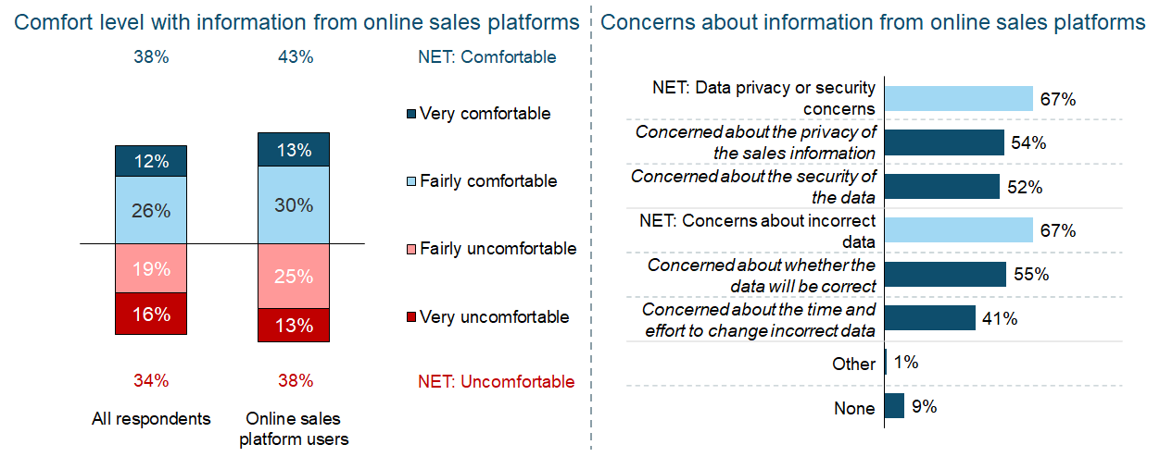
Source: VCR. How comfortable are you in principle with HMRC receiving (your) sales information from online sales platforms such as, eBay, Etsy, and Airbnb? VCV. What concerns, if any, do you have with HMRC receiving (your) data from online platforms?
Base: All Respondents (2434), Customers who use online sales platforms (106)
The accompanying data table (Table 8) for Figure 8 can be found in the appendix to this report.
The qualitative discussions indicated that participants recognised the benefits of HMRC receiving sales information from these platforms. It would reduce the annual submission burden and, if it would allow HMRC to provide forecast of tax due, it would help with financial planning by providing more certainty and preventing end of year surprises
There were equal levels of concern about data privacy or security (67%) and about incorrect data (67% - Figure 8). There were similar concerns among users of online sales platforms. 54% of respondents expressed concern about the privacy of sales information. Among those who were comfortable with HMRC receiving information from online sales platforms 49% expressed concern about the privacy of data, compared to 69% of those uncomfortable. This highlights how those who are more comfortable with data sharing are more likely to recognise the benefits and to perceive them to outweigh the concerns. As clarified in the qualitative discussions however, they still want transparent communication about how data will be used.
The qualitative discussions also highlighted concerns about how HMRC would address these issues. Participants questioned how practical and viable it would be for HMRC to receive data and how accuracy would be ensured, particularly where people sell across multiple platforms. There were also concerns about how HMRC would cope with sales in foreign currencies.

HMRC receiving data from online work platforms
The following explanation was given to survey respondents before they were asked for their comfort levels:
‘Platform-based employers such as Uber and Deliveroo where people can earn money for work can share earnings data with HMRC and deduct the tax due each month. This way tax payments would be made more regularly across the year and they would end the year having paid all the tax due on these earnings. It would also mean they wouldn’t have to provide this earnings information to HMRC themselves.’
While the scenario did not apply to all respondents, all were asked for their views in principle.
Half of all respondents (51%) were comfortable with this proposition (Figure 9), reflecting comments made in the qualitative research about this approach making things more equitable between PAYE taxpayers and the self-employed. There was only a small sample of gig workers, and they showed similar levels of comfort (55%).
However, they were marginally less likely to express concerns (9% had no concerns compared with 18% of all respondents). Among all respondents, the levels of concern were equal for data security (47%) and that the data might be incorrect (48%). The qualitative research also highlighted some worries about managing cashflow if tax is collected more regularly, suggesting that some gig workers are using the tax monies to help manage peaks and troughs in their income over the course of the year.

Figure 9: Level of comfort with and concerns about HMRC receiving data from platform-based employers
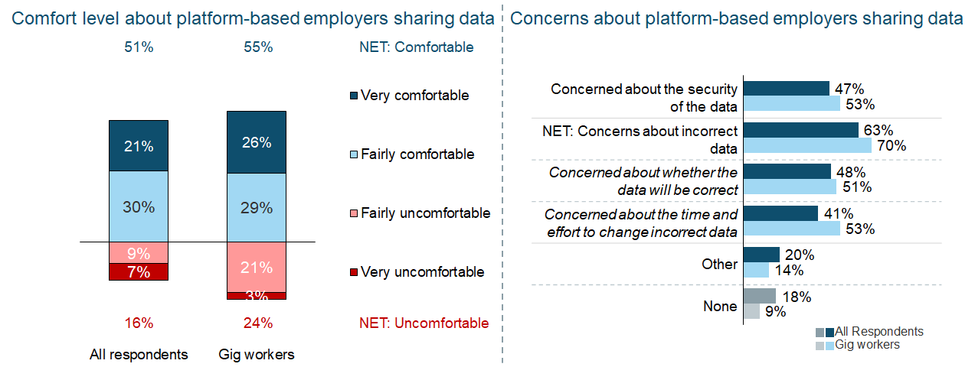
Source: VCX. How comfortable are you in principle with platform-based employers such as Uber and Deliveroo sharing (your) earnings data with HMRC and deducting any tax due each month? VDB. What concerns, if any, do you have with HMRC receiving (your) data from platform-based employers?
Base: All Respondents (2434), Gig workers (58)
The accompanying data table (Table 9) for Figure 9 can be found in the appendix to this report.

Agents having access to HMRC data
The following explanation was given to survey respondents who used a tax agent before they were asked for their comfort levels:
‘Currently tax agents are unable to complete all actions on behalf of clients as the existing systems require clients to take some actions themselves. Proposed changes would allow you to decide what data they can see and what actions they can to perform on your behalf’.
Most respondents who used a tax agent were comfortable with this scenario (81% - Figure 10). Furthermore, respondents were more likely to not identify any concerns with this element of the TAS reforms, compared to the other scenarios (39%). The main concerns expressed were about retaining control of their data (40%) and worrying about their agent making mistakes (36%). The high comfort levels reflect that this is an extension of what these customers do already and that they have high levels of trust in their agent. Where taxpayers are not comfortable, the qualitative research suggested that it was mainly because they did not have a good relationship with their agent.

Figure 10: Level of comfort with and concerns about agent access to HMRC data
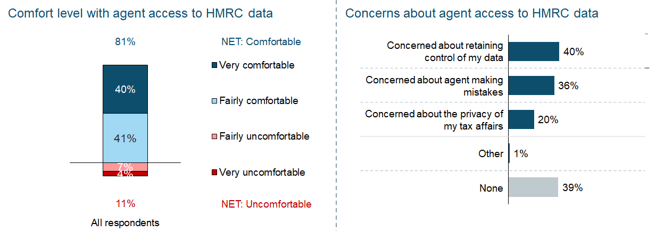
Source: VDD. How comfortable are you in principle with your agent having access to the data HMRC holds on you and acting on your behalf? VDH. What concerns, if any, do you have with your agent having access to the data HMRC holds on you and acting on your behalf?
Base: Respondents who use a tax agent (403),
The accompanying data table (Table 10) for Figure 10 can be found in the appendix to this report.

Drivers of acceptability of data sharing
This final chapter discusses what HMRC can do to build comfort with data sharing. Factors influencing the acceptability of data sharing were explored in the qualitative research. The survey was used to quantify the response to potential mitigators. This included preference for an opt-in versus an opt-out approach. The survey also measured the impact on comfort of asking taxpayers for permission and of giving them the opportunity to check data before it is shared.

Factors influencing acceptability of data sharing
The qualitative research revealed the following in terms of drivers of acceptability of data sharing.
Reforms that raised the most concerns across participants were those that were seen to reduce or did not offer greater privacy, security, accuracy or control.
A breach in privacy was perceived as a breach in trust of HMRC, particularly when considering data sharing with banks. Participants voiced concerns about the journey of data when being shared. They were fearful of data leaving ‘government's hands’ where it felt safe and protected and being transferred through third-party software where it may be scrutinised or accessed somehow. Some also voiced concerns about security and access to data stored on the cloud.
There was uncertainty as to which ‘third parties’ could be trusted to protect the privacy of individual’s data. Some concern was also raised that HMRC could share personal data with further third parties for commercial gain. However most felt that this was highly unlikely given their trust in HMRC.
Participants also voiced concerns about the type of data that third parties might share with HMRC. In particular, they were concerned what level of information banks might share with HMRC, as discussed in 5.3.
"[HMRC gathering data from banks] feels a little too Big Brother for me."
(FG, gig economy worker, additional income, Completed SA, Mixed ages)
Regarding security, participants’ initial impulse was to trust HMRC’s ability to keep data secure. However, they expressed some concern that data sharing or third-party involvement could undermine HMRC security procedures and potentially increase risks of data breaches and fraud. Whilst participants had high levels of trust in HMRC, the majority had low levels of trust in third-party software providers, online platforms and other third parties. As above, some had concerns that software and the cloud could be hacked or accessed, heightening feelings of vulnerability and insecurity. It was suggested that all data that is shared should be encrypted.
It was felt that confidence in security could be reinforced by clear communications from HMRC about the processes in place. Participants expected complete transparency in the event of a data breach – it would be unacceptable to find out about it months after the event. They also sought reassurances on the safety and security of HMRC systems and the processes involved in data transfer. Additional reassurance could be provided by the use of fingerprint logins and voice recognition.
“There is always a danger of hacking, and the more links in the chain the more opportunity to break into it."
(FG, PAYE employee, Completed SA, 50+ years)
"Security is a big thing now because technology can be hacked into at any time, it's always at the back of your mind".
(FG, gig economy worker, multiple platforms, Completed SA, Mixed ages)
"I don't have any cause for concern on security because [HMRC] is a government organisation and I know they're the ones who issue out fines for companies breach in data, I imagine they want to get their house in order."
(FG, gig economy worker, additional income, Completed SA, Mixed ages)
Turning to accuracy, participants had concerns that HMRC did not have adequate processes, the competence or the customer service staff to deal with the impact of data being shared that was not accurate. This stemmed in part from the expectation that online platforms and other third parties would not have the adequate skills and processes to share accurate data.
Participants felt that commercial organisations might use different accounting packages and have different processes in place. They were concerned about the compatibility of third-party systems with HMRC systems and whether the data would be entered in the correct fields. There was also some anxiety that third parties might not be able to share accurate, real time data, that would reflect the reality of all sales, returns and profit.
Participants also raised a fear of errors occurring in pre-populated forms and were concerned as to how these could be corrected if data was inaccurate. They wanted clarity on the process for reporting and correcting errors. They felt unsure that HMRC would be able to deliver good quality customer service in response to the anticipated influx of queries about inaccurate data. Some also voiced concerns about HMRC processing data from multiple streams to feed into a single tax calculation. They wanted reassurances on the checks and balances in place in order to ensure an accurate outcome.
“You've got to look at what happened to the Post Office when that software got it wrong."
(FG, PAYE employee, Completed SA, 50+ years)
"There was a systems fault with the Post Office… who's to say it can't happen again?"
(FG, PAYE employee, Completed SA, 30 to 49 years)
"How do we know it's all accurate and some botch-up hasn't been made somewhere?"
(FG, PAYE employee, Completed SA, 50+ years)
Regarding control, participants expressed a strong desire to review and check the data underpinning tax calculations and to control the flow of data by opting in or out of data sharing. They also wanted to be able to give permission to banks and other third parties about the type of information or data that was shared with HMRC. They also wanted to be able to control whether HMRC takes tax direct from online platforms or just uses their data to calculate tax obligations.
Importantly, participants also wanted to have some control over who was involved in the chain of data sharing. There was a broad consensus that the introduction of a third-party added a layer of risk and heightened fears about loss of control. They wanted to retain control of reviewing and approving data in their SCA before HMRC took tax. They also sought reassurances on the processes in place to redress any inconsistencies or errors in data in their SCA before tax was taken.
“Once a third-party is introduced, you do not know where that information is going to go."
(Depth, Sole trader, Completed SA, 50 years)

Permissions: Opt-in versus opt-out approaches
An explanation was given to respondents of opting in or opting out to give permission for data sharing, in relation to the broadest generally applicable scenario of pre-population:
‘There are 2 ways in which HMRC could potentially receive permission to pre-populate your online tax forms. The first way would be that HMRC would ask you for your permission and you need to answer yes or no. The alternative would be that when HMRC ask your permission, you only need to respond if your answer is no’.
When asked which approach they would prefer, most chose ‘opt-in’ (73%) with just 16% saying they would rather ‘opt out’ (Figure 11). Those who were not digitally confident were less likely to say they wanted to ‘opt-in’ (64%) and more likely to say they had no preference (16%). There was little difference in preference by employment or tax status or by age.
Figure 11: Preference for opt-in or opt out approach to pre-population, by digital confidence
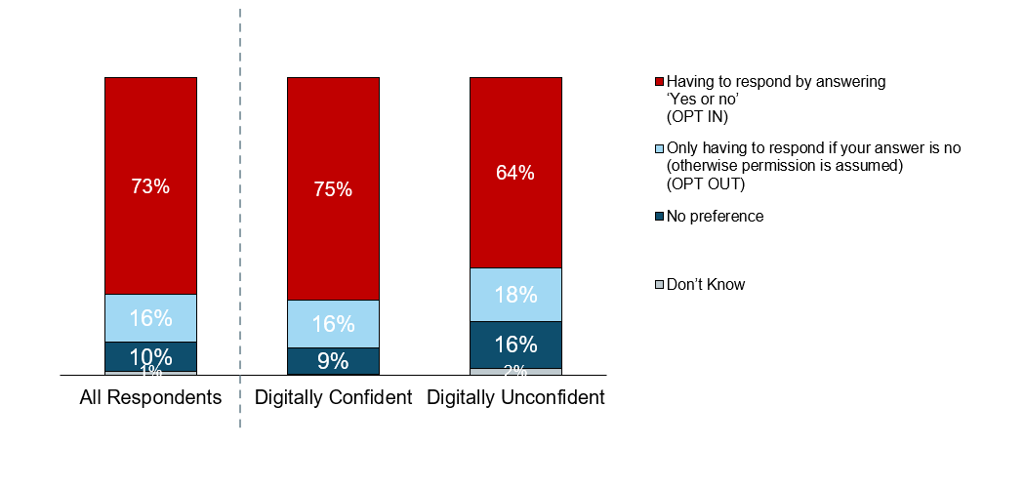Figure 11: Preference for opt-in or opt out approach to pre-population, by digital confidence
Source: VCG. There are 2 ways in which HMRC could potentially receive permission to pre-populate your online tax forms. The first way would be that HMRC would ask you for your permission and you need to answer 'yes' or 'no'. The alternative would be that when HMRC ask your permission, you only need to respond if your answer is 'no'. Which of these options would you be more comfortable with?
Base: All Respondents (2434), Digitally confident (1827), digitally unconfident (217)
The accompanying data table (Table 11) for Figure 11 can be found in the appendix to this report.

Impact of controls on acceptability of data sharing
Finally, respondents were asked about the likely impact of controls on their level of comfort in principle with each scenario. 2 controls were introduced, building on the findings of the qualitative research, in relation to each scenario:
- HMRC having to ask customers for permission before sharing data
- HMRC giving customers the opportunity to check their data is correct before proceeding
All respondents were asked about the impact of having a control in place for the first, pre-population scenario. For the other concepts, those who had said they were very comfortable with each scenario in principle were not asked these follow up questions. Those who were very comfortable in principle are included along with the ‘lot more comfortable’ respondents in the charts. This provides an overall measure of comfort in the presence of controls among all respondents.
As shown in Figure 12, controls have the most potential to increase acceptability for the scenarios with which respondents felt least comfortable in principle.
Since most of those using a tax agent were already comfortable with allowing them access to their HMRC data, the provision of controls had little impact on comfort levels. In relation to pre-population, the opportunity to check data was correct was much more likely to increase comfort (83%) than HMRC having to ask permission before using data (69%).
For the other 3 scenarios, the impact of the opportunity to make checks was marginally higher than the impact of being asked for permission for sharing of information with HMRC. Around three in four said the opportunity to make checks meant they would be very comfortable, or more comfortable with each.
Figure 12: Comfort in principle, and impact on comfort level if asked for permission, and if opportunity given to check data for each of the 5 scenarios
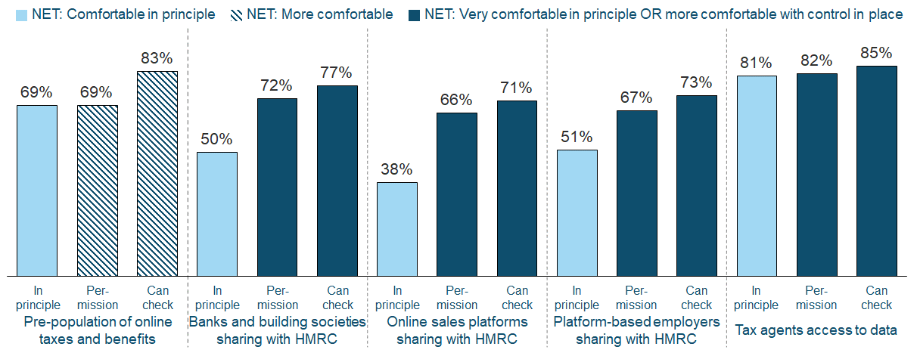
Source: VCD/VCL/VCR/VCX/VDD*. How comfortable are you in principle with…;
VCF/VCM/VCT/VCY/VDF*. If HMRC had to ask you for your permission before… would it make you feel...? VCH/VCN/VCS/VCZ/VDG*. If HMRC gave you an opportunity to check the data/information… would it make you feel...?
Asked for each of: Pre-population of your online tax or benefits; HMRC receiving your data from banks/building societies; HMRC receiving (your) sales information from online sales platforms such as, eBay, Etsy, and Airbnb; Platform-based employers such as Uber and Deliveroo sharing (your) earnings data with HMRC and deducting any tax due each month; Platform-based employers such as Uber and Deliveroo sharing (your) earnings data with HMRC and deducting any tax due each month; Your agent having access to the data HMRC holds on you and acting on your behalf*.
Base: All Respondents (2434), * VDD/VDF/VDG asked of all who use an agent (403)
The accompanying data table (Table 12) for Figure 12 can be found in the appendix to this report.
The impact of controls on comfort for each of these scenarios is discussed in more detail in the remainder of this chapter.

7.3.1 Pre-population using customer data
As previously stated (see Figure 6), 69% of respondents were comfortable with the first scenario of HMRC using customer data for pre-population for online tax or benefits forms in principle, with comfort levels much lower among those who were not digitally confident (35%).
If asked for permission, 69% said this would make them more comfortable with pre-population (Figure 13). Far more (83%) said that the opportunity to check their data would make them more comfortable. This reflects the earlier finding that the primary concerns around pre-population were related to the potential for data to be incorrect (see Figure 6).
The potential impact of each of these controls was similarly high among those who were digitally confident (73% for permission, 87% for checking) and those comfortable with pre-population in principle (74% for permission, 89% for checking). Of those not digitally confident, 70% said being able to check the data would make them more comfortable, with this similar at 66% of those who were uncomfortable with pre-population in principle. This provides evidence of the scope of using controls to increase the acceptability of pre-population, even among those who are less comfortable or confident with digital approaches.
Figure 13: Proportion more comfortable with pre-population if asked for permission and if opportunity given to check data
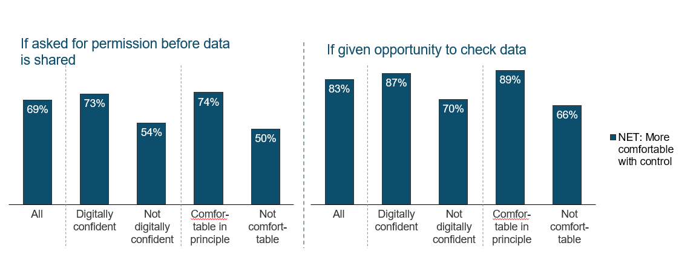
Source: VCF. If HMRC had to ask you for your permission before pre-populating your online tax forms would it make you feel...
VCH. If HMRC gave you an opportunity to check your pre-populated data to ensure it is correct, would it make you feel...
Base: All respondents (2434), Digitally confident (1827), digitally unconfident (217), comfortable with pre-population (1773), not comfortable with pre-population (243)
The accompanying data table (Table 13) for Figure 13 can be found in the appendix to this report.

7.3.2 HMRC receiving data from banks and building societies
As discussed earlier (see Figure 7) 50% of respondents were comfortable in principle with the hypothetical situation of banks providing data on all monies received to HMRC (much lower than for pre-population), with this similar for those paying tax under Self Assessment (46%), but higher for those with savings and investments (62%).
In this scenario respondents who weren’t ‘very comfortable’ in principle were asked 2 follow up questions to assess what controls could make them more comfortable. 72% said being asked for permission would make them very comfortable, or more comfortable with banks providing information (Figure 14). Unlike for pre-population the opportunity to check the data did not make a much greater difference in levels of comfort, with 77% saying this would make them much more comfortable or more comfortable. This reflects the earlier finding that concerns about banks providing data were related more to privacy than accuracy (see Figure 7).
The impact of being given an opportunity to check their data was, however, greater among those with savings and investments (83% much more comfortable or more comfortable). This reflects the higher level of concerns about privacy among these respondents, as discussed earlier. Among those who had not been comfortable with banks sharing data in principle, each proposed control had a large impact (55% more comfortable with permission, 56% more comfortable with checking).
Figure 14: Proportion very comfortable with banks providing data to HMRC or more comfortable if asked for permission and if opportunity given to check data
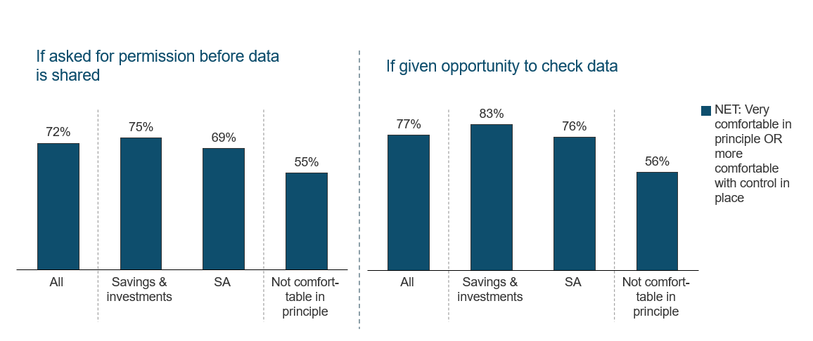
Source: VCM. If HMRC had to ask your permission before receiving your data from banks/building societies would it make you feel… VCN. If HMRC gave the opportunity to check your data from banks/building societies to ensure it was correct, would it make you feel…
Base: All Respondents (2434), those with savings and investments (544), SA customers (720), comfortable with information from banks (779)
The accompanying data table (Table 14) for Figure 14 can be found in the appendix to this report.

7.3.4 HMRC receiving data from online sales platforms and platform-based employers
As discussed earlier (see Figure 8.), 38% of respondents were comfortable in principle with online sales platforms providing data to HMRC, the lowest for all scenarios. Comfort levels were similar among those using such platforms to sell (43%). Respondents also expressed similar levels of concern about each of data privacy and data accuracy for this scenario.
Respondents who weren’t initially ‘very comfortable’ in principle with the scenario were asked 2 follow up questions to assess what controls could make them more comfortable. The likely impact of having an opportunity to check data provided by online sales platforms was slightly higher (71% very comfortable or more comfortable) than that of being asked for permission (66% - see Figure 15).
The potential impact of both controls was greater among those who used online sales platforms (81% a lot more comfortable or more comfortable for permission, 85% for checking). Among those who had not been comfortable with online sales platforms sharing data in principle, each proposed control had a similar impact (52% more comfortable with permission, 56% more comfortable with checking).
As previously discussed, (see Figure 9), 51% of respondents were comfortable in principle with HMRC receiving earnings information from platform-based employers. A similar proportion of gig workers (55%) were comfortable with this reform, the group most directly impacted by it.
Respondents who weren’t initially ‘very comfortable’ in principle with the scenario were asked 2 follow up questions to assess what controls could make them more comfortable. The impact of having an opportunity to check data provided by platform-based employers was slightly higher (73% very comfortable or more comfortable) than that of being asked for permission before this data is shared (67% - see Figure 15). The potential impact of both controls was relatively greater among gig workers (84% very comfortable or more comfortable for permission, 83% for checking). Among those who had not been comfortable with platform-based employers sharing data in principle, checking had a slightly greater impact (56% more comfortable) than permission (51%).
Figure 15: Proportion very comfortable with online sales platforms and platform-based employers providing data to HMRC or more comfortable if asked for permission and if opportunity given to check data
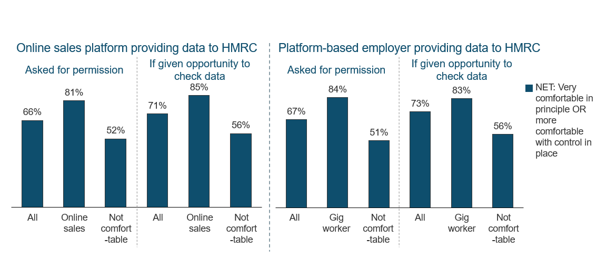
Source: VCT. If HMRC had to ask you for your permission before receiving (your) data from online platforms would it make you feel... VCS. If HMRC gave you the ability to check sales information collected from online platforms to ensure it is correct, would it make you feel... VCY. If HMRC had to ask you your permission before receiving (your) earnings information collected from platform-based employers would it make you feel... VCZ. If HMRC gave you the ability to check (your) earnings information collected from platform-based employers is correct, would it make you feel...
Base: All Respondents (2434), those using an online sales platform (106), not comfortable with information from sales platforms (857), gig workers (58), not comfortable with information from online employer (377)
The accompanying data table (Table 15) for Figure 15 can be found in the appendix to this report.

7.3.5 Tax agents having access to HMRC data
Among those who use a tax agent, most (81%) were comfortable in principle with their agent having greater access to data HMRC held on them and the ability to act on their behalf (see Figure 12). Respondents who weren’t initially ‘very comfortable’ in principle with the scenario were asked 2 follow up questions to assess what controls could make them more comfortable. If asked for permission, 82% were very comfortable or stated that this would make them more comfortable.
The opportunity to check their data had a similar impact, with 85% saying they were very comfortable, or this would make them more comfortable. There were too few respondents using a tax agent who were not comfortable with their agent having access to their HMRC data to break this impact down further.

Conclusions
Trust in HMRC to handle data confidentially was high and sharing of data between government agencies was both expected and accepted, even though spontaneous awareness of data sharing related to HMRC was low. However, respondents had stronger concerns about data sharing with third parties. Key drivers of acceptance of data sharing included understanding why HMRC is sharing data, and transparency about the process, as well the benefits to them as customers. Outlining why data is being shared, what data is being shared and the process for doing so as well as clearly demonstrating how customers will benefit from data sharing could help to overcome latent concerns.
Data sharing was spontaneously associated with social media. The main perceived benefits of data sharing were convenience and time saving from pre-population. Concerns centred on the security risks of data sharing. They were keen to have high levels of transparency and a degree of control about how far personal data would be shared.
Data sharing is an emotive topic with mixed responses reflecting lack of awareness and understanding of the issues. Reassurances are required on security, control, accuracy, transparency and privacy of their data. However, data sharing presents an opportunity to contribute to streamlined and positive digital experiences.
Digital confidence, familiarity in using digital tax tools such as the PTA, as well as levels of trust in HMRC were correlated with more positive reactions to data sharing. General digital confidence was high but people’s confidence in their ability to make informed decisions regarding data sharing was lower. Customers could therefore benefit from further explanation around the implications of data sharing.
Having the ability to check and correct data was most likely to increase levels of comfort. Respondents would prefer HMRC to seek their permission to share data and to ‘opt-in’ to doing so, rather than using an opt-out approach.
When presented with specific examples of data sharing which HMRC may undertake in relation to the TAS reforms, comfort levels were highest for the pre-population of online forms and for tax agents having greater access to the data HMRC holds and acting on their behalf. These are the concepts with which respondents were already most familiar. There were reasonable levels of comfort with the other scenarios, with those affected having higher levels of comfort.

Technical Annex

Introduction
In 2022 HMRC commissioned Kantar Public to undertake qualitative research to explore attitudes to data sharing among individuals who pay tax. In April 2022 a follow-on survey was commissioned to quantify some of the main themes emerging from the qualitative stage. It would also provide a benchmark measure of attitudes to data sharing against which changes can be tracked over time as TAS reforms are rolled out. This section provides further details on the methodology for conducting the qualitative and quantitative stages.

Qualitative Research

9.2.1 Recruitment
Participants were recruited through the Kantar Public’s specialist qualitative recruitment partner, Roots Research, who have a database of 350,000 people on their panel.
The sample included a mix of people of differing employment statuses, with a range of self-employed and micro-employers, gig economy workers using online platforms, and PAYE employees. Gig economy workers included those for whom this was the totality of their income and those who sold goods or offered services as a supplementary income, as well as those who were using multiple platforms. The sample also included those who filed taxes via Self Assessment (SA), and those that did and did not use tax agents. The sample also sought to include people from different generational groups. Secondary variables included in the sample frame were level of digital confidence, socioeconomic group, gender and regional spread.

9.2.2 Fieldwork
Before developing research materials, a Hypotheses workshop was held between Kantar Public and HMRC to share knowledge and hypotheses from previous related research.
The qualitative phase involved 12 online discussion groups of 6 participants and 6 in-depth telephone interviews to reach less digitally confident individuals. Fieldwork took place between 22 March and 8 April.

9.2.3 Sample
The full breakdown of the sample achieved can be found below in Table 1.
Table 1. Sample achieved
 |  | Focus groups | Telephone interviews
Primary variables
Employment Status | Self-employed/Micro-employer | 16 | 2
Employment Status | Gig economy worker | 16
Employment Status | PAYE employee (do not fill in SA forms) | 16 | 2
Employment Status | PAYE employee (do fill in SA forms) | 16 | 2
Age | 18 to 29 | 23
Age | 30 to 49 | 21 | 4
Age | 50+ | 20 | 2
Use of Agent | Yes | 19 | 2
Use of Agent | No | 45 | 4
Secondary variables
Gender | Male | 35 | 2
Gender | Female | 29 | 4
Gender | Other | 0
Digital Confidence | 3 | 3
Digital Confidence | 4 | 0
Digital Confidence | 5 | 9
Digital Confidence | 6 | 6
Digital Confidence | 7 | 11
Digital Confidence | 8 | 9
Digital Confidence | 9 | 2
Digital Confidence | 10 | 8
Segment | ABC1 | 44 | 6
Segment | C2DE | 20

9.2.4 Topics covered
The qualitative fieldwork explored participants’ views on data sharing generally, and in relation to HMRC’s proposed TAS reforms, which are summarised in Chart 1. To bring the reforms to life participants were introduced to 6 scenarios relating to HMRC’s proposed TAS reforms to explore views.
The topics covered in the qualitative fieldwork are summarised in Table 2.
Table 2. Topics covered in qualitative fieldwork
Introduction to the research (purpose, aims, structure of the session, ethics)
Participant introductions
Current understanding and experience of data sharing | - Spontaneous associations with ‘data sharing’  - Understanding of data sharing  - Examples of data sharing  - Pros and cons of data sharing (to be revisited later in relation to HMRC)
Data sharing and HMRC | - Spontaneous associations between ‘HMRC and data sharing’  - Expectations of data sharing in relation to HMRC  - What kind of data  - Who might HMRC share data with  - Views on HMRC receiving and sharing data from/with other parties
Prompted response to data sharing scenarios (using stimulus material to introduce HMRC proposals e.g., creation of single customer record and account, pre-population, timely payment of tax, use of real-time information, changes for tax agents, third-party data sharing) | - How do they envisage this?  - Potential benefits  - Potential concerns  - Reflection on response  - Drivers of acceptance  - Barriers to acceptance
Further exploration of the dynamics of data sharing | - Data accuracy  - Data transparency  - Data privacy and type of data shared  - Data security  - Control over data  - Consent to sharing – opt-in vs. opt-out
Exploration of trust | - In HMRC  - In governmental third parties  - In non-governmental third parties  - Implications for data sharing
Reflection on pros and cons of data sharing for HMRC customers | - Advantages for customers  - Disadvantages for customers  - Comparison to data sharing examples given at the start of the group  - How disadvantages can be overcome and what trade-offs exist

Chart 1. Overview of proposed TAS reforms explored in this research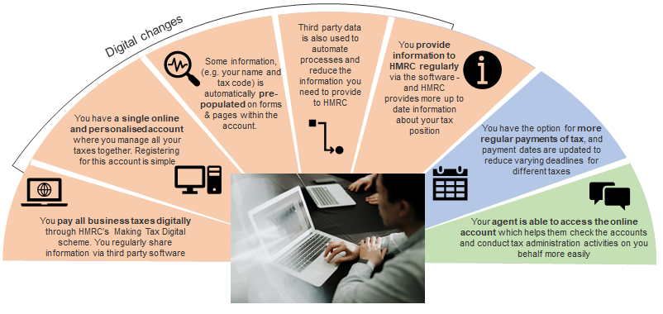

9.2.5 Qualitative stage data sharing scenarios
During the qualitative fieldwork participants were introduced to 6 data sharing scenarios which explored data sharing in the context of SCA, using the persona of ‘Sam’ (a self-employed taxpayer). The 6 scenarios are outlined by the following stimulus:

9.2.6 Introduction to the Single Customer Account
The Single Customer Account will mean all of your tax administration will be handled together in one place. It will be securely hosted on the cloud.
- Sam only needs to log in once to manage all the different taxes he pays in one place
- Registration for the account is simple and quick
- Customer and HMRC data will be used to pre-populate information, reducing what Sam needs to enter within his account – e.g., name, address and tax code will be automatically filled in (pre-populated) on online tax forms
- The account will provide personalised information and generate reminder notifications that are specific to Sam’s tax activities and obligations, e.g. reminders of upcoming payments
- Online secure messages can be sent to customer service staff

9.2.7 Third-party data in the context of the Single Customer Account
Within the Single Customer Account, HMRC will also be able to draw on third-party data (e.g. data from banks and companies) to further automate processes; for example, HMRC will be able to take tax direct from sales made through online platforms
- Use of other third-party data will further reduce the need for Sam to undertake tax related administration as it will further automate processes

9.2.8 Use of third-party software in the context of Making Tax Digital
MTD for VAT will roll out to all VAT registered businesses from April 2022, Income Tax Self Assessment from April 2024 and potentially Corporation Tax.
MTD will allow payment and provision of digital information from customers to HMRC more regularly (for example, quarterly) using third-party software (free software packages will be available).
- Providing information digitally through software will automate tax administration
- It will reduce the burden of annual tax administration obligations
- It reduces the need to receive and send letters and forms as more activities can be conducted online
- More up to date information will better enable HMRC to be agile when responding to emerging situations, such as the Covid-19 pandemic

9.2.9 Data sharing to enable real time reporting of information to HMRC
Sam provides information to HMRC regularly via third-party software. HMRC uses this to provide more up to date information to customers about their tax obligations.
- Reporting more often will increase the likelihood of Sam getting his tax right first time; e.g. he will be more likely to remember how to provide information if done more regularly
- Reporting more regular information to HMRC will reduce the size of any errors by allowing HMRC to more regularly monitor activities
- It will enable real time updates of Sam’s tax codes throughout the year
- HMRC will use the more regular information to make payment in-year calculations and forecasts to the end of the year for Sam so he understands his present and future tax obligations

9.2.10 Data sharing to enable more timely payments
HMRC are exploring appropriate timings and frequency of payments of different taxes to see if different timings and paying taxes more frequently could benefit customers
- Changing the timings certain taxes are paid could help simplify payments by having more taxes paid at the same time
- Paying smaller amounts more regularly could help Sam manage cash-flow
- More regular payments will reduce the size of errors when they happen
- HMRC will also look to improve debt repayment schemes to allow plans to be better tailored to suit individual businesses

9.2.11 The effect of TAS reforms on agents and agent users
Currently agents are unable to complete all actions on behalf of clients as current systems require clients to take some actions themselves. Proposed changes would allow agents to access their clients’ Single Customer Account, increasing their ability to access information and complete tasks on behalf of their clients
- By giving agents greater access and abilities, it will allow them to do more on Sam’s behalf and further reduce the burden on Sam to complete tax related activities
- Simplification of tax administration processes may reduce the need for Sam to use an agent as its easier for him to manage his tax obligations himself. This could save Sam money.

Survey
The questionnaire was developed by HMRC and Kantar Public to address the research objectives. The topics covered and answer codes were based on findings from the qualitative research. This ensured that that the content of the survey covered the key issues taxpayers had with data sharing to inform HMRC’s Tax Administration Strategy.
The survey covered individual taxpayers and was conducted using Public Voice. Public Voice is Kantar Public’s random sample panel, which includes nearly 27,000 members drawn from across the UK. The survey was primarily completed online, however some respondents were interviewed over the phone to ensure that the survey covered those who are digitally excluded.

9.3.1 Questionnaire development
The draft questionnaire was subject to 2 levels of testing:
- Kantar Public held a questionnaire workshop with HMRC
- Cognitive testing
Prior to questionnaire development Kantar Public held a workshop with HMRC stakeholders, to inform questionnaire coverage. HMRC policy priorities in relation to TAS and the qualitative research findings guided the discussion on what areas would benefit from quantification. This included establishing a baseline measure of attitudes to data sharing and drivers of acceptability. The workshop also determined the examples of data sharing to be covered in the survey, recognising that it was not possible to cover all the concepts explored in the qualitative discussions.
Kantar Public then cognitively tested the questionnaire through 10 interviews between June and July 2022, prior to launch in August 2022. The objectives of cognitive testing included:
- Exploring understanding of the question wording and phraseology
- Testing overall feelings about the questionnaire including the ordering of questions and complexity of the topic
- Making recommendations on how the questions can be improved or refined

9.3.2 Questionnaire structure
The questionnaire began with demographic questions, followed by screening questions to ensure only taxpayers responded to the main survey. The questionnaire then covered questions on taxpayers’ understanding and attitudes to data sharing in general, before moving on to questions related to the data sharing approaches proposed in HMRC’s TAS reforms. The topics included in the questionnaire are detailed in Table 3.
Table 3. Questionnaire structure
Topic | Question
Data sharing understanding and attitudes
Attitudes to data privacy and digital confidence | - Rating confidence in the government to keep personal data confidential  - Rating confidence in HMRC keeping personal data confidential  - Rating confidence in digital capabilities  - Use of cloud storage devices
Taxpayers’ familiarity with the concept of data sharing | - Taxpayer perceptions of the potential benefits of data sharing  - Taxpayer concerns around data sharing  - Rating confidence in making informed decisions around data sharing and understanding of its implication
Scenarios related to proposed TAS reforms
Pre-Population and opt-out vs. opt-in | - Rating comfort with HMRC using customer data for pre-population  - Assessing level of comfort with HMRC using customer data for pre-population when permission is asked  - Whether opt-in or opt-out of data sharing is preferred  - Assessing level of comfort with HMRC using customer data for pre-population when taxpayers can check data is correct  - Taxpayer concerns with using customer data for pre-population
Banks and building societies sharing earnings information with HMRC | - Rating comfort with HMRC receiving earnings information from banks/building societies  - Assessing level of comfort with HMRC receiving earnings information from banks/building societies if permission is asked  - Assessing level of comfort with HMRC receiving information from banks/building societies when taxpayers can check data is correct  - Taxpayer concerns with HMRC receiving earnings information from banks/building societies
Online sales platforms sharing earnings information with HMRC | - Rating comfort with HMRC receiving earnings information from online sales platforms  - Assessing level of comfort with HMRC receiving earnings information from online sales platforms if permission is asked  - Assessing level of comfort with HMRC receiving earnings information from online sales platforms when taxpayers can check data is correct  - Taxpayer concerns with HMRC receiving earnings information from online sales platforms
Online work platforms sharing earnings information with HMRC | - Rating comfort with HMRC receiving earnings information from online work platforms  - Assessing level of comfort with HMRC receiving earnings information from online work platforms if permission is asked  - Assessing level of comfort with HMRC receiving earnings information from online work platforms when taxpayers can check data is correct  - Taxpayer concerns with HMRC receiving earnings information from online work platforms
Agents having more access to taxpayers’ financial data and ability to act on their behalf | - Level of comfort with agent having access to data HMRC holds on taxpayer  - Assessing level of comfort with agent having access to data when permission is asked  - Assessing level of comfort with agent having access when taxpayer can check which data  - Taxpayer concerns with agent having access to data HMRC holds
PTA (Personal Tax Account)
PTA (Personal Tax Account) | - Familiarity with PTA  - Use of PTA in the last 12 months

9.3.4 Summary of the sample design
HMRC required ‘robust’ samples from several overlapping subpopulations within the overall population of individual taxpayers. These included: (i) self-employed/micro employers, (ii) gig workers, (iii) PAYE employees, (iv) those who use SA to pay income tax, (v) those who use an agent to help them pay tax, and (vi) those in different generations: 18 to 34, 35 to 64, and 65+.
Kantar Public drew a sample from its probabilistic panel Public Voice (see below) with the expectation that 90% of those responding would screen-in to the survey (this expectation was exactly met).
Groups (i) and (vi) could be identified with very high probability from the Public Voice profile database that includes age and broad working status. Group (iii) was identified with slightly lower but still high probability but the other groups were more ‘hidden’. Kantar Public used data from the 2020 ISBA individuals survey to estimate – for every panel member – a membership probability with respect to each of the ‘hidden’ groups. This data was then used to identify a sample design that (i) would be expected to yield a respondent sample size of approximately 500 in each group apart from gig workers (group (ii)), (ii) would not require excessive weighting to obtain cross-group ‘all taxpayers’ population estimates, and (iii) was affordable within the budget.
Every panel member was allocated a ‘size measure’ that was a combination of (i) their general statistical value, and (ii) their estimated probability of being a member of one of the hidden groups. The larger the size measure the greater the probability of being sampled. Panel members were also sorted by sex/age group and by original recruitment survey sample stratum before a systematic sample was drawn.
In total, 6,974 panel members were sampled, 20% of whom were allocated to a reserve pool that was not used: 5,502 were issued to the field. Of these, 500 were issued early as part of a ‘soft launch’.

9.3.5 Summary of the Public Voice panel design
The Public Voice panel has c.27,000 members in the UK, most of them recruited via the ‘ABOS’ method in which (probabilistically) sampled individuals complete the recruitment questionnaire either online or on paper.
An ABOS recruitment survey was carried out in each of 2019, 2020 and 2021. In 2019, Kantar Public also carried out a ‘benchmark’ (smaller sample) interview-based recruitment survey in parallel with the contemporary ABOS recruitment survey. The interview survey sample was compared to the ABOS recruitment survey sample with respect to every question, whether demographic or non-demographic. This allowed a multidimensional selection model to be generated, operationalised through a set of ‘calibration’ weights applied to the mixed-mode survey sample. These calibration weights are used to inform sampling from the panel for particular surveys. Kantar Public expects that this approach limits the influence of recruitment method on the validity of the survey estimates.
The Covid-19 pandemic affected recruitment because Kantar Public needed to carry out the second and third Public Voice recruitment surveys (in 2020 and 2021) without a benchmarking interview survey. Use was made of the data from the original recruitment surveys in 2019 to estimate a period effect that could be layered across the original weighting model.
A full technical report for Public Voice is available separately.

9.3.6 Fieldwork
The survey was conducted between 4 August and 5 September. In week one, a ‘soft launch’ was conducted amongst 500 panellists to check all aspects of the survey and fieldwork procedures were working effectively.

9.3.7 Survey response information
2,715 screening interviews were completed and passed all quality checks: 2,434 with eligible individuals. The survey response rate was 49%. The interview length was up to 20 minutes on average, with telephone interviews taking longer (average 28 minutes) due to the need to read out all the response codes. The achieved sample is outlined in table is outline Table 4 below.
All web survey responses were run through a data quality algorithm to identify (i) responses completed too quickly for data to be reliable, (ii) excessive levels of question non-response, (iii) no selection of multiple responses where more than one is available, and (iv) low quality textual data. We took a ‘two strikes-and-out’ approach to removing cases. 67 responses were removed following these quality control checks.
For the smaller proportion of telephone interviews, research was validated, as the interview occurred, by a team of supervisors using undetected, remote listening facilities. No interviews were carried out without a supervisor present. Kantar Public’s own standards exceed ISO 20252 prescribed standards. At least 7% of completed interviews were monitored for at least 75% of the interview. A systematic method was used to select interviewers to be monitored, such that all interviewers were monitored on a regular basis. In total 172 telephone interviews were completed, 35 of which were screened out, leaving 137.

Table 4. Achieved sample
Taxpayer group | Respondent sample size | % of responding sample
1: Self-employed/micro-employers | 376 | 14%
2: Gig workers (within last 3 years) | 58 | 2%
3: PAYE employees | 1613 | 59%
4: SA taxpayers | 720 | 26%
5: Agent users | 403 | 15%
6a: 18 to 34 taxpayer | 631 | 23%
6b: 35 to 64 taxpayer | 1291 | 48%
6c: 65+ taxpayer | 506 | 19%
All taxpayers | 2434 | 90%
Non-taxpayers (screened out) | 283 | 10%
All | 2717 | 100%

9.3.8 Summary of the weighting procedure
Once fieldwork was complete, Kantar Public weighted the respondent set (including screen-outs) to ensure it was representative of the UK adult population aged 18+with respect to multiple life dimensions, not just sex, age, region, and a few other demographic characteristics. The screened-out cases were then removed from the dataset, leaving a representative weighted sample of the taxpayer subset of the UK adult population.
Kantar Public used its standardised procedure for weighting Public Voice survey samples. This combines a design weighting stage, an ‘internal’ calibration procedure, and an external calibration procedure, supported by appropriate benchmarks. The ONS Labour Force Survey (LFS) of January-March 2022 was used as the external benchmark for population distributions with regard to sex/age group, region of residence, highest educational level, and birth country.

Data table annex
This annex contains the data presented in charts throughout the report for ease of accessibility

Data for Chapter 4

Table 1: Confidence in own digital capabilities, by employment and tax status (Figure 1)
 | All | PAYE  employees | Full-time PAYE | Part-time PAYE | SA taxpayers | Self-employed | Benefits and credit recipients
Net: Confident | 71% | 79% | 81% | 74% | 70% | 70% | 73%
5 – Very confident | 40% | 46% | 48% | 35% | 40% | 39% | 41%
4 | 31% | 34% | 34% | 39% | 30% | 31% | 32%
3 | 17% | 14% | 13% | 17% | 18% | 18% | 18%
2 | 5% | 4% | 4% | 4% | 5% | 6% | 7%
1 – Not confident at all | 7% | 3% | 2% | 5% | 7% | 6% | 2%
Don’t Know | 0% | 0% | 0% | 0% | 0% | 0% | 0%
Base size | 2434 | 1613 | 1232 | 312 | 720 | 376 | 518
Source: VBQ. Overall, how confident are you in your digital capabilities? (e.g., use of devices, apps, software to do things like online banking, buying and paying bills online and communicating online via email and social media etc.)
Base: All Respondents

Table 2. Perceived benefits of and concerns about data sharing (Figure 2)
Benefits of data sharing | All | Concerns about data sharing | All
Convenient: don’t have to provide information | 60% | Fear of fraud | 68%
Saves time: don’t have to input same information each time | 60% | Identity could be stolen | 64%
Improves customer service | 35% | How data is transferred/shared | 62%
Can drive relevant targeted ads | 21% | Won't be asked consent to share data | 49%
Helps social media platforms to provide relevant information | 17% | Won't know I am being targeted by advertising | 43%
Other | 0% | Not confident enough in digital capabilities to understand implications | 20%
Net: Saves time/Convenience | 82% | Other | 1%
Net: Personalised Information | 27% | Net: Data Security risks | 87%
None of these | 13% | None of these | 4%
Base size | 2434 | Base size | 2434
Source: VBW. Thinking about the concept of data sharing... what do you think are the potential benefits to yourself, if any? VBQ. And what potential concerns, if any, do you have?
Base: All Respondents

Table 3: Confidence in own ability to make informed decisions about data sharing by digital confidence, employment and tax status (Figure 3)
 | All | Digitally Confident | Digitally Unconfident | PAYE employees | Full-time PAYE | Part-time PAYE | Self-employed | Benefits and credit recipients
Net: Confident | 49% | 62% | 12% | 56% | 58% | 46% | 43% | 51%
5 – Very confident | 15% | 19% | 8% | 17% | 18% | 13% | 16% | 19%
4 | 34% | 42% | 5% | 39% | 40% | 33% | 28% | 32%
3 | 33% | 31% | 27% | 33% | 33% | 37% | 35% | 37%
2 | 10% | 5% | 25% | 7% | 6% | 10% | 14% | 8%
1 – Not confident at all | 8% | 2% | 36% | 4% | 3% | 8% | 8% | 4%
Don’t Know | 0% | 0% | 0% | 0% | 0% | 0% | 0% | 0%
Base size | 2434 | 1827 | 217 | 1613 | 1232 | 312 | 376 | 518
Source: VBY. Overall, how confident are you that you can make informed decisions regarding data sharing and understand the implications of data sharing?
Base: All Respondents

Data for Chapter 5

Table 4: Confidence in the government and in HMRC to keep data confidential (Figure 4)
a) Confidence in the government | All | Digitally Confident | Digitally Unconfident
Net: Confident | 49% | 55% | 25%
5 – Very confident | 16% | 18% | 9%
4 | 33% | 37% | 16%
3 | 32% | 30% | 31%
2 | 10% | 9% | 17%
1 – Not confident at all | 9% | 6% | 27%
Don’t Know | 0% | 0% | 1%
Base size | 2434 | 1827 | 217
b) Confidence in HMRC | All | Digitally Confident | Digitally Unconfident
Net: Confident | 58% | 64% | 35%
5 – Very confident | 20% | 23% | 14%
4 | 37% | 41% | 21%
3 | 27% | 24% | 29%
2 | 10% | 8% | 19%
1 – Not confident at all | 6% | 3% | 17%
Don’t Know | 0% | 0% | 1%
Base size | 2434 | 1827 | 217
Source: VBN. Overall, how confident are you in the government keeping your data confidential?
VBP. Overall, how confident are you in HMRC keeping your data confidential?
Base: All Respondents

Data for Chapter 6

Table 5: Level of comfort with data sharing for each of the 5 scenarios (Figure 5)
 | Pre-population of online tax or benefits | Receiving earnings and interest information from banks | Receiving sales information from online platforms | Platform-based employers sharing earnings data | Tax agents having access to the data HMRC holds and acting on your behalf*
NET: Comfortable | 69% | 50% | 38% | 51% | 81%
Very comfortable | 20% | 17% | 12% | 21% | 40%
Fairly comfortable | 49% | 33% | 26% | 30% | 41%
Fairly uncomfortable | 8% | 19% | 19% | 9% | 7%
Very uncomfortable | 4% | 13% | 16% | 7% | 4%
Net: Uncomfortable | 12% | 32% | 34% | 16% | 11%
Base size: | 2434 | 2434 | 2434 | 2434 | 403
Source: VCD. How comfortable are you with HMRC using your customer data to enable pre-population of your online tax or benefits? VCL. How comfortable are you in principle with HMRC receiving your data from banks/building societies? VCR. How comfortable are you in principle with HMRC receiving (your) sales information from online sales platforms such as, eBay, Etsy, and Airbnb? VCX. How comfortable are you in principle with platform-based employers such as Uber and Deliveroo sharing (your) earnings data with HMRC and deducting any tax due each month? VDD*. How comfortable are you in principle with your agent having access to the data HMRC holds on you and acting on your behalf? Base: All Respondents; * all with tax agent

Table 6: Level of comfort with and concerns about pre-population using customer data (Figure 6)
 |  | All respondents | Digitally Confident | Digitally Unconfident
Comfort | NET: Comfortable | 69% | 79% | 35%
 | Very comfortable | 20% | 24% | 9%
 | Fairly comfortable | 49% | 54% | 26%
 | Fairly uncomfortable | 8% | 4% | 25%
 | Very uncomfortable | 4% | 2% | 15%
 | Net: Uncomfortable | 12% | 6% | 40%
 | Base size: | 2434 | 1827 | 217
Concerns | Concerned about the security of the data | 45%
 | NET: Concerns about incorrect data | 76%
 | Concerned about my ability to change incorrect data | 52%
 | Concerned that the data may not be correct | 39%
 | Concerned about time and effort to change incorrect data | 36%
 | Other | 0%
 | None | 9%
 | Base size: | 2434
Source: VCD. How comfortable are you with HMRC using your customer data to enable pre-population of your online tax or benefits? Source: VCJ. What concerns, if any, do you have with HMRC using your data to enable pre-population of your online tax or benefit forms?
Base: All Respondents

Table 7: Level of comfort with HMRC receiving HMRC receiving data from banks and building societies (Figure 7)
 |  | All respondents | With savings/ investments | SA customers
Comfort | NET: Comfortable | 50% | 62% | 46%
 | Very comfortable | 17% | 27% | 17%
 | Fairly comfortable | 33% | 36% | 29%
 | Fairly uncomfortable | 19% | 16% | 23%
 | Very uncomfortable | 13% | 10% | 17%
 | Net: Uncomfortable | 32% | 26% | 40%
 | Base size: | 2434 | 420 | 720
Concerns | NET: Data privacy/security concerns | 70% |  | 74%
 | Concerned about the privacy of my financial information | 60% |  | 66%
 | Concerned about my data security | 49% |  | 53%
 | NET: Concerns about incorrect data | 59% |  | 63%
 | Concerned that the data may not be correct | 43% |  | 49%
 | Concerned about the time/effort to change incorrect data | 40% |  | 47%
 | Concerned that tax might vary across the year | 30% |  | 34%
 | Other | 1% |  | 2%
 | None | 9% |  | 10%
 | Base size: | 2434 | NA | 720
Source: VCL. How comfortable are you in principle with HMRC receiving your data from banks/building societies? VCP. What concerns, if any, do you have with HMRC receiving your data from banks/building societies?
Base: All Respondents

Table 8: Level of comfort with HMRC receiving information from online sales platforms (Figure 8)
 |  | All respondents | Use online sales platform
Comfort | NET: Comfortable | 38% | 43%
 | Very comfortable | 12% | 13%
 | Fairly comfortable | 26% | 30%
 | Fairly uncomfortable | 19% | 25%
 | Very uncomfortable | 16% | 13%
 | Net: Uncomfortable | 34% | 38%
 | Base size: | 2434 | 93
Concerns | NET: Data privacy/security concerns | 67%
 | Concerned about the privacy of the sales information | 54%
 | Concerned about the security of the data | 52%
 | NET: Concerns about incorrect data | 67%
 | Concerned whether the data will be correct | 55%
 | Concerned the about the time/effort to change incorrect data | 41%
 | Other | 1%
 | None | 9%
 | Base size: | 2434 | NA
Source: VCR. How comfortable are you in principle with HMRC receiving (your) sales information from online sales platforms such as, eBay, Etsy, and Airbnb? VCV. What concerns, if any, do you have with HMRC receiving (your) data from online platforms?
Base: All Respondents

Table 9: Level of comfort with HMRC receiving data from platform-based employers (Figure 9)
 |  | All respondents | Gig workers
Comfort | NET: Comfortable | 51% | 55%
 | Very comfortable | 21% | 26%
 | Fairly comfortable | 30% | 29%
 | Fairly uncomfortable | 9% | 21%
 | Very uncomfortable | 7% | 3%
 | Net: Uncomfortable | 16% | 24%
 | Base size: | 2434 | 58
Concerns | Concerned about the security of the data | 47% | 53%
 | NET: Concerns about incorrect data | 63% | 70%
 | Concerned about whether the data will be correct | 48% | 51%
 | Concerned about the time/effort to change incorrect data | 41% | 53%
 | Other | 20% | 14%
 | None | 18% | 9%
 | Base size: | 2434 | 58
Source: VCX. How comfortable are you in principle with platform-based employers such as Uber and Deliveroo sharing (your) earnings data with HMRC and deducting any tax due each month? VDB. What concerns, if any, do you have with HMRC receiving (your) data from platform-based employers?
Base: All Respondents

Table 10: Level of comfort about agents having access to HMRC data (Figure 10)
 |  | Respondents using a tax agent
Comfort | NET: Comfortable | 81%
 | Very comfortable | 40%
 | Fairly comfortable | 41%
 | Fairly uncomfortable | 7%
 | Very uncomfortable | 4%
 | Net: Uncomfortable | 11%
 | Base size: | 403
Concerns | Concerned about retaining control of my data | 40%
 | Concerned about agent making mistakes | 36%
 | Concerned about the privacy of my tax affairs | 20%
 | Other | 1%
 | None | 39%
 | Base size: | 403

Source: VDD. How comfortable are you in principle with your agent having access to the data HMRC holds on you and acting on your behalf? VDH. What concerns, if any, do you have with your agent having access to the data HMRC holds on you and acting on your behalf?
Base: Respondents who use a tax agent

Data for Chapter 7

Table 11: Preference for opt-in or opt out approach to pre-population, by digital confidence (Figure 11)
 | All respondents | Digitally Confident | Digitally Unconfident
Having to respond by answering ‘Yes or no’ (OPT IN) | 73% | 75% | 64%
Only having to respond if your permission is already assumed unless you answer is ‘No’ (OPT OUT) | 16% | 16% | 18%
No preference | 10% | 9% | 16%
Don’t Know | 1% | 0% | 2%
Base size: | 2434 | 1827 | 217
Source: VCG. There are 2 ways in which HMRC could potentially receive permission to pre-populate your online tax forms. The first way would be that HMRC would ask you for your permission and you need to answer 'yes' or 'no'. The alternative would be that when HMRC ask your permission, you only need to respond if your answer is 'no'. Which of these options would you be more comfortable with?
Base: All Respondents

Table 12: Comfort in principle, and impact on comfort level if asked for permission, and if opportunity given to check data for each of the 5 scenarios (Figure 12)
 |  | NET: very comfortable in principle
Pre-population of online tax or benefits | In principle | 69%
Data from banks | In principle | 50%
Sales information from online platforms | In principle | 38%
Platform-based employers sharing data | In principle | 51%
Tax agents having access to HMRC data | In principle | 81%
 |  | NET: very comfortable in principle or more comfortable with control
Pre-population of online tax or benefits | Asked permission | 69%
 | Opportunity to check | 83%
Data from banks | Asked permission | 72%
 | Opportunity to check | 77%
Sales information from online platforms | Asked permission | 66%
 | Opportunity to check | 71%
Platform-based employers sharing data | Asked permission | 67%
 | Opportunity to check | 73%
Tax agents having access to HMRC data | Asked permission | 82%
 | Opportunity to check | 85%
Source: VCD/VCL/VCR/VCX/VDD*. How comfortable are you in principle with … VCF/VCM/VCT/VCY/VDF*. If HMRC had to ask you for your permission before… would it make you feel...? VCH/VCN/VCS/VCZ/VDG*. If HMRC gave you an opportunity to check the data/information… would it make you feel...?
Asked for each of: Pre-population of your online tax or benefits; HMRC receiving your data from banks/building societies; HMRC receiving (your) sales information from online sales platforms such as, eBay, Etsy, and Airbnb; Platform-based employers such as Uber and Deliveroo sharing (your) earnings data with HMRC and deducting any tax due each month; Platform-based employers such as Uber and Deliveroo sharing (your) earnings data with HMRC and deducting any tax due each month; Your agent having access to the data HMRC holds on you and acting on your behalf*.
Base: All Respondents (2434), * VDD/VDF/VDG asked of all who use an agent (403)

Table 13: Proportion more comfortable with pre-population if asked for permission and if opportunity given to check data (Figure 13)
 | All | Digitally Confident | Not  digitally confident | Comfortable in principle | Not comfortable in principle
If asked permission | 69% | 73% | 54% | 74% | 50%
Opportunity to check | 83% | 87% | 70% | 89% | 66%
Base size: | 2434 | 1827 | 217 | 1773 | 243
Source: VCF. If HMRC had to ask you for your permission before pre-populating your online tax forms would it make you feel... VCH. If HMRC gave you an opportunity to check your pre-populated data to ensure it is correct, would it make you feel...
Base: All respondents

Table 14: Proportion very comfortable with banks providing data to HMRC or more comfortable if asked for permission and if opportunity given to check data (Figure 14)
 | All | Savings & investments | Self Assessment | Not comfortable  in principle
If asked permission | 72% | 75% | 69% | 55%
Opportunity to check | 77% | 83% | 76% | 56%
Base size: | 2434 | 420 | 720 | 779
Source: VCM. If HMRC had to ask your permission before receiving your data from banks/building societies would it make you feel... VCN. If HMRC gave the opportunity to check your data from banks/building societies to ensure it was correct, would it make you feel...
Base: All Respondents

Table 15: Proportion very comfortable with online sales platforms and platform-based employers providing data to HMRC or more comfortable if asked for permission and if opportunity given to check data (Figure 15)
Online sales | All | Use online sales platform | Not comfortable  in principle
If asked permission | 66% | 81% | 52%
Opportunity to check | 71% | 85% | 56%
Base size: | 2434 | 93 | 857
 | All | Gig worker | Not comfortable  in principle
If asked permission | 67% | 84% | 51%
Opportunity to check | 73% | 83% | 56%
Base size: | 2434 | 58 | 377
Source: VCT. If HMRC had to ask you for your permission before receiving (your) data from online platforms would it make you feel... VCS. If HMRC gave you the ability to check sales information collected from online platforms to ensure it is correct, would it make you feel... VCY. If HMRC had to ask you your permission before receiving (your) earnings information collected from platform-based employers would it make you feel... VCZ. If HMRC gave you the ability to check (your) earnings information collected from platform-based employers is correct, would it make you feel...
Base: All Respondents (2434), those using an online sales platform (106), not comfortable with information from sales platforms (857), gig workers (58), not comfortable with information from online employer (377)
Base: All Respondents

