New Towns Taskforce Members
Sir Michael Lyons (Chair)
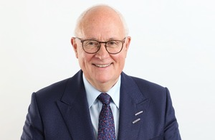
Sir Michael Lyons is the Chair of the New Towns Taskforce.
Sir Michael is the non-executive Chairman of the English Cities Fund, a joint venture set up by three partners – including Homes England – which has large scale regeneration developments in London, Liverpool, Plymouth, Salford and Wakefield.
He is also the non-executive Chairman of SQW Ltd and has spent 26 years in local government, including 17 years as Chief Executive of three major UK local authorities including Birmingham City Council.
He has been a member of the boards of Redrow homes and Sage Housing as well as a strategic adviser on public asset management and regeneration to the commercial real estate and investment firm CBRE. He was also a former Chair of the BBC.
He previously chaired the Housing Commission in 2014 established by Ed Miliband, which set out how the UK can boost housing supply. He also led the national ‘Lyons Inquiry into Local Government’ in 2007 about workings and funding of local government which argued for greater devolution and emphasised the local authority’s role in ‘placeshaping’.

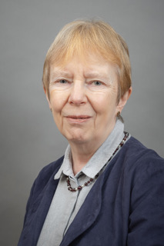
Dame Kate Barker (Deputy Chair)
Dame Kate Barker is the Deputy Chair of the New Towns Taskforce.
Dame Kate chairs the trustee for the Universities Superannuation Scheme, and is also a Church Commissioner for the Church of England. She chairs the Governing Council of the Productivity Institute.
She was a former non-executive director at Taylor Wimpey plc, at Man Group plc and at the Yorkshire Building Society. She was an external member of the Bank of England’s Monetary Policy Committee between 2001 and 2010.
During that time, she was commissioned by the government to conduct a major independent policy review of UK Housing Supply in 2004 followed by a review of Land Use Planning in 2006. She has also authored a book titled ‘Housing: where’s the plan’ and was previously a Commissioner for the National Infrastructure Commission.
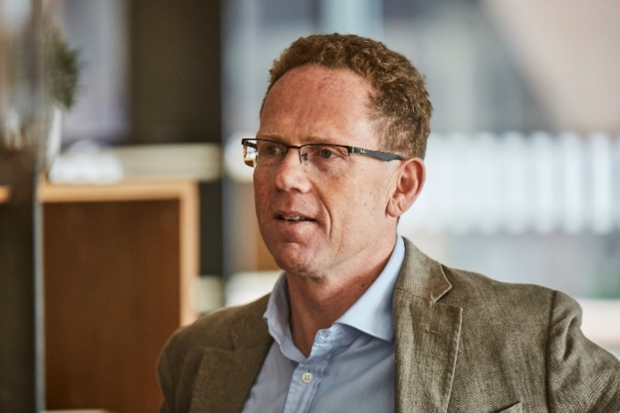
Bill Hughes
Bill is Global Head of Real Assets and Co-Head of Private Markets at Legal & General.
He plays an active role in the wider infrastructure and housing industry, having been Chair of the Property Industry Alliance since 2016.
Bill is also a Global Governing Trustee of the Urban Land Institute and is on the UK Net Zero Carbon Buildings Standard (NZCBS) Governance Board. Previously, Bill was CEO at RREEF UK and Deputy Managing Director at Schroder Property Investment Management.


Dame Diane Coyle
Dame Diane Coyle is an economist and Bennett Professor of Public Policy at the University of Cambridge.
She is also a Director of the Productivity Institute, a Fellow of the Office for National Statistics, and an academic adviser to the CMA.
Dame Diane was awarded a DBE for her contribution to economic policy in the 2023 King’s Birthday Honours.

Helen Gordon
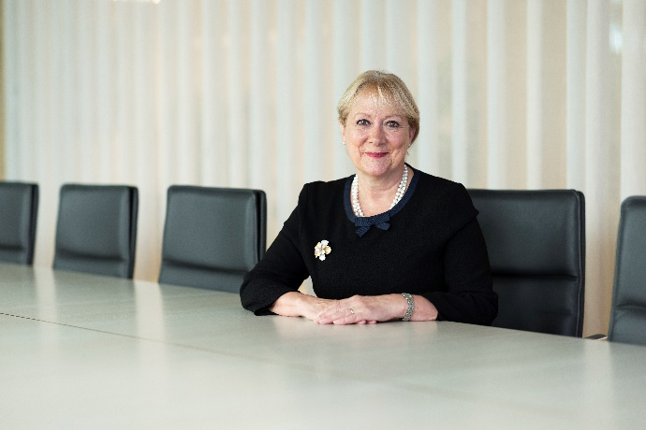
Helen is the CEO of Grainger, the UK’s largest publicly listed residential landlord and Build to Rent developer.
Helen has been in position since 2016, having previously working at RBS and Legal & General.
Helen has a wealth of experience developing new towns, working on the development of Milton Keynes early in her career. Helen was also formally the president of the British Property Foundation and is Vice Chair of the European Public Real Estate Association.

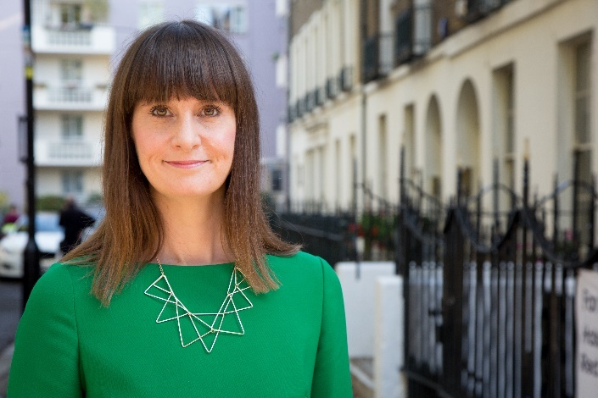
Kate Henderson
Kate is the Chief Executive of the National Housing Federation, the voice of England’s housing associations.
Kate is currently a member of several government panels including the Rough Sleeping Advisory Panel and the Social Housing Quality Expert Challenge Panel.
Kate was previously Chief Executive of the Town and Country Planning Association.

Lyn Garner
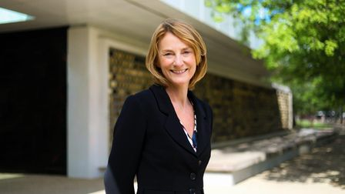
Lyn is the former Chief Executive of the London Legacy Development Corporation and has been Senior Professional Lead for GLA Group Housing Delivery since 2022. She is also a Director and Chair of Future of London.
Lyn has over 25 years experience working across the housing, regeneration and finance sectors, and is the incoming Chair of E20 Stadium LLP.

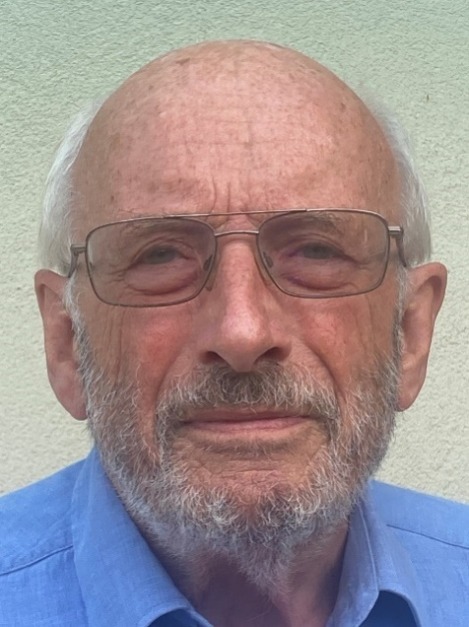
Nick Raynsford
Nick is the current President of the Town and Country Planning Association and author of the 2018 Raynsford Review of Planning.
Nick was an MP from 1986 to 2015 and held multiple ministerial positions including Minister of State for Housing and Planning, Minister for London and Minister of State for Local and Regional Government.
Since leaving Parliament he has held a number of positions including Deputy Chairman of Crossrail, Chair of CICAIR and a Director of Pocket Living.


Sowmya Parthasarathy
Sowmya is an architect and urban designer at ARUP, with over 30 years of global experience. She has been involved in award-winning masterplans, strategic plans, and urban design guides, such as London’s 2012’s Olympic Legacy Masterplan.
Sowmya is also a UK Design Council Ambassador, serves as a Design Advocate for the Mayor of London and sits on the London Design Review Panel.


Dr Wei Yang
Dr Wei is a town planner and urban designer. She is CEO of the Digital Task Force for Planning and Chairman of Wei Yang & Partners.
Dr Wei currently serves as the Chair of the Construction Industry Council and a member of the UN Habitat World Urban Campaign Steering Committee.
Previously, Wei was President of the Royal Town Planning Institute for 2021.

