NOTICE OF ORDER
Wildlife and Countryside Act 1981 Section 53

Trafford Metropolitan Borough Council
THE BOROUGH OF TRAFFORD (BROOKS DRIVE) DEFINITIVE MAP
MODIFICATION ORDER 2023
Notice is hereby given that the above referenced Order has been submitted to the Secretary of State for Environment, Food and Rural Affairs for determination. An Inspector will be appointed by the Secretary of State to determine the Order.
The start date for the above Order is 19 February 2025
Consideration of the Order will take the form of a public local inquiry.
The Inquiry will be held at Trafford Council, Trafford Town Hall, Talbot Road, Stretford, M32 0TH on Tuesday 8 July 2025 at 10.00am.
The effect of the Order, if confirmed without modifications, will modify the definitive map and statement for the area by:
-adding a restricted byway along Brooks Drive, Hale commencing at its junction with Hale Road at O.S. grid reference SJ 7987 8549 (point ‘A’ marked on the Order Map) continuing in a generally northeasterly direction for a distance of approximately 715 metres to its junction with definitive footpath no. 16, Hale at O.S. grid reference SJ 8016 8613 (point ‘B’ marked on the Order Map) and then continuing in a generally northeasterly direction for a distance of approximately 420 metres to O.S. grid reference SJ 8043 8644 (point ‘E’ marked on the Order Map) where the way terminates on the southerly kerb line of Thorley Lane near its junction with Roaring Gate Lane.
The width of the Restricted Byway is 9 metres with a local narrowing at O.S. grid reference SJ 8028 8622 (point ‘C’ marked on the Order Map) to 2m metres and a local narrowing at point ‘D’ marked on the Order Map to 2 metres to the west side and 1.4 metres to the east side of a gate. Point ‘D’ on the Order Map is 8 metres from Point ‘E’ on the Order Map in a southerly direction along the way to be added. The approximate length of the Restricted Byway is 1135 metres.
Any queries relating to this Order should be referred to Ian Aston by email: rightsofway2@planninginspectorate.gov.uk quoting reference numbers ROW/3339282 on all correspondence. Alternatively, queries may be sent in writing to The Planning Inspectorate, Rights of Way Section, Room 3/A Eagle Wing, Temple Quay House, 2 The Square, Temple Quay, Bristol, BS1 6PN. Telephone: 0303 444 5670.
Any person wishing to view the statements of case and other documents relating to this Order may do so by appointment at: Sale Library, 2 Tatton Road, Sale, M337EB. Contact: Geoff Evenson email; geoff.evenson@amey.co.uk tel; 07710 965750.

Timetable for sending in statements of case and proofs of evidence

Within 8 weeks of the start date [by 15 April 2025]
The Order Making Authority must ensure their statement of case is received by the Secretary of State. As soon as possible after the deadline, the Secretary of State will send a copy (excluding copies of any supporting documents - these will be available to view at the Authority’s offices) to everyone who has made an objection or representation and the applicant and any other person who has written to us in respect of the Order.

Within 14 weeks of the start date [by 26 May 2025]
Everyone who has made an objection or representation and anyone who wishes to give evidence at the Inquiry must ensure their statement of caseis received by the Secretary of State. As soon as possible after the deadline, the Secretary of State will send full copies to the Authority. Copies will also be sent to the applicant, every person who has made an objection or representation and any other person who has written to us in respect of the Order (excluding copies of any supporting documents - these will be available to view at the Authority’s offices).
Within the same period the applicant (if applicable) must ensure their statement of case is received by the Secretary of State. As soon as possible after the deadline, the Secretary of State will send a full copy to the Authority. Copies will also be sent to everyone who has made an objection or representation and any other person who has written to us in respect of the Order (excluding copies of any supporting documents - these will be available to view at the Authority’s offices).

weeks before the date of the inquiry [by 16 June 2025]
The Authority, everyone who has made an objection or representation, the applicant (if applicable) and anyone who wishes to give evidence at the Inquiry must ensure their proof of evidence (together with any summary) is received by the Secretary of State. As soon as possible after the deadline, the Secretary of State will send copies of:
- the Authority’s proof of evidence to everyone who has made an objection or representation, the applicant and anyone who has submitted a statement of case (including copies of any supporting documents – although none should be submitted with a proof of evidence);
- the applicant’s proof of evidence to the Authority, everyone who has made an objection or representation and anyone else who has submitted a statement of case (including copies of any supporting documents – although none should be submitted with a proof of evidence); and
- all other proofs of evidence to the Authority, the applicant, everyone who has made an objection or representation and anyone else who has submitted a statement of case (including copies of any supporting documents – although none should not be submitted with a proof of evidence).
All parties must keep to the timetable set out above and ensure that statements of case and proofs of evidence are received by the Secretary of State on time. Late documents will be returned.
We cannot accept any inflammatory, discriminatory or abusive comments. Any documents containing such comments will be returned.
Notice of order for inquiry
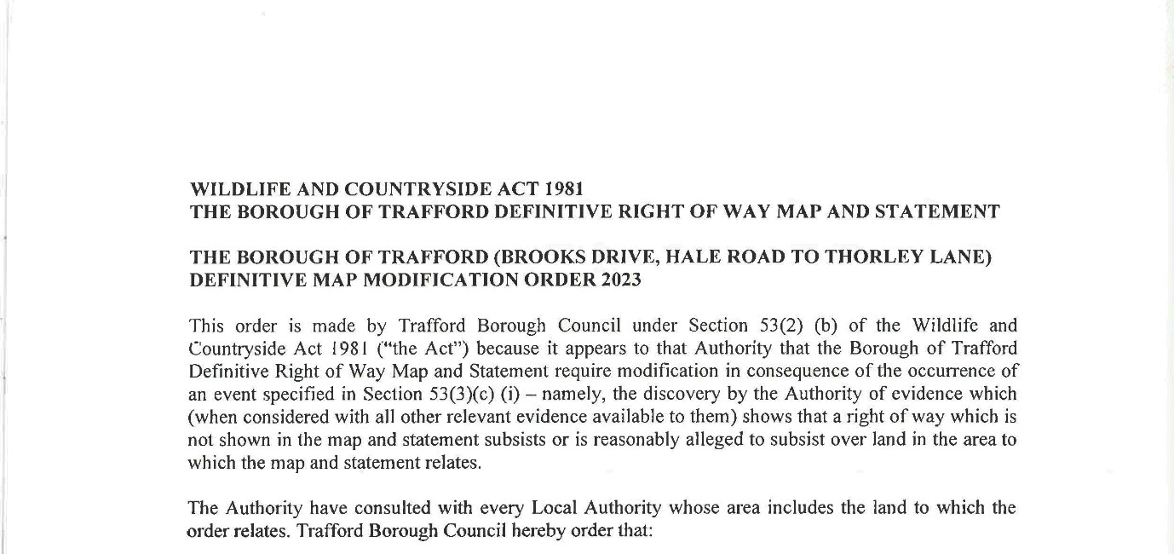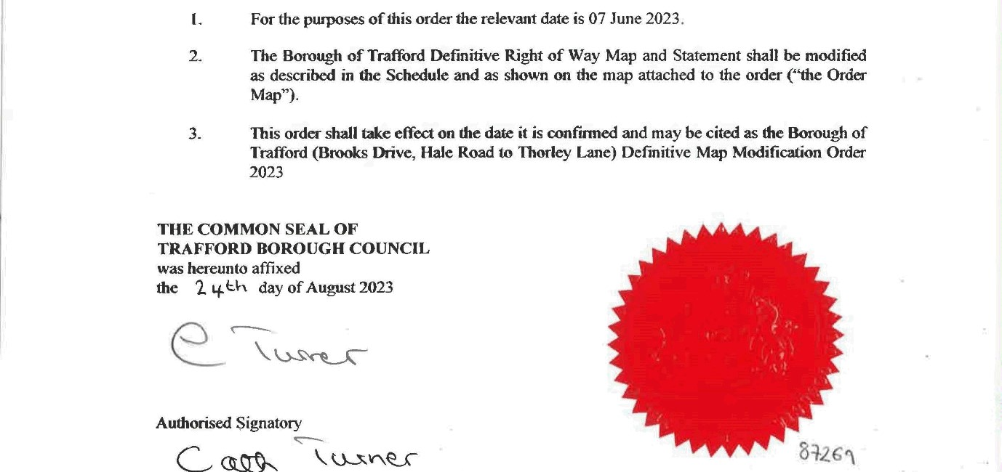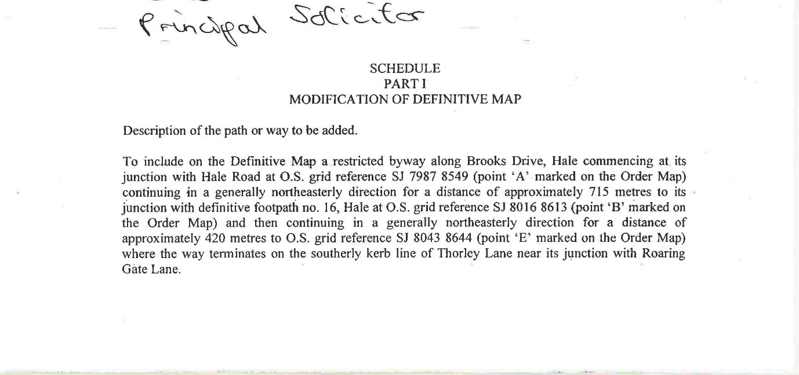
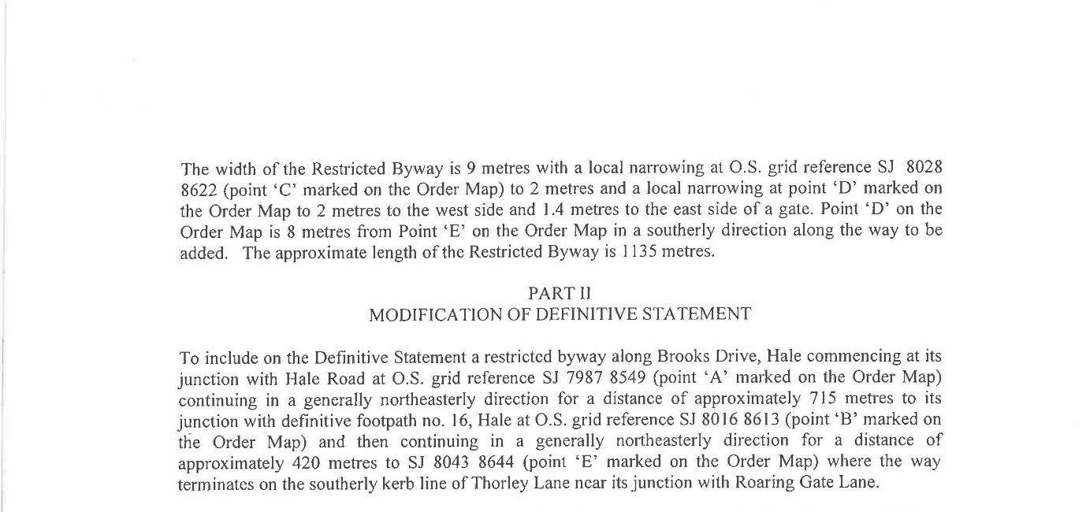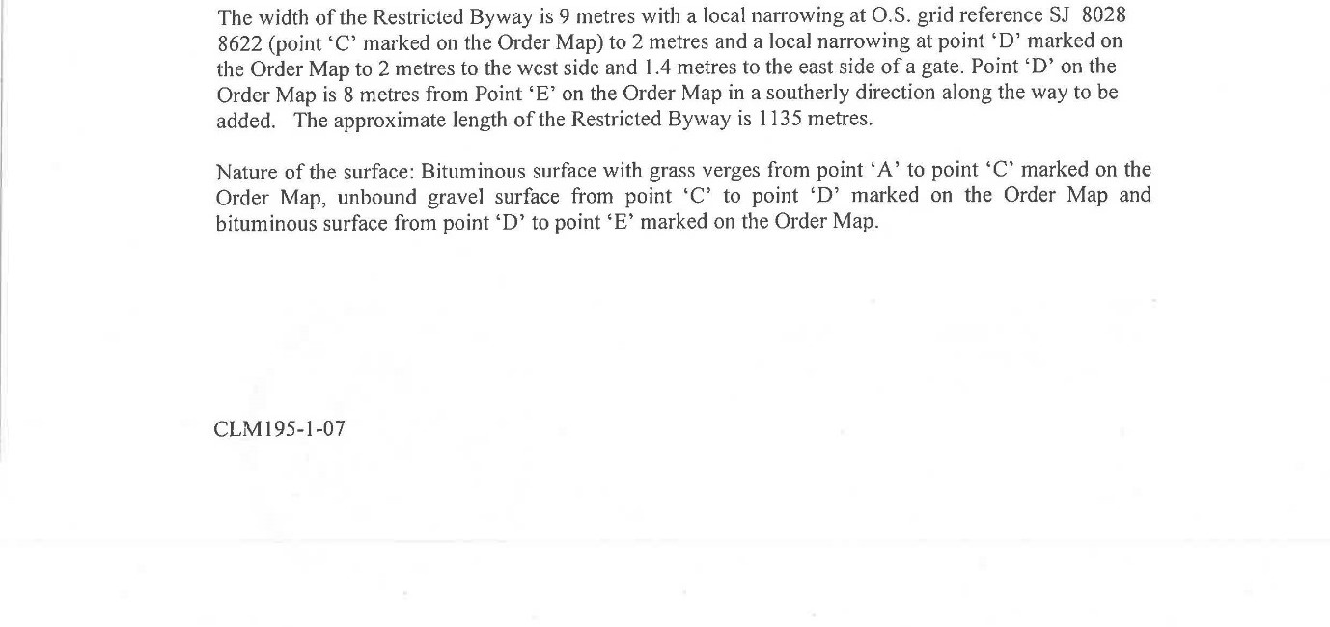
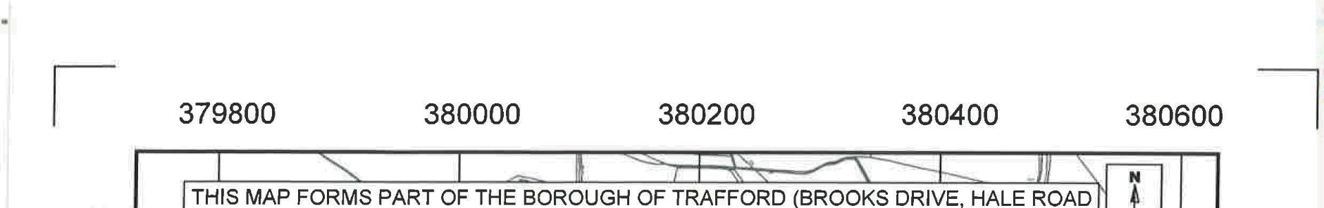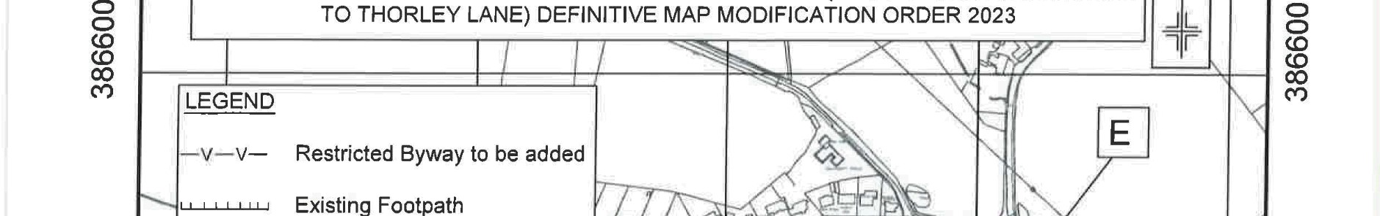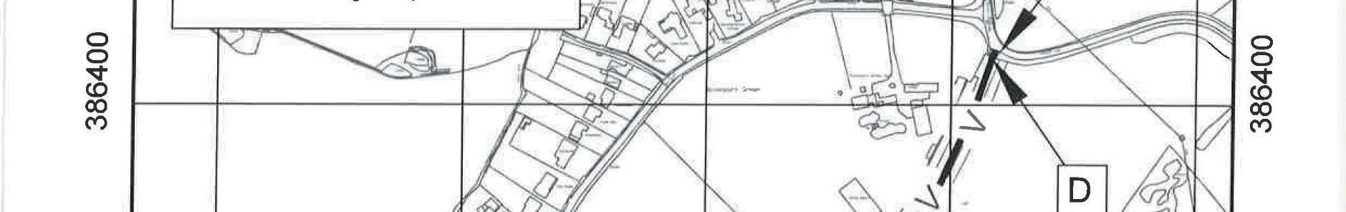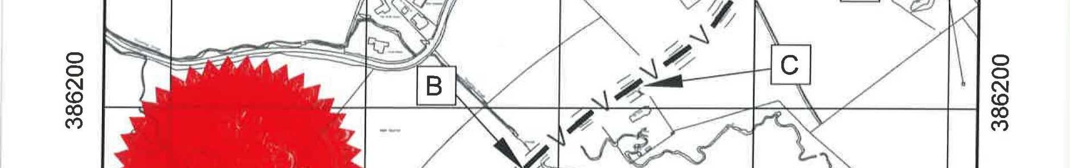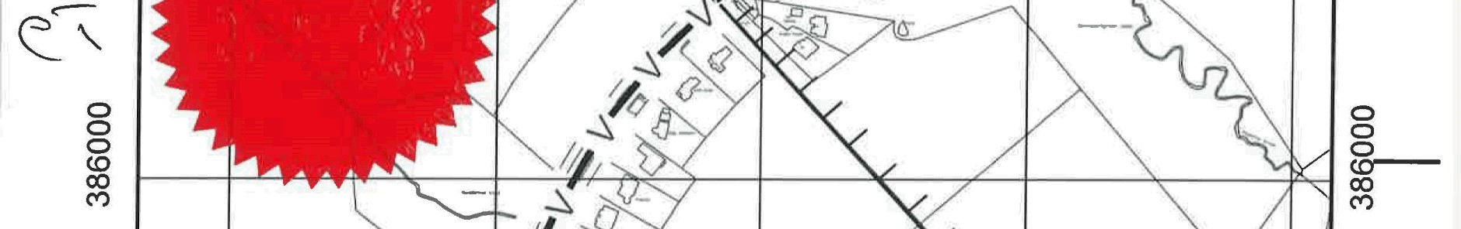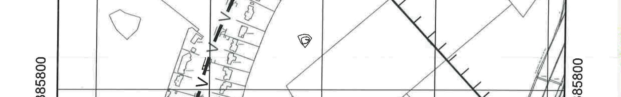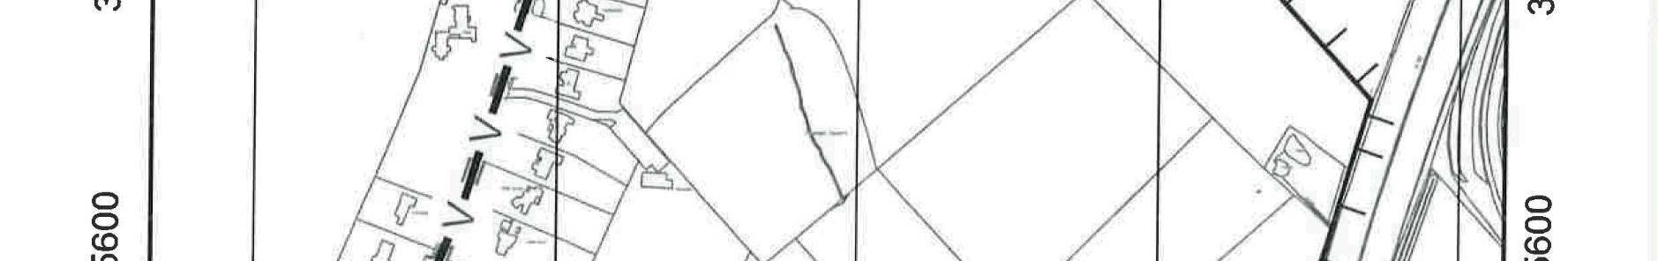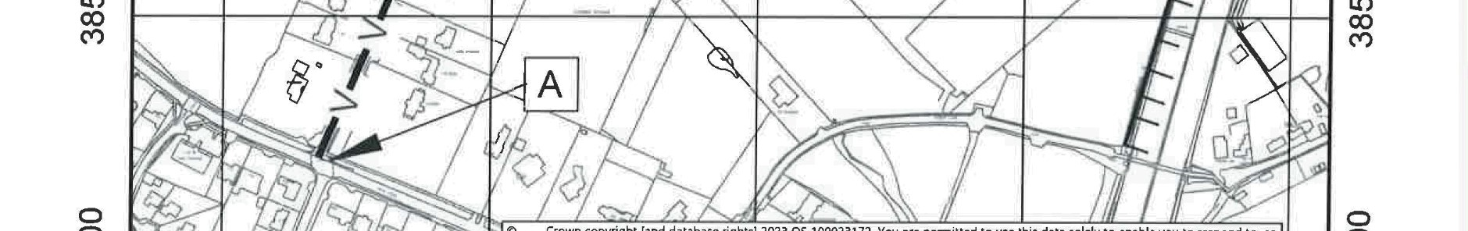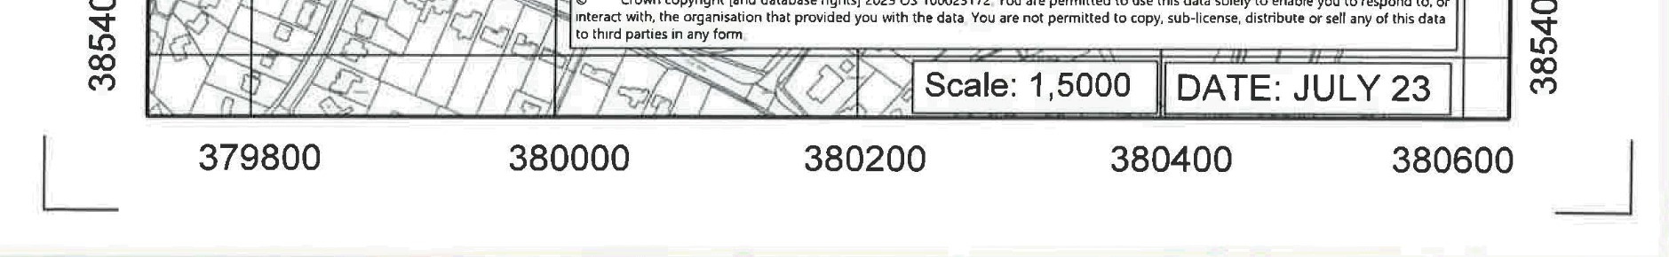

If you wish to make a legal submission, this should be submitted at the same time as your statement of case. Otherwise legal submissions will have to be submitted in writing on the day of the inquiry.

