NOTICE OF ORDER
Wildlife and Countryside Act 1981

Staffordshire County Council

Public Bridleway at Church Lane, FP28 to Sharpecliffe Lodge, FP29, Ipstones Parish, Modification Order 2024

Notice is hereby given that the above referenced Order has been submitted to the Secretary of State for Environment, Food and Rural Affairs for determination. An Inspector will be appointed by the Secretary of State to determine the Order.
The start date for the above Order is 8th APRIL 2025.

Consideration of the Order will take the form of a public local inquiry.

The Inquiry will be held at Dove Room, Moorlands House, Staffordshire Moorlands District Council Office, Moorlands House, Leek, ST13 6HQ on 14th OCTOBER 2025 at 10.00am.

The effect of the Order, if confirmed without modifications, will be the upgrade of the entire length of the existing public footpath known as Ipstones 28 to a bridleway, commencing at point A on the map (NGR 401518, 350455), on the north side of Church Lane, Ipstones, and running in a generally northerly direction along the unclassified public road known as Clerks Bank for approximately 140 metres then in a generally north westerly direction for approximately 41 metres, then in a generally northerly direction for approximately 38 metres to the northern end of Clerks Bank, then in a generally north easterly direction for approximately 132 metres then in a generally north westerly direction for approximately 420 metres to the unclassified public road known as Coley Hole, point B on the map, (NGR 401367, 351114).

And the upgrade of the entire length of the existing public footpath known as Ipstones 29 to a bridleway, commencing at point C on the map (NGR 401383, 351115) then running along Coley Hole in a generally east north easterly direction for approximately 125 metres towards the eastern end of Coley Hole, then a generally east north easterly direction for approximately 530 metres, then in a generally northerly direction for approximately 72 metres then in a generally north easterly direction for approximately 177 metres to point D on the map (NGR 402051, 351641) its terminus on the south side of Bradshaw Lane adjacent to Sharpecliffe Lodge.
Width: The width of the Public Bridleway will be 7 metres Limitations: None
Any queries relating to this Order should be referred to Paul Scrivener by email: paul.scrivener@planninginspectorate.gov.uk quoting reference number ROW/3343511 on all correspondence. Alternatively, queries may be sent in writing to The Planning Inspectorate, Rights of Way Section, Room 3/A Eagle Wing, Temple Quay House, 2 The Square, Temple Quay, Bristol, BS1 6PN. Telephone: 0303 444 5000.

Any person wishing to view the statements of case and other documents relating to this Order may do so by appointment at Staffordshire County Council, 1 Staffordshire Place, Tipping Street, Stafford, ST16 2DH during normal working hours, Monday to Friday. Contact: email laura.james1@staffordshire.gov.uk Tel: 01785 278778

Timetable for sending in statements of case and proofs of evidence
Within 8 weeks of the start date by 3rd JUNE 2025

The Order Making Authority must ensure their statement of case is received by the Secretary of State. As soon as possible after the deadline, the Secretary of State will send a copy (excluding copies of any supporting documents - these will be available to view at the Authority’s offices) to everyone who has made an objection or representation and the applicant and any other person who has written to us in respect of the Order.

Within 14 weeks of the start date by 15th JULY 2025
Everyone who has made an objection or representation and anyone who wishes to give evidence at the Inquiry must ensure their statement of case1 is received by the Secretary of State. As soon as possible after the deadline, the Secretary of State will send full copies to the Authority. Copies will also be sent to the applicant, every person who has made an objection or representation and any other person who has written to us in respect of the Order (excluding copies of any supporting documents - these will be available to view at the Authority’s offices).

Within the same period the applicant (if applicable) must ensure their statement of case is received by the Secretary of State. As soon as possible after the deadline, the Secretary of State will send a full copy to the Authority. Copies will also be sent to everyone who has made an objection or representation and any other person who has written to us in respect of the Order (excluding copies of any supporting documents - these will be available to view at the Authority’s offices).
4 weeks before the date of the inquiry by 16th SEPTEMBER 2025

1 If you wish to make a legal submission, this should be submitted at the same time as your statement of case. Otherwise legal submissions will have to be submitted in writing on the day of the inquiry.
The Authority, everyone who has made an objection or representation, the applicant (if applicable) and anyone who wishes to give evidence at the Inquiry must ensure their proof of evidence (together with any summary) is received by the Secretary of State. As soon as possible after the deadline, the Secretary of State will send copies of:

- the Authority’s proof of evidence to everyone who has made an objection or representation, the applicant and anyone who has submitted a statement of case (including copies of any supporting documents – although none should be submitted with a proof of evidence);
- the applicant’s proof of evidence to the Authority, everyone who has made an objection or representation and anyone else who has submitted a statement of case (including copies of any supporting documents – although none should be submitted with a proof of evidence); and
- all other proofs of evidence to the Authority, the applicant, everyone who has made an objection or representation and anyone else who has submitted a statement of case (including copies of any supporting documents – although none should not be submitted with a proof of evidence).

All parties must keep to the timetable set out above and ensure that statements of case and proofs of evidence are received by the Secretary of State on time. Late documents will be returned.
NOTE: If you use Artificial Intelligence (AI) to create or alter any part of your documents, information or data, you should tell us that you have done this when you provide the material to us. See the detailed guidance for further information.

We cannot accept any inflammatory, discriminatory or abusive comments. Any documents containing such comments will be returned.

Notice of order for inquiry
I
WILDLIFE AND COUNTRYSIDE ACT 1981
DEFINITIVE MAP AND STATEMENT FOR THE STAFFORDSHIRE MOORLANDS DISTRICT
STAFFORDSHIRE COUNTY COUNCIL (PUBLIC BRIDLEWAY AT CHURCH LANE, FP28 TO COLEY HOLE & FP29 TO SHARPECLIFFE LODGE IPSTONES PARISH}
MODIFICATION ORDER 2024
This Order is made by Staffordshire County Council under section 53(2)(b) of the Wildlife and Countryside Act 1981 ("the Act") because it appears to the Authority that the Definitive Map and Statement of Public Rights of Way in the Staffordshire Moorlands District require modification in consequence of the occurrence of an event specified in section 53(3)(c)(ii), of the Act, namely the discovery by the Authority of evidence which (when considered with all other relevant evidence available to them) shows that a highway shown in the map and statement as a highway of a particular description ought to be there
I shown as a highway of a different description.
The Authority has consulted with every local authority whose area includes the land to which the Order relates. Staffordshire County Council hereby
I order that:
- For the purposes of this Order the relevant date is the date that it is
I made.
- The Definitive Map and Statement for the Staffordshire Moorlands
I District shall be modified as described in Part I and Part II of the Schedule and shown on the map attached to the Order ("the Order
Plan").
i
- This Order shall take effect on the date it is confirmed and may be cited
as the Staffordshire County Council (Public Bridleway at Church Lane,
I FP28 to Coley Hole and FP29 to Sharpecliffe Lodge Ipstones Parish) Modification Order 2024.
I Given under the Common Seal of Staffordshire County Council on the 9th day of January 2024.

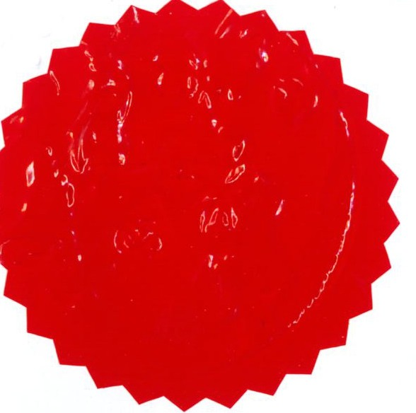
I
THE COMMON SEAL of

I
' STAFFORDSHIRE COUNTY COUNCIL
was hereunto affixed in the presence
r-�
I
of:-
I Authorised Signatory
ll.tt

LJ/01181BDW

I
I
Page 2

p 2
SCHEDULE
I
PART I
I Modification of Definitive Map
i
DESCRIPTION OF PUBLIC RIGHT OF WAY TO BE UPGRADED

I
The upgrade of the entire length of the existing public footpath known as
Ipstones 28 to a bridleway, commencing at point A on the map (NGR 401518, 350455), on the north side of Church Lane, Ipstones, and running in a generally northerly direction along the unclassified public road known as Clerks Bank for approximately 140 metres then in a generally north westerly direction for approximately 41 metres, then in a generally northerly direction for approximately 38 metres to the northern end of Clerks Bank, then in a generally north easterly direction for approximately 132 metres then in a
generally north westerly direction for approximately 420 metres to the
I unclassified public road known as Coley Hole, point B on the map, (NGR
401367, 351114).
And the upgrade of the entire length of the existing public footpath known as Ipstones 29 to a bridleway, commencing at point C on the map (NGR 401383,
I 351115) then running along Coley Hole in a generally east north easterly
direction for approximately 125' metres towards the eastern end of Coley
I Hole, then a generally east north easterly direction for approximately 530 metres, then in a generally northerly direction for approximately 72 metres
then in a generally north easterly direction for approximately 177 metres to
I point D on the map (NGR 402051, 351641) its terminus on the south side of
Bradshaw Lane adjacent to Sharpecliffe Lodge.
I Width: The width of the Public Bridleway will be 7 metres
Limitations: None
I

I

I I

I

LJ/01181BDW Page 3

I
p 3
I
I

PART II

I
Modification of Definitive Statement
I VARIATION OF PARTICULARS OF PATH OR WAY

Variation of Particulars of Public Rights of Way

Path No. Type of Path Path Path finishes Documents creating
commences at at or modifying the right
I of way and any other
 |  |  |  | relevant information
28 | Public | Coley Hole, | North side of | (Public Bridleway at
Ipstones | Bridleway | about 210 metres south  of Whitehough | Church Lane, west of  Above | Church Lane, FP28 to Coley Hole and FP29 to Sharpecliffe Lodge
 |  |  | Church Farm | Ipstones Parish)

I

I
29 Public Coley Hole, South side of (Public Bridleway at
Ipstones Bridleway about 203 Bradshaw Church Lane, FP28 to
I metres south Lane, Coley Hole and FP29 of Whitehough adjacent to to Sharpecliffe Lodge
I Sharpcliffe Ipstones Parish)
Lodge.
I

I

I

I
I
!
I'

I

LJ/011818DW Page4

t
p 4
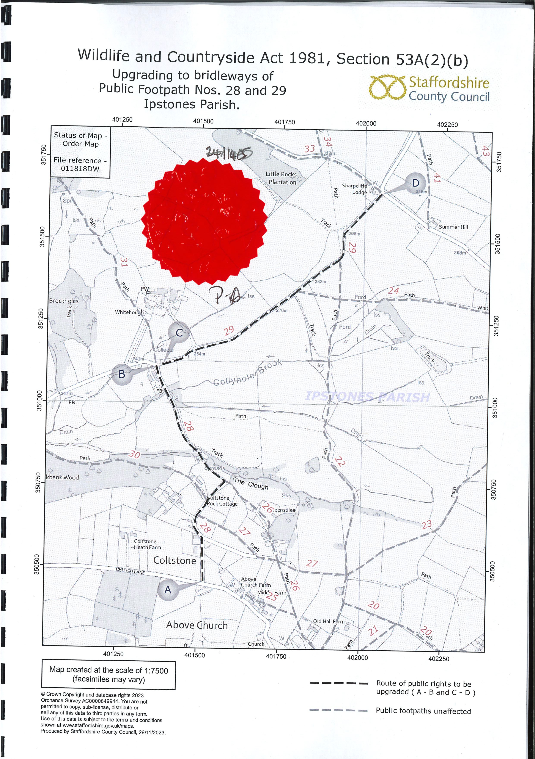

p 5

