NOTICE OF ORDER
Wildlife and Countryside Act 1981 Section 53
Bedford Borough Council (Definitive Map and Statement for The
Former North Bedfordshire Borough) (Odell: Byway Open to All
Traffic No.42) Modification Order 2022
Notice is hereby given that the above referenced Order has been submitted to the Secretary of State for Environment, Food and Rural Affairs for determination. An Inspector will be appointed by the Secretary of State to determine the Order.
The start date for the above Order is 25 February 2025.
Consideration of the Order will take the form of a hearing.
The Hearing will be held at a venue to be confirmed on Tuesday 10th June 2025 at 10.00am.
The effect of the Order, if confirmed without modifications, will be to modify the definitive map and statement for the area by adding to them a length of Byway Open to All Traffic in the Parish of Odell to be numbered 42 in the Definitive Statement commencing from a point where it has a junction with the northernmost extent of the Borough Highway “Church Lane” which is shown on the List of Streets as a highway maintainable at public expense approximately 55 metres south west of Byway Open to All Traffic No. 4 Odell at Ordnance Survey Grid Reference (OSGR) SP 9677/5918 then running in a generally north-eastern direction for 55 metres to a point where it joins with Byway Open to All Traffic No. 4 Odell at OSGR SP 9679/5922.
Any queries relating to this Order should be referred to Ian Aston by email rightsofway2@planninginspectorate.gov.uk quoting reference number ROW/3339981 on all correspondence. Alternatively, queries may be sent in writing to The Planning Inspectorate, Rights of Way Section, Room 3/A Eagle Wing, Temple Quay House, 2 The Square, Temple Quay, Bristol, BS1 6PN. Telephone: 0303 444 5670.
Any person wishing to view the statements of case and other documents relating to this Order may do so by appointment Mon-Fri between 10am3pm Bedford Borough Council, Main Reception, Borough Hall, Cauldwell Street, Bedford, MK42 9AP. Contact Georgina McDade email georgina.mcdade@bedford.gov.uk tel: 01234 276070.
Timetable for sending in statements of case
Within 8 weeks of the start date [by 22 April 2025]
The Order Making Authority must ensure their statement of case is received by the Secretary of State. As soon as possible after the deadline, the Secretary of State will send a copy (excluding copies of any supporting documents, although these will be available to view at the Authority’s offices) to everyone who has made an objection or representation, the applicant and any other person who has written to us in respect of the Order.
Within 12 weeks of the start date [by 20 May 2025]
Everyone who has made an objection or representation and anyone who wishes to give evidence at the Hearing must ensure their statement of caseis received by the Secretary of State. As soon as possible after the deadline, the Secretary of State will send full copies to the Authority. Copies will also be sent to the applicant, every person who has made an objection or representation and any other person who has written to us in respect of the Order (excluding copies of any supporting documents - these will be available to view at the Authority’s offices).
Within the same period the applicant (if applicable) must ensure their statement of case is received by the Secretary of State. As soon as possible after the deadline, the Secretary of State will send a full copy to the Authority. Copies will also be sent to everyone who has made an objection or representation and any other person who has written to us in respect of the Order (excluding copies of any supporting documents - these will be available to view at the Authority’s offices).
All parties must keep to the timetable set out above and ensure that statements of case are received by the Secretary of State on time. Late documents will be returned.
NOTE: If you use Artificial Intelligence (AI) to create or alter any part of your documents, information or data, you should tell us that you have done this when you provide the material to us.
https://www.gov.uk/guidance/use-of-artificial-intelligence-in-caseworkevidence
We cannot accept any inflammatory, discriminatory or abusive comments. Any documents containing such comments will be returned.
Notice of order for hearing
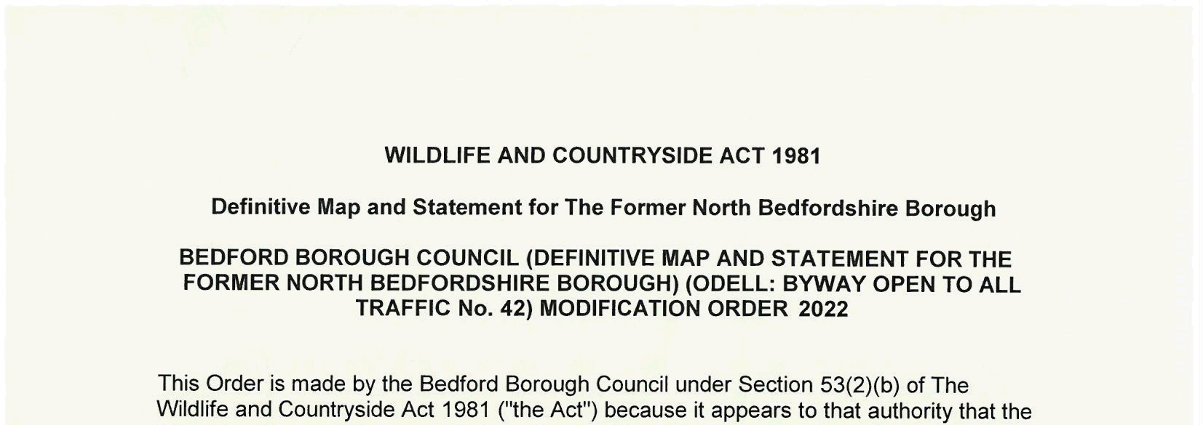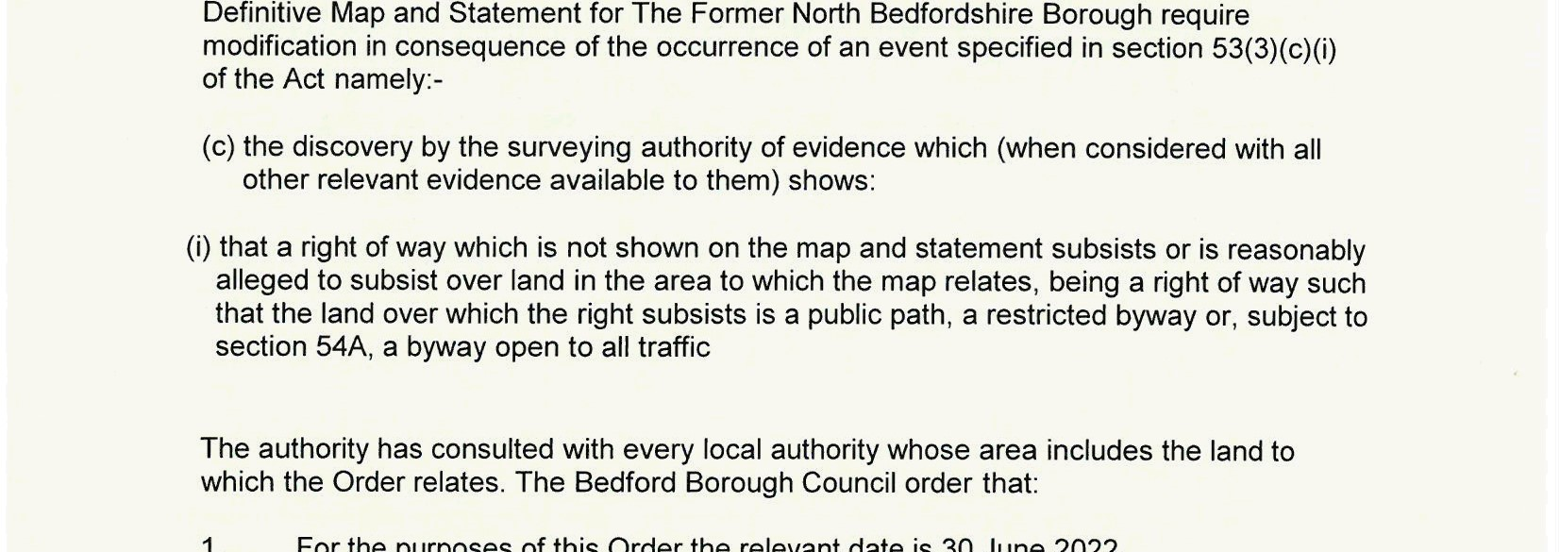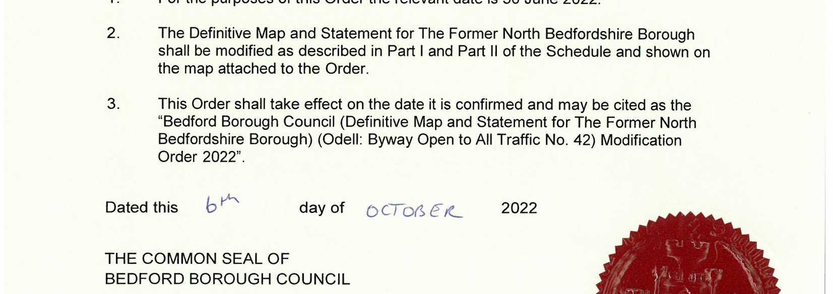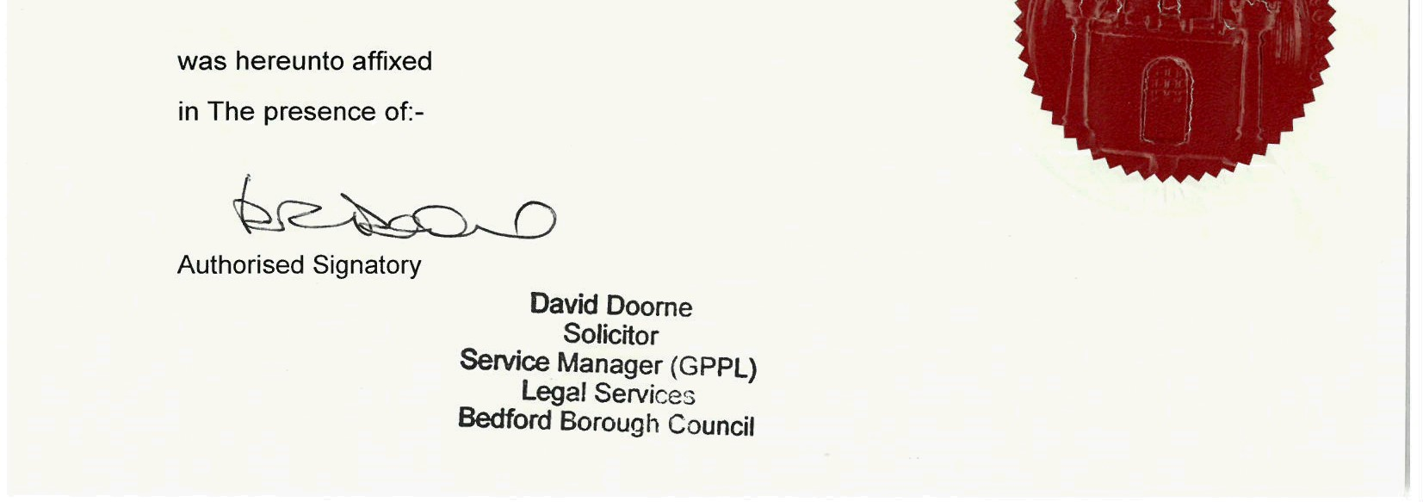
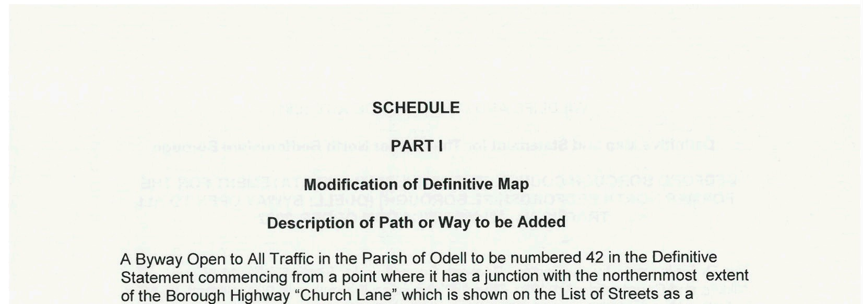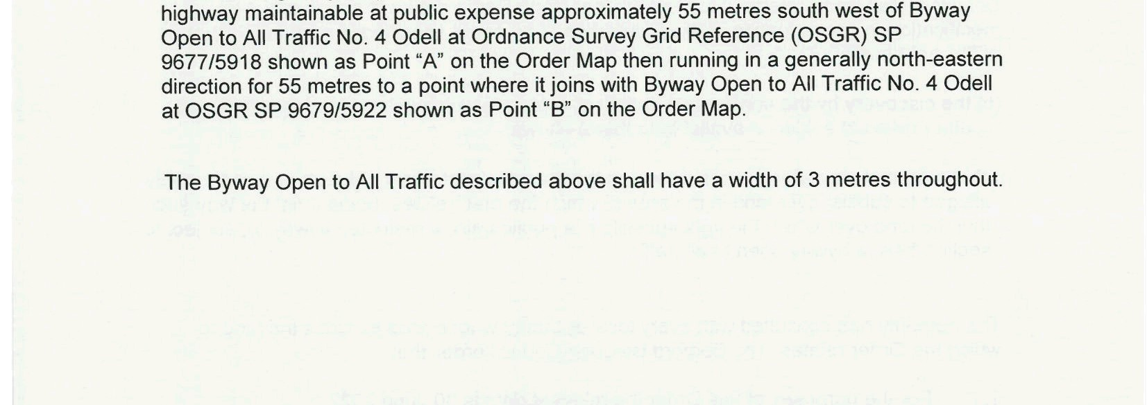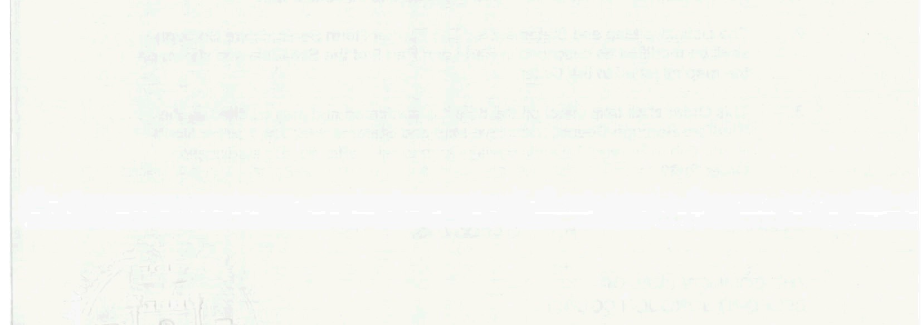
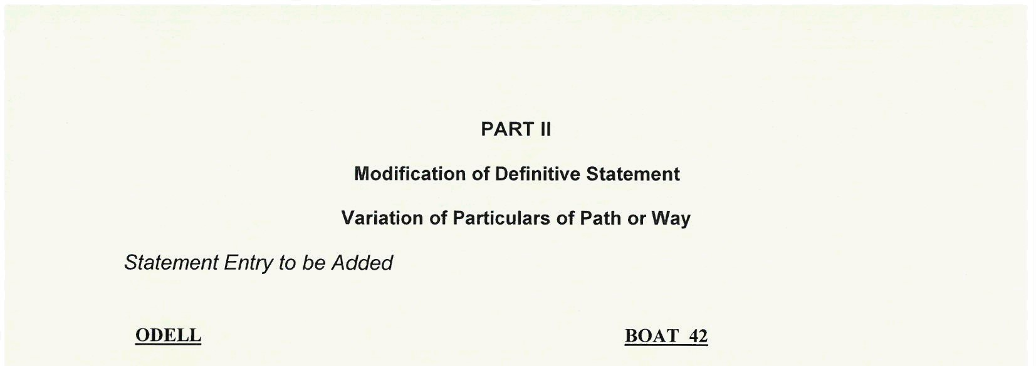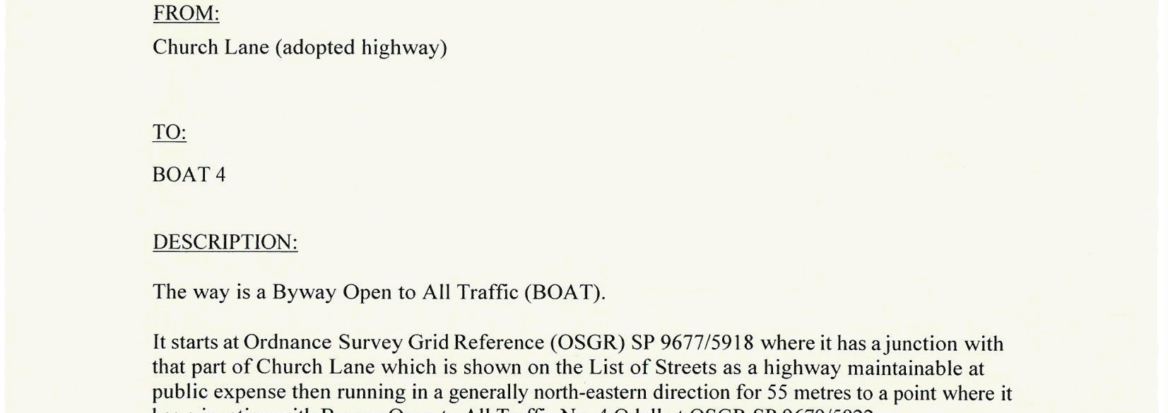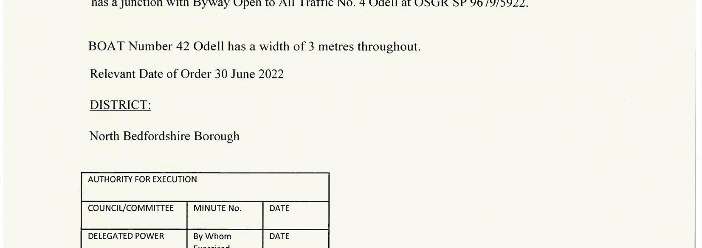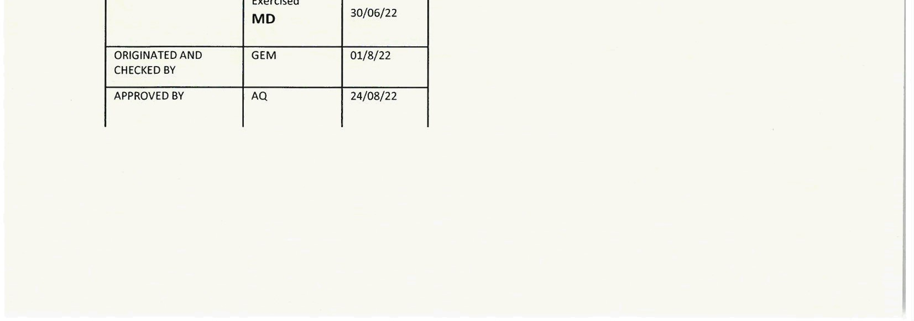
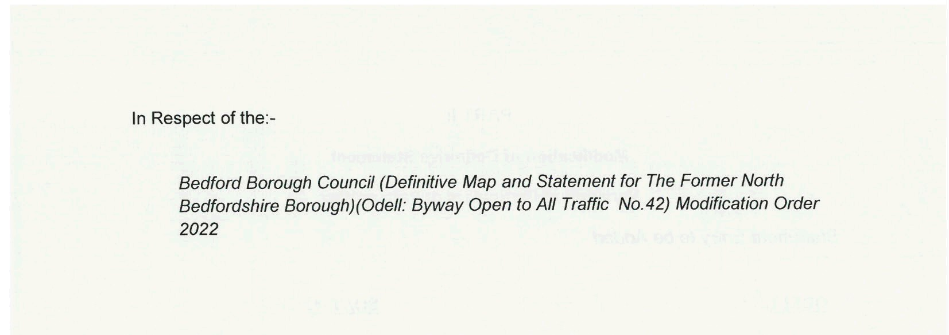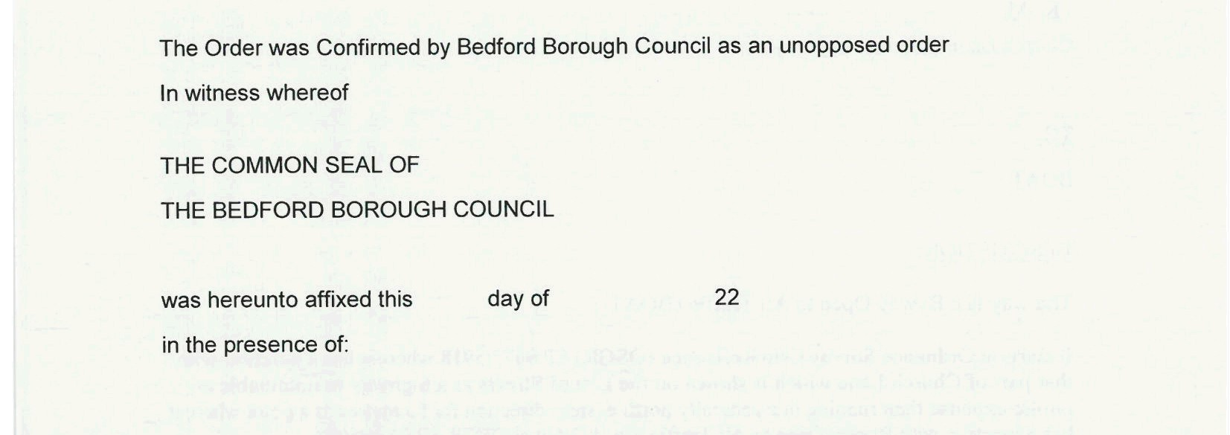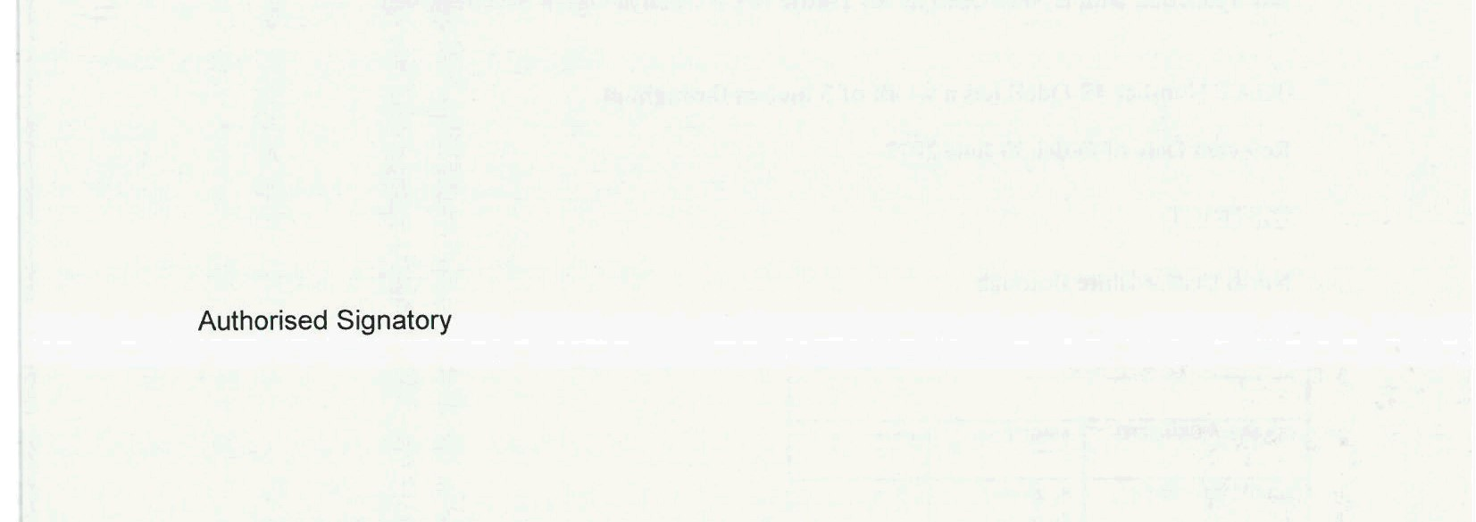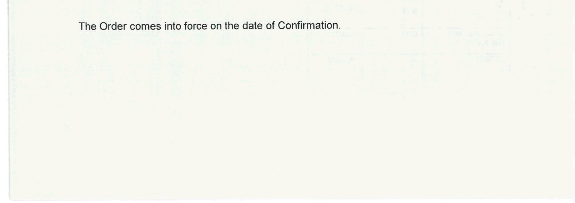
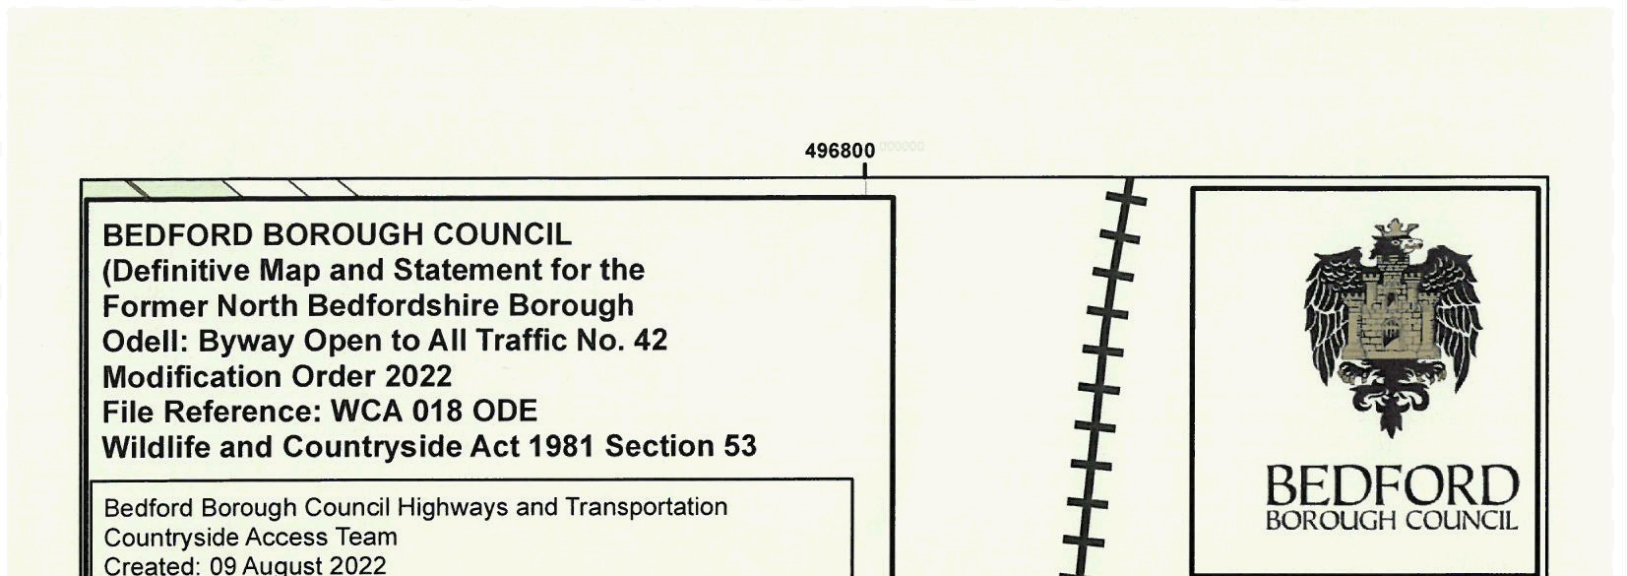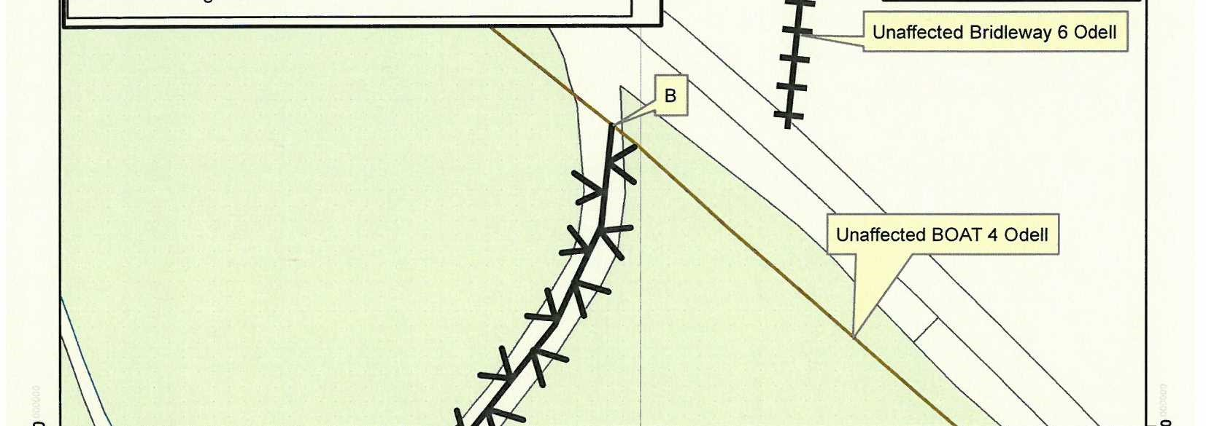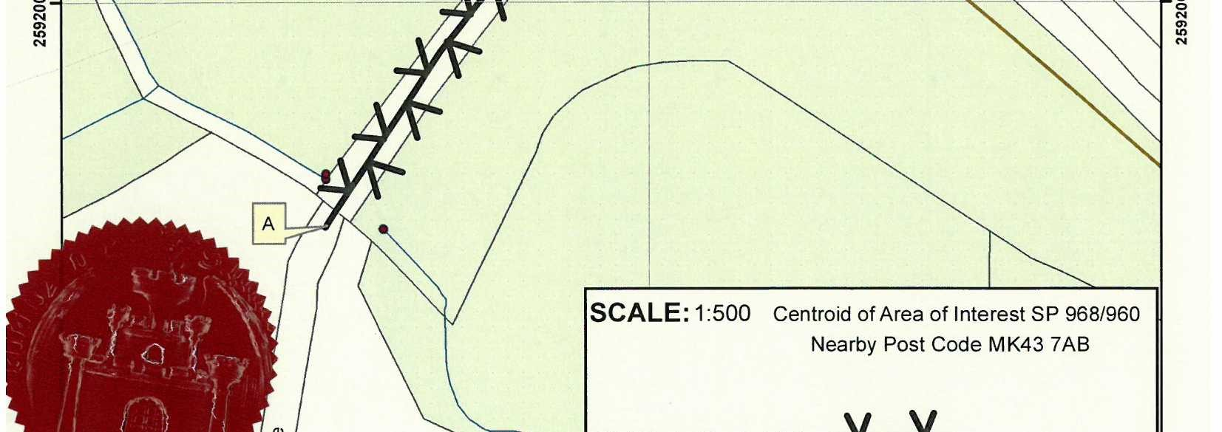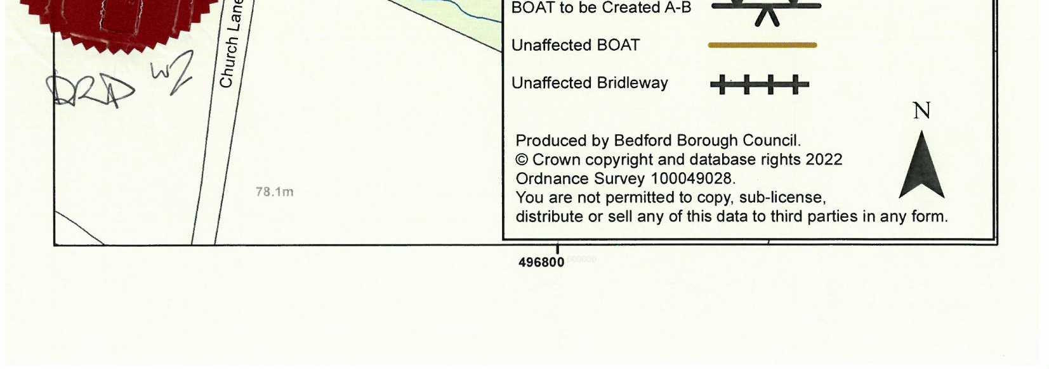

If you wish to make a legal submission, this should be submitted at the same time as your statement of case. Otherwise legal submissions will have to be submitted in writing on the day of the hearing.

