NOTICE OF ORDER
Town and Country Planning Act 1990
Blackburn with Darwen Borough Council
The Borough of Blackburn with Darwen- (Footpaths 185 (part) and 226 (part) Darwen) Public Path Diversion Order 2023

Notice is hereby given that the above referenced Order has been submitted to the Secretary of State for Environment, Food and Rural Affairs for determination. An Inspector will be appointed by the Secretary of State to determine the Order.
The start date for the above Order is 25th March 2025

Consideration of the Order will take the form of exchanges of statements of case and comments on statements of case.

The effect of the Order, if confirmed without modifications, will be to divert the public footpaths as described in Schedule 1 to this Notice onto the route described in Schedule 2 as listed below:
SCHEDULE 1 – LINE OF EXISTING ROUTE

Footpath 185 Darwen
From the junction of FP’s 186 & 187 Darwen (SD 71761 20822) in a general south easterly direction via Point A (SD 72044 20697) and Point C (SD 72070 20680) to Cuckoldman’s at Point D (SD 72118 20650) then in a general southerly direction via Point E (SD 72118 20612) to Far Hillock (SD 72127 20501), approximate length 570 metres, with a fork from Point E south of Cuckoldman’s in a general south easterly direction to connect with FP67 Edgworth (SD 72322 20546), approximate length 220 metres.

Footpath 226 Darwen
From Middle Scotland Farm (SD 71900 21452) in a general southerly direction via Point B (SD 72054 20721) to Cuckoldman’s at Point C (SD 72070 20680), approximate length 808 metres.

SCHEDULE 2 – LINE OF DIVERSIONARY ROUTE

Footpath 185 Darwen
From the junction of FP’s 186 & 187 Darwen (SD 71761 20822) in a general south easterly direction to Point A (SD 72044 20697), then in a south south westerly direction to Point F (SD 72035 20657), then in a general south easterly direction via Point E (SD 72118 20612) to connect with FP67 Edgworth (SD 72322 20546), approximate length 672 metres, with a fork from Point E south of Cuckoldman’s in a general southerly direction to Far Hillock (SD 72127 20501), approximate length 128 metres.

Footpath 226 Darwen
From Middle Scotland Farm (SD 71900 21452) in a general southerly direction via Point B (SD 72054 20721) to Cuckoldman’s at Point A (SD 72044 20697), approximate length 797 metres.

Any queries relating to this Order should be referred to Paul Scrivener by email: paul.scrivener@planninginspectorate.gov.uk quoting reference number ROW/3350914
on all correspondence. Alternatively, queries may be sent in writing to The Planning Inspectorate, Rights of Way Section, Room 3/A Eagle Wing, Temple Quay House, 2 The Square, Temple Quay, Bristol, BS1 6PN. Telephone: 0303 444 5000.

Any person wishing to view the statements of case and other documents relating to this Order may do so by appointment at Blackburn with Darwen Town Hall, King William Street, Blackburn BB1 7DY. Contact Rabia Saghir email: Rabia.saghir@blackburn.gov.uk Telephone: 01254 585233

Timetable for sending in statements of case and comments Within 2 weeks of the start date 8 APRIL 2025
The Order Making Authority must ensure their statement of case is received by the
Secretary of State. As soon as possible after the deadline, the Secretary of State will send a copy (excluding copies of any supporting documents - these will be available to view at the Authority’s offices) to everyone who has made an objection or representation, the applicant and any other person who has written to us in respect of the Order.
Within 8 weeks of the start date 20 MAY 2025
Everyone who has made an objection or representation or any other written representation or any other person wishing to make representations in writing must ensure their statement of case is received by the Secretary of State. As soon as possible after the deadline, the Secretary of State will send full copies to the Authority. Copies (excluding copies of any supporting documents - these will be available to view at the Authority’s offices) will also be sent to the applicant, every person who has made an objection or representation and any other person who has written to us in respect of the Order.

Within the same period the applicant (if applicable) must ensure their statement of case is received by the Secretary of State. As soon as possible after the deadline, Secretary of State will send a full copy to the Authority. Copies will also be sent to everyone who has made an objection or representation and any other person who has written to us in respect of the Order (excluding copies of any supporting documents - these will be available to view at the Authority’s offices).
Within 14 weeks of the start date 1 JULY 2025
Everyone who has made an objection or representation, the Authority, the applicant (if applicable) and anyone who has written to us in respect of the Order must ensure that their comments on any or every other statement of case is received by the Secretary of State. As soon as possible after the deadline, the Secretary of State will send copies of these comments to everyone else.

In fairness to the other parties everyone should keep to the timetable to ensure that statements of case and comments are received on time. Late documents will be returned.

We cannot accept any inflammatory, discriminatory or abusive comments. Any documents containing such comments will be returned.

Notice of order for w/r
i!;.

PUBLIC PATH DIVERSION AND DEFINITIVE MAP AND STATEMENT MODIFICATION ORDER
TOWN AND COUNTRY PLANNING ACT 1990, SECTION 257 WILDLIFE COUNTRYSIDE ACT 1981, SECTION 53A(2)

The Borough of Blackburn with Darwen {Footpaths 185 {part) and 226 {part) Darwen) Public Path Diversion Order 2023

This order is made by Blackburn with Darwen Borough Council under section 257 of the Town and Country Planning Act 1990 because it is satisfied that it is necessary to divert the footpath to which this order relates in order to enable development to be carried out (in accordance with planning permission granted under Part III of the Town and Country Planning Act 1990) namely for the extension of one dwelling, the creation of an additional dwelling in the barn attached; erection of single storey extensions to the north facing elevation of both buildings, creation of associated residential curtilages and erection of boundary fencing at Cuckoldmans Farm Roman Road Eccleshill Darwen BB3 3PP (Application 10/17/1373).
This Order is also made under section 53A(2) of the Wildlife and Countryside Act 1981 ("the 1981 Act") because it appears to the authority that the Blackburn with Darwen Borough Council definitive map and statement require modification in consequence of the occurrence of an event specified
in section 53(3)(a)(i) of the 1981 Act, namely the diversion (as authorised by this order) of a highway shown or required to be shown in the map and statement
BY THIS ORDER:
- The footpath over the land shown by a bold black line on the attached map and described in Part I of the Schedule to this order ("the Schedule") shall be diverted as provided below.
- There shall be created to the reasonable satisfaction of Blackburn with Darwen Borough Council an alternative highway for use as a replacement for the said footpath as provided in Part 2 of the Schedule and shown by bold black dashes on the attached map.
- The diversion of the footpath shall have effect upon confirmation of the Order.
- All works will be undertaken by the landowner.
- The Definitive Map and Statement of Public Rights of Way for Blackburn with Darwen Borough Council shall be modified as described in Part 3 of the Schedule to this Order.
- The limitations as provided in Part 4 of the Schedule to this Order.
SCHEDULE PART 1
Description of site of existing path or way

Footpath 185 Darwen
From the junction of FP's 186 & 187 Darwen (SD 71761 20822) in a general south easterly direction via Point A (SD 72044 20697) and Point C (SD 72070 20680) to Cuckoldman's at Point D (SD 72118 20650) then in a general southerly direction via Point E (SD 72118 20612) to Far Hillock (SD 72127 20501), approximate length 570 metres, with a fork from Point E south of Cuckoldman's in a general south easterly direction to connect with FP67 Edgworth (SD 72322 20546), approximate length 220 metres.

Footpath 226 Darwen
From Middle Scotland Farm (SD 71900 21452) in a general southerly direction via Point B (SD 72054 20721) to Cuckoldman's at Point C (SD 72070 20680), approximate length 808 metres.

PART 2

Description of site of new path or way

Footpath 185 Darwen
From the junction of FP's 186 & 187 Darwen (SD 71761 20822) in a general south easterly direction to Point A (SD 72044 20697), then in a south south westerly direction to Point F (SD 72035 20657), then in a general south easterly direction via Point E (SD 72118 20612) to connect with FP67 Edgworth (SD 72322 20546), approximate length 672 metres, with a fork from Point E south of Cuckoldman's in a general southerly direction to Far Hillock (SD 72127 20501), approximate length 128 metres.

Footpath 226 Darwen
From Middle Scotland Farm (SD 71900 21452) in a general southerly direction via Point B (SD 72054 20721) to Cuckoldman's at Point A (SD 72044 20697), approximate length 797 metres.

PART3
Modification of Definitive Statement Variation of Particular of path or way

Footpath 185 Darwen
A path 1.8m wide from the junction of FP's 186 & 187 Darwen (SD 71761 20822) in a general south easterly direction for a distance of approximately 316m to a point just before Cuckoldman's (SD 72044 20697), then in a south south westerly direction for a distance of 40m (SD 72035 20657), then in a general south easterly direction for a distance of
approximately 316m to connect with FP67 Edgworth, with a fork from a point south of Cuckoldman's (SD 72118 20612) in a general southerly direction to Far Hillock (SD 72127 20501), approximate length 128 metres.

Footpath 226 Darwen
A path 1.8m wide from Middle Scotland Farm (SD 71900 21452) in a general southerly direction for a distance of approximately 797m via a kissing gate at (SD 72044 20700) to join FP 185 at a point just west of Cuckoldman's (SD 72044 20697).

PART 3
Limitations and conditions
Footpath 185 Darwen
Position on path - OS Grid Reference Limitation

SD 71796 20797 Stile
SD 71952 20736 Gate
SD 72125 20613 Gap
SD 72321 20546 Footbridge

SD 72122 20596 Gate
SD 72130 20545 Stile
SD 72134 20532 Stile
SD 72138 20527 Gap

Footpath 226 Darwen
Position on path - OS Grid Reference Limitation

SD 71898 21445 Gate
SD 71897 21423 Gate
SD 71952 20936 Stile and 3m of boardwalk on south side
SD 71959 20900 Gap
SD 71987 20800 Gate

SD 72044 20700 Kissing gate

The Common Seal of ) Blackburn with Darwen ) Borough Council was )
hereunto affixed by: )

=

Authorised Signatory: Made on 29th June 2023
010 ,
By resolution of the Planning and Highways Committee of 16th December 2021, Min No 49
N ,/ ,· /,/ /
/,,
-
7as

w.,
s
/
·/
'"
'.,
' '·, 1-..

1-.!>

I

r
I

I I I
D

E 0 5 101520 metres
Point Grid references:
A - SD 72044 20697
B - SD 72054 20721
C - SD 72070 20680
D- SD 72118 20650
E - SD 72118 20612
F - SD 72035 20657

Key:
- - - - Existing Public Footpaths
- - - - Proposed Diversion
Footpath to be stopped up

The Borough of Blackburn with Darwen FP's 185(part) & 226(part) Darwen Diversion Order 2023

BLAC ,URN
DARWEN
noROllGt-1 l'OUNC!l

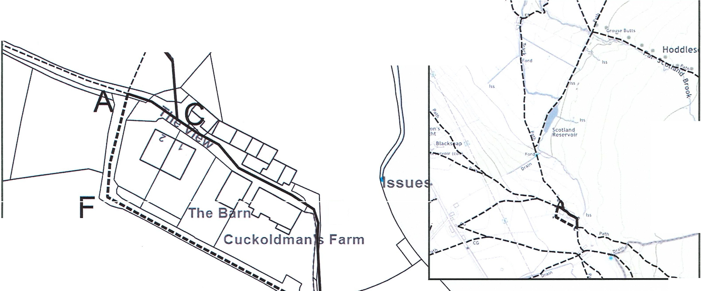
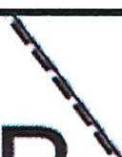
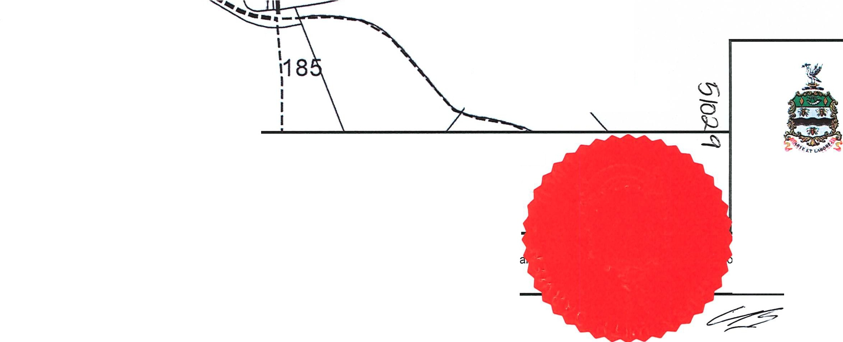
The Public Rights of Way information shown on this plan should be used as guidance only.
Rights of Way information should be verified by consulting the Definitive Map (the legal record) which can be inspected by appointment during norm
© Crown copyright and database rights 2022. Ordnance Survey licence number: 100019493

fWay@blackburn.gov.uk

