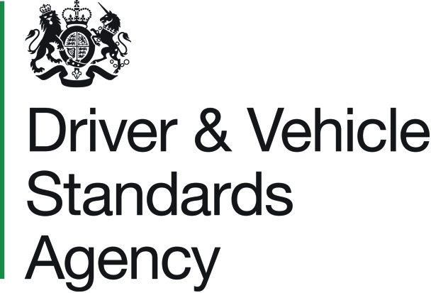 |  |  |  |  |  |  |  |  |  |  |  |  | NOTIFICATION OF CHANGE TO AN  ACCESSIBILITY VEHICLE APPROVED TYPE  PSV 400B  Equality Act 2010  The PSV Accessibility Regulations 2000
FAILURE TO COMPLETE THE FORM ACCURATELY OR IN FULL COULD RESULT IN
DELAYS OR REJECTION

1. APPLICANT DETAILS

Title : |  |  |  |  |  |  | Name :
Address :

Postcode : |  |  |  |  |  |  |  |  |  |  | Tel. No. :
Email :

2. VEHICLE DETAILS

Vehicle Type Approval number(s) and, if applicable, carrying capacity variation
letter(s) : ▼
Chassis  Make : |  |  |  |  |  |  |  |  |  |  |  |  |  |  |  |  |  |  |  | Chassis  Model :
Body  Make : |  |  |  |  |  |  |  |  |  |  |  |  |  |  |  |  |  |  |  | Body  Model :
VIN of vehicle to be inspected :
Which test location would you prefer? :
Please give brief details below of changes to the accessibility features required by
schedules* ► |  |  |  |  |  | 1 |  |  | 2 |  |  | 3
Please ensure that an amended (accessibility) specification report for this vehicle type is
submitted. (*Please indicate above)

Continued Overleaf ►

PSV 400B

3. DATA PROTECTION, DECLARATION & SIGNATURE DETAILS

DATA PROTECTION – We collect, use and store your personal data so that we can process your application notifying DVSA of a change to an accessibility vehicle (approved type).
We may share your personal data if we have a lawful reason. For example as part of a criminal investigation or to prevent fraud. Find out more at www.gov.uk/dvsa/privacy.

DECLARATION – I confirm that, as far as I know, all statements in this application are true.

Signature : |  | Date : | / /
Print Full Name :
Please Note : All ‘Declaration’ sections above must be completed.
A A typed ‘Signature’ is acceptable if sending your form electronically.

4. PAYMENT OPTIONS & DETAILS – POSTAL APPLICATIONS ONLY

If you choose to send your application by post, you can pay the required fee by one of several methods :

- Cheques/Postal Orders - Payable to the ‘Driver and Vehicle Standards Agency’
(or ‘DVSA’) and only accepted with postal applications.

- Credit/Debit card - If you choose to pay by this method, then once your application has been received, you will be contacted by email with instructions on how to arrange your card payment.

- DVSA Pre-Funded Customer Account - If you are a regular user of the scheme this is the quickest method to use. For pre-funded customer accounts, the signatory on the application must be a delegate authorised to use the account. Find out how you can apply for a DVSA pre-funded customer account.

You can see the Vehicle Approvals fees online or by telephoning our Customer Service Centre on 0300 123 9000.

How are you paying for this application? (Please tick one box)
Cheque / Postal Order |  |  |  | Payable to ‘Driver and Vehicle Standards Agency’ or ‘DVSA’ (only with postal applications).
Credit / Debit Card |  |  |  | Payment to be made once application is received.
DVSA Pre-Funded Account |  |  |  | Account ‘C’ No. :
I hereby authorise the Driver and Vehicle Standards Agency to take the amount stated below from my bank / pre-funded customer account in respect of my application.

 |  |  | £ .
Signature details : Please sign and print your name if you are the DVSA customer account delegate.

Signature : |  |  |  |  |  |  | Date :
Print Full Name :
ON COMPLETION

Use the service to Apply for a vehicle test or certificate for a coach or bus to send your
fully completed form to the Driver and Vehicle Standards Agency (DVSA).

DVSA Customer Contact Centre - 0300 123 9000

