LED Ceiling Light
Aspect | Details
Images | 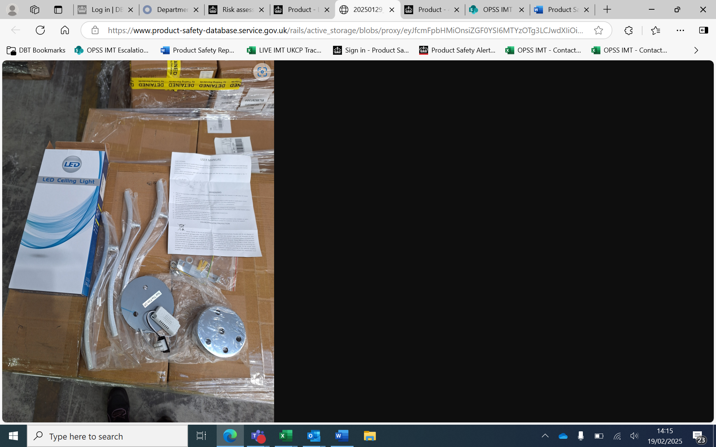
PSD Number | 2502-0044
Product Type | Electrical appliances and equipment – LED ceiling light
Product Identifiers | Barcode: B08YDN4Y3Y  Other Product Identifiers: 2645442, FBA15JT7DNZVU000008.
Product Description | An LED ceiling mounted light
Country of Origin | China
Counterfeit | Unknown
Risk Level | Serious
Risk Type | Electric shock
Risk Description | The product presents a serious risk of electric shock as the product failed the 1250 V electric strength test. The insulation broke down at 700 V when applied between the live input and earthed metal parts.  The product’s insulation may therefore break down over time due to the low strength of the product, and a surge in current could cause it to become live, causing the consumer to receive an electric shock.  The product does not meet the requirements of the Electrical Equipment (Safety) Regulations 2016.
Corrective Measures | The import has been rejected at the border and destroyed.
Online Marketplace | Amazon – The listing has been removed by the online marketplace
Notifier | Local Authority Trading Standards

