

|  |
| --- |
| **Order Decision** |
| on papers on file |
| **by Susan Doran BA Hons MIPROW** |
| **an Inspector appointed by the Secretary of State for Environment, Food and Rural Affairs** |
| **Decision date: 06 March 2025** |

|  |
| --- |
| **Order Ref: ROW/3329685** |
| * This Order is made under Section 53(2)(b) of the Wildlife and Countryside Act 1981 and is known as the West Sussex County Council (Cuckfield Rural No.1: Horsted Keynes (Addition of a Restricted Byway)) Definitive Map Modification Order 2023. |
| * The Order is dated 23 March 2023 and proposes to modify the Definitive Map and Statement for the area by adding a restricted byway as shown in the Order plan and described in the Order Schedule. |
| * There were 6 objections outstanding when the Order was submitted to the Secretary of State for Environment, Food and Rural Affairs for confirmation. |
| **Summary of Decision: The Order is confirmed** |
|  |

Preliminary Matters

1. This Order concerns the addition of a restricted byway between Birchgrove Lane and School Lane, Horsted Keynes as shown on the plan attached to the Order. The application to add the Order route to the Definitive Map and Statement (‘DMS’) was made by the Open Spaces Society.
2. The objections to the Order, received within the statutory notice period following its making by West Sussex County Council (‘the Council’), have not been withdrawn but raise matters I cannot take into account in determining it (paragraphs 16-17).
3. My decision is reached based on the papers on file. I have not visited the site but am satisfied that I can reach my decision without the need to do so.

The Main Issues

1. The Order is made under Section 53(3)(c)(i) of the Wildlife and Countryside Act 1981. This requires me to consider whether, on a balance of probabilities, the evidence discovered by the Council, together with all other evidence available, shows that a restricted byway subsists over the Order route. This is a higher test than that required to make the Order.
2. The evidence adduced is documentary. Section 32 of the Highways Act 1980 requires I take into consideration any map, plan or history of the locality, or other relevant document provided, giving it appropriate weight, before determining whether a way has been dedicated as a highway.

Reasons

*Early Maps*

1. Three maps of Sussex, Gardener and Gream Map 1795, Greenwood and Greenwood Map 1825, and Mudge’s Map 1813 (with updates to 1873) are consistent in depicting the Order route as a ‘road’, with the 1825 map denoting it as a ‘cross road’.These maps provide evidence of the physical existence and longevity of the Order route as a feature. They are suggestive of it forming part of the wider highway network but should be considered alongside all the evidence.

*Ordnance Survey records*

1. Ordnance Survey (‘OS’) mapping is consistent in depicting the Order route as a ‘road’ bounded on both sides and open to the wider highway network, as seen in the First Edition map of 1813-1819, and later maps of 1879, Second Edition 1898, 1911, and Third Edition 1910/14.The 25-inch OS First Edition map shows it as part of a longer route running to the south, numbered 849a. The accompanying Book of Reference records this parcel number as a ‘Road’, indicating it had the reputation of being such a way. Its continuation to the south is recorded today as a County maintained road.
2. Collectively these maps provide good evidence of the Order route as a physical feature, unobstructed and connecting with a wider network of routes which are recorded as public roads today. However, they are not considered to provide evidence as to status and should be evaluated alongside the evidence as a whole.

*Tithe Records*

1. The Order route is coloured on the West Hoathly Tithe Map, and there is no apportionment number. As above, it is shown in the same manner as other routes that are now public roads, although its colouring on the Map is not necessarily indicative of its status.
2. The purpose of these records was not to record public rights of way, though they may give an indication as to whether a way was public or private. They provide good evidence of the topography of the roads they portray especially where they form the boundaries of titheable land, as here.

*Finance Act 1910 records*

1. The Valuation Plan shows the Order route uncoloured and separate from adjoining numbered hereditaments. This is strong possibility it was considered a public vehicular highway rather than a footpath or bridleway which were usually recorded in the Field Books with a tax deduction applied. The recording of public rights of way was incidental to the main purpose of these records, and again they need to be considered together with all other evidence available.

*Highways records*

1. The Handover Records 1930 are a record of maintenance responsibilities passed from the District Councils to the County Council. The East Grinstead Rural District Council Handover Map showing publicly maintained roads in yellow, includes the Order route. Accordingly, this provides conclusive evidence of the highway authority’s acceptance of public maintenance responsibility and is suggestive of the Order route’s status as a road.
2. There is no evidence the Order route was considered for inclusion during the survey prior to the preparation of the DMS, indicating it was not regarded as a public footpath or bridleway. Nor was it included in the 1953 Draft DMS, 1957 DMS, or Draft Revised DMS 1960 so must have been viewed as a public or private road.

*Conclusions on the evidence*

1. Few documentary sources are conclusive as to status, but when considered together can demonstrate the reputation of a way over many years and the rights which subsist over it, on the balance of probability.
2. The Order route has been depicted consistently throughout the documentary record from its earliest depiction in 1795 as an open way connecting with and to the wider highway network, and in early OS records as part of a longer route which is a public road today. Nothing in the sources considered above suggests it was a private way to access adjoining land or property. I am therefore satisfied the Order route is a longstanding public vehicular highway which has latterly fallen into disuse. There is no evidence that any rights existing over it have been legally stopped up, or its alignment altered. However, the effect of section 67 of the Natural Environment and Rural Communities Act 2006 is that mechanically propelled vehicular rights over it have been extinguished as none of the exemptions in section 67 applies. It should therefore be recorded in the DMS as a restricted byway.

**Other matters**

1. Several issues are raised in representations and objections to the Order including cost implications to the public purse if the Order is confirmed; animal welfare especially of elderly and sick livestock; security; environmental concerns including damage to ecology and wildlife; potential fly tipping; suitability as the route is densely vegetated and treed, and often waterlogged; safety concerns; that the route is not used; and the Order does not represent the wishes of the community.
2. I understand these concerns and their importance to those expressing them. However, I am unable to consider them in reaching my decision under the relevant legislation. Accordingly, I have not attached weight to these issues in reaching my decision, which must be based on the evidence as to the existence, status and alignment of the Order route.

*Width*

1. It is suggested the 6-metre width recorded in the Order is unnecessary. No evidence has been put forward for an alternative width. In the absence of evidence to the contrary and having regard to the documentary sources adduced, I consider this width to represent the width available historically.

Conclusion

1. Having regard to these and all other matters raised in the written representations, I conclude the Order should be confirmed.

**Formal Decision**

1. I confirm the Order.

S Doran

**Inspector**

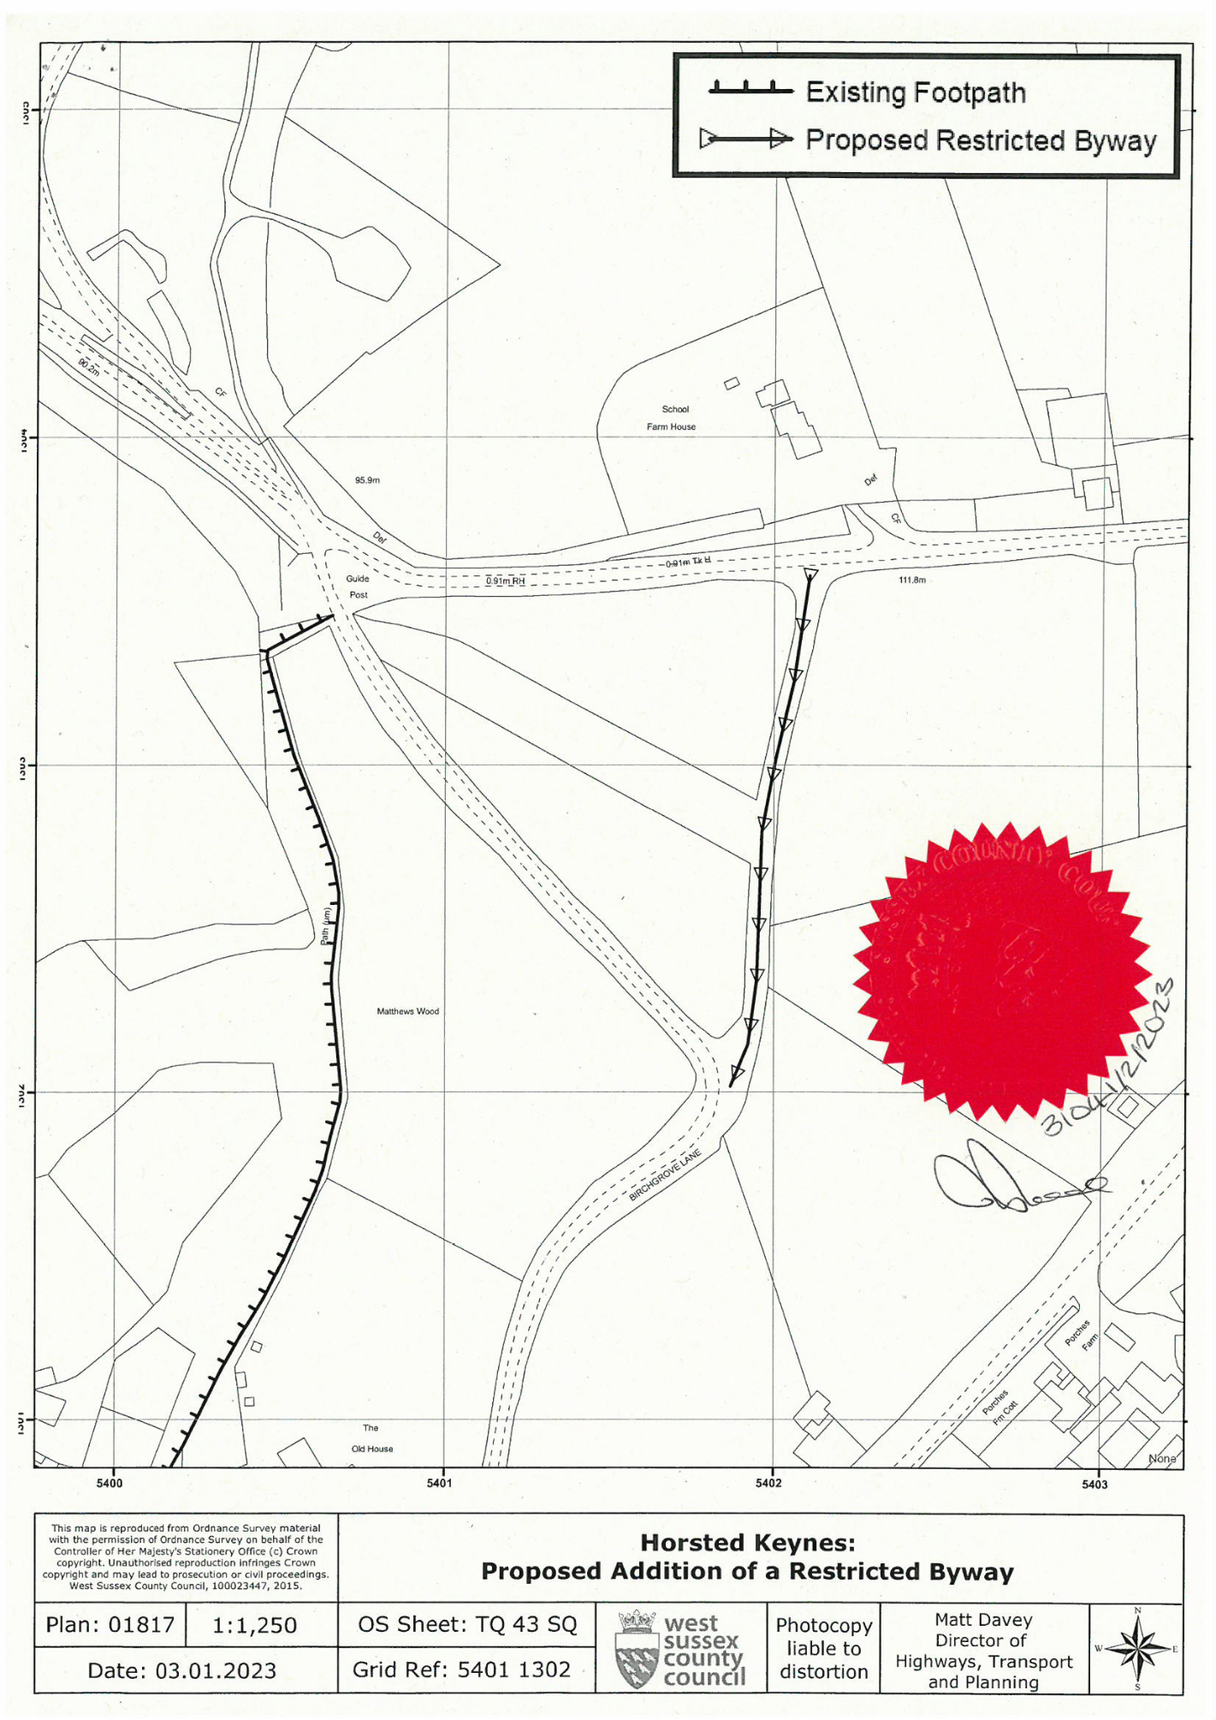

|  |
| --- |
| **MAP NOT TO ORIGINAL SCALE** |