NOTICE OF ORDER
Wildlife and Countryside Act 1981

Norfolk County Council
Norfolk County Council (King’s Lynn, Spring Wood) Modification Order 2022

Notice is hereby given that the above referenced Order has been submitted to the Secretary of State for Environment, Food and Rural Affairs for determination. An Inspector will be appointed by the Secretary of State to determine the Order.

The start date for the above Order is 11 FEBRUARY 2025

Consideration of the Order will take the form of a public local inquiry.

The Inquiry will be held at Venue TBC on 12 August 2025 at 10.00am.

The effect of the Order, if confirmed without modifications, will modify the Definitive Map and Statement for the area by adding the following footpaths –

Footpath (Baldwin Road to Suffolk Road)
Starts from the U20744 Baldwin Road at grid reference TF 6445 2060 (point A on annexed map) and runs in a generally south south westerly direction for approximately 80 metres to meet the U20745 Suffolk Road at grid reference TF 6444 2052 (point B on annexed map).
Footpath
Starts from a point on the previously mentioned footpath at grid reference TF 6445 2056 (point Con annexed map) and runs in a generally east south easterly direction for approximately 59 metres to join Cycle Path 2Y28 at grid reference TF 6451 2056 (point D on annexed map).
Footpath (Cycle Path 2Y28 to U23049 Langland)
Starts from the Shared Use Cycle Path 2Y28 at grid reference TF 6452 2056 (point E on annexed map) and runs in a generally east south easterly direction for approximately 5.5 metres to grid reference TF 6452 2056 (point Fon annexed map) where the path turns to run in a generally north easterly direction for approximately 23 metres to grid reference TF 6454 2057 (point G on annexed map) where the path turns to run in an east south easterly direction for approximately 78 metres to grid reference TF 6462 2056 (point H on annexed map) where the path turns to run in a north easterly direction for approximately 50 metres to meet the U23049 Langland at grid reference TF 6466 2059 (point I on annexed map).
Footpath
Starts from a point on the previously mentioned footpath at grid reference TF 6452 2056 (point F on annexed map) and runs in a generally south easterly direction for approximately 31 metres to grid reference TF 6454 2054 (point J on annexed map) where the path turns to run in an east south easterly direction for approximately 48 metres to grid reference TF 6459 2053 (point K on annexed map) where the path turns to run in a north easterly direction for approximately 44 metres to meet the above mentioned footpath at grid reference TF 6462 2056 (point Hon annexed map) where the path turns to run in a south easterly direction for approximately 20 metres to grid reference TF 6463 2054 (point L on annexed map) where the path turns to run in a generally east south easterly direction for approximately 23 metres to meet the U23049 Langland at grid reference TF 6466 2054 opposite and on the other side of the road to the footpath leading to Courtnell Place (point M on annexed map).

Any queries relating to this Order should be referred to Paul Scrivener by email: Paul.Scrivener@planninginspectorate.gov.uk quoting reference number ROW/3344727 on all correspondence. Alternatively, queries may be sent in writing to The Planning Inspectorate, Rights of Way Section, Room 3/A Eagle Wing, Temple Quay House, 2 The Square, Temple Quay, Bristol, BS1 6PN. Telephone: 0303 444 5000.

Any person wishing to view the statements of case and other documents relating to this Order may do so by appointment at the offices of Norfolk County Council, Floor 1, County Hall, Martineau Lane, NORWICH, NR1 2DH during normal office hours. It is preferable for interested parties to arrange a mutually convenient appointment by contacting legalordersandregisters@norfolk.gov.uk
Contact - Lawrence Malyon – email: Lawrence.malyon@norfolk.gov.uk

Timetable for sending in statements of case and comments

Within 8 weeks of the start date by [by 08 April 2025]

The Order Making Authority must ensure their statement of case is received by the Secretary of State. As soon as possible after the deadline, the Secretary of State will send a copy (excluding copies of any supporting documents - these will be available to view at the Authority’s offices) to everyone who has made an objection or representation and the applicant and any other person who has written to us in respect of the Order.

Within 14 weeks of the start date [by 20 May 2025]

Everyone who has made an objection or representation and anyone who wishes to give evidence at the Inquiry must ensure their statement of case is received by the Secretary of State. As soon as possible after the deadline, the Secretary of State will send full copies to the Authority. Copies will also be sent to the applicant, every person who has made an objection or representation and any other person who has written to us in respect of the Order (excluding copies of any supporting documents - these will be available to view at the Authority’s offices).

Within the same period the applicant (if applicable) must ensure their statement of case is received by the Secretary of State. As soon as possible after the deadline, the Secretary of State will send a full copy to the Authority. Copies will also be sent to everyone who has made an objection or representation and any other person who has written to us in respect of the Order (excluding copies of any supporting documents - these will be available to view at the Authority’s offices).

4 weeks before the date of the inquiry [by 15 July 2025]

The Authority, everyone who has made an objection or representation, the applicant (if applicable) and anyone who wishes to give evidence at the Inquiry must ensure their proof of evidence (together with any summary) is received by the Secretary of State. As soon as possible after the deadline, the Secretary of State will send copies of:

- the Authority’s proof of evidence to everyone who has made an objection or representation, the applicant and anyone who has submitted a statement of case (including copies of any supporting documents – although none should be submitted with a proof of evidence);

- the applicant’s proof of evidence to the Authority, everyone who has made an objection or representation and anyone else who has submitted a statement of case (including copies of any supporting documents – although none should be submitted with a proof of evidence); and

- all other proofs of evidence to the Authority, the applicant, everyone who has made an objection or representation and anyone else who has submitted a statement of case (including copies of any supporting documents – although none should not be submitted with a proof of evidence).

All parties must keep to the timetable set out above and ensure that statements of case and proofs of evidence are received by the Secretary of State on time. Late documents will be returned.

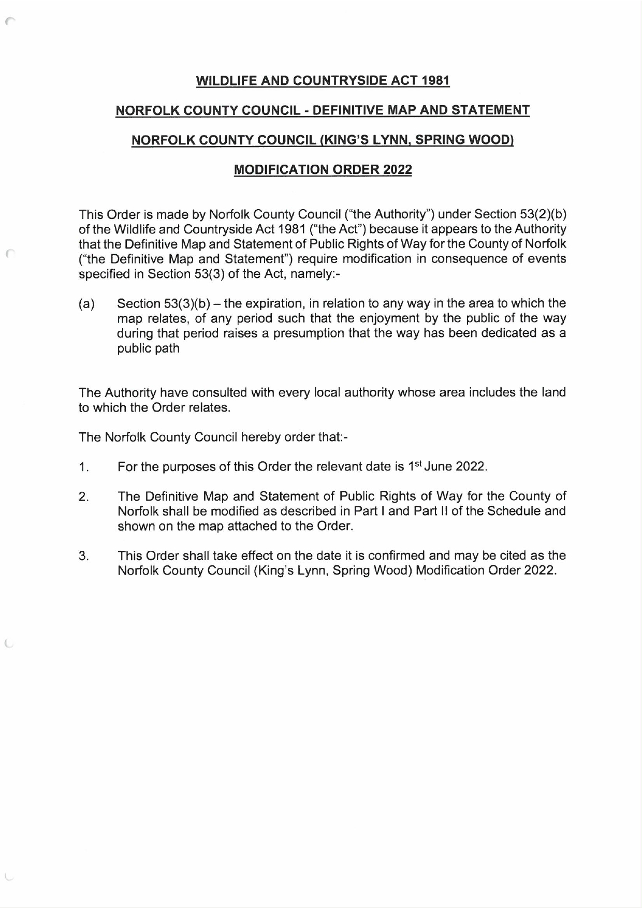

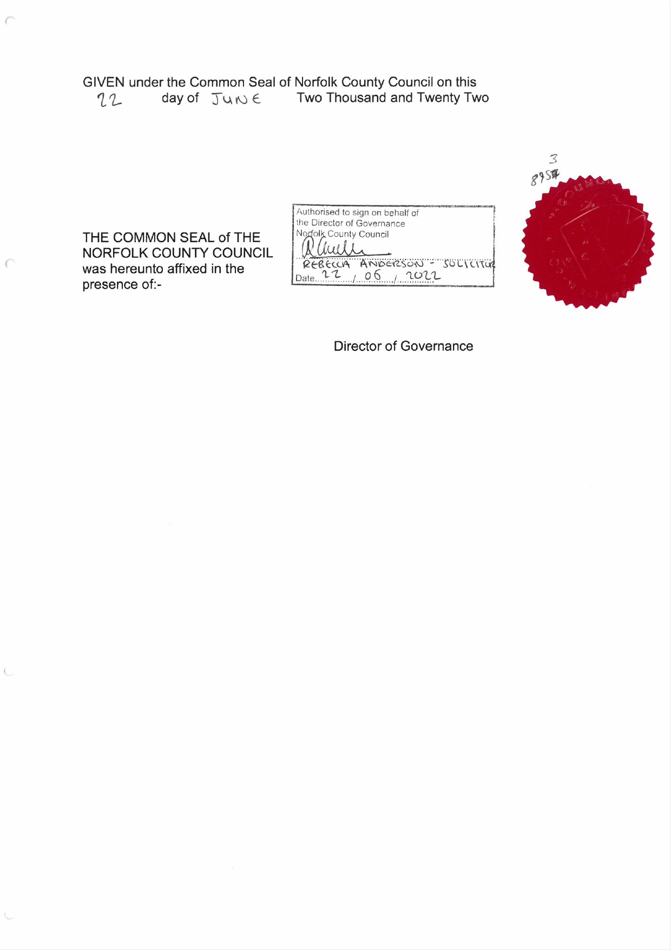

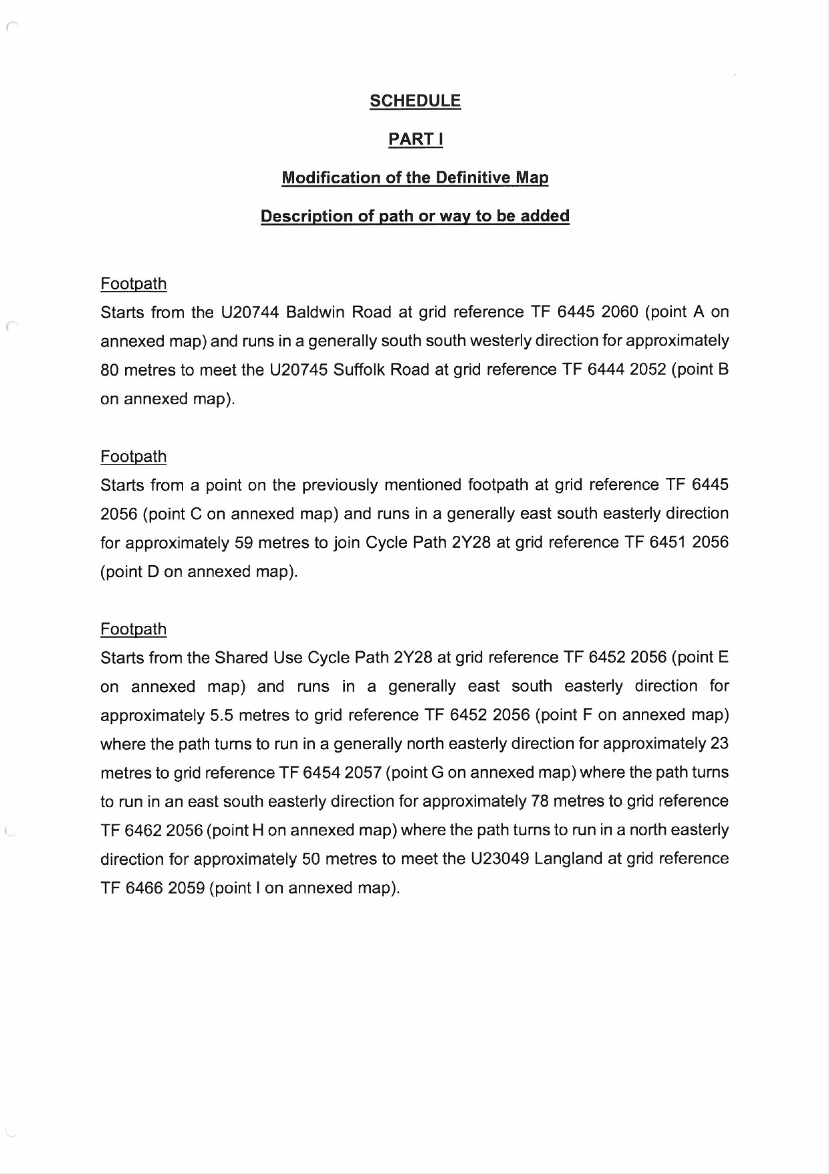

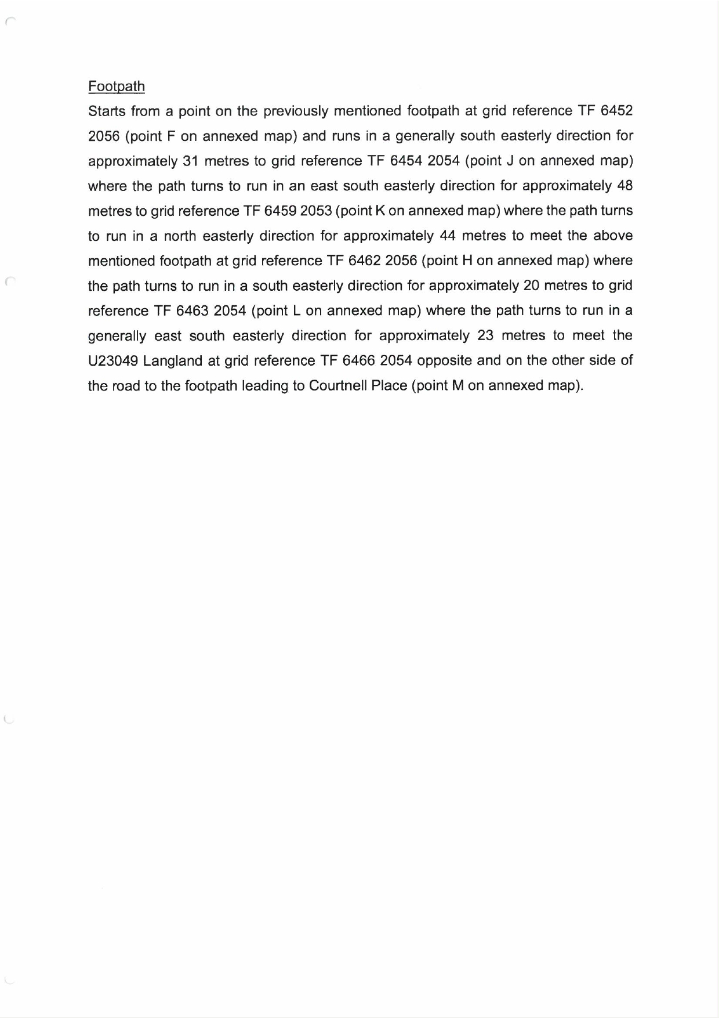

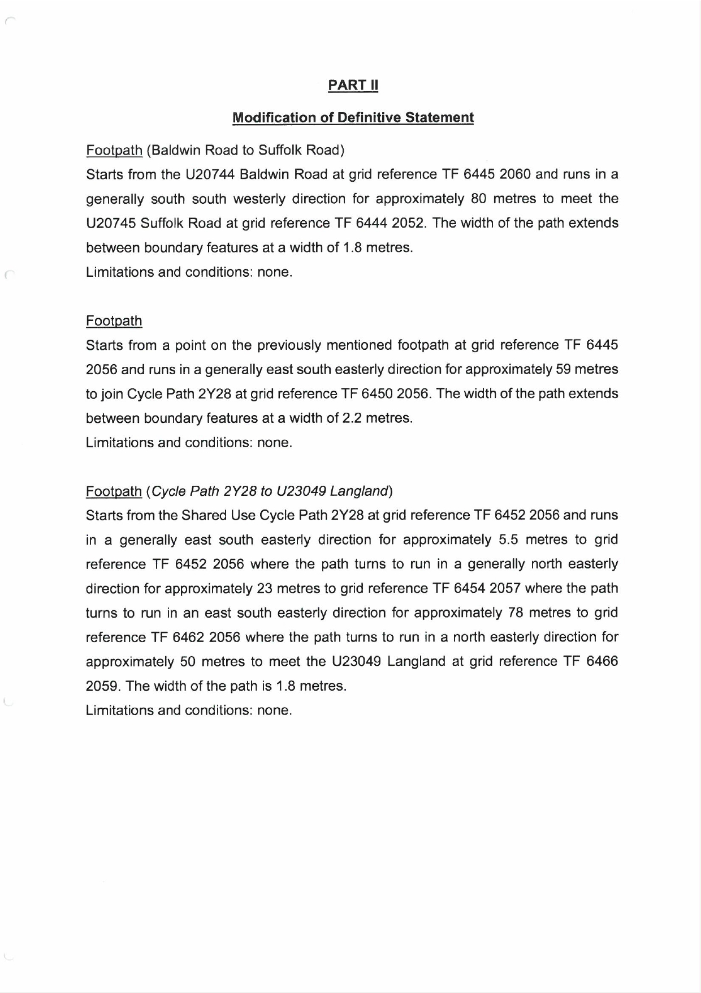

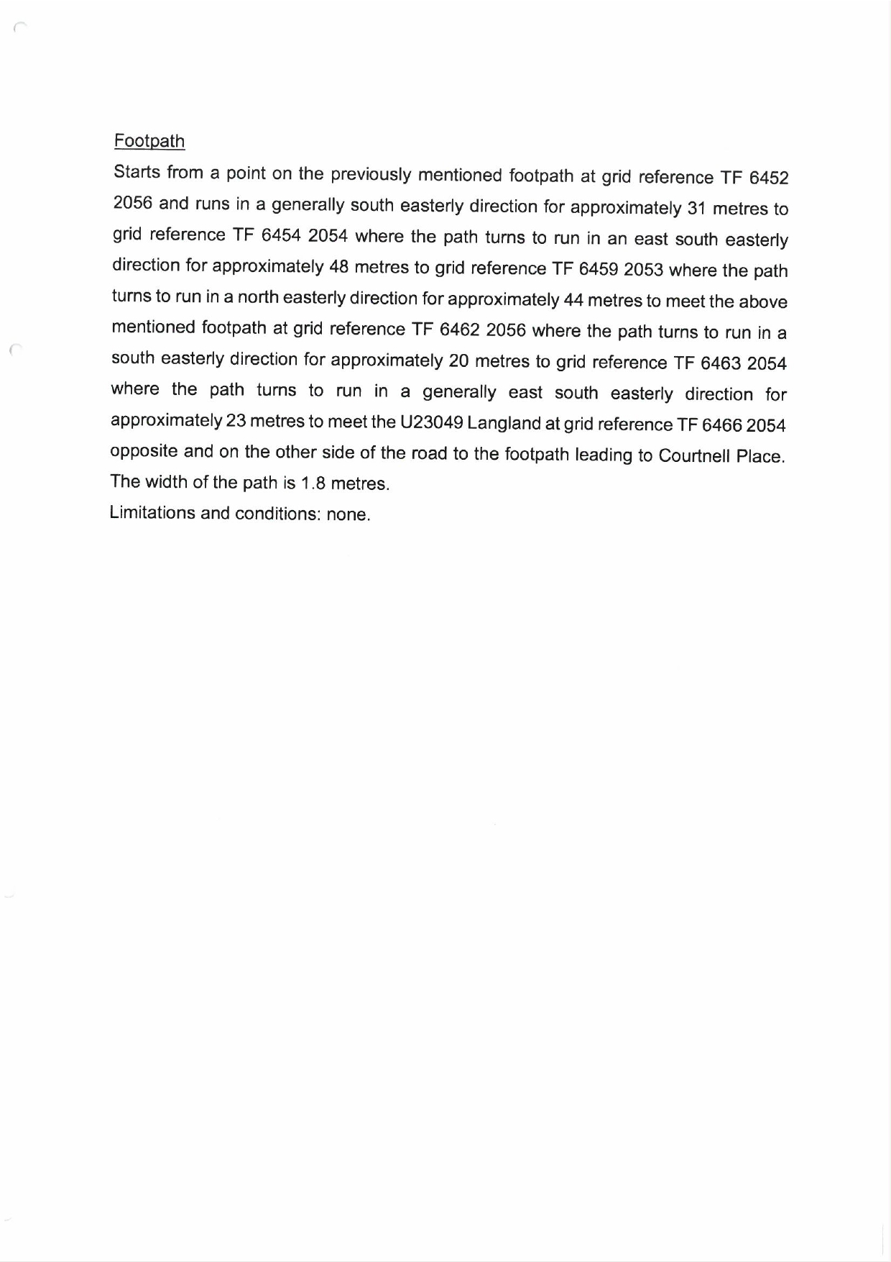

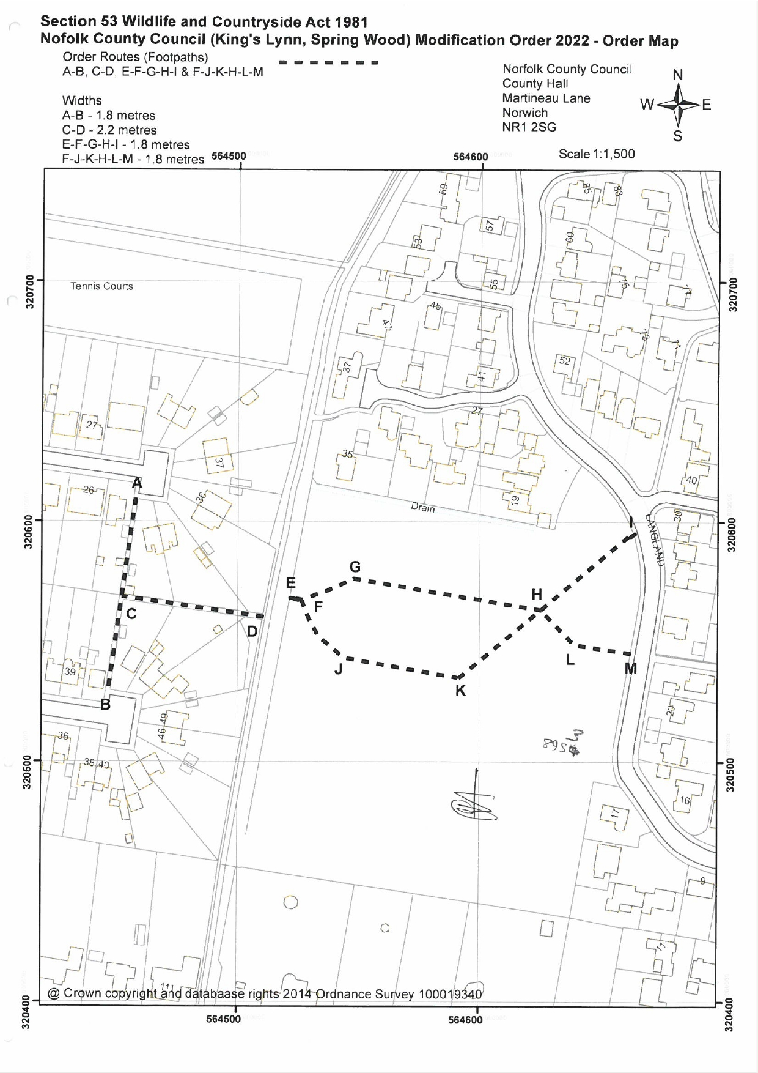

If you wish to make a legal submission, this should be submitted at the same time as your statement of case. Otherwise legal submissions will have to be submitted in writing on the day of the inquiry.

