This guidance was withdrawn on 6 February 2025.

For the current diabetic eye screening (DES) invitation and results letters, log in to FutureNHS (registration required) and go to DES Letter Templates - Vaccinations and Screening.

Mr A Person
Address
XX month 20xx
Reference: XXXXXXXXXX (please quote in any enquiry)

Dear [insert name],

Result of your diabetic eye screening test

Thank you for attending your recent diabetic eye screening test.

Your test result showed no signs of diabetic retinopathy. This means you are currently at very little risk of damage to your eyesight from your diabetes.

Evidence shows that if you are found not to have diabetic retinopathy after two successive screenings, you can safely be screened every two years instead of every year. Consequently, as this applies to you, your next appointment will be due 2 years from now. We will send you a reminder nearer the time.

Diabetic eye screening specifically tests for signs of diabetic retinopathy. It is not the same as your regular eye test with your optometrist or optician. You should have both tests.

If you notice any changes to your eyesight, contact your local optometrist or optician straight away. Do not wait for your next screening appointment.
We have informed your GP Practice of your test result. If you have any questions about your test result, please contact the screening service on [insert number].
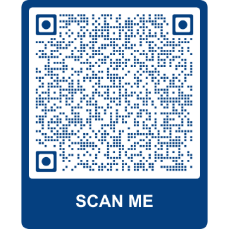
Further information about diabetic retinopathy can be found here: www.nhs.uk/retinopathy. You can also find the information by scanning this QR code with the camera on your smartphone or tablet.

Yours sincerely,
[SIGNATURE]
Mr A Screener

[insert name and address of local screening programme here]

