

Application Decision
Site visit made on 18 December 2024
by Mark Yates BA(Hons) MIPROW
an Inspector appointed by the Secretary of State for Environment, Food and Rural Affairs
Decision date: 27 January 2025

Application Ref: COM/3344390
Powick Hams Common, Powick, Worcestershire
Register Unit: CL77
Registration Authority: Worcestershire County Council

- The application was submitted on 9 May 2024 and is made under Section 16 of the Commons Act 2006 (‘the 2006 Act’) to deregister and exchange land registered as common land.
- The application was made on behalf of Ms Hawkins and Mr Murch.
- The release land comprises of 5570m² of semi-improved grassland.
- The replacement land comprises of two areas of semi-improved grassland with a total area of 5570m².

Decision
- The above application is granted.
Main Issues
- I am required by Section 16(6) of the 2006 Act to have regard to the following in determining this application:-
- the interests of persons having rights in relation to, or occupying, the release land (and in particular persons exercising rights of common over it);
- the interests of the neighbourhood;
- the public interest which includes the interest in nature conservation, the conservation of the landscape, the protection of public rights of access to any area of land and the protection of archaeological remains and features of historic interest; and
- any other matter considered to be relevant.
Reasons
The Application
- Previous applications to deregister and exchange land at Powick Hams Common for a highway scheme involving the A4440 Road were approved by an Inspector appointed by the Secretary of State on 15 April 2019 (Planning Inspectorate Refs: COM/3215021 and COM/3217252).
- The release land comprises of 5570m² of land lying to the south of the A4440 Road between the River Severn and Powick Roundabout. This application has been submitted in order to enable the drainage ditch alongside the road to be fenced off from the agricultural land.
- Two pieces of land have been identified as a replacement which are equivalent in area to the release land. The majority of the replacement land is located approximately 1.6km to the west of the Powick Roundabout and lies between the River Teme to the north, Lord’s Wood to the south and adjacent to existing common land to the east. The second area is to the west of the A449 Road and to the south of Powick Roundabout and adjacent to existing common land.
- The one representation from Natural England raised no objection to the application.

The interests of those occupying or having rights over the release land
- It is apparent that rights of common are currently exercised over Powick Hams Common for a proportion of the year for the grazing of livestock. At other times, the landowner can make use of the pasture land. The application was made at the request of the landowners and the commoners have raised no concerns about the loss of the release land. The fencing would keep cattle away from the drainage ditch and road and the proposed exchange is clearly in the interests of these parties.
The interests of the neighbourhood
- The impact of the application on members of the public generally is considered below. These matters will have particular relevance to local people. There is nothing to indicate that there are any matters that would impact on residents of the neighbourhood alone.
The public interest
- Access to the larger part of the replacement land will be available from the existing common land and a public right of way also crosses the land. The smaller area of replacement land is adjacent to the common with access available from a field gate off the A449 Road. The replacement land generally offers a more suitable area for public access than the narrow strip of release land which lies alongside the A4440 Road.
- Natural England have confirmed that they do not consider the exchange will have an adverse impact on any designated sites for which they are the regulatory body. Both the release land and replacement land comprise of semi-improved agricultural land with some remnants of hedgerows and mature trees. Although parts of both areas are around 100 metres from the River Teme, which is a site of special scientific interest, there is nothing from the information supplied to indicate that the exchange would have an adverse impact on nature conservation. Nor is there anything apparent in relation to the exchange in terms of the conservation of the landscape.
- The release land is situated adjacent to a civil war battlefield site. However, there is nothing to suggest that the proposed exchange would have an impact on this site. Additionally, there is no evidence of any archaeological remains or features of historical interest that would be affected by the exchange.
Conclusion
- Having regard to these and all other matters raised in relation to the application I conclude on balance that the application should be granted.

Mark Yates
Inspector

Order

On behalf of the Secretary of State for Environment, Food and Rural Affairs and pursuant to section 17 (1) and (2) of the Commons Act 2006, I HEREBY ORDER the Worcestershire County Council, as Commons Registration Authority for the area in which the release land and the replacement lands are situated:

(a) to remove the release land from its register of common land, by amending register unit CL 77 to exclude the release land;

(b) to register the replacement lands as common land, by amending the register unit CL 77 to include the replacement lands;

(c) to register as exercisable over the replacement lands (in addition to remaining exercisable over the remainder of the land comprised in register unit CL77) any rights of common which, immediately before the date on which the release land is removed from the register, are registered as exercisable over the release land and the remainder of the land comprised in register unit CL77.

First Schedule – the release land

Colour on Plan | Description | Extent
Edged red | An area lying south of the A4440 Road between the River Severn and Powick Roundabout. | 5570m²

Second Schedule – the replacement lands

Colour on Plan | Description | Extent
Edged light green | One area of land located approximately 1.6 km to the west of the Powick Roundabout which lies between the River Teme to the north, Lord’s Wood to the south and adjacent to existing common land to the east.  A second area of land located to the west of the A449 Road and to the south of Powick Roundabout and adjacent to existing common land. | 5570m²

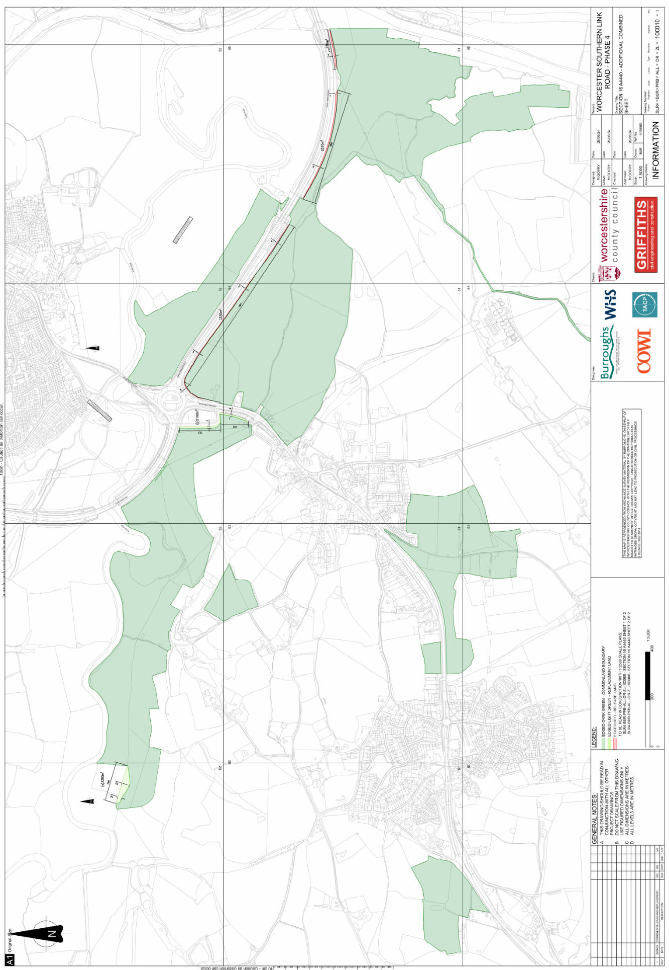
Figure 1 – Application map

