This document provides a notice of extension of the validity of the following PGD:
UKHSA Publications gateway number: GOV-15399
Reference no: Hepatitis B (Hep B) vaccine PGD
Version no: v5.0
Valid from: 31 October 2023
Expiry date: 30 April 2025 (Extended to 31 October 2025)
This PGD is extended and valid until 31 October 2025, pending anticipated revisions to the childhood immunisation programme and the impact of changes to the infant hexavalent regime on advice provided in the hepatitis B PGD.
This extension is approved by the following health professionals on behalf of UKHSA:
Developed by: | Name | Signature | Date
Pharmacist  (Lead Author) | Christina Wilson  Lead Pharmacist – Immunisation Programmes Division, UKHSA |  | 12 December 2024
Doctor | Dr Sema Mandal  Deputy Director and Consultant Medical Epidemiologist, Blood Safety, Hepatitis, STI:s and HIV, UKHSA | 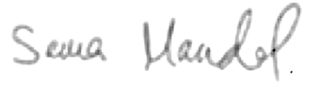 | 12 December 2024
Registered Nurse  (Chair of Expert Panel) | David Green  Nurse Consultant – Immunisation Programmes Division, UKHSA | 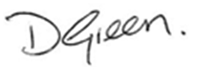 | 12 December 2024
This extension has been approved by the UKHSA Medicines Governance Committee.

Insert authorising body name authorises this extension and continued used of Hepatitis B vaccine PGD v5.0 during the assigned period by the services or providers listed below:

Authorised for use by the following organisations and/or services

For instance, all NHS England commissioned immunisation services or NHS Trusts providing immunisation services.

Limitations to authorisation

For instance, any local limitations the authorising organisation feels they need to apply in line with the way services are commissioned locally. This organisation does not authorize the use of this PGD by…

Organisational approval (legal requirement)
Role | Name | Sign | Date

For instance, NHS England Governance Lead, Medical Director

Additional signatories according to locally agreed policy
Role | Name | Sign | Date

