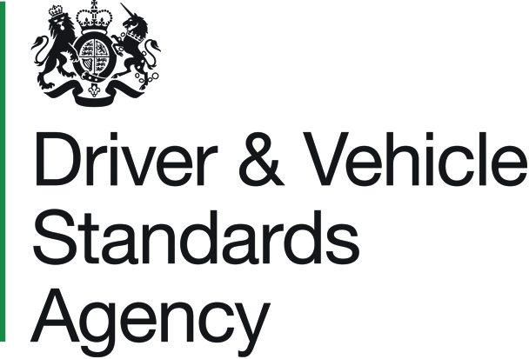
IVA TILT JUSTIFICATION REPORT

IVA 52A

Applicant / Company Name :
Master Vehicle Tilt Number :
If the Master Vehicle Tilt Number is not quoted above, a copy of the tilt held for the Master Vehicle must be enclosed or the following information must be completed in full.
DETAILS |  |  |  | MASTER VEHICLE |  | SUBSEQUENT VEHICLE
CHASSIS
Number

Make

Model

Year

BODY
Make

Model

Year

ENGINE
Make

Type (inc. Euro status)

Number of Cylinders

DIMENSIONS
Length

Height | Inc. Air Conditioning
Height | Exc. Air Conditioning
Width

Wheelbase

Height of Passenger Deck from Ground

WEIGHTS
Mass in Running Order  (See Note 1 on page 2) |  | Axle 1
 |  | Axle 2
 |  | Axle 3
 |  | GVW
Laden Mass  (See Note 2 on page 2) |  | Axle 1
 |  | Axle 2
 |  | Axle 3
 |  | GVW

IVA 52A
DETAILS |  |  | MASTER VEHICLE | SUBSEQUENT VEHICLE
WEIGHTS (Continued)
Design Weights |  | Axle 1
 |  | Axle 2
 |  | Axle 3
 |  | GVW
(Note 1) Mass in Running Order means the mass of the unladen vehicle with bodywork, and with coupling device in the case of a towing vehicles, (including coolant, oils, 90% fuel, 100% other liquids (except used waters), tools, spare wheel and driver (75kg), and, for buses and coaches, the mass of the crew member (75kg) if there is a crew seat in the vehicle.

(Note 2) Laden Mass means the mass in running order plus passenger weight of Classes I and A, 68kg, Classes II & III and B, 71kg, placed on each seat (top deck only of a double deck vehicle). A weight of 75kg representing a driver or seated crew member will be placed on the associated seats. If the vehicle is intended for standees or with a crew member who is not seated, the centre of gravity of the loads for passengers of 75kg, representing them, shall be uniformly distributed over the standee or crew area respectively, at a height of 875mm. For luggage carried on a roof rack, any weight declared by the manufacturer must exert a specific load of not less than 75kg/m² over the whole surface area of the roof equipped for the carriage of baggage. For wheelchair users the mass is 100kg at a height of 500mm.

DETAILS |  |  | MASTER VEHICLE | SUBSEQUENT VEHICLE
TRACK (between centre of tyres)
Axle 1
Axle 2
Axle 3
TYRES
Tyre Size and Indices  (Use suffix (T) if twin tyres) |  | Axle 1
 |  | Axle 2
 |  | Axle 3
SEATING ARRANGEMENTS
Number of Crew Seats
Maximum  Number Seated Passengers | Upper Deck
Maximum  Number Seated Passengers | Lower Deck
Standees
Wheelchairs

Continued Overleaf ►

IVA 52A
REMARKS
Include here details of any feature(s) of the vehicle which are different to the master vehicle and which could affect its stability and/or assist in future identification of type e.g. roof luggage rack, fuel tanks, air conditioning and any other special equipment, noting its size, position and loading.

FEATURE | MASTER VEHICLE |  | SUBSEQUENT VEHICLE |  | COMMENTS
Double Glazing | Yes |  | Yes
Double Glazing | No |  | No
Suspension Dump Valves or other Suspension Modifications | Yes |  | Yes
Suspension Dump Valves or other Suspension Modifications | No |  | No
Retarder | Yes |  | Yes
Retarder | No |  | No
Crew Seat(s)  (Inc. number) | Yes |  | Yes
Crew Seat(s)  (Inc. number) | No |  | No
Air Conditioning  (Inc. location on vehicle) | Yes |  | Yes
Air Conditioning  (Inc. location on vehicle) | No |  | No
Alloy Wheels | Yes |  | Yes
Alloy Wheels | No |  | No
Combustion Heater | Yes |  | Yes
Combustion Heater | No |  | No
TV Monitors  (Inc. location) | Yes |  | Yes
TV Monitors  (Inc. location) | No |  | No
Spare Wheel | Yes |  | Yes
Spare Wheel | No |  | No
Load for Additional Seats  (Inc. location on vehicle) | Yes |  | Yes
Load for Additional Seats  (Inc. location on vehicle) | No |  | No
Ballast  (Inc. location on vehicle) | Yes |  | Yes
Ballast  (Inc. location on vehicle) | No |  | No
Other  (Please use the box below if required) | Yes |  | Yes
Other  (Please use the box below if required) | No |  | No

IVA 52A
Are there any variations in the suspension from the original (Master) vehicle? If ‘Yes’ please specify the variations below ▼ |  |  |  |  |  | Yes |  | No
DATA PROTECTION AND SIGNATURE
DATA PROTECTION – We collect, use and store your personal data so that we can process your IVA tilt justification report.

We may share your personal data if we have a lawful reason. For example as part of a criminal investigation or to prevent fraud. Find out more at www.gov.uk/dvsa/privacy.

DECLARATION – I confirm that, as far as I know, all statements in this application are true.

Signed :
Print Full Name : |  |  |  |  | Date : | / /
Please Note : All ‘Declaration’ sections above must be completed. A typed ‘Signature’ is
acceptable if sending your application electronically.

ON COMPLETION

Use the service to Apply for Individual Vehicle Approval (IVA) to send your fully completed application form to the Driver and Vehicle Standards Agency (DVSA).

For further information, please email :

enquiries@dvsa.gov.uk

or telephone :

DVSA Customer Contact Centre : 0300 123 9000

